ICTPRG430 AT1: Gold Coast E-Sports



# Scenario

**Gold Coast E-Sports** is a junior e-sports organisation which holds events for juniors throughout the local Gold Coast area. They currently hold about 12 events per year in various locations within the region where young children and teens compete in competitive video games with their teams.

Over the last few months, the organisation’s manager, Mark Brown has noticed it is becoming increasingly difficult to keep track of event results as the organisation keeps growing and having more teams compete each week. Currently the event results are being collected on a series of handwritten and excel documents, but recent events have required Mark to carry around a large amount of paperwork for managing the teams and events, leading to his decision to investigate digitising some of the management process.

Mark has approached you for assistance in developing a system to help manage and record competition information to make it easier for him to manage e-sport teams. He has asked that you develop an initial prototype system which will initially just manage information about the competitions and teams. He has indicated that if he is happy with this prototype, it could potentially lead to further jobs to digitize Gold Coast E-Sports' entire operations.

# Requirements

Mark is intending to run the system you develop on either his personal Windows 10 laptop or Windows 10 PC so he can enter data at home or directly at events. Mark has indicated that he is experienced with using both Console based applications and GUI based applications and that either choice will suit the prototype.

Therefore, he has asked that the system:

* Must be able to run on Windows 10
* Must provide the ability to add new entries to existing data – this includes:  
  Add a new competition result for a team (date, location, game, team, points earned)  
  Add a new team (team name, contact person, phone, email, player names)
* Must be able to update existing team data (e.g. change contact person name, phone, email or add/remove player names in the team)
* Must be able to save entered data to disk when the application is closed
* Must be able to read previously entered data in from disk when the application is opened
* Must be able to display retrieved data in a list or table

Mark requires the application to be able to store and retrieve the following data for each team:

* **Team Details**
  + Team Name
  + Primary Contact Name
  + Contact Phone
  + Contact Email
  + Player names in the team

Below is an example of how team details are currently recorded (on paper) for entry to a spreadsheet application; the developed system should present the same amount of detail in a digital format.

|  |  |  |  |  |
| --- | --- | --- | --- | --- |
| **Team Name** | **Primary Contact** | **Contact Phone** | **Contact Email** | **Player’s names** |
| Coomera Bombers | James Taylor | 0433948765 | [jamestaylor123@coolmail.com](mailto:jamestaylor123@coolmail.com) | James Taylor  Andre Parker  Sally Johns  Persephone Jamieson |
| Nerang Necros | Sophie Jamieson | 0440888222 | [sophie_jamieson@geemail.com](mailto:sophie_jamieson@geemail.com) | Sophie Jamieson  Will Anderson  John Pinkerton  Ivan Yankovich |

* **Competition results**
  + Date
  + Location
  + Game
  + Team name
  + Result for team (points)

Below is an example of how competition details are currently recorded (on paper) for entry into a spreadsheet program; the developed system should present the same amount of detail in a digital format.

|  |  |  |  |  |
| --- | --- | --- | --- | --- |
| **Date** | **Location** | **Game** | **Team** | **Points** |
| 14-Jan-2022 | TAFE Coomera | League of Legends | BioHazards | 5 |
| 15-Jan-2022 | TAFE Coomera | Dota 2 | Buttercups | 4 |

Mark uses MS Excel as his spreadsheet application to store all data on three (3) CSV (Comma Separated Value) files – for example:

**teams.csv** (formatted: Team Name,Contact Person,Phone,Email)

Coomera Bombers,James Taylor,0433948765,jamestaylor123@coolmail.com  
Nerang Necros,Sophie Jamieson,0440888222,sophie_jamieson@geemail.com  
Buttercups,Eric Stratton,040765123,eric_stratto@deltaomni.com  
BioHazards,Zheng Lee,0418999888,zhenglee99@geemail.com

**players.csv** (formatted: Player Name,Team Name)

Zheng Lee,BioHazards  
Sunil Pradesh,BioHazards  
Michelle Chan,BioHazards  
Amber Chia,BioHazards

**competitions.csv** (formatted: Game Name,Competition Date,Location,Team Name,Points)

League of Legends,14-Jan-2022,TAFE Coomera,BioHazards,5  
League of Legends,14-Jan-2022,TAFE Coomera,Buttercups,4  
League of Legends,14-Jan-2022,TAFE Coomera,Coomera Bombers,5  
League of Legends,14-Jan-2022,TAFE Coomera,Nerang Necros,7  
Dota 2,15-Jan-2022,TAFE Coomera,BioHazards,1  
Dota 2,15-Jan-2022,TAFE Coomera,Buttercups,5  
Dota 2,15-Jan-2022,TAFE Coomera,Coomera Bombers,3  
Dota 2,15-Jan-2022,TAFE Coomera,Nerang Necros,6  
Call of Duty,21-Jan-2022,TAFE Coomera,BioHazards,1  
Call of Duty,21-Jan-2022,TAFE Coomera,Buttercups,5  
Call of Duty,21-Jan-2022,TAFE Coomera,Coomera Bombers,2  
Call of Duty,21-Jan-2022,TAFE Coomera,Nerang Necros,7

The following is a suggested GUI design approach (including functionalities) for the Gold Coast E-Sports prototype application:

1. When the program launches, it reads the three (3) external csv files of data (competitions.csv, teams.csv and players.csv).

The read-in data needs to be stored in a suitable data structure(s).

The GUI application displays the header jpeg image (provided in the support files), along with four (4) tabbed panels:

* Team competition results
* Add new team
* Add new competition result
* Update an existing team

The tab panel for the **TEAM COMPETITION RESULTS** displays a table of competition results (read in from the competitions.csv file) showing all competition data in rows with columns: date, location, game, team and points (ordered by date). Refer screen shot example below:

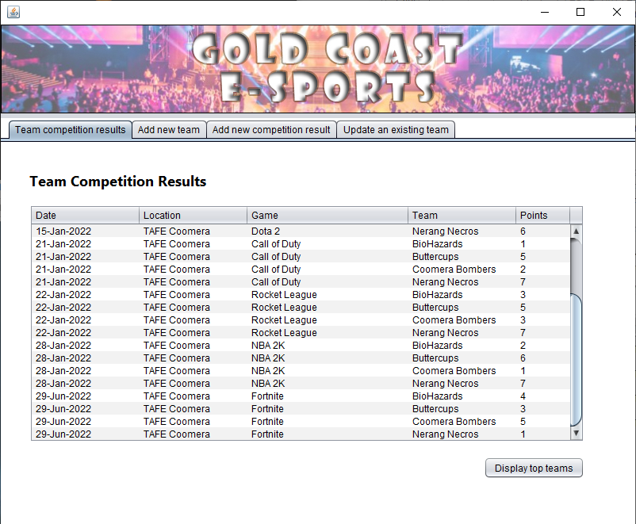

2. When the DISPLAY TOP TEAMS button is clicked in this tab panel, a small pop-up displays the leader board of team names and accumulated points (descending order of highest to lowest score). Refer screen shot example below:

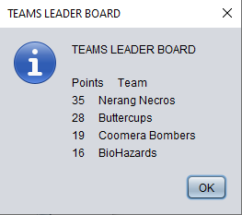

3. When the **ADD NEW TEAM** tab is selected, the following panel display (with UI controls) should resemble the screen shot example below:

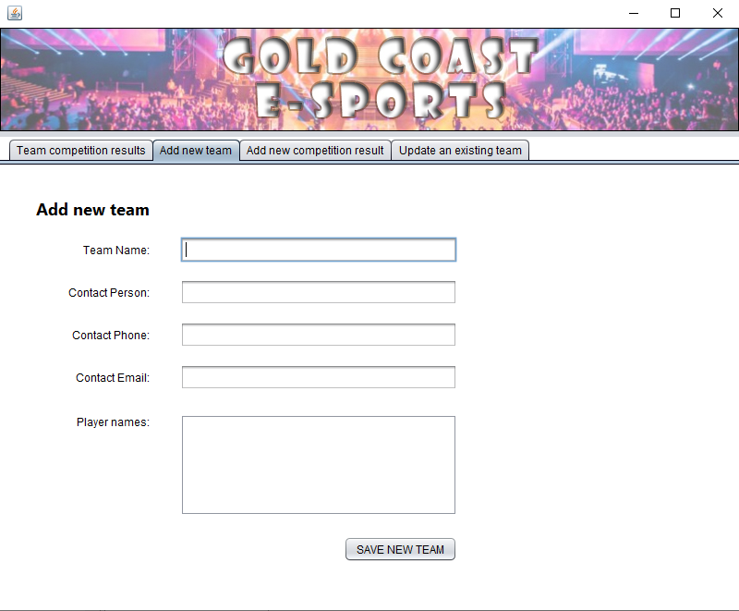

The five (5) text fields/text area allow the user to enter data for a new team – refer screen shot example below:

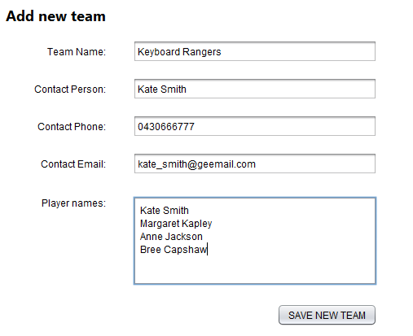

The user clicks the SAVE NEW TEAM button to save the new entry. If the text fields are correctly entered, a pop-up appears to ask the user whether the new competition entry is to be saved – yes or no.

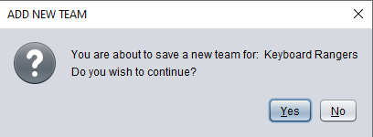

If the NO button is selected, nothing further happens. If the YES button is selected, the relevant data from the new team entry is saved to the two (2) external csv files: teams.csv and players.csv.

Note that the newly entered (and saved) team will need to be displayed in the TEAM combo box control in the ADD NEW COMPETITION RESULT tab panel. Refer screen shot example below:

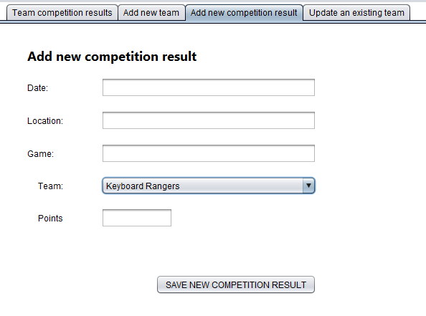

Note also that the newly entered (and saved) team will need to be displayed in the TEAM combo box control in the UPDATE AN EXISTING TEAM tab panel. Refer screen shot example below:

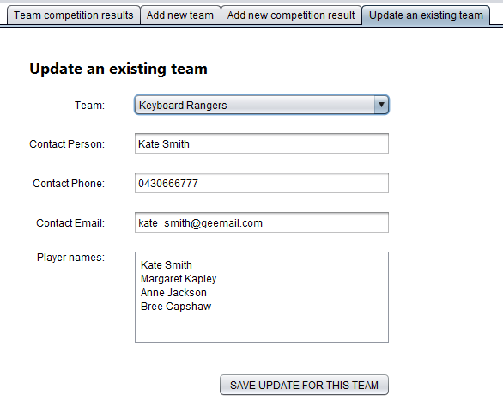

When the SAVE NEW TEAM button is clicked (in the ADD NEW TEAM tab panel) --- and there are no entries for any of the text fields/text area, a pop-up displays an error message addressing the missing items. Refer example screen shot below.

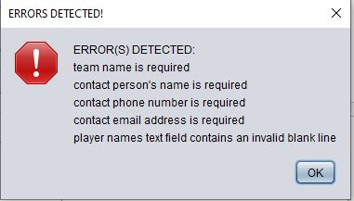

4. When the **ADD NEW COMPETITION RESULT** tab is selected, the following panel display (with UI controls) should resemble the screen shot example below:

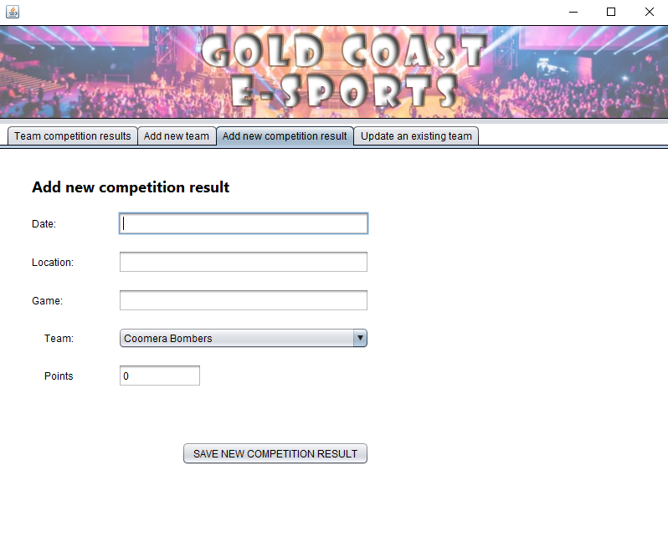

The four (4) text fields and team combo box allow the user to enter data for a new competition result – refer screen shot example below:

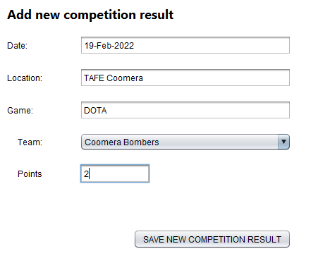

The user than clicks the SAVE NEW COMPETITION RESULT button to save the new competition entry. If the text fields are correctly entered, a pop-up appears to ask the user whether the new competition entry is to be saved – yes or no.

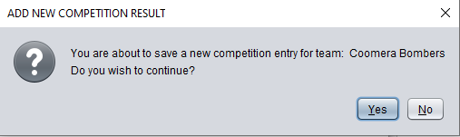

If the NO button is selected, nothing further happens. If the YES button is selected, the entry is saved to the external csv file: competitions.csv and the entry is shown in the TEAM COMPETITION RESULTS table in the relevant tab panel – refer screen shot example below:

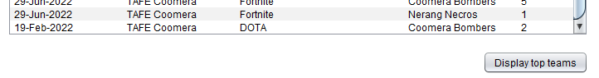

If any of the four (4) text fields contain no entries, then a pop-up displays an error message indicating what entries are missing:

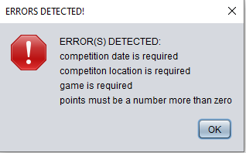

If the points text field contains non-numeric values (e.g. symbols or alphabetic characters or blanks), or contains a number less than zero, then a pop-up displays an error message indicating the issue.

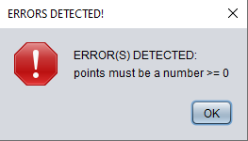

5. When the **UPDATE AN EXISTING TEAM** tab is selected, the following panel display (with UI controls) should resemble the screen shot example below. The details of the first (alphabetically sorted) team should appear in the combo box, text fields and text area controls.

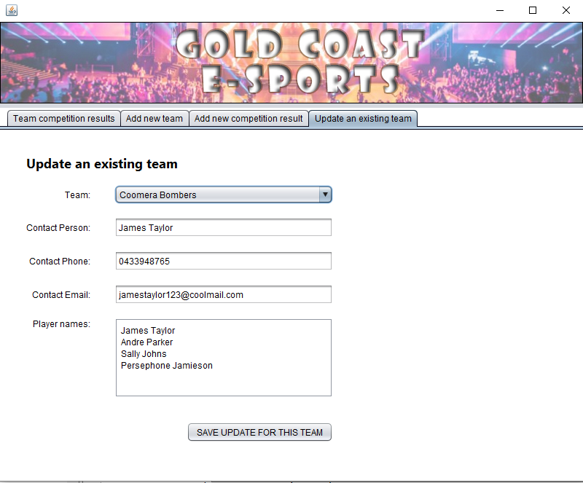

The combo box, three (3) text fields and text area allow the user to change data for an existing team – refer screen shot example below:

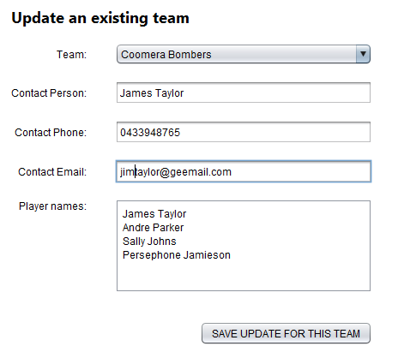

The user clicks the SAVE UPDATE FOR THIS TEAM button to save the updated entry. If the text fields and text area are correctly entered, a pop-up appears to ask the user whether the team update is to be saved – yes or no.

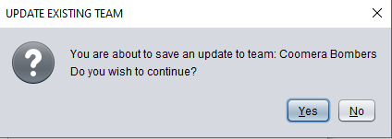

If the NO button is selected, nothing further happens. If the YES button is selected, the relevant data of the updated entry is saved to the two (2) external csv files: teams.csv and players.csv.

If any of the three (3) text fields or text area contain no entries, then a pop-up displays an error message indicating what entries are missing:

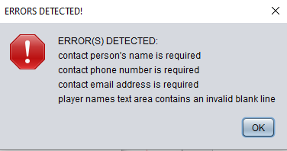

**- End of File -**