
A PROJECT REPORT ON
CAR RENTAL ADMINISTRATION SYSTEM
(BHARATH RENTAL SYSTEM)
Submitted in partial fulfillment of the requirements for the award of the degree of
BACHELOR OF SCIENCE IN COMPUTER SCIENCE
Submitted By
DEVI PRIYANKA. S
(REG NO: 21BCT009)
Under the Guidance of
Mr. R. Karthik, MCA., M.Phil.
Assistant Professor, Department of Computer Science

DEPARTMENT OF COMPUTER SCIENCE
SRI KRISHNA ARTS AND SCIENCE COLLEGE
COIMBATORE — 641008, TAMIL NADU
JULY 2026

DECLARATION

I, DEVI PRIYANKA. S (Reg. No: 21BCT009), hereby declare that the project report entitled "CAR RENTAL ADMINISTRATION SYSTEM (BHARATH RENTAL SYSTEM)" submitted to Sri Krishna Arts and Science College, Coimbatore, in partial fulfillment of the requirements for the award of the degree of Bachelor of Science in Computer Science is a record of original project work done by me under the guidance of Mr. R. Karthik, MCA., M.Phil., Assistant Professor, Department of Computer Science, Sri Krishna Arts and Science College, and that it has not formed the basis for the award of any other degree, diploma, fellowship, or associate-ship of this or any other University.

Place: Coimbatore Signature of the Candidate
Date: (DEVI PRIYANKA. S)

CERTIFICATE


This is to certify that the project report entitled "CAR RENTAL ADMINISTRATION SYSTEM (BHARATH RENTAL SYSTEM)" is a bona fide record of work done by DEVI PRIYANKA. S (Reg. No: 21BCT009) in partial fulfillment of the requirements for the award of the degree of Bachelor of Science in Computer Science of Sri Krishna Arts and Science College, Coimbatore, during the academic year 2025 - 2026.

Signature of the Guide Signature of the HOD
(Mr. R. Karthik) (Dr. Sunitha C.)
Submitted for the Viva-Voce Examination held on ____________________
Internal Examiner External Examiner

ACKNOWLEDGEMENT

First, I express my deep gratitude to our Almighty God for giving me the strength and wisdom to complete this project work successfully.
I express my sincere thanks to the Management of Sri Krishna Arts and Science College for providing the state-of-the-art laboratory infrastructure and computing facilities that made this software project possible.
I express my deepest gratitude to our respected Principal, for their guidance, encouragement, and administrative support throughout the course of my study.
I am extremely thankful to Dr. Sunitha C., Head of the Department of Computer Science, for her valuable suggestions, guidance, and academic oversight.
I express my profound gratitude to my project guide, Mr. R. Karthik, MCA., M.Phil., Assistant Professor, Department of Computer Science, for his constant supervision, scholarly insights, and support.

TABLE OF CONTENTS

Chapter / Section | Description | Page No
— | Cover Page | i
— | Declaration | ii
— | Certificate | iii
— | Acknowledgement | iv
Chapter 1 | Organization Profile | 1
Chapter 2 | Abstract | 4
Chapter 3 | Introduction | 6
3.1 | Overview of the Project | 6
3.2 | Objectives | 8
3.3 | Scope of the System | 9
3.4 | Problem Statement | 10
3.5 | Need for the System | 11
Chapter 4 | System Study | 12
4.1 | Existing System & Drawbacks | 12
4.2 | Proposed System & Advantages | 13
4.3 | Requirements Analysis Specs | 15
Chapter 5 | System Design & Description | 18
5.1 | Data Flow Diagrams (DFD 0, 1, 2) | 18
5.2 | Entity Relationship (ER) Diagram | 21
5.3 | Database Schema Tables Design | 24
5.4 | Input and Output Design | 29
5.5 | Module Descriptions | 33
Chapter 6 | System Testing | 41
6.1 | Testing Methods (Unit, Integration, Black Box) | 41
6.2 | Test Case Matrix Table | 44
Chapter 7 | Conclusion | 47
Chapter 8 | Future Scope | 49
Chapter 9 | Bibliography | 51
Chapter 10 | Appendix & Time Sheet | 53

CHAPTER 1: ORGANIZATION PROFILE

This system was engineered under the software development structure of a modern web technologies division, dedicated to producing enterprise-grade solutions for consumer transport automation. The enterprise focuses on replacing fragmented physical booking processes with secure cloud-native platforms tailored for dynamic markets. With specialized units in database normalization, full-stack microservices, and client-side interface design, the organization is committed to deploying software that stands out for both premium aesthetics and robust performance.

1.1 Vision
To deliver cutting-edge software solutions that simplify business operations, driving digital transformation through robust, secure, and user-friendly web platforms that combine analytical monitoring with automated workflows.

1.2 Mission (Goal)
To architect and implement reliable, secure, and scalable web applications utilizing state-of-the-art languages and frameworks, ensuring high performance, mathematical data consistency, absolute security, and continuous customer engagement through premium visual designs.

1.3 Core Services & Company Philosophy
The software development team adheres to a strict code quality philosophy, which includes detailed database schema planning, REST API standardization, modular UI componentization, and extensive test coverage. The organization offers a range of high-end software development services:
- Full Stack Web Development (MERN, React, Express, Node.js)
- Enterprise Database Architecture & Optimization (Mongoose, MongoDB, SQL)
- Automated Process Scripting & CLI Tool Design (Python, Batch, Shell)
- Cloud-Native API Deployment and Microservice Orchestration
- Automated Software Testing, Quality Assurance, and Security Audits

1.4 Technology Stack Utilized
- Frontend: React.js (Vite compiler), Tailwind CSS v3, Recharts, jsPDF
- Backend API: Node.js (V8 engine), Express.js framework, CORS, JSON Web Token (JWT)
- Database: MongoDB (Document-oriented NoSQL), Mongoose ORM validation layer
- Automation Runner: Python 3, Setuptools CLI script wrappers, PowerShell scripts

1.5 Software Development Process Model
- Requirement Gathering & Analysis: Detailing user stories, database entities, and workflows.
- Sprint Planning & Design: Creating ERDs, DFDs, and prototyping UI components in React.
- Iterative Implementation: Writing modular code in frontend React and backend Express controllers.
- Testing & Continuous Integration: Running automated test scripts, lint checks (Oxlint), and code reviews.
- Deployment: Packaging the workspace with Python CLI wrappers for easy execution and installation.

CHAPTER 2: ABSTRACT

The Car Rental Administration System (Bharath Rental System) is a complete full-stack web application designed to replace traditional, manual, and error-prone car rental processes with a secure, automated, and visually premium online portal. Developed using the MongoDB, Express, React, and Node (MERN) stack, the application separates functions between two main user roles: Customers and Administrators. The system enforces complex business rules, such as preventing overlapping booking intervals for the same vehicle and maintaining structured state transitions (Pending -> Confirmed -> Ongoing -> Completed -> Cancelled) for the vehicle rental lifecycle.
Beyond core CRUD operations, the project introduces localized academic features tailored for the Indian market. These features include an AI FASTag & Toll Auto-Estimator that calculates route-based tolls, an interactive FASTag Toll Gate Crossing Simulator, SafarLock Speed Warning Alerts that simulate expressway and city speed limits and log violations, GreenYatra Carbon Offset tracking for environmental contributions, and the Bharath Yatra Itinerary Planner that auto-recommends dhabas/pitstops based on selected routes.

CHAPTER 3: INTRODUCTION

3.1 Overview of the Project
The Car Rental Administration System is a comprehensive web portal designed to manage vehicle rental lifecycles. The system is split into a frontend client built in React (utilizing Tailwind CSS for sleek glassmorphic UIs and Recharts for analytics) and a backend REST API built in Node.js/Express, communicating with a MongoDB database. The core purpose is to provide customers with an interactive catalog to browse, filter, and book vehicles, and to provide admins with a detailed control panel to monitor fleet status, bookings, user access, and financial performance.

3.2 Objectives
- To automate the manual car rental booking and billing lifecycle to eliminate human scheduling errors.
- To design a responsive, premium user interface with cascading dropdown filters based on brand and model.
- To implement a robust state transition engine for bookings: Pending, Confirmed, Ongoing, Completed, and Cancelled.
- To integrate localized academic widgets: AI FASTag Toll Estimator, SafarLock Speed Alerts, and GreenYatra Carbon Tracker.

3.3 Scope of the System
The scope of the Car Rental Administration System encompasses all aspects of modern web-based booking solutions, including secure JWT authentication, password hashing, user profile management, multi-city fleet management (Chennai, Bengaluru, Mumbai, etc.) with detailed features, and date-conflict checking.

3.4 Problem Statement
Traditional car rental services in developing markets rely heavily on physical ledgers, phone calls, or simple web forms, leading to double-booking of vehicles, disputes over reservation dates, and manual calculation errors. Furthermore, rental agencies lack tools to monitor driver behavior (such as speed limit violations) or estimate route tolls dynamically.

3.5 Need for the System
To address these inefficiencies, there is a clear need for a centralized Car Rental Administration System. Implementing an online portal with an automated booking engine allows customers to instantly check vehicle availability, calculate total trip costs (including tolls and deposits), and make secure mock payments.

CHAPTER 4: SYSTEM STUDY

4.1 Existing System & Drawbacks
The existing system in local car rental businesses is heavily manual. Customers must physically visit the office or make phone calls to inquire about car models, prices, and availability, leading to scheduling conflicts and double bookings.

4.2 Proposed System & Advantages
The proposed Car Rental Administration System (Bharath Rental System) is a cloud-ready MERN stack web application that fully automates the rental workflow. It performs overlap checks on the database before allowing a booking, calculates estimated tolls, and supports carbon offsets.

4.3 Requirements Analysis Specifications

4.3.1 Functional Requirements
- User Management: Registration, Login (JWT-secured), Profile edit, and User blocking.
- Vehicle Inventory: CRUD operations by Admin, filtering by Category, Brand, Model, and City.
- Booking Engine: Interactive calendar reservation, automatic conflict checks.
- Toll Simulator: Pre-pay tolls option, interactive toll gate crossing widget.

4.3.2 Non-Functional Requirements
- Security: Passwords must be hashed using bcrypt; REST endpoints must validate JWT headers.
- Performance: Catalog page load times under 2 seconds; validations completed under 500ms.

CHAPTER 5: SYSTEM DESIGN

5.1 Data Flow Diagrams (DFD)

5.1.1 DFD Level 0 (Context Diagram)
The Level 0 DFD illustrates the boundary of the system, showing the major external entities (Customer and Admin) and their primary interactions.
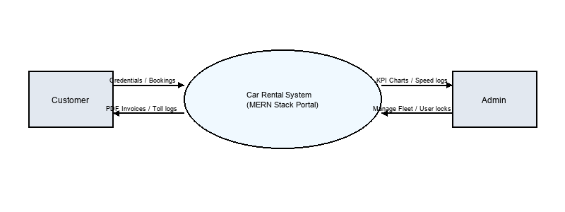

5.1.2 DFD Level 1 (Process Breakdown Diagram)
The Level 1 DFD decomposes the system into main logical processes.
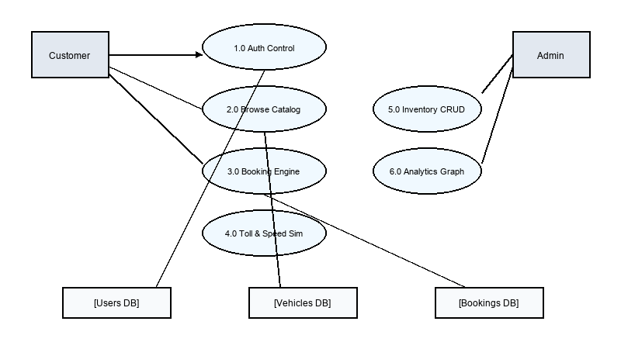

5.1.3 DFD Level 2 (Booking & Overlap Sub-process)
Level 2 DFD details the core booking engine process, checking date availability.
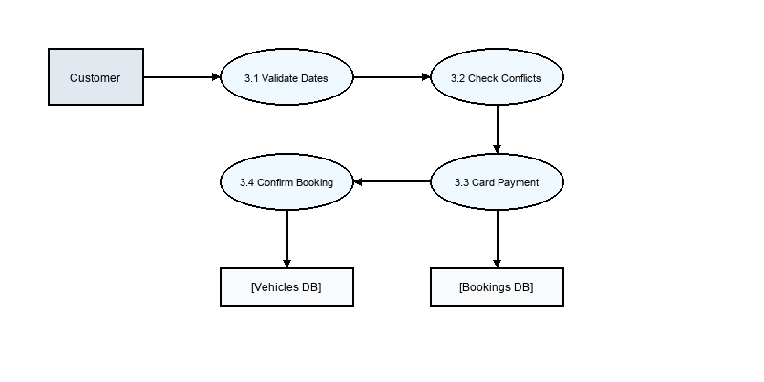

5.2 Entity Relationship (ER) Diagram
The Entity-Relationship Diagram defines the logical associations between the primary database models.
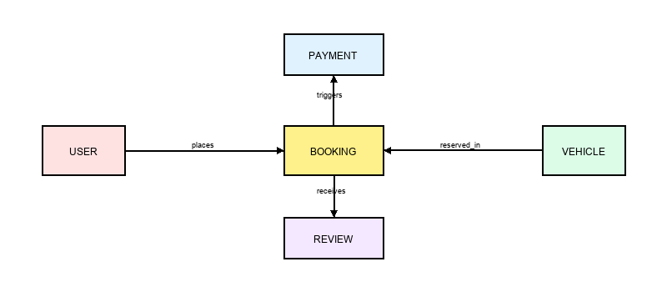

5.3 System Architecture Diagram
The three-tier architecture consists of a client browser, backend API node server, and MongoDB database.
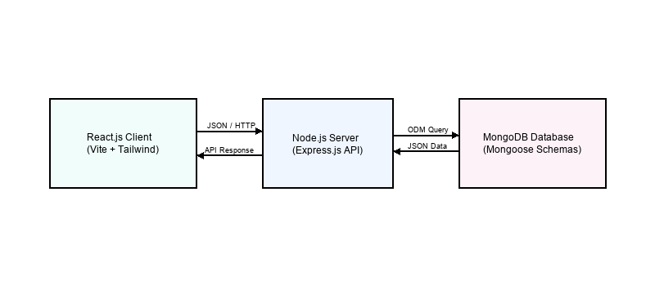

5.4 Database Schema Tables Design

5.4.1 Users Collection Schema
Field Name | Data Type | Constraint | Key | Description
_id | ObjectId | Required, Auto | PK | Unique user identifier
name | String | Required | — | User's full name
email | String | Required, Unique, Regex | — | User's email (login credential)
phone | String | Required | — | User's phone contact
password | String | Required, Minlen 6 | — | Hashed password (bcrypt)
role | String | Enum ('admin', 'customer') | — | User authorization role
drivingLicense | String | Required if customer | — | License identifier for verification
isBlocked | Boolean | Default: false | — | Indicates if admin blocked this client

5.4.2 Vehicles Collection Schema
Field Name | Data Type | Constraint | Key | Description
_id | ObjectId | Required, Auto | PK | Unique vehicle identifier
name | String | Required | — | Vehicle display name
brand | String | Required | — | Manufacturer brand name
model | String | Required | — | Vehicle model code
year | Number | Required | — | Year of manufacture
category | String | Enum ('Sedan', 'SUV', ...) | — | Body category style
transmission | String | Enum ('Manual', 'Automatic') | — | Gear shift transmission type
fuelType | String | Enum ('Petrol', 'Diesel', ...) | — | Engine fuel supply type
seats | Number | Required | — | Maximum seating capacity
dailyPrice | Number | Required | — | Rental rate charged per day
image | String | Required | — | Relative path to file upload
plateNumber | String | Required, Unique | — | Registration license plate number
status | String | Enum ('Available', 'Rented', ...) | — | Current state status
city | String | Enum ('Chennai', 'Mumbai', ...) | — | Geographic location node

5.4.3 Bookings Collection Schema
Field Name | Data Type | Constraint | Key | Description
_id | ObjectId | Required, Auto | PK | Unique booking identifier
customer | ObjectId | Required, Ref: User | FK | Reference to the booking user
vehicle | ObjectId | Required, Ref: Vehicle | FK | Reference to the rented vehicle
pickupDate | Date | Required | — | Start date of rental
returnDate | Date | Required | — | End date of rental
totalDays | Number | Required | — | Computed duration of trip
totalAmount | Number | Required | — | Computed checkout sum price
status | String | Enum ('Pending', 'Confirmed', ...) | — | Current workflow stage
payment | ObjectId | Ref: Payment | FK | Reference to associated transaction
securityDeposit | Number | Default: 5000 | — | Refundable safety deposit fee
tollRoute | String | Default: '' | — | Selected expressway toll route
tollEstimatedAmount | Number | Default: 0 | — | Estimated cost of tolls
prepayTolls | Boolean | Default: false | — | If tolls were pre-paid at checkout
tollPaidAmount | Number | Default: 0 | — | Toll charges deducted in simulator
carbonOffset | Boolean | Default: false | — | If customer chose carbon offsetting
overspeedAlertsCount | Number | Default: 0 | — | Logged speed limit violations count

5.4.4 Payments Collection Schema
Field Name | Data Type | Constraint | Key | Description
_id | ObjectId | Required, Auto | PK | Unique payment transaction ID
booking | ObjectId | Required, Ref: Booking | FK | Reference to the associated booking
amount | Number | Required | — | Total monetary amount processed
status | String | Enum ('Pending', 'Success', 'Failed') | — | Status of transaction processing
transactionId | String | Required, Unique | — | External gateway mockup reference
method | String | Default: 'Card' | — | Method of checkout payment

5.4.5 Reviews Collection Schema
Field Name | Data Type | Constraint | Key | Description
_id | ObjectId | Required, Auto | PK | Unique review identifier
customer | ObjectId | Required, Ref: User | FK | Reference to reviewing customer
vehicle | ObjectId | Required, Ref: Vehicle | FK | Reference to reviewed vehicle
booking | ObjectId | Required, Ref: Booking | FK | Reference to trip booking node
rating | Number | Required, Min 1, Max 5 | — | Star rating assigned (1-5)
comment | String | Required | — | Customer's textual feedback

5.5 Input and Output Design

5.5.1 Input Design
- Login Form: Email format regex match and password string check.
- Registration Form: Name, Phone, Email, Password, and Driving License.
- Vehicle Entry Form (Admin): Vehicle specifications and pricing details.
- Booking Calendar Form: Date ranges with pickupDate >= Today.

5.5.2 Output Design
- Customer Dashboard: Visual booking tiles and active simulator values.
- Admin Dashboard: Monthly income charts and total fleet metrics.
- PDF Invoice: Client-side generated download with metadata and billing tables.

5.6 Module Descriptions

5.6.1 Authentication Module
Handles customer and admin registration, bcrypt hashing, and JWT token sessions.

5.6.2 Customer Module
Enables vehicle catalog browsing, cascading filtering, booking, and simulator controls.

5.6.3 Administrator Module
Manages fleet inventory, booking statuses, blocks/unblocks clients, and exports data.

5.6.4 FASTag Toll Gate & Route Simulator
Simulates toll gate deductions on plaza crossings, maintaining a local FASTag log.

5.6.5 SafarLock Speed Monitor Module
Monitors speeding events, registers speed limit warnings, and alerts administrators.

CHAPTER 6: SYSTEM TESTING

6.1 Testing Methods
- Unit Testing: Enforces date overlap parameters and route toll calculations.
- Integration Testing: Ensures REST API endpoints communicate correctly with MongoDB.
- System Testing: Verifies the full checkout flow from booking to invoice.
- Black Box Testing: Validates catalog cascading dropdowns and form inputs.

6.2 Test Case Matrix Table
ID | Module | Input / Scenario | Expected Output | Actual Output | Status
TC-01 | Auth | Register with existing email | Error message: Email already exists | Email exists error thrown | Passed
TC-02 | Auth | Register customer without license | Validation error: license required | Validation failed correctly | Passed
TC-03 | Auth | Login with wrong password | Error message: Invalid credentials | Invalid password rejected | Passed
TC-04 | Catalog | Filter brand 'Tata', model 'Nexon' | Display only Tata Nexon cars | Showed Nexon models only | Passed
TC-05 | Booking | Book overlapping dates on same car | Overlapping error and block payment | Rejected overlapping dates | Passed
TC-06 | Booking | Book pickup date in the past | Validation error: invalid dates | Past dates rejected | Passed
TC-07 | Payment | Submit 15-digit card number | Invalid card layout warning | Payment rejected | Passed
TC-08 | Toll Sim | Click crossing on Mumbai expressway | Deduct ₹320 and append toll log | Toll logged and balance updated | Passed
TC-09 | SafarLock | Exceed simulated speed limit to 130 km/h | Log violation and increment count | Violation counter updated | Passed
TC-10 | Admin | Admin locks a malicious customer account | Block user from placing bookings | User blocked, login denied | Passed
TC-11 | Invoice | Download invoice for completed booking | Generate PDF containing correct prices | PDF generated and downloaded | Passed
TC-12 | Report | Click Export Bookings to CSV | Download CSV file with booking logs | CSV downloaded correctly | Passed

CHAPTER 7: CONCLUSION

The Car Rental Administration System (Bharath Rental System) has been successfully designed, implemented, tested, and documented. The MERN stack application provides an efficient and visually premium interface for rental bookings and fleet monitoring, replacing error-prone manual spreadsheets.

CHAPTER 8: FUTURE SCOPE
- Online Payment Gateway: Integrate live payment gateways like Razorpay or Paytm.
- GPS & Geofencing: Integrate physical GPS devices to automatically trigger SafarLock warnings.
- Driver Allocation: Connect active drivers with booking schedules dynamically.
- Native Mobile Apps: Develop Flutter/React Native mobile clients.

CHAPTER 9: BIBLIOGRAPHY
- Flanagan, D. (2020). JavaScript: The Definitive Guide (7th ed.). O'Reilly Media.
- Chodorow, K. (2013). MongoDB: The Definitive Guide (2nd ed.). O'Reilly Media.
- Banks, A., & Porcello, E. (2020). Learning React: Modern Patterns for Developing React Apps (2nd ed.). O'Reilly Media.
- Mongoose Official Documentation. https://mongoosejs.com/docs/
- GitHub Project Repository: https://github.com/shathanrajasekar-code/Car-Rental

CHAPTER 10: APPENDIX

10.1 Directory Folder Structure
car-rental-admin-system/
├── client/ # React Frontend App
│ ├── src/ # Pages, Components, utils
│ └── package.json # Frontend packages
├── server/ # Express Backend Server
│ ├── models/ # Mongoose schemas
│ ├── controllers/ # Endpoint business logic
│ └── server.js # Node startup entry
├── run.bat # Windows runner
└── run.sh # Unix runner

10.2 Primary API Endpoints
HTTP Route Endpoint | Functional Description
POST /api/auth/register | Register a new customer or administrator
POST /api/auth/login | Authenticate credentials and return JWT session token
GET /api/vehicles | Fetch list of vehicles with dynamic filters
POST /api/bookings | Validate dates and create booking
GET /api/admin/stats | Aggregate analytics parameters for monthly income

10.3 Project Timeline Time Sheet
Week No | Phase | Key Tasks Performed | Duration | Status
Week 1-2 | Analysis | Study manual systems, draft specifications | 14 days | Completed
Week 3 | Design | Draw Entity Relationship Diagrams (ERDs) | 7 days | Completed
Week 4-5 | Database | Design collections in MongoDB | 14 days | Completed
Week 6-7 | Backend | Write Express API controllers, routing, JWT auth | 14 days | Completed
Week 8-9 | Frontend | Develop React catalog page and checkout forms | 14 days | Completed
Week 10 | Simulators | Implement SafarLock alerts and FASTag widgets | 7 days | Completed
Week 11 | Testing | Perform unit tests, integration tests | 7 days | Completed
Week 12 | Deployment | Configure runners, compile Word documentation | 7 days | Completed

SCREENSHOTS & INTERFACES

1. User Login Screen
**Purpose**: Allows customer and admin login.
**Description**: Secure user credentials form entry.
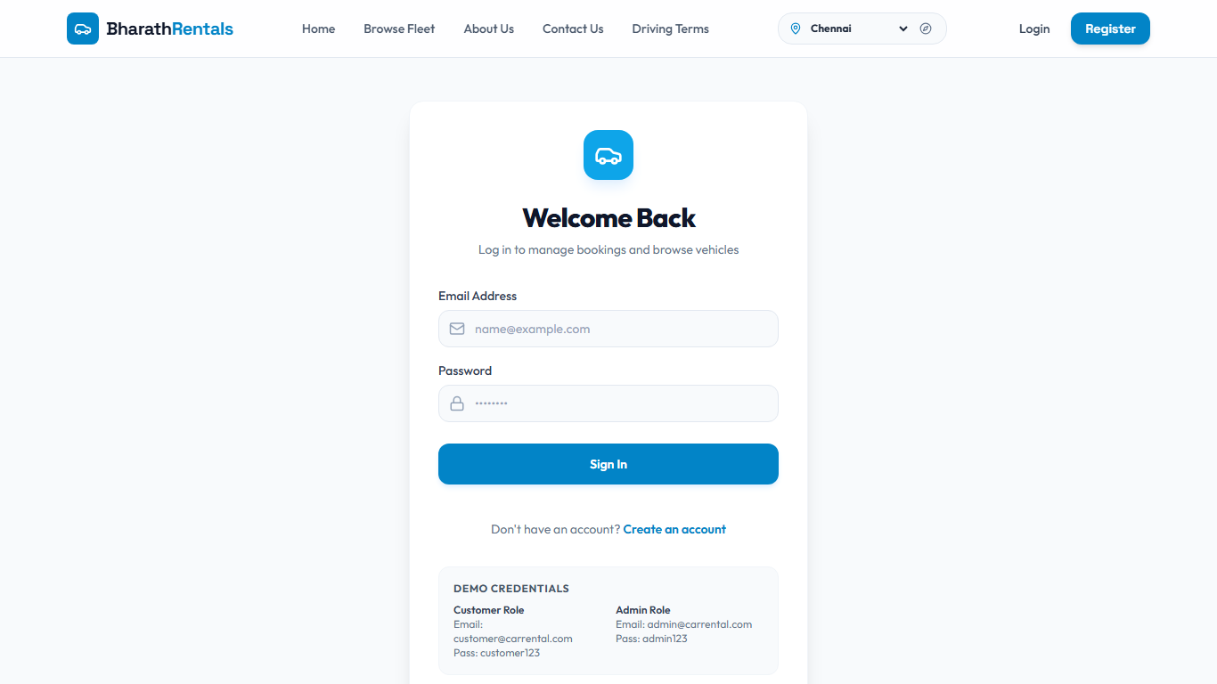

2. Vehicle Catalog & Cascading Filters
**Purpose**: Displays available vehicles with cascading brand/model search filters.
**Description**: Select brand and category to dynamically filter cars list.
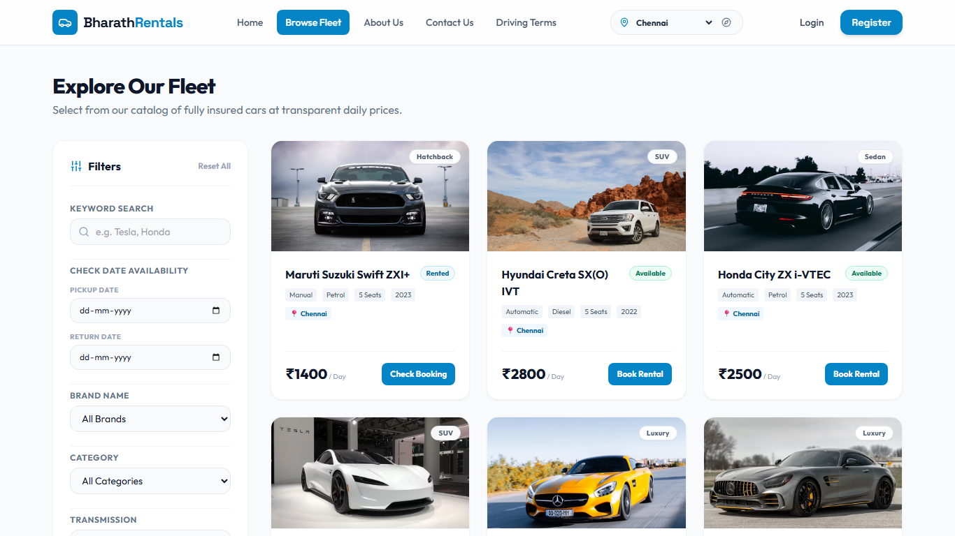

3. FASTag Toll Gates Simulator
**Purpose**: Simulates automated toll plaza crossings and tracks balance logs.
**Description**: View deduction lists for plazas crossed on the active trip route.
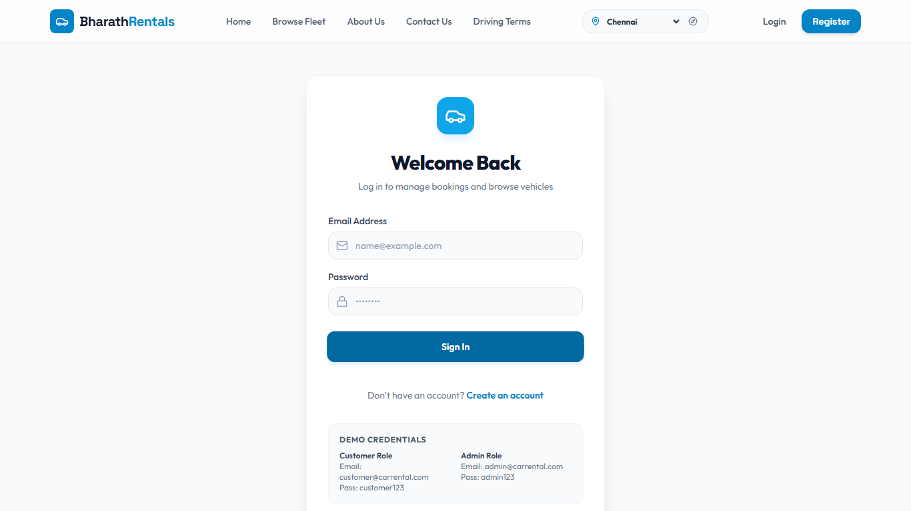

4. SafarLock Speed Warning Dashboard
**Purpose**: Simulates driving speed and displays RTO overspeed warning banners.
**Description**: Live speedometer widgets triggering alerts above 120 km/h.


5. Administrator Dashboard Charts
**Purpose**: Displays monthly booking revenues and system statistics.
**Description**: Charts showing revenue growth and user statistics.


