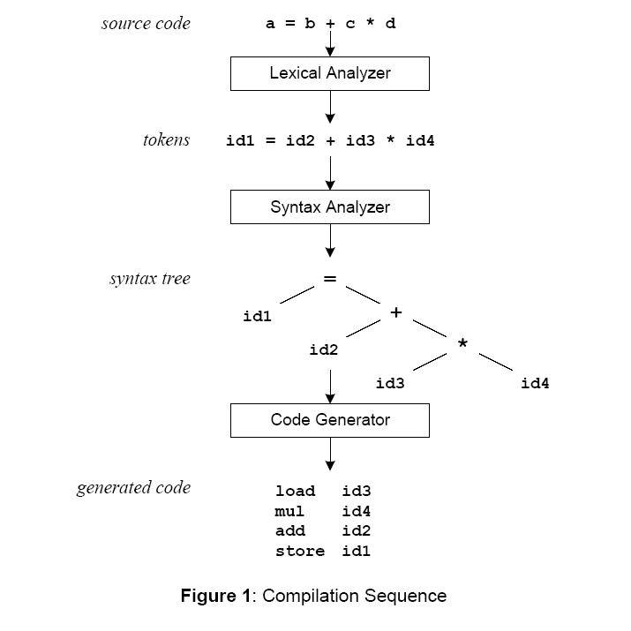

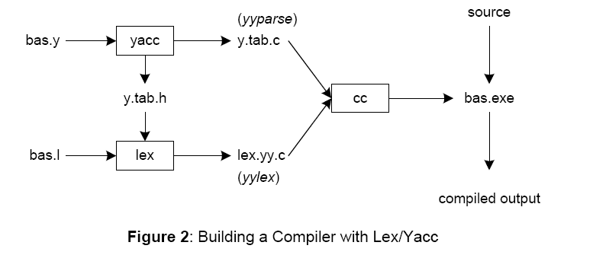

yacc –d bas.y # create y.tab.h, y.tab.c
lex bas.l # create lex.yy.c
cc lex.yy.c y.tab.c –obas.exe # compile/link

Yacc reads the grammar descriptions in bas.y and generates a parser, function yyparse, in file
y.tab.c. Included in file bas.y are token declarations. The –d option causes yacc to generate
definitions for tokens and place them in file y.tab.h. Lex reads the pattern descriptions in bas.l,
includes file y.tab.h, and generates a lexical analyzer, function yylex, in file lex.yy.c.
Finally, the lexer and parser are compiled and linked together to form the executable, bas.exe.
From main, we call yyparse to run the compiler. Function yyparse automatically calls yylex to
obtain each token.

