Created S3 bucket

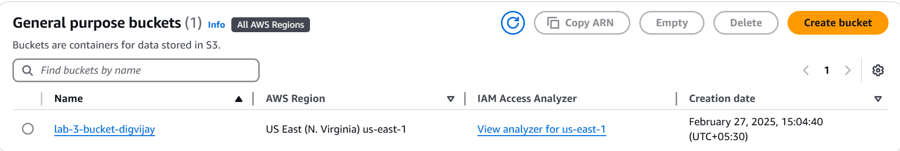

Enabled bucket versioning

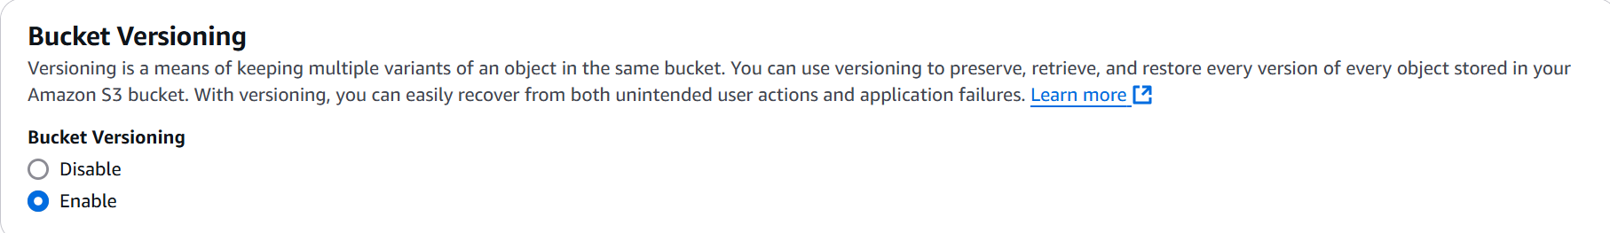

Configured bucket policy such that IAM user is not allowed access to bucket

