Creating EKS cluster with eksctl

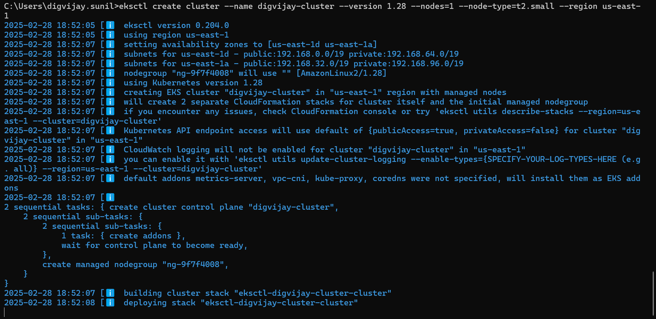

Configure EKS on AWS cli



Retrieve an authentication token and authenticate your Docker client to your registry



Docker build

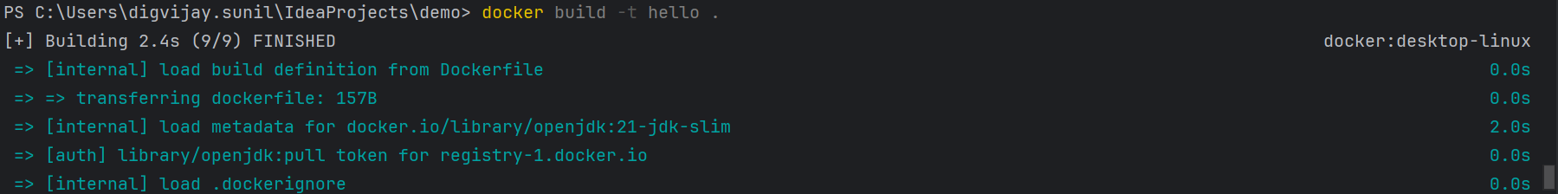

Tag image



Push image to ecr

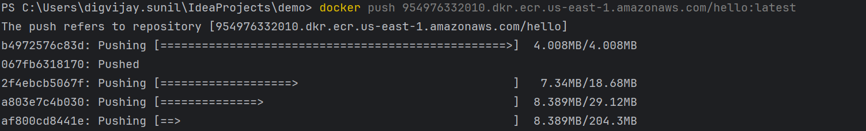

Image made on ecr

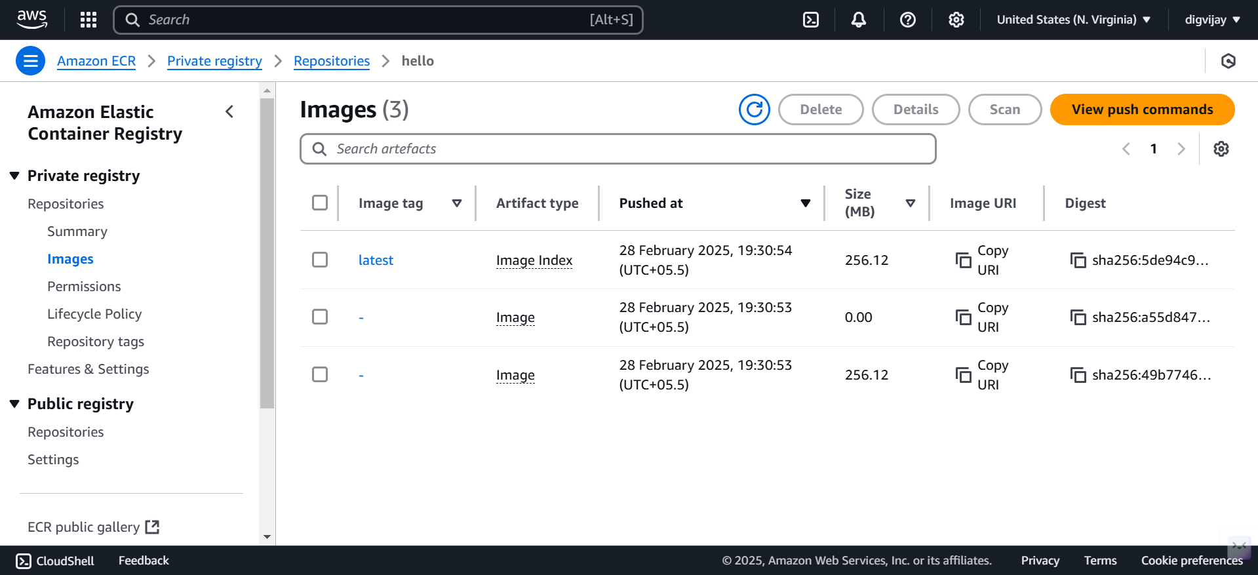

Apply kubectl

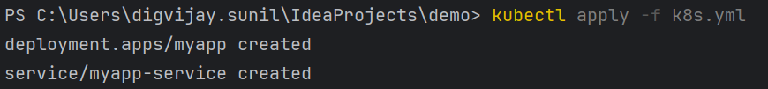

To check running pods

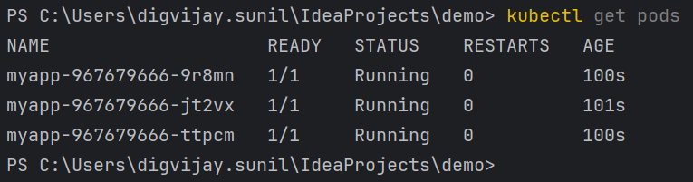

Running it on browser

