Created queue

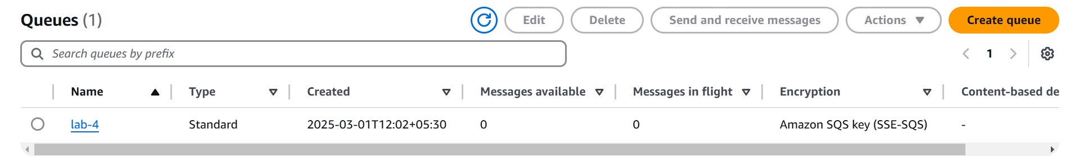

Sent message

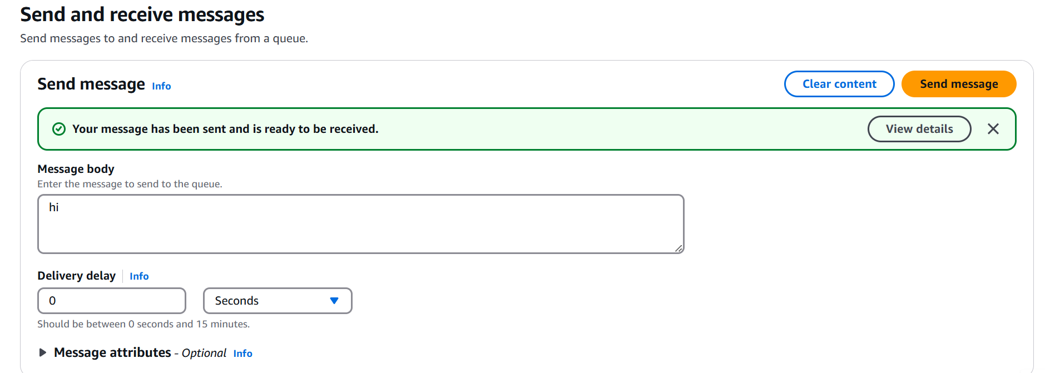

Received message

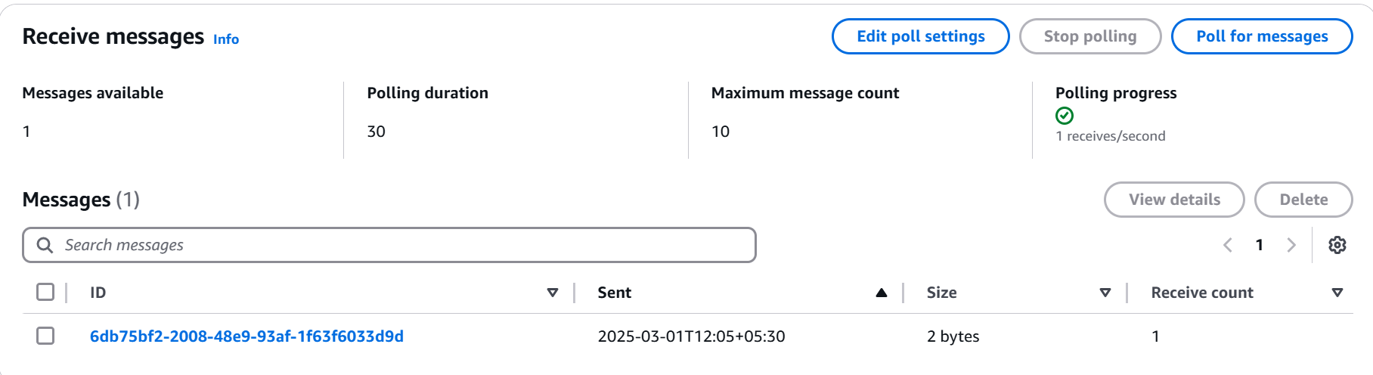

Sending message with spring boot

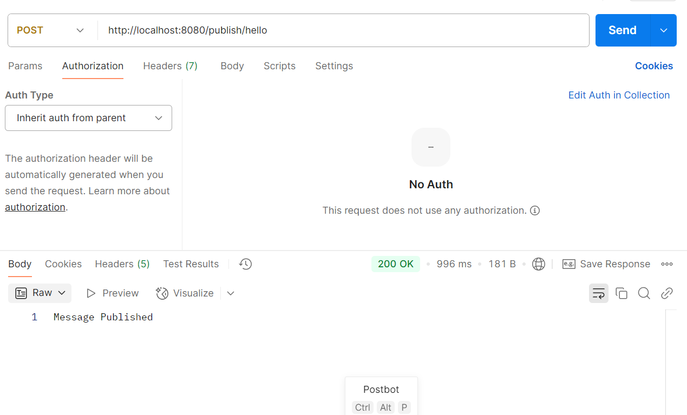

Received image

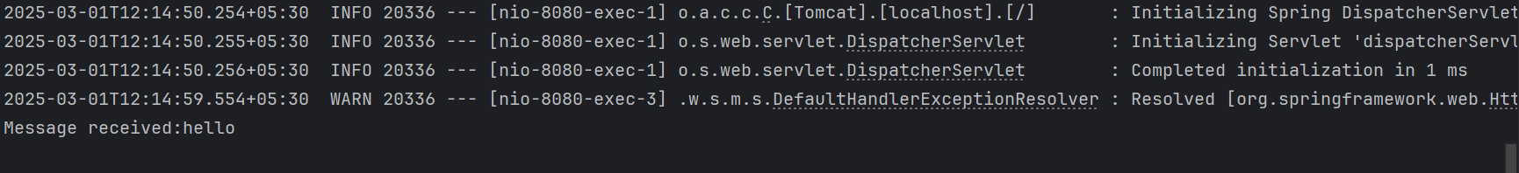

Created topic in SNS

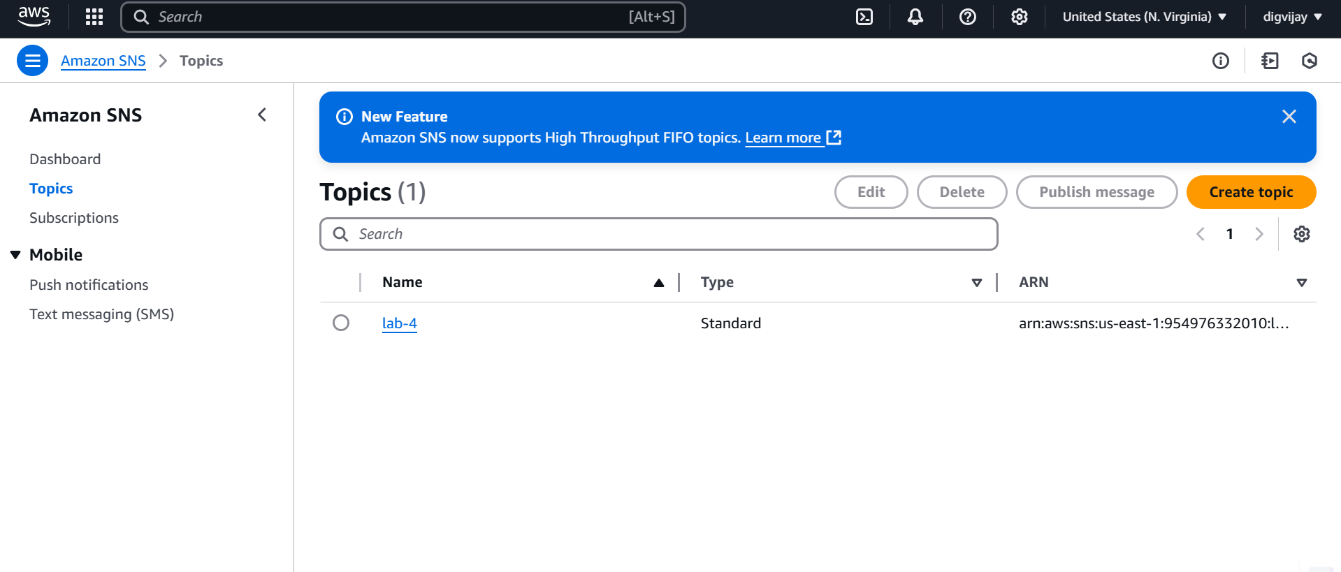

Created subscription

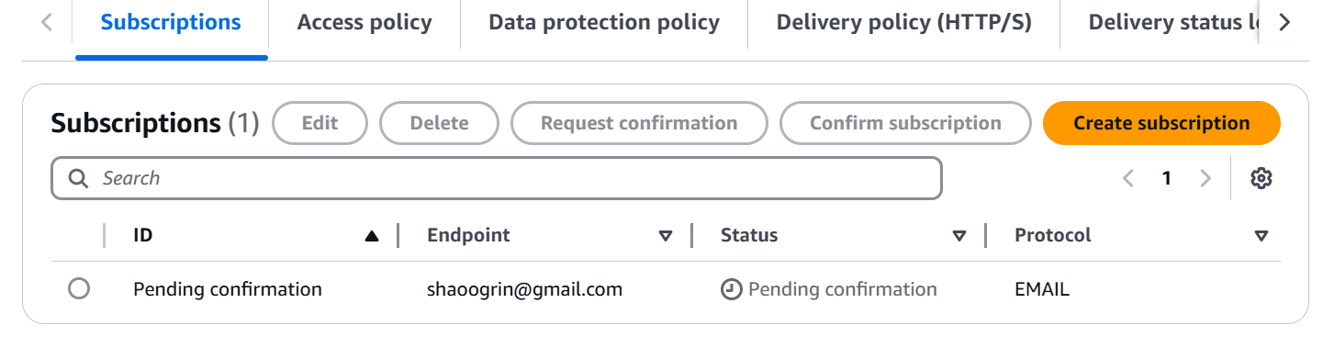

Confirmed subscription

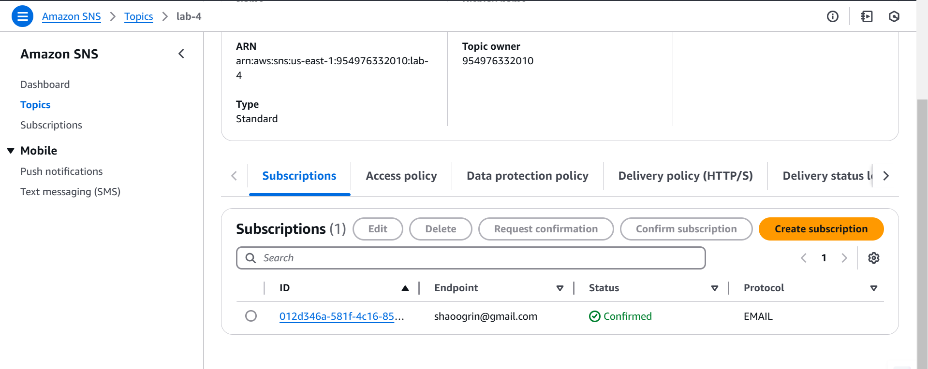

Published message to subscriber

