Created sql database

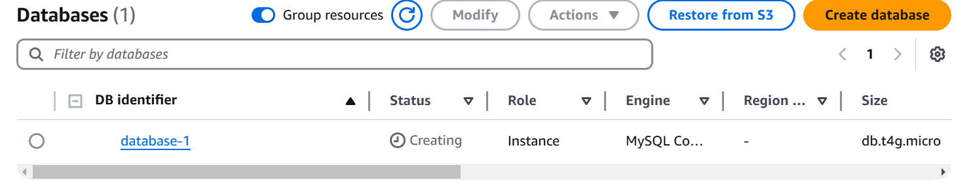

Created dynamo db table

