**What is Virtualization?**

Virtualization is the technique of importing a Guest operating system on top of a Host operating system. This technique was a revelation at the beginning because it allowed developers to run multiple operating systems in different virtual machines all running on the same host. This eliminated the need for extra hardware resource. The advantages of Virtual Machines or Virtualization are:

* Multiple operating systems can run on the same machine
* Maintenance and Recovery were easy in case of failure conditions
* Total cost of ownership was also less due to the reduced need for infrastructure

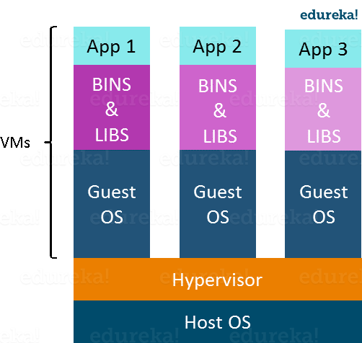

In the diagram on the right, you can see there is a host operating system on which there are 3 guest operating systems running which is nothing but the virtual machines.

As you know nothing is perfect, Virtualization also has some shortcomings. Running multiple Virtual Machines in the same host operating system leads to performance degradation. This is because of the guest OS running on top of the host OS, which will have its own kernel and set of libraries and dependencies. This takes up a large chunk of system resources, i.e. hard disk, processor and especially RAM.

Another problem with Virtual Machines which uses virtualization is that it takes almost a minute to boot-up. This is very critical in case of real-time applications.

Following are the disadvantages of Virtualization:

* Running multiple Virtual Machines leads to unstable performance
* Hypervisors are not as efficient as the host operating system
* Boot up process is long and takes time

These drawbacks led to the emergence of a new technique called Containerization. Now let me tell you about Containerization.

**What is Containerization?**

Containerization is the technique of bringing virtualization to the operating system level. While Virtualization brings abstraction to the hardware, Containerization brings abstraction to the operating system. Do note that Containerization is also a type of Virtualization. Containerization is however more efficient because there is no guest OS here and utilizes a host’s operating system, share relevant libraries & resources as and when needed unlike virtual machines. Application specific binaries and libraries of containers run on the host kernel, which makes processing and execution very fast. Even booting-up a container takes only a fraction of a second. Because all the containers share, host operating system and holds only the application related binaries & libraries. They are lightweight and faster than Virtual Machines.

Advantages of Containerization over Virtualization are:

* Containers on the same OS kernel are lighter and smaller
* Better resource utilization compared to VMs
* Boot-up process is short and takes few seconds

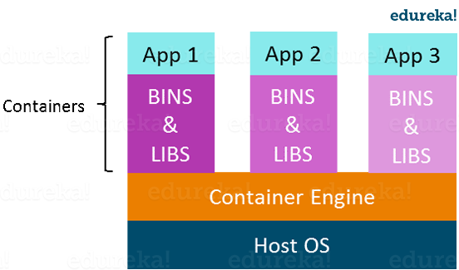

In the diagram on the right, you can see that there is a host operating system which is shared by all the containers. Containers only contain application specific libraries which are separate for each container and they are faster and do not waste any resources.

All these containers are handled by the containerization layer which is not native to the host operating system. Hence a software is needed, which can enable you to create & run containers on your host operating system.

Check out this Docker tutorial video for deep understanding of Docker.

**Docker Tutorial for Beginners – Part 1 | What is Docker? | Docker Training | DevOps Tools |**

This is where Docker comes in. Now I will quickly take you through the introduction to Docker.

**Docker Tutorial – Introduction To Docker**

Docker is a containerization platform that packages your application and all its dependencies together in the form of Containers to ensure that your application works seamlessly in any environment.

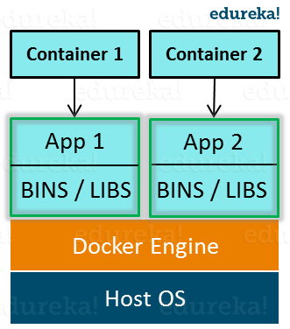

As you can see in the diagram on the right, each application will run on a separate container and will have its own set of libraries and dependencies. This also ensures that there is process level isolation, meaning each application is independent of other applications, giving developers surety that they can build applications that will not interfere with one another.

As a developer, I can build a container which has different applications installed on it and give it to my QA team who will only need to run the container to replicate the developer environment.