SmartPropoPlus Version 3.3.4
Release Notes

- Bug fixes:
  - Vista is now supported
Thanks to Antony Briggs who analysed and solved the problem for you guys!
  - Futaba PCM
    - Problem:
Channels 9 & 10 were incorrectly coded.
    - Fixed.
    - Problem:
Hiccups every few seconds
Fixed (Thank you, Niels Laukens of Belgium)

  - Jitter cancellation in PPM
    - The fixed introduced in version 3.3.3 now expanded to the manually selected PPM shifts.

- New Features:
  - PPJoy buttons supported
    - Background:
Transmitter switches are usually mapped into high channels. Usually channel 6 and higher. Until this version, SmartPropoPlus presented all channels to PPJoy as analogue. This include channels that had only two states.
    - Change in this version:
All channels are also presented to PPJoy as digital. This will ease the introduction of buttons as seen in Illustration 1: PPJoy button mapping:
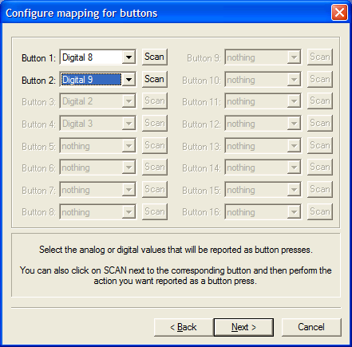Illustration 1: PPJoy button mapping
In this example, Channel 9 (Digital 8) is mapped to button 1 while Channel 10 (Digital 9) is mapped to button 2.

