SmartPropoPlus Version 3.3.3
Release Notes

- Improved PPM behaviour:
  - Less Jitter
    - Problem:
Some users complained that the controls are slightly moving (jitter) even when the transmitter-sticks are still.
    - Cause:
SmartPropoPlus converts the input signal into discrete joystick values according to the input signal values. If the input signal values are also discrete as in PCM than SmartPropoPlus does a one-to-one conversion. However, since PPM is an analogue technique, very slight changes in the input signal may be translated into two different joystick levels.
    - Solution:
Added resistance to small, oscillating changes in the PPM translation algorithm.
    - Possible side-effects:
reduced sensitivity around the mid-point of the sticks.
  - Self-adjusting
    - Problem:
SmartPropoPlus was incapable of interpreting some signals as PPM.
    - Cause:
Some PPM Transmitters drive an incompatible signal as displayed in Illustration 1:
Earlier versions of SmartPropoPlus could not interpret such signal as a legitimate PPM signal.
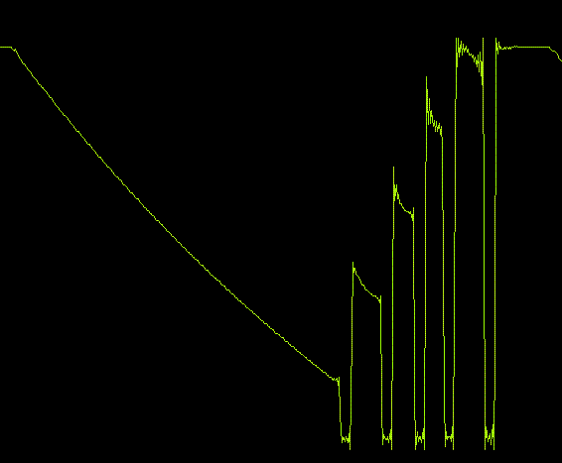Illustration 1: Sloping PPM signal
    - Solution:
SmartPropoPlus PPM algorithm was replaced by a better algorithm developed by Ph. G. De Coninck. Now SmartPropoPlus and PPM-Audio (a.k.a. Thermometer) share the same algorithm.
    - Possible side-effects:
None.

- External audio control
  - Change of default behaviour
    - Background:
In previous versions of SmartPropoPlus, the selection of audio signal source was done by default from within SPPconsole.
    - Problem:
This 'kidnapping' of the control of the audio confused many users.
    - Solution:
Installing SmartPropoPlus for the first time will not 'kidnap' the control of the audio. This will not affect users installing version 3.3.3 on top of earlier versions.

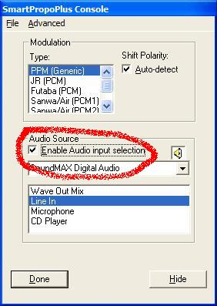Previous Default
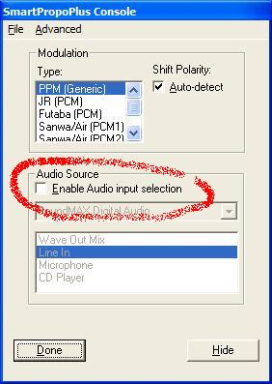New Default

