# 50.007 Machine Learning

# Design Project

Samuel Lim 1000971

Lin Junsheng 1000947

Shaun Chiang 1001085

## Part 2

## Emission Parameters

In part 2, we are interested in obtaining the emission parameters from the training set using the maximum likelihood estimation.

However, we still need to first parse in the data. We do this in parse_labeled_data(), and returns a 2-d integer array (n columns with 7 rows, each row representing a label) along with a list of words corresponding to each column. From this, we are able to obtain the count of each label for a specific word.

Using this 2-d integer array, we then are able to calculate emission parameters using the above formula, for the test set dev.in. We use function emission(), which outputs a Collections.OrderedDict() with the word as key, and list of the 7 label emission parameters. We note that some words that appear in the test set may not appear in the training set; we simply assign a fixed probability to all new words, using the formula described:

* If X is a new word:
* If x appeared in the training set:

From this, we get dev.p2.out by choosing the label with the highest emission parameter, and assigning it to the word. From here, we calculate the various scores required:

1. Results

**SG**

Entity in gold data: 4779

Entity in prediction: 5978

Correct Entity: 641

Entity precision: 0.1072

Entity recall: 0.1341

Entity F: 0.1192

Correct Sentiment: 164

Sentiment precision: 0.0274

Sentiment recall: 0.0343

Sentiment F: 0.0305

**CN**

Entity in gold data: 935

Entity in prediction: 1665

Correct Entity: 64

Entity precision: 0.0384

Entity recall: 0.0684

Entity F: 0.0492

Correct Sentiment: 20

Sentiment precision: 0.0120

Sentiment recall: 0.0214

Sentiment F: 0.0154

**ES**

Entity in gold data: 1326

Entity in prediction: 2493

Correct Entity: 138

Entity precision: 0.0554

Entity recall: 0.1041

Entity F: 0.0723

Correct Sentiment: 31

Sentiment precision: 0.0124

Sentiment recall: 0.0234

Sentiment F: 0.0162

**EN**

Entity in gold data: 662

Entity in prediction: 1405

Correct Entity: 98

Entity precision: 0.0698

Entity recall: 0.1480

Entity F: 0.0948

Correct Sentiment: 30

Sentiment precision: 0.0214

Sentiment recall: 0.0453

Sentiment F: 0.0290

## Part 3

For part 3, we were tasked to calculate the transmission parameters as well as run the Viterbi algorithm with the emission and transmission parameters

1. Transmission Parameters

For transmission parameters, we first spilt our training data set into its respective sequences.

After splitting the data set, we create a 7 x 7 2D-array to store the results in the following format.

|  |  |  |  |  |  |  |  |  |
| --- | --- | --- | --- | --- | --- | --- | --- | --- |
| Next From | O | I-positive | B-positive | I-neutral | B-neutral | I-negative | B-negative | End |
| O |  |  |  |  |  |  |  |  |
| I-positive |  |  |  |  |  |  |  |  |
| B-positive |  |  |  |  |  |  |  |  |
| I-neutral |  |  |  |  |  |  |  |  |
| B-neutral |  |  |  |  |  |  |  |  |
| I-negative |  |  |  |  |  |  |  |  |
| B-negative |  |  |  |  |  |  |  |  |
| Start |  |  |  |  |  |  |  |  |

We then start by filling out the count for the table. Each time a case is observed, we increment the count. I.e. if we see a case of O 🡪 B-negative, we increment the table entry of [0, 6] by one. Note that the first dimension of the array is stored as rows, meaning entry [0] is row 1, entry [3] is row 4 etc.

Once the table is complied, we calculate the sum of each row, and then calculate a new 7 x 7 2D array, this time containing the transmission parameters using:

1. Viterbi

For Viterbi, we used the following structure.

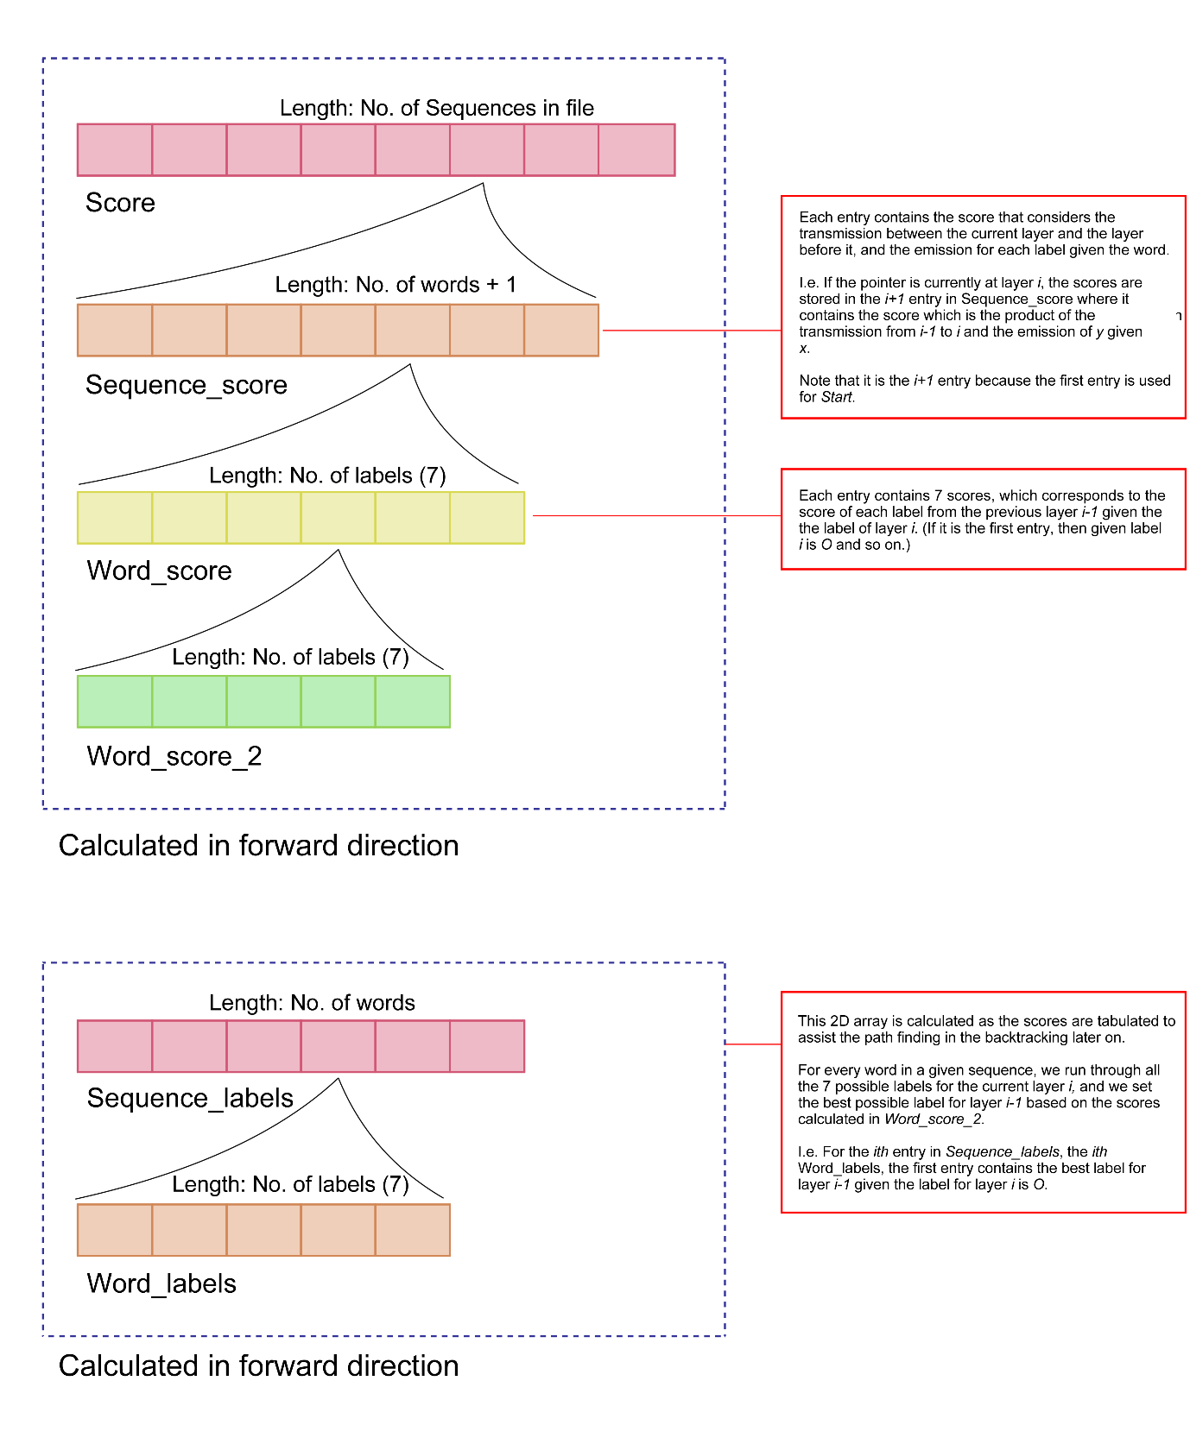

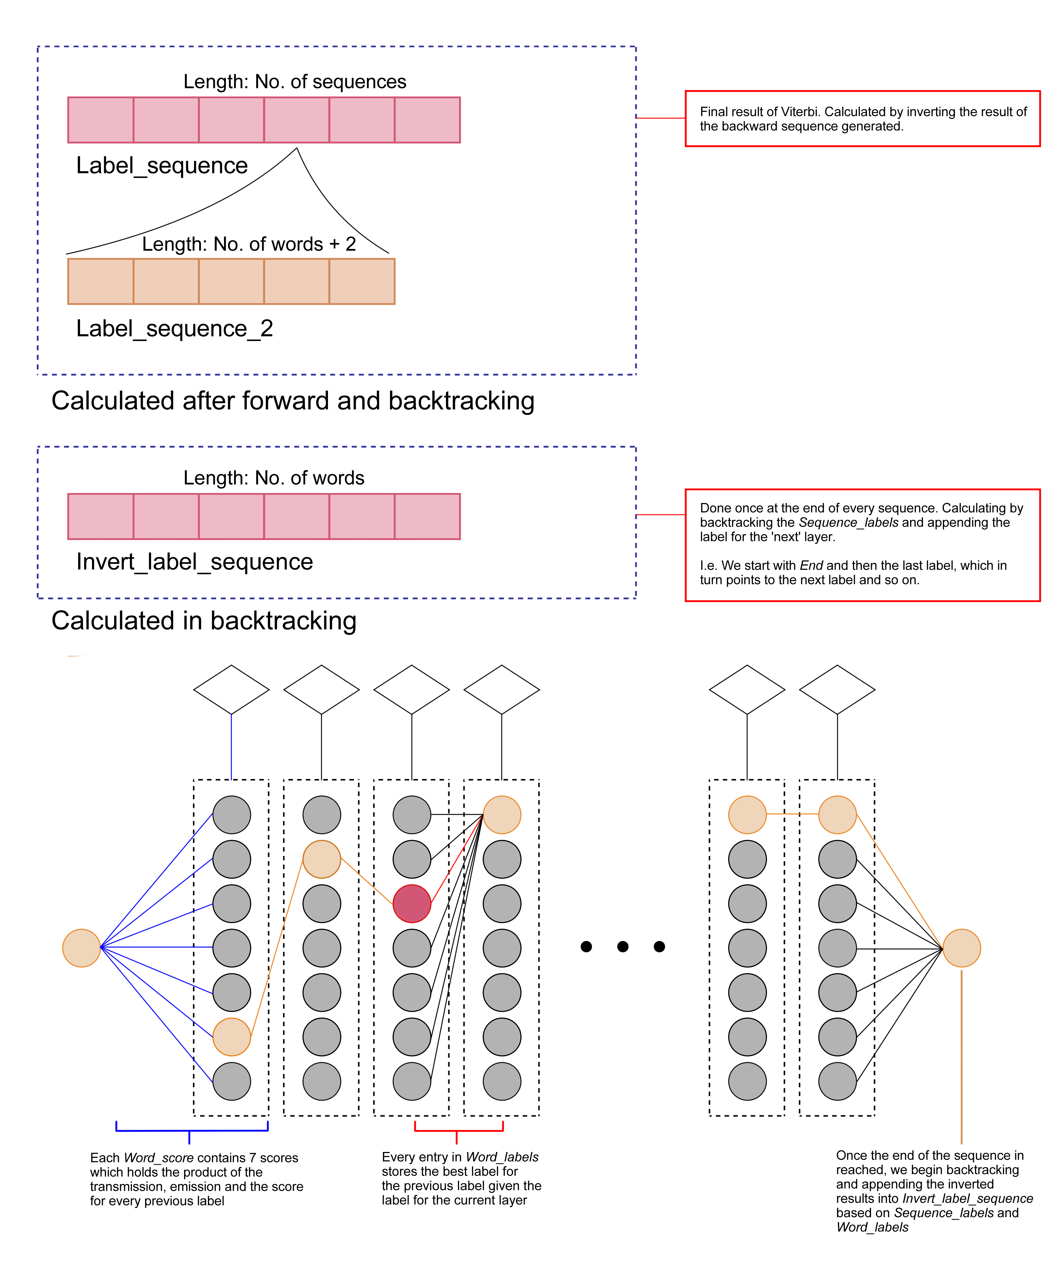

We generated a 4D array where the structure of the array is as follows:

* 1st Dimension: List of all sequences
* 2nd Dimension: List of all words in each sequence
* 3rd Dimension: List of all labels in each word
* 4th Dimension: List of each possible combination with the labels of the previous layer per label

**Start**

At the start of every sequence, we only calculate up to the 3rd dimension, and add the scores based on and . We multiply the two scores and add it to the array.

**Middle layers**

We then run through each label, with seven in total, with the seven labels of the previous layer. We multiply the score from each label from the previous layer with the transmission and emission score of the current layer, and store it in the 4th dimension of the array. This will give us a total of 49 scores per layer (sum of 3rd and 4th dimension). After running through all the seven labels of the previous layer, we compare the best label for layer given label for layer .

Once we finish running through all 49 possible combinations, and have the 7 best label for layer given each label in layer as well as their respective scores then append the label of into the selected sequence.

**Note:** that the pointer is at layer but we are appending the label for layer .

**End**

At the end, we do something similar to the middle layers, but we only calculate till the 3rd dimension. We then add the final label of the sequence and then add an ‘End’ label as well.

1. Results

**SG**

Entity in gold data: 4779

Entity in prediction: 4041

Correct Entity: 301

Entity precision: 0.0745

Entity recall: 0.0630

Entity F: 0.0683

Correct Sentiment: 132

Sentiment precision: 0.0327

Sentiment recall: 0.0276

Sentiment F: 0.0299

**CN**

Entity in gold data: 935

Entity in prediction: 1660

Correct Entity: 20

Entity precision: 0.0120

Entity recall: 0.0214

Entity F: 0.0154

Correct Sentiment: 6

Sentiment precision: 0.0036

Sentiment recall: 0.0064

Sentiment F: 0.0046

**ES**

Entity in gold data: 1326

Entity in prediction: 2262

Correct Entity: 98

Entity precision: 0.0433

Entity recall: 0.0739

Entity F: 0.0546

Correct Sentiment: 42

Sentiment precision: 0.0186

Sentiment recall: 0.0317

Sentiment F: 0.0234

**EN**

Entity in gold data: 662

Entity in prediction: 769

Correct Entity: 33

Entity precision: 0.0429

Entity recall: 0.0498

Entity F: 0.0461

Correct Sentiment: 12

Sentiment precision: 0.0156

Sentiment recall: 0.0181

Sentiment F: 0.0168

## Part 4

For part 4, we were tasked to find the top-k best output sequences by implementing an algorithm making use of the estimated emission and transmission parameters from earlier parts

**Setup:**

Generate the *transmission_array* and *emission_array* using the input file functions designed in part 2 and part 3.

Process input file by splitting the sequences up and storing them in 2d *input_array*

In addition to the input file, *transmission_array* and *emission_array*, the function also takes in a K parameter which sets the desired top result.

We will initialize a 2d array *Sets_of_Sequence* which will store the output top K’th state sequences for each of the sequence

**Top-K Viterbi algorithm**

We will be diving into 2 loops.

The first loop iterates through the sequences and initializes *SequenceScores* and *Sequence*.

The second loop iterates through the words of the sequence

**Start**

**Middle Layers**

**End**

**Decoding via backtracking**

## Part 5