THM CTF
Support

Write-Up

By
Shaun McCasker

CTF TASK 3
Target 3
Summary 3
Attack workflow 4
Recon 4
NMAP 4
Gobuster 5
Vulnerabilities and Exploitation 5
Weak credentials and exposed username – brute force attack 5
Insecure/non-validated cookies – cookie manipulation 7
Misconfigured Access Controls - BOLA 8
Non-Sanitsed user input - File Inclusion 9
Command Injection 12

CTF TASK
A new internal Support Operations Platform has been deployed to assist IT and helpdesk teams. The application handles user management, internal APIs, and system-level operations. However, security was not the primary focus during development. Several features rely on user-controlled input and weak trust boundaries.
What is the flag value after logging in as admin?
What is the content of the file /home/ubuntu/user.txt?

Target
IP 10.49.154.66
Logged as Admin FLAG: THM{I_AM_ADMIN999}
/home/ubuntu/user.txt FLAG: THM{GOT_THE_FLAG001}

Summary
The assessment began with reconnaissance using Nmap and Gobuster, identifying SSH and an Apache web server, along with potentially interesting directories and files such as /includes, /skins, /info.php and /config.php.

The initial login page exposed a valid username (help@support.thm). Testing revealed no apparent brute-force protection, allowing Hydra to identify the password snoopy. After logging in, the session cookie isITUser was found to contain an MD5 hash of the value false. Replacing it with the MD5 hash of true allowed access to additional functionality.

Further investigation uncovered a Broken Object Level Authorization (BOLA) vulnerability in the user API. By changing the user ID in the API URL, it was possible to access another user's information, including the administrator's email address.

A Local File Inclusion (LFI) vulnerability was then discovered through the dashboard's theme selection parameter. This allowed access to internal PHP files, including config.php, which exposed the administrator's password. After correcting the password format, administrator access was successfully obtained.

Finally, the administrator dashboard provided a system date functionality that was vulnerable to command injection. By manipulating the sys parameter, it was possible to execute additional system commands and retrieve the contents of /home/ubuntu/user.txt.

Attack workflow
This section outlines the thoughts and processes used to complete this CTF. It was already known this CTF would be focusing on session management, broken authentication, file inclusion, command injection and API testing. Therefore it was likely the attack vector would be the web-page itself, hence the decision to limit reconnaissance to the webserver on port 80.

Recon

NMAP
As expected only ssh on 22 and webserver on 80. Noted it was Apache hosted Ubuntu.
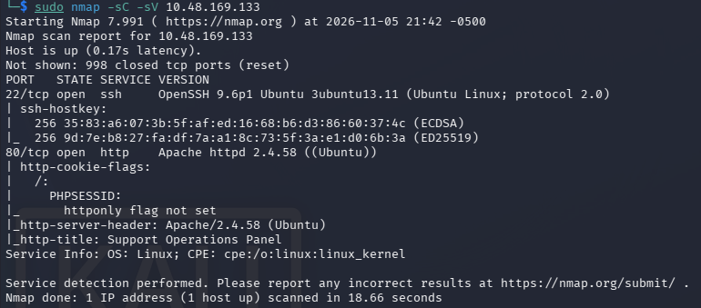

Gobuster
Gobuster directory enum most notably revealed /includes, this could indicate a local file inclusion, /info.php revealed information the webserver and /config.php which rendered nothing but still executed. Another directory /skins was found which would be useful later for local file inclusion.

Vulnerabilities and Exploitation
After exploring the exposed directories and finding nothing to exploit the login form became the target.

Weak credentials and exposed username – brute force attack
When loading the homepage we are presented with a login form. Within the form and below the form it is indicated that there is an account with
email “help@support.thm”.
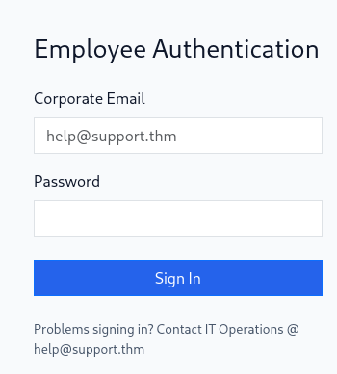

Knowing this a few login attempts were made to observe the response.
First logging in with help@support.thm with random password. Second logging in with random username and password.
The login parameters were identified as email and password.
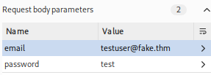
Both these attempts failed we received a 200OK and the message “invalid credentials”. Its worth noting that repeating this attack did not return a 429 indicating a brute force could work.

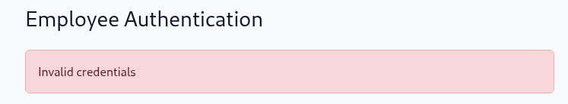
Knowing this a hyrda payload was created
hydra -l help@support.thm -P /usr/share/wordlists/rockyou.txt 10.49.154.66 http-post-form '/:email=^USER^&password=^PASS^:Invalid credentials' -f -V
Credentials found email: help@support.thm password: snoopy
Logging in using these credentials we get to the dashboard.
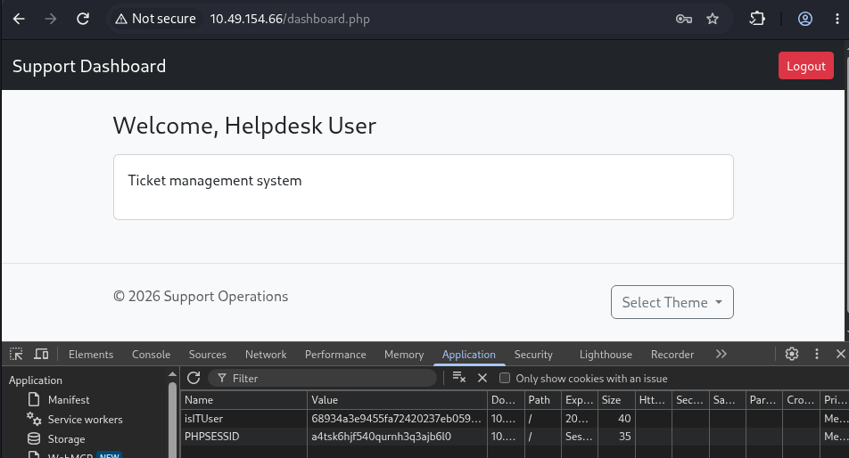

Insecure/non-validated cookies – cookie manipulation
Within the dashboard we can see we can change themes, this allows us to change the colour from red, green, blue and default. We can also see out session is stored in the local storage as a cookie with isITUser and PHPSESSID.
IsITUser stands out. After a quick reverse hash check it’s found to be an md5 hash of the word false.
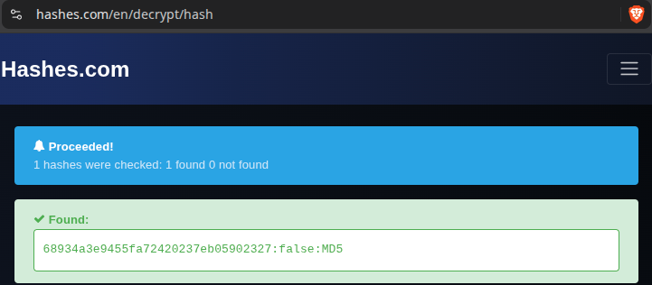
I encoded ‘true’ as md5 hash == b326b5062b2f0e69046810717534cb09 and replaced the old value.
Refreshing the page revealed an api link when pressed revealed how to get user info from the api.
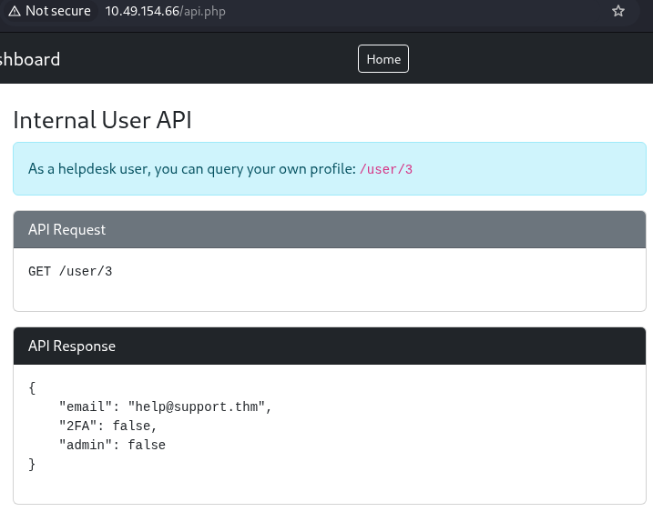

Misconfigured Access Controls - BOLA
This looked indicative of a potential BOLA so I inputted my user info @ 10.49.154.66/user/3 which rendered my details. Next I tried 10.49.154.66/user/1 which revealed the credentials of an admin user. Email: specialadmin@support.thm
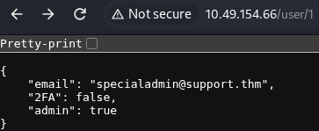

Non-Sanitsed user input - File Inclusion
When examining the select themes button it loads the url
http://10.49.154.66/dashboard.php?skin=red
Note we already know the application is adding .php to the url as we saw the skins directory earlier host the files as red.php, blue.php, green.php but the php is removed in the previous url.
Testing for file inclusion I try
http://10.49.154.66/dashboard.php?skin=../dashboard

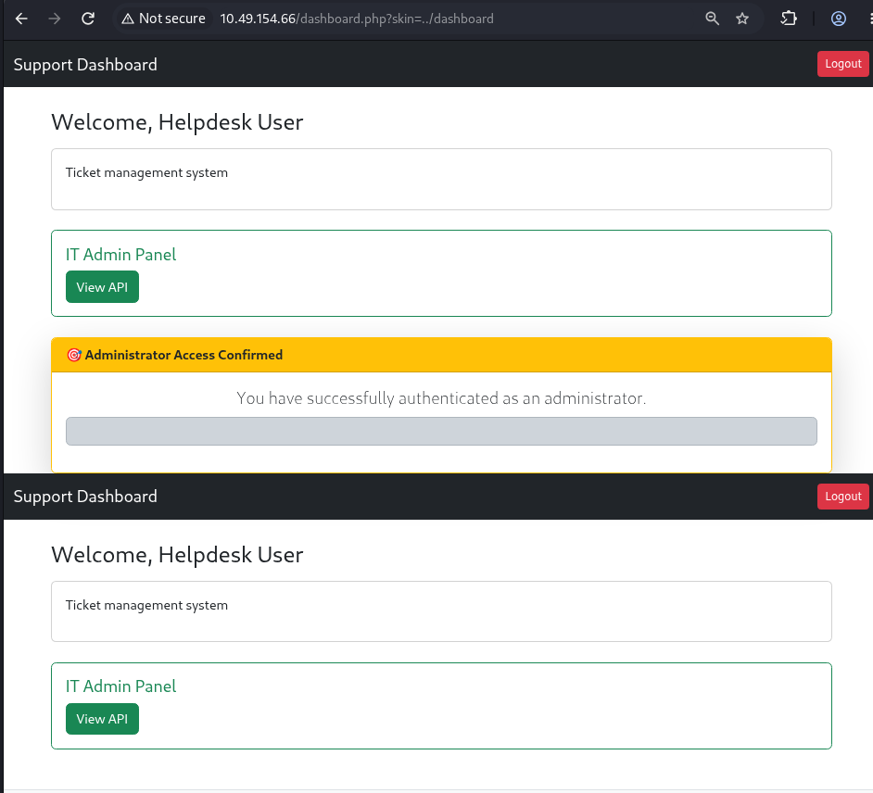
We can see this loads the dashboard twice indicating file inclusion is working. Looking at the page source we can also see internal code which is not usually visible.
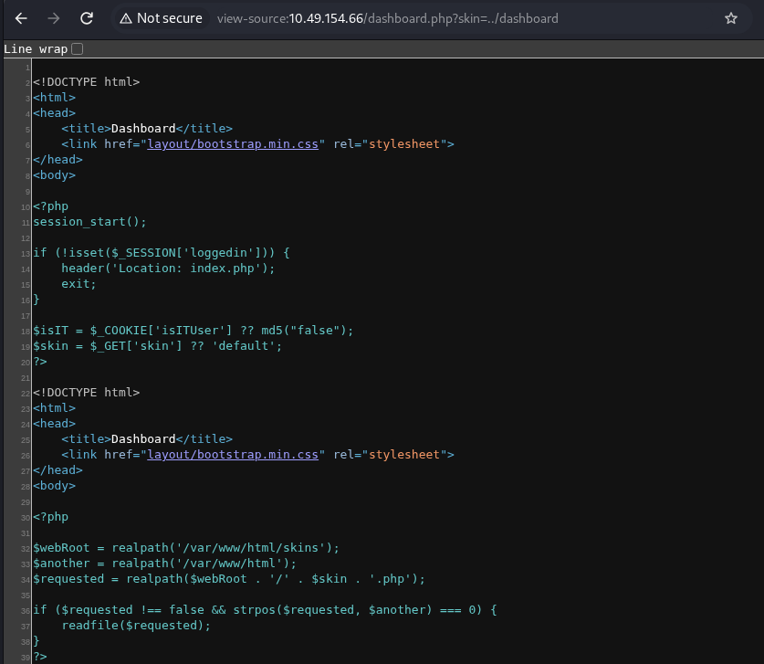
Knowing this I begin enumerating the files found in gobuster earlier.
Notably the /config.php file does not render to the browser however when using file inclusion @ 10.49.154.66/dashboard.php?skin=../config the page renders differently and when observing the page source we can see the config.php file which contains the master password: support@110
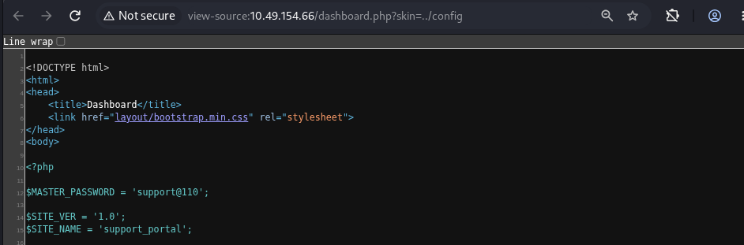

Command Injection
We know have username: specialadmin@support.thm password: support@110
Attempting to login with these credentials fails, for whatever reason the actual password removes the @ resulting in support110

After logging in we get the first flag THM{I_AM_ADMIN999}
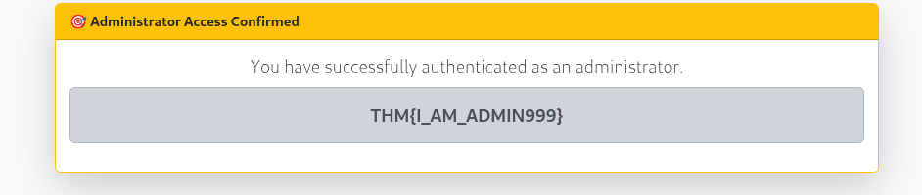

The only different thing about the admin account is the ability to display the date or time. Intercepting this request in burp suite reveals a parameter called ‘sys’ with value ‘date’.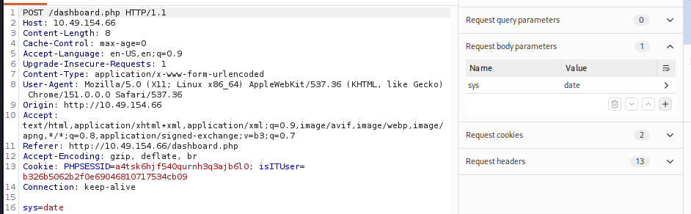
This looked like a potential command injection so I inputted who am I which returned the error ‘Only date is allowed’.

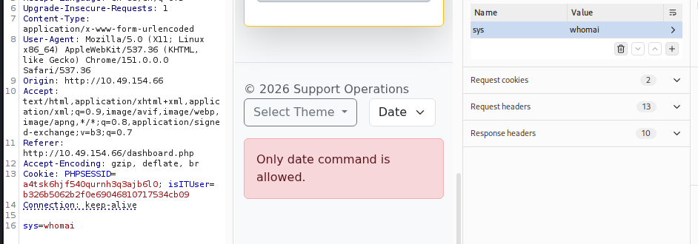
The logic was filtering the sys input. A simple check by inputting ‘date; whoami’ revealed it was only checking to see if the date value existed returning
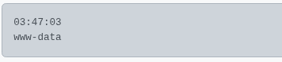
indicating a successful command injection. The task said the flag is located at /home/ubuntu/user.txt therefore I ran date; cat /home/ubuntu/user.txt which revealed the final FLAG: THM{GOT_THE_FLAG001}


