**Calculations in Tableau**  06-10-23

* **General operators:**

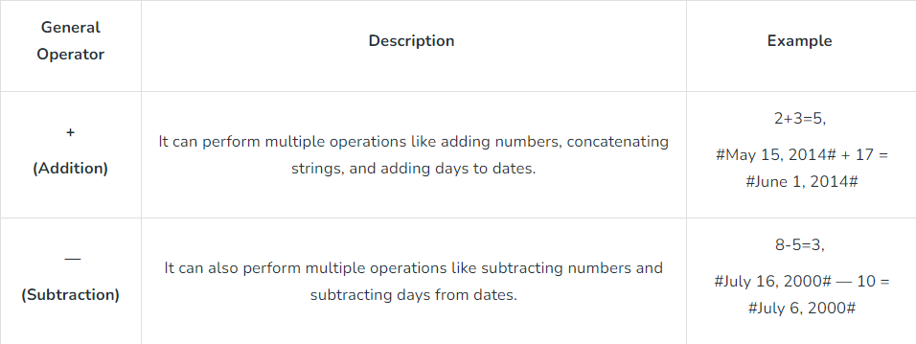

* **Arithmetic operator**

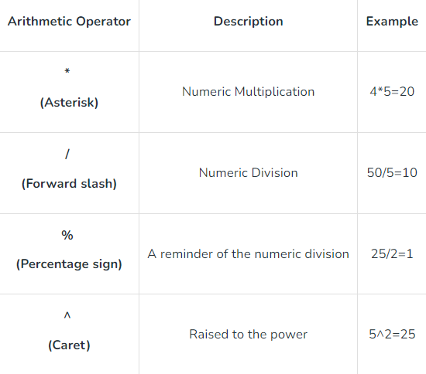

* **Relational operators**

== or =

!= or <>

>

<

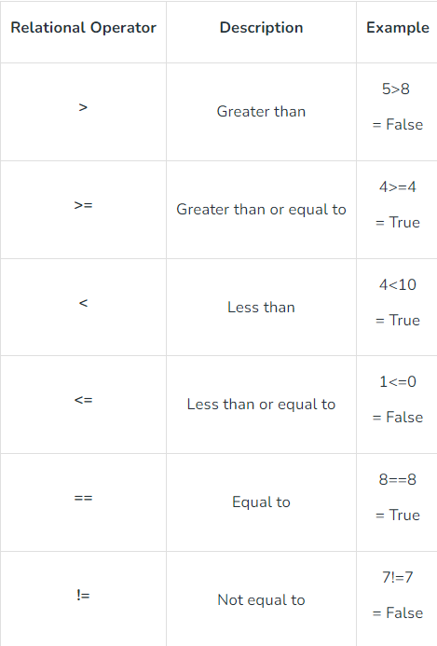

* **Logical operators:**

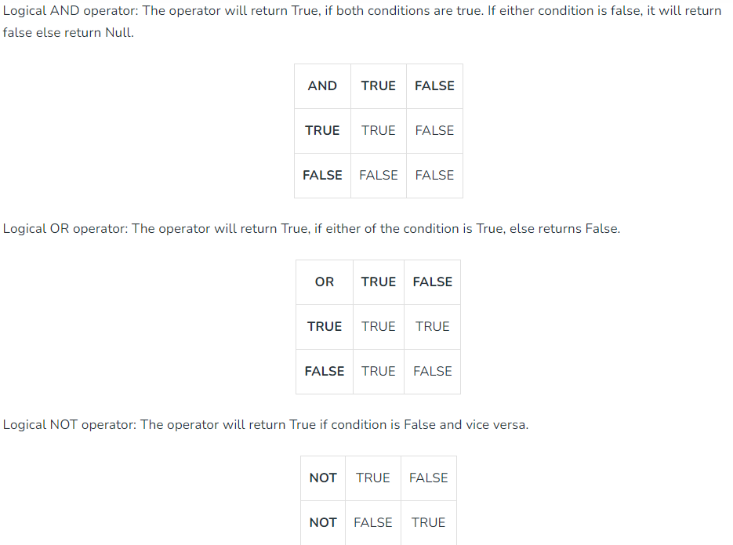

**Number functions:**

Ceiling func: Rounds a number to the nearest of equal or greater

Power func: Raises the no to the specified power

Round func: Rounds the no

**String Functions:**

LEN

LTRIN(string): Returns the string with the spaces removed

REPLACE(string, stubstring)

**Date Functions:**

DATEADD(date_part, increment, date)

DATENAME(date_part, date, start_of_week)

DAY(date)

NOW(): Returns the current date and time

**Logical Functions:**

IFNULL(exp1, exp2): Returns first exp if result is not null and second if it is null

ISDATE(string): Return TRUE if the string argument can be converted to date, and FALSE if

MIN(exp): checks the minimum value

**Aggregate functions:**

AVG(exp): Finds the average.

COUNT(exp):

MEDIAN(exp):

STDEV(exp):

**Types of Calculations:**

* Numeric calculations
* String calculations
* Date calculations
* Table calculations