California Lutheran University
Modelling and Forecasting the Technology Industry Production Function
ECON 513: Modelling
Dan Hamilton
Summer 2025
Shaun Levenson
8-17-2025

Modelling and Forecasting the Technology Industry Production Function

Introduction
The technology industry stands as a cornerstone of modern economic growth and societal transformation. Its influence extends far beyond traditional economic metrics, reshaping how individuals live, work, and interact. As digital innovations permeate communication, healthcare, finance, retail, education, and entertainment, the tech sector has become a central force driving productivity gains, high-value employment, and global competitiveness. On a personal level, technologies such as smartphones, cloud services, and connected devices have fundamentally altered daily routines, enabling real-time access to information, remote collaboration, and greater convenience in countless aspects of life. At the frontier of this evolution lies artificial intelligence (AI), which is revolutionizing both the economy and human experience. From predictive analytics in business to generative models in creative industries, AI is accelerating automation, enhancing decision-making, and opening entirely new fields of innovation. The rapid integration of AI technologies has amplified the strategic importance of the tech sector, prompting heightened attention from policymakers, investors, and educators. Measuring the real GDP contribution of the technology industry thus provides critical insight into its expanding economic footprint and its pivotal role in shaping the future of labor markets, global trade, and societal development.
To ground the discussion in empirical context, this paper begins with a visual overview of the key dependent variable: U.S. GDP attributed to the technology sector. These figures, presented in both real and nominal terms, highlight the scale and trajectory of tech’s economic contribution over time. For analytical clarity, the data is also shown in log-transformed levels to capture proportional changes, and in growth rates to reflect dynamics over the years. These visualizations provide essential background for the modeling approach that follows, allowing readers to observe key trends before examining the structural drivers of growth.

(Figure 1: Technology Industry GDP in Levels)
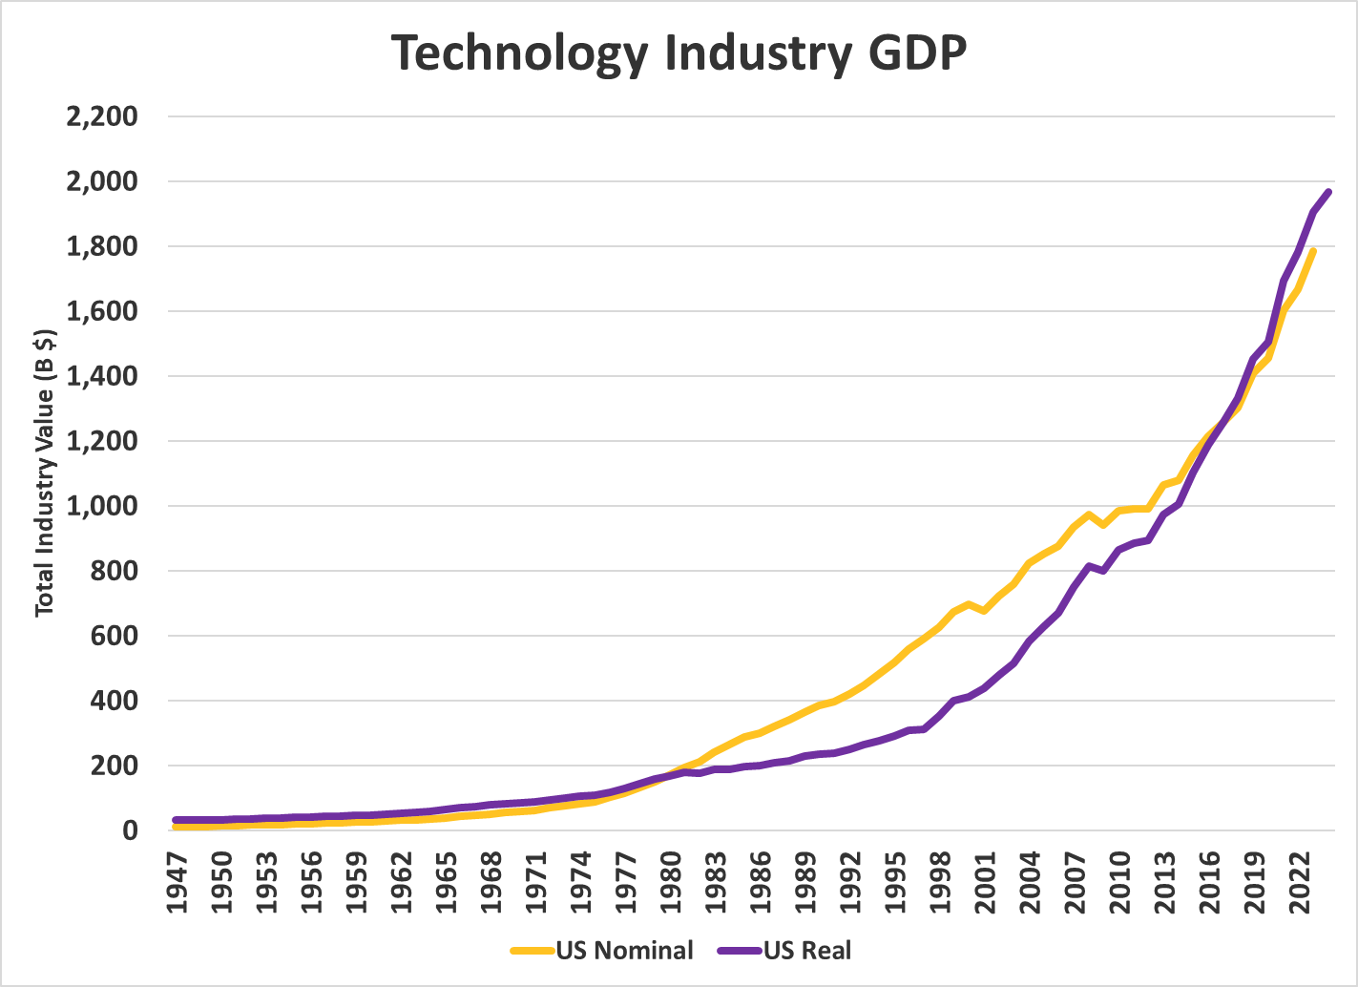
This overlay of nominal and real GDP levels for the U.S. technology industry from 1947 to 2024 highlights the long-run expansion of the sector and the impact of inflation on growth metrics. While nominal GDP reflects increasing dollar values over time, real GDP, adjusted for inflation, offers a clearer perspective on true industry growth. The divergence between these two measures illustrates both technological advancements and inflationary effects, providing insights into the sector's economic impact. Further details can be found in the Data Section.

(Figure 2: Technology vs Total GDP in Log Scale)
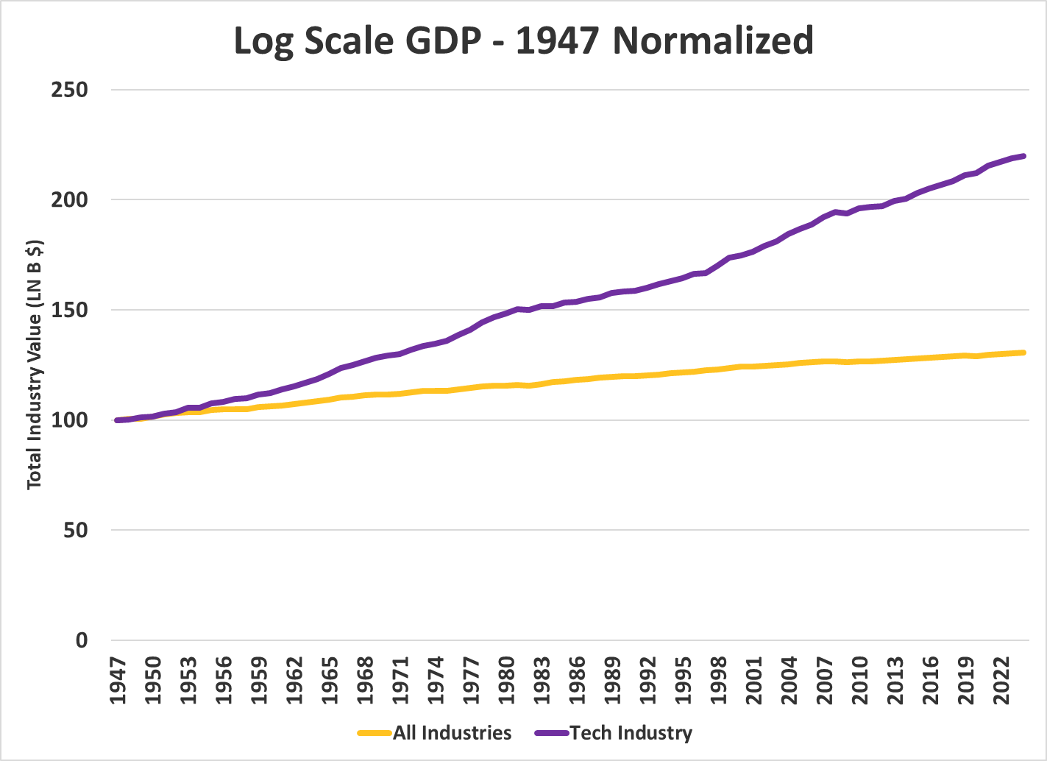
This chart presents the normalized natural logarithms of real GDP for both the U.S. technology sector and total GDP across all industries from 1947 to 2024, effectively illustrating the technology sector’s sustained exponential growth. When expressed in logarithmic terms, both series follow a near-linear trajectory, which highlights the consistent and resilient nature of their inflation-adjusted growth over time. The non-parallel movement of these two paths suggests that the long-term growth dynamics of the technology sector have surpassed the broader economy. Since the start of the series in 1947, the average annual growth rate has been approximately 6% for the technology sector and 3% for total industry, emphasizing the sector's long run outperformance over the broader economy.

(Figure 3: Technology Sector Growth Rates)
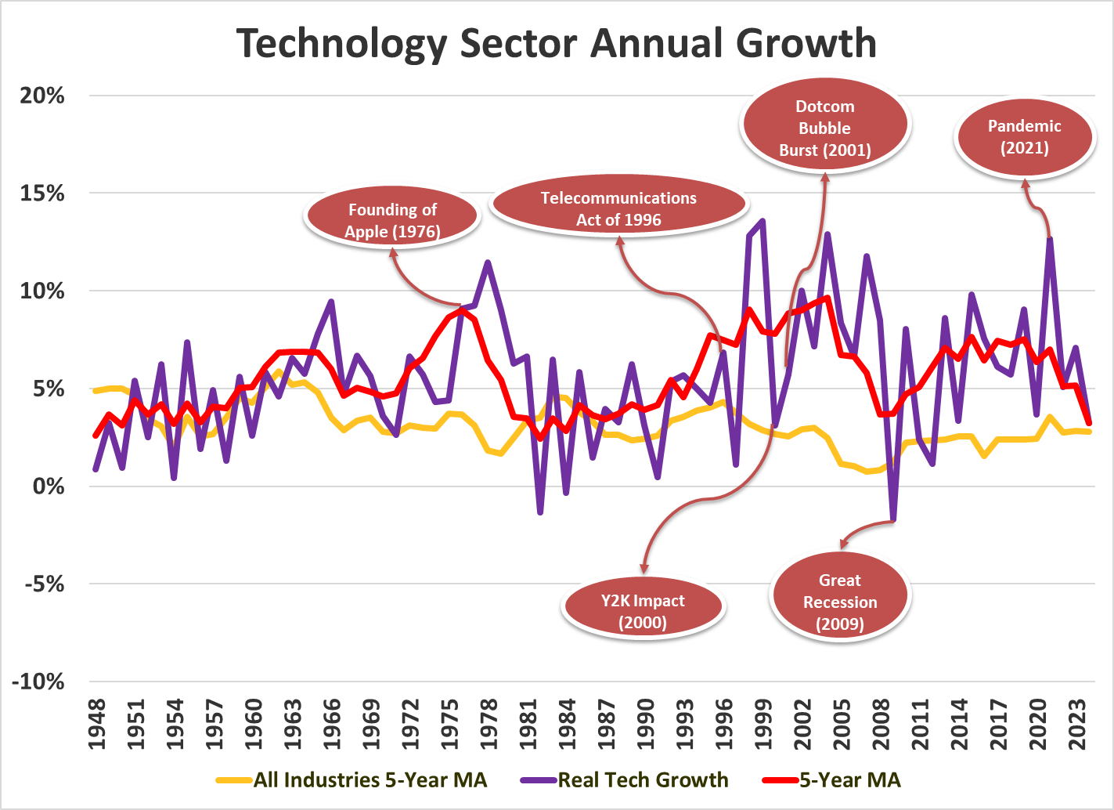
This chart provides shows the evolution of growth in the U.S. technology sector from 1947 to 2024, comparing real annual growth with five-year moving averages for both the sector and the overall economy to provide context on the greater economic climate. The contrast between these lines brings to light how long-term trends interact with shorter-term fluctuations driven by innovation cycles, macroeconomic pressures, and policy shifts. By focusing on real values and smoothed performance, the chart clarifies whether periods of rapid change reflect sustained sector expansion or broader economic dynamics, making it an essential lens for evaluating the tech industry's enduring impact.

Motivation
This paper is driven by a desire to quantify the technology sector’s contributions to the economy and identify the forces behind its rapid expansion. The tech industry’s importance is not confined to companies producing software or hardware; it extends across nearly all sectors. From the use of accurate GPS systems in tractors enabling precision agriculture, to machine learning algorithms that improve early disease detection in healthcare, to automation reshaping logistics and manufacturing, technological innovation enhances productivity and resource efficiency across the economy. In recent years, the emergence and rapid deployment of artificial intelligence have further amplified this effect; AI is introducing transformative changes in decision-making, content creation, data analysis, and operations management across industries. These systemic and spillover effects underscore the importance of understanding the underlying inputs driving growth in the tech sector itself; they indirectly shape outcomes throughout the broader economy.
Through econometric estimation and navigating the specification issues of a production function model of technology GDP, this paper aims to identify, test, and utilize relevant inputs to production as well as long term productivity factors that are well-known in the production function literature, but where in my analysis, I employ the data and estimation techniques to Technology GDP rather than overall GDP. Crucially, generating an accurate and theoretically guided forecast of real GDP attributed to the technology sector is central—not only does it offer economists, forecasters, and policymakers a more precise lens for assessing structural economic trends and anticipating future cycles shaped by technological change, it also enhances our capacity to evaluate how these advances influence broader price dynamics. Rapid technological change, particularly in the tech sector, has driven significant declines in quality-adjusted prices for products such as computers, electronics, and, to some extent, automobiles and other goods. These innovations have benefited the consumer in significant ways. Utilizing my modelling and estimation effort within a rigorous the multifaceted impacts of technology on both sectoral and aggregate economic performance.

Background
SIC and NAICS
The Standard Industrial Classification (SIC) system was the primary method for categorizing industries in the United States from the 1930s until the late 1990s. Developed by the U.S. government, the SIC was designed to facilitate the collection, presentation, and analysis of economic data across a wide array of industries. It organized businesses based on their primary economic activity, using a four-digit code structure that grouped similar industries together. While the SIC served as a foundational tool for decades, its structure became increasingly outdated, particularly as the U.S. economy shifted toward services, information, and high-technology sectors that were not well represented in the original classifications. Its limited ability to reflect emerging industries and evolving production processes created challenges for researchers and policymakers who relied on accurate industry-level data.
In 1997, the North American Industry Classification System (NAICS) was introduced to replace the SIC system. Developed jointly by the United States, Canada, and Mexico, NAICS was designed to provide a consistent framework for economic analysis across North America and to better reflect the modern, service-oriented, and globalized economy. Unlike SIC’s four-digit structure, NAICS introduced a more detailed six-digit coding system, which allowed for finer distinctions among industries, particularly in areas such as information technology, telecommunications, and advanced manufacturing. Since its inception, NAICS has undergone periodic revisions every five years with updates aimed at capturing changes in production technologies and business practices. One major shift occurred in the 2022 revision, where industries began to be grouped more by the nature of their output rather than by how services or goods were delivered, thus merging internet-based and traditional providers under unified classifications. This evolution has enabled more relevant and comparable industry data over time but also introduces complexities for long-term historical comparisons.
With the shift from the Standard Industrial Classification (SIC) system to the North American Industry Classification System (NAICS) in 1997, the U.S. economic classification structure was updated to more accurately reflect modern, service-oriented sectors, including high-technology industries. As a result, real GDP data for key technology-related sectors such as Information and Computer and Electronic Product Manufacturing are only available under the NAICS framework from 1997 onward. However, nominal GDP data for these sectors are available dating back to 1947. To construct a consistent long-run measure of technology sector output, this study combines historical nominal data with earlier real series in 2012 chained dollars, rebased into 2017 dollars to align with more recent data. This approach enables the construction of a unified, inflation-adjusted $\text{GDP_Tech}\text{\$}$ series that spans from 1947 to 2024, making it possible to analyze long-term trends despite changes in classification systems and price indexing.
Although the composition of the technology sector has changed slightly over time, this paper uses the 2022 NAICS classification system to describe the industries currently included in $\text{GDP_Tech}\text{\$}$. This provides a consistent reference for interpreting the variable’s scope. $\text{GDP_Tech}\text{\$}$ comprises selected six-digit industries from the Computer and Electronic Product Manufacturing sector (NAICS 334) and the Information sector (NAICS 51). Table 1 lists the relevant NAICS codes and industry descriptions.
(Table 1: NAICS Composition)
Composition of Key Dependent Variable - 2022 NAICS
Name |  | Code
Manufacturing |  | 31-33
Computer and Electronic Products Manufacturing |  | 334
Computer and Peripheral Equipment Manufacturing |  | 3341
Electronic Computer Manufacturing |  | 334111
Computer Storage Device Manufacturing |  | 334112
Computer Terminal and Other Computer Peripheral Equipment Manufacturing |  | 334118
Communications Equipment Manufacturing |  | 3342
Telephone Apparatus Manufacturing |  | 334210
Radio and Television Broadcasting and Wireless Communications Equipment Manufacturing |  | 334220
Other Communications Equipment Manufacturing |  | 334290
Audio and video Equipment Manufacturing |  | 3343
Audio and Video Equipment Manufacturing |  | 334310
Semiconductor and Other Electronic Component Manufacturing |  | 3344
Bare Printed Circuit Board Manufacturing |  | 334412
Semiconductor and Related Device Manufacturing |  | 334413
Capacitor, Resistor, Coil, Transformer, and Other Inductor Manufacturing |  | 334416
Electronic Connector Manufacturing |  | 334417
Printed Circuit Assembly (Electronic Assembly) Manufacturing |  | 334418
Other Electronic Component Manufacturing |  | 334419
Navigational, Measuring, Electromedical, and Control Instruments Manufacturing |  | 3345
Electromedical and Electrotherapeutic Apparatus Manufacturing |  | 334510
Search, Detection, Navigation, Guidance, Aeronautical, and Nautical System and Instrument Manufacturing |  | 334511
Automatic Environmental Control Manufacturing for Residential, Commercial, and Appliance Use |  | 334512
Instruments and Related Products Manufacturing for Measuring, Displaying, and Controlling Industrial Process Variables |  | 334513
Totalizing Fluid Meter and Counting Device Manufacturing |  | 334514
Instrument Manufacturing for Measuring and Testing Electricity and Electrical Signals |  | 334515
Analytical Laboratory Instrument Manufacturing |  | 334516
Irradiation Apparatus Manufacturing |  | 334517
Other Measuring and Controlling Device Manufacturing |  | 334519
Manufacturing and Reproducing Magnetic and Optical Media |  | 3346
Manufacturing and Reproducing Magnetic and Optical Media |  | 334610
Information |  | 51
Motion Picture and Sound Recording Industries |  | 512
Motion Picture and Video Industries |  | 5121
Motion Picture and Video Production |  | 51211
Motion Picture and Video Exhibition |  | 51213
Motion Picture Theaters (except Drive-Ins) |  | 512131
Drive-In Motion Picture Theaters |  | 512132
Postproduction Services and Other Motion Picture and Video Industries |  | 51219
Teleproduction and Other Postproduction Services |  | 512191
Other Motion Picture and Video Industries |  | 512199
Sound Recording Industries |  | 5122
Music Publishers |  | 51223
Sound Recording Studios |  | 51224
Record Production and Distribution |  | 51225
Other Sound Recording Industries |  | 51229
Publishing Industries |  | 513
Newspaper, Periodical, Book, and Directory Publishers |  | 5131
Newspaper Publishers |  | 51311
Periodical Publishers |  | 51312
Book Publishers |  | 51313
Directory and Mailing List Publishers |  | 51314
Other Publishers |  | 51319
Greeting Card Publishers |  | 513191
All Other Publishers |  | 513199
Software Publishers |  | 5132
Broadcasting and Content Providers |  | 516
Radio Television and Broadcasting Stations |  | 5161
Radio Broadcasting Stations |  | 51611
Television Broadcasting Stations |  | 51612
Media Streaming Distribution Services, Social Networks, and Other Media Networks and Content Providers |  | 5162
Telecommunications |  | 517
Wired and Wireless Telecommunications (except Satellite) |  | 5171
Wired and Wireless Telecommunications Carriers (except Satellite) |  | 51711
Wired Telecommunications Carriers |  | 517111
Wireless Telecommunications Carriers (except Satellite) |  | 517112
Telecommunications Resellers and Agents for Wireless Telecommunication Services |  | 51712
Telecommunications Resellers |  | 517121
Agents for Wireless Telecommunications Services |  | 517122
Satellite Telecommunications |  | 5174
All Other Telecommunications |  | 5178
Computing Infrastructure Providers, Data Processing, Web Hosting, and Related Services |  | 518
Web Search Portals, Libraries, Archives, and Other Information Services |  | 519
Web Search Portals, Libraries, Archives, and Other Information Services |  | 5192
Libraries and Archives |  | 51921
Web Search Portals and All Other Information Services |  | 51929

Telecommunications act of 1996
The Telecommunications Act of 1996 significantly reshaped the U.S. communications landscape and had broad economic implications. By removing barriers to entry and encouraging competition across local and long-distance telephone services, cable, and broadcasting, the Act spurred rapid technological innovation and infrastructure investment. It allowed telephone companies to enter cable markets and vice versa, increasing the speed in which broadband entered the ecosphere and contributing to the growth of the Internet economy. The deregulation of media ownership also led to industry consolidation, creating economies of scale while raising concerns about market concentration. Overall, the Act played a key role in modernizing the telecommunications sector, fostering job creation, enhancing productivity, and laying the groundwork for the digital economy.

Theory
Understanding the factors that influence specific industries is essential for both effective policy implementation and a deeper understanding of how the economy functions at a sectoral level. Industry-specific dynamics—particularly within rapidly evolving sectors like technology—require analytical frameworks that can account for a wide range of inputs and contextual factors. One way to formalize these relationships is through a general functional form, shown in Equation (1), where $\text{GDP_Tech}\text{\$}$ represents the real level of gross domestic product attributable to the technology sector. This is the key dependent variable in the analysis, while $x_{1}$​ through $x_{n}$​ represent independent variables that either have a demonstrated effect on the sector or are theoretically expected to influence it:

$GDP_Tech\$ =f(x_{1},x_{2},x_{3},…,x_{n})$ (1)

The selection of these explanatory variables is guided by foundational economic principles, particularly the theory of the firm, which provides a conceptual framework for how output is produced based on available resources and technology. Central to this framework is the production function—a supply-side model that links the quantity of output to the quantities of various inputs. In its most basic form, output ($Y$) is expressed as a function of the level of technology ($A$), capital inputs ($K$), and labor inputs ($L$):

$$Y=A*f(K,L)$$

This classical formulation serves as the theoretical basis for identifying relevant determinants of technology sector output. However, when applying this to empirical research, the production function is often extended to include more detailed and industry-specific inputs, such as measures of human capital, research and development activity, and intermediate input costs. These additions help bridge the gap between abstract economic theory and the real-world complexities faced by modern industries. In the case of the technology sector, which relies heavily on intangible assets and rapidly changing inputs, such extensions are not only appropriate but necessary for producing meaningful estimates of sectoral output behavior.
Using theory provided by other texts allows for proper knowledge with which to proceed prior to empirical testing. The basis for all of these models follows the Cobb-Douglas production function:

$$Y=AK^{α}L^{β}$$

Where $Y$ is output, $A$ is technology level, $K$ is labor or workforce, and $α \text{and} β$ are elasticity parameters of capital and labor respectively. From Intriligator’s book on econometrics, he explains that there is a generalization approach to the Cobb-Douglas production function called the translog production function where:

$$lnY=α+αlnL+βlnK+γLnL*lnK+δ(ln{L)}^{2}+ϵ{\left(lnK\right)}^{2}$$

This technique reduces to the standard Cobb-Douglas if $γ, δ, \text{and} ϵ$ all vanish. Otherwise, it exhibits nonunitary elasticity of substitution. This form is more flexible than the standard Cobb-Douglas as it allows for interactions and non-constant elasticities. Additionally, something else mentioned by Intriligator that time-series models run into is the issue of serial correlation. This occurs when the error terms in a regression model are correlated across time periods which violates independent errors assumption leading to biased standard errors.
As quoted by Intriligator “The most important type of serial correlation is first-order linear serial correlation, namely the linear relation between successive stochastic disturbance terms. Such first-order serial correlation takes the form of a Markov Process or First-Order Autoregressive Scheme.” To fix this issue economists use lagged variables, generalized least squares, or Autoregressive Integrated Moving Average (ARIMA) models. In structural regressions, we aim to uncover causal relationships that are grounded in economic theory. To achieve this, we restrict RHS variables to those that are theoretically justified and exogenous (i.e., not determined within the system) to avoid issues of endogeneity and simultaneity bias. Including variables like lagged dependent (or inertial) terms can undermine the structural interpretation because they often reflect statistical persistence rather than economic causality. Moreover, inertial terms are typically not derived from theory and may capture dynamics driven by omitted variables or unmodeled feedback effects.

Literature
The intent of finding valuable literature is to find potential variables that others may have considered and have put quantitative research into and incorporate them into your own model. Since this paper is solely focused on technology GDP via the production function, most if not all of the literature I use will be related either in its entirety or partially to GDP, production, or technology, as each may have valuable insight into the inner workings of technology GDP.
Studies on production and productivity have emphasized the value that public and private capital accumulation have as determinants on output. Every literature that I explored included some form of capital and labor, which is consistent with production function theory. Hamilton (2001) finds that public capital remains a significant factor on output even after including variables, such as human capital and R&D, that prior studies wrongfully omitted. Similarly, Lynde and Richmond (1993) find that a large portion of productivity decline can be attributed to the fall of the public capital to labor ratio, indicating that if public capital accumulation remains constant and public labor increases, productivity and thus production should decrease. This notion is mirrored by another paper on productivity where public labor share was a key factor driving productivity and had an inverse relationship (Unknown Author, BIS). This is all to say that my models should include public capital and public employment share with expected relationships as positive and inverse respectively. Productivity is also a major factor when considering output, although it is not always observable. Olley and Pakes (1992) consider standard production function variables (capital and labor) but include productivity as an unobserved factor separate from the error term, indicating that it is valuable for consideration. They claim that productivity is a major factor when the firm is considering both liquidation and input demand decisions, whereas anything left in the error term is not. Other researchers took a more traditional approach to production. Levinsohn and Petrin (2002) built on ideas developed by Olley and Pakes by showing that intermediate inputs, in this case electricity, fuel, and materials, were significant factors to include to solve simultaneity issues formed by correlation between input levels and unobserved productivity. Levinsohn and Petrin also break up labor into unskilled labor and skilled labor to account for nuances between the two. The literature shown above highlights that public and private capital, labor dynamics, and intermediate goods play crucial roles in estimating output across sectors or industries. They collectively determine production capability, reinforcing the need for comprehensive modeling approaches that account for these independent variables.
While the production approach highlights the contribution of inputs to the production function, understanding growth dynamics requires examining key drivers that sustain expansion. Variables that are not input specific such as R&D, technological change, and human capital accumulation are vital for examining the impact of growth on the production function. Hamilton (2001) examines the effects of human capital and R&D in his fully modified ordinary least squares model estimating output. Lynde and Richmond (1993) take a standard production function approach by including technological change in their production model.
Most researchers take the standard theoretical production function approach by including capital and labor in some form in their model except for Macarrone’s paper on a machine learning approach to prediction. While they did include some variables typical of an econometric study, their methodology and variable selection is not based on economic theory and does not follow the typical Cobb-Douglas framework. Since data science approaches focus on prediction and pattern recognition, they may not follow typical economic causality structure using economic theory leading to more “black-box” methods that have low interpretability. Using these methods could be useful if the only goal is to be as accurate with predictions as possible, but oftentimes having the interpretability of an economic model is just as important, if not more important, than accurate predictions.

Building on the existing literature provides a foundation for developing a theoretically informed econometric model by incorporating variables identified in previous studies. In the context of production inputs, I will separate total capital into private and public components. A similar distinction will be made for labor by dividing it into skilled and unskilled categories, subject to the availability of appropriate data. The model will also test the price of oil as an intermediate input, due to its widespread relevance in production processes across multiple sectors.
From the perspective of growth-related factors, I will include human capital and investment in research and development, alongside a standard representation of technological progress as captured in the Cobb-Douglas framework. Literature use human capital and research and development as partial proxies for overall productivity, which is an important way to use existing data to add relevant RHS variables in an attempt to reduce omitted variable bias.

Data Section
The dataset compiles annual data from several sources, including the Bureau of Economic Analysis (BEA), the National Bureau of Economic Research (NBER), the Bureau of Labor Statistics, Penn World Tables, and the U.S. Census Bureau’s ACS 1-Year Estimates. The primary variable of interest, GDP_Tech$, represents the real GDP of the technology industry (in billions of 2017 dollars), covering the period from 1947 to 2024. A related variable, GDP_Tech, captures nominal technology GDP over the same period. Both real and nominal tech GDP figures were constructed using BEA industry data by aggregating the Information and Computer and Electronic Products sectors. For the earlier portion of the series, real tech GDP was derived by deflating nominal values using industry-specific price indices, with 2017 as the base year. Recession indicators are included from two sources: REC1 (sourced from Investopedia) and REC2 (from NBER), both spanning 1947–2024. While Investopedia is not considered an authoritative economic source, its indicator is retained for completeness and comparison. The dataset also incorporates capital stock measures (private and public) from the BEA for 1925–2023, rolled forward one year due to their nature as stock variables. Of which, only real capital stock for information K_Info$ real capital stock for industrial equipment K_IndEq$ , and real public capital investment Pk$ were used in the final models. Various labor components such as L_Info (1939-2024) and L_CEP (1950-2024) are sourced from the Bureau of Labor Statistics. Price indices for key technology-related components are also sourced from the Bureau of Labor Statistics, with the following time ranges:
- $P^{Oil}$: 1947–2024
- $P^{Semi}$ (Semiconductors): 1985–2024
- $P^{EC}$ (Electrical Components): 1968–2024
- $P^{CopProd}$ (Copper Products): 1967–2024
- $P^{CBMS}$ (Copper and Brass Mill Shapes): 1954–2024
- $P^{BTC}$ (Electric Lamp Bulbs, Tubes, and Components): 1947–2024
Additional variables include RnD investment, human capital index values from Penn World Tables (1950–2024, with 2020–2024 forecasted), and educational attainment (e.g., percentage of the population with a bachelor’s degree) from the Census Bureau ACS 1-Year Estimates (2010–2024, with 2024 forecasted). Lastly, we have technological growth variables Multifactor Productivity (MFP) and Patent Grants (PatGrant), the prior sourced from the BLS and ranged from 1950 to 2024 and the latter source from the World Intellectual Property Organization (WIPO), ranging from 1940 to 2024, where 2024 was derived using a simple 5-year growth trend.
Before the dataset could be used in analysis, several adjustments were necessary to address gaps and inconsistencies in coverage. Certain labor variables, such as L_CEP​, were only available from 1990 to 2024, requiring us to construct estimates for the earlier period from 1950 to 1989. Human capital (Hk​) data stopped in 2019, so we extended the series using the share of the population with bachelor’s degrees to estimate the remaining years. Industry price deflators had to be rebased from a 2012 base year to 2017 for the pre-1997 period, while the technology sector deflator was extrapolated using the derived GDP_Tech$​ variable. GDP_Tech$​ was constructed by combining the information sector (GDP_Info$) with the computer and electronic products manufacturing sector (GDP_CEP$), with values from 1947 to 1996 estimated by deflating nominal output figures. Additionally, an intervention variable was created for CEP shocks, where 1999 and 2000 were set at 1, and 2001 was set at 2, all else set to 0. The following table provides a full breakdown of the variables included in the dataset.

Metadata
(Table 2: Metadata)

(Figure 1: Technology Industry GDP in Levels)

The chart presents two principal data series: Nominal GDP (yellow) and Real GDP (purple, chained to 2017 dollars) for the technology sector from 1947 through 2024.
Nominal GDP steadily increases across the chart, with relatively modest growth during the mid-20th century. The curve steepens notably beginning in the 1980s and continues through the 1990s and 2000s, corresponding with several waves of technological adoption: mainframe computers, personal computing, the internet, and mobile technology. The most pronounced upward inflection occurs after 2010, likely reflecting the explosion in cloud services, digital platforms, and accelerated digital transformation across the broader economy. Periods of elevated inflation, such as the 1970s and the early 2020s, are also reflected as faster rises in the nominal series.
Real GDP, which adjusts for inflation, has a similar underlying trend but with less pronounced inflation-driven swings. The early decades (1947–1980) show slow but steady growth, suggesting measured expansion in real terms. From the 1980s, real GDP growth begins to quicken, tracking many of the same inflection points as nominal GDP but more smoothly. The most dramatic rise occurs after the mid-1990s—paralleling the widespread adoption of the internet and information technologies in business and consumer markets. A critical feature emerges post-2020 as the real GDP line overtakes the nominal GDP line, indicating that the technology sector experienced exceptionally strong real output growth, likely caused by increased technological reliance from the COVID-19 lockdown.

(Figure 2: Technology vs Total GDP in Log Scale)

The log-scale GDP chart highlights the divergent long-term growth paths of the U.S. technology sector and the broader economy from 1947 to 2024. Both series are normalized to be 100 in 1947. From the onset of the series, the tech sector exhibits a noticeably steeper upward slope. This steeper trajectory signals a significantly higher compound annual growth rate, reflecting the accelerating influence of technological innovation, digitalization, and the sector’s rising economic importance. The overall economy demonstrates steady, stable growth with low volatility, while the tech sector’s sharper ascent reflects periods of rapid expansion driven by breakthroughs in computing, electronics, and the internet. By 2024, the tech sector has clearly emerged as a dominant force, with growth trends that underscore a broader structural shift toward technology-led economic output in the U.S.
(Figure 3: Technology Sector Growth Rates)

This chart displays real annual growth rates of the U.S. technology sector from 1947 to 2024 (purple line), alongside two five-year moving averages: one for the technology sector (red line) and one for all industries (yellow line). While the entire time span is marked by a continual push and pull between peaks and troughs, certain periods—particularly the mid-1970s through the early 2000s—exhibit notably heightened volatility, reflecting structural shifts and cycles of intense innovation and adjustment. Interestingly, the early postwar years appear relatively more stable in comparison, despite being foundational in the sector’s development.
Negative growth is rare, underscoring the sector’s long-run resilience. Yet it’s the red moving average that best captures the rhythm of the industry: a wavelike pattern that closely mirrors the broader tech business cycle. This smooth trace helps contextualize periods of sustained expansion and softening, offering clarity amid the noisy annual fluctuations.
Notably, 1998 and 1999 saw tech growth surge to nearly 15% in consecutive years, reflecting the height of the dot-com boom. The 2008 financial crisis brought growth down to just below -2%, one of the few contractionary moments in the series. More recently, the 2021 recovery during the COVID-19 pandemic drove a spike to approximately 13%, underscoring the sector’s adaptability and continued centrality in a changing economic landscape.
Importantly, for most of the range, tech sector growth consistently exceeds that of the broader economy, highlighted by the red line staying above the yellow one, reinforcing the industry’s outsized role in driving long-term economic momentum.

(Figure 4: Technology Sector and Components Deflator Growth)
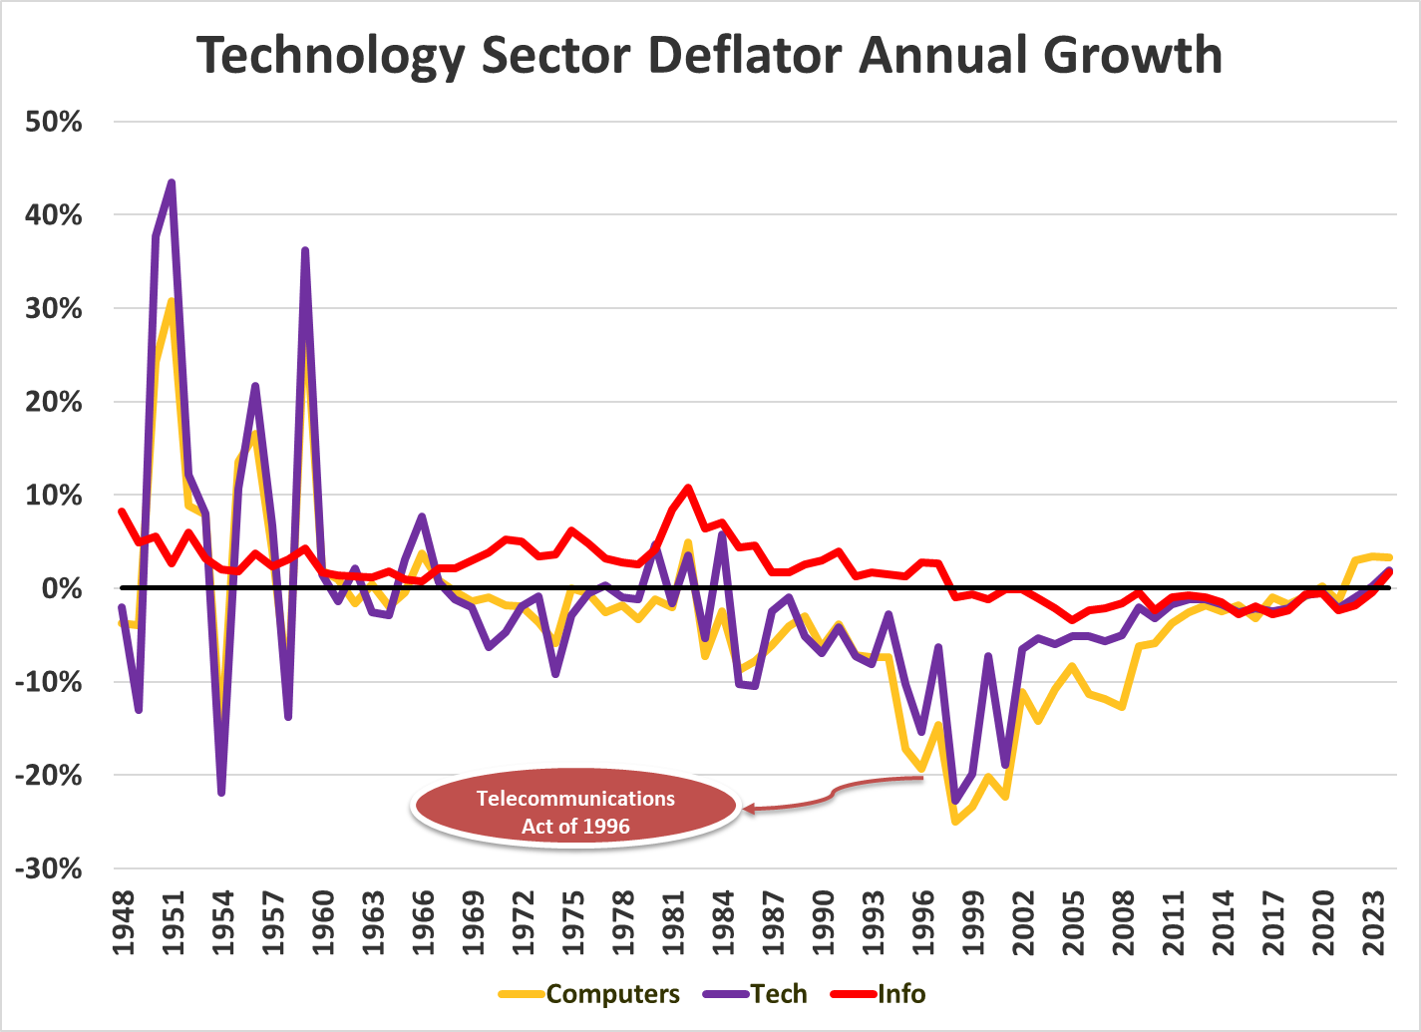

(Figure 5: Technology Sector and Components Deflator in Levels)
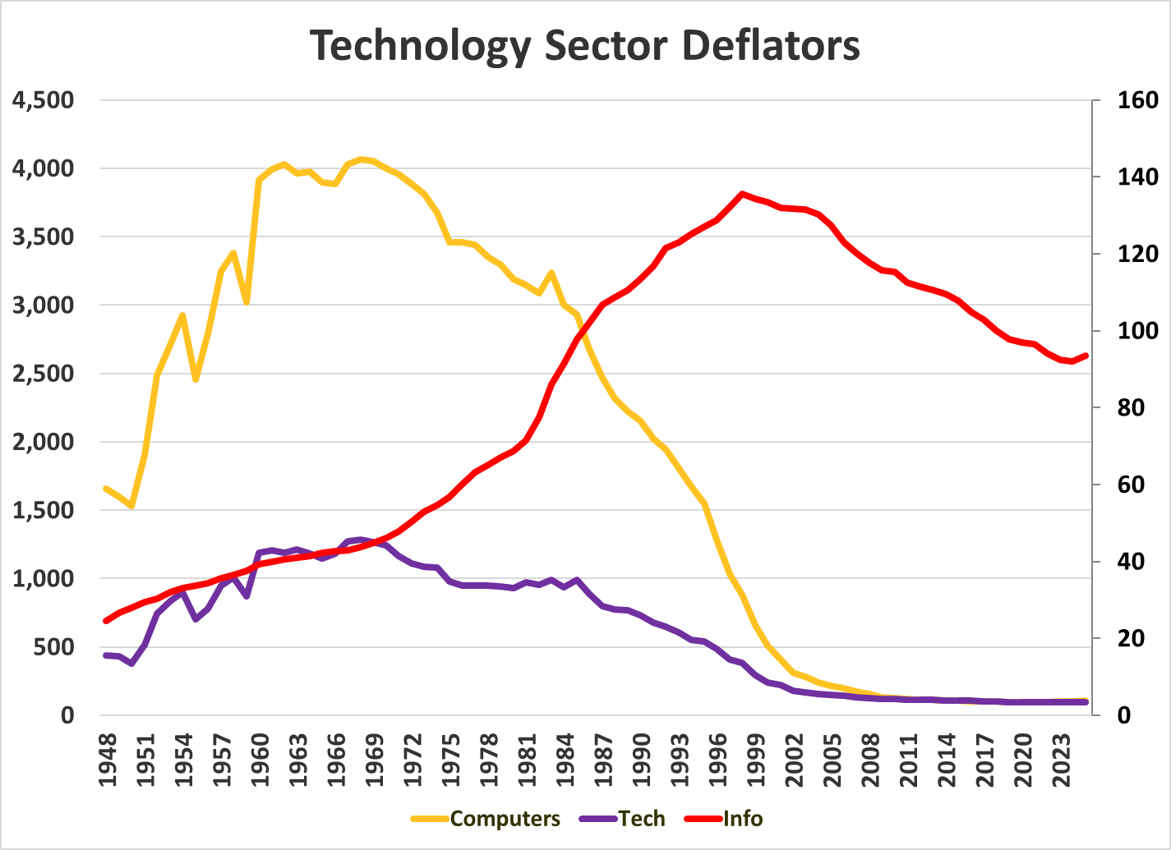
These two charts on price deflators for the technology industry provide additional context on the value of the technology sector. Over the same time period that we have seen significant real positive growth in GDP, we see significant negative growth in the price level, with the greatest decreases shown between 1996 and 2001, corresponding with the prior mentions to the Telecommunications act of 1996.

Descriptive Statistics
(Figure 6: Descriptive Statistics for GDP_Tech$ Growth)
The histogram illustrates the distribution of annual GDP growth rates in the U.S. technology sector from 1947 to 2024 (range on the table shows 1925-2029, but the real range is 1947-2024), showcasing a relatively stable and symmetric pattern of fluctuations. The mean (5.57%) and median (5.7%) are nearly identical, suggesting a balanced distribution with no substantial skew. The standard deviation (3.37%) indicates moderate dispersion, while the maximum (13.56%) and minimum (−1.72%) highlight the sector's upper-bound dynamism and limited downside volatility. With skewness of 0.214 and kurtosis of 2.86, the distribution is close to normal, lacking fat tails or pronounced asymmetry. The Jarque-Bera statistic (0.657) with a p-value of 0.72 fails to reject the null of normality, reinforcing the impression of a relatively well-behaved distribution.

Stochastic Properties
(Figure 7 and 8: GDP_Tech$ - Correlogram Comparison)
(No Transformation) (First Difference of Natural Log)
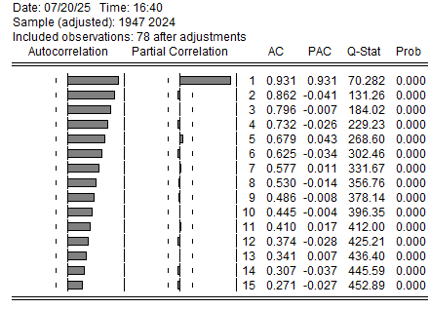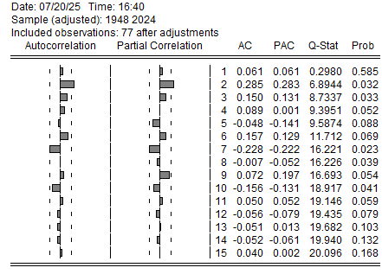

(Table 3: Unit Root Testing on GDP_Tech$)
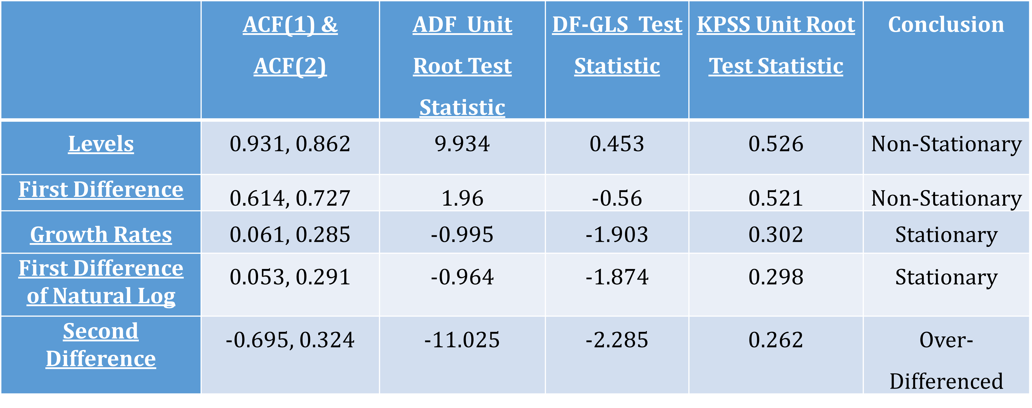
There is consistent evidence of non-stationarity in the level form and the first differenced form of the series across all tests. Both the growth rates and the first difference and of the natural logs provide evidence in favor of stationarity, where the ADF unit root test shows non-stationarity for both series whereas DF-GLS and KPSS provide evidence of stationarity. Notably, attempts to second difference the series led to over-differencing, as evidenced by a pronounced and negative first-lag autocorrelation, suggesting the introduction of artificial dynamics not present in the original process.

(Figure 9: Residual Shocks on First Differenced Natural Log of GDP_Tech$)
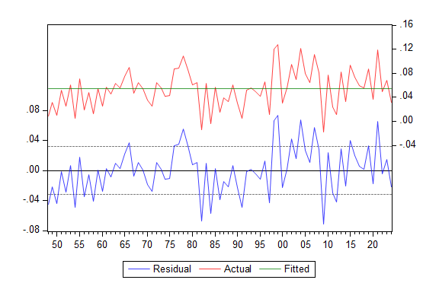
(Table 4: Top 5 Shocks for First Differenced Natural Log of GDP_Tech$)
Year | Shock
1999 | 2.308364
2009 | -2.23318
2004 | 2.121298
1982 | -2.11089
1998 | 2.097265
The residual chart demonstrates that the prewhitening fits the data well, with residuals oscillating closely around zero and no signs of persistent deviation or clustering. The size and pattern of the residuals suggest that there are no significant outliers or notable shocks impacting the series over the sample period. Examining the largest estimated shock sizes, none exceed the threshold typically considered exceptional within this context. All values, while fluctuating slightly, remain within a plausible and expected range, further supporting the stability of the model. Additionally, the Augmented Dickey-Fuller (ADF) test applied to the residuals yields a highly significant t-statistic of -8.30, comfortably rejecting the null hypothesis of a unit root. This outcome conclusively indicates that the pre-whitening renders the series stationary, reinforcing the absence of any notable structural breaks or shocks in the data.
In preparation for modelling, I went further to check the specific components for their stochastic properties. Below are the results:

(Table 5: Component Stochastic Properties and Shocks)
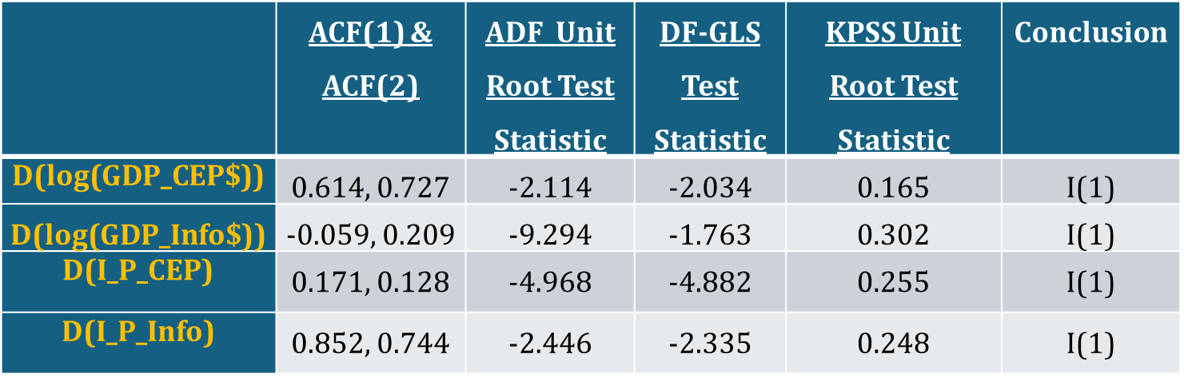
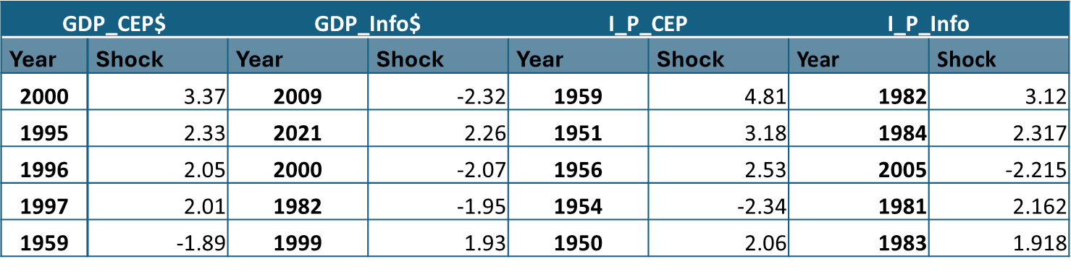
The four stochastic properties I examined are GDP_CEP$, GDP_Info$, I_P_CEP, and I_P_Info. I found that each series is I(1), with GDP_CEP$ and GDP_Info$ requiring logarithmic transformation. In terms of shocks, GDP_CEP$ exhibited a significant shock in the year 2000, consistent with the dotcom bubble, while GDP_Info$ showed no significant shocks. I_P_CEP appeared to have shocks, but they all occurred at the beginning of the series, so I deemed modeling them unnecessary. I_P_Info also exhibited a shock early in the series, but because it was fairly old, I did not model it explicitly.

Structural Regressions
This analysis employs a set of structural regressions to explore the drivers of key economic indicators, focusing on both output and price measures. The regressions include GDP_Info$, which examines the impact of information-related variables on real GDP; GDP_CEP$, which assesses the effects of CEP factors on GDP; I_P_Info, which investigates the relationship between information-driven variables and the industry price deflator; I_P_CEP, which captures the influence of CEP components on the industry price deflator; and a tautological regression for I_P_Tech, used here as a reference benchmark for the industry price deflator and technological variables. By structuring the analysis around these models, we provide a clear framework for understanding the interplay between information, policy, and industry prices within the macroeconomic environment. The following sections have detailed associated regression statistics.
Based on two key factors, the theory of the production function, and the stochastic property analysis in the Data Section, my production function estimation strategy is to use FMOLS for the GDP structural regressions.

GDP_CEP$
$\text{ln}\left(\frac{{\text{GDP_CEP\$}}_{t}}{{\text{L_CEP}}_{t}}\right)=α_{0}+α_{1}\text{ln}\left(\frac{{\text{K_IndEq\$}}_{t}}{{\text{L_CEP}}_{t}}\right)+α_{2}\text{ln}\left(\frac{{\text{Hk\$}}_{t}}{{\text{L_CEP}}_{t}}\right)+α_{3}\text{ln}\left(\frac{{\text{RND\$}}_{t}}{{\text{Pk}}_{t-5}}\right)+α_{4}\text{ITV_CEP}+ϵ_{t}$ (1)
Coefficients: | 0.36 | 1.44 | 0.83 | 0.26
T-Statistics: | 1.70 | 4.19 | 3.65 | 2.74

Estimation Technique | Fully Modified Least Squares (FMOLS)
Data Frequency | Annual
Estimation Range | 1953 to 2024 (72 Observations)
Net D.F. | 67 (i.e. 72-5)
Residual Unit Root Test | -4.396 -> Stationary at 10% Significance
Residual ACF(1) | 0.560
Seasonal Dummies | N/A
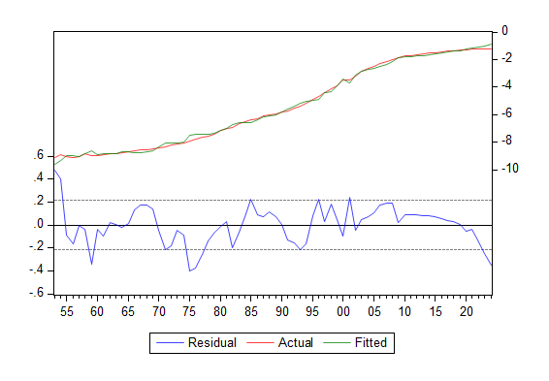
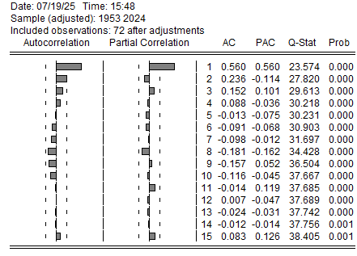

GDP_Info$
$\text{ln}\left(\frac{{\text{GDP_Info\$}}_{t}}{{\text{L_Info}}_{t-3}}\right)=α_{0}+α_{1}\text{ln}\left(\frac{{\text{K_Info\$}}_{t-5}}{{\text{L_Info}}_{t-3}}\right)+α_{2}\text{ln}\left(\frac{{\text{Pk\$}}_{t-2}}{{\text{L_Info}}_{t-3}}\right)+ℇ_{t}$ (2)
Coefficients: | 0.18 | 1.16
T-Statistics: | 31.61 | 36.12

Estimation Technique | Fully Modified Least Squares (FMOLS)
Data Frequency | Annual
Estimation Range | 1957 to 2024 (68 Observations)
Net D.F. | 65 (i.e. 68-3)
Residual Unit Root Test | -3.299 -> Stationary at 15% Significance
Residual ACF(1) | 0.844
Seasonal Dummies | N/A
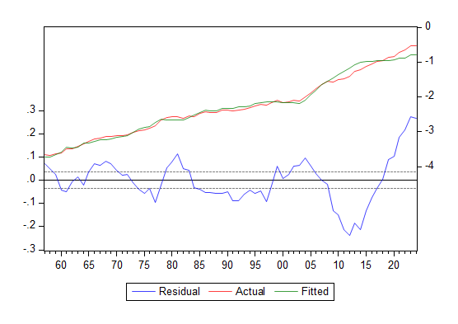
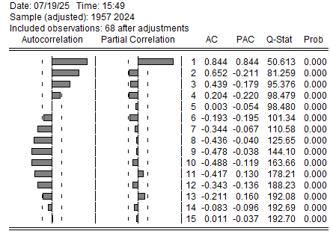

I_P_CEP
$Δ\ln\left(\frac{\text{I_P_CEP}}{\text{RND\$}}\right)=α_{0}+α_{1}Δ\ln\left({\text{MFP}}_{t-3}\right)+α_{2}Δ\ln\left({\text{PatGrant}}_{t}\right)+α_{3}Δ\ln\left({\text{K_IP\$}}_{t-2}\right)+α_{4}Δ\ln\left({\text{RND}}_{t-4}\right)+η_{t}$ (3)
Coefficients: | -1.13 | -0.24 | -0.68 | -0.51
T-Statistics: | -1.77 | -2.06 | -3.39 | -2.80

Estimation Technique | Ordinary Least Squares (OLS)
Data Frequency | Annual
Estimation Range | 1956 to 2024 (69 Observations)
Net D.F. | 64 (i.e. 69-5)
Residual Unit Root Test | N/A
Residual ACF(1) | 0.421
Seasonal Dummies | N/A
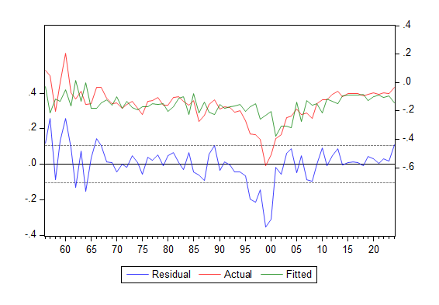
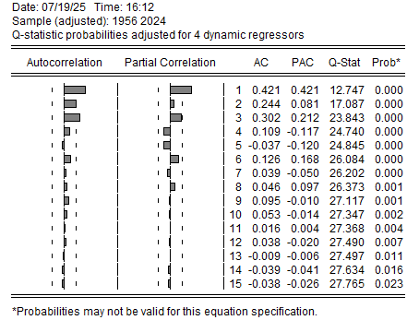
I_P_Info
$Δ\ln\left(\frac{\text{I_P_Info}}{\text{RND\$}}\right)=α_{0}+α_{1}Δ\ln\left({\text{MFP}}_{t-3}\right)+α_{2}Δ\ln\left({\text{PatGrant}}_{t-3}\right)+α_{3}Δ\ln\left({\text{K_IP\$}}_{t-2}\right)+α_{4}Δ\ln\left({\text{RND}}_{t-4}\right)+μ_{t}$ (4)
Coefficients: | -0.77 |  | -0.14 | -0.19 | -0.16
T-Statistics: | -1.93 |  | -1.93 | -1.71 | -2.23
Estimation Technique |  | Ordinary Least Squares (OLS)
Data Frequency |  | Annual
Estimation Range |  | 1956 to 2024 (69 Observations)
Net D.F. |  | 64 (i.e. 69-5)
Residual Unit Root Test |  | N/A
Residual ACF(1) |  | 0.067
Seasonal Dummies |  | N/A
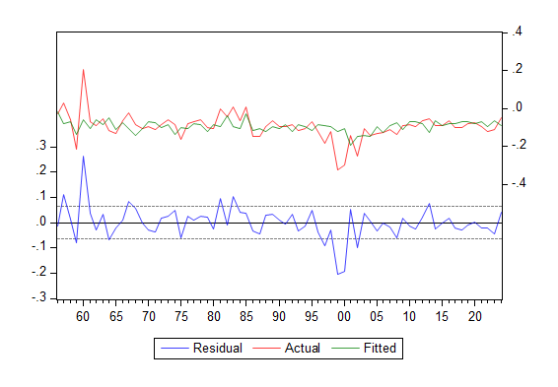
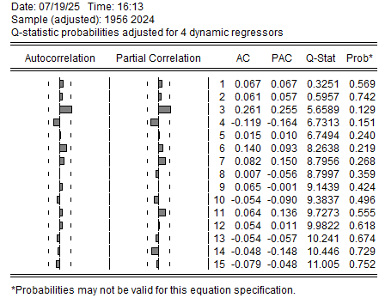
I_P_Tech
${\text{I_P_Tech}}_{t}=α_{0}+α_{1}{\text{I_P_CEP}}_{t}+α_{2}{\text{I_P_Info}}_{t-1}+ϕ_{t}$ (5)
Coefficients: | 1.19 | 0.30
T-Statistics: | 31.23 | 4.96

Estimation Technique | Ordinary Least Squares (OLS)
Data Frequency | Annual
Estimation Range | 1948 to 2024 (77 Observations)
Net D.F. | 74 (i.e. 77-3)
Residual Unit Root Test | N/A
Residual ACF(1) | 0.717
Seasonal Dummies | N/A
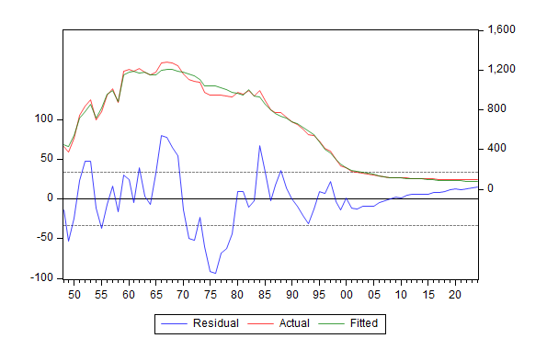
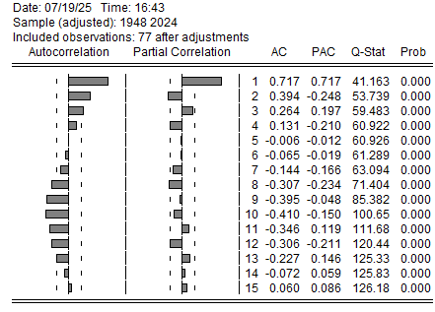

GDP_CEP$ Regression Respecification Challenges
Specifying the GDP_CEP$ regression presented a range of methodological challenges shaped by both theoretical demands and empirical constraints. Because production function theory requires the equation to be estimated in levels, difference-based methods were ruled out, leaving FMOLS as the only suitable estimator. This theoretical rigidity significantly constrained the specification process. A central difficulty was achieving cointegration significance: many seemingly plausible combinations of variables and lag structures failed to yield a cointegrated relationship, undermining statistical support for models that were otherwise grounded in sound economic reasoning.
Compounding these issues were instabilities in coefficient signs, which frequently shifted depending on the lag specification and variable selection. This was especially true for K_IndEq$, whose estimated effect often flipped direction across specifications. In some cases, even variable sets with strong theoretical backing failed to reach cointegration significance under any lag configuration. Conversely, other specifications produced statistically significant models but with coefficients that defied economic logic—for instance, signs opposite of those predicted by theory.
A particularly critical empirical constraint concerned the coefficient for capital investment, which is widely supported in the literature to fall between 0.2 and 0.4. Yet, several runs produced estimates well outside this range, rendering the models implausible and requiring their rejection or respecification.
Ultimately, these challenges highlight the difficult balance between maintaining theoretical coherence and achieving empirical adequacy. The requirement to estimate the model in levels, though theoretically justified, frequently conflicted with the practical realities of macroeconomic data, which seldom provided consistent or theoretically plausible results. This experience not only underscores the importance of rigorous model testing and respecification, but also suggests that methodological compromises or alternative econometric strategies may at times be necessary to reconcile theory with data when employing structural regressions in this context.
A key breakthrough in making not just GDP_CEP$, but all of the regressions feasible, was the development and implementation of a mass respecification method in code. By manually curating a relevant set of variables and then automating the process of running every possible combination of lags from 0 to 5, this approach allowed for comprehensive exploration of the model space. For each specification, the code systematically saved vital outputs—including the cointegration statistic using ADF unit root tests on residuals, individual coefficient t-statistics, the coefficients themselves, and the exact lag configuration employed. This automation transformed what would have been an overwhelming manual task into an efficient and transparent process, enabling quick identification of specifications that were both statistically robust and theoretically sound. Ultimately, this methodological innovation proved crucial in overcoming the empirical obstacles encountered during model development, facilitating the discovery of viable regressions across the entire analysis.

GDP_CEP$ Robustness Checks
As a robustness check for the GDP_CEP$ production function, I estimated an alternative specification using the translog method. As previously discussed, the translog function expands the standard Cobb-Douglas form by including interaction terms and squared terms for each input, allowing for more flexible substitution patterns and varying returns to scale. This approach enabled me to assess whether the results obtained under the Cobb-Douglas assumption were sensitive to the functional form, providing additional confidence in the robustness of the production function estimates.
Using a translog production function presents several challenges. Because it includes both interaction terms and squared terms for all inputs, the number of parameters increases rapidly, which can lead to estimation complexity and potential multicollinearity among regressors. The interpretation of individual coefficients becomes less straightforward compared to simpler forms like Cobb-Douglas, making it harder to draw clear conclusions about input elasticities. Additionally, the translog requires a relatively large dataset to achieve reliable estimates, and the flexibility of the functional form can sometimes lead to overfitting, especially in small samples or when data quality is uneven.
On top of the translog robustness check, I also ran specifications using input prices. Of which, P_Oil was the only variable that I found to meet cointegration and be significant with the correct sign. I still suspect that P_Semi would be significant, but using that data series consistently caused program crashes.
GDP_CEP$ Translog
$$\text{ln}\left(\frac{{\text{GDP_CEP\$}}_{t}}{{\text{L_CEP}}_{t}}\right)=α_{0}+α_{1}\text{ln}\left(\frac{{\text{K_IndEq\$}}_{t}}{{\text{L_CEP}}_{t}}\right)+α_{2}\text{ln}\left(\frac{{\text{Hk\$}}_{t}}{{\text{L_CEP}}_{t}}\right)+α_{3}\text{ln}\left(\frac{{\text{RND\$}}_{t}}{\text{Pk\$}}\right)+β_{1}\text{ln}{\left(\frac{{\text{RND\$}}_{t}}{\text{Pk\$}}\right)}^{2}+$$
Coefficients: | 55.22 | -3.83 | -50.89 | 0.26
T-Statistics: | 7.30 | -7.07 | -7.41 | 4.28
$γ_{1}\ln\left(\frac{{\text{K_IndEq\$}}_{t}}{\text{L_CEP}}\right)*\ln\left(\frac{\text{Hk}}{\text{L_CEP}}\right)+γ_{2}\ln\left(\frac{{\text{K_IndEq\$}}_{t}}{\text{L_CEP}}\right)*\ln\left(\frac{\text{RND\$}}{\text{L_CEP}}\right)+γ_{3}\ln\left(\frac{\text{Hk}}{\text{L_CEP}}\right)*\ln\left(\frac{\text{RND\$}}{\text{L_CEP}}\right)+ϵ_{t}$ (6)
 | 8.89 |  | -0.28 | -8.38
 | 7.09 |  | -7.45 | -7.82
Estimation Technique |  | Fully Modified Least Squares (FMOLS)
Data Frequency |  | Annual
Estimation Range |  | 1952 to 2024 (73 Observations)
Net D.F. |  | 67 (i.e. 72-5)
Residual Unit Root Test |  | -5.02 -> Stationary at 10% Significance
Residual ACF(1) |  | 0.444
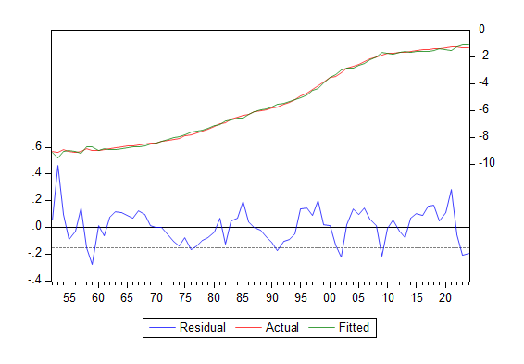
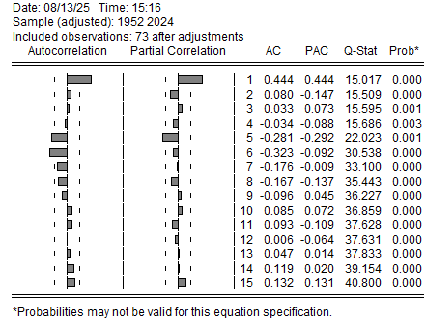
GDP_CEP$ Input Price Testing
$\text{ln}\left(\frac{{\text{GDP_CEP\$}}_{t}}{{\text{L_CEP}}_{t-1}}\right)=α_{0}+α_{1}\text{ln}\left(\frac{{\text{K_IndEq\$}}_{t-1}}{{\text{L_CEP}}_{t-1}}\right)+α_{2}\text{ln}\left(\frac{{\text{Hk\$}}_{t}}{{\text{L_CEP}}_{t-1}}\right)+α_{3}\text{ln}\left(\frac{{\text{RnD\$}}_{t-1}}{{\text{Pk\$}}_{t-1}}\right)+α_{4}\ln\left(\text{P_Oil}\right)+ϵ_{t}$ (7)
Coefficients: | 0.51 |  | 0.64 | 0.84 | -0.12
T-Statistics: | 2.62 |  | 2.19 | 4.57 | -2.47
Estimation Technique |  | Fully Modified Least Squares (FMOLS)
Data Frequency |  | Annual
Estimation Range |  | 1952 to 2024 (72 Observations)
Net D.F. |  | 67 (i.e. 72-5)
Residual Unit Root Test |  | -3.92 -> Stationary at 15% Significance
Residual ACF(1) |  | 0.721
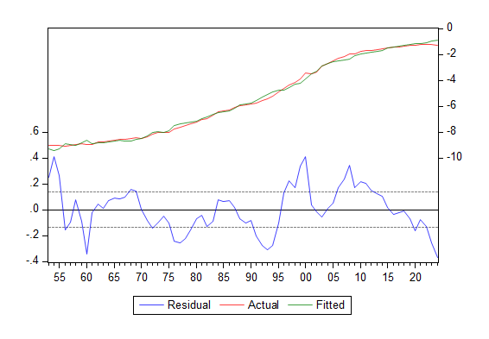
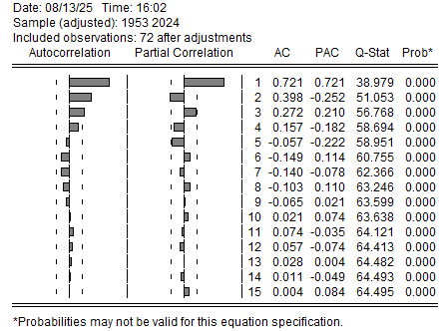

Functional Form
This section outlines the general functional forms and associated causal logic associated with each regression. The effects are different for each type of regression so the section will be split into output, deflators, the tautology for total technology price deflator, and then the price variables for robustness checks.
GDP Regressions
$\text{GDP_CEP\$}=f\left(\text{K_IndEq\$}, \text{L_CEP}, \text{Hk}, \text{RnD\$}, \text{Pk\$}\right)+ϵ_{t}$ (8)
(+) | (+) | (+) | (+) | (+)
$\text{GDP_Info}\text{\$}=f\left(\text{K_Info\$}, \text{L_Info}, \text{Pk\$}\right)+ℇ_{t}$ (9)
(+) | (+) | (+)

Real Private Capital Investment (K_Info$, K_IndEq$) – An increase in real private capital investment enhances the economy’s productive capacity by providing more physical assets in the form of more or better machinery, buildings, etc, for production, which boosts output capacity and efficiency, thus increasing output.
Private Labor (L_Info, L_CEP) - An increase in private labor for information, measured as the number of workers in the industry, directly expands the workforce engaged in producing and managing information goods and services. This growth in labor input supports higher production capacity and operational scale within the sector, thereby contributing to greater overall economic output and, consequently, increasing output.
Human Capital (Hk) – An increase in human capital, which is a measure of education, skill, and experience in the workforce, allows for workers to contribute more value to their organization through improved and more sophisticated ways of aiding production, leading to increased output.
Research and Development (RnD$) - An increase in R&D investment leads to greater innovation and technological advancements, which enhance production efficiency across all inputs and production processes and drive long-term economic growth, thus leading to long-term increased output.
Real Public Capital Investment (Pk$) - An increase in public capital investment, such as infrastructure and transportation, enables firms to more efficiently receive intermediate goods or output final products, thus increasing output.

Deflator Regressions
$\text{I_P_CEP}=f\left(\text{MFP}, \text{PatGrant}, \text{K_IP\$}, \text{RnD\$}\right)+η_{t}$ (10)
(-) | (-) | (-) | (-)

$\text{I_P_Info}=f\left(\text{MFP}, \text{PatGrant}, \text{K_IP\$}, \text{RnD\$}\right)+μ_{t}$ (11)
(-) | (-) | (-) | (-)
Multifactor Productivity (MFP) – An increase in multifactor productivity enables an industry to produce more output with the same—or fewer—inputs, effectively reducing marginal costs. As production becomes more efficient and costs decline, firms gain the flexibility to lower their prices in order to remain competitive, or to restrain price increases relative to input costs, thus causing a decrease in industry prices
Patent Grants (PatGrant) – An increase in patent grants reflects a higher rate of innovation within an industry, as each grant was earned in part due to inducing an incentive to innovate, and, is evidence of a novel technological advance; these innovations lead to improved production processes or new products, which reduce costs and thus decrease industry prices over time.
Real Private Capital Investment in Intellectual Property (K_IP$) – An increase in capital investment in intellectual property—such as spending on patents, copyrights, trademarks, or trade secrets—directly raises the stock of intangible assets available to a company or industry. This results in more advanced or unique processes, products, and technology, which enhance production efficiency and foster innovation. As these improvements take hold, firms are able to produce the same output at lower cost or increase output for the same cost, leading to downward pressure on industry prices through greater efficiency and competitive advantage.
Research and Development Investment (RnD$) - An increase in research and development (R&D) investment enhances an industry’s capacity to introduce new technologies, processes, or products, leading to greater production efficiency and innovation. As these advances reduce per-unit costs or enable more effective production, competitive pressures or cost savings are passed on, resulting in lower industry prices over time.

Tautology
$\text{I_P_Tech}=f\left(\text{I_P_Info, I_P_CEP}\right)+ϕ_{t}$ (12)
(+) | (+)
Industry Prices (I_P_Info, I_P_CEP) - An increase in any one of the industry prices, ceteris paribus, mechanically leads to an increase in the aggregate industry price index. By definition, a higher value in any component price—holding others constant—raises the composite index, making this relationship a tautology within price index construction.

Price Factors for Robustness Checks
The following price variables remain for robustness checks:
Price of Oil ($P^{Oil}$) – An increase in the price of oil raises operational and energy costs for technology firms, particularly in manufacturing and data center operations. Additionally, an increase in the price of oil would lead to greater costs for other intermediate goods that flow into the technology sector leading to higher prices of those intermediate goods. Higher intermediate good and energy costs lead to a shift in the production possibilities frontier leading to a decrease in total output.
Price of Semiconductors ($P^{Semi}$) - Because the semiconductor is the critical component for processors, memory, and logic circuits, an increase in the price of semiconductors would make the marginal costs of inputs go up, shifting the production possibilities frontier inward, lowering production capacity and lowering overall output.
Having established the individual functional forms and causal mechanisms for each key regression, the analysis now turns to the description of the full multi-equation modeling framework. This next section details how these equations are integrated, allowing for the joint consideration of sectoral outputs and prices, and providing a richer understanding of dynamic interactions across industries and policy variables.

Multi-Equation Model Description
Having outlined the individual causal pathways and functional forms for each variable, the analysis now progresses toward a system-level perspective that captures the interconnections among key sectoral dynamics. A central component of this integrated framework is the multi-equation model (MEM) flowchart, which serves as a visual representation of the previously specified stochastic regressions developed in the Structural Regressions section. Within the flowchart, triangles denote exogenous variables, circles represent endogenous stochastic components, and squares indicate endogenous identities. This structure clarifies how the model’s components interact—highlighting feedback loops, mutual influences, and dynamic relationships among sectoral outputs, prices, and policy drivers. By linking these elements in a unified framework, the analysis provides a more comprehensive foundation for interpreting the mechanisms at work within the information sector.

(Figure 10: MEM Flowchart)
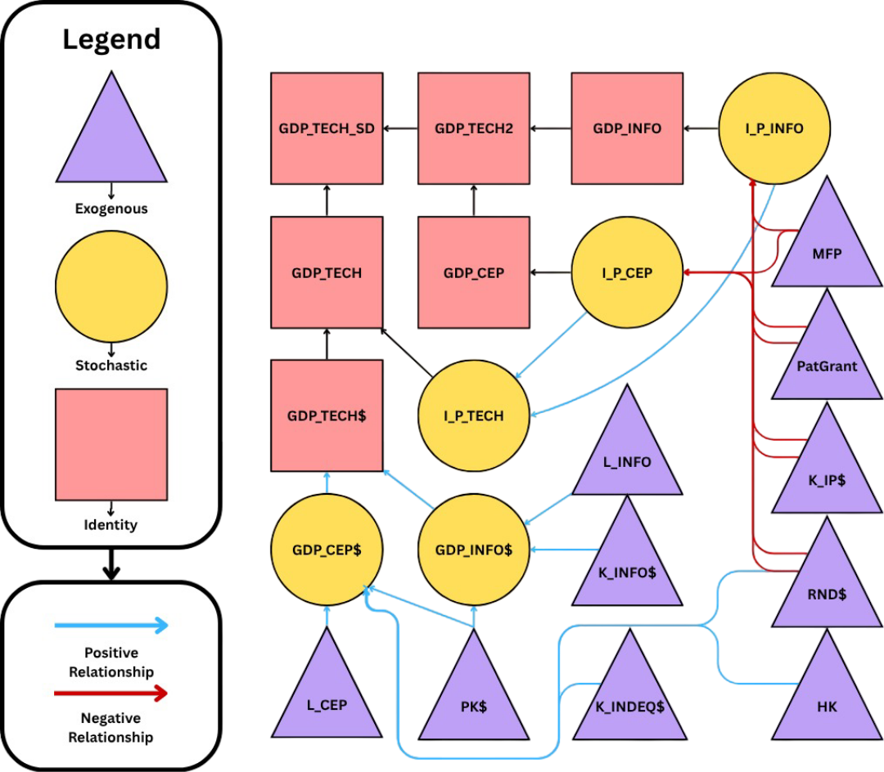
This flowchart is represented mathematically in equations (6) through (12), taking advantage of 5 stochastics (GDP_Info$, GDP_CEP$, I_P_Info, I_P_CEP, and I_P_Tech) and 6 identities, taking 2 approaches to reflating GDP_Tech$. First, adding the real components together and then reflating them using the tautology for I_P_Tech. The second, reflating the components first then adding those together to get the nominal value. The difference between the two methods is then found as the statistical discrepancy.
$\text{GDP_CEP\$}=f\left(\text{K_IndEq\$}, \text{L_CEP}, \text{Hk}, \text{RnD\$}, \text{Pk\$}\right)+ϵ_{t}$ (8)
$\text{GDP_Info}\text{\$}=f\left(\text{K_Info\$}, \text{L_Info}, \text{Pk\$}\right)+ℇ_{t}$ (9)
$\text{I_P_CEP}=f\left(\text{MFP}, \text{PatGrant}, \text{K_IP\$}, \text{RnD\$}\right)+η_{t}$ (10)
$\text{I_P_Info}=f\left(\text{MFP}, \text{PatGrant}, \text{K_IP\$}, \text{RnD\$}\right)+μ_{t}$ (11)
$\text{I_P_Tech}=f\left(\text{I_P_Info, I_P_CEP}\right)+ϕ_{t}$ (12)
$\text{GDP_Tech}\text{\$}=\text{GDP_CEP\$}+\text{GDP_Info\$}$ (13)
$\text{GDP_Tech}=\text{GDP_Tech\$}*\left(\frac{\text{I_P_Tech}}{100}\right)$ (14)
$\text{GDP_Info}=\text{GDP_Info\$}*\left(\frac{\text{I_P_Info}}{100}\right)$ (15)
$\text{GDP_CEP}=\text{GDP_CEP\$}*\left(\frac{\text{I_P_CEP}}{100}\right)$ (16)
$\text{GDP_Tech2}=\text{GDP_Info}+\text{GDP_CEP}$ (17)
$\text{GDP_Tech_SD}=\text{GDP_Tech}-\text{GDP_Tech2}$ (18)

This framework lays the foundation for dynamic simulation and forecasting by capturing the interdependent behavior of key sectoral variables. With the structure of causal relationships and feedback effects now established, the model is equipped to generate forward-looking projections under various economic scenarios. The following section applies this framework by employing inertial modeling for the exogenous variables, generating forecasts in support of the stochastic equations.

Exogenous Forecasts in Support of Baseline Forecasts
This section outlines the forecasting of exogenous variables that underpin the stochastic equations in the broader model. Most exogenous inputs, including price variables robustness checks, were forecasted using ARIMA models. For a subset of variables tied to technological progress, baseline trajectories were constructed using fixed assumptions, serving as neutral reference points for the scenario forecasts that follow. These exogenous forecasts form the critical foundation for simulating the system’s baseline behavior. Below will be first, the ARIMA associated forecast charts then the assumption charts with the detailed baseline assumption set associated. All assumptions were made based on historical 5 year moving averages.

ARIMA Table
(Table 6: ARIMA Specifications)
Variable | Code | Model Notation | Q-Stat @Lag 8
Industrial Equipment Private Capital | K_IndEq$ | ARIMA(4,1,0) | 8.07
Information Private Capital | K_Info$ | ARIMA(1,1,0) | 4.03
Computers and Electronic Products Labor | L_CEP | ARIMA(0,1,0) | 4.99
Information Labor | L_Info | ARIMA(1,1,0) | 5.34
Price of Electric Lamp Bulbs, Tubes, and Components | P_B_T_C | ARIMA(2,1,0) | 4.79
Price of Copper and Brass Mill Shapes | P_Cop_Brass | ARIMA(8,1,0) | 7.64
Price of Copper Products | P_Cop_Prod | ARIMA(8,1,0) | 7.62
Price of Oil | P_Oil | ARIMA(7,1,0) | 1.35
Price of Semiconductors | P_Semi | ARIMA(1,1,0) | 4.32

ARIMA Forecasts
(Figure 11: Inertial Forecast – K_IndEq$) (Figure 12: Inertial Forecast – K_Info$)
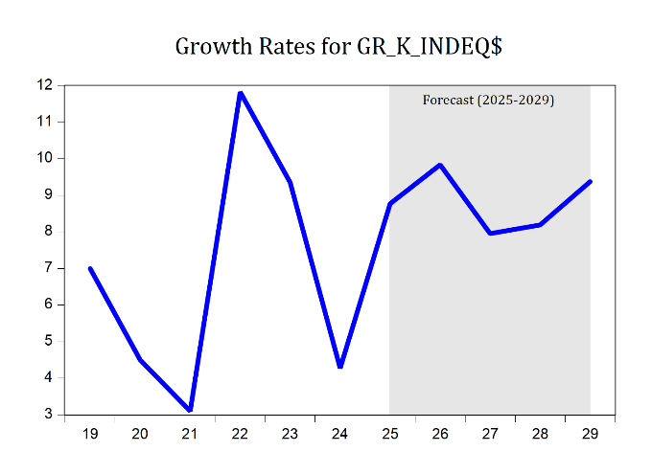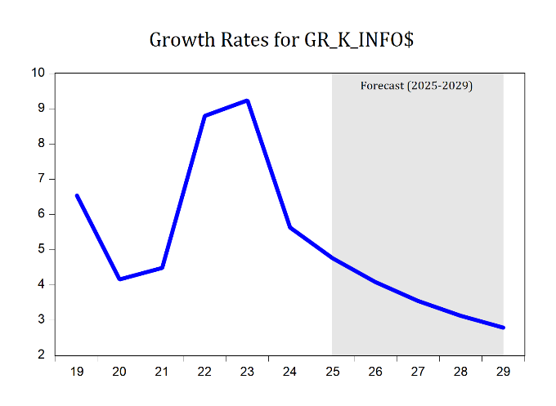
(Figure 13: Inertial Forecast – L_CEP) (Figure 14: Inertial Forecast – L_Info)
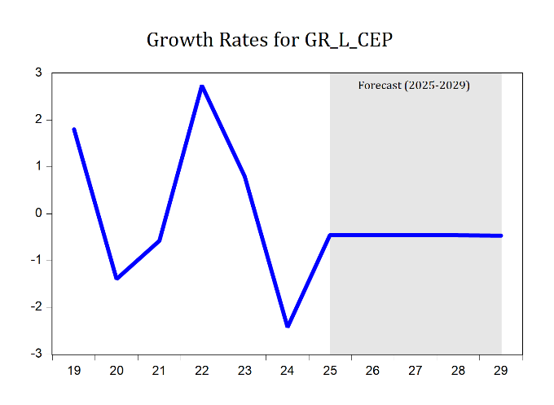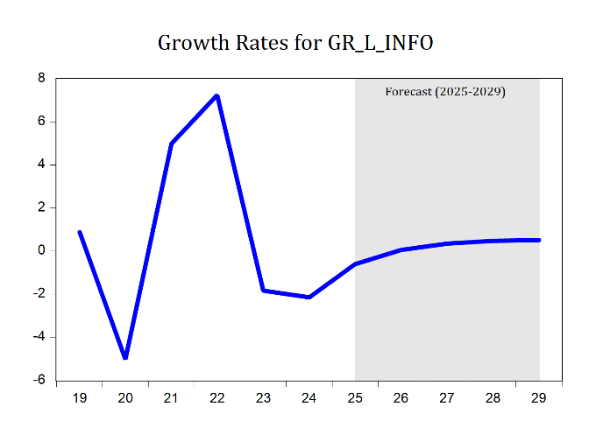
(Figure 15: Inertial Forecast – P_B_T_C) (Figure 16: Inertial Forecast –P_Cop_Brass)
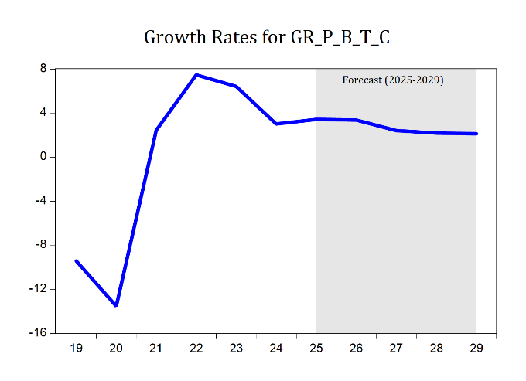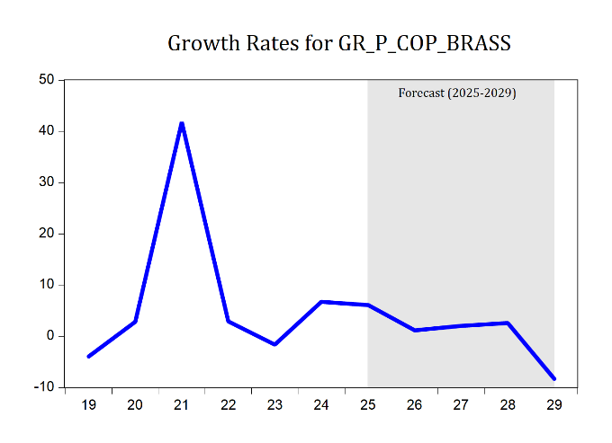
(Figure 17: Inertial Forecast –P_Cop_Prod) (Figure 18: Inertial Forecast – P_Oil)

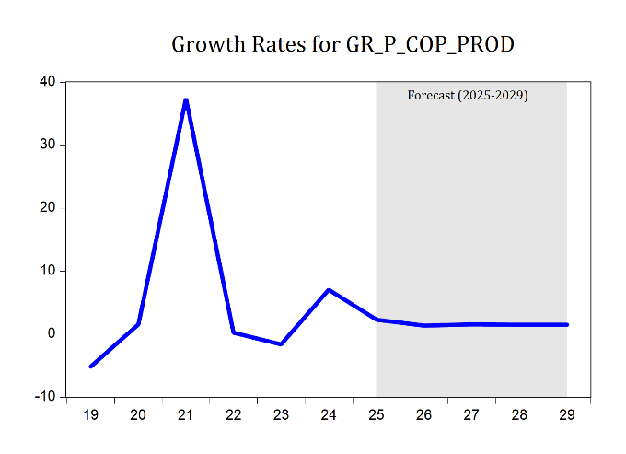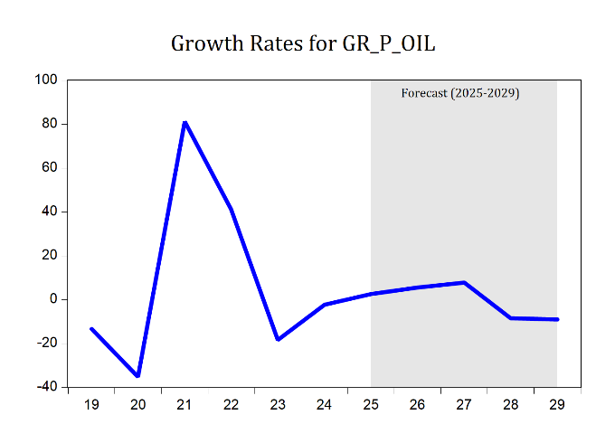

(Figure 18: Inertial Forecast – P_Semi)
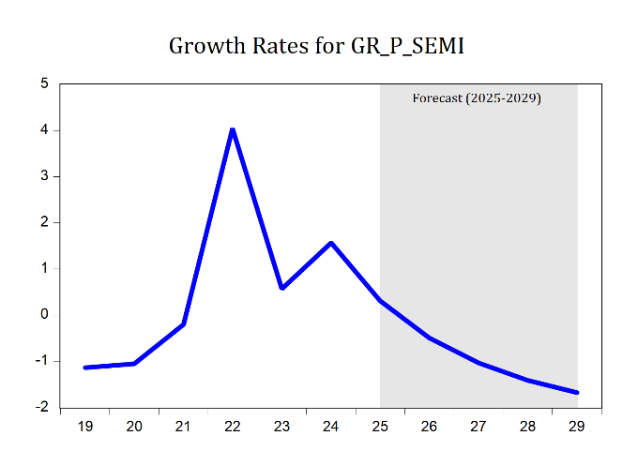
Baseline Assumptions Forecasts
(Figure 19: Assumption Forecast – Pk$)
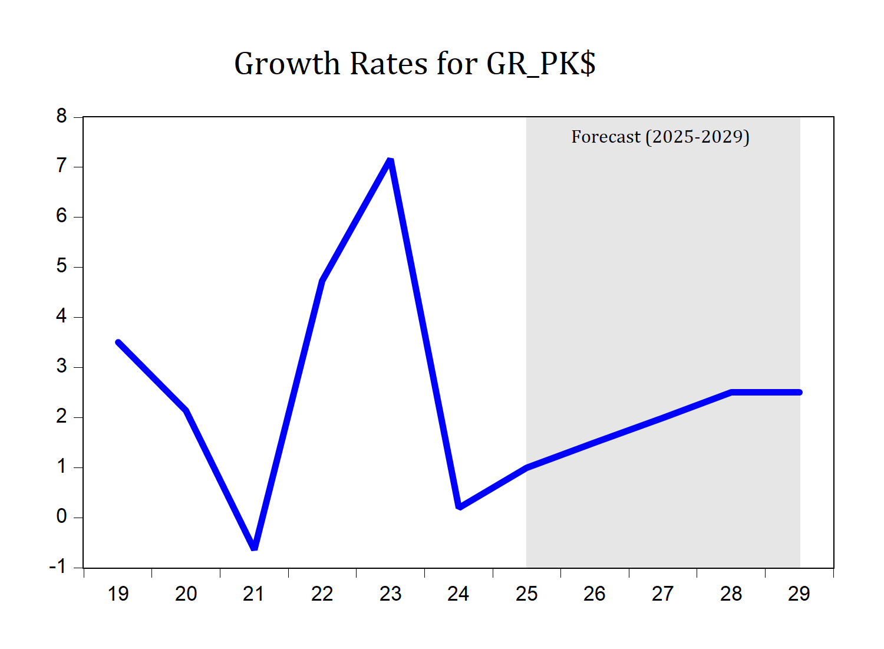
Baseline Assumption: increasing growth rate over 3 years up to 2.5% in 2028 and 2029

(Figure 19: Assumption Forecast – Hk)
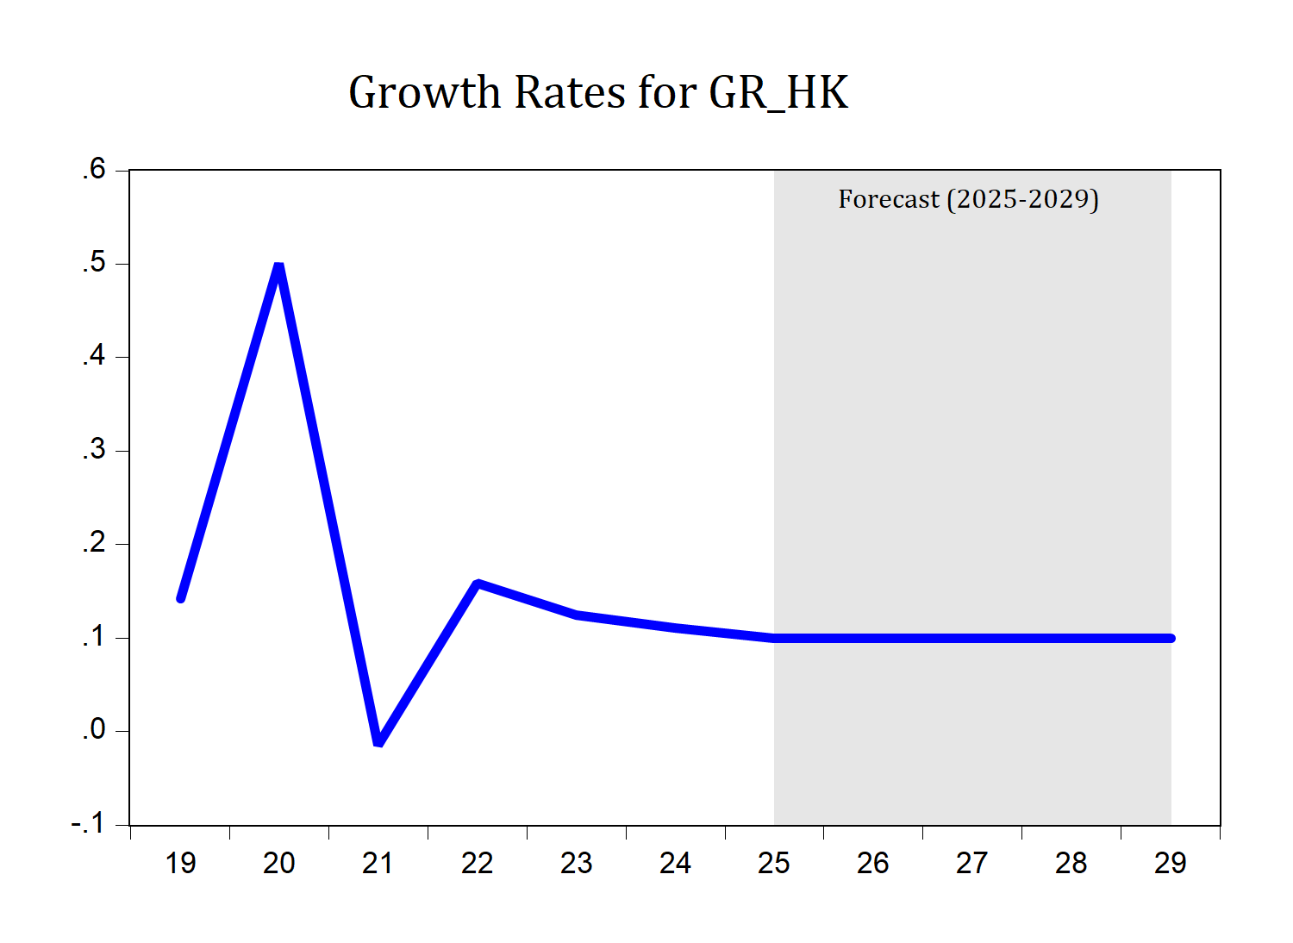

Baseline Assumption: Steady growth of 0.12% across each year of 2025-2029

(Figure 20: Assumption Forecast – RnD$)
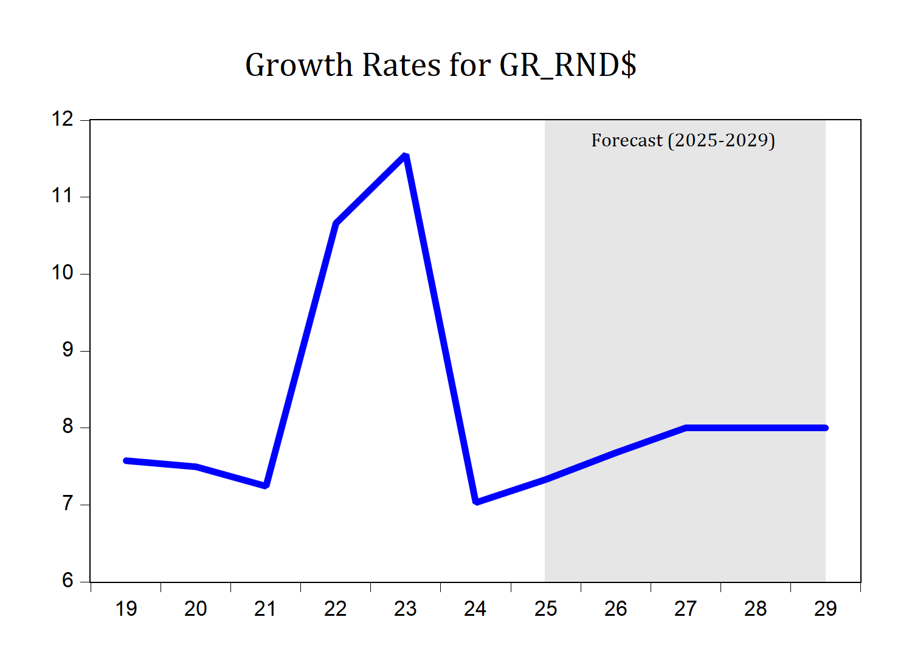
Baseline Assumption: increasing growth rate over 2 years up to 8% in 2027-29

(Figure 21: Assumption Forecast – K_IP$)
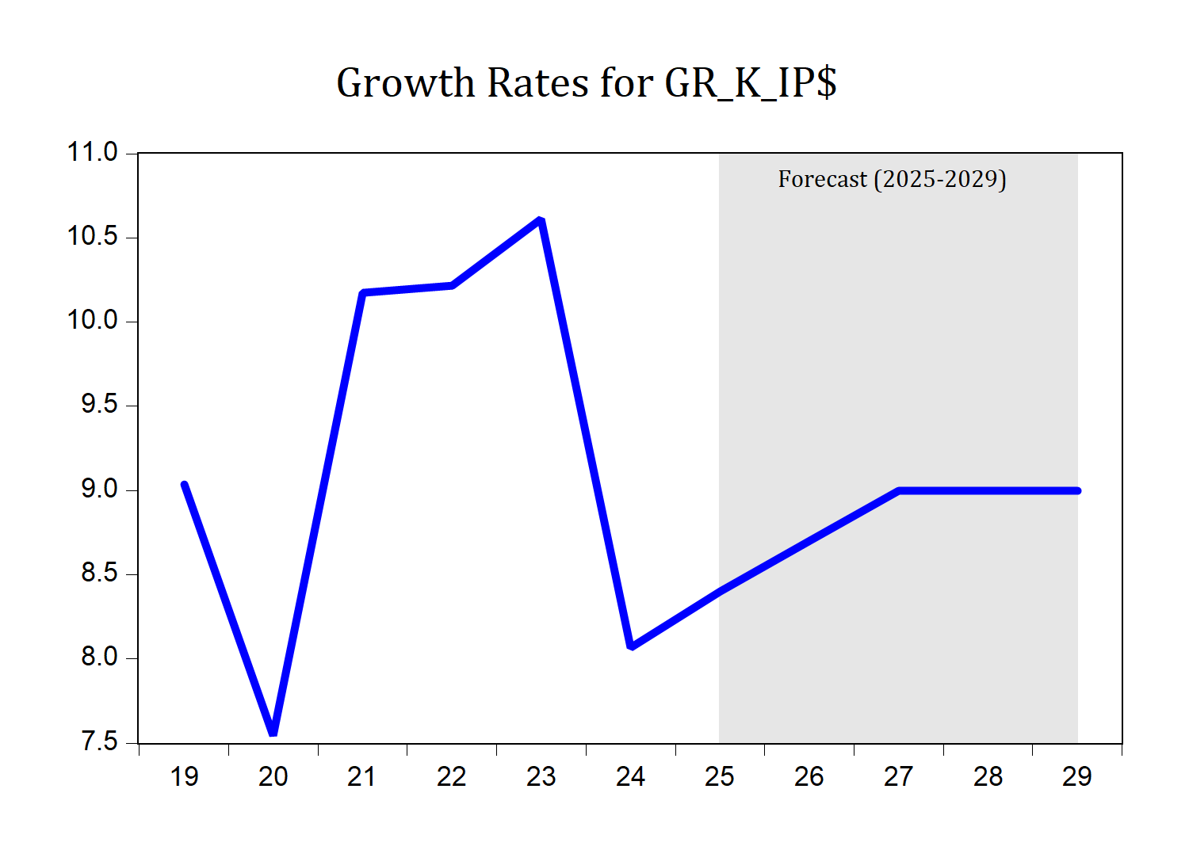
Baseline Assumption: increasing growth rate over 2 years up to 9% in 2027-29

(Figure 22: Assumption Forecast –PatGrant)
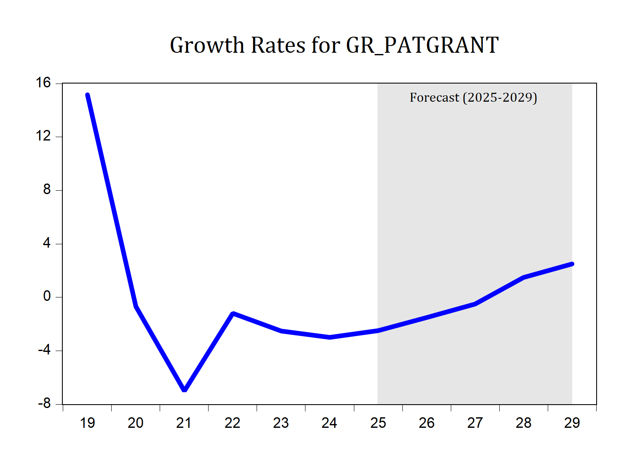
Baseline Assumption: rebound in growth after more years of reduction. -2.5%, -1.5%, -0.5%, 1.5%, 2.5% for forecasted range of 2025-2029

With exogenous inputs now in place, the model is fully specified and ready for forecasting. The next section turns to the multi-equation model’s forecasts, representing the central analytical output of this study.

Multi-Equation Model Structural Forecast
This forecast presents a unified set of out-of-sample projections from our multi-equation model (MEM), displaying the baseline, optimistic, and pessimistic scenarios within a single chartspace. The baseline reflects the most likely trajectory under a continuation of recent trends, with stable structural relationships and balanced assumptions about economic momentum and technological progress. The alternative scenarios bracket this path by adjusting a targeted set of technology-sensitive variables that play a central role in long-run growth dynamics:
- HK (human capital investment),
- K_IP$ (real private capital investment in intellectual property),
- Pk$ (real public capital investment),
- PatGrant (patent grants), and
- RnD$ (real investment in research and development).
The optimistic scenario assumes an acceleration in these inputs, reflecting an environment of heightened innovation and improved absorptive capacity—that is, the economy's ability to effectively incorporate and diffuse new technologies across sectors through a well-trained workforce, modern infrastructure, and supportive institutions. The pessimistic case reflects weaker technological momentum, slower spillovers, and diminished capacity to convert innovation inputs into productivity gains. Other right-hand-side variables were evaluated during scenario development, but their impact on scenario outcomes was limited, reinforcing the central role of technological drivers in shaping growth trajectories within the MEM. Together, these bracketing scenarios illustrate how shifts in innovation intensity propagate through the system, altering the evolution of key dependent variables while preserving the structural coherence of the model.

Exogenous Assumption Forecasts
(Figure 23: Scenario Assumption Forecasting - Hk)
Human Capital Growth Assumptions
Year | Baseline | Optimistic | Pessimistic
2025 | 0.12 | 0.22 | 0.06
2026 | 0.12 | 0.22 | 0.06
2027 | 0.12 | 0.22 | 0.06
2028 | 0.12 | 0.22 | 0.06
2029 | 0.12 | 0.22 | 0.06
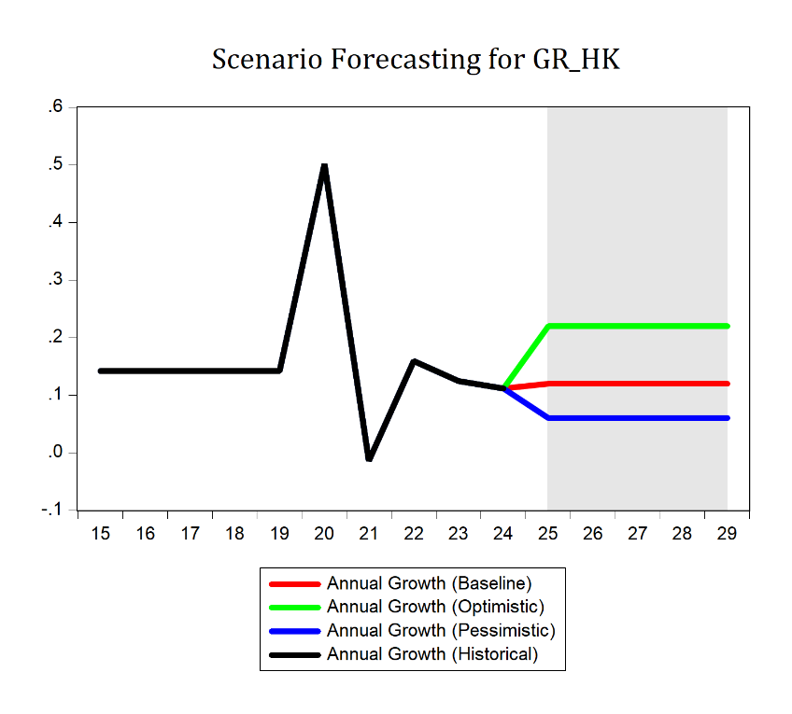

(Figure 24: Scenario Assumption Forecasting – K_IP$)
Intellectual Property Capital Investment
Year | Baseline | Optimistic | Pessimistic
2025 | 8.40 | 9.00 | 8.00
2026 | 8.70 | 10.00 | 6.50
2027 | 9.00 | 11.00 | 4.00
2028 | 9.00 | 12.00 | 2.50
2029 | 9.00 | 14.00 | 1.50
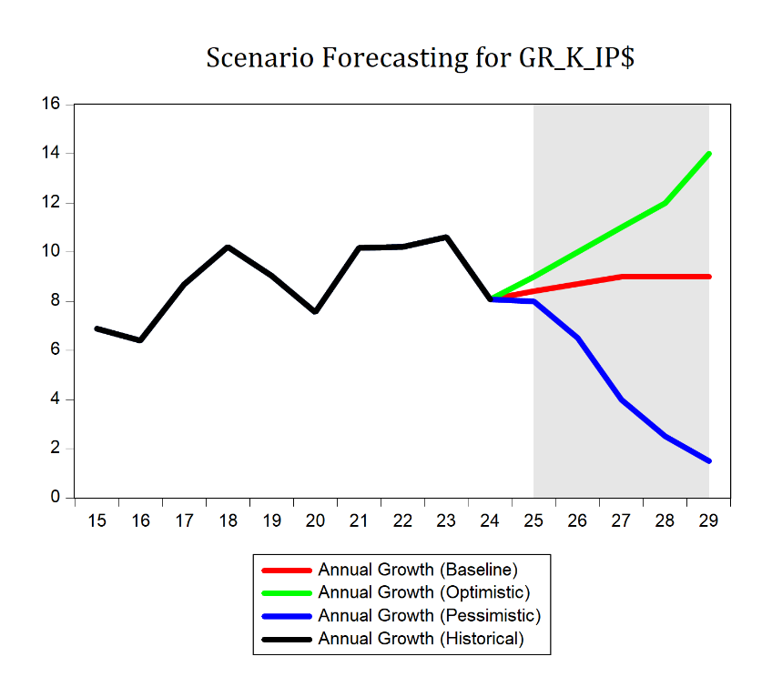

(Figure 25: Scenario Assumption Forecasting - PatGrant)
Patent Grants
Year | Baseline | Optimistic | Pessimistic
2025 | -2.50 | 0.00 | -3.50
2026 | -1.50 | 1.00 | -3.50
2027 | -0.50 | 2.50 | -4.00
2028 | 1.50 | 4.50 | -4.50
2029 | 2.50 | 7.00 | -5.00
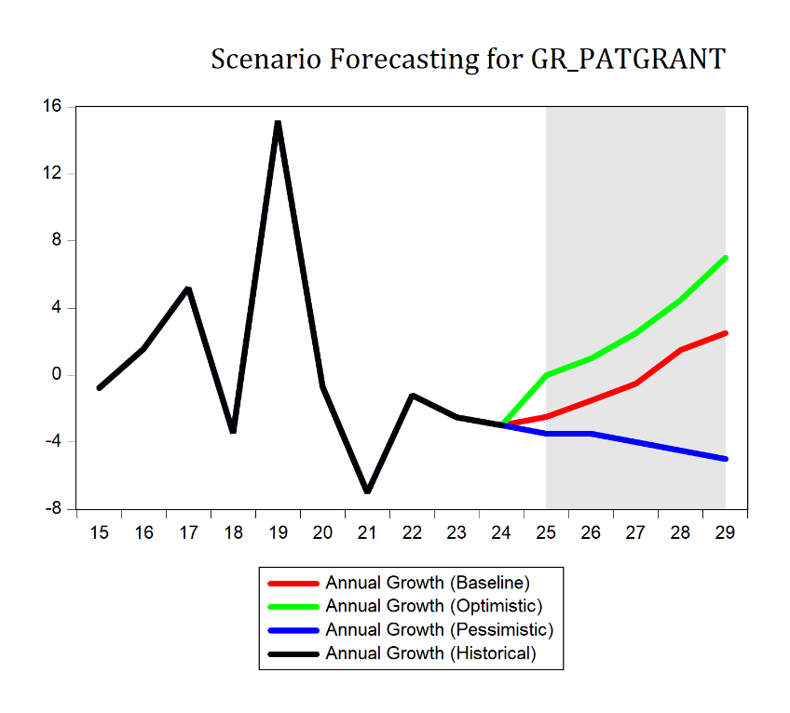

(Figure 26: Scenario Assumption Forecasting – Pk$)
Public Capital Investment
Year | Baseline | Optimistic | Pessimistic
2025 | 1.00 | 2.00 | 0.50
2026 | 1.50 | 3.00 | 0.00
2027 | 2.00 | 4.00 | -0.50
2028 | 2.50 | 4.50 | -1.00
2029 | 2.50 | 5.50 | -1.50
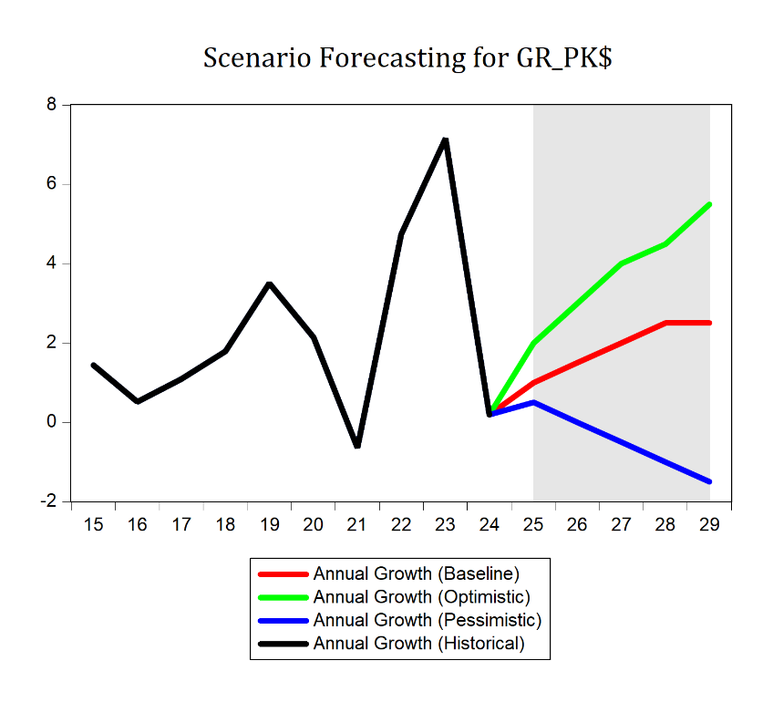

(Figure 27: Scenario Assumption Forecasting – RnD$)
Research and Development Investment
Year | Baseline | Optimistic | Pessimistic
2025 | 7.33 | 9.00 | 6.50
2026 | 7.68 | 10.00 | 5.50
2027 | 8.00 | 11.00 | 4.50
2028 | 8.00 | 12.00 | 3.50
2029 | 8.00 | 14.00 | 2.50
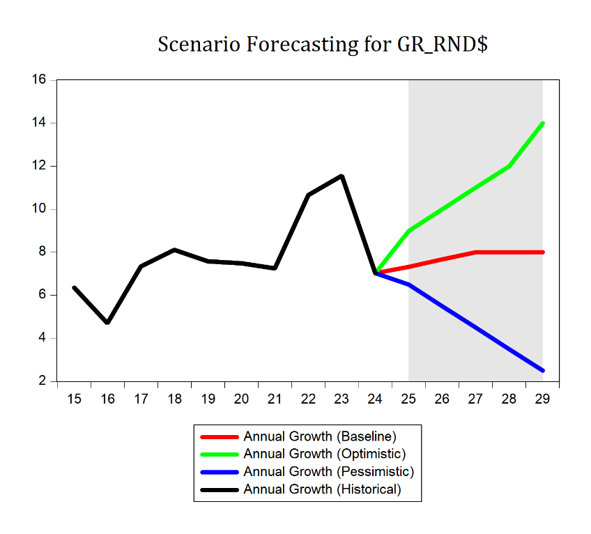
The exogenous forecasts give us a clear starting point for the modeling work that follows. They set the path for key outside drivers so any differences in results come from how the model behaves, not from shifting assumptions. With these in place, we can move on to forecasting the endogenous variables and see how the economy might develop under each scenario.

Multi-Equation Model Forecasts
In this section, the multi-equation model is used to generate scenario forecasts for the key endogenous variables. The exogenous paths developed in the previous section serve as inputs, providing the model with predetermined trajectories for variables outside the system’s feedback loop. By combining these externally specified paths with the estimated relationships among the endogenous variables, the model produces internally consistent forecasts that reflect the different scenarios under consideration.

Gross Domestic Product
(Figure 28 - 30: Scenario Forecasts – GDP_CEP$, GDP_Info$, and GDP_Tech$)
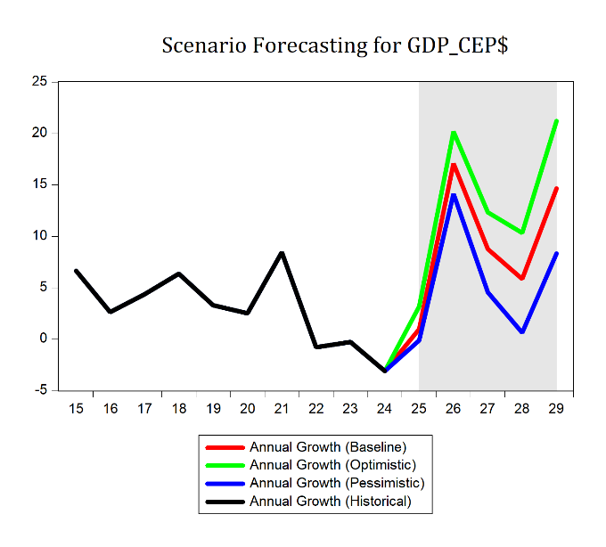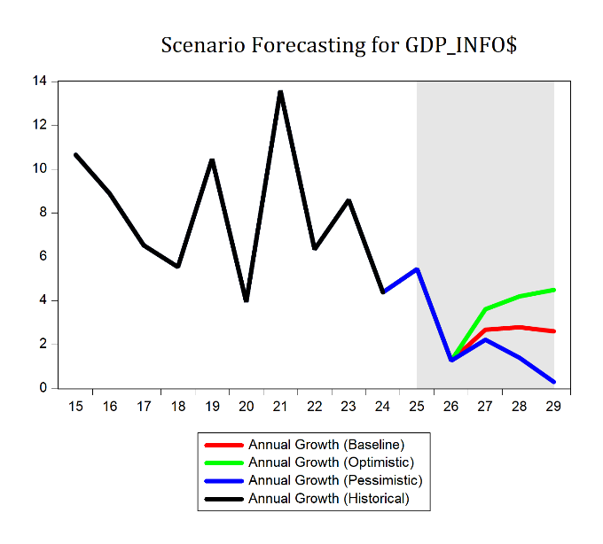
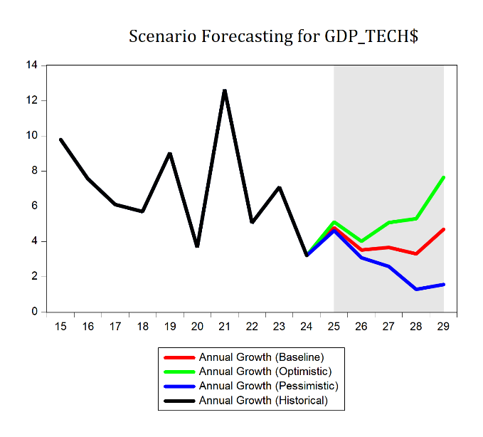
This chart block displays the projected real GDP growth rates for the computer and electronic products (GDP_CEP$), information (GDP_Info$), and combined technology (GDP_Tech$) sectors under the baseline, optimistic, and pessimistic scenarios. All three forecasts are generated within a consistent MEM framework, with GDP_Tech$ constructed as the additive identity of its two components.
GDP_CEP$ exhibits dramatic expansion across all scenarios, particularly under the optimistic case. Growth accelerates rapidly from 2025 onward, reaching a temporary peak of nearly 20% in 2026 before easing slightly and rising again to exceed 21% by 2029. While the baseline and pessimistic cases follow a similar temporal pattern, their growth magnitudes are substantially lower — reflecting the sector’s sensitivity to innovation-driven assumptions.
In contrast, GDP_Info$ shows a much more muted and delayed response to the alternate scenarios. The series remains unified across all three paths through 2026, after which the optimistic case begins to pull away — rising to around 5% growth by 2029. The baseline holds steady near 2.5%, while the pessimistic case trends downward, ending just above zero. This subdued divergence highlights the more structurally inert nature of the information sector in the model, particularly under exogenous shifts in R&D and capital investment.
The forecast for GDP_Tech$ — a weighted blend of the two sectors — captures the dynamics of both components. Historically, GDP_Tech$ has closely tracked GDP_Info$ due to its dominant share in the identity. However, under the forecast horizon, the extraordinary strength in GDP_CEP$ begins to reshape this balance. As a result, GDP_Tech$ starts to diverge across scenarios after 2026, with the optimistic case reaching 8% growth by 2029 and the pessimistic case settling near 2%. Notably, these scenario outcomes were found to be relatively insensitive to small changes in the assumed growth rates of the exogenous drivers, underscoring the robustness of the MEM’s structural propagation.

Industry Prices (Price Deflators)

(Figure 31 - 33: Scenario Forecasts – I_P_CEP, I_P_Info, and I_P_Tech)
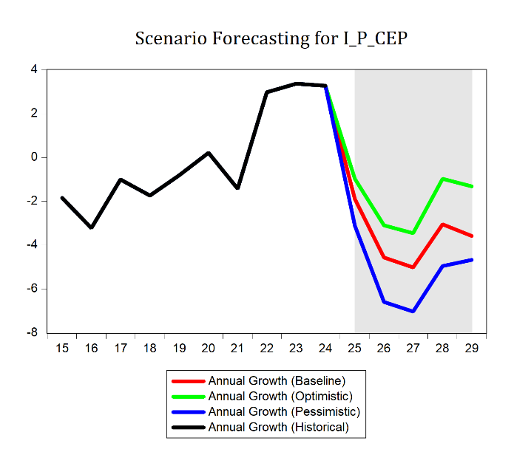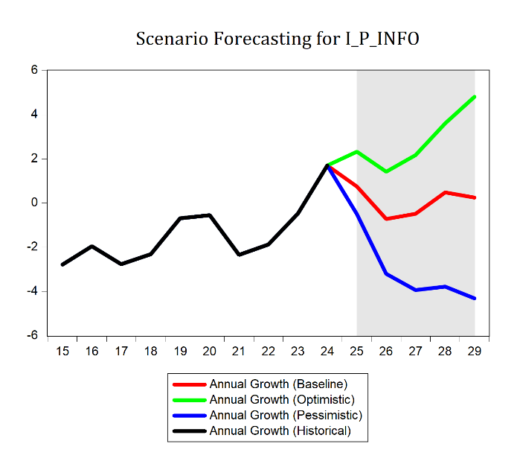
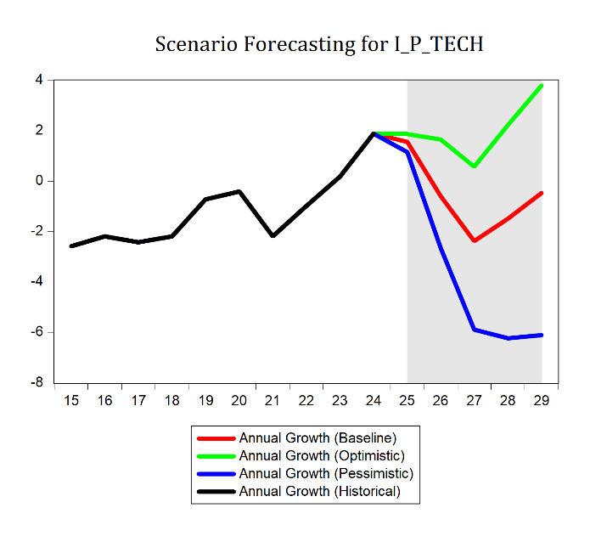
The forecasted price dynamics across technology sectors reveal distinct paths under each scenario, shaped by both sector-specific forces and broader macroeconomic interactions embedded in the MEM.
For Computers and Electronic Products (I_P_CEP$), prices are expected to decline in all scenarios, continuing the sector’s longstanding trend of rapid productivity-driven deflation. Surprisingly, the pessimistic scenario shows the steepest price decline, suggesting that weaker demand or excess capacity could dominate cost-push dynamics in the absence of innovation. Meanwhile, the optimistic scenario still implies falling prices, but at a slower rate — consistent with high productivity offset by robust demand. However, strangely, there is an anomaly in 2029 where the pessimistic scenario rises to above the baseline scenario.
The Information sector deflator (I_P_Info$) presents more dramatic divergence. The optimistic scenario follows a continuation of recent upward price momentum, starting near 2% in 2025 and rising steadily to nearly 5% by 2029. This path may reflect increased valuation of high-skill services, platform-based pricing power, or rising demand for digital content and data services. The baseline shows a temporary price deceleration — from about 2% in 2024 to near zero by 2026 — followed by stabilization. The pessimistic path, however, plunges to –3.5% by 2027, likely driven by depressed investment, weakened pricing power, or negative spillbacks from reduced innovation intensity.
For the aggregate tech sector deflator (I_P_Tech$), the results reflect the net effect of the two component sectors. The optimistic scenario yields rising prices through 2029, while the pessimistic forecast shows sharp price contractions — aligning directionally with the behavior of I_P_Info$ but amplified by the model’s fitted response. This suggests that innovation and demand-side effects dominate price levels in the broader tech sector, with substantial pass-through from information services.
Together, these dynamics illustrate that while productivity typically lowers prices, model-consistent price behavior also incorporates changing sector weights, demand responsiveness, and interactions with technological momentum, resulting in nuanced, occasionally counterintuitive forecast paths.

Reflating Real GDP
(Figure 34: Scenario Forecasts – GDP_Tech)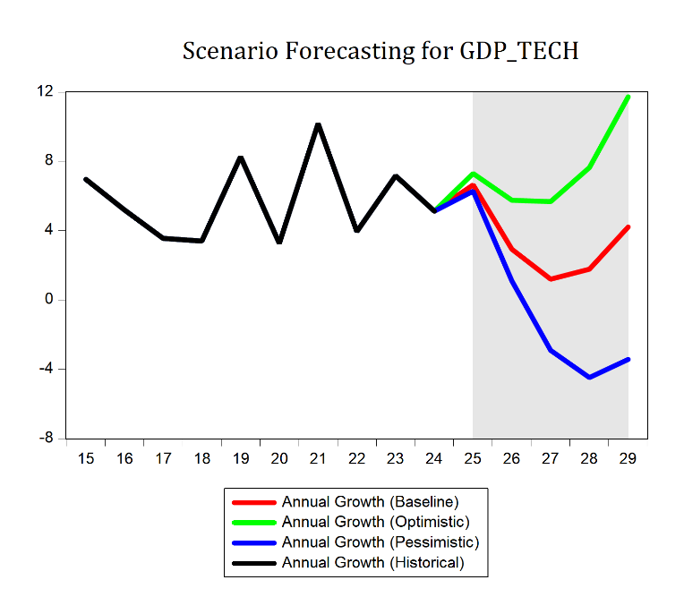
Nominal GDP for Technology follows a broadly similar trajectory across all scenarios, differing mainly in magnitude and timing. Each path features an initial slowdown followed by a rebound, with the turning point arriving a year later for each progressively weaker scenario. The optimistic case sees growth dip slightly from ~7% in 2025 to ~5% in 2026, then reaccelerate to nearly 12% by 2029. The baseline shows a more pronounced deceleration, hitting ~1% growth by 2027 before recovering to just above 4%. The pessimistic scenario, however, falls into contraction: growth turns negative by 2027, bottoms out around –4% in 2028, and remains below zero in 2029. These patterns reflect the compounding effects of diverging real output and price trajectories across the scenarios.

MEM Conclusion
This forecast exercise concludes the full implementation of the technology sector MEM, structured to track real GDP, industry-level prices, and nominal output across the Information and Computers & Electronic Products (CEP) sectors. The model links real output to key drivers of technological progress—capital investment, labor, human capital, public capital, and R&D—while also incorporating industry prices and sector-level identities to ensure internal consistency. The baseline scenario assumes stable investment and innovation trends, resulting in moderate growth in real and nominal GDP with subdued price fluctuations. To bracket uncertainty, optimistic and pessimistic scenarios were developed by adjusting exogenous innovation-related variables. The optimistic case reflects accelerated technological progress, leading to stronger real growth and nominal expansion. In contrast, the pessimistic case simulates weaker innovation and investment, producing slower growth and even contraction in key areas. Each component of the model—real output, prices, and nominal GDP—responded logically to the scenarios. The bracketing highlights the sensitivity of the sector to innovation dynamics and the importance of continued investment in R&D, IP, and human capital. Overall, the MEM provides a coherent and transparent framework for assessing the potential trajectories of the technology sector under different economic conditions. It serves as a robust foundation for scenario planning, policy evaluation, and future research into the role of innovation in driving sectoral growth.

Competitor VAR Forecasts
The goal of using competitor VAR forecasts is to serve as a benchmark for the MEM forecasts. By estimating both standard and Bayesian VARs using alternative combinations of explanatory variables, reduced-form forecast trajectories for GDP_Info$ and GDP_CEP$ are generated that can be directly compared to the structurally derived MEM forecasts. These competitor models rely exclusively on historical movements among variables rather than imposed economic theory, offering a more agnostic perspective on future dynamics. The comparison provides a basis for evaluating the plausibility of the MEM results, highlighting any substantial deviations and identifying areas where structural assumptions may either strengthen or weaken forecast credibility.
VAR or BVAR
Two sets of competitor vector autoregressions (VARs) were estimated: one using ordinary least squares (OLS) and the other using Bayesian methods with a Minnesota prior. Each approach was applied to two systems of first-differenced logged variables. The first system emphasizes innovation-related inputs—GDP in the information and CEP sectors, R&D investment, and multifactor productivity—while the second focuses on production factors, including capital stocks for information and industrial equipment. Standard VARs rely solely on the data to identify dynamic relationships, which can risk overfitting in smaller samples. In contrast, Bayesian VARs incorporate prior beliefs that favor random walks for own lags and shrink cross-variable and higher-order lag coefficients toward zero, promoting stability. Lag lengths were selected using information criteria and aligned with those used in MEM structural estimation. These competitor VARs provide not only an empirical benchmark but also aid in bracketing the MEM’s structural forecasts within a plausible range of outcomes.

Competing VAR Tables
Below are the specifications and results of the competing VARs. Note that lag length criteria are not reported for Bayesian VARs, as such criteria are not typically applicable given the prior-based estimation approach.

Endogenous variables: GDP_Info$, RND$, MFP, GDP_CEP$
Exogenous variables: Intercept
(Table 7: Technological Progress VARs)
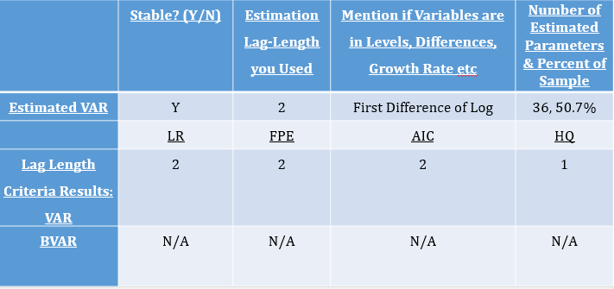
Endogenous variables: GDP_Info$, K_Info$, K_IndEq$, GDP_CEP$
Exogenous variables: Intercept

(Table 8: Capital Accumulation VARs)
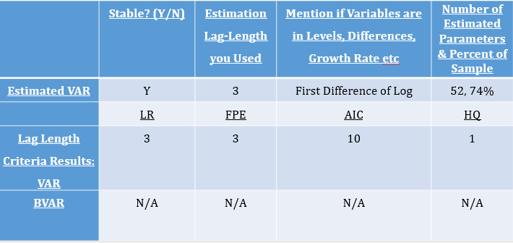

Competitor VAR Forecasts
(Figure 35 – 41: Competitor Forecasts 1 and 2 for CEP$, Info$, and Tech$)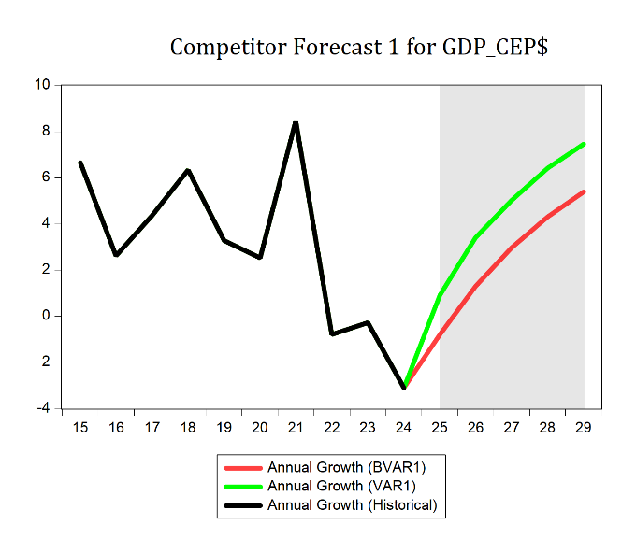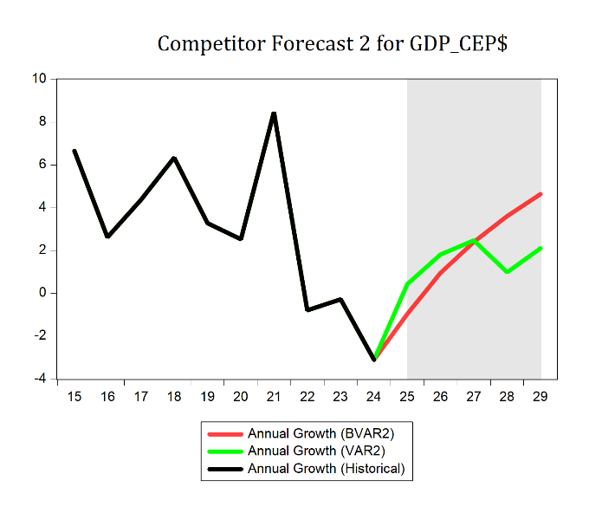
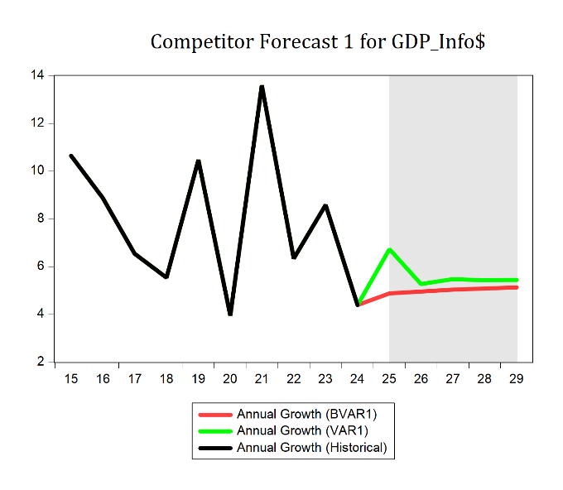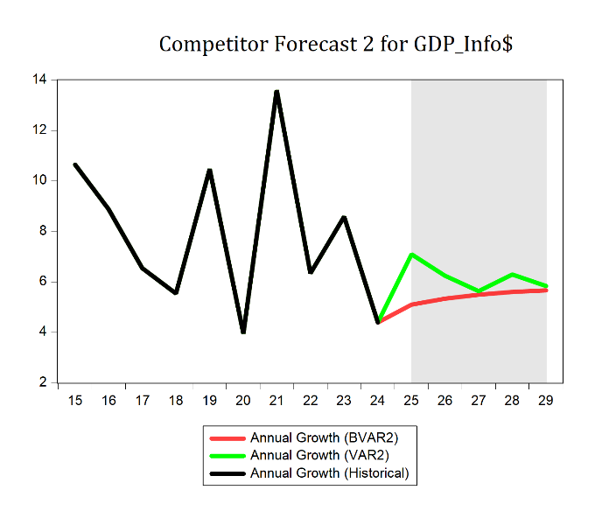
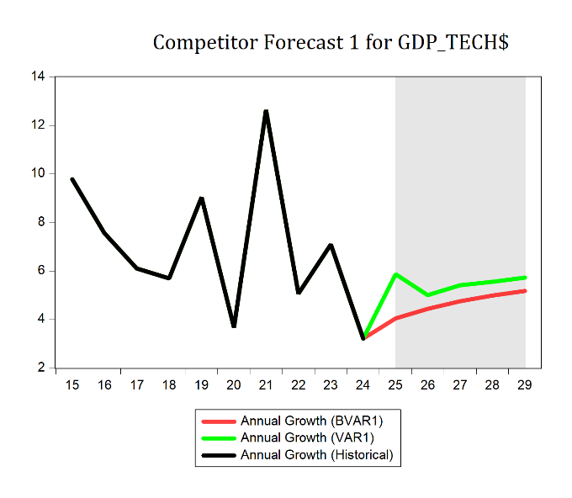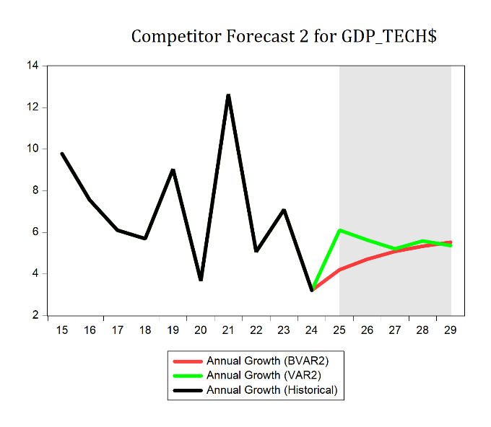
The VAR forecasts show rapidly accelerating growth for GDP_CEP$, with more stable growth for GDP_Info$ and GDP_Tech$. The standard VAR models exhibit greater short-term volatility, particularly around turning points, due to the unrestricted nature of OLS estimation. In contrast, the Bayesian VARs yield smoother forecast paths, reflecting the shrinkage imposed by the Minnesota prior. While the two systems differ in their variable compositions, both center around the rough 6% average growth for GDP_Tech$ highlighted earlier in the report. Together, these alternative forecast paths offer a bracket around the MEM projections and help assess the robustness of the structural forecast results across estimation strategies.

VAR vs Baseline Structural Forecast
Figures 42 through 44 provide a comparison between the structural baseline forecast scenario and the alternative forecasts generated by the VAR and BVAR models. These visual comparisons highlight the differences in dynamics produced by the structurally estimated MEM models versus the statistically driven VAR systems. Together, these competing forecasts help define a statistically plausible range of outcomes, offering perspective on the uncertainty surrounding the baseline structural projections.
(Figure 42 - 44: Baseline Forecast Comparison versus VARs)
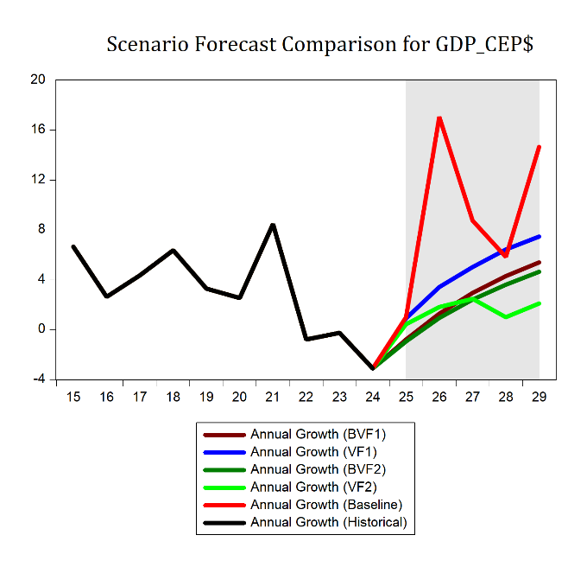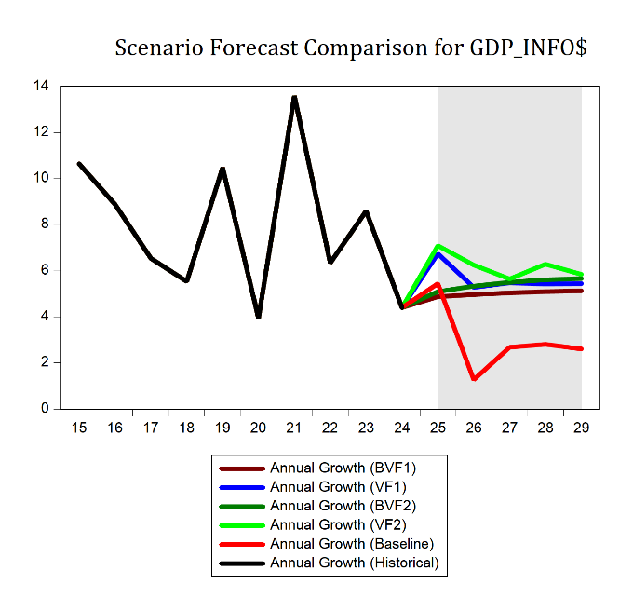
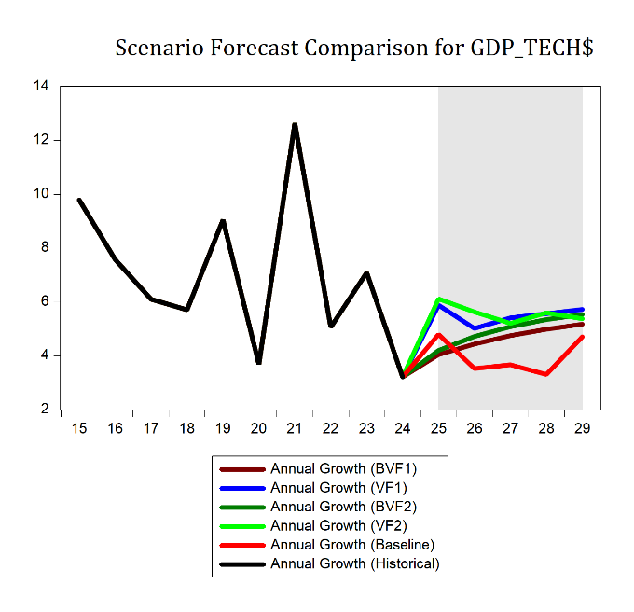
The forecasted range across models illustrate the diversity of plausible growth paths implied by different estimation strategies. For GDP_CEP$, the forecasts span from 2.1% under the Capital Accumulation VAR to 14.7% in the Structural Baseline, reflecting the strong role of embedded structural assumptions in amplifying growth. For GDP_Info$, the Capital Accumulation VAR yields the highest forecast at 5.8%, while the Structural Baseline forecasts the most conservative path at 2.6%. GDP_Tech$ projections fall within a narrower range—between 4.7% (Structural Baseline) and 5.7% (Technological Progress VAR)—highlighting overall alignment across systems. These ranges, bracketed by alternative VAR approaches, provide a statistically informed corridor within which the MEM projections reside, helping to validate their plausibility and robustness.

Competitor ARIMA Forecasts
A competitor ARIMA forecast is handy as a reality check for a more complex model. Since ARIMA only uses the past behavior of a single series, it avoids the extra assumptions built into structural or multi-equation setups. This makes it a good way to see if all that added complexity is actually buying us better accuracy. If the ARIMA does just as well, we might question whether the complex model is worth the effort; if it does worse, it shows the richer model is picking up patterns a simple time-series approach can’t. Below is the forecast of the ARIMA using 1 AR term at lag 4 plus the intervention used in the structural regression. On the left is levels, right is growth.

(Figure 45-46: Competitor ARIMA Forecast – Levels and Growths)
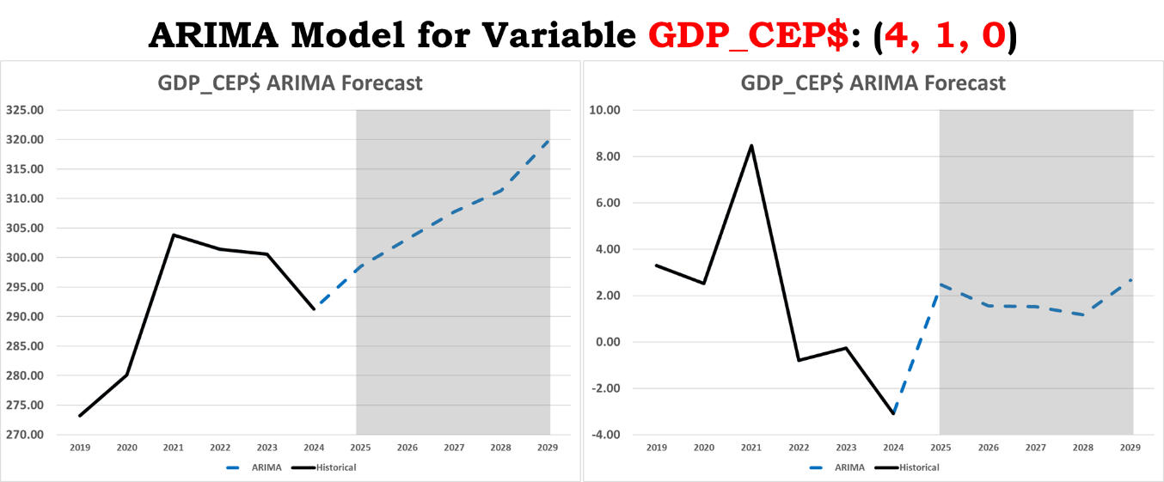
Methods Comparison
To produce a range of out-of-sample forecasts, I applied several different modeling approaches. The structural model used estimated economic relationships to project the variables based on theory-driven equations. Alongside it, I built two vector autoregressions: VAR1, focused on technological progress, and VAR2, centered on capital accumulation. Each of these VARs was also estimated in a Bayesian framework to see if incorporating priors could improve stability and forecast performance. Finally, I ran ARIMA models for each variable as a purely statistical benchmark, relying only on their historical time-series patterns without any structural assumptions.

(Figure 47-48: Model Forecast Comparison – Levels and Growths)
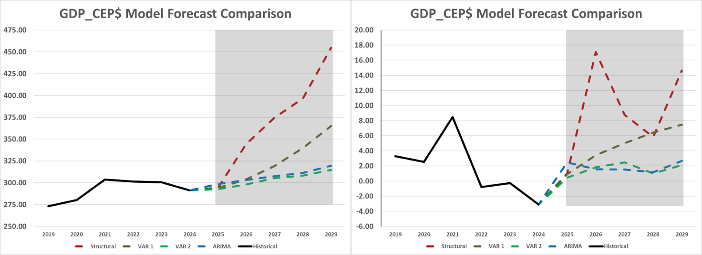
For GDP_CEP$, I compared forecasts from the structural model, the technological progress VAR1, the capital accumulation VAR2, and the ARIMA model, excluding the Bayesian VARs from this analysis. All four produce the same general trajectory, with positive growth throughout the forecast horizon. The capital accumulation VAR and ARIMA show very similar paths, with only minimal differences in both growth rates and levels. The technological progress VAR projects continued growth but at a slowing pace, while the structural model forecasts the strongest overall growth, accompanied by the highest volatility.

In Sample Error Analysis
In-sample error analysis helps an analyst assess how well a model fits the historical data it was trained on, providing an early check on model accuracy before relying on it for forecasts. By comparing predicted values to actual outcomes within the estimation period, we can identify potential biases, overfitting, or systematic errors, and gauge whether the model’s structure is capturing the key relationships in the data. For my models, I compute in-sample errors over the 2015–2019 range using the Root Mean Squared Error (RMSE):
$RMSE=\sqrt{\frac{1}{n}\sum_{t=1}^{n}{{\left(Y_{t}-\hat{Y_{t}}\right)}^{2}}}$ (19)
And the Mean Absolute Percent Error (MAPE):

$MAPE=\frac{1}{n}\sum_{t=1}^{n}{\frac{\left|Y_{t}-\hat{Y_{t}}\right|}{Y_{t}}}$ (20)

(Figure 49-50: Model In Sample Errors - Models)
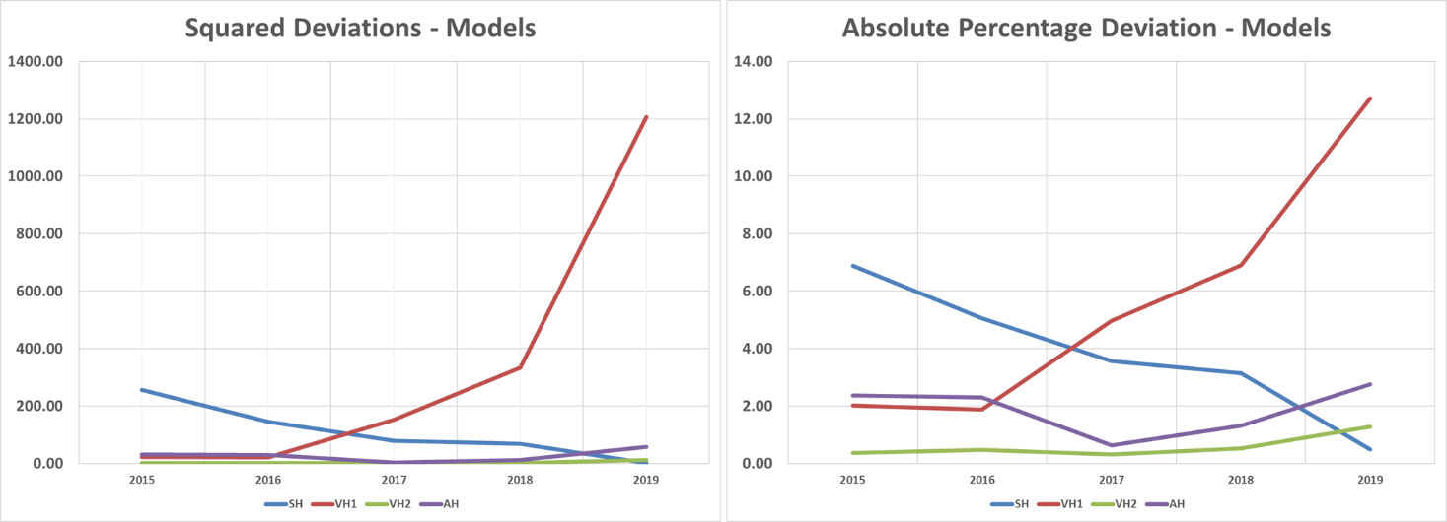
These error charts illustrate the in-sample performance of all four modeling approaches—Structural, VAR1 (Technological Progress), VAR2 (Capital Accumulation), and ARIMA—over the 2015–2019 period. Early in the range, all models show similar accuracy, though the structural model’s errors are noticeably higher than the others. As the period progresses, VAR1’s errors climb quickly and stay elevated, while the structural and ARIMA models maintain moderate, relatively stable error levels. VAR2 consistently delivers the lowest RMSE and MAPE in most years, indicating it provides the most accurate in-sample forecasts overall.
The in-sample error analysis highlights the relative strengths and weaknesses of each modeling approach, showing which models produce more accurate forecasts over the historical period. These insights provide a foundation for the next step: combination forecasting. By understanding how each model performs in-sample, we can construct weighted forecasts that leverage the strengths of multiple approaches, improving overall predictive accuracy and reducing the risk associated with relying on any single model.

Combination Forecasting
Combination forecasting involves combining forecasts from two or more models into a single prediction. The goal is to take advantage of the strengths of each model while reducing the impact of their individual weaknesses. This approach can improve overall accuracy and make forecasts more robust, since errors from one model can be offset by another. By using multiple models together, combination forecasting tends to produce predictions that are more reliable and stable than those from any single model. The formulae used for combination forecasting includes an equal weighting and an optimal weighting set shown below.

$y_{t}^{C}=\frac{1}{n}\sum_{i=1}^{n}{{\hat{y}}_{i,t}}$ (21)
${\hat{y}}_{t}^{C}=\sum_{i=1}^{n}{w_{i}}{\hat{y}}_{i,t}, \text{where} \sum_{i=1}^{n}{w_{i}=1}$ (22)

The forecasting analysis uses five different combination methods. Equal weighting gives each model the same share, in this case 25 percent, and serves as a baseline for comparison. Inverse-MAPE weighting gives more weight to models with lower Mean Absolute Percentage Error by taking the inverse of each MAPE and scaling the results so they sum to one. Inverse-MSE weighting works the same way but uses the Mean Squared Error, which puts more penalty on large misses. Adjusted RMSE share weighting starts from equal weights and shifts them up or down depending on each model’s share of total Root Mean Squared Error, lowering the share for weaker models and raising it for stronger ones. The final method is a meta-combination that averages the forecasts from the four other weighting schemes using equal weights. The algorithms used are as follows:
Inverse MAPE:
$w_{i}^{MAPE}=\frac{\frac{1}{MAPE_{i}}}{\sum_{j=1}^{n}{\frac{1}{MAPE_{j}}}}$, ${\hat{y}}_{t}^{MAPE}=\sum_{i=1}^{n}{w_{i}^{MAPE}{\hat{y}}_{i}}$ (23)
Where:
- $i=1,…,n$ indexes the models.
- $j=1,…,n$ is used in the denominator to sum over all models for normalization.
- $MAPE_{i}$ is the mean absolute percentage error of model $i$.
- $w_{i}^{MAPE}$ is the normalized inverse-MAPE weight for model $i$.
- ${\hat{y}}_{t}^{MAPE}$ is the combined forecast under MAPE weighting.

Inverse MSE:
$w_{i}^{MSE}=\frac{\frac{1}{MSE_{i}}}{\sum_{j=1}^{n}{\left.\frac{1}{MSE_{j}}\right.}}$, ${\hat{y}}_{t}^{MSE}=\sum_{i=1}^{n}{w_{i}^{MSE}{\hat{y}}_{i}}$ (24)
- $i=1,…,n$ indexes the models.
- $j=1,…,n$ is used in the denominator to sum over all models for normalization.
- $MSE_{i}$ is the mean squared error of model $i$.
- $w_{i}^{MSE}$ is the normalized inverse-MSE weight for model $i$.
- ${\hat{y}}_{t}^{MSE}$ is the combined forecast under MSE weighting.

Adjusted RMSE Share Weighting:
$w_{i}^{RMSE}=\frac{1}{n}+\left(\frac{1}{n}-\frac{RMSE_{i}}{\sum_{j=1}^{n}{RMSE_{j}}}\right)$, ${\hat{y}}_{t}^{RMSE}=\sum_{i=1}^{n}{w_{i}^{RMSE}{\hat{y}}_{i}}$ (25)
- $i=1,…,n$ indexes the models.
- $j=1,…,n$ is sums over all models in the denominator to compute each model’s share of RMSE.
- $RMSE_{i}$ is the root mean squared error of model $i$.
- $w_{i}^{RMSE}$ is the adjusted RMSE weight for model $i$.
- ${\hat{y}}_{t}^{RMSE}$ is the combined forecast under share adjusted RMSE weighting.

Combination In-Sample Error
(Figure 51-52: In Sample Errors – Combination)
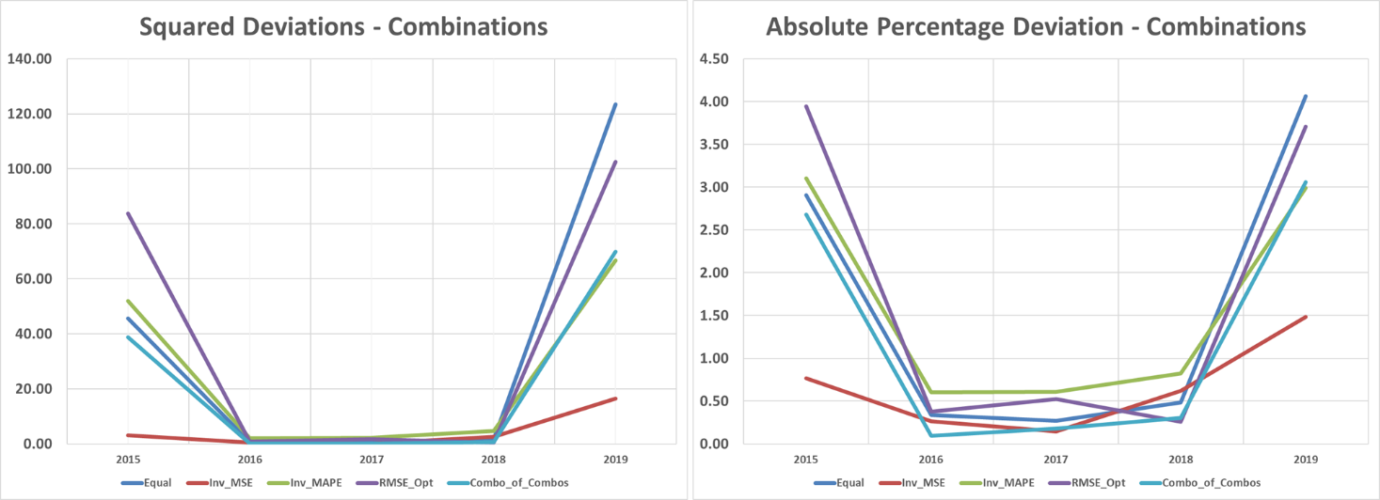

(Table 9: Error Metrics and Combination Weightings)
 | METHOD | RMSE | MAPE | Equal | Inv MAPE | Inv MSE | RMSE Adj.
Models | Structural | 10.48 | 3.82 | 25% | 9.8% | 2.6% | 20.9%
 | VAR1 | 18.62 | 5.69 | 25% | 6.6% | 0.8% | -1.7%
 | VAR2 | 1.82 | 0.58 | 25% | 63.7% | 85.6% | 44.9%
 | ARIMA | 5.13 | 1.87 | 25% | 20% | 10.8% | 35.8%
Combos | Equal | 5.86 | 1.61 | - | - | - | -
 | Inv MAPE | 3.12 | 0.87 | - | - | - | -
 | Inv MSE | 2.13 | 0.66 | - | - | - | -
 | RMSE Adj. | 3.60 | 1.31 | - | - | - | -
 | Meta Combo | 4.68 | 1.26 | 25% | 25% | 25% | 25%

The table shows the performance of the individual models and the different combination forecasts using RMSE and MAPE as evaluation metrics. Among the individual models, VAR2 clearly outperforms the others, with the lowest RMSE (1.82) and MAPE (0.58%), while VAR1 has the highest errors. The weighting schemes reflect these differences: inverse-MAPE and inverse-MSE weights heavily favor VAR2, assigning it 63.7% and 85.6% of the total weight, respectively, while the other models receive much smaller shares. The adjusted RMSE weighting moderates this, spreading the weight more evenly but still favoring VAR2 and ARIMA.
All combination forecasts outperform most individual models, demonstrating the value of combination forecasting. The inverse-MSE combination achieves the lowest RMSE (2.13) and MAPE (0.66%), closely followed by the inverse-MAPE combination. Equal-weighted combinations and the adjusted RMSE combination also improve on the worst-performing individual models but are slightly less optimal. The meta-combination, which averages across all combination methods, produces stable performance (RMSE 4.68, MAPE 1.26%), highlighting that averaging different combination strategies can yield robust, interpretable forecasts even if it doesn’t achieve the absolute lowest errors.

Combination In-Sample Forecast
(Figure 52-53: In Sample Combination Forecasts – Levels and Growths)
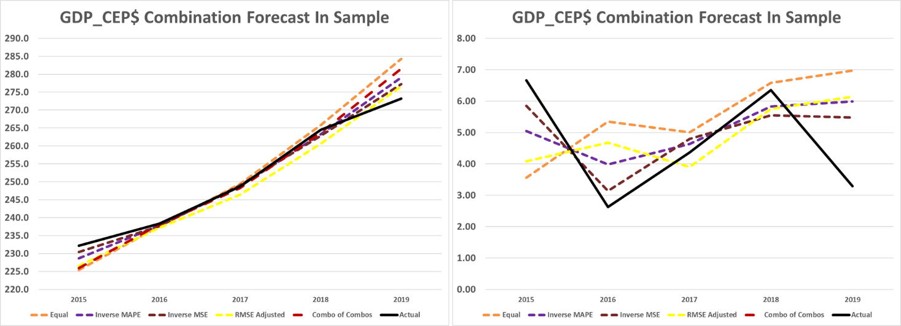
The in-sample forecast charts show both the level and growth rate predictions relative to the actual data. All combination methods under-forecast in 2015, align closely with actual values over the middle three years, and then over-forecast in 2019. The inverse-MSE combination stands out for maintaining the closest correspondence to the actual growth dynamics, with minimal divergence across the in-sample period, clearly reflecting the trends observed in the actual data.

Combination Out-of-Sample Forecast
(Figure 54-55: Out of Sample Combination Forecasts – Levels and Growths)
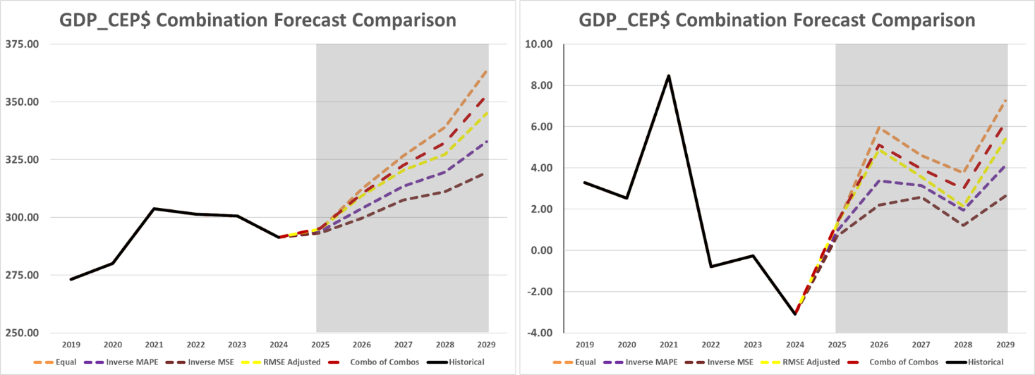
The out-of-sample forecasts illustrate how the final predictions are shaped by the relative performance of the individual models and the weighting schemes applied. The structural model (CEP) produces a relatively high baseline forecast, so even modest increases in its weight noticeably raise the overall forecasted growth. In contrast, VAR 2 consistently predicts lower growth and exhibits the lowest out-of-sample errors, making it the most accurate model in this set.
These dynamics are reflected in the combination weights. Equal weighting assigns 25% to each model, allowing the structural model to retain a relatively strong influence. Inverse-MSE weighting, however, allocates up to 85% of the total weight to VAR 2 due to its superior error performance. The adjusted RMSE weighting similarly reduces the structural model’s influence while boosting VAR 2’s contribution. Overall, the results demonstrate that the better a model performs out-of-sample, the more it drives the combined forecast, with VAR 2 emerging as the dominant influence under most optimized weighting schemes.

Combination Conclusion
The combination forecasts show a few clear takeaways. Weighting the models based on performance, like with inverse-MSE or adjusted RMSE, improves accuracy compared to simply giving all models equal weight. In our case, the inverse-MSE combination had the lowest errors and stayed closest to the actual growth patterns, capturing the trends better than equal weighting. The adjusted RMSE approach also helped by reducing the influence of weaker models and giving more weight to the stronger ones. Visually, all the out-of-sample forecasts follow similar patterns, differing mainly in magnitude. The equal-weighted combination projects the highest growth, while the inverse-MSE combination projects the lowest, with both appearing reasonable and consistent with the underlying trends. Overall, combining forecasts makes predictions more reliable, and in this application, the optimal weights clearly improved both the numerical accuracy and the visual fit compared to equal weighting.

Best of Models and Combinations
So far, we have produced a range of forecasts using both model-based approaches and combination methods, each showing different levels of accuracy. For the comparison that follows, the focus will be on Capital Accumulation (VAR2), the Equal Weighting combination, and the Inverse MAPE combination. While the Inverse MSE weighting delivered the lowest errors, its forecast essentially mirrored VAR2 because of the extremely high weight assigned to that model, making it less useful for comparison. For this reason, I used the second best in-sample performance, that being VAR 2.

(Figure 56-57: Out of Sample Special Forecasts Comparison – Levels and Growths)
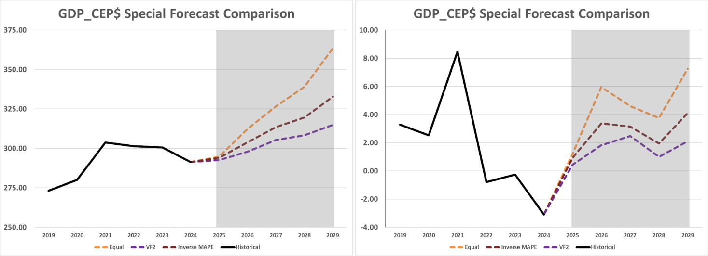
The out-of-sample forecasts from Equal Weighting, VAR 2, and the Inverse MAPE combination form a clear bracketing set. Equal Weighting produces the highest projected growth rates, largely because it gives greater influence on the structural model’s optimistic outlook. At the other end, VAR 2 generates the lowest forecast, consistent with its more conservative stance and stronger in-sample accuracy. The Inverse MAPE combination sits between these two extremes, tempering the influence of the structural model while still improving on accuracy. This bracketing of forecasts illustrates how different weighting schemes shape the growth trajectory in distinct but interpretable ways.

Concluding Remarks
The goal of this project was to model the production function of the technology sector and, in doing so, better understand how technology drives long-run growth and social welfare. The work began by looking at the big picture: why technology matters, how the sector is structured, and the major events that have shaped its adoption over time. From there, the theoretical foundation was laid using Cobb–Douglas and translog production functions, guided by insights from the literature on which variables are most critical.
The next step was practical: assembling data from a wide range of sources and reshaping it into a form suitable for modeling. With that foundation in place, structural regressions were estimated and thousands of specifications tested to approximate the sector’s causal structure as closely as possible. This effort expanded into a multi-equation EViews model with exogenous forecasts, including scenario exercises built on different growth assumptions.
To provide benchmarks, competing VAR and ARIMA forecasts were also developed. Finally, the analysis turned to combination forecasting, asking whether blending the strengths of multiple methods could reduce forecast error and provide more reliable projections.
Altogether, the project moved from theory to data, from structural models to benchmarks, and finally to combinations that tied everything together; a full arc aimed at capturing the dynamics of the technology sector as faithfully as possible.

Model Analysis Wrap-Up
The multi-equation model (MEM) brought together exogenous ARIMA forecasts, structural Cobb-Douglas production functions, and identities that combined real GDP for computers and electronic products with real GDP for information to produce an overall forecast for the technology sector. Estimating the production functions required refining lag structures, and the per capita versions ultimately provided the best fit. Scenario forecasting was then layered on by assuming optimistic, baseline, and pessimistic paths for sector growth. For computers and electronic products, the results pointed to high but volatile growth across all scenarios, which makes sense given the sector’s relatively small share of GDP. For information, the forecasts suggested accelerating growth in the optimistic case, stability in the baseline, and slowing growth in the pessimistic case, though the lag structure muted the differences across these paths.
For comparison, benchmark forecasts were generated using VAR and ARIMA models. The VARs tended to project more optimistic and volatile paths, while ARIMA produced very stable forecasts with only slight fluctuations. Taken together, these benchmarks provided useful context for evaluating the dynamics coming out of the structural model.

Error Analysis Wrap-Up
For error analysis, performance was evaluated using both RMSE and MAPE. Among the individual models, the capital accumulation VAR stood out as the most accurate across the in-sample period, followed by ARIMA, then the structural regressions, with the technological progress VAR trailing far behind. In fact, the technological progress VAR’s errors increased sharply toward the end of the range, making it an unreliable benchmark. To build on this, several combination methods were tested, including equal weighting, inverse MSE, inverse MAPE, RMSE share adjustment, and a meta-combination that averaged across the combined forecasts. All of the optimal weighting schemes outperformed simple equal weighting, with inverse MSE providing the strongest overall results. Still, equal weighting held up reasonably well, suggesting that even a straightforward approach can deliver solid performance. More importantly, the set of combination forecasts formed a useful bracket, balancing between optimistic and conservative paths without drifting into extremes.

Key Takeaway Wrap-Up
The structural model analysis reinforced the central role of capital and labor in technology sector production while also highlighting the contribution of public capital in both regressions for real GDP. Using consistent deflators and similar lag structures across the regressions, together with a strong grounding in theory and widely accepted empirical patterns, was essential for effective respecification. Working within the FMOLS framework for the production function presented challenges, but it provided a clearer picture of the long-run importance of technology for the broader economy and offered an opportunity to develop a mass estimation approach, greatly improving efficiency during specification testing.
Comparing structural and inertial modeling underscored the value of theory-driven approaches. Inertial methods are fast and often produce reasonable forecasts, but they fail to capture the nuanced dynamics that structural models reveal and cannot support scenario forecasting. This contrast highlights the importance of a fully specified, theoretically guided structural model, as omitting key variables or mis-specifying the structure can dramatically alter results. Combination forecasting further reinforced this lesson. By allowing each model to contribute according to its strengths, the combination approach provides a more balanced and robust forecast. Even simple equal weighting performed reasonably well, while optimized weights such as inverse MSE or inverse MAPE offered measurable improvements. The combination forecasts also formed a useful bracket, balancing between optimistic and conservative paths without drifting into extremes.
Ultimately, this work highlights the central role of the technology sector in driving economic growth. Technological innovation enhances productivity and efficiency not only within the tech industry but across nearly all sectors, from precision agriculture and healthcare to manufacturing and logistics. By examining the contributions of key inputs to technology sector output and generating theoretically guided forecasts of real GDP, the analysis illustrates how these innovations ripple through the broader economy. Understanding the drivers of technology GDP allows economists, forecasters, and policymakers to anticipate structural trends, evaluate future cycles, and assess the impacts on prices and consumer welfare. The modeling and forecasting conducted here provide a clearer picture of how technology supports growth, showing both its direct contributions and the wider effects that improve efficiency, reduce costs, and strengthen long-term economic performance.

Looking Forward
Looking ahead, if additional time were available, a key priority would be to restructure the code in both EViews and R to make it more generalizable and easier to adapt for other projects. For this specific project, expanding the scope would be a natural next step, transforming the MEM into a full-scale estimation of real GDP across all industries. Achieving this would require significantly enlarging the dataset to include capital and labor for each industry, as well as researching and incorporating industry-specific variables. In addition, further testing of the translog production function could be conducted to include input prices and better capture cost structures. Overall, the focus would be on improving code efficiency, broadening the project’s scope, and enhancing the analytical power of the model for future applications.

Appendix 1 – Additional Charts and Tables
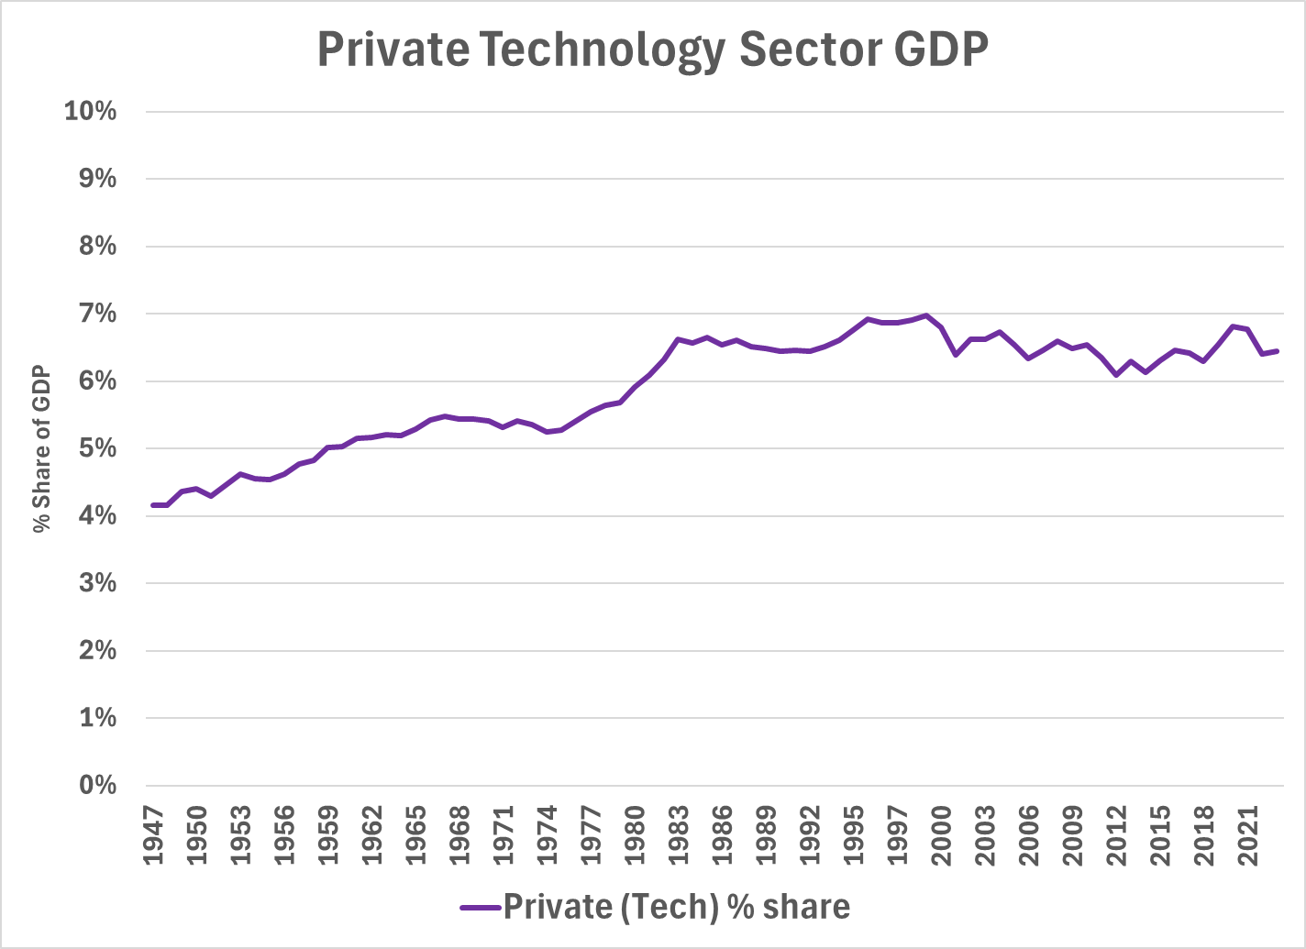
The next 3 charts illustrate the shares of GDP accounted for by the private sector (excluding technology), the technology sector, and the public sector, respectively. Derived by rolling up Information and Computer and Electronic Products sectors and dividing by Total GDP, this chart focuses specifically on the technology sector’s contribution to total GDP. In 1947, the technology sector represented approximately 4.1% of GDP. It gradually expanded, reaching a peak of around 7% in the late 1990s, and currently stands near 6.5%. Given its relatively modest share of the overall economy, the sector exhibits low volatility in its GDP contribution, making fluctuations less pronounced over time.

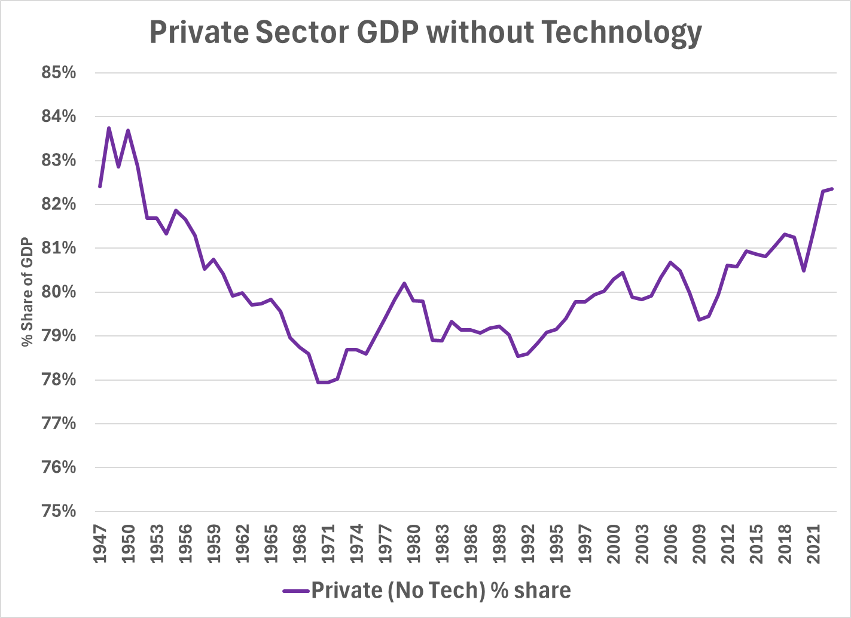
This chart, derived by taking Total Private Sector less Technology Industry (derived earlier) divided by Total GDP, along with the subsequent one, derived using Total Public Sector, presents a side-by-side comparison of the percentage share of GDP attributed to the private (excluding technology) and public sectors. Notably, the shares of the private and public sectors are horizontally mirrored—peaks in the private sector correspond to troughs in the public sector, and vice versa. This inverse relationship highlights the shifting balance between public and private economic activity over time. The chart exhibits clear cyclical patterns, with recurring peaks and troughs that likely align with broader business cycles. Periods of decline followed by recovery suggest responses to economic recessions, expansions, and deeper structural transformations within the economy.
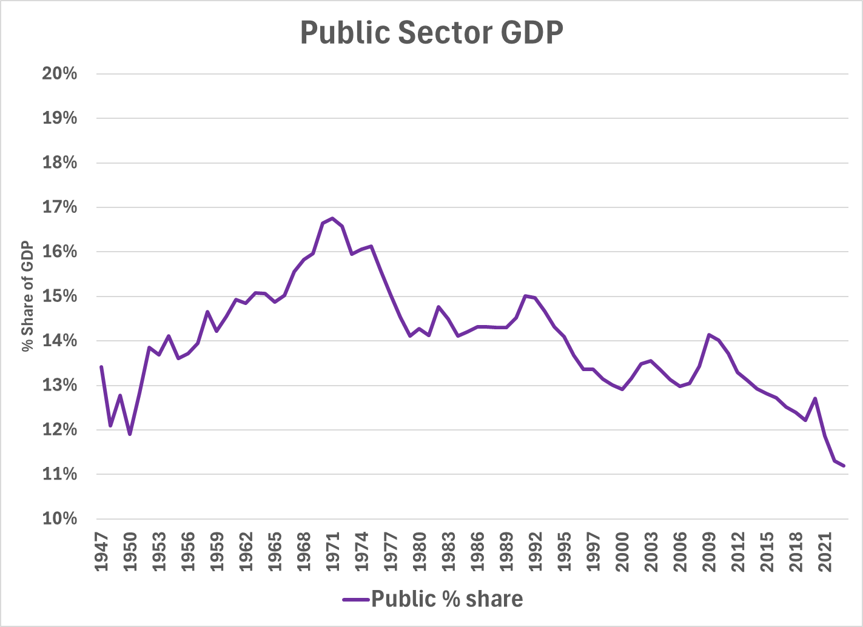
The public sector's share of GDP has experienced a long-term decline since the mid-20th century. After rising steadily from the late 1940s to a peak in the early 1970s, the public sector began a gradual descent in its relative economic weight. This pattern indicates a sustained shift away from government-led economic activity toward a greater emphasis on private sector dynamics. The trend is smooth and directional rather than erratic, reflecting a structural transformation likely driven by policy changes, privatization, and broader macroeconomic shifts. As previously noted, this graph is horizontally mirrored by the private sector’s share, underscoring the inverse relationship between the two over time.

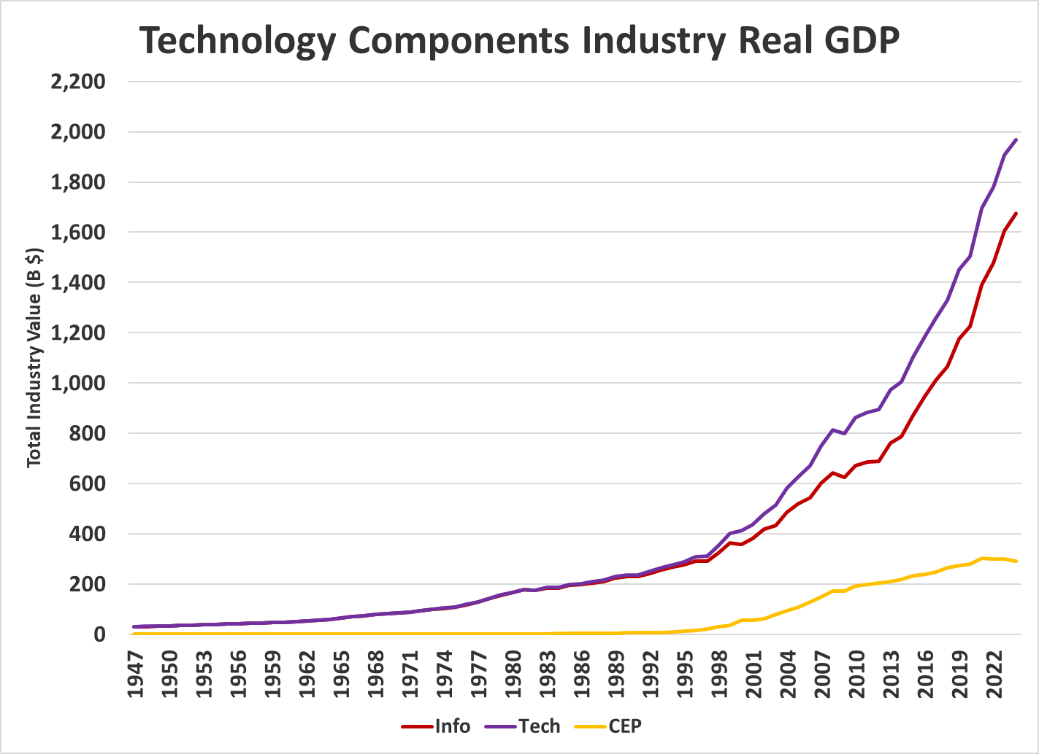
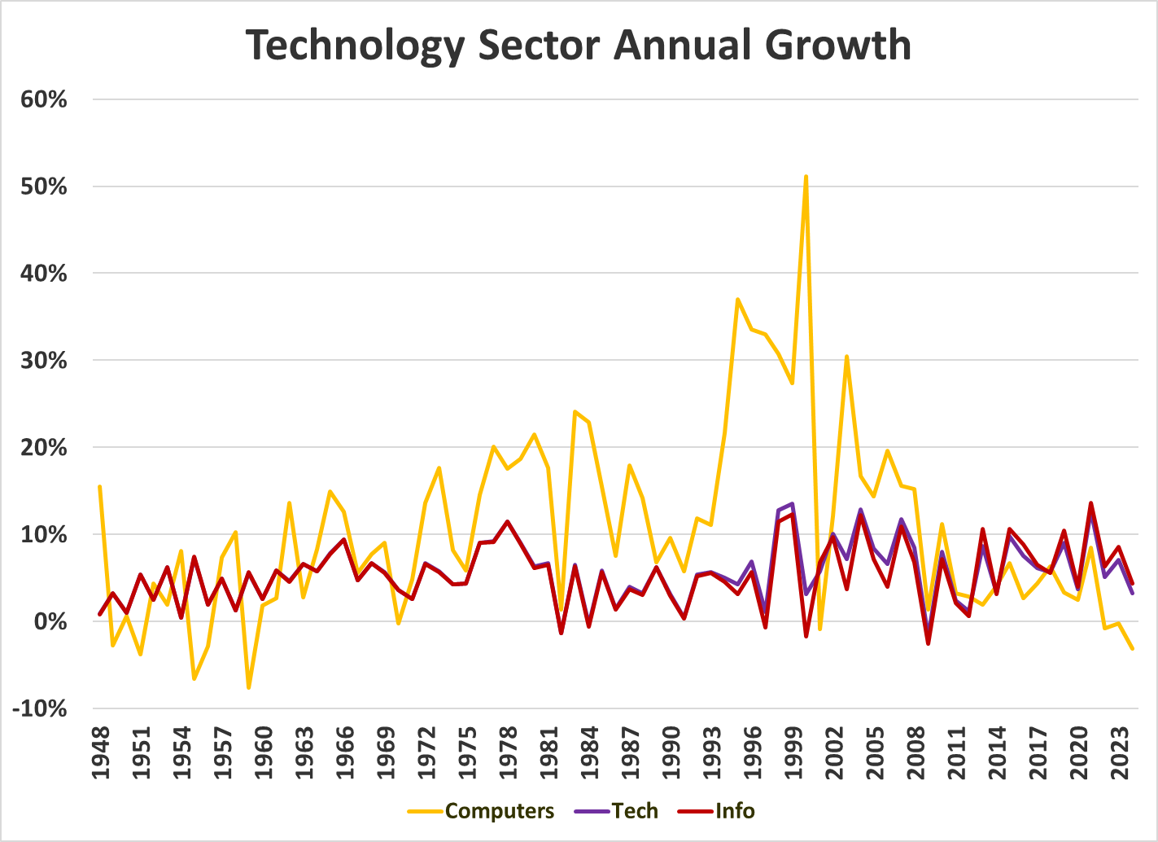
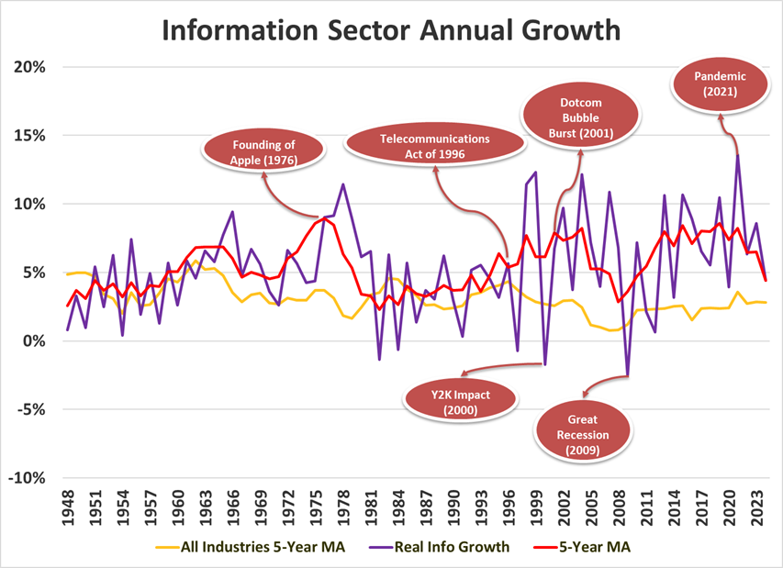
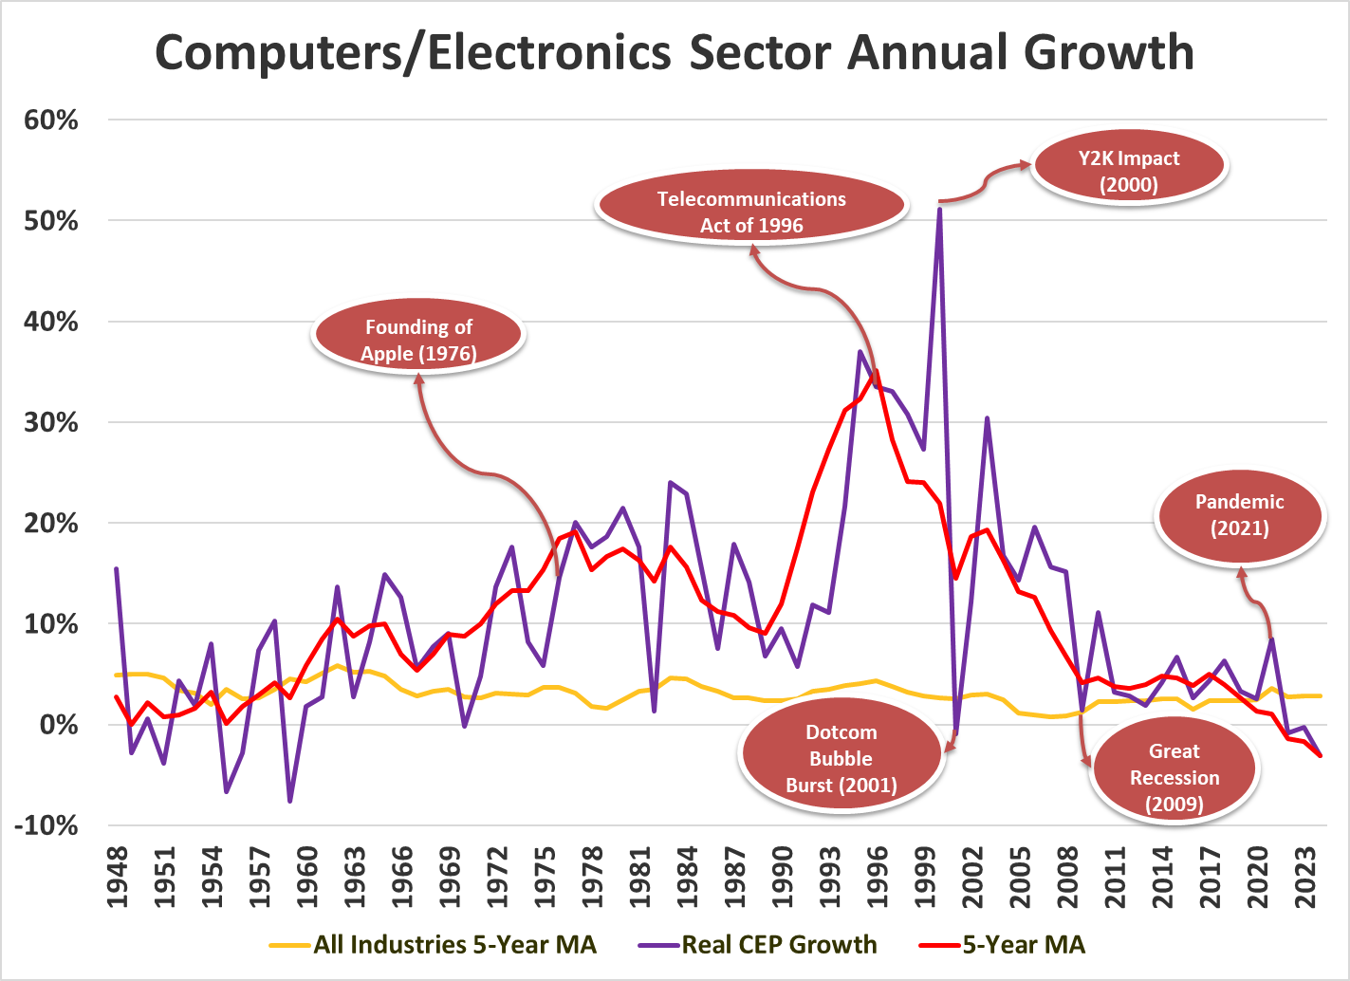
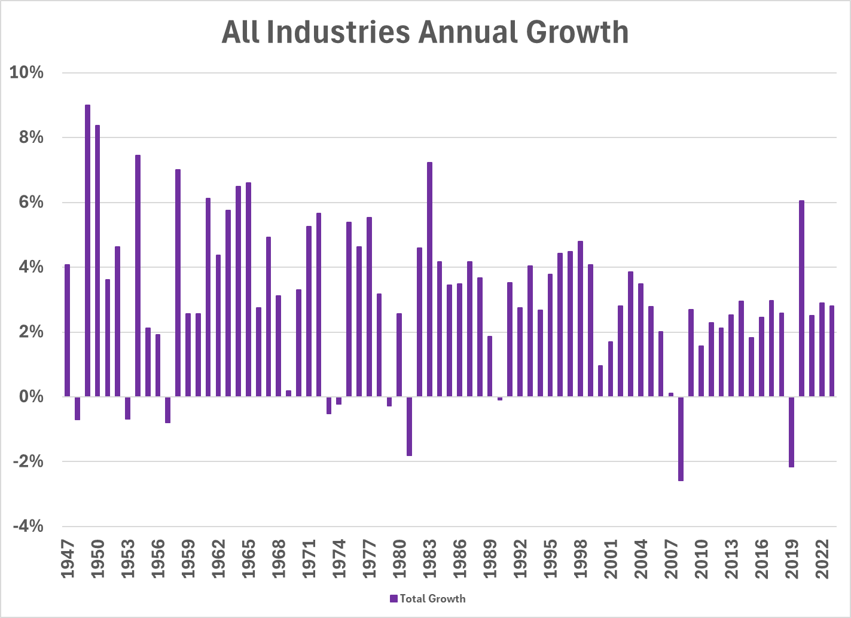
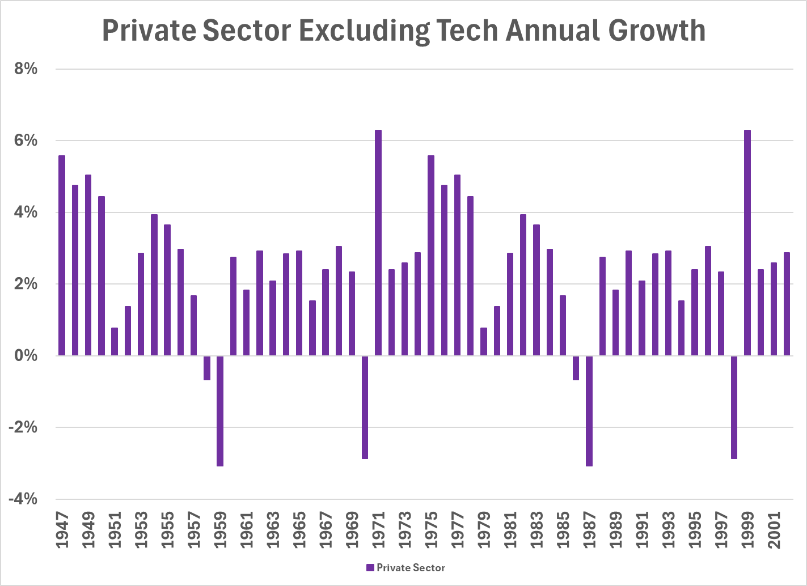
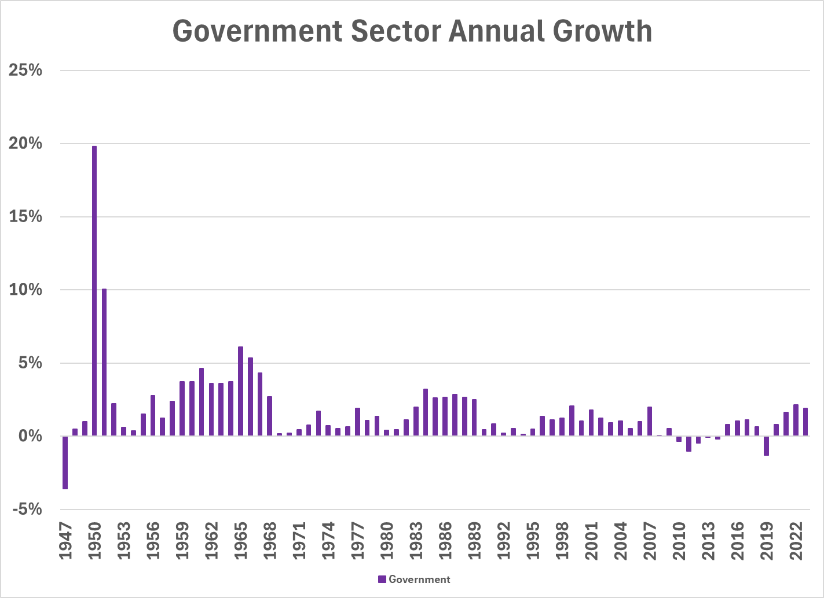

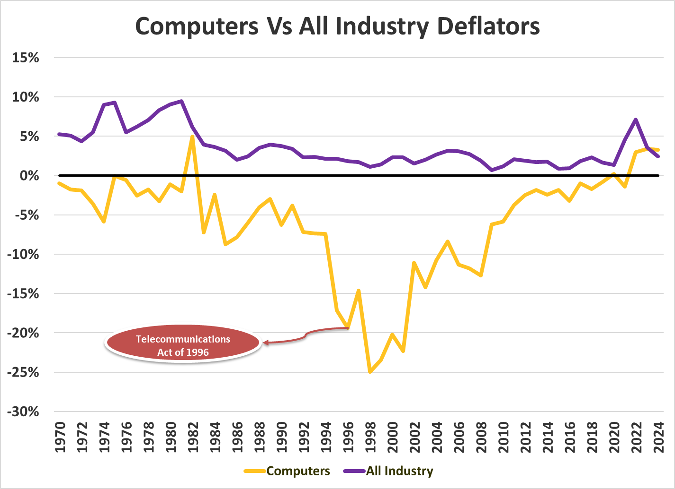

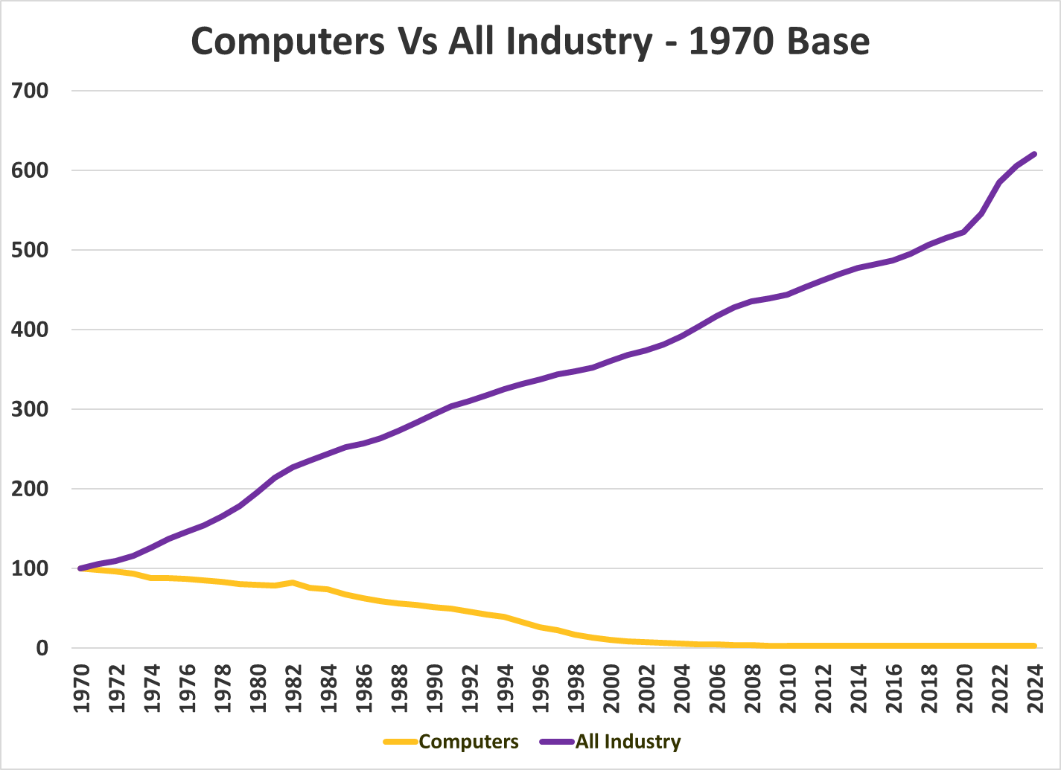

Appendix 2 - References

“GDP by Industry.” GDP by Industry | U.S. Bureau of Economic Analysis (BEA), www.bea.gov/itable/gdp-by-industry. Accessed 30 Dec. 2024.

Hahn, Elke, and Frauke Skudelny. “Early estimates of Euro area real GDP growth: A bottom up approach from the production side.” SSRN Electronic Journal, 2008, https://doi.org/10.2139/ssrn.1304533.

Hamilton, Dan E. “How Productive are Public Capital, Private Capital, Human Capital and R&D in the U.S.?” Department of Economics at UCSB, 16 Nov. 2001, pp. 1–49.

Intriligator, Michael D., et al. Econometric Models, Techniques, and Applications. Prentice Hall, 1996.

Levinsohn, James, and Amil Petrin. “Estimating production functions using inputs to control for unobservables.” Review of Economic Studies, vol. 70, no. 2, Apr. 2003, pp. 317–341, https://doi.org/10.1111/1467-937x.00246.

Lynde, Catherine, and J. Richmond. “Public Capital and Total Factor Productivity.” International Economic Review, vol. 34, no. 2, May 1993, p. 401, https://doi.org/10.2307/2526921.

Maccarrone, Giovanni, et al. “GDP forecasting: Machine learning, linear or autoregression?” Frontiers in Artificial Intelligence, vol. 4, 15 Oct. 2021, https://doi.org/10.3389/frai.2021.757864.

NAICS Association. “Six-Digit NAICS Codes & Titles.” NAICS.com, 2017, https://www.naics.com/six-digit-naics/?v=2017&code=31-33.

Olley, G. Steven, and Ariel Pakes. The Dynamics of Productivity in the Telecommunications Equipment Industry, Jan. 1992, https://doi.org/10.3386/w3977.

Team, The Investopedia. “US Recessions throughout History: Causes and Effects.” Investopedia, Investopedia, www.investopedia.com/articles/economics/08/past-recessions.asp. Accessed 30 Dec. 2024.

United States. Office of Management and Budget, Economic Classification Policy Committee. North American Industry Classification System: United States Manual 2002. National Technical Information Service, Jan. 2002

Unknown Author. Understanding the Drivers of Productivity Through Regression Analysis

What Is the Average Technology Salary by State in 2024?, www.ziprecruiter.com/Salaries/What-Is-the-Average-Technology-Salary-by-State. Accessed 31 Dec. 2024.

Wijeweera, Albert, et al. “Economic growth and FDI inflows: A stochastic frontier analysis.” The Journal of Developing Areas, vol. 43, no. 2, Mar. 2010, pp. 143–158, https://doi.org/10.1353/jda.0.0059.

Appendix 3 – AI Searches
Search:
- Give me a list outlining what the SIC was, the changes that the inception of the NAICS brought, and how the NAICS has changed regarding the information sector and the Computer and Electronic Components industry

Result:
1. What the SIC Was
- Introduced in the 1930s and used extensively through the 1990s.
- Employed a four-digit code system to classify industries based on primary economic activity.
- Focused on manufacturing and goods-producing industries, with limited granularity for service and high-tech sectors.
- Became outdated as the economy shifted toward services, information, and technology-based industries.

2. Changes Brought by the Inception of NAICS (1997)
- Replaced the SIC system to better reflect a modern, global, service-oriented economy.
- Developed jointly by the U.S., Canada, and Mexico for cross-national data consistency.
- Introduced a six-digit hierarchical coding structure for more detailed and flexible classification.
- Placed greater emphasis on production processes rather than just output or end use.
- Enabled the creation of entirely new industry categories, especially in areas like information technology, telecommunications, and biotechnology.

3. How NAICS Has Changed – Focus on Two Sectors
A. Information Sector (NAICS 51)
- Initially distinguished between delivery platforms (e.g., print vs. internet, radio vs. streaming).
- NAICS 2022 removed many of these distinctions, instead grouping industries by content type or service rather than delivery method.
- For example, internet-only publishers are now classified alongside traditional publishers, and digital broadcasters are grouped with legacy broadcast media.
- Emphasis shifted from how content is delivered to what the content or service is.
B. Computer and Electronic Product Manufacturing (NAICS 334)
- Introduced in 1997 NAICS to reflect the unique structure and innovation cycles of electronics manufacturing.
- Consolidated and expanded categories previously scattered under SIC into a unified electronics sector.
- Covered production of semiconductors, computers, communications equipment, and electronic components.
- While the overall structure has remained stable, periodic revisions (e.g., 2007, 2012) have added detail or reorganized sub-industries to account for technological advancements and shifting industry practices.

Search:
- What specifically impacted the economic surges in the mid 1990s in regards to technology?

Result:
The economic surge in the mid-1990s, often referred to as the “productivity boom”, was heavily influenced by several structural and technological shifts that transformed the U.S. economy. Specifically, the following developments in the technology sector were central to this surge:

1. Rapid Diffusion of Information Technology (IT)
The widespread adoption of personal computers, local area networks (LANs), and enterprise software significantly enhanced productivity in both goods-producing and service industries. Unlike earlier periods where technological innovations were confined to specific industries, the 1990s saw general-purpose IT tools permeate nearly every sector.

2. Growth of the Internet and Telecommunications Infrastructure
The commercialization and expansion of the Internet in the early-to-mid 1990s unlocked new platforms for communication, commerce, and information exchange. The Telecommunications Act of 1996 further deregulated the industry, spurring massive private investment in fiber-optic networks, mobile infrastructure, and broadband capacity. This lowered transaction costs, improved coordination, and enabled entirely new business models.

3. Falling Prices of Computing Power and Semiconductors
Driven by Moore’s Law, the price-performance ratio of semiconductors and computing devices improved dramatically. This led to rapid capital deepening, where firms invested heavily in IT capital—computers, servers, networking equipment—to enhance productivity.

4. Organizational Transformation Enabled by Technology
Technology adoption was accompanied by changes in business practices, such as supply chain optimization, just-in-time inventory, and digitally integrated operations. Economists like Brynjolfsson and Hitt argued that these complementary investments in organizational capital took time to implement but paid off significantly in the 1990s.

5. Shift Toward a Knowledge-Based Economy
There was a measurable rise in human capital-intensive industries such as software development, IT services, and professional and business services, all of which rely heavily on digital infrastructure. This sectoral shift magnified the impact of tech-led productivity gains.

Together, these factors explain why total factor productivity growth accelerated in the second half of the 1990s after lagging for much of the 1970s and 1980s. The technology sector didn’t just grow—it enabled the rest of the economy to produce more efficiently, making the mid-1990s a turning point for modern economic growth.

Search:
- Could you give me a detailed list of the telecommunications act of 1996

Result:
Here’s a clear and detailed breakdown of the Telecommunications Act of 1996, highlighting its most significant provisions:

📜 Key Provisions of the Telecommunications Act of 1996
1. Promoting Competition in Local and Long-Distance Markets
Incumbent local phone companies (ILECs) were required to open their networks to competitors (CLECs), allowing access to network elements and interconnection at regulated rates. This dismantled regional monopolies and enabled new entrants to compete both locally and in long-distance services cga.ct.gov+15en.wikipedia.org+15firstamendment.mtsu.edu+15en.wikipedia.org+3mason.gmu.edu+3canonica.ai+3.
2. Deregulation of Media Ownership
Regulatory caps on ownership of radio and television stations were loosened or eliminated, and cross-ownership between phone, cable, and broadcast services was permitted, leading to a wave of industry consolidation en.wikipedia.org+1en.wikipedia.org+1.
3. Cable and Broadcast Services Reform
Telephone companies were allowed to enter the cable business; cable rate regulations were phased out; new obligations were placed on cable operators to provide accessible video programming; and spectrum licensing was updated to support broadband services .
4. Universal Service and E-Rate Program
The Act codified universal service and led to the creation of the Universal Service Fund, ensuring funding for rural areas, low-income customers, schools, libraries, and hospitals. It also established the E-Rate program to subsidize discounted Internet access in educational and healthcare institutions reddit.com+12en.wikipedia.org+12en.wikipedia.org+12.
5. Accessibility for Persons with Disabilities
Manufacturers and service providers were required to make telecom equipment accessible when readily achievable (Section 255), and video programming was to include closed-caption services for individuals with hearing impairments (Section 713) fcc.gov.
6. Interconnection and Unbundling Requirements
Local exchange carriers were required to lease parts of their networks (like local loops and central office facilities) to competitors at cost-based rates—and to support features like number portability and reciprocal compensation wired.com+2mason.gmu.edu+2en.wikipedia.org+2.
7. Regulatory Streamlining and Innovation Support
The FCC was granted authority to reduce outdated regulations and to encourage deployment of advanced telecom services, with a mandate to conduct biannual regulatory reviews. The Act also empowered the FCC to promote broadband deployment and facilitate medical and educational applications of advanced services .
8. Communications Decency Act & Section 230
Title V of the Act, known as the Communications Decency Act (CDA), included provisions prohibiting indecent online content accessible to minors—most of which was struck down by the Supreme Court—but Section 230, which protects online intermediaries from liability for user-generated content, remains intact en.wikipedia.org+1apnews.com+1.

These provisions collectively aimed to create a more competitive landscape in telecommunications, expand service access, and encourage broadband deployment. Let me know if you’d like to integrate this into a timeline, include legislative citations, or explore each title in greater detail.

Appendix 4 – Machine Output
Exogenous ARIMA
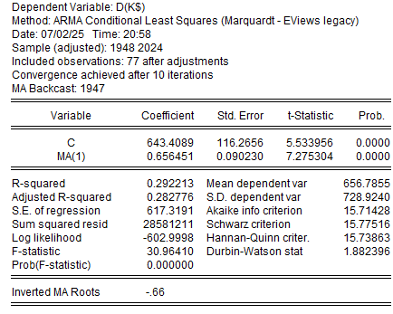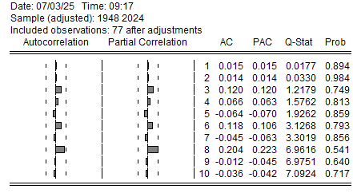
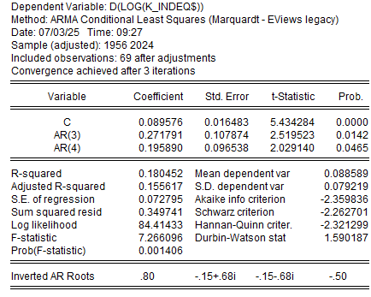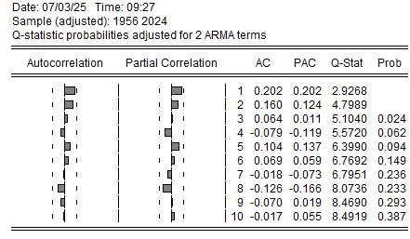
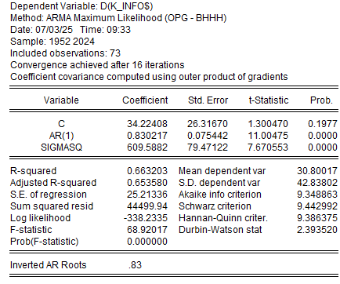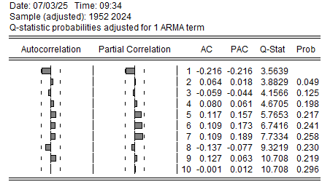

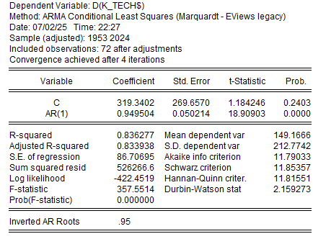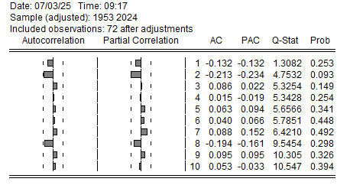

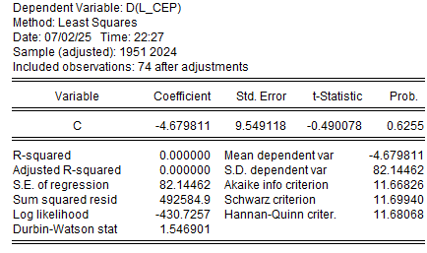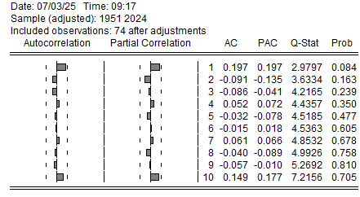

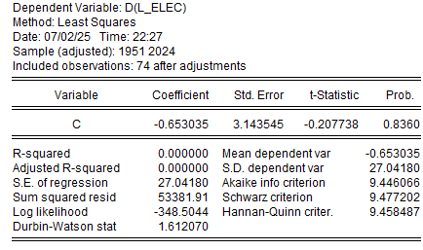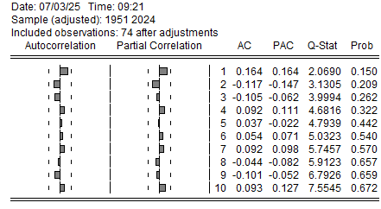
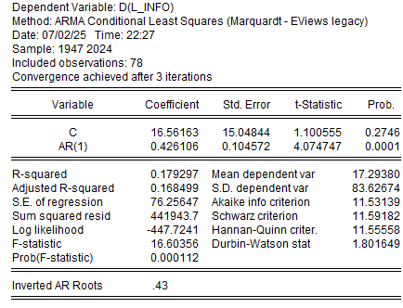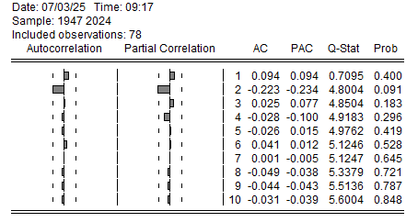
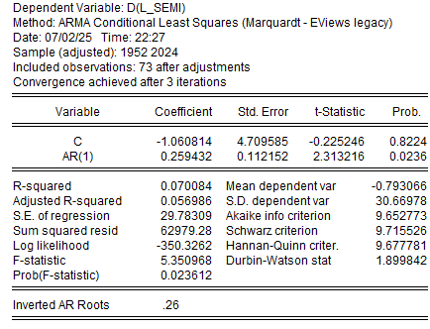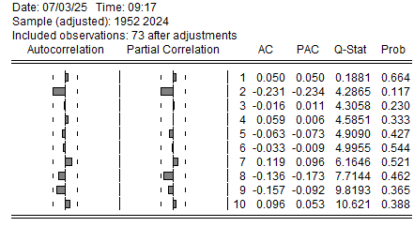
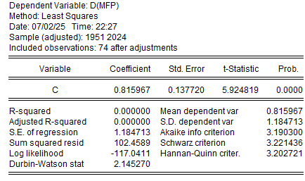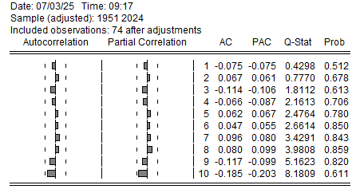

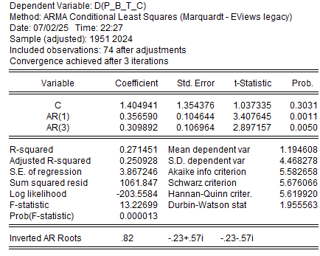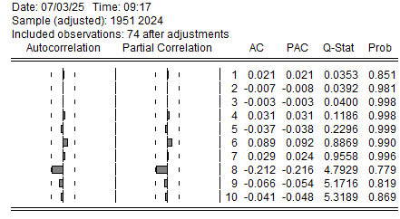

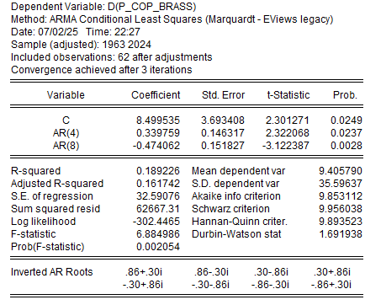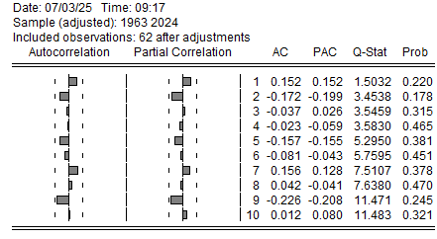

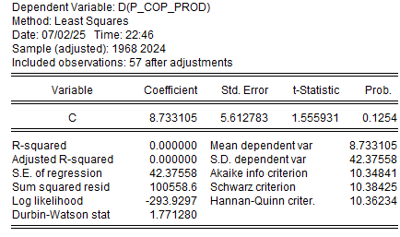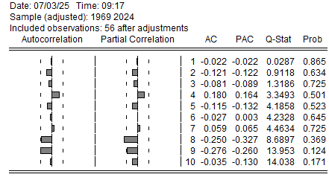

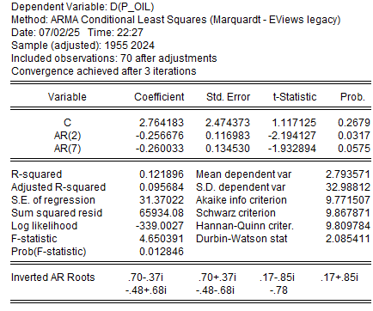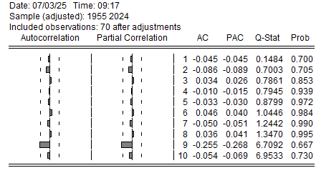

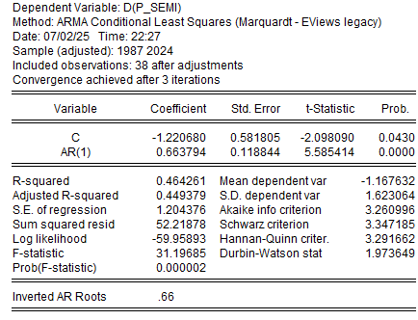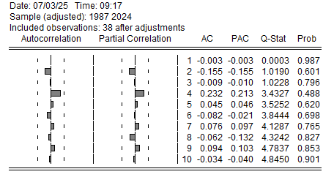

Structural Regressions
GDP_CEP$
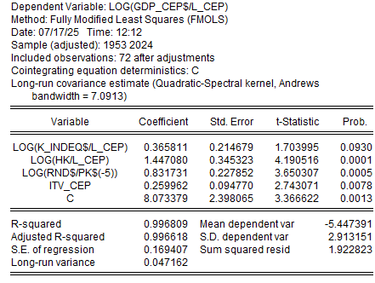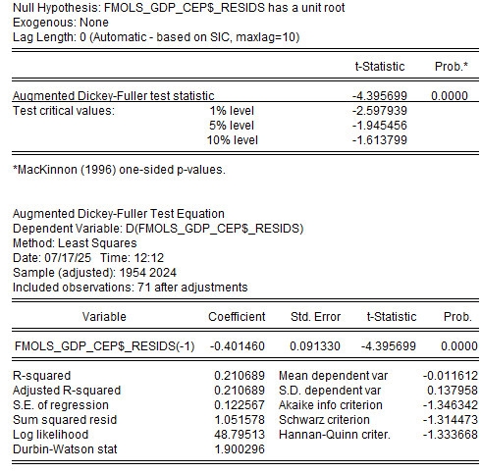


GDP_CEP$ Robustness Check 1
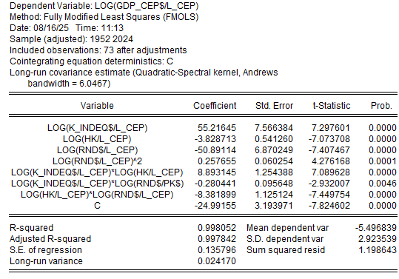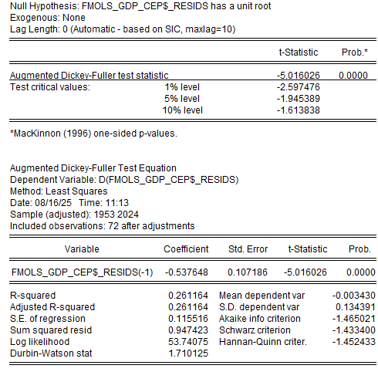


GDP_CEP$ Robustness Check 2
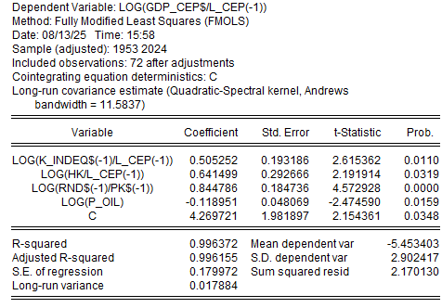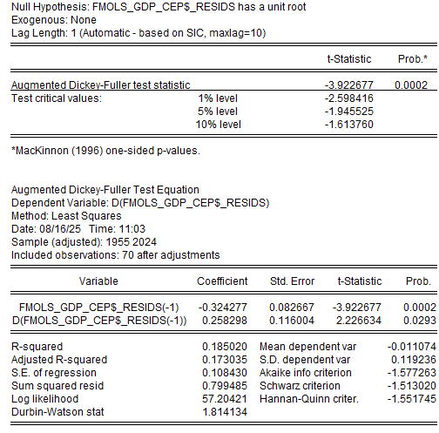


GDP_Info$
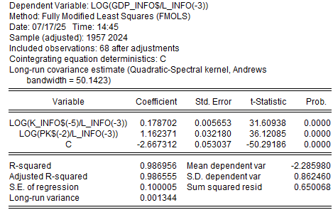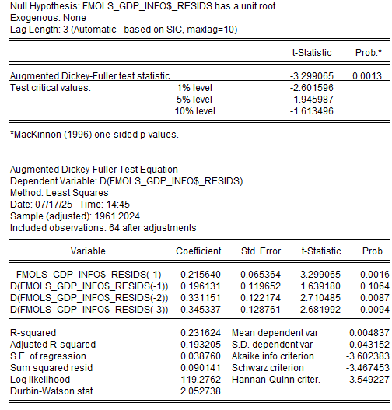


I_P_CEP
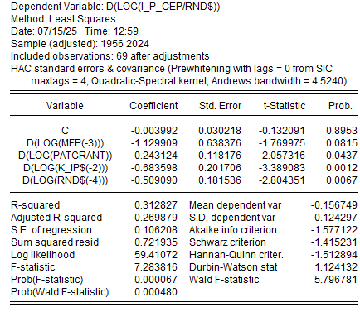


I_P_Info
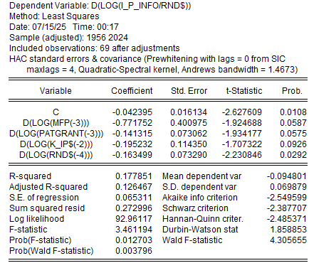

I_P_Tech
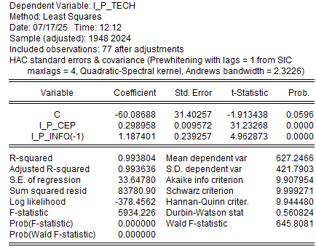

Appendix 5 – Eviews Programming
'-----------------------------------------------------------'
's.levenson Capstone 8.17.2025 '
'-----------------------------------------------------------'

CD F:\ECON\Capstone\Capstone_Workfile

WORKFILE Capstone.WF1 A 1925 2029

READ(B8,S=Annual) Capstone_main.XLS GDP_Tech Log_GDP_Tech REC1 REC2 RnD_NonRes RnD_N RnD$ K K$ K_IP K_IP$ K_Info K_Info$ K_IndEq K_IndEq$ K_Tech K_Tech$ Pk Pk$ L_INFO L_CEP L_SEMI L_ELEC P_Oil P_Semi P_E_C P_Cop_Prod P_Cop_Brass P_B_T_C Hk BAPerc_Pop BAPerc_Pop_S GDP_Info GDP_CEP GDP GDP_Gov GDP_PrivNT GDP$ log_GDP$ GDP_Info$ GDP_CEP$ GDP_Tech$ Log_GDP_Tech$ GDP_PrivNT$ GDP_Gov$ I_P_GDP I_P_Info I_P_CEP I_P_Tech I_P_PrivNT I_P_Gov MFP PatGrant

'-------------------------------------------------------'
' DESCRIPTIVE STATS '
'-------------------------------------------------------'
SERIES D_GDP_TECH$ = D(GDP_Tech$)
'FREEZE D_GDP_TECH$.LINE
'FREEZE D_GDP_TECH$.HISTOGRAM

SERIES D_LOG_GDP_TECH$ = D(LOG(GDP_Tech$))
'FREEZE D_LOG_GDP_TECH$.LINE
'FREEZE D_LOG_GDP_TECH$.HISTOGRAM

SERIES GR_TECH$ = @PC(GDP_TECH$)
'FREEZE GR_TECH$.LINE
'FREEZE GR_TECH$.HISTOGRAM

SERIES DD_GDP_TECH$ = D(D(GDP_TECH$))
'FREEZE DD_GDP_TECH$.LINE
'FREEZE DD_GDP_TECH$.HISTOGRAM

'-------------------------------------------------------'
' STOCHASTIC PROPERTIES '
'-------------------------------------------------------'
GDP_TECH$.IDENT(15)
FREEZE(GDP_TECH$_ADF) GDP_TECH$.UROOT(ADF,N,LAGMETHOD=SIC,MAXLAG=15)
FREEZE(GDP_TECH$_DFGLS) GDP_TECH$.UROOT(DFGLS,C,DIF=0,LAGMETHOD=SIC,MAXLAG=15)
FREEZE(GDP_TECH$_KPSS) GDP_TECH$.UROOT(KPSS,C,HAC=QS,BAND=12)

D_GDP_TECH$.IDENT(15)
FREEZE(D_GDP_TECH$_ADF) D_GDP_TECH$.UROOT(ADF,N,LAGMETHOD=SIC,MAXLAG=15)
FREEZE(D_GDP_TECH$_DFGLS) D_GDP_TECH$.UROOT(DFGLS,C,DIF=0,LAGMETHOD=SIC,MAXLAG=15)
FREEZE(D_GDP_TECH$_KPSS) D_GDP_TECH$.UROOT(KPSS,C,HAC=QS,BAND=12)

D_LOG_GDP_TECH$.IDENT(15)
FREEZE(D_LOG_GDP_TECH$_ADF) D_LOG_GDP_TECH$.UROOT(ADF,N,LAGMETHOD=SIC,MAXLAG=15)
FREEZE(D_LOG_GDP_TECH$_DFGLS) D_LOG_GDP_TECH$.UROOT(DFGLS,C,DIF=0,LAGMETHOD=SIC,MAXLAG=15)
FREEZE(D_LOG_GDP_TECH$_KPSS) D_LOG_GDP_TECH$.UROOT(KPSS,C,HAC=QS,BAND=12)

GR_TECH$.IDENT(15)
FREEZE(GR_TECH$_ADF) GR_TECH$.UROOT(ADF,N,LAGMETHOD=SIC,MAXLAG=15)
FREEZE(GR_TECH$_DFGLS) GR_TECH$.UROOT(DFGLS,C,DIF=0,LAGMETHOD=SIC,MAXLAG=15)
FREEZE(GR_TECH$_KPSS) GR_TECH$.UROOT(KPSS,C,HAC=QS,BAND=12)

DD_GDP_TECH$.IDENT(15)
FREEZE(DD_GDP_TECH$_ADF) DD_GDP_TECH$.UROOT(ADF,N,LAGMETHOD=SIC,MAXLAG=15)
FREEZE(DD_GDP_TECH$_DFGLS) DD_GDP_TECH$.UROOT(DFGLS,C,DIF=0,LAGMETHOD=SIC,MAXLAG=15)
FREEZE(DD_GDP_TECH$_KPSS) DD_GDP_TECH$.UROOT(KPSS,C,HAC=QS,BAND=12)

'-------------------------------------------------------'
' Shock Size '
'-------------------------------------------------------'

EQUATION RSSM1_EQ.LS(COV=HAC, COVLAG=A, COVINFO=SIC, COVKERN=QUADSPEC, COVBW=ANDREWS) D(LOG(GDP_TECH$)) C

RSSM1_EQ.MAKERESIDS RSSM1_RESIDS
SCALAR RSSM1_SD = @STDEV(RSSM1_RESIDS)
SERIES RSSM1=RSSM1_RESIDS/RSSM1_SD
GROUP RSSM1_RESIDS_2 RSSM1_RESIDS RSSM1

FREEZE(RSSM1_ADF) RSSM1.UROOT(ADF,N,LAGMETHOD=SIC,MAXLAG=18)
FREEZE(RSSM1_DFGLS) RSSM1.UROOT(DFGLS,C,DIF=0,LAGMETHOD=SIC,MAXLAG=15)
FREEZE(RSSM1_KPSS) RSSM1.UROOT(KPSS,C,HAC=QS,BAND=12)
EQUATION RSSM2_EQ.LS(COV=HAC, COVLAG=A, COVINFO=SIC, COVKERN=QUADSPEC, COVBW=ANDREWS) D(LOG(GDP_CEP$)) C

RSSM2_EQ.MAKERESIDS RSSM2_RESIDS
SCALAR RSSM2_SD = @STDEV(RSSM2_RESIDS)
SERIES RSSM2=RSSM2_RESIDS/RSSM2_SD
GROUP RSSM2_RESIDS_2 RSSM2_RESIDS RSSM2

FREEZE(RSSM2_ADF) RSSM2.UROOT(ADF,N,LAGMETHOD=SIC,MAXLAG=18)
FREEZE(RSSM2_DFGLS) RSSM2.UROOT(DFGLS,C,DIF=0,LAGMETHOD=SIC,MAXLAG=15)
FREEZE(RSSM2_KPSS) RSSM2.UROOT(KPSS,C,HAC=QS,BAND=12)
EQUATION RSSM3_EQ.LS(COV=HAC, COVLAG=A, COVINFO=SIC, COVKERN=QUADSPEC, COVBW=ANDREWS) D(LOG(GDP_INFO$)) C

RSSM3_EQ.MAKERESIDS RSSM3_RESIDS
SCALAR RSSM3_SD = @STDEV(RSSM3_RESIDS)
SERIES RSSM3=RSSM3_RESIDS/RSSM3_SD
GROUP RSSM3_RESIDS_2 RSSM3_RESIDS RSSM3

FREEZE(RSSM3_ADF) RSSM3.UROOT(ADF,N,LAGMETHOD=SIC,MAXLAG=18)
FREEZE(RSSM3_DFGLS) RSSM3.UROOT(DFGLS,C,DIF=0,LAGMETHOD=SIC,MAXLAG=15)
FREEZE(RSSM3_KPSS) RSSM3.UROOT(KPSS,C,HAC=QS,BAND=12)
EQUATION RSSM4_EQ.LS(COV=HAC, COVLAG=A, COVINFO=SIC, COVKERN=QUADSPEC, COVBW=ANDREWS) D(I_P_CEP) C

RSSM4_EQ.MAKERESIDS RSSM4_RESIDS
SCALAR RSSM4_SD = @STDEV(RSSM4_RESIDS)
SERIES RSSM4=RSSM4_RESIDS/RSSM4_SD
GROUP RSSM4_RESIDS_2 RSSM4_RESIDS RSSM4

FREEZE(RSSM4_ADF) RSSM4.UROOT(ADF,N,LAGMETHOD=SIC,MAXLAG=18)
FREEZE(RSSM4_DFGLS) RSSM4.UROOT(DFGLS,C,DIF=0,LAGMETHOD=SIC,MAXLAG=15)
FREEZE(RSSM4_KPSS) RSSM4.UROOT(KPSS,C,HAC=QS,BAND=12)
EQUATION RSSM5_EQ.LS(COV=HAC, COVLAG=A, COVINFO=SIC, COVKERN=QUADSPEC, COVBW=ANDREWS) D(I_P_INFO) C

RSSM5_EQ.MAKERESIDS RSSM5_RESIDS
SCALAR RSSM5_SD = @STDEV(RSSM5_RESIDS)
SERIES RSSM5=RSSM5_RESIDS/RSSM5_SD
GROUP RSSM5_RESIDS_2 RSSM5_RESIDS RSSM5

FREEZE(RSSM5_ADF) RSSM5.UROOT(ADF,N,LAGMETHOD=SIC,MAXLAG=18)
FREEZE(RSSM5_DFGLS) RSSM5.UROOT(DFGLS,C,DIF=0,LAGMETHOD=SIC,MAXLAG=15)
FREEZE(RSSM5_KPSS) RSSM5.UROOT(KPSS,C,HAC=QS,BAND=12)
'-------------------------------------------------------'
' Inertial Modelling '
'-------------------------------------------------------'

'-- ARIMA --'
SMPL 1947 2024
EQUATION ARIMA_P_Semi.LS(ARMA=CLS) D(P_Semi) C AR(1)
' ARIMA_P_Semi.STATS
ARIMA_P_Semi.MAKERESIDS ARIMA_P_Semi_RESIDS
FREEZE ARIMA_P_Semi_RESIDS.IDENT(10)

EQUATION ARIMA_K$.LS(ARMA=CLS) D(K$) C MA(1)
' ARIMA_K$.STATS
ARIMA_K$.MAKERESIDS ARIMA_K$_RESIDS
FREEZE ARIMA_K$_RESIDS.IDENT(10)

EQUATION ARIMA_K_INFO$.LS(ARMA=CLS) D(K_INFO$) C AR(1)
' ARIMA_K_INFO$.STATS
ARIMA_K_INFO$.MAKERESIDS ARIMA_K_INFO$_RESIDS
FREEZE ARIMA_K_INFO$_RESIDS.IDENT(10)

EQUATION ARIMA_K_INDEQ$.LS(ARMA=CLS) D(LOG(K_INDEQ$)) C AR(3) AR(4)
' ARIMA_K_INDEQ$.STATS
ARIMA_K_INDEQ$.MAKERESIDS ARIMA_K_INDEQ$_RESIDS
FREEZE ARIMA_K_INDEQ$_RESIDS.IDENT(10)

EQUATION ARIMA_K_TECH$.LS(ARMA=CLS) D(K_TECH$) C AR(1)
' ARIMA_K_TECH$.STATS
ARIMA_K_TECH$.MAKERESIDS ARIMA_K_TECH$_RESIDS
FREEZE ARIMA_K_TECH$_RESIDS.IDENT(10)

EQUATION ARIMA_L_INFO.LS(ARMA=CLS) D(L_INFO) C AR(1)
' ARIMA_L_INFO.STATS
ARIMA_L_INFO.MAKERESIDS ARIMA_L_INFO_RESIDS
FREEZE ARIMA_L_INFO_RESIDS.IDENT(10)

EQUATION ARIMA_L_CEP.LS(ARMA=CLS) D(L_CEP) C
' ARIMA_L_CEP.STATS
ARIMA_L_CEP.MAKERESIDS ARIMA_L_CEP_RESIDS
FREEZE ARIMA_L_CEP_RESIDS.IDENT(10)

EQUATION ARIMA_L_SEMI.LS(ARMA=CLS) D(L_SEMI) C AR(1) AR(2)
' ARIMA_L_SEMI.STATS
ARIMA_L_SEMI.MAKERESIDS ARIMA_L_SEMI_RESIDS
FREEZE ARIMA_L_SEMI_RESIDS.IDENT(10)

EQUATION ARIMA_L_ELEC.LS(ARMA=CLS) D(L_ELEC) C
' ARIMA_L_ELEC.STATS
ARIMA_L_ELEC.MAKERESIDS ARIMA_L_ELEC_RESIDS
FREEZE ARIMA_L_ELEC_RESIDS.IDENT(10)

EQUATION ARIMA_P_OIL.LS(ARMA=CLS) D(P_OIL) C AR(2) AR(7)
' ARIMA_P_OIL.STATS
ARIMA_P_OIL.MAKERESIDS ARIMA_P_OIL_RESIDS
FREEZE ARIMA_P_OIL_RESIDS.IDENT(10)

EQUATION ARIMA_P_COP_PROD.LS(ARMA=CLS) D(P_COP_PROD) C AR(8)
' ARIMA_P_COP_PROD.STATS
ARIMA_P_COP_PROD.MAKERESIDS ARIMA_P_COP_PROD_RESIDS
FREEZE ARIMA_P_COP_PROD_RESIDS.IDENT(10)

EQUATION ARIMA_P_COP_BRASS.LS(ARMA=CLS) D(P_COP_BRASS) C AR(4) AR(8)
' ARIMA_P_COP_BRASS.STATS
ARIMA_P_COP_BRASS.MAKERESIDS ARIMA_P_COP_BRASS_RESIDS
FREEZE ARIMA_P_COP_BRASS_RESIDS.IDENT(10)

EQUATION ARIMA_P_B_T_C.LS(ARMA=CLS) D(P_B_T_C) C AR(1) AR(3)
' ARIMA_P_B_T_C.STATS
ARIMA_P_B_T_C.MAKERESIDS ARIMA_P_B_T_C_RESIDS
FREEZE ARIMA_P_B_T_C_RESIDS.IDENT(10)

EQUATION ARIMA_MFP.LS(ARMA=CLS) D(MFP) C
' ARIMA_MFP.STATS
ARIMA_MFP.MAKERESIDS ARIMA_MFP_RESIDS
FREEZE ARIMA_MFP_RESIDS.IDENT(10)

SMPL 2025 2029
%VARS = "P_SEMI K$ K_INFO$ K_INDEQ$ K_TECH$ L_INFO L_CEP L_SEMI L_ELEC P_OIL P_COP_PROD P_COP_BRASS P_B_T_C MFP"

FOR %V {%VARS}
' FORECAST USING ARIMA OBJECT NAMED ARIMA_%V
ARIMA_{%V}.FORECAST {%V}_F

' ASSIGN FORECASTED VALUES BACK TO THE ORIGINAL SERIES
SERIES {%V} = {%V}_F
NEXT

SMPL @ALL

%VARS = "K$ K_INFO$ K_INDEQ$ K_TECH$ L_INFO L_CEP L_SEMI L_ELEC P_SEMI P_OIL P_COP_PROD P_COP_BRASS P_B_T_C MFP PATGRANT HK PK$ K_IP$ RND$"

FOR %V {%VARS}
SERIES GR_{%V} = @PC({%V})
NEXT

SMPL 2019 2029
'--- List of growth rate series
%vars = "GR_K$ GR_K_INFO$ GR_K_INDEQ$ GR_K_TECH$ GR_L_INFO GR_L_CEP GR_L_SEMI GR_L_ELEC GR_P_SEMI GR_P_OIL GR_P_COP_PROD GR_P_COP_BRASS GR_P_B_T_C GR_MFP GR_PATGRANT GR_HK GR_PK$ GR_K_IP$ GR_RND$"

for %v {%vars}
%gname = @replace(%v, "$", "$")
graph {%gname}_LINE.line(b,w) {%v}
{%gname}_LINE.delete text
{%gname}_LINE.draw(shade, bottom, @rgb(230,230,230)) 2025 2029
%titletext = "Growth Rates for " + %v
{%gname}_LINE.addtext(1, -.5, font(cambria, 16, bold)) {%titletext}
{%gname}_LINE.addtext(3.25, .05, font(cambria, 9)) "Forecast (2025-2029)"
{%gname}_LINE.SETELEM(1) LINEWIDTH(3) LINEOPACITY(OFF,1)
{%gname}_LINE.save(t=png, u=in, w=5, d=300) F:\ECON\Capstone\Capstone_Workfile\Charts\{%gname}_LINE
next

'-- VAR --'

'-------------------------------------------------------'
' Model Building '
'-------------------------------------------------------'
'--- ITVs ---'
SMPL @ALL
SERIES STEP_2000=0.0
SMPL 2001 @LAST
SERIES STEP_2000 = 1.0
SMPL @ALL
SERIES SPIKE_2000=0.0
SMPL 2000 2000
SERIES SPIKE_2000 = 1.0

SMPL @ALL
SERIES ITV_CEP=0.0
SMPL 1997 1999
SERIES ITV_CEP=1.0
SMPL 2000 2000
SERIES ITV_CEP=2.0

'-- Structural Regressions --'
SMPL 1947 2024
'------------------------ 1st Block ------------------------'
' -- Usable Variables: MFP, PatGrant, K_IP$, RnD$ '
'-- All must have negative coefficients according to theory '
'-----------------------------------------------------------'
'-- I_P_CEP regression including only MFP and K_IP$
' smpl @all

'-- Total combinations = 6 x 6 x 6 x 6 = 1296
' table(1297,9) tstats_table

'-- Column headers
' tstats_table(1,1) = "MFP_LAG"
' tstats_table(1,2) = "PatGrant_LAG"
' tstats_table(1,3) = "K_IP$_LAG"
' tstats_table(1,4) = "RND$_LAG"
' tstats_table(1,5) = "tstat_DLOG_MFP"
' tstats_table(1,6) = "tstat_DLOG_PatGrant"
' tstats_table(1,7) = "tstat_DLOG_K_IP$"
' tstats_table(1,8) = "tstat_DLOG_RND$"
' tstats_table(1,9) = "tstat_Constant"

' !count = 0

' for !mfp_lag = 0 to 5
' for !pat_lag = 0 to 5
' for !kip_lag = 0 to 5
' for !rnd_lag = 0 to 5

' !count = !count + 1
' %eqname = "eq_" + @str(!count)

'-- Equation: dependent is log(I_P_CEP / RND$), differenced
' %eqstring = "D(LOG(I_P_CEP / RND$)) C " + _
' "D(LOG(MFP(-" + @str(!mfp_lag) + "))) " + _
' "D(LOG(PatGrant(-" + @str(!pat_lag) + "))) " + _
' "D(LOG(K_IP$(-" + @str(!kip_lag) + "))) " + _
' "D(LOG(RND$(-" + @str(!rnd_lag) + ")))"

'-- Estimate equation
' equation {%eqname}.ls(cov=hac, covlag=a, covCEP=sic, covkern=quadspec, covbw=andrews) {%eqstring}

'-- Store lag settings
' tstats_table(!count + 1, 1) = @str(!mfp_lag)
' tstats_table(!count + 1, 2) = @str(!pat_lag)
' tstats_table(!count + 1, 3) = @str(!kip_lag)
' tstats_table(!count + 1, 4) = @str(!rnd_lag)

'-- Store t-stats (order: 1=const, 2=MFP, 3=PatGrant, 4=K_IP$, 5=RND$)
' tstats_table(!count + 1, 5) = @str({%eqname}.@tstats(2))
' tstats_table(!count + 1, 6) = @str({%eqname}.@tstats(3))
' tstats_table(!count + 1, 7) = @str({%eqname}.@tstats(4))
' tstats_table(!count + 1, 8) = @str({%eqname}.@tstats(5))
' tstats_table(!count + 1, 9) = @str({%eqname}.@tstats(1))

' next
' next
' next
' next

'-- Show and export
' show tstats_table
' tstats_table.save(t=xlsx) "F:\ECON\CAPSTONE\CAPSTONE_WORKFILE\INDUSTRY_DEFLATOR_CEP_OLS_YDIVRND_RESULTS.xlsx"

EQUATION OLS_I_P_CEP.LS(COV=HAC, COVLAG=A, COVINFO=SIC, COVKERN=QUADSPEC, COVBW=ANDREWS) D(LOG(I_P_CEP / RND$)) C D(LOG(MFP(-3))) D(LOG(PATGRANT(-0))) D(LOG(K_IP$(-2))) D(LOG(RND$(-4)))
EQUATION FMOLS_I_P_CEP.COINTREG(METHOD=FMOLS,KERN=QUADSPEC,BW=ANDREWS) LOG(I_P_CEP) C LOG(MFP) LOG(PatGrant) LOG(K_IP$) LOG(RND$)
FMOLS_I_P_CEP.MAKERESIDS FMOLS_I_P_CEP_RESIDS
FREEZE(I_P_CEP_RESIDS_ADF) FMOLS_I_P_CEP_RESIDS.UROOT(ADF,N,LAGMETHOD=SIC,MAXLAG=10)

'-- I_P_Info
EQUATION OLS_I_P_Info.LS(COV=HAC, COVLAG=A, COVINFO=SIC, COVKERN=QUADSPEC, COVBW=ANDREWS) D(LOG(I_P_INFO/RND$)) C D(LOG(MFP(-3))) D(LOG(PATGRANT(-3))) D(LOG(K_IP$(-2))) D(LOG(RND$(-4)))
EQUATION FMOLS_I_P_Info.COINTREG(METHOD=FMOLS,KERN=QUADSPEC,BW=ANDREWS) LOG(I_P_Info) C LOG(MFP) LOG(RnD$) LOG(PatGrant(-4))
FMOLS_I_P_Info.MAKERESIDS FMOLS_I_P_Info_RESIDS
FREEZE(I_P_Info_RESIDS_ADF) FMOLS_I_P_Info_RESIDS.UROOT(ADF,N,LAGMETHOD=SIC,MAXLAG=10)

'------------------------ 2nd Block ------------------------'
' -- Useable Variables:
'
'-----------------------------------------------------------'
'-- I_P_Tech Tautology

EQUATION OLS_I_P_Tech.LS(COV=HAC, COVLAG=A, COVINFO=SIC, COVKERN=QUADSPEC, COVBW=ANDREWS) I_P_Tech C I_P_CEP I_P_INFO(-1)

'EQUATION FMOLS_I_P_Tech.COINTREG(METHOD=FMOLS,KERN=QUADSPEC,BW=ANDREWS) I_P_Tech C I_P_CEP I_P_INFO(-1)
' FMOLS_I_P_Tech.MAKERESIDS FMOLS_I_P_Tech_RESIDS
' FREEZE(I_P_Tech_RESIDS_ADF) FMOLS_I_P_Tech_RESIDS.UROOT(ADF,N,LAGMETHOD=SIC,MAXLAG=10)

'------------------------ 3rd Block ------------------------'
' -- Useable Variables:
'
'-----------------------------------------------------------'

'-- GDP_CEP$
'smpl @all
'table(2000,15) adf_results_table
'adf_results_table(1,1) = "K_INDEQ$_LAG"
'adf_results_table(1,2) = "HK_LAG"
'adf_results_table(1,3) = "L_CEP_LAG"
'adf_results_table(1,4) = "PK_LAG"
'adf_results_table(1,5) = "RND_LAG"
'adf_results_table(1,6) = "P_OIL_LAG"
'adf_results_table(1,7) = "ADF_STAT"
'adf_results_table(1,8) = "ADF_LAG"
'adf_results_table(1,9) = "ADF_CRIT_5PCT"
'adf_results_table(1,10) = "TSTAT_K_INDEQ$"
'adf_results_table(1,11) = "TSTAT_HK"
'adf_results_table(1,12) = "TSTAT_RND$"
'adf_results_table(1,13) = "TSTAT_P_OIL"
'adf_results_table(1,14) = "TSTAT_CONST"
'
'!count = 0
'
'for !k_lag = 0 to 2
'for !hk_lag = 0 to 2
'for !l_lag = 0 to 2
'for !pk_lag = 0 to 2
'for !rnd_lag = 0 to 2
'for !oil_lag = 0 to 5
'
' !count = !count + 1
' %eqname = "eq_" + @str(!count)
' %residname = "resid_" + @str(!count)
' %uresulttab = "ures_" + @str(!count)
' %temp_tab = "temp_table_" + @str(!count)
'
' ' Build regression equation string with only P_OIL
' %eqstring = "LOG(GDP_CEP$/L_CEP(-" + @str(!l_lag) + ")) C " + _
' "LOG(K_INDEQ$(-" + @str(!k_lag) + ")/L_CEP(-" + @str(!l_lag) + ")) " + _
' "LOG(HK(-" + @str(!hk_lag) + ")/L_CEP(-" + @str(!l_lag) + ")) " + _
' "LOG(RND$(-" + @str(!rnd_lag) + ")/PK$(-" + @str(!pk_lag) + ")) " + _
' "LOG(P_OIL(-" + @str(!oil_lag) + ")) "
'
' ' Run FMOLS regression
' equation {%eqname}.cointreg(method=fmols, kern=quadspec, bw=andrews) {%eqstring}
'
' ' Save residuals
' {%eqname}.makeresids {%residname}
'
' ' Run ADF test on residuals
' freeze({%uresulttab}) {%residname}.uroot(adf, n, lagmethod=sic, maxlag=10)
'
' ' Copy ADF output to temporary table
' table {%temp_tab}
' {%uresulttab}.copyrange D7 F7 {%temp_tab} A1
'
' !adf_stat = @val({%temp_tab}(1,1))
' !adf_lag = @val({%temp_tab}(1,2))
' !adf_crit5 = @val({%temp_tab}(1,3))
'
' ' Extract t-stats (order: K_INDEQ$, HK, RND$, P_OIL, CONST)
' !tstat_k = {%eqname}.@tstats(1)
' !tstat_hk = {%eqname}.@tstats(2)
' !tstat_rnd = {%eqname}.@tstats(3)
' !tstat_oil = {%eqname}.@tstats(4)
' !tstat_const = {%eqname}.@tstats(5)

' ' Store results
' adf_results_table(!count + 1, 1) = @str(!k_lag)
' adf_results_table(!count + 1, 2) = @str(!hk_lag)
' adf_results_table(!count + 1, 3) = @str(!l_lag)
' adf_results_table(!count + 1, 4) = @str(!pk_lag)
' adf_results_table(!count + 1, 5) = @str(!rnd_lag)
' adf_results_table(!count + 1, 6) = @str(!oil_lag)
' adf_results_table(!count + 1, 7) = @str(!adf_stat)
' adf_results_table(!count + 1, 8) = @str(!adf_lag)
' adf_results_table(!count + 1, 9) = @str(!adf_crit5)
' adf_results_table(!count + 1, 10) = @str(!tstat_k)
' adf_results_table(!count + 1, 11) = @str(!tstat_hk)
' adf_results_table(!count + 1, 12) = @str(!tstat_rnd)
' adf_results_table(!count + 1, 13) = @str(!tstat_oil)
' adf_results_table(!count + 1, 14) = @str(!tstat_const)

'next
'next
'next
'next
'next
'next

' show adf_results_table

EQUATION FMOLS_GDP_CEP$.COINTREG(METHOD=FMOLS,KERN=QUADSPEC,BW=ANDREWS) LOG(GDP_CEP$/L_CEP) C LOG(K_INDEQ$/L_CEP) LOG(HK/L_CEP) LOG(RND$/PK$(-5)) ITV_CEP
' EQUATION FMOLS_GDP_CEP$.COINTREG(METHOD=FMOLS,KERN=QUADSPEC,BW=ANDREWS) LOG(GDP_CEP$/L_CEP(-1)) C LOG(K_INDEQ$(-1)/L_CEP(-1)) LOG(HK/L_CEP(-1)) LOG(RND$(-1)/PK$(-1)) LOG(P_OIL)
' EQUATION FMOLS_GDP_CEP$.COINTREG(METHOD=FMOLS,KERN=QUADSPEC,BW=ANDREWS) LOG(GDP_CEP$/L_CEP()) C LOG(K_INDEQ$(-1)/L_CEP()) LOG(HK/L_CEP()) LOG(RND$()/PK$(-2)) LOG(P_OIL) SPIKE_2000
' EQUATION FMOLS_GDP_CEP$.COINTREG(METHOD=FMOLS,KERN=QUADSPEC,BW=ANDREWS) LOG(GDP_CEP$/L_CEP) C LOG(K_INDEQ$/L_CEP) LOG(HK/L_CEP) LOG(RND$/L_CEP) LOG(RND$/L_CEP)^2 LOG(K_INDEQ$/L_CEP)*LOG(HK/L_CEP) LOG(K_INDEQ$/L_CEP)*LOG(RND$/PK$()) LOG(HK/L_CEP)*LOG(RND$/L_CEP)

FMOLS_GDP_CEP$.MAKERESIDS FMOLS_GDP_CEP$_RESIDS
FREEZE(GDP_CEP$_RESIDS_ADF) FMOLS_GDP_CEP$_RESIDS.UROOT(ADF,N,LAGMETHOD=SIC,MAXLAG=10)

SCALAR RSSM_CEP$_SD = @STDEV(FMOLS_GDP_CEP$_RESIDS)
SERIES RSSM_CEP$=FMOLS_GDP_CEP$_RESIDS/RSSM_CEP$_SD
GROUP RSSM_RESIDS_2 FMOLS_GDP_CEP$_RESIDS RSSM_CEP$

FREEZE(RSSM_CEP$_ADF) RSSM_CEP$.UROOT(ADF,N,LAGMETHOD=SIC,MAXLAG=18)

'-- GDP_Info$
' smpl @all
' table(216,10) adf_results_table
' adf_results_table(1,1) = "K_INFO$_LAG"
' adf_results_table(1,2) = "PK$_LAG"
' adf_results_table(1,3) = "L_INFO_LAG"
' adf_results_table(1,4) = "ADF_STAT"
' adf_results_table(1,5) = "ADF_LAG"
' adf_results_table(1,6) = "ADF_CRIT_5PCT"
' adf_results_table(1,7) = "TSTAT_K_INFO$"
' adf_results_table(1,8) = "TSTAT_PK$"
' adf_results_table(1,9)= "TSTAT_CONST"
' !count = 0
' for !k_lag = 0 to 5
' for !pk_lag = 0 to 5
' for !l_lag = 0 to 5
' !count = !count + 1
' %eqname = "eq_" + @str(!count)
' %residname = "resid_" + @str(!count)
' %uresulttab = "ures_" + @str(!count)
' %temp_tab = "temp_table_" + @str(!count)
' %eqstring = "LOG(GDP_INFO$/L_INFO(-" + @str(!l_lag) + ")) C " + _
' "LOG(K_INFO$(-" + @str(!k_lag) + ")/L_INFO(-" + @str(!l_lag) + ")) " + _
' "LOG(PK$(-" + @str(!pk_lag) + ")/L_INFO(-" + @str(!l_lag) + "))"
' equation {%eqname}.cointreg(method=fmols, kern=quadspec, bw=andrews) {%eqstring}
' {%eqname}.makeresids {%residname}
' freeze({%uresulttab}) {%residname}.uroot(adf, n, lagmethod=sic, maxlag=10)
' table {%temp_tab}
' {%uresulttab}.copyrange D7 F7 {%temp_tab} A1
' !adf_stat = @val({%temp_tab}(1,1))
' !adf_lag = @val({%temp_tab}(1,2))
' !adf_crit5 = @val({%temp_tab}(1,3))
' ' Extract t-stats from the equation object
' !tstat_k = {%eqname}.@tstats(1)
' !tstat_pk = {%eqname}.@tstats(2)
' !tstat_const = {%eqname}.@tstats(3)
' adf_results_table(!count + 1, 1) = @str(!k_lag)
' adf_results_table(!count + 1, 2) = @str(!pk_lag)
' adf_results_table(!count + 1, 3) = @str(!l_lag)
' adf_results_table(!count + 1, 4) = @str(!adf_stat)
' adf_results_table(!count + 1, 5) = @str(!adf_lag)
' adf_results_table(!count + 1, 6) = @str(!adf_crit5)
' adf_results_table(!count + 1, 7) = @str(!tstat_k)
' adf_results_table(!count + 1, 8) = @str(!tstat_pk)
' adf_results_table(!count + 1, 9) = @str(!tstat_const)
' next
' next
' next
' show adf_results_table

EQUATION FMOLS_GDP_INFO$.COINTREG(METHOD=FMOLS,KERN=QUADSPEC,BW=ANDREWS) LOG(GDP_INFO$/L_INFO(-3)) C LOG(K_INFO$(-5)/L_INFO(-3)) LOG(PK$(-2)/L_INFO(-3))
FMOLS_GDP_Info$.MAKERESIDS FMOLS_GDP_Info$_RESIDS
FREEZE(GDP_Info$_RESIDS_ADF) FMOLS_GDP_Info$_RESIDS.UROOT(ADF,N,LAGMETHOD=SIC,MAXLAG=10)

SCALAR RSSM_Info$_SD = @STDEV(FMOLS_GDP_Info$_RESIDS)
SERIES RSSM_Info$=FMOLS_GDP_Info$_RESIDS/RSSM_Info$_SD
GROUP RSSM_RESIDS_3 FMOLS_GDP_Info$_RESIDS RSSM_Info$

FREEZE(RSSM_Info$_ADF) RSSM_Info$.UROOT(ADF,N,LAGMETHOD=SIC,MAXLAG=18)

'-- Model Build --'
MODEL CAPSTONE_MOD

SERIES GDP_TECH2 = GDP_INFO + GDP_CEP
SERIES GDP_TECH_SD = GDP_TECH - GDP_TECH2

'CAPSTONE_MOD.MERGE FMOLS_I_P_CEP
'CAPSTONE_MOD.MERGE FMOLS_I_P_Info
'CAPSTONE_MOD.MERGE FMOLS_I_P_Tech
CAPSTONE_MOD.MERGE OLS_I_P_CEP
CAPSTONE_MOD.MERGE OLS_I_P_Info
CAPSTONE_MOD.MERGE OLS_I_P_Tech

CAPSTONE_MOD.MERGE FMOLS_GDP_CEP$
CAPSTONE_MOD.MERGE FMOLS_GDP_Info$

CAPSTONE_MOD.APPEND GDP_Tech$ = GDP_CEP$ + GDP_Info$
CAPSTONE_MOD.APPEND GDP_Tech = GDP_Tech$ * (I_P_Tech/100)
CAPSTONE_MOD.APPEND GDP_INFO = GDP_INFO$ * (I_P_INFO/100)
CAPSTONE_MOD.APPEND GDP_CEP = GDP_CEP$ * (I_P_CEP/100)
CAPSTONE_MOD.APPEND GDP_TECH2 = GDP_INFO + GDP_CEP
CAPSTONE_MOD.APPEND GDP_TECH_SD = GDP_TECH - GDP_TECH2

'------------------------------------------------------'
' Forecasting '
'------------------------------------------------------'
'-HISTORICAL SOLVE-'
'AKA IN SAMPLE FORECAST'

CAPSTONE_MOD.APPEND ASSIGN @ALL _SH
SMPL 2015 2019
CAPSTONE_MOD.SOLVE

'------------------------------------------------------'
' Scenarios '
'------------------------------------------------------'
'-- SETUP --'
SMPL @FIRST 2024
%VARS = "PK$ HK RND$ K_IP$ PATGRANT"

FOR %V {%VARS}
SERIES GR_{%V} = @PC({%V})
NEXT

SMPL 2025 2029

'-- BASE CASE --'
GR_PK$.FILL(S) 1.00, 1.50, 2.00, 2.50, 2.50
GR_HK.FILL(S) 0.12, 0.12, 0.12, 0.12, 0.12
GR_RND$.FILL(S) 7.33, 7.68, 8.00, 8.00, 8.00
GR_K_IP$.FILL(S) 8.40, 8.70, 9.00, 9.00, 9.00
GR_PATGRANT.FILL(S) -2.50, -1.50, -0.50, 1.50, 2.50

FOR %V {%VARS}
SERIES {%V} = {%V}(-1)*(1 + GR_{%V}/100)
NEXT
CAPSTONE_MOD.APPEND ASSIGN @ALL _BASE

CAPSTONE_MOD.ADDASSIGN(V) GDP_CEP$ GDP_INFO$ I_P_TECH
SERIES GDP_CEP$_A = -152
SERIES GDP_INFO$_A = +400
SERIES I_P_TECH_A = +15

CAPSTONE_MOD.SOLVE

'-- OPTIMISTIC CASE --'
GR_PK$.FILL(S) 2.00, 3.00, 4.00, 4.50, 5.50
GR_HK.FILL(S) 0.22, 0.22, 0.22, 0.22, 0.22
GR_RND$.FILL(S) 9.00, 10.00, 11.00, 12.00, 14.00
GR_K_IP$.FILL(S) 9.00, 10.00, 11.00, 12.00, 14.00
GR_PATGRANT.FILL(S) 0.00, 1.00, 2.50, 4.50, 7.00

FOR %V {%VARS}
SERIES {%V} = {%V}(-1)*(1 + GR_{%V}/100)
NEXT
CAPSTONE_MOD.APPEND ASSIGN @ALL _OPT

CAPSTONE_MOD.ADDASSIGN(V) GDP_CEP$ GDP_INFO$ I_P_TECH
SERIES GDP_CEP$_A = -152
SERIES GDP_INFO$_A = +400
SERIES I_P_TECH_A = +15

CAPSTONE_MOD.SOLVE

'-- PESSIMISTIC CASE --'
GR_PK$.FILL(S) 0.50, 0.00, -0.50, -1.00, -1.50
GR_HK.FILL(S) 0.06, 0.06, 0.06, 0.06, 0.06
GR_RND$.FILL(S) 6.00, 5.00, 4.00, 3.00, 2.00
GR_K_IP$.FILL(S) 7.00, 6.50, 5.50, 4.50, 3.50
GR_PATGRANT.FILL(S) -2.50, -3.00, -3.50, -4.00, -4.50

FOR %V {%VARS}
SERIES {%V} = {%V}(-1)*(1 + GR_{%V}/100)
NEXT
CAPSTONE_MOD.APPEND ASSIGN @ALL _PESS

CAPSTONE_MOD.ADDASSIGN(V) GDP_CEP$ GDP_INFO$ I_P_TECH
SERIES GDP_CEP$_A = -152
SERIES GDP_INFO$_A = +400
SERIES I_P_TECH_A = +15

CAPSTONE_MOD.SOLVE

'------------------------------------------------------'
' Competitor VARs '
'------------------------------------------------------'
'-- Growth Factors --'
SMPL 1947 2024
VAR BVAR_1.BVAR 1 2 D(LOG(GDP_Info$)) D(LOG(RnD$)) D(LOG(MFP)) D(LOG(GDP_CEP$)) @ C
FREEZE(RESULTS_BVAR_1) BVAR_1.RESULTS
FREEZE(ROOTS_BVAR_1) BVAR_1.ARROOTS
' FREEZE(LAGLEN_BVAR_1) BVAR_1.LAGLEN(10)
' FREEZE(TESTEXOG_BVAR_1) BVAR_1.TESTEXOG(10)
BVAR_1.MAKEMODEL(BVAR_1_MOD)

BVAR_1_MOD.APPEND ASSIGN @ALL _BVH1
SMPL 2015 2019
BVAR_1_MOD.SOLVE

BVAR_1_MOD.APPEND ASSIGN @ALL _BVF1
SMPL 2025 2029
BVAR_1_MOD.SOLVE
SMPL @ALL
SERIES GDP_TECH$_BVF1 = GDP_INFO$_BVF1 + GDP_CEP$_BVF1
'-----------------------------------------------------------'
SMPL 1947 2024
VAR VAR_1.LS 1 2 D(LOG(GDP_Info$)) D(LOG(RnD$)) D(LOG(MFP)) D(LOG(GDP_CEP$)) @ C
FREEZE(RESULTS_VAR_1) VAR_1.RESULTS
FREEZE(ROOTS_VAR_1) VAR_1.ARROOTS
FREEZE(LAGLEN_VAR_1) VAR_1.LAGLEN(10)
FREEZE(TESTEXOG_VAR_1) VAR_1.TESTEXOG(10)
VAR_1.MAKEMODEL(VAR_1_MOD)

VAR_1_MOD.APPEND ASSIGN @ALL _VH1
SMPL 2015 2019
VAR_1_MOD.SOLVE

VAR_1_MOD.APPEND ASSIGN @ALL _VF1

SMPL 2025 2029
VAR_1_MOD.SOLVE
SMPL @ALL
SERIES GDP_TECH$_VF1 = GDP_INFO$_VF1 + GDP_CEP$_VF1
'---------------------------'
'-- Capital Inputs
SMPL 1947 2024
VAR BVAR_2.BVAR 1 3 D(LOG(GDP_Info$)) D(LOG(K_Info$)) D(LOG(K_INDEQ$)) D(LOG(GDP_CEP$)) @ C
FREEZE(RESULTS_BVAR_2) BVAR_2.RESULTS
FREEZE(ROOTS_BVAR_2) BVAR_2.ARROOTS
' FREEZE(LAGLEN_BVAR_2) BVAR_2.LAGLEN(10)
' FREEZE(TESTEXOG_BVAR_2) BVAR_2.TESTEXOG(10)
BVAR_2.MAKEMODEL(BVAR_2_MOD)

BVAR_2_MOD.APPEND ASSIGN @ALL _BVH2
SMPL 2015 2019
BVAR_2_MOD.SOLVE

BVAR_2_MOD.APPEND ASSIGN @ALL _BVF2

SMPL 2025 2029
BVAR_2_MOD.SOLVE
SMPL @ALL
SERIES GDP_TECH$_BVF2 = GDP_INFO$_BVF2 + GDP_CEP$_BVF2
'----------------------------'
SMPL 1947 2024
VAR VAR_2.LS 1 3 D(LOG(GDP_Info$)) D(LOG(K_Info$)) D(LOG(K_INDEQ$)) D(LOG(GDP_CEP$)) @ C
FREEZE(RESULTS_VAR_2) VAR_2.RESULTS
FREEZE(ROOTS_VAR_2) VAR_2.ARROOTS
FREEZE(LAGLEN_VAR_2) VAR_2.LAGLEN(10)
FREEZE(TESTEXOG_VAR_2) VAR_2.TESTEXOG(10)
VAR_2.MAKEMODEL(VAR_2_MOD)

VAR_2_MOD.APPEND ASSIGN @ALL _VH2
SMPL 2015 2019
VAR_2_MOD.SOLVE

VAR_2_MOD.APPEND ASSIGN @ALL _VF2

SMPL 2025 2029
VAR_2_MOD.SOLVE
SMPL @ALL
SERIES GDP_TECH$_VF2 = GDP_INFO$_VF2 + GDP_CEP$_VF2

'------------------------------------------------------'
' Forecast Charts '
'------------------------------------------------------'
SMPL 2015 2029
%vars = "GDP_INFO$ GDP_CEP$ GDP_TECH$ GDP_TECH GDP_INFO GDP_CEP GDP_TECH2 I_P_CEP I_P_INFO I_P_TECH"
for %v {%vars}
%groupname = %v + "_FCST_SCN"
group {%groupname} @pc({%v}_BASE) @pc({%v}_OPT) @pc({%v}_PESS) @pc({%v})
%graphname = %groupname + "_G"
graph {%graphname}.LINE {%groupname}
%titletext = "Scenario Forecasting for " + %v
{%graphname}.addtext(1,-.5,font(cambria,16)) {%titletext}
{%graphname}.draw(shade, bottom, @rgb(230,230,230)) 2025 2029
{%graphname}.setelem(4) legend("Annual Growth (Historical)") linecolor(@rgb(0,0,0)) LINEWIDTH(3) LINEOPACITY(OFF,1)
{%graphname}.setelem(1) legend("Annual Growth (Baseline)") linecolor(@rgb(255,0,0)) LINEWIDTH(3) LINEOPACITY(OFF,1)
{%graphname}.setelem(2) legend("Annual Growth (Optimistic)") linecolor(@rgb(0,255,0)) LINEWIDTH(3) LINEOPACITY(OFF,1)
{%graphname}.setelem(3) legend("Annual Growth (Pessimistic)") linecolor(@rgb(0,0,255)) LINEWIDTH(3) LINEOPACITY(OFF,1)
{%graphname}.save(t=png, u=in, w=5, d=300) F:\ECON\Capstone\Capstone_Workfile\Charts\{%v}_FCST.png
next

SMPL 2025 2029
SERIES RND$ = NA
SERIES MFP = NA
SMPL 2015 2029
%vars = "GDP_Info$ RnD$ MFP GDP_CEP$ GDP_TECH$"
for %v {%vars}
%groupname = %v + "_FCST_SCN_BVF"
group {%groupname} @pc({%v}_BVF1) @pc({%v}_VF1) @pc({%v})
%graphname = %groupname + "_G"
graph {%graphname}.LINE {%groupname}
%titletext = "Competitor Forecast 1 for " + %v
{%graphname}.addtext(1,-.5,font(cambria,16)) {%titletext}
{%graphname}.draw(shade, bottom, @rgb(230,230,230)) 2025 2029
{%graphname}.setelem(3) legend("Annual Growth (Historical)") linecolor(@rgb(0,0,0)) LINEWIDTH(3) LINEOPACITY(OFF,1)
{%graphname}.setelem(1) legend("Annual Growth (BVAR1)") linecolor(@rgb(255,0,0)) LINEWIDTH(3)
{%graphname}.setelem(2) legend("Annual Growth (VAR1)") linecolor(@rgb(0,255,0)) LINEWIDTH(3) LINEOPACITY(OFF,1)
{%graphname}.save(t=png, u=in, w=5, d=300) F:\ECON\Capstone\Capstone_Workfile\Charts\{%v}_FCST_VF1.png
next

SMPL 2025 2029
SERIES K_Info$ = NA
SERIES K_IndEq$ = NA
SMPL 2015 2029
%vars = "GDP_Info$ K_Info$ K_IndEq$ GDP_CEP$ GDP_TECH$"
for %v {%vars}
%groupname = %v + "_FCST_SCN_VF"
group {%groupname} @pc({%v}_BVF2) @pc({%v}_VF2) @pc({%v})
%graphname = %groupname + "_G"
graph {%graphname}.LINE {%groupname}
%titletext = "Competitor Forecast 2 for " + %v
{%graphname}.addtext(1,-.5,font(cambria,16)) {%titletext}
{%graphname}.draw(shade, bottom, @rgb(230,230,230)) 2025 2029
{%graphname}.setelem(3) legend("Annual Growth (Historical)") linecolor(@rgb(0,0,0)) LINEWIDTH(3) LINEOPACITY(OFF,1)
{%graphname}.setelem(1) legend("Annual Growth (BVAR2)") linecolor(@rgb(255,0,0)) LINEWIDTH(3)
{%graphname}.setelem(2) legend("Annual Growth (VAR2)") linecolor(@rgb(0,255,0)) LINEWIDTH(3) LINEOPACITY(OFF,1)
{%graphname}.save(t=png, u=in, w=5, d=300) F:\ECON\Capstone\Capstone_Workfile\Charts\{%v}_FCST_VF2.png
next

SMPL 2015 2024

SERIES GR_PK$_BASE = GR_PK$
SERIES GR_HK_BASE = GR_HK
SERIES GR_RND$_BASE = GR_RND$
SERIES GR_K_IP$_BASE = GR_K_IP$
SERIES GR_PATGRANT_BASE = GR_PATGRANT
SERIES GR_K_INFO$_BASE = GR_K_INFO$

SERIES GR_PK$_OPT = GR_PK$
SERIES GR_HK_OPT = GR_HK
SERIES GR_RND$_OPT = GR_RND$
SERIES GR_K_IP$_OPT = GR_K_IP$
SERIES GR_PATGRANT_OPT = GR_PATGRANT
SERIES GR_K_INFO$_OPT = GR_K_INFO$_OPT

SERIES GR_PK$_PESS = GR_PK$
SERIES GR_HK_PESS = GR_HK
SERIES GR_RND$_PESS = GR_RND$
SERIES GR_K_IP$_PESS = GR_K_IP$
SERIES GR_PATGRANT_PESS = GR_PATGRANT

SMPL 2025 2029
GR_PK$_BASE.FILL(S) 1.00, 1.50, 2.00, 2.50, 2.50
GR_HK_BASE.FILL(S) 0.12, 0.12, 0.12, 0.12, 0.12
GR_RND$_BASE.FILL(S) 7.33, 7.68, 8.00, 8.00, 8.00
GR_K_IP$_BASE.FILL(S) 8.40, 8.70, 9.00, 9.00, 9.00
GR_PATGRANT_BASE.FILL(S) -2.50, -1.50, -0.50, 1.50, 2.50

GR_PK$_OPT.FILL(S) 2.00, 3.00, 4.00, 4.50, 5.50
GR_HK_OPT.FILL(S) 0.22, 0.22, 0.22, 0.22, 0.22
GR_RND$_OPT.FILL(S) 9.00, 10.00, 11.00, 12.00, 14.00
GR_K_IP$_OPT.FILL(S) 9.00, 10.00, 11.00, 12.00, 14.00
GR_PATGRANT_OPT.FILL(S) 0.00, 1.00, 2.50, 4.50, 7.00

GR_PK$_PESS.FILL(S) 0.50, 0.00, -0.50, -1.00, -1.50
GR_HK_PESS.FILL(S) 0.06, 0.06, 0.06, 0.06, 0.06
GR_RND$_PESS.FILL(S) 6.00, 5.00, 4.00, 3.00, 2.00
GR_K_IP$_PESS.FILL(S) 7.00, 6.50, 5.50, 4.50, 3.50
GR_PATGRANT_PESS.FILL(S) -2.50, -3.00, -3.50, -4.00, -4.50

SERIES GR_PK$ = NA
SERIES GR_HK = NA
SERIES GR_RND$ = NA
SERIES GR_K_IP$ = NA
SERIES GR_PATGRANT = NA
SMPL 2015 2029
%vars = "GR_PK$ GR_HK GR_RND$ GR_K_IP$ GR_PATGRANT"
for %v {%vars}
%groupname = %v + "_FCST_SCN"
group {%groupname} ({%v}_BASE) ({%v}_OPT) ({%v}_PESS) ({%v})
%graphname = %groupname + "_G"
graph {%graphname}.LINE {%groupname}
%titletext = "Scenario Forecasting for " + %v
{%graphname}.addtext(1,-.5,font(cambria,16)) {%titletext}
{%graphname}.draw(shade, bottom, @rgb(230,230,230)) 2025 2029
{%graphname}.setelem(4) legend("Annual Growth (Historical)") linecolor(@rgb(0,0,0)) LINEWIDTH(3) LINEOPACITY(OFF,1)
{%graphname}.setelem(1) legend("Annual Growth (Baseline)") linecolor(@rgb(255,0,0)) LINEWIDTH(3) LINEOPACITY(OFF,1)
{%graphname}.setelem(2) legend("Annual Growth (Optimistic)") linecolor(@rgb(0,255,0)) LINEWIDTH(3) LINEOPACITY(OFF,1)
{%graphname}.setelem(3) legend("Annual Growth (Pessimistic)") linecolor(@rgb(0,0,255)) LINEWIDTH(3) LINEOPACITY(OFF,1)
{%graphname}.save(t=png, u=in, w=5, d=300) F:\ECON\Capstone\Capstone_Workfile\Charts\{%v}_FCST.png
next

%VARS = "GDP_CEP$ GDP_INFO$ GDP_TECH$"
FOR %v {%VARS}
%GROUPNAME = %V + "_FCST_COMP"
GROUP {%GROUPNAME} @PC({%V}_BVF1) @PC({%V}_VF1) @PC({%V}_BVF2) @PC({%V}_VF2) @PC({%V}_BASE) @PC({%V})
%GRAPHNAME = %GROUPNAME +"_G"
GRAPH {%GRAPHNAME}.LINE {%GROUPNAME}
%titletext = "Scenario Forecast Comparison for " + %V
{%GRAPHNAME}.addtext(0.5,-.5,font(cambria,16)) {%titletext}
{%GRAPHNAME}.draw(shade, bottom, @rgb(230,230,230)) 2025 2029
{%GRAPHNAME}.setelem(6) legend("Annual Growth (Historical)") linecolor(@rgb(0,0,0)) LINEWIDTH(3) LINEOPACITY(OFF,1)
{%GRAPHNAME}.setelem(1) legend("Annual Growth (BVF1)") linecolor(@rgb(125,0,0)) LINEWIDTH(3) LINEOPACITY(OFF,1)
{%GRAPHNAME}.setelem(2) legend("Annual Growth (VF1)") linecolor(@rgb(0,0,255)) LINEWIDTH(3) LINEOPACITY(OFF,1)
{%GRAPHNAME}.setelem(3) legend("Annual Growth (BVF2)") linecolor(@rgb(0,125,0)) LINEWIDTH(3) LINEOPACITY(OFF,1)
{%GRAPHNAME}.setelem(4) legend("Annual Growth (VF2)") linecolor(@rgb(0,255,0)) LINEWIDTH(3) LINEOPACITY(OFF,1)
{%GRAPHNAME}.setelem(5) legend("Annual Growth (Baseline)") linecolor(@rgb(255,0,0)) LINEWIDTH(3) LINEOPACITY(OFF,1)
{%GRAPHNAME}.save(t=png, u=in, w=5, d=300) F:\ECON\Capstone\Capstone_Workfile\Charts\{%V}_FCST_COMP.png
NEXT

SMPL 1947 2029
GROUP SEND_TO_R GDP_CEP$_BASE GDP_CEP$_VF1 GDP_CEP$_VF2 GDP_CEP$_SH GDP_CEP$_VH1 GDP_CEP$_VH2 GDP_CEP$ ITV_CEP
SEND_TO_R.TABLE
WRITE(T=TXT,D=C,DATES) SENT_TO_R.CSV SEND_TO_R
SAVE Capstone.WF1

Appendix 6 – R Programming
#----------------------------------------------------------------#
# C4_R_PRG.R S.LEVENSON 8.17.2025 #
#----------------------------------------------------------------#

#----------------------------#
# Load Required Packages #
#----------------------------#
packages <- c("forecast", "xts", "stats", "purrr", "ggplot2", "dplyr", "tidyr", "RColorBrewer","openxlsx2")
installed <- packages %in% rownames(installed.packages())
if (any(!installed)) {
install.packages(packages[!installed])
}
invisible(lapply(packages, library, character.only = TRUE))

#--------------------------#
# Set Working Directory #
#--------------------------#
output_path <- "F:/ECON/Capstone/Capstone_Workfile/RStudio/"
setwd(output_path)

#------------------------------#
# Load and Prepare Data #
#------------------------------#
data <- read.csv("IN_R.csv", header = TRUE, stringsAsFactors = FALSE)
IN_R <- ts(data, start = c(1947,1), frequency = 1)

# Extract individual series into objects
for (col in colnames(IN_R)) {
assign(col, IN_R[, col])
}

# Restrict sample to 1947–2024 for needed series
ITV_CEP <- window(ITV_CEP, start = 1947, end = 2024)
GDP_CEPR <- window(GDP_CEPR, start = 1947, end = 2024)

#------------------------------#
# Fit ARIMA Model with Exogenous Regressor #
#------------------------------#
GDP_CEPR_arima <- Arima(log(GDP_CEPR), order = c(4, 1, 0), include.drift = TRUE, xreg = ITV_CEP)
print(GDP_CEPR_arima)

# Residual diagnostics
#par(mfrow = c(1, 2))
#acf(residuals(GDP_CEPR_arima), main = "ACF of Residuals")
#pacf(residuals(GDP_CEPR_arima), main = "PACF Residuals")

#------------------------------#
# Extract Fitted Values & Forecast Out of Sample #
#------------------------------#
GDP_CEPR_AH <- exp(fitted(GDP_CEPR_arima)) # Back-transform fitted values to original scale
GDP_CEPR_OOS <- forecast(GDP_CEPR_arima, h = 5, xreg = tail(ITV_CEP, 5))
GDP_CEPR_OOS_AF <- exp(GDP_CEPR_OOS$mean) # Back-transform forecast mean

# Combine original data and forecast for continuity
GDP_CEPR_OOS_AF <- c(GDP_CEPR, GDP_CEPR_OOS_AF)
GDP_CEPR_OOS_AF <- ts(GDP_CEPR_OOS_AF, start = c(1947, 1), frequency = 1)

#------------------------------#
# Define In-Sample Series (2015-2019) for Model Variants #
#------------------------------#
series_names <- c("SH", "VH1", "VH2", "AH", "") # "" corresponds to original GDP_CEPR
for (suffix in series_names) {
input_name <- if (suffix == "") "GDP_CEPR" else paste0("GDP_CEPR_", suffix)
output_name <- paste0("GDP_CEPR_IS_", if (suffix == "") "H" else suffix)
series <- get(input_name)
assign(output_name, window(series, start = 2015, end = 2019))
}

#------------------------------#
# Compute Forecast Errors & Metrics (RMSE, MAPE) In-Sample #
#------------------------------#
pred_suffixes <- c("SH", "VH1", "VH2", "AH")
actual <- as.numeric(GDP_CEPR_IS_H)
years <- as.numeric(time(GDP_CEPR_IS_H))

# Collect errors
error_list <- lapply(pred_suffixes, function(suffix) {
pred <- as.numeric(get(paste0("GDP_CEPR_IS_", suffix)))
data.frame(
Year = years,
Model = suffix,
Squared_Deviation = (pred - actual)^2,
Absolute_Percent_Error = abs(pred - actual) / actual * 100
)
})
error_df <- bind_rows(error_list)

# Summary metrics
metrics <- error_df %>%
group_by(Model) %>%
summarise(
RMSE = sqrt(mean(Squared_Deviation, na.rm = TRUE)),
MAPE = mean(Absolute_Percent_Error, na.rm = TRUE),
.groups = 'drop'
)

print(metrics)
write.csv(metrics, file.path(output_path, "GDP_CEPR_IS_Summary_Metrics.csv"), row.names = FALSE)
write.csv(error_df, file.path(output_path, "GDP_CEPR_IS_Errors.csv"), row.names = FALSE)

#------------------------------#
# Create Combination Forecasts with Various Weights #
#------------------------------#
# Assemble prediction matrix
pred_mat <- do.call(cbind, lapply(pred_suffixes, function(s) as.numeric(get(paste0("GDP_CEPR_IS_", s)))))
colnames(pred_mat) <- pred_suffixes
metrics <- metrics[match(pred_suffixes, metrics$Model), ]
# Equal Weights
equal_weights <- rep(1 / length(pred_suffixes), length(pred_suffixes))
combo_equal <- pred_mat %*% equal_weights

# Inverse-MAPE Weights and Combination Forecast
inv_mape_weights <- 1 / metrics$MAPE
inv_mape_weights <- inv_mape_weights / sum(inv_mape_weights)
combo_inv_mape <- pred_mat %*% inv_mape_weights

# Inverse MSE Weights
mse <- colMeans((pred_mat - actual)^2)
inv_mse_weights <- 1 / mse
inv_mse_weights <- inv_mse_weights / sum(inv_mse_weights)
combo_inv_mse <- pred_mat %*% inv_mse_weights

# Optimized RMSE Weights (based on penalizing RMSE share from equal weight)
rmse_shares <- metrics$RMSE / sum(metrics$RMSE)
rmse_adjustment <- 0.25 - rmse_shares
rmse_weights <- 0.25 + rmse_adjustment
combo_opt <- pred_mat %*% rmse_weights

# Combine results
combo_df <- data.frame(
Year = years,
Actual = actual,
Equal = as.numeric(combo_equal),
Inv_MAPE = as.numeric(combo_inv_mape),
Inv_MSE = as.numeric(combo_inv_mse),
Adj_RMSE = as.numeric(combo_opt)
)

# Prepare model names and combinations
model_names <- pred_suffixes
combination_names <- c("Equal", "Inv_MAPE", "Inv_MSE", "Adj_RMSE")

# Ensure all weight vectors have names for clarity
equal_weights_named <- setNames(equal_weights, model_names)
inv_mape_weights_named <- setNames(inv_mape_weights, model_names)
inv_mse_weights_named <- setNames(inv_mse_weights, model_names)
rmse_weights_named <- setNames(rmse_weights, model_names)

# Create a list of named vectors
weight_list_named <- list(
Equal = equal_weights_named,
Inv_MAPE = inv_mape_weights_named,
Inv_MSE = inv_mse_weights_named,
Adj_RMSE = rmse_weights_named
)

# Combine by column binding - this produces a matrix with model names as rownames
weight_df <- do.call(cbind, weight_list_named)

print(weight_df)
#------------------------------#
# Compute Metrics for Combination Forecasts #
#------------------------------#
combo_metrics <- lapply(names(combo_df)[3:6], function(name) {
fcst <- combo_df[[name]]
rmse <- sqrt(mean((fcst - actual)^2, na.rm = TRUE))
mape <- mean(abs((fcst - actual) / actual), na.rm = TRUE) * 100
data.frame(Model = name, RMSE = rmse, MAPE = mape)
}) %>% bind_rows()

print(combo_metrics)
write.csv(combo_metrics, file.path(output_path, "combo_metrics.csv"), row.names = FALSE)

#------------------------------#
# Compare Model-Based & Combination Forecasts #
#------------------------------#
model_preds <- data.frame(
Year = time(GDP_CEPR_IS_H),
SH = as.numeric(GDP_CEPR_IS_SH),
VH1 = as.numeric(GDP_CEPR_IS_VH1),
VH2 = as.numeric(GDP_CEPR_IS_VH2),
AH = as.numeric(GDP_CEPR_IS_AH)
) %>%
pivot_longer(cols = SH:AH, names_to = "Model", values_to = "Forecast")

#---------------------------------------------------------------#
# Generate OOS Combination Forecasts (2025–2029) #
#---------------------------------------------------------------#
arima_oos <- forecast(GDP_CEPR_arima, h = 5, xreg = tail(ITV_CEP, 5))
GDP_CEPR_ARIMA_OOS <- as.numeric(exp(arima_oos$mean)) # Back-transform from log scale

SF_oos <- tail(GDP_CEPR_BASE, 5)
VF1_oos <- tail(GDP_CEPR_VF1, 5)
VF2_oos <- tail(GDP_CEPR_VF2, 5)

pred_mat_oos <- cbind(SF = SF_oos, VF1 = VF1_oos, VF2 = VF2_oos, ARIMA = GDP_CEPR_ARIMA_OOS)

combo_oos_df <- data.frame(
Year = 2025:2029,
SF = SF_oos,
VF1 = VF1_oos,
VF2 = VF2_oos,
ARIMA = GDP_CEPR_ARIMA_OOS,
Equal = as.numeric(pred_mat_oos %*% equal_weights),
Inv_MAPE = as.numeric(pred_mat_oos %*% inv_mape_weights),
Inv_MSE = as.numeric(pred_mat_oos %*% inv_mse_weights),
RMSE_Opt = as.numeric(pred_mat_oos %*% rmse_weights)
)

write.csv(combo_oos_df, file.path(output_path, "combo_forecasts_OOS.csv"), row.names = FALSE)

combo_oos_long <- pivot_longer(combo_oos_df, cols = -Year, names_to = "Model", values_to = "Forecast")
combo_oos_long$Type <- ifelse(combo_oos_long$Model %in% c("SF", "VF1", "VF2", "ARIMA"), "Model", "Combination")

#------------------------------#
# Growth Rate Forecasts for OOS Period (2025–2029) #
#------------------------------#
start_year <- start(GDP_CEPR)[1]
end_year_hist <- end(GDP_CEPR)[1]
years_hist <- seq(start_year, end_year_hist)
stopifnot(length(years_hist) == length(GDP_CEPR)) # sanity check

years_forecast <- 2025:2029
all_years <- c(years_hist, years_forecast)

extend_series <- function(hist_data, forecast_data) {
c(as.numeric(hist_data), as.numeric(forecast_data))
}

GDP_combined_df <- data.frame(
Year = all_years,
GDP_CEPR = extend_series(GDP_CEPR, rep(NA, length(years_forecast))),
SF = extend_series(GDP_CEPR, SF_oos),
VF1 = extend_series(GDP_CEPR, VF1_oos),
VF2 = extend_series(GDP_CEPR, VF2_oos),
ARIMA = extend_series(GDP_CEPR, GDP_CEPR_ARIMA_OOS),
Equal = extend_series(GDP_CEPR, as.numeric(pred_mat_oos %*% equal_weights)),
Inv_MAPE = extend_series(GDP_CEPR, as.numeric(pred_mat_oos %*% inv_mape_weights)), # Added Inv_MAPE
Inv_MSE = extend_series(GDP_CEPR, as.numeric(pred_mat_oos %*% inv_mse_weights)),
RMSE_Opt = extend_series(GDP_CEPR, as.numeric(pred_mat_oos %*% rmse_weights)) # Renamed from Adj_RMSE for consistency
)

growth_df <- data.frame(Year = GDP_combined_df$Year)
for (col in names(GDP_combined_df)[-1]) {
x <- GDP_combined_df[[col]]
growth_df[[col]] <- c(NA, diff(x) / head(x, -1) * 100)
}

levels_df <- GDP_combined_df
names(levels_df)[-1] <- paste0(names(levels_df)[-1], "_Level")

growth_rates_df <- growth_df
names(growth_rates_df)[-1] <- paste0(names(growth_rates_df)[-1], "_Growth")

combined_df <- left_join(levels_df, growth_rates_df, by = "Year")
write.csv(combined_df, file.path(output_path, "GDP_CEPR_Levels_and_Growth.csv"), row.names = FALSE)

#------------------------------#
# In-Sample Combination-of-Combinations
#------------------------------#

# Step 1: Individual Combo Forecasts (In-Sample & OOS)
combo_fcsts_IS <- sapply(comb_weights_list, function(w) as.numeric(pred_mat %*% w))
combo_fcsts_OOS <- sapply(comb_weights_list, function(w) as.numeric(pred_mat_oos %*% w))

# Step 2: Combo of Combos Forecast (Mean of All Combos)
combo_of_combos_IS <- rowMeans(combo_fcsts_IS)
combo_of_combos_OOS <- rowMeans(combo_fcsts_OOS)

# Step 3: In-Sample Errors
combo_rmse <- sqrt(mean((combo_of_combos_IS - actual)^2, na.rm = TRUE))
combo_mape <- mean(abs((combo_of_combos_IS - actual) / actual), na.rm = TRUE) * 100

cat("\nModel: Combo_of_Combos\n")
cat("Overall RMSE:", round(combo_rmse, 4), "MAPE:", round(combo_mape, 4), "%\n")

# Step 4: Yearly Errors
combo_sq_err <- (combo_of_combos_IS - actual)^2
combo_ape <- abs((combo_of_combos_IS - actual) / actual) * 100

combo_of_combos_yearly <- data.frame(
Year = years,
Model = "Combo_of_Combos",
Squared_Error = combo_sq_err,
Absolute_Percent_Error = combo_ape
)

print(combo_of_combos_yearly)

# Store into list for merging
yearly_errors_list[["Combo_of_Combos"]] <- combo_of_combos_yearly
all_yearly_errors <- bind_rows(yearly_errors_list)

# Step 5: Add in-sample forecast levels
combo_insample_levels <- data.frame(
Year = years,
Actual = actual,
Combo_of_Combos = combo_of_combos_IS
)

# Step 6: Add out-of-sample forecast levels (if years_oos available)
if (exists("years_oos") && exists("actual_oos")) {
combo_oos_levels <- data.frame(
Year = years_oos,
Actual = actual_oos,
Combo_of_Combos = combo_of_combos_OOS
)

# Optional: OOS Yearly Errors
combo_sq_err_oos <- (combo_of_combos_OOS - actual_oos)^2
combo_ape_oos <- abs((combo_of_combos_OOS - actual_oos) / actual_oos) * 100

combo_of_combos_yearly_oos <- data.frame(
Year = years_oos,
Model = "Combo_of_Combos",
Squared_Error = combo_sq_err_oos,
Absolute_Percent_Error = combo_ape_oos
)
}

# Step 7: Append to combo_metrics
combo_metrics <- bind_rows(
combo_metrics,
data.frame(
Model = "Combo_of_Combos",
RMSE = combo_rmse,
MAPE = combo_mape
)
)

# Step 8: Add to combo_oos_df
combo_oos_df$Combo_of_Combos <- combo_of_combos_OOS

#------------------------------#
# "Combo of Combos" Forecasts #
#------------------------------#

# In-Sample Combination-of-Combinations
combo_fcsts_IS <- sapply(comb_weights_list, function(w) as.numeric(pred_mat %*% w))
combo_of_combos_IS <- rowMeans(combo_fcsts_IS)

# Out-of-Sample Combination-of-Combinations
combo_fcsts_OOS <- sapply(comb_weights_list, function(w) as.numeric(pred_mat_oos %*% w))
combo_of_combos_OOS <- rowMeans(combo_fcsts_OOS)

# In-sample errors
combo_rmse <- sqrt(mean((combo_of_combos_IS - actual)^2, na.rm = TRUE))
combo_mape <- mean(abs((combo_of_combos_IS - actual) / actual), na.rm = TRUE) * 100

cat("\nModel: Combo_of_Combos\n")
cat("Overall RMSE:", round(combo_rmse, 4), "MAPE:", round(combo_mape, 4), "%\n")

# Yearly errors
combo_sq_err <- (combo_of_combos_IS - actual)^2
combo_ape <- abs((combo_of_combos_IS - actual) / actual) * 100

combo_of_combos_yearly <- data.frame(
Year = years,
Model = "Combo_of_Combos",
Squared_Error = combo_sq_err,
Absolute_Percent_Error = combo_ape
)

# Print and store
print(combo_of_combos_yearly)
yearly_errors_list[["Combo_of_Combos"]] <- combo_of_combos_yearly

all_yearly_errors <- bind_rows(yearly_errors_list) # Now includes Combo_of_Combos
combo_oos_df$Combo_of_Combos <- combo_of_combos_OOS

#---------------------------------------------------------------#
# Append Combo_of_Combos to combined_df #
#---------------------------------------------------------------#

# Extend historical GDP with Combo_of_Combos forecast (2025–2029)
combo_of_combos_extended <- extend_series(GDP_CEPR, combo_of_combos_OOS)

# Calculate growth rates
combo_of_combos_growth <- c(NA, diff(combo_of_combos_extended) / head(combo_of_combos_extended, -1) * 100)

# Append to combined_df
combined_df$Combo_of_Combos_Level <- combo_of_combos_extended
combined_df$Combo_of_Combos_Growth <- combo_of_combos_growth

# Put the combo of combos forecast into combo_df
combo_df <- combo_df %>%
mutate(Combo_of_Combos = combo_of_combos_IS)

#------------------------------#
# Export to Excel Workbook
#------------------------------#

excel_path <- file.path(output_path, "Forecast_Outputs.xlsx")
wb <- wb_workbook()

add_or_replace <- function(wb, sheet_name, data) {
if (sheet_name %in% names(wb)) wb <- wb_remove_worksheet(wb, sheet = sheet_name)
wb <- wb_add_worksheet(wb, sheet_name)
wb <- wb_add_data(wb, sheet = sheet_name, x = data)
wb
}

wb <- add_or_replace(wb, "InSample_Errors", error_df)
wb <- add_or_replace(wb, "InSample_Summary", metrics)
wb <- add_or_replace(wb, "Combo_Metrics", combo_metrics)
wb <- add_or_replace(wb, "Combo_Forecasts_OOS", combo_oos_df)
wb <- add_or_replace(wb, "GDP_Levels_and_Growth", combined_df)
wb <- add_or_replace(wb, "Combo_InSample_Yearly_Errors", all_yearly_errors)
wb <- add_or_replace(wb, "Combo_InSample_Forecast", combo_df)

# Only if years_oos and actual_oos exist
if (exists("combo_oos_levels")) {
wb <- add_or_replace(wb, "Combo_OutSample_Forecast", combo_oos_levels)
}
if (exists("combo_of_combos_yearly_oos")) {
wb <- add_or_replace(wb, "Combo_OutSample_Yearly_Errors", combo_of_combos_yearly_oos)
}

wb_save(wb, file = excel_path, overwrite = TRUE)

#------------------------------#
# Save Workspace #
#------------------------------#
save.image(file = file.path(output_path, "ECON_513.RData"))

