LOGICAL WAN STRUCTURE

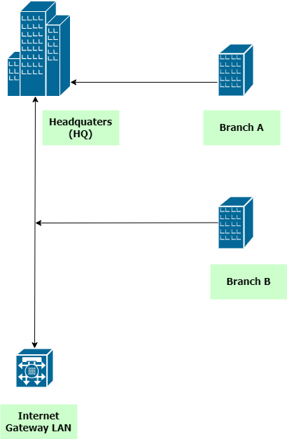

SITE-SPECIFIC BREAKDOWN OF LAN SERVICES

🏢 Headquarters (HQ)

🔹 Staff LAN
- Purpose: Core user access for internal operations
- Services:
  - DHCP for dynamic IP assignment
  - DNS for internal name resolution
  - Access to internal servers (file, email, database)
  - Internet access via centralized NAT/PAT
  - VLAN segmentation for department-level isolation

🔹 Guest LAN
- Purpose: Internet-only access for visitors
- Services:
  - DHCP with restricted scope
  - NAT/PAT for outbound traffic
  - ACLs to block access to internal resources

🔹 Server LAN
- Purpose: Hosts centralized services
- Services:
  - Static IPs for servers
  - Web, DNS, Email, and File services
  - Internal routing and service backbone
  - Backup and redundancy systems

🔹 Management LAN
- Purpose: Secure administrative access
- Services:
  - SSH/Telnet for device configuration
  - SNMP for monitoring
  - AAA (RADIUS/TACACS+) for authentication
  - Syslog and NTP services

🔹 Wireless Control LAN
- Purpose: Wireless infrastructure management
- Services:
  - CAPWAP traffic for WLC and APs
  - Centralized SSID management
  - VLAN tagging for wireless clients

🔹 Internet Gateway LAN
- Purpose: External connectivity
- Services:
  - NAT/PAT for all outbound traffic
  - Firewall and IDS/IPS
  - BGP or static routing to ISP
  - DMZ (optional) for public-facing services

🏬 Branch A

🔹 Staff LAN
- Purpose: Local user access
- Services:
  - DHCP relay to HQ or local DHCP
  - DNS via HQ or local cache
  - Access to HQ-hosted services (via routing)
  - Internet access routed through HQ

🔹 Guest LAN
- Purpose: Visitor access
- Services:
  - DHCP with limited scope
  - Internet-only access via HQ NAT/PAT
  - ACLs for isolation

🔹 Wireless Control LAN
- Purpose: AP management
- Services:
  - CAPWAP traffic to HQ WLC
  - VLAN tagging for SSIDs
  - Local fallback if autonomous APs are used

🏬 Branch B

🔹 Staff LAN
- Purpose: Remote user access
- Services:
  - DHCP relay or local DHCP
  - DNS via HQ or local cache
  - Access to internal services via WAN
  - Internet routed through HQ

🔹 Guest LAN
- Purpose: Visitor access
- Services:
  - DHCP with restricted scope
  - Internet-only access via HQ
  - ACLs for segmentation

🔹 Wireless Control LAN
- Purpose: Wireless infrastructure
- Services:
  - CAPWAP traffic to HQ WLC
  - VLAN tagging for SSIDs
  - Optional autonomous AP support

LAYER 3 TOPOLOGY

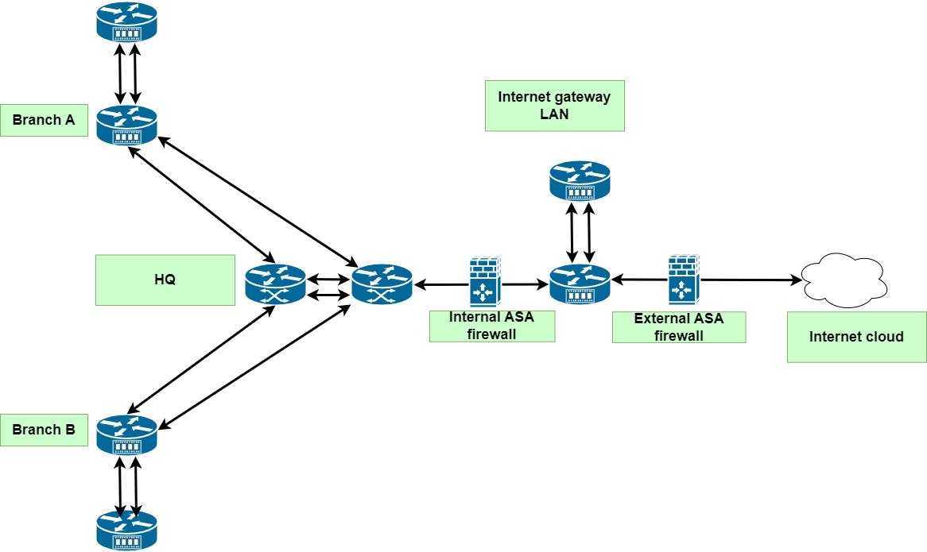

Reliability

- To ensure reliability, all LANs that make up the WAN have dual routers, with one active router and the other in standby mode.
- Branch A and B forward their internet traffic to the HQ router, which is responsible for consolidating internet traffic and sending it to the internet gateway LAN.

🌐 Layer 3 Topology Overview

📌 Topology Type: Dual-Hub Centralized WAN
This design employs a redundant dual-hub architecture at the headquarters (HR), ensuring high availability, scalability, and efficient routing across the enterprise WAN.

🧭 Topology Description
- Headquarters (HR):
  - Two core routers: HR-R1 and HR-R2
  - Interconnected via a dedicated Layer 3 link for OSPF adjacency and internal failover
  - Each router connects independently to the Internet Edge Router, enabling redundant upstream access
- Branch Sites (A and B):
  - Each branch router has dual WAN links:
    - One to HR-R1
    - One to HR-R2
  - Links are configured as point-to-point /30 subnets
- Routing Protocol:
  - OSPF Area 0 is used across all Layer 3 links
  - Equal-cost multipath (ECMP) routing enables automatic load balancing and failover

🔍 Design Rationale – Key Features

I. Redundancy
- A. Dual core routers at HQ eliminate single points of failure.
- B. Branch routers connect to both HQ routers for WAN path redundancy.
- C. Inter-router link between HR-R1 and HR-R2 ensures internal failover capability.

II. Scalability
- A. Modular design allows easy addition of new branches or services.
- B. Centralized architecture simplifies expansion and policy enforcement.

III. Routing Efficiency
- A. OSPF Area 0 used across all Layer 3 links.
- B. Equal-cost multipath (ECMP) routing enables automatic load balancing.
- C. Fast convergence through direct OSPF adjacency between HQ routers.

IV. Security and Control
- A. Centralized Internet access via edge router allows unified security policies.
- B. Simplified traffic monitoring and firewall placement at the edge.

V. Operational Resilience
- A. Simulated link failures confirm uninterrupted routing via alternate paths.
- B. Design supports graceful degradation under partial network outages.

⚙️ Configuration Highlights
- IP Addressing: All WAN links use /30 subnets for efficient point-to-point routing.
- OSPF Setup:
  - All routers participate in Area 0
  - OSPF automatically balances traffic across equal-cost paths
- Failover Testing: Simulated link failures confirm uninterrupted routing via alternate paths

Logical topology designs for each LAN

Headquarters

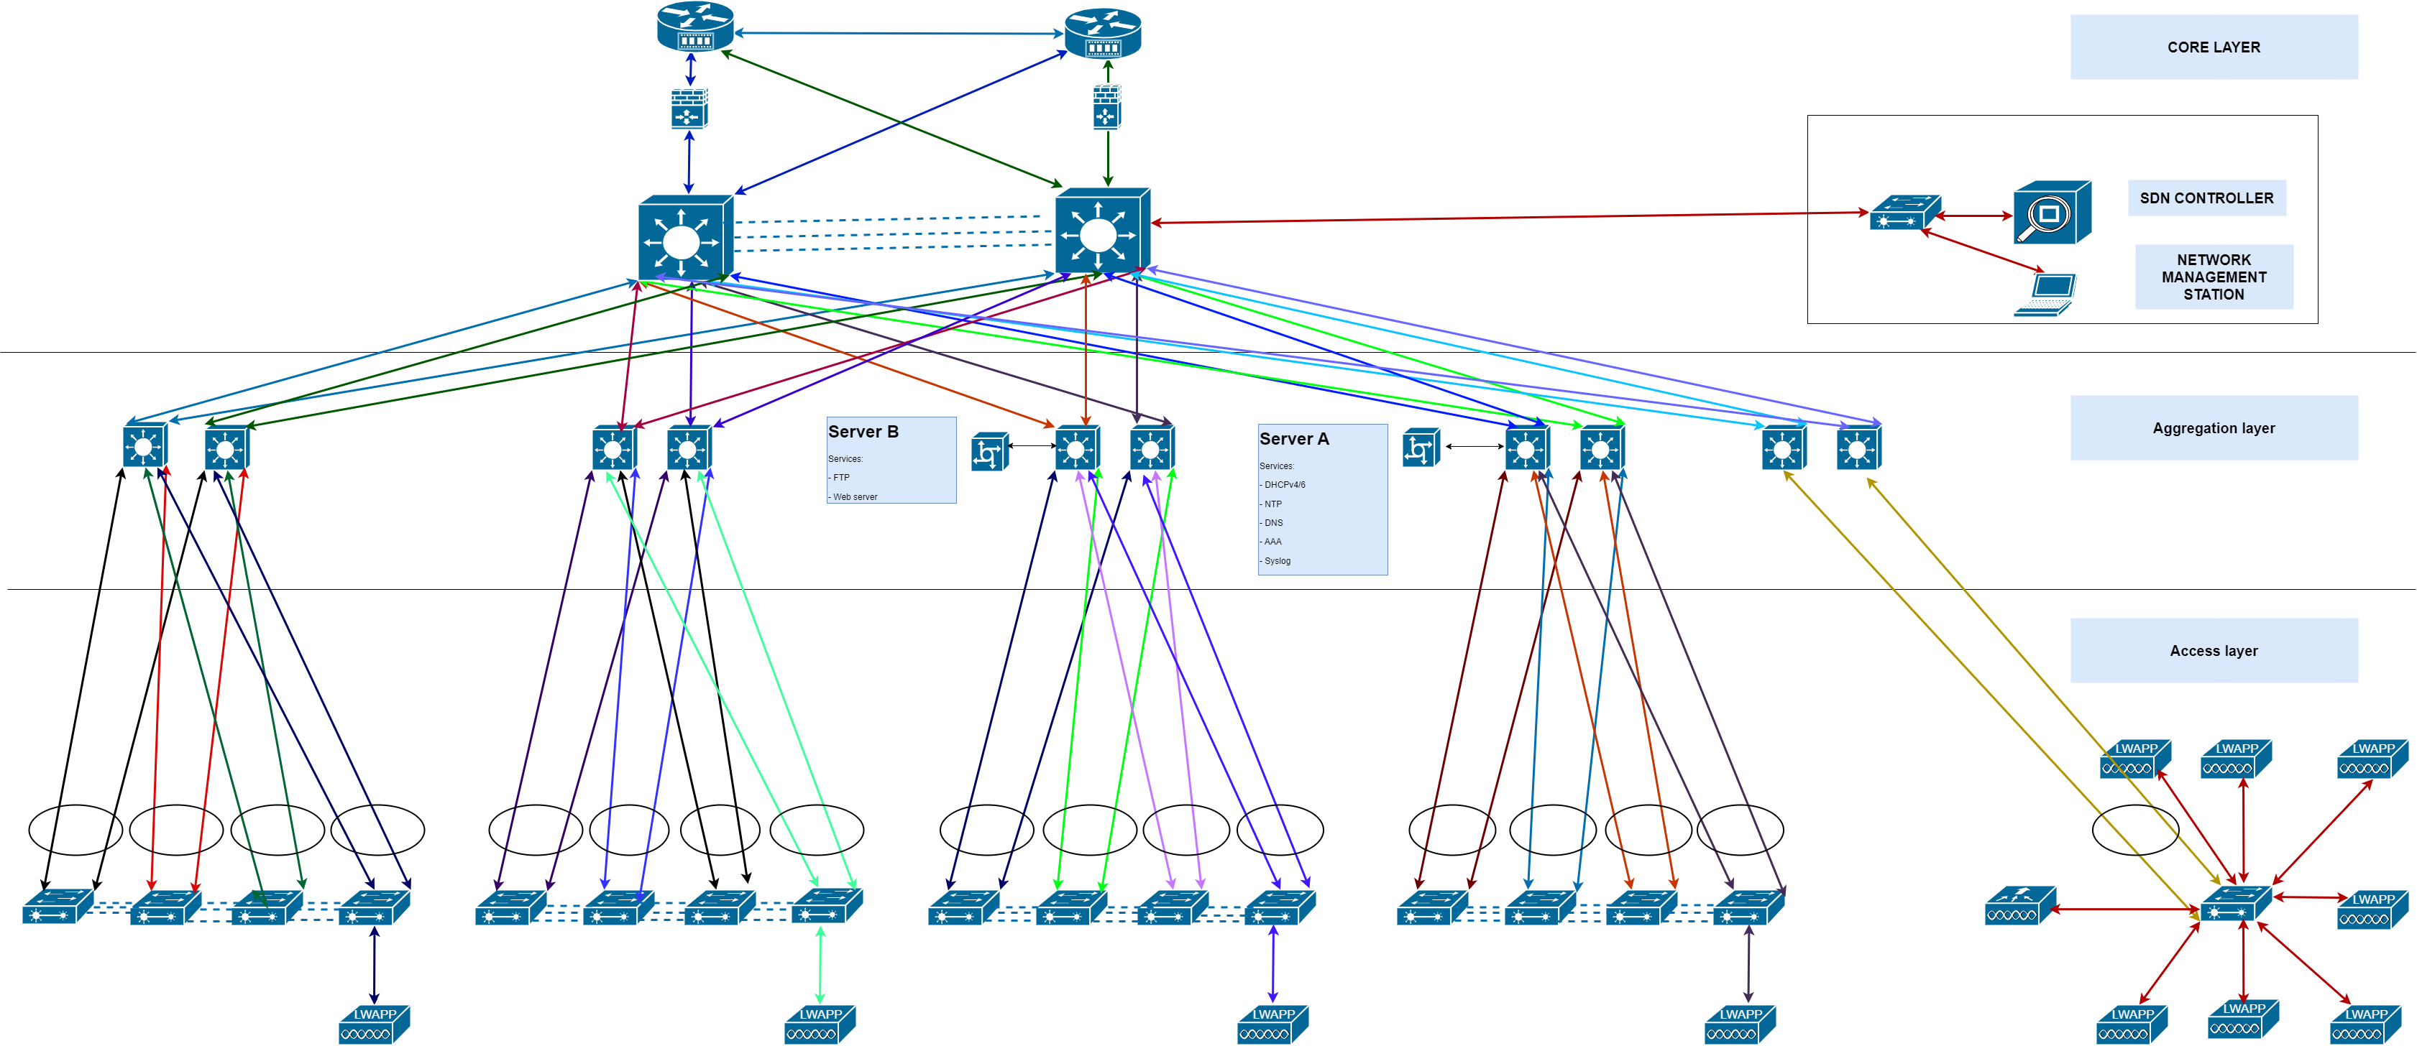
Branch A

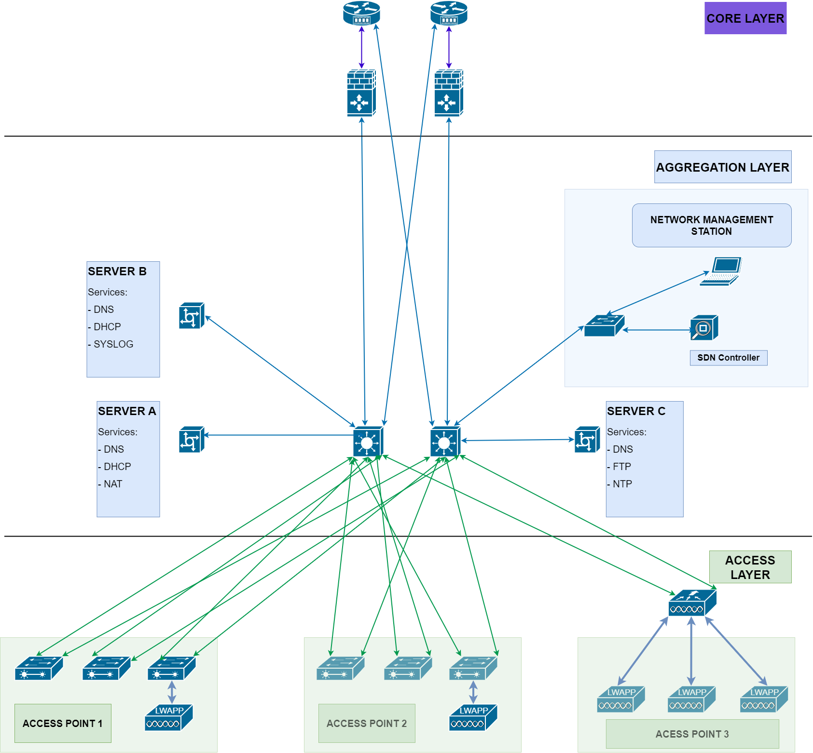

Branch B

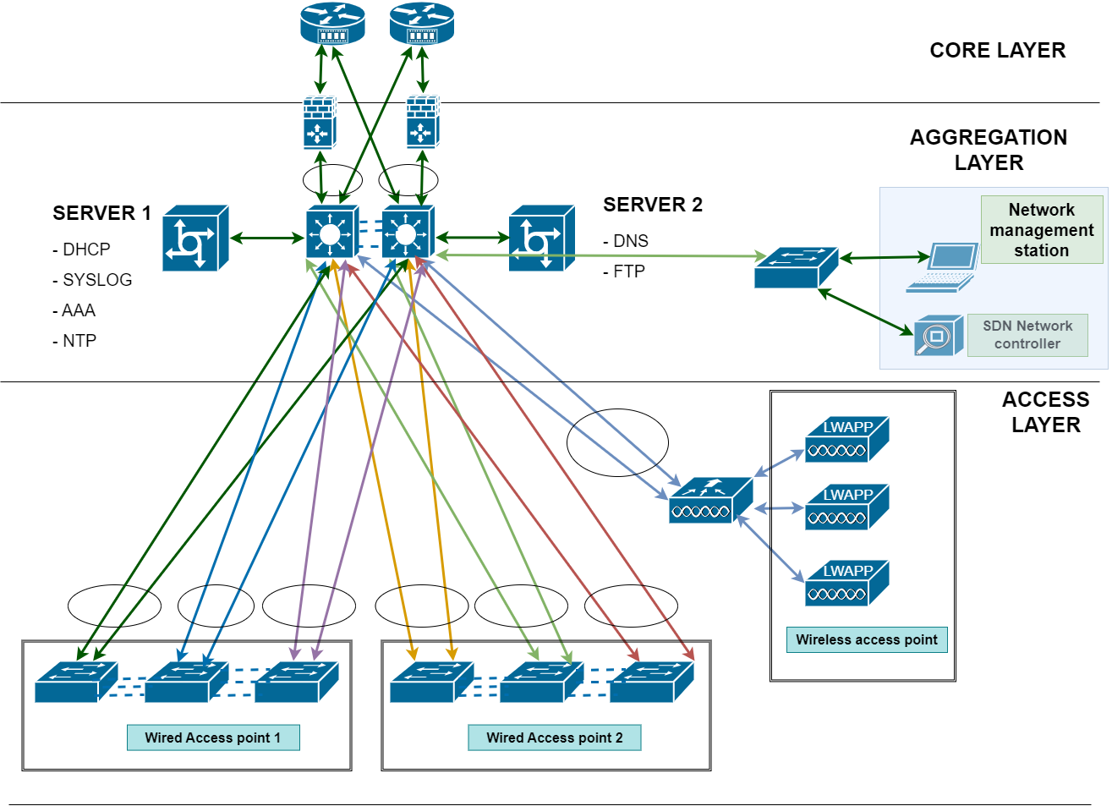
Internet gateway LAN

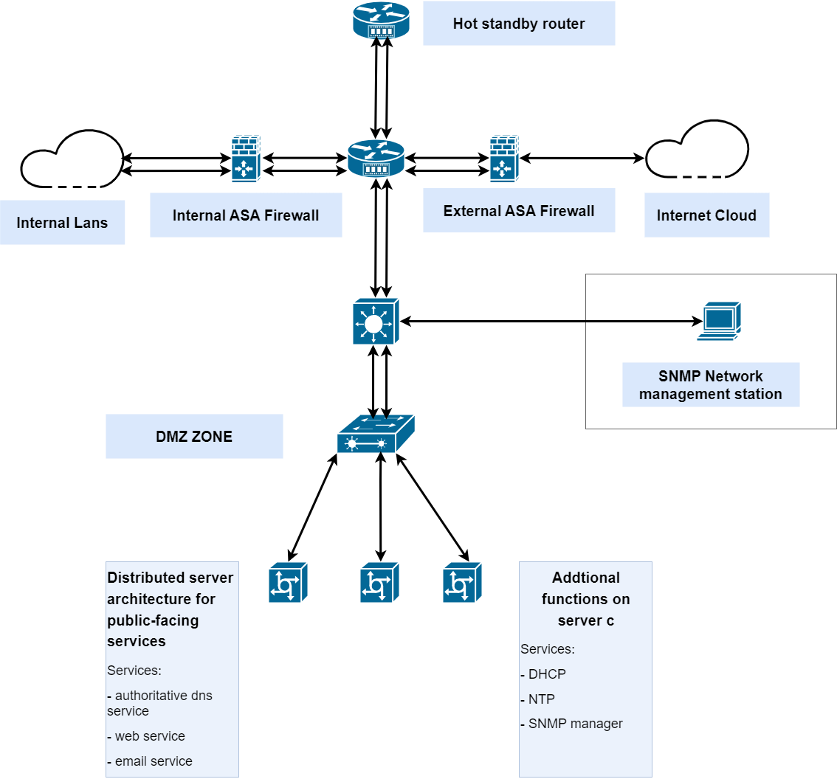
IP address planning

Branch A

IPv4
- Range: 10.0.10.0/24–10.0.19.0/24

IPv6
FD00::/8 will be used for ULA

LAN SEGMENT | PURPOSE | IPV4 SUBNET | IPV6 SUBNET | DHCP Type
Staff LAN | Internet user access | 10.0.10.0/24 | FD00:0A:01::/64 | DHCPv4 + DHCPv6
Guest LAN | Visitor internet access | 10.0.11.0/24 | FD00:0A:02::/64 | DHCPv4 + DHCPv6
Wireless Control LAN | AP management | 10.0.12.0/24 | FD00:0A:03::/64 | DHCPv4 + DHCPv6
Management LAN (local) | Optional fallback access | 10.0.13.0/24 | FD00:0A:04::/64 | Static + DHCPv6
Inter-router link | Branch A ↔ HQ WAN link | 10.0.254.0/30 | FD00:0A:FE::/126 | Static

Branch B

IPv4 Subnet Blocks: Branch B starts at 10.0.20.0/24, following Branch A’s 10.0.10.0/24 range and ends at 10.0.29/0/24.
- IPv6 ULA Scheme: FD00:0B:XX::/64 where 0B denotes Branch B and XX maps to LAN segment.

LAN SEGMENT | PURPOSE | IPV4 SUBNET | IPV6 SUBNET | DHCP TYPE
Staff LAN | Internet user access | 10.0.20.0/24 | FD00:0B:01::/64 | DHCPv4 + DHCPv6
Guest LAN | Visitor internet access | 10.0.21.0/24 | FD00:0B:02::/64 | DHCPv4 + DHCPv6
Wireless Control LAN | AP management | 10.0.22.0/24 | FD00:0B:03::/64 | DHCPv4 + DHCPv6
Management LAN (local) | Optional fallback access | 10.0.23.0/24 | FD00:0B:04::/64 | Static + DHCPv6
Inter-router link | Branch A ↔ HQ WAN link | 10.0.254.4/30 | FD00:0B:FE::/126 | Static

HQ

LAN SEGMENT | PURPOSE | IPV4 SUBNET | IPV6 SUBNET | DHCP TYPE
Staff LAN | Internet user access | 10.0.0.0/24 | FD00:00:01::/64 | DHCPv4 + DHCPv6
Guest LAN | Visitor internet access | 10.0.1.0/24 | FD00:00:02::/64 | DHCPv4 + DHCPv6
Server LAN | AP management | 10.0.2.0/24 | FD00:00:03::/64 | Static + DHCPv6
Management LAN | Admin access | 10.0.3.0/24 | FD00:00:04::/64 | Static + DHCPv6
Wireless Control LAN | WLC & AP management | 10.0.4.0/24 | FD00:00:05::/64 | DHCPv4 + DHCPv6

Internet gateway LAN

Subnet | Purpose | Notes
FD00:00:FE::/64 | Internet Gateway Core | NAT64, firewall, BGP/static routing
FD00:00:FD::/64 | DMZ Services | Public-facing IPv6 services
FD00:00:FF::/126 | ISP Link | Point-to-point IPv6 uplink

IPv6 Highlights
- FE = Internet Gateway Core
- FD = DMZ
- FF = ISP link
- Use SLAAC + DHCPv6 for DMZ clients if needed
- Enable RA + DNS64/NAT64 for IPv6-only clients accessing IPv4 services

Device | IPv4 | IPv6 | Notes
Internet Gateway Firewall 1 | 10.0.0.241 | FD00:00:FE::1 | Primary outbound NAT, DMZ filtering
Internet Gateway Firewall 2 | 10.0.0.242 | FD00:00:FF::1 | Redundant failover unit
HQ Core Router (to Gateway) | 10.0.0.243 | FD00:00:FE::3 | Internal uplink to Gateway LAN
ISP Router | 10.0.0.221 | FD00:00:FF::1 | External uplink

Next step is vlan planning, the ip planning will be modified here and there

