(WBS) – Nexora HQ LAN Project (3-Day Sprint)

🗓️ Day 1: Design Phase – Architecture & Planning

1.0 Network Architecture Design
- 1.1 Define VLANs for IT, Finance, HR, Guest, and NMS
- 1.2 Assign IP subnets and gateway logic per VLAN
- 1.3 Plan Layer 3 routing strategy (SVIs vs router-on-a-stick)
- 1.4 Design EtherChannel topology (tri-switch core + access)
- 1.5 Reserve IP ranges for future WAN interfaces

2.0 Security & Access Control Planning
- 2.1 Define ACL rules (e.g., restrict HR ↔ Finance traffic)
- 2.2 Plan SSH and NTP setup for secure management
- 2.3 Document DHCP exclusion zones for static IPs

3.0 Documentation & Peer Review Prep
- 3.1 Draft IP plan and VLAN table
- 3.2 Create commit message structure for each config phase
- 3.3 Annotate design diagrams for peer clarity

🗓️ Day 2: Implementation Phase – Configuration & Simulation

4.0 VLAN & Interface Configuration
- 4.1 Create VLANs on switches
- 4.2 Configure trunk ports and EtherChannel
- 4.3 Assign SVIs or sub-interfaces with IPs

5.0 DHCP & Management Setup
- 5.1 Configure DHCP pools per VLAN
- 5.2 Exclude static IPs for servers and NMS
- 5.3 Assign management IPs to switches
- 5.4 Enable SSH and NTP on NMS switches

6.0 Routing & ACLs
- 6.1 Enable inter-VLAN routing
- 6.2 Apply ACLs for traffic control
- 6.3 Verify routing logic with simulation tools

🗓️ Day 3: Validation & Documentation

7.0 Simulation & Testing
- 7.1 Test DHCP assignment and gateway reachability
- 7.2 Verify VLAN isolation and ACL enforcement
- 7.3 Simulate failover and EtherChannel behavior

8.0 Final Documentation
- 8.1 Annotate configs with peer-friendly comments
- 8.2 Finalize commit messages and simulation notes
- 8.3 Prepare lab guide for academic submission or peer review

WBS

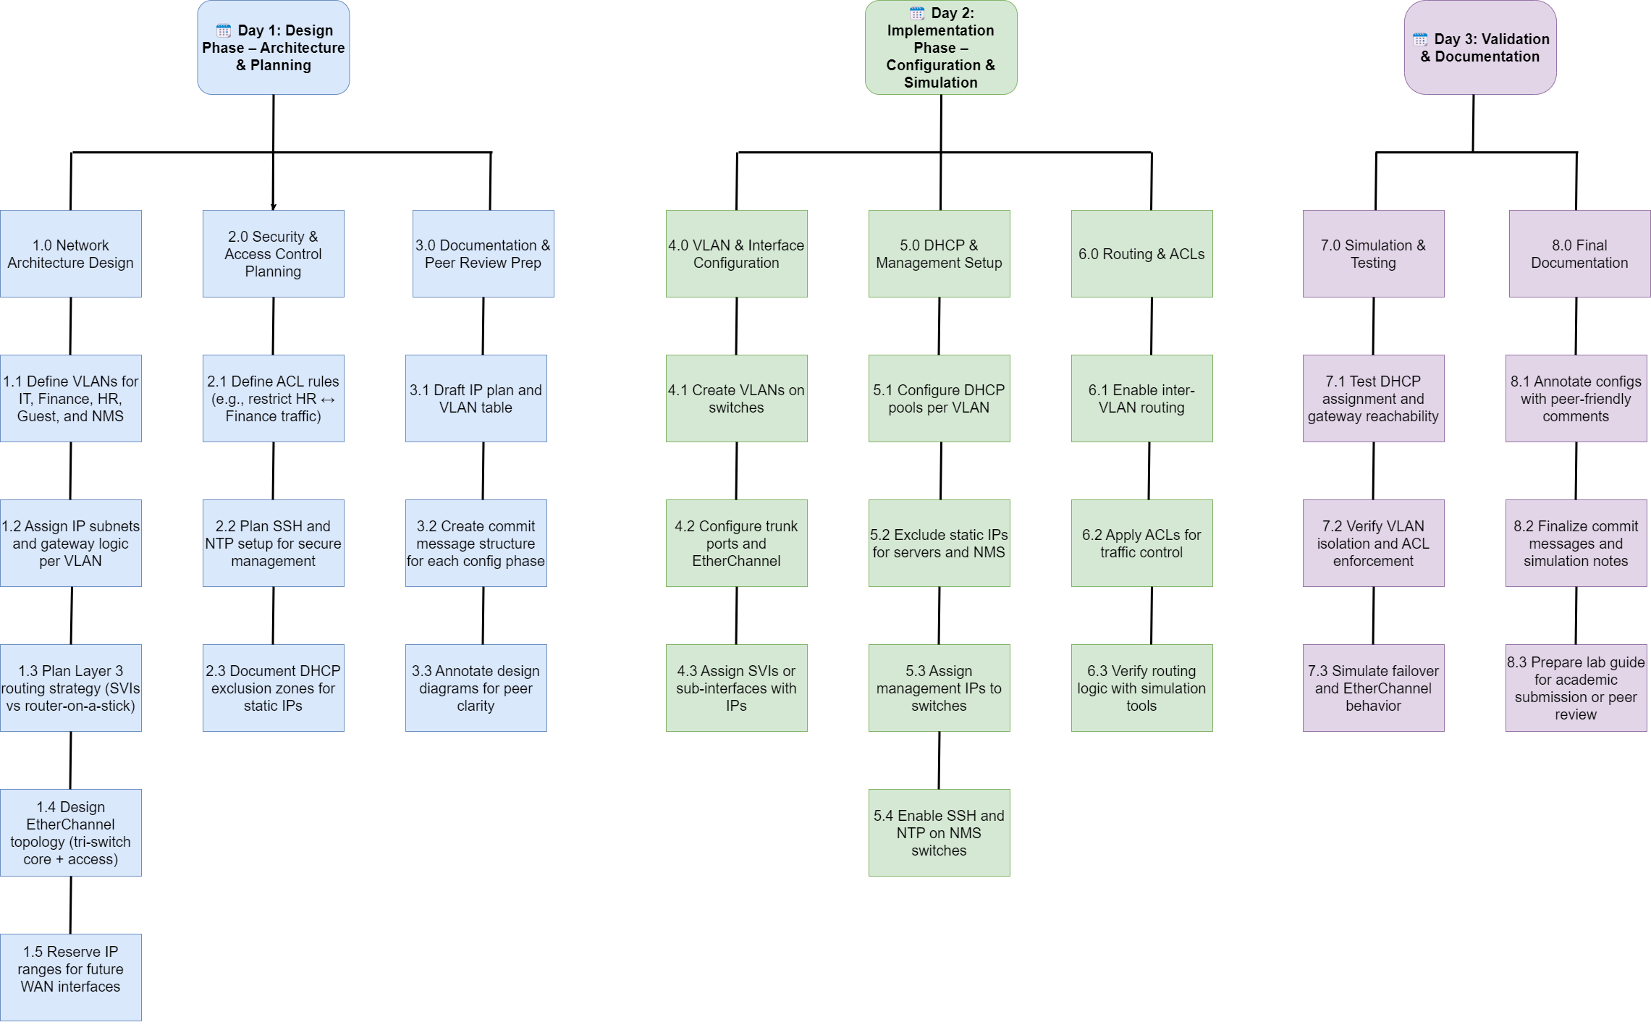

Day 1

Finalized 1.0 – Network Architecture Design (Layered, Service-Integrated, WLC-Enabled)

🏢 Corporation: Nexora Systems Ltd.
Location: Johannesburg, South Africa
Mission: Deliver secure, high-availability fintech services across departments with strict compliance and modular scalability.

🏗️ Layered LAN Architecture – Three-Tier Model
Layer | Role | Devices & Count
Access Layer | Connects end devices and APs | 4 Layer 2 switches, 6 APs (3 Staff, 3 Guest)
Distribution Layer | Aggregates access, enforces policy | 2 Layer 3 switches (SVIs, ACLs, DHCP relay)
Core Layer | High-speed backbone, WAN-ready uplinks | 2 Routers or L3 switches, 1 WLC, firewall, core services

Node Breakdown & Roles

Access Layer
- End Devices: PCs, printers, VoIP phones
- Wireless Clients:
  - Staff SSID → VLAN 10/20/30
  - Guest SSID → VLAN 40
- Switches: 4 PoE-enabled Layer 2 switches
- APs: 6 total (3 Staff, 3 Guest)
- Connection: APs operate in lightweight mode, tunnel traffic to WLC via CAPWAP

Distribution Layer
- Switches: 2 Layer 3 switches
- Functions:
  - SVIs for VLANs
  - Inter-VLAN routing
  - ACL enforcement
  - DHCP relay
  - EtherChannel to core

Core Layer
- Devices:
  - 2 routers or high-performance L3 switches
  - Wireless LAN Controller (WLC)
  - Firewall (stateful, NAT, ACLs, DoH/DoT filtering)
  - Authoritative DNS Server
  - HTTP Server
  - Email Server
- Functions:
  - WAN uplinks (192.168.254.0/30)
  - PAT for outbound traffic
  - SSH, NTP, NetFlow
  - Centralized wireless control via WLC

🔐 Port Address Translation (PAT)
Public IP for LAN: 196.44.3.9
- Configured on core firewall/router
- All internal devices use this IP for outbound Internet
- ACLs enforce Guest VLAN isolation and restrict internal exposure

🔹 VLAN Definitions
VLAN ID | Name | Purpose | Subnet
10 | IT | Wired + Staff AP (SSID: Nexora_Staff) | 192.168.10.0/24
20 | Finance | Wired + Staff AP (SSID: Nexora_Staff) | 192.168.20.0/24
30 | HR | Wired + Staff AP (SSID: Nexora_Staff) | 192.168.30.0/24
40 | Guest | Guest AP only (SSID: Nexora_Guest) | 10.10.10.0/24
99 | NMS | Management, DHCP, SSH, NTP, DNS, HTTP | 192.168.99.0/24

🔹 Gateway IPs per VLAN
VLAN | Gateway IP | Notes
10 | 192.168.10.1 | IT VLAN gateway
20 | 192.168.20.1 | Finance VLAN gateway
30 | 192.168.30.1 | HR VLAN gateway
40 | 10.10.10.1 | Guest VLAN gateway
99 | 192.168.99.1 | NMS VLAN gateway

🔹 Core Services (VLAN 99)
Service | Protocols | Notes
DNS Server | TCP/UDP 53 | Authoritative for internal zones, recursion disabled externally
HTTP Server | TCP 80/443 | Hosts internal web apps, documentation portal
Email Server | SMTP/IMAP | Internal email routing, optional external relay
Firewall | Stateful + NAT | ACLs, PAT, DNS redirect, DoH/DoT filtering
NTP Server | UDP 123 | Time sync for all devices
SSH Access | TCP 22 | Secure management of switches and servers
WLC | CAPWAP (UDP 5246/5247) | Centralized control of APs, SSID/VLAN mapping, client authentication

🔹 ACL Strategy
- Guest VLAN (40):
  - Denied access to VLANs 10, 20, 30, 99
  - Allowed outbound Internet via PAT
- HR ↔ Finance:
  - Denied direct communication
- IT VLAN:
  - Full access to all services
- DNS NAT Redirect:
  - Rogue clients forced to use internal DNS

📘 Network Topology Documentation
Corporation: Nexora Systems Ltd.
Location: Johannesburg, South Africa
Mission: Deliver secure, high-availability fintech services with modular scalability, centralized wireless control, and strict VLAN segmentation.

🧱 Layered Architecture Overview
Layer | Devices & Roles
Access Layer | 4 × Layer 2 PoE switches, 6 × Lightweight APs (3 Staff, 3 Guest), end devices
Distribution Layer | 2 × Layer 3 switches (Dist-SW1, Dist-SW2), DHCP servers, WLC, network controller uplinks
Core Layer | 1 × Firewall, 2 × Routers (WAN uplinks), future VRRP support

🔹 Access Layer Details
Switch | Role | Connected APs | VLANs Served
SW1 | Guest Access | 3 × Guest APs | VLAN 40
SW2 | Staff Access | 1 × Staff AP (IT) | VLAN 10
SW3 | Staff Access | 1 × Staff AP (Finance) | VLAN 20
SW4 | Staff Access | 1 × Staff AP (HR), Network Controller uplink | VLAN 30, 99
- All access switches connect to both Dist-SW1 and Dist-SW2 via trunk links
- APs operate in Lightweight Mode, tunneling traffic to WLC via CAPWAP
- Network Controller connects to SW4, then uplinks to aggregation layer

🔹 Distribution Layer Details
Device | Role | Connections
Dist-SW1 | Aggregation + Services | Uplinks from all access switches, DHCP Server 1, WLC, Firewall
Dist-SW2 | Aggregation + Services | Uplinks from all access switches, DHCP Server 2, WLC, Firewall
- DHCP Server 1: Assigns IPs to Staff APs and wired clients (VLANs 10/20/30)
- DHCP Server 2: Assigns IPs to Guest APs and clients (VLAN 40)
- WLC: Connected to both Dist-SW1 and Dist-SW2, resides in VLAN 99
- Network Controller reaches aggregation via SW4 → Dist-SW2

🔹 Core Layer Details
Device | Role | Connections
Firewall | NAT, ACL, DNS redirect | Connected to Dist-SW1 and Dist-SW2, Routers 1 & 2
Router 1 | WAN Uplink | Connected to Firewall
Router 2 | WAN Uplink | Connected to Firewall
- Firewall enforces ACLs, NAT, DNS filtering
- Routers provide WAN uplinks (e.g., 192.168.254.0/30 subnet)
- VRRP planned for future implementation

🔹 DHCP Strategy
Server | VLANs Served | Purpose
DHCP Server 1 | 10, 20, 30 | Staff APs and wired clients
DHCP Server 2 | 40 | Guest APs and clients
- Each server resides in VLAN 99
- DHCP relay configured on SVIs in distribution switches

🔹 VLAN Definitions
VLAN ID | Name | Purpose | Subnet | Gateway IP
10 | IT | Staff AP + wired clients | 192.168.10.0/24 | 192.168.10.1
20 | Finance | Staff AP + wired clients | 192.168.20.0/24 | 192.168.20.1
30 | HR | Staff AP + wired clients | 192.168.30.0/24 | 192.168.30.1
40 | Guest | Guest APs only | 10.10.10.0/24 | 10.10.10.1
99 | NMS | Management, DHCP, DNS, HTTP, SSH, WLC | 192.168.99.0/24 | 192.168.99.1

🔹 ACL Strategy Summary
Target VLAN | ACL Rules Summary
VLAN 40 | Deny access to VLANs 10, 20, 30, 99; Allow outbound Internet via PAT
VLAN 20 ↔ 30 | Deny direct communication between HR and Finance
VLAN 10 | Full access to all services
DNS Redirect | Block external DNS, force internal DNS usage

🔹 Core Services (VLAN 99)
Service | Protocols | Notes
DNS Server | TCP/UDP 53 | Authoritative, recursion disabled externally
HTTP Server | TCP 80/443 | Internal web apps, documentation portal
Email Server | SMTP/IMAP | Internal routing, optional external relay
Firewall | Stateful + NAT | ACLs, PAT, DNS redirect, DoH/DoT filtering
NTP Server | UDP 123 | Time sync for all devices
SSH Access | TCP 22 | Secure switch/server management
WLC | CAPWAP (UDP 5246/5247) | Centralized AP control, SSID/VLAN mapping

