ASSIGNMENT 4

Shauna Smith

2022-07-16

# Markdown Basics

* [Introduction to R Markdown](https://rmarkdown.rstudio.com/lesson-1.html)
* [The R Markdown Cheatsheet](https://www.rstudio.com/wp-content/uploads/2016/03/rmarkdown-cheatsheet-2.0.pdf)
* [The R Markdown Reference Guide](https://www.rstudio.com/wp-content/uploads/2015/03/rmarkdown-reference.pdf)

## Favorite Foods

1.Nectarines 2.pho soup 3.mashed potatoes and gravy

## Images

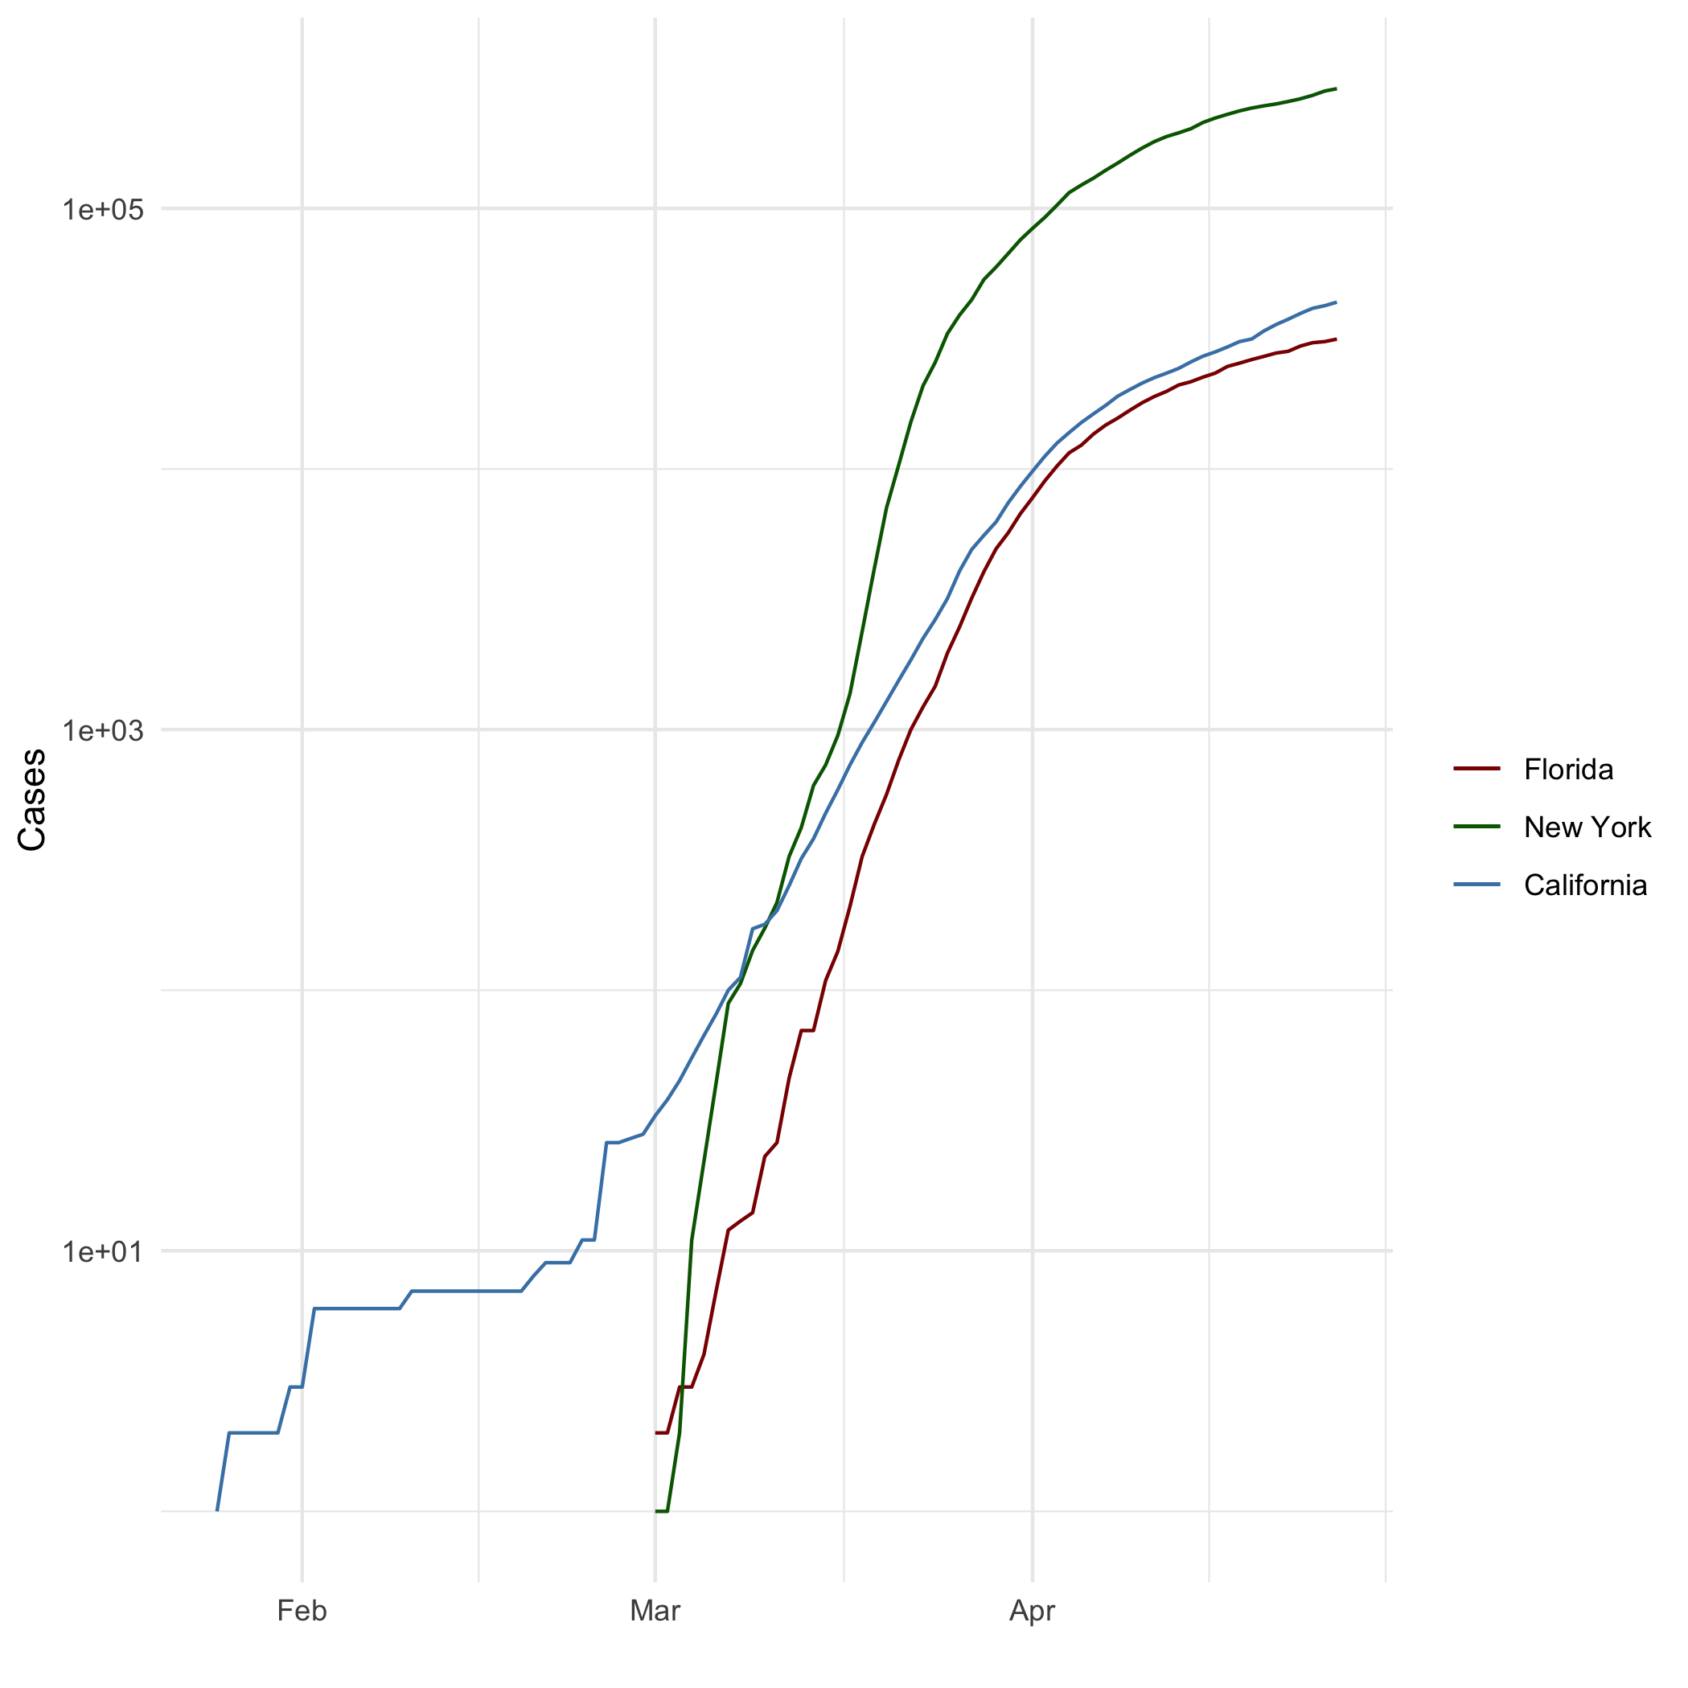

requested image

## Add a Quote

“It’s all a great mystery…look up to the sky and you’ll see how everything changes.”- Antoine de Saint-Exupery

## Add an Equation

$$\left(1+\frac{1}{x}\right)$$

## Add a Footnote

blase blasa [1]

## Add Citations

writing something[@RforEveryone] something wrote[@DiscoveringStatisticsUsingR]

# Inline Code

## NY Times COVID-19 Data

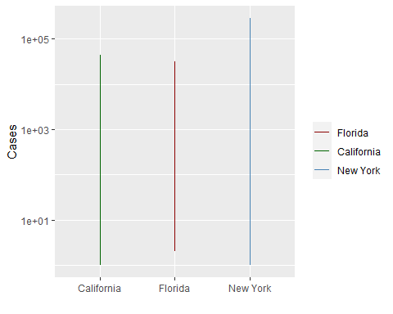

## R4DS Height vs Earnings

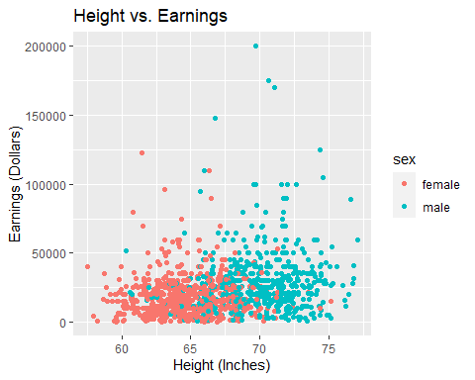

# Tables

## name race in_fellowship ring_bearer age  
## 1 Aragon Men TRUE FALSE 88  
## 2 Bilbo Hobbit FALSE TRUE 129  
## 3 Frodo Hobbit TRUE TRUE 51  
## 4 Galadriel Elf FALSE FALSE 7000  
## 5 Sam Hobbit TRUE TRUE 36  
## 6 Gandalf Maia TRUE TRUE 2019  
## 7 Legolas Elf TRUE FALSE 2931  
## 8 Sauron Maia FALSE TRUE 7052  
## 9 Gollum Hobbit FALSE TRUE 589

## Knitr Table with Kable

knitr::kable(characters_df, caption ="One Ring to Rule Them All")

One Ring to Rule Them All

| name | race | in_fellowship | ring_bearer | age |
| --- | --- | --- | --- | --- |
| Aragon | Men | TRUE | FALSE | 88 |
| Bilbo | Hobbit | FALSE | TRUE | 129 |
| Frodo | Hobbit | TRUE | TRUE | 51 |
| Galadriel | Elf | FALSE | FALSE | 7000 |
| Sam | Hobbit | TRUE | TRUE | 36 |
| Gandalf | Maia | TRUE | TRUE | 2019 |
| Legolas | Elf | TRUE | FALSE | 2931 |
| Sauron | Maia | FALSE | TRUE | 7052 |
| Gollum | Hobbit | FALSE | TRUE | 589 |

## Pandoc Table

# Tables

| Name | Race | In Fellowship? | Is Ring Bearer? | Age |
| --- | --- | --- | --- | --- |
| Aragon | Men | Yes | No | 88 |
| Bilbo | Hobbit | No | Yes | 129 |
| Frodo | Hobbit | Yes | Yes | 51 |
| Sam | Hobbit | Yes | Yes | 36 |
| Sauron | Maia | No | Yes | 7052 |

# References

1. This is a footnote