Responsive Robots
Characteristic | N | CONTROL N = 8¹ | EXPERIMENTAL N = 13¹ | p-value²
Gender | 19 |  |  | >0.9
Woman |  | 3 / 7 (42.9%) | 5 / 12 (41.7%)
Man |  | 4 / 7 (57.1%) | 7 / 12 (58.3%)
Missing |  | 1 | 1
Age Group | 19 |  |  | 0.5
18-24 |  | 2 / 7 (28.6%) | 7 / 12 (58.3%)
25-34 |  | 3 / 7 (42.9%) | 3 / 12 (25.0%)
34-44 |  | 2 / 7 (28.6%) | 2 / 12 (16.7%)
Missing |  | 1 | 1
Program | 19 |  |  | 0.2
Psychology |  | 0 / 7 (0.0%) | 2 / 12 (16.7%)
Engineering |  | 1 / 7 (14.3%) | 0 / 12 (0.0%)
Computer Science |  | 6 / 7 (85.7%) | 7 / 12 (58.3%)
Other |  | 0 / 7 (0.0%) | 3 / 12 (25.0%)
Missing |  | 1 | 1
Experience w/Robots | 19 | 3 / 7 (42.9%) | 4 / 12 (33.3%) | >0.9
Missing |  | 1 | 1
Native English Speaker | 21 |  |  | 0.3
FALSE |  | 7 / 8 (87.5%) | 8 / 13 (61.5%)
TRUE |  | 1 / 8 (12.5%) | 5 / 13 (38.5%)
NARS | 21 | 43 (7) | 40 (10) | 0.4
nars_pre_s2 | 21 | 16.88 (3.38) | 14.90 (3.62) | 0.3
nars_pre_s3 | 21 | 10.5 (2.7) | 9.4 (3.5) | 0.6
nars_pre_s1 | 21 | 15.9 (4.5) | 16.4 (5.8) | 0.7
Need for Cognition | 21 | 3.21 (0.78) | 3.35 (1.06) | >0.9
¹n / N (%); Mean (SD)
²Fisher's exact test; Wilcoxon rank sum test
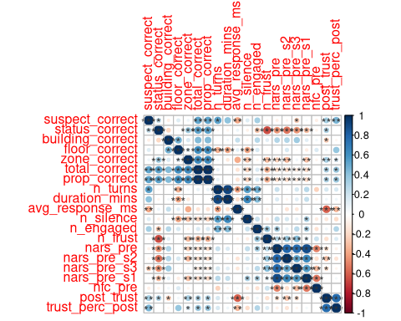
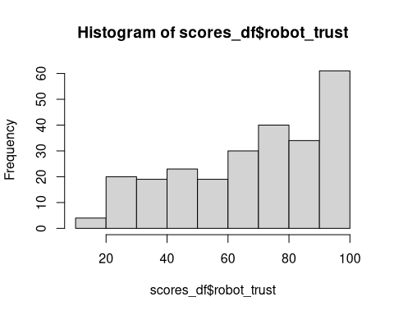
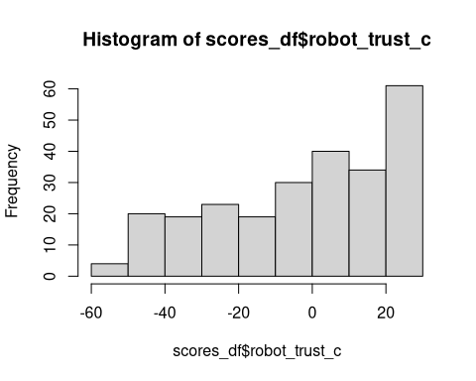
Data: scores_df
Models:
mod1: robot_trust ~ group + nars_pre + nfc_pre + (1 | session_id) + (1 | trust_items)
mod3: robot_trust ~ group * trust_items + nars_pre + nfc_pre + (1 | session_id)
mod2: robot_trust ~ group * trust_items + nars_pre + nfc_pre + (1 | session_id) + (1 | trust_items)
npar AIC BIC logLik -2*log(L) Chisq Df Pr(>Chisq)
mod1 7 2104.7 2129.3 -1045.3 2090.7
mod3 28 2113.6 2212.2 -1028.8 2057.6 33.14 21 0.04469 *
mod2 29 2115.6 2217.7 -1028.8 2057.6 0.00 1 1.00000
---
Signif. codes: 0 '***' 0.001 '**' 0.01 '*' 0.05 '.' 0.1 ' ' 1
Data: scores_df
Models:
mod1: robot_trust ~ group + nars_pre + nfc_pre + (1 | session_id) + (1 | trust_items)
mod2: robot_trust ~ group * trust_items + nars_pre + nfc_pre + (1 | session_id) + (1 | trust_items)
npar AIC BIC logLik -2*log(L) Chisq Df Pr(>Chisq)
mod1 7 2104.7 2129.3 -1045.3 2090.7
mod2 29 2115.6 2217.7 -1028.8 2057.6 33.14 22 0.05994 .
---
Signif. codes: 0 '***' 0.001 '**' 0.01 '*' 0.05 '.' 0.1 ' ' 1
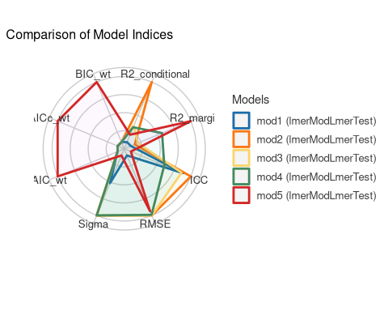
Data: scores_df2
Models:
mod1: robot_trust ~ group + nars_pre + nfc_pre + (1 | session_id) + (1 | trust_items)
mod2: robot_trust ~ group * trust_items + nars_pre + nfc_pre + (1 | session_id) + (1 | trust_items)
mod4: robot_trust ~ group * trust_items + native_english + nars_pre + nfc_pre + (1 | session_id)
mod3: robot_trust ~ group * trust_items + nars_pre + nars_pre_s1 + nars_pre_s2 + nars_pre_s3 + (1 | session_id)
npar AIC BIC logLik -2*log(L) Chisq Df Pr(>Chisq)
mod1 7 657.11 679.81 -321.56 643.11
mod2 23 659.82 734.38 -306.91 613.82 29.2899 16 0.02205 *
mod4 23 658.33 732.89 -306.17 612.33 1.4915 0
mod3 24 657.41 735.21 -304.70 609.41 2.9230 1 0.08732 .
---
Signif. codes: 0 '***' 0.001 '**' 0.01 '*' 0.05 '.' 0.1 ' ' 1
