**A**

**PROJECT REPORT**

**ON**

**“ANALOG CLOCK”**

**BY**

**Chinmay Aserkar**

**and**

**Shaunak Khatavkar**

**OF**

**Kaveri College of Arts, Science and Commerce**

**ERANDWANE, PUNE-04**

**FOR**

**SAVITRIBAI PHULE PUNE UNIVERSITY**

**ACADEMIC YEAR 2019-2020**

**BACHELOR OF SCIENCE (Computer Science)**

**(PATTERN-2013)**

**SEMESTER-VI**

**UNDER THE GUIDANCE OF**

**Mrs. Pallavi Joshi**



**INDEX**

|  |  |  |
| --- | --- | --- |
| **Sr. No** | **TOPIC** | **Page No.** |
| **1** | **Acknowledgement** | **4** |
| **2** | **Computer Graphics concepts used in the project** | **5** |
| **3** | **OpenGL library and methods** | **6** |
| **4** | **Screenshots** | **10** |
| **5** | **Bibliography** | **11** |

**Acknowledgement**

While presenting our OpenGL project on Analog Clock, we feel that it is our duty to acknowledge the help rendered to us by various persons.

We would like to convey my thanks to **HOD(CS)** **Mrs. Chitra Alavani** for being kind enough to provide us an opportunity to do a project in this institution.

We would greatly mention the enthusiastic influence provided by **Mrs. Pallavi Joshi**, our project guide, for her ideas and co-operation showed on us during the venture and making this project a great success.

We are very much pleasured to express our sincere gratitude to the friendly cooperation showed by all the staff members of Computer Science Department, KCASC.

**Computer Graphics**

* Graphics provides one of the most natural means of communicating with a computer, since our highly developed 2D Or 3D pattern-recognition abilities allow us to perceive and process pictorial data rapidly.

* Computers have become a powerful medium for the rapid and economical production of pictures. • Graphics provide a so natural means of communicating with the computer that they have become widespread.
* Interactive graphics is the most important means of producing pictures since the invention of photography and television .
* We can make pictures of not only the real world objects but also of abstract objects such as mathematical surfaces on 4D and of data that have no inherent geometry.
* A computer graphics system is a computer system with all the components of the general purpose computer system. There are five major elements in system: input devices, processor, memory, frame buffer, output devices.

**OpenGL libraries and method –**

**Libraries used in the project**

#include <gl/glut.h>

#include <gl/gl.h>

#include <math.h>

#include <time.h>

#include <sys/timeb.h>

**Methods used**

1. **glutInit();**

Initialize GLUT library

1. **glutInitDisplayMode();**

Display mode : GLUT_DOUBLE & GLUT_RGBA

1. **glutCreateWindow("Analog Clock by Chinmay & Shaunak");**

Title of window

1. **glutDisplayFunc(); -**

Syntax - void glutDisplayFunc(void (*func)(void));

Functionality - The new display callback function.

1. **glutReshapeFunc();**

Syntax : void glutReshapeFunc(void (*func)(int width, int height))

Funcionaliy : The new reshape callback function.

1. **glutTimerFunc();**

Syntax : void glutTimerFunc(unsigned int msecs, void (*func)(int value), value);

1. **SetupRC();**

Clear color window

1. **glutMainLoop();**

Window closes only after clicking cross "x"

**Other methods :**

1. **glVertex2f() :**

The glVertex function commands are used within **[glBegin](https://docs.microsoft.com/en-us/windows/win32/opengl/glbegin)**/**[glEnd](https://docs.microsoft.com/en-us/windows/win32/opengl/glend)** pairs to specify point, line, and polygon vertices.

1. **glClear();**

clear buffers to preset values

1. **glColor3f();**

Can be used to give each vertex its own color

1. **glLineWidth(2.0f)**

|  |  |
| --- | --- |
| void **glLineWidth**( | GLfloat *width*); |

specify the width of rasterized lines

1. **glEnable(GL_LINE_SMOOTH);**

|  |  |
| --- | --- |
| void **glEnable**( | GLenum *cap*); |

enable or disable server-side GL capabilities

1. **glBegin(GL_LINES);**

void **glBegin**(GLenum mode);

delimit the vertices of a primitive or a group of like primitives

1. **glLineWidth(1.0f);**

void **glLineWidth**(GLfloat width);

specify the width of rasterized lines

1. **glEnd();**

|  |  |
| --- | --- |
| void **glBegin**( | GLenum *mode*) |

delimit the vertices of a primitive or a group of like primitives

1. **glutSwapBuffers();**

swaps the buffers of the current window if double buffered.

1. **glMatrixMode(GL_MODELVIEW);**

void **glMatrixMode**(GLenum mode);

specify which matrix is the current matrix

1. **glLoadIdentity();**

replace the current matrix with the identity matrix

1. **glViewport(0, 0, w, h);**

|  |  |
| --- | --- |
| void **glViewport**( | GLint *x*, |
|  | GLint *y*, |
|  | GLsizei *width*, |
|  | GLsizei *height*); |
| set the viewport |  |
|  |  |

1. **glutPostRedisplay();**

marks the current window as needing to be redisplayed.

1. **glutTimerFunc(33,TimerFunction, 1);**

void glutTimerFunc(unsigned int msecs,

void (*func)(int value), value);

registers a timer callback to be triggered in a specified number of milliseconds.

**Screenshot :**

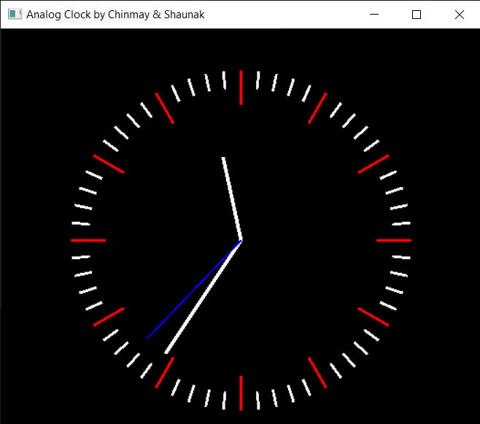

**Bibliography :**

**Book :**

Poonam Ponde ,

***Computer Graphics****,* Vision Publications, 2020 edition

**Website :**

<http://www.opengl-tutorial.org/>

<https://www.youtube.com/>