**Project 2 Documentation**

**Neha Shet**

**UTA ID - 1001387308**

**Shaunak Joshi**

**UTA ID – 1001417919**

Programming language used: **Java**

Databases used: **MySql, Mongodb**

For this project we will be using bean classes namely : Project, Department, and Employee.

Class Project {

String pname;

int pnumber;

String dname;

List <Employee> employee = new ArrayList<Employee>();

}

Class Department {

String Dname;

String DM_lname;

List <String> dlocations = new ArrayList<String>();

}

Class Employee {

String lname;

String fname;

int hours;

}

Public class MainClass {

public static void insertIntoDb(String modelName) {

//reads the data from the file

//inserts it into mysql db

}

public static void loadIntoProjectTable() {

//This function will load the data in Project dpcument.

//For this it will perform join on works_on and project return dept id.

//Perform join on department, which will give department name.

//Also perform join with employee table which will return employee details.

// save the data to List< Project> and loop each object to save in mongodb

}

public static void loadIntoDepartmentTable() {

//Perform join on department and employee which will give the department managers last name.

//Also perform join on department_locations which will return the department locations.

// save the data to List< Department> and loop each object to save in mongodb

}

}

**ScreenShots:**

1. Server Start:

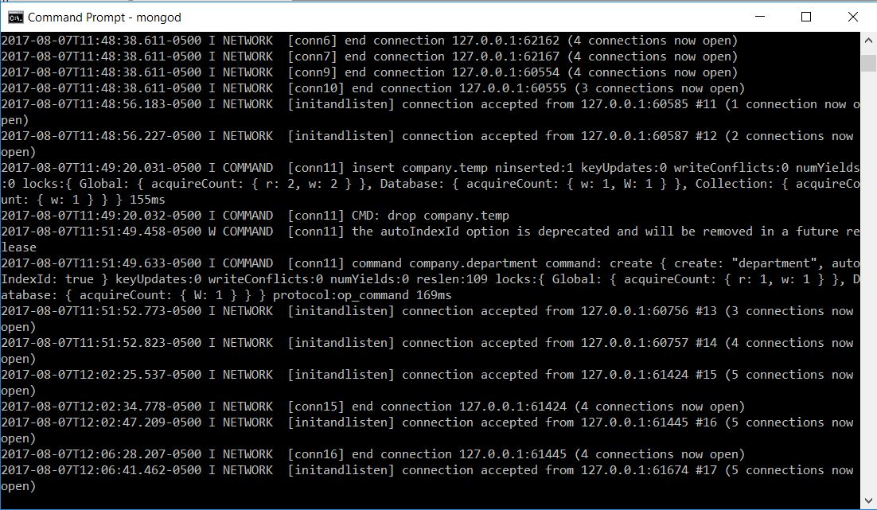

1. Database Connection:

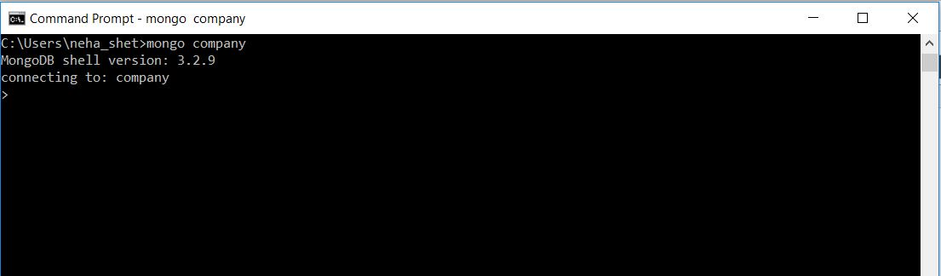

1. Find Query:

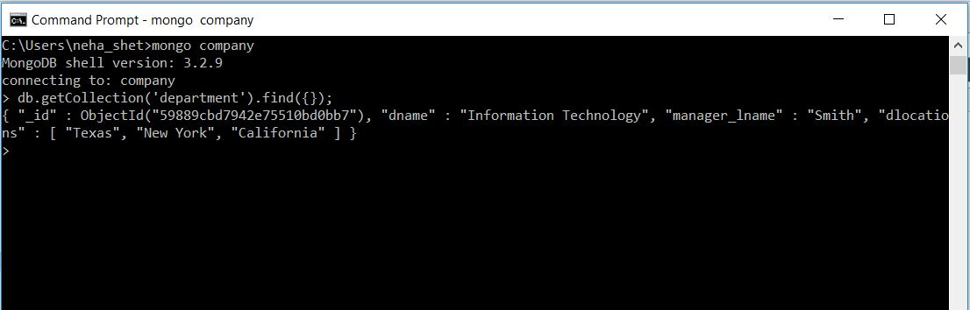

1. In RoboMongo:

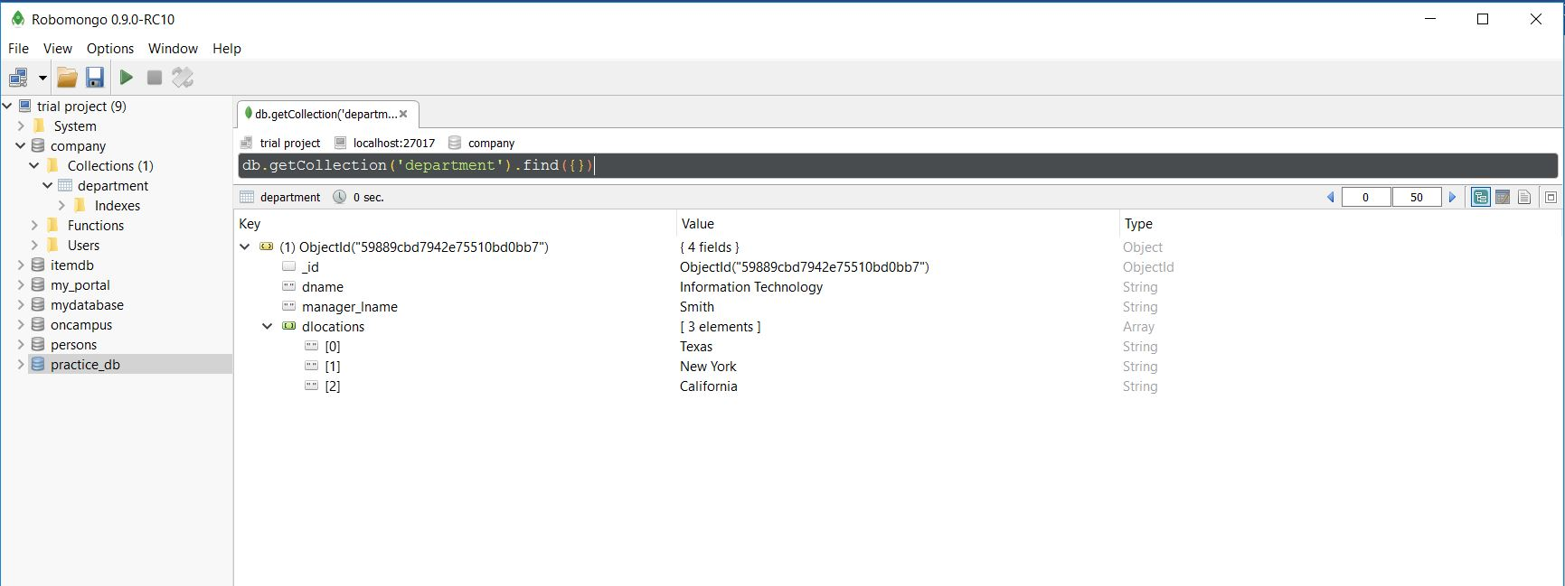

1. Data loaded in the MySql db
2. Employee Table

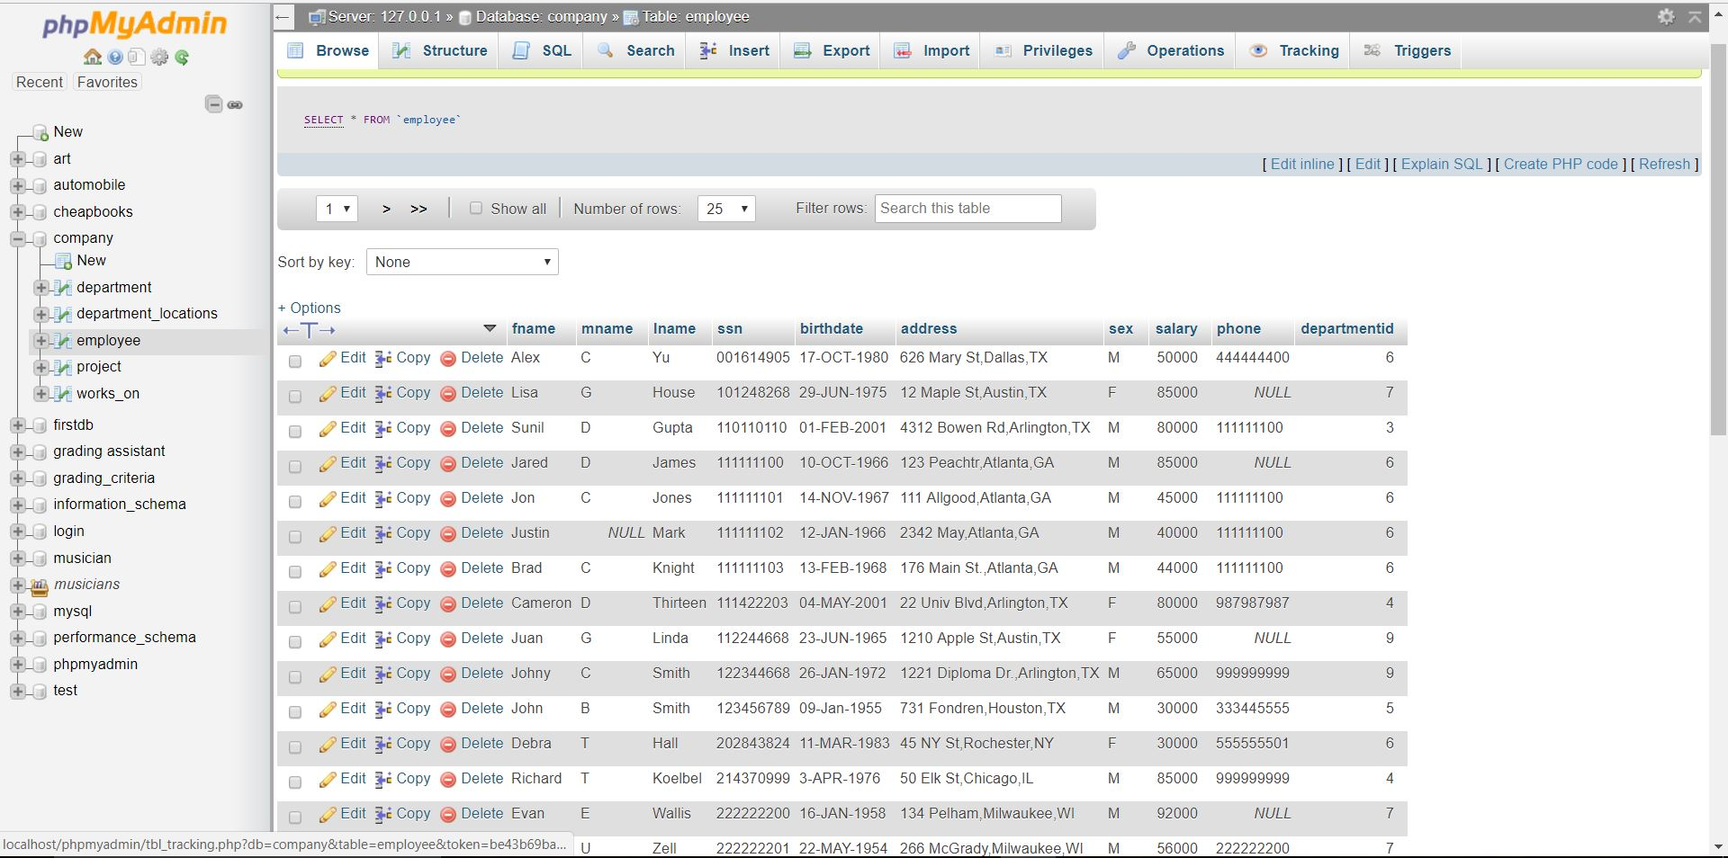

1. Department Table

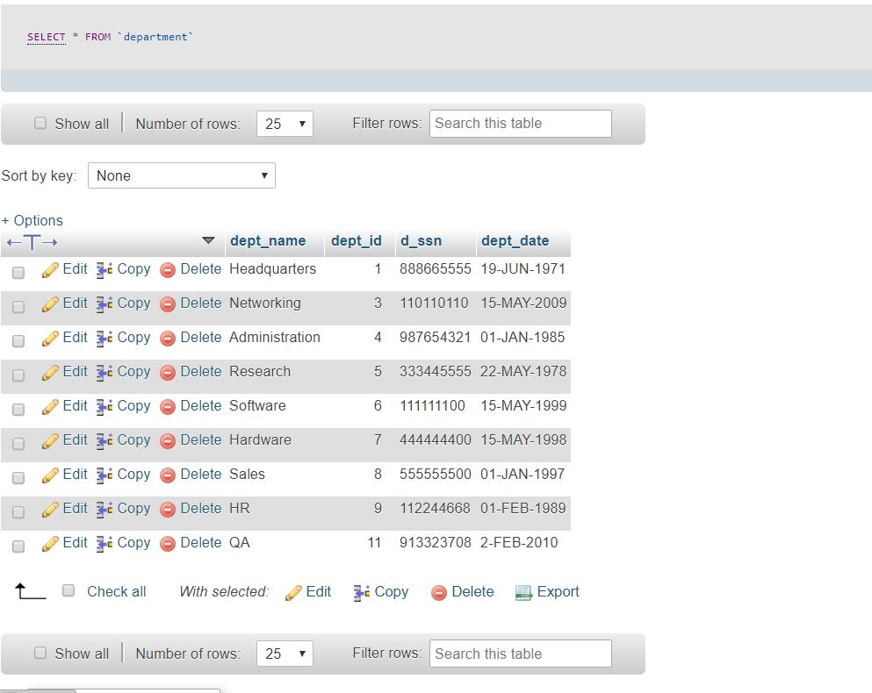

1. Department_locations Table

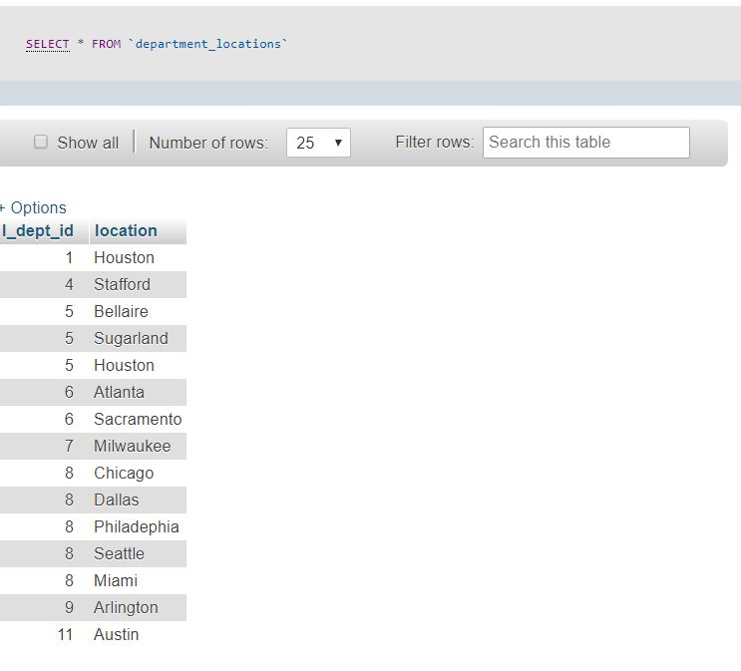

1. Works_on Table

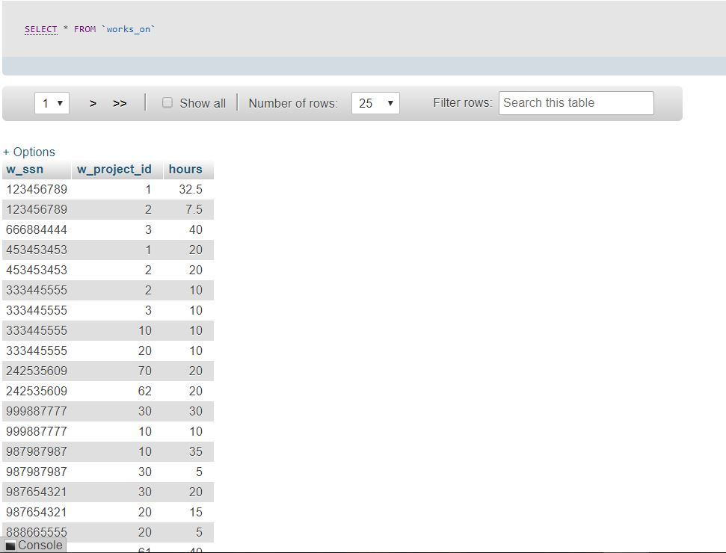

1. Project Table

