Edge Enhancement using Sobel function

Matlab sript for sobel function edge enhancement
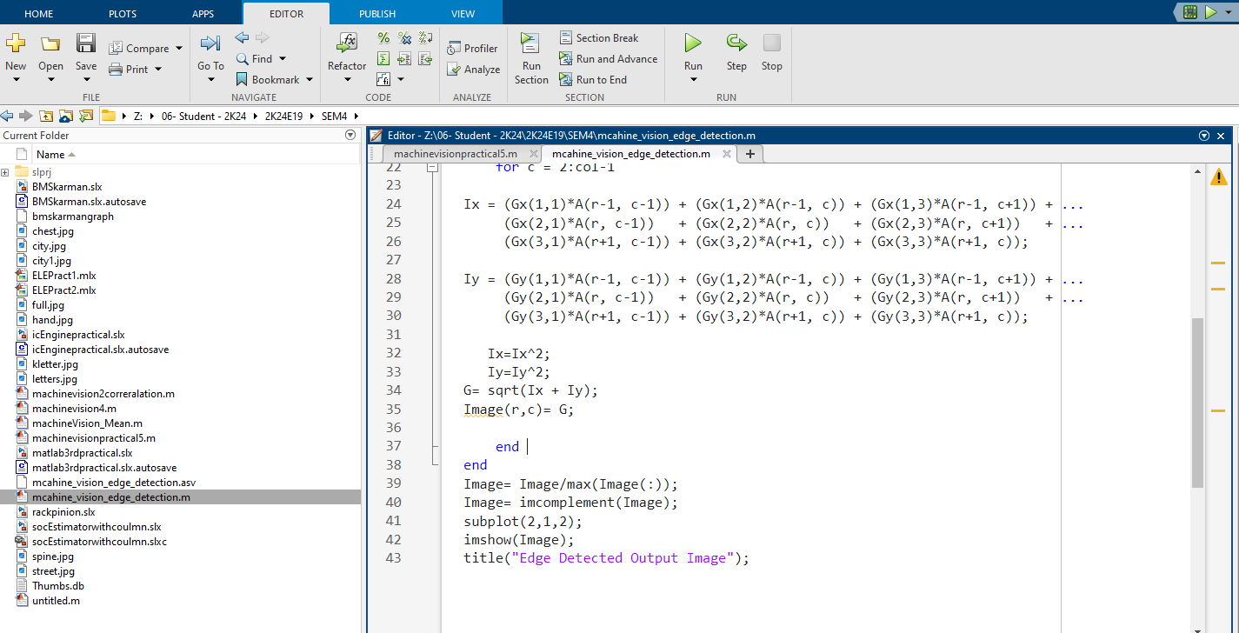

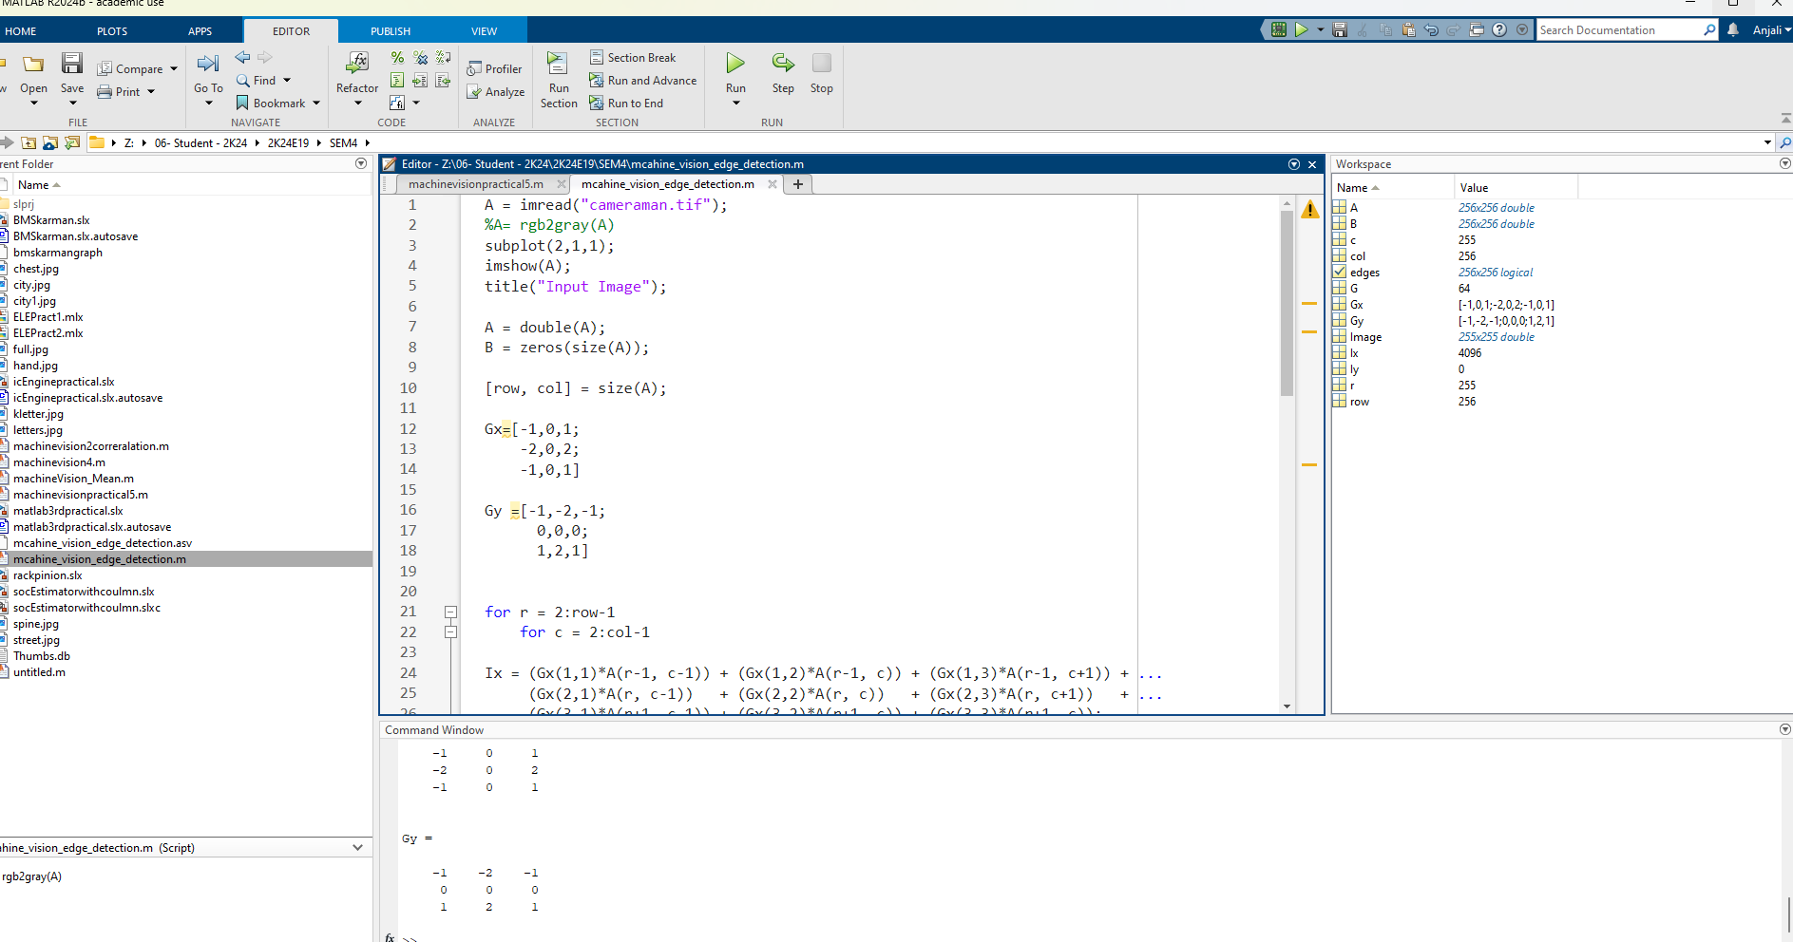
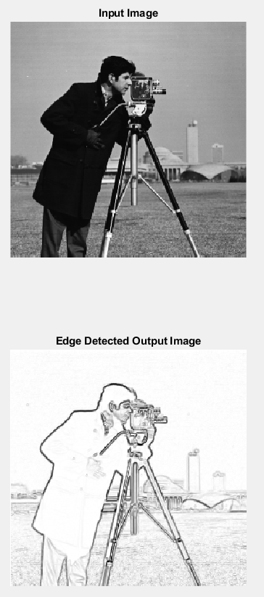

A = imread("cameraman.tif");
%A= rgb2gray(A)
subplot(2,1,1);
imshow(A);
title("Input Image");

A = double(A);
B = zeros(size(A));

[row, col] = size(A);

Gx=[-1,0,1;
-2,0,2;
-1,0,1]

Gy =[-1,-2,-1;
0,0,0;
1,2,1]

for r = 2:row-1
for c = 2:col-1

Ix = (Gx(1,1)*A(r-1, c-1)) + (Gx(1,2)*A(r-1, c)) + (Gx(1,3)*A(r-1, c+1)) + ...
(Gx(2,1)*A(r, c-1)) + (Gx(2,2)*A(r, c)) + (Gx(2,3)*A(r, c+1)) + ...
(Gx(3,1)*A(r+1, c-1)) + (Gx(3,2)*A(r+1, c)) + (Gx(3,3)*A(r+1, c));

Iy = (Gy(1,1)*A(r-1, c-1)) + (Gy(1,2)*A(r-1, c)) + (Gy(1,3)*A(r-1, c+1)) + ...
(Gy(2,1)*A(r, c-1)) + (Gy(2,2)*A(r, c)) + (Gy(2,3)*A(r, c+1)) + ...
(Gy(3,1)*A(r+1, c-1)) + (Gy(3,2)*A(r+1, c)) + (Gy(3,3)*A(r+1, c));

Ix=Ix^2;
Iy=Iy^2;
G= sqrt(Ix + Iy);
Image(r,c)= G;

end
end
Image= Image/max(Image(:));
Image= imcomplement(Image);
subplot(2,1,2);
imshow(Image);
title("Edge Detected Output Image");

