I=imread("texture.png");
I=rgb2gray(I);
subplot(1,3,1);
imshow(I);
title('original Image');
E=entropyfilt(I);

S=stdfilt(I,ones(9));
R=rangefilt(I,ones(9));
Eim=rescale(E);
Sim=rescale(S);
BW1=imbinarize(Eim,0.8);
BWao=bwareaopen(BW1,2000);
nhood=ones(9);
closeBWao=imclose(BWao,nhood);
mask=imfill(closeBWao,'holes');

textureTop=I;
textureTop(mask)=0;
textureBottom=I;
textureBottom(~mask)=0;
L=mask+1;
subplot(1,3,2);
imshow(labeloverlay(I,L));
title('Labeled Segmentation Region')

boundary=bwperim(mask);
subplot(1,3,3);
imshow(labeloverlay(I,boundary,"Colormap",[0 1 1]));
title('Boundary Between Textures');

Final Output
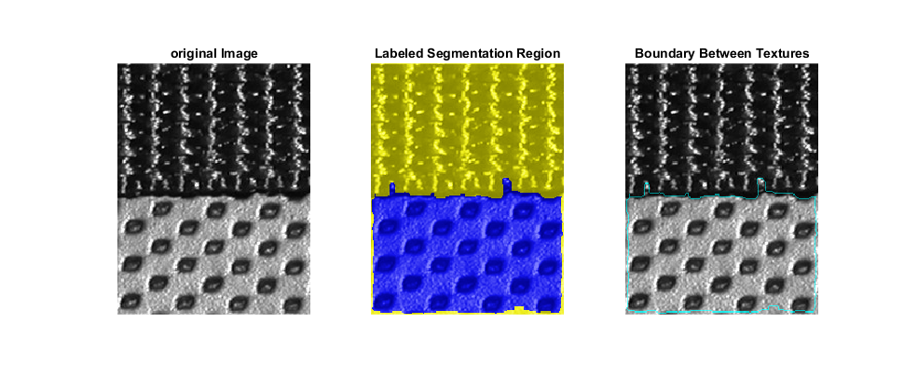

Steps-
