Create the Storage Account (Portal)
place in Resource group: rg-storage-we
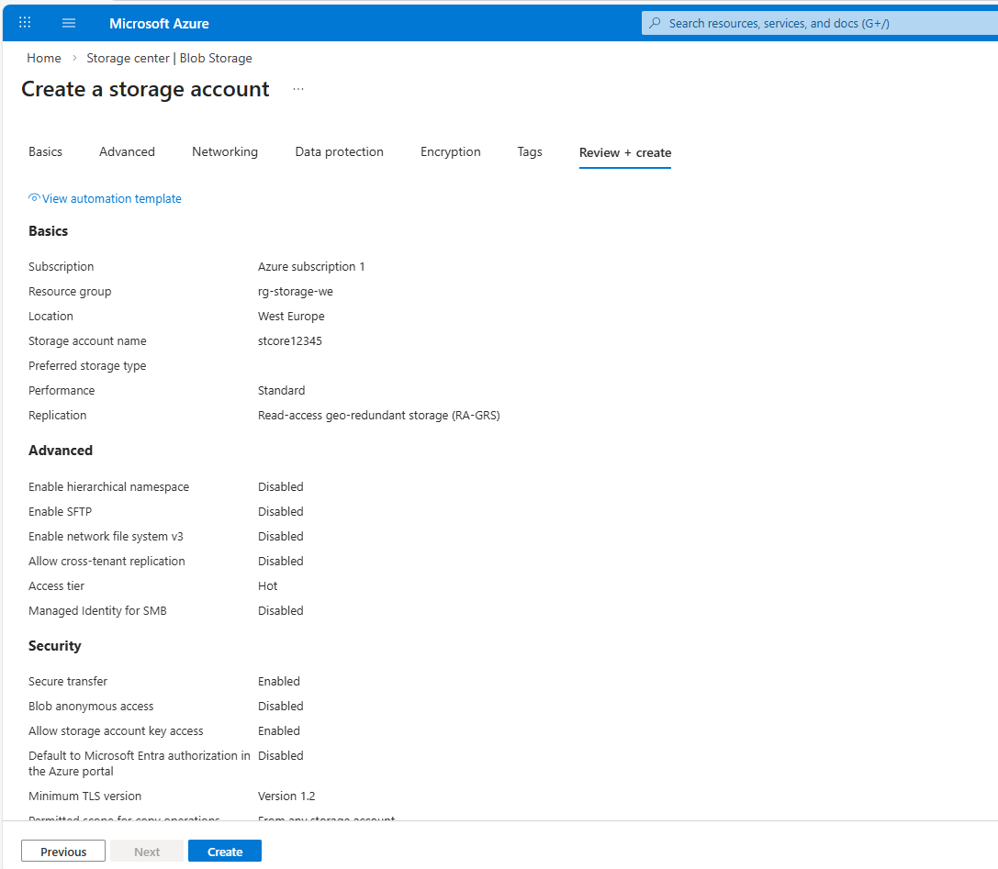
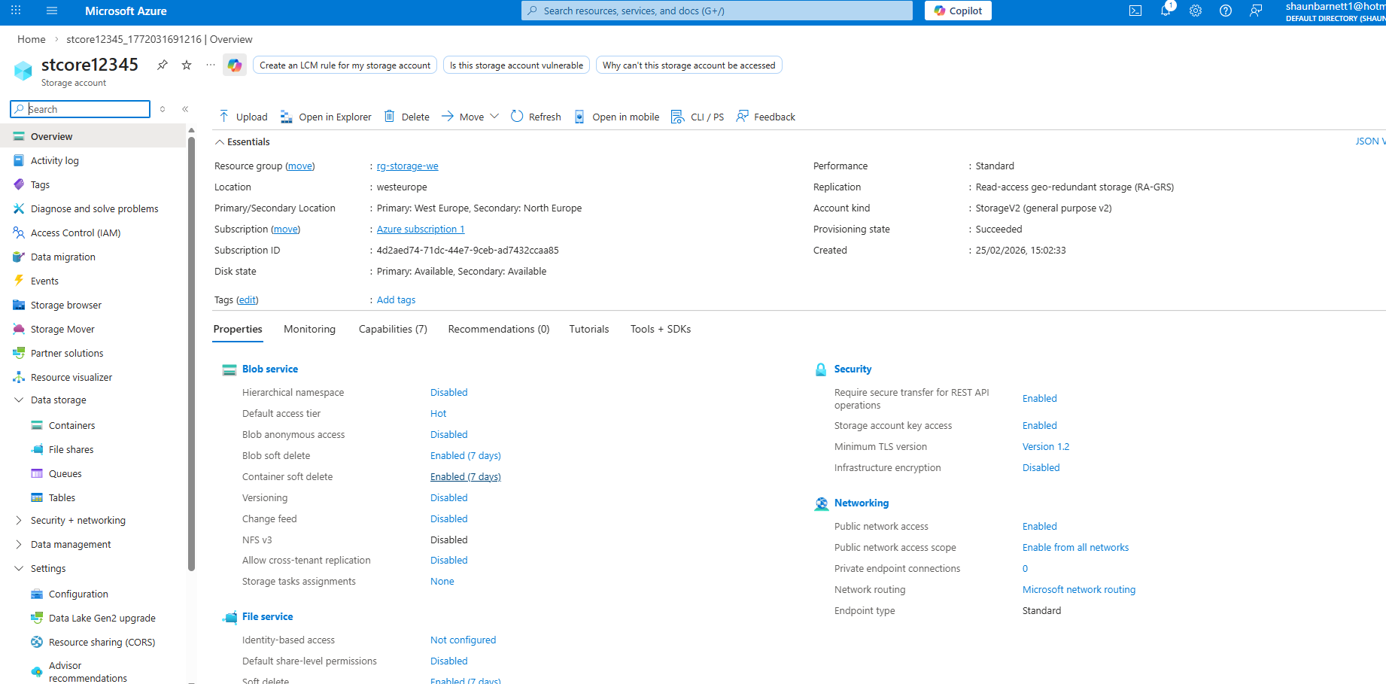

Create a “boot-diagnostics” container:
az storage container create \
--account-name stcore12345$suffix \
--name boot-diagnostics
Create a “vm-uploads” container
az storage container create \
--account-name stcore12345$suffix \
--name vm-uploads
