Apply Tags to Resource Groups
az group update \
--name rg-core-we \
--set tags.Owner=ShaunBarnett \
tags.Environment=Training \
tags.Project=AZ104

az group update \
--name rg-compute-we \
--set tags.Owner=ShaunBarnett \
tags.Environment=Training \
tags.Project=AZ104

az group update \
--name rg-storage-we \
--set tags.Owner=ShaunBarnett \
tags.Environment=Training \
tags.Project=AZ104
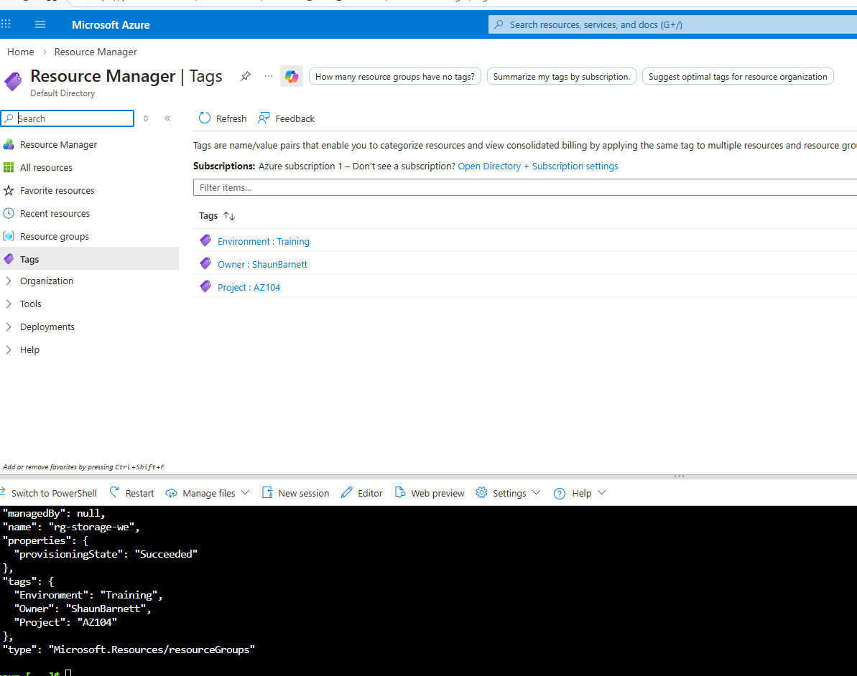
Add a Resource Lock. VM and Storage account
VM by CLI
az lock create \
--name lock-delete \
--resource-group rg-compute-we \
--resource-name vm-web01 \
--resource-type Microsoft.Compute/virtualMachines \
--lock-type CanNotDelete
Storage by Portal
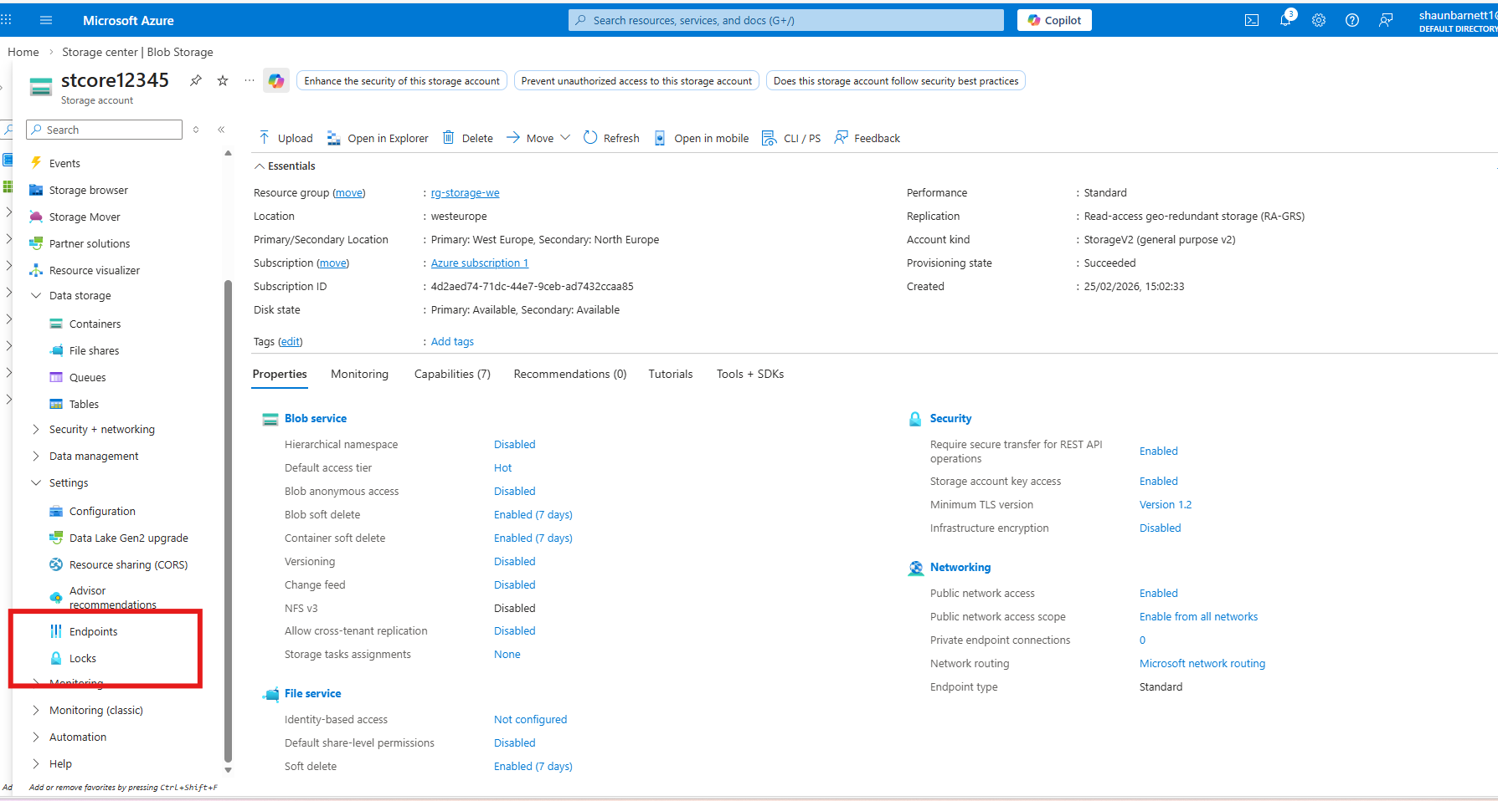
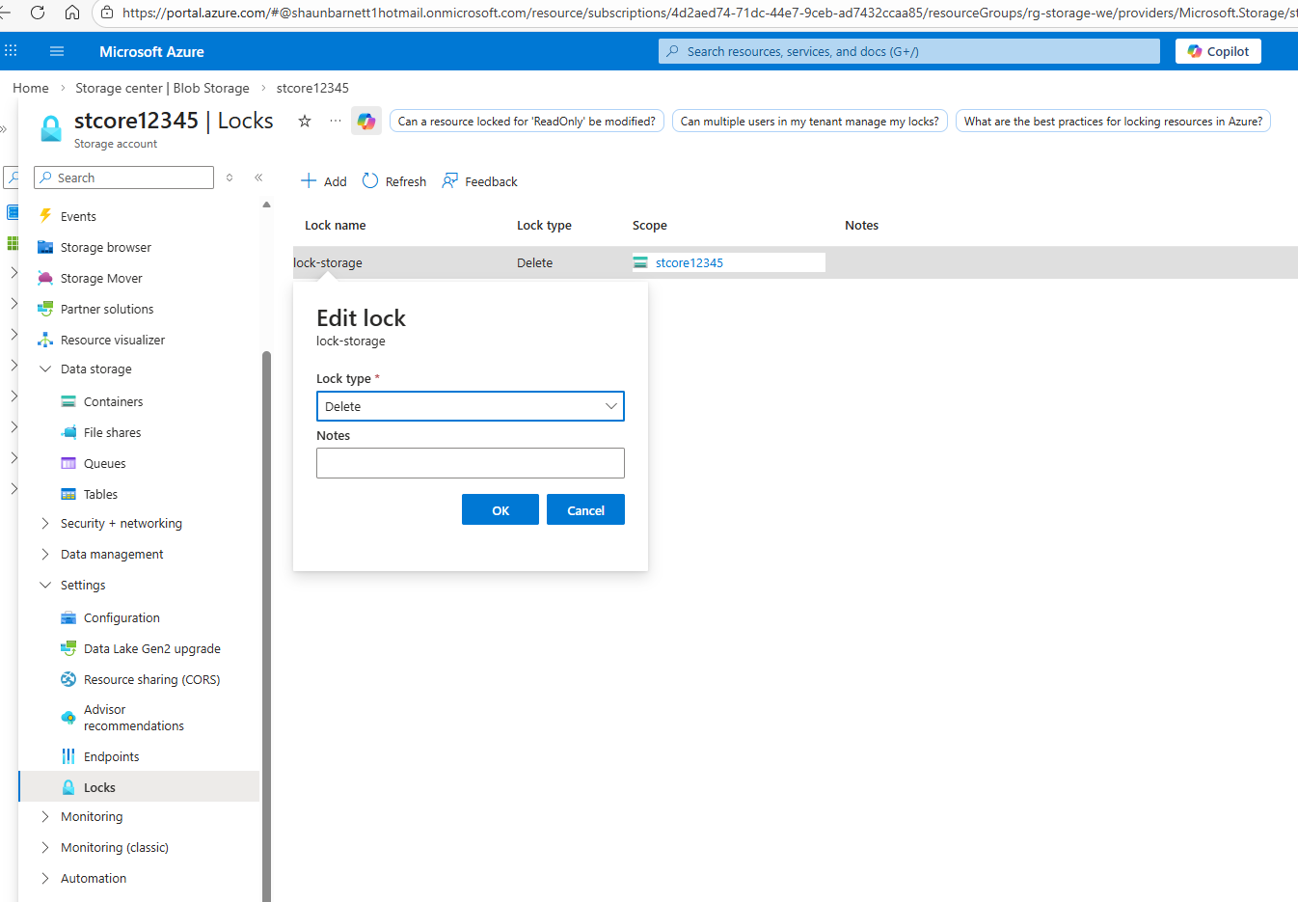

Azure Policy (Built-In)
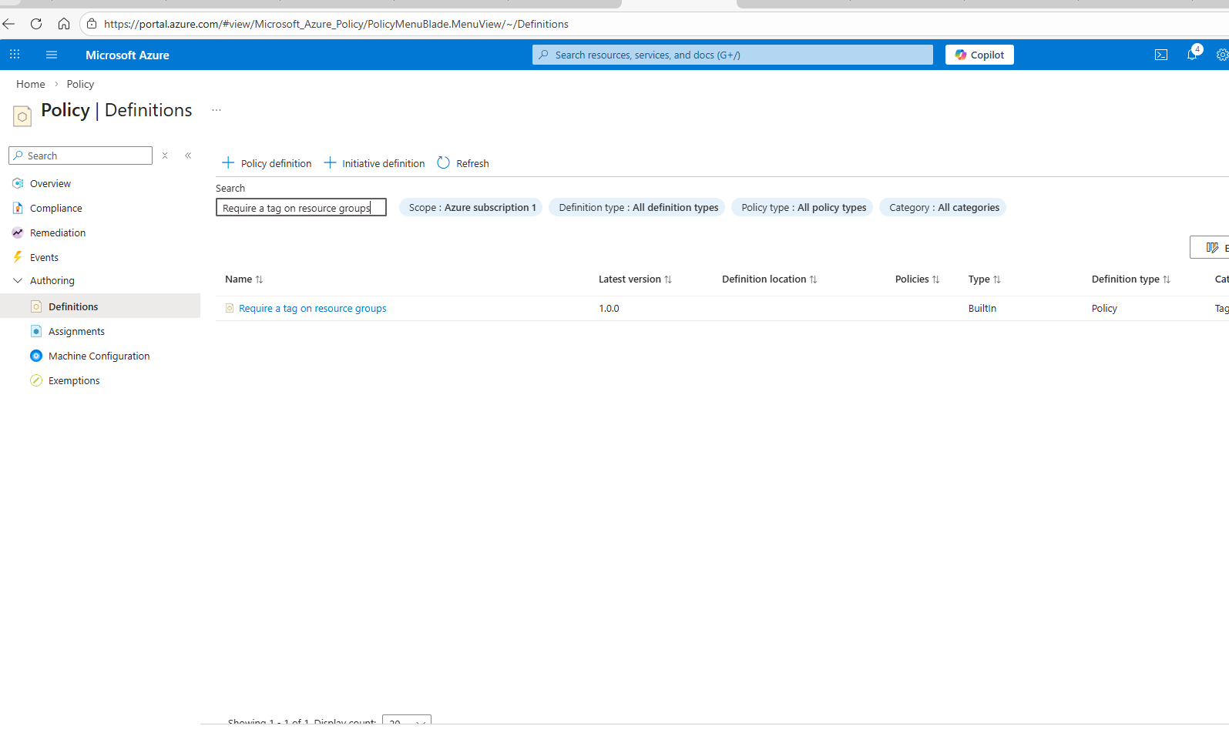
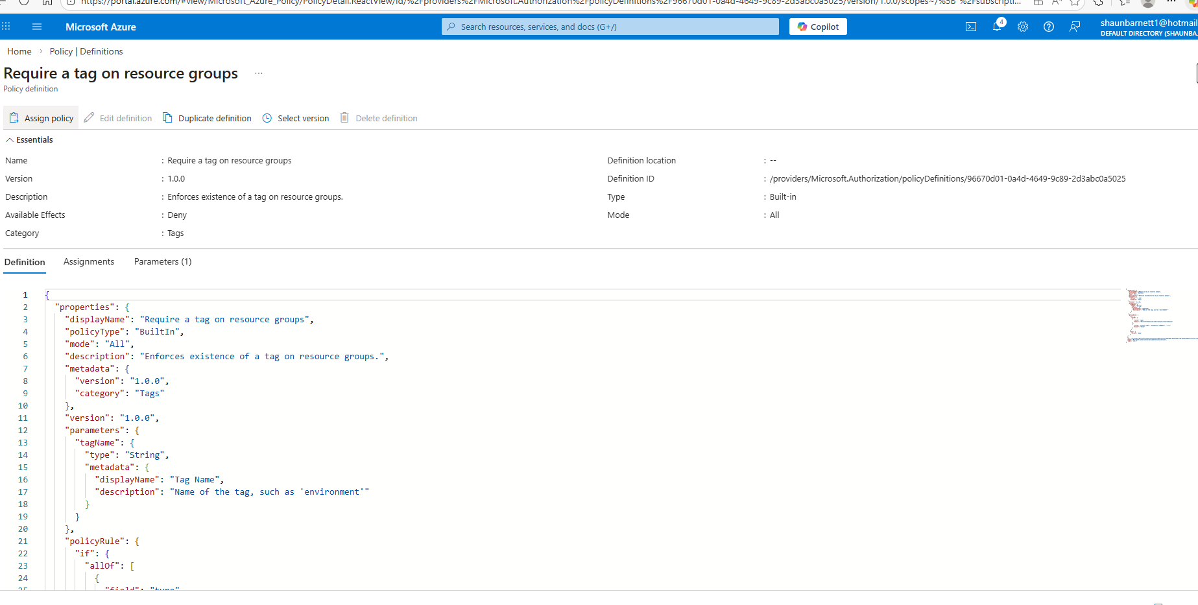
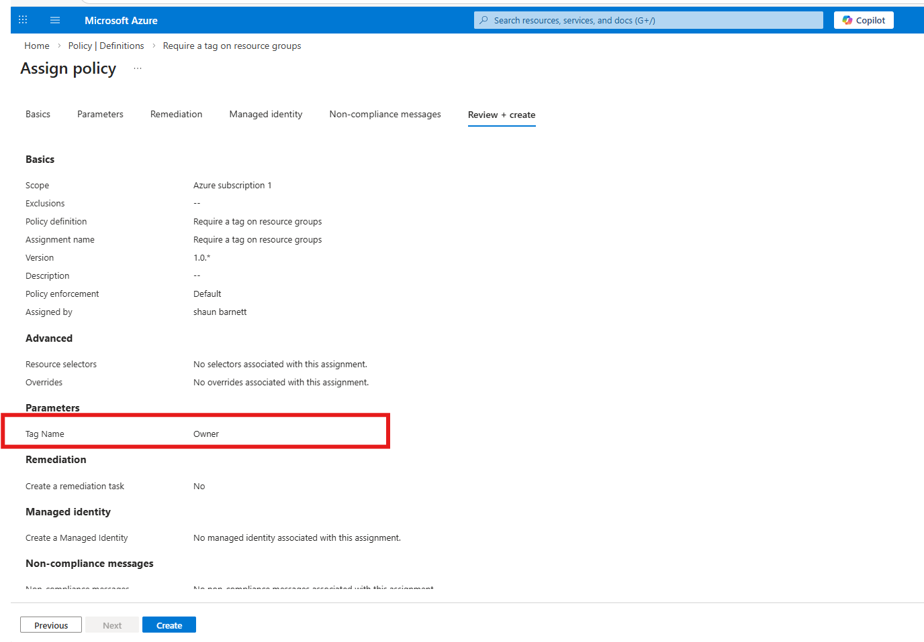
Policy in affect
