SUGAR TERMINALS LIMITED
Lucinda Bulk Sugar Terminal
STAGE 1 ACCESS METHODOLOGY OPTIONS ASSESSMENT
Authoring Brief and Independent Engineering Basis
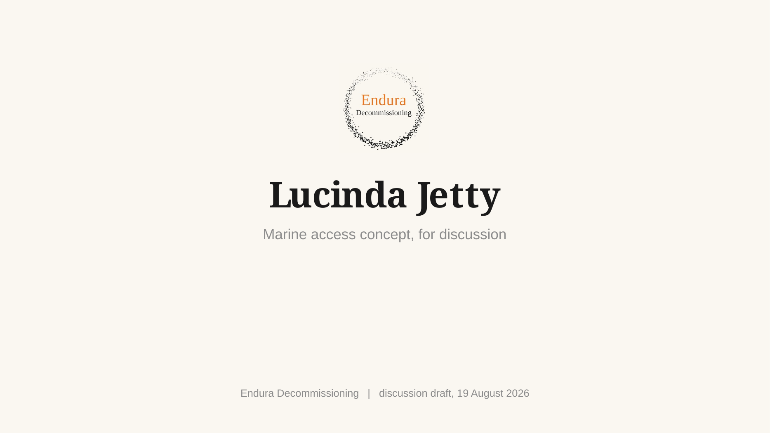
Prepared under engagement ED-018-2026-01
Prepared for Claude authoring and Shaun / Jed review
20 August 2026
Working draft. Not for STL issue.

Document control and intended use
Field | Entry
Document type | Independent engineering basis and authoring brief. This is not the client deliverable.
Authoring workflow | Claude prepares the controlled Stage 1 report. ChatGPT remains the independent checker.
Engagement reference | ED-018-2026-01, Stage 1 Access Methodology Options Assessment.
Primary purpose | Freeze the source-based engineering, productivity, cost-model structure and proposal compliance before the author prepares the client draft.
Assurance status | Working basis. Supplier, site and owner inputs remain open.
Companion model | ED018202607_STL_Access_Productivity_Cost_Model_RevA.xlsx.
Issue restriction | Not for construction, procurement, contractual action or cost commitment.

This document deliberately separates project facts, current contractor evidence, engineering assumptions, supplier inputs and open verification gates. It must not be converted into stronger client claims without the evidence identified in the relevant section.

Executive summary
STL requires the priority integrity repairs on the Lucinda jetty to be closed out by the end of 2028. The boundary between the priority package and the wider remaining scope has not yet been confirmed. A conservative stress test of 227 remaining bents over two nominal 30-week production seasons requires 3.783 QA-closed bents per week. This is a planning stress case, not confirmation that all 227 bents form the priority package.
The current scaffold methodology has not demonstrated the required production. From March to July 2026, safe access was claimed on 7.9 typical-bent equivalents over approximately 21.9 calendar weeks, equal to about 0.36 stage equivalents per week. Inspection and UT reached about 0.41 equivalents per week and blast/coating about 0.32 equivalents per week. These are contract payment-stage quantities. The supplied records do not establish the number of fully completed and QA-closed bents.
The preferred candidate for typical two-pile bents is a reusable marine access system. One complete set comprises two full-length floating platforms, one on each long face of the headstock, laterally travelling suspension to follow the 1:4 pile rake, traversing decks between the platforms for 360-degree access, opposing half-shell pile containment, a movable access tower, workboat support and an adjacent jack-up barge carrying the campaign utilities and welfare.
The access concept addresses a real constraint, but the current model does not prove that two sets can deliver the programme. Two sets should be treated as the proving/leapfrog pair. The current incomplete base model produces approximately 0.73 bents per week for two sets and mathematically requires 11 sets to reach the 3.783-bent stress rate. Improved welding and a pre-approved repair library reduce the diagnostic requirement to six to nine sets, but headstock containment, below-LAT jackets, clean-out/rework and coating elapsed holds are still outside the completed cycle. The final fleet is therefore an output of the proving campaign and dated line-of-balance, not a concept assumption.
The recommendation is to retain the marine access system as the preferred candidate for typical bents, use conventional or hybrid access for non-typical families where needed, complete the supplier and site gates, run a two-set proving campaign, then size the production fleet and cost from measured QA-closed output. No board decision should rely on an unsupported claim that two sets alone will complete the programme.

Key decision position
Matter | Current position | Required next step
Preferred direction | Reusable marine access for typical two-pile bents; hybrid access for other families. | Confirm direction at STL workshop.
Proving configuration | Two complete access sets forming one leapfrog operating pair. | Obtain GGC/supplier data and undertake a timed proving campaign.
Production fleet | Not fixed. Current diagnostic range is six to eleven sets depending proven improvements and missing work. | Complete work-lot and resource-loaded model after trial.
Repair approval | One bent-level submission after diagnostic exposure of both piles and headstock is the current modelling basis. | Confirm with Jed, STL and reviewing engineer.
Commercial position | Detailed bottom-up cost model exists, but a total remains incomplete. | Load written GGC, JUB, labour and material rates; reconcile current cost to complete.

1. Proposal scope and deliverable compliance
The client draft must answer every output committed under the accepted Stage 1 proposal. The following matrix is the authoring control. It is not optional content.
Proposal output | Required treatment in Stage 1 report
Information review and source basis | Describe reviewed contract, drawings, Shoreline report, current progress, programme, site reports, ship profile and RFIs. Include source limitations.
Options identification and screening | Screen current scaffold, reusable marine access, jack-up supported access, hybrid/special-bent access and any other credible alternative.
Working configuration and equipment make-up | Define platforms, suspension, traversing decks, containment, access towers, JUB, workboats, services and rescue arrangement.
Deployment and relocation | Provide mobilisation, assembly, proof load, pre-rig, float-in, hook-on, lift, restrain, services, lower, tow and recommission sequence.
Tide, weather and operability | Define separate limits for approach, hook-on, lift, occupied work, lowest-position work, lowering, tow, survival, ship make-safe and cyclone recovery.
Containment and waste | Define pile half-shell and headstock containment, negative pressure, extraction, spent abrasive, wash water, coating overspray, noise and waste handling.
Materials, crew and waste logistics | Define crew-by-road, heavy materials by water, JUB services, shore base, waste runs, fuel, accommodation and rescue coverage.
Structural and temporary works interfaces | Define host structure capacity, hang-off points, unequal load/fault cases, travelling suspension, traversing-deck load path, containment alignment and platform states.
Shipping, cyclone and wet season | Define two-day make-safe, ship-call reinstatement, warning-time recovery, refuge and full Dec-Mar demobilisation/remobilisation.
Productivity, programme, cost and risk comparison | Use one measurement basis, QA-closed bents/week, a dated calendar, bottom-up cost build-up and a transparent risk/gate register.
Market sounding | Record GGC/Hansen platform data, containment suppliers, JUB/workboat candidates, availability, rates and exclusions.
Options workshop | Present decisions, open gates and required client inputs.
Final recommendation and roadmap | Recommend method by bent family, proving campaign, procurement path, implementation sequence and decision gates.

2. Source basis and evidence hierarchy
The repository was inventoried programmatically and the material sources were subjected to targeted engineering review. The companion workbook contains the full file manifest, file hashes and extraction status. The following sources carry the main technical and commercial basis.
Ref | Source | Use / limitation
S01 | ED-018-2026-01 Method Assessment Proposal Rev A | Engagement scope, deliverables and exclusions.
S02 | AAB Contract Scope & Specification | Contract scope, bent families, coating/jacket requirements and current access/commercial basis.
S03 | SCMC-22020-REP-001 Rev 1 Phase 1 Summary Report | Condition and strategy basis; multiple fronts and movable platform precedent.
S04 | AAB Claim Qty workbook | Claimed stage quantities, weld actuals and monthly performance.
S05 | AAB Program (June 26).mpp and screenshots | Current planned sequence, durations and concurrent WIP. Native logic remains to be planner-verified.
S06 | July 2026 JPHR inspection reports | Workfront, access, welding, weather, rework and coating observations.
S07 | Original and Aurecon drawings, G01/G02 | Bent geometry, levels, structural interfaces, coating and repair details.
S08 | Hansen Engineering platform drawings and GGC images | Closest supplier platform basis. Written current data and commercial offer still required.
S09 | JUB and marine spread data sheets | Candidate equipment classes only. No unit selected.
S10 | RFI register and ship-loading profile | Open client inputs and operational interruptions.
S11 | Jed/Shaun/Tim method discussions and accepted concept plate | Current concept direction. Supplier implementation remains open.

Evidence rule: the current contract and formal STL instructions govern. Claim stages are not completed bents. Programme screenshots can support visible durations and WIP, but not an independently verified native critical path. GGC and marine supplier information must be issued in writing before it is used as a committed cost or capacity basis.

3. Current methodology and demonstrated performance

3.1 Current delivery sequence
- Install kerb-hung scaffold and full-bent encapsulation from the roadway.
- Remove existing wrapping, wash, inspect and perform UT.
- Determine and submit weld repair requirements.
- Wait for repair approval while the scaffold remains at the bent.
- Complete plate preparation, fit-up, welding, NDT and rectification.
- Abrasive blast, apply the two-coat system and complete coating QA.
- Install pile jackets within available tidal windows.
- Dismantle and relocate the scaffold and repeat at the next bent.

3.2 Claimed progress, March to July 2026
Stage | Claimed total | Calendar rate | Best month | Interpretation
Safe access | 7.9 bent eq | 0.36/week | 3.2 | Not completed bents
Inspection and UT | 9.0 bent eq | 0.41/week | 5.0 | Payment-stage equivalent
Blast and coating | 7.0 bent eq | 0.32/week | 3.5 | Payment-stage equivalent
Pile jackets | 12.0 pile eq | 0.55/week | 7.3 | Pile equivalent
Weld preparation and welding | 473.0 lm | 21.6 lm/week | 202.0 lm | 10 mm share 61.1%

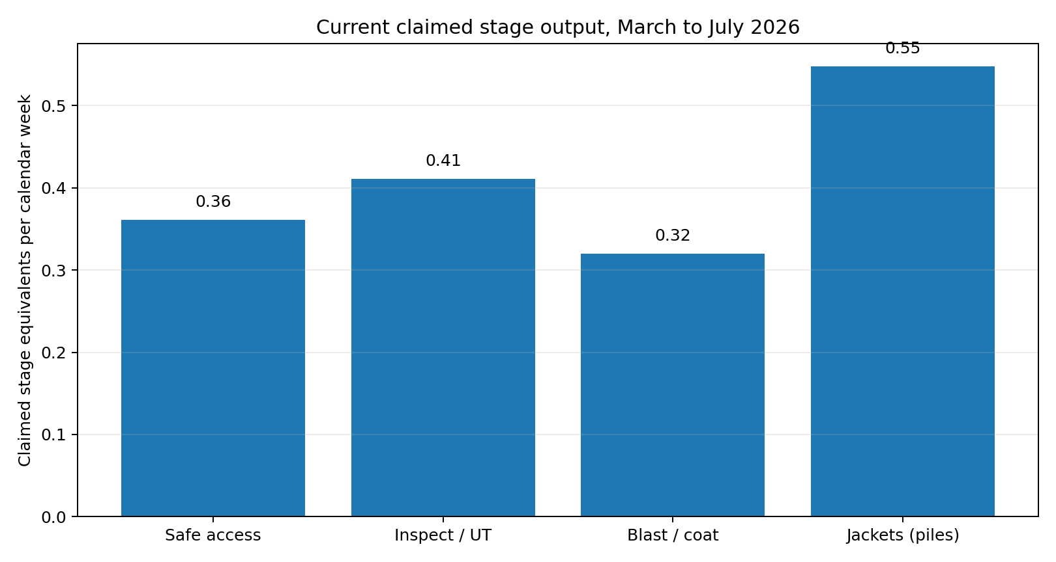
Figure 1. Current claimed stage rates. Stage equivalents are not QA-closed bents.

3.3 Current cycle and constraints
Activity | Range, days | Central, days | Character
Scaffold erection and encapsulation | 2 to 3 | 2.5 | Access handling
High pressure wash, inspection, UT | 1 to 1 | 1 | Productive
Weld repairs | 2 to 7 | 4.5 | Productive, variable
Repair approval hold | 3 to 3 | 3 | Waiting
Abrasive blast and two coats | 3 to 4 | 3.5 | Productive
Pile jacket installation | 0 to 2 | 1 | Tide limited
Scaffold strip and relocation | 1 to 2 | 1.5 | Access handling

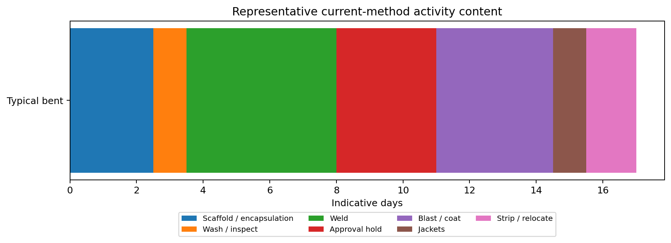
Figure 2. Representative current-method activity content. Actual calendar elapsed time varies.
The records support a multi-constraint diagnosis. Four scaffold sets did not provide four continuously available trade fronts. July reports record welders without usable fronts, incomplete lower access, weather/removal backlogs, post-blast defect discovery, reblast and coating touch-up. Peak programme WIP of up to nine bents is not evidence of nine physical scaffold sets. The dominant recoverable issue is the serial access and workflow cycle, but repair quantity, approval, coating, tide, weather and vessel operations remain material.

4. Access options and screening basis
Option | Method | Advantage | Limitation | Screening position
O1 | Continue current full-bent scaffold | Known and contract-established. | Repeated build/strip, roadway pressure, standing hire and serial queue remain. | Retain only as baseline or local special-bent method.
O2 | Reusable floating/suspended platforms with local containment | Moves access instead of rebuilding it; supports work at multiple levels and marine logistics. | Temporary works, supplier capacity, headstock enclosure, below-LAT method and fleet requirement are open. | Preferred candidate for typical two-pile bents, subject to proving.
O3 | Jack-up as primary workface | Stable plant, crane and utilities. | JUB relocation, water depth, reach and cost can put production on marine critical path. | Do not adopt as universal workface without candidate-unit study.
O4 | Hybrid floating platforms plus scaffold/rope/MEWP for special families | Avoids forcing one geometry onto anchored, passing-bay, EJ and interface work. | More method interfaces and mobilisation complexity. | Likely required for full scope; map by bent family.
O5 | Enhanced incumbent method with more scaffold/crews | Lower concept change. | Does not by itself remove serial cycle and trade/access mismatch. | Evaluate only against a resource-loaded recovery programme.

The Stage 1 report should include a weighted screening table after supplier input. Recommended criteria are programme confidence, QA-closed productivity, safety and rescue, constructability, bent-family coverage, environmental containment, ship/cyclone response, roadway impact, mobilisation lead time and whole-campaign cost.

5. Preferred candidate concept
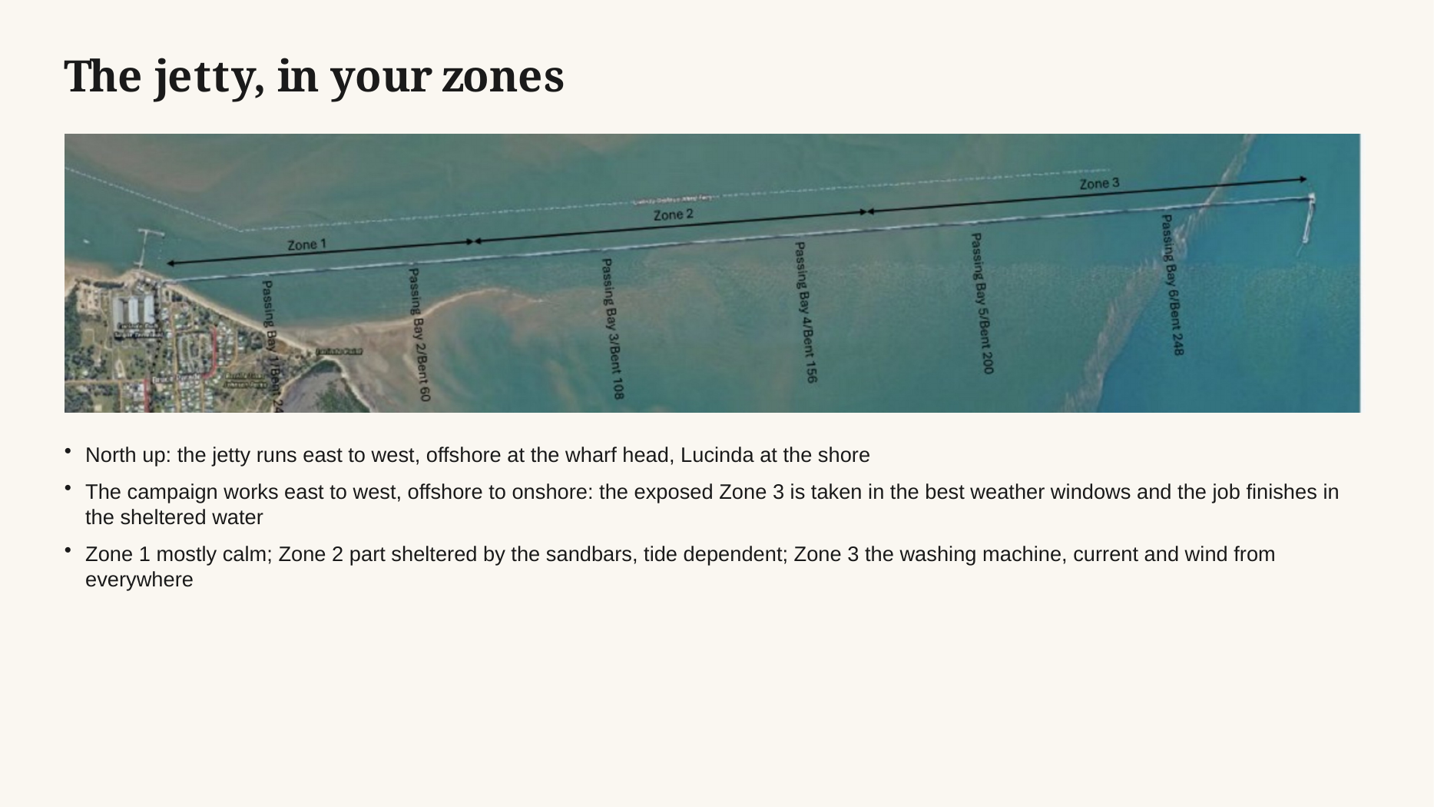
Figure 3. Current accepted concept basis. Indicative only, not for construction.

5.1 One complete access set
- Two full-length modular floating platforms, one along each long face of the headstock.
- Winches and a laterally travelling suspension or sliding beam-clamp system so the platforms can remain aligned as the 1:4 piles move outboard with depth.
- Two traversing or drop-down decks bridging between the main platforms at the active pile position to provide 360-degree access.
- Two opposing half-shell containment sections that close around the active pile, with extraction, recovery and environmental monitoring.
- A headstock enclosure configuration, still to be developed, covering beam faces, soffit, ends, pile connections, gallery feet and keeper-angle interfaces.
- One movable access tower from the jetty deck to platform level, with independent emergency/recovery provision at every platform elevation.
- An adjacent JUB carrying generation, compressed and breathing air, extraction, coating stores, waste, welfare and crane support.
- A workboat for platform positioning, advance rigging, materials and marine support, plus a dedicated rescue craft when personnel work over water.

5.2 Bent-family applicability
Bent family | Original firm quantity | Candidate application | Required development
Typical two-pile bents | 212 | Primary target for reusable platform system. | Dimensioned plan/elevation, load path and trial.
Anchor bents | 13 | May require modified decks, containment or hybrid scaffold. | Bent-family concept and intertidal quantity.
Passing-bay variants | 10 | Geometry and third pile can obstruct platform/traversing deck. | Dedicated layout and marine clearance.
Special bents | 2 | Do not assume typical method. | Bent-specific method.
Optional expansion joints | 20 optional | Deck jacking and bearing interfaces are separate critical scope. | STL option decision and engineered access method.
Excluded bents | 27 | Outside current contract basis unless formally changed. | No silent inclusion.

The current remaining quantity by family is not established. The report must not state that 212 typical bents remain. The figure 212 is the original typical-bent population within the 237 firm bents.

6. Mobilisation, assembly and initial proving

6.1 Pre-mobilisation engineering
- Confirm the STL bent register, priority boundary, bathymetry, seabed and metocean basis.
- Obtain the GGC/Hansen platform technical schedule: module dimensions, bare and rigged mass, buoyancy/freeboard, WLL/deck load, lift points, winch configuration, control system, sliding travel, locking, transport and commercial terms.
- Develop the temporary-works load path for every platform state, including floating, hook-on, transition, suspended working, lowest working elevation, power loss, one-hoist fault, snag/stall, wind restraint, unoccupied survival and recovery.
- Design traversing decks and platform-to-platform interfaces, including relative movement, locking, gap/edge protection and rescue.
- Develop pile and headstock containment with airflow, pressure, filtration, waste and wash-water recovery, noise and wind acceptance criteria.
- Select candidate JUB/workboats and confirm bathymetry, leg penetration, crane reach, deck layout, services, access tower moves, refuge and rates.
- Prepare marine operations, SIMOPS, environmental, rescue, shipping, cyclone and wet-season plans.

6.2 Assembly and proving sequence
- Transport modular components to the nominated assembly base.
- Assemble main platforms, handrails, buoyancy sections, winches, travelling supports, traversing decks and containment components.
- Prepare the mass, centre-of-gravity and lifting-point schedule for every configuration.
- Complete fabrication inspection, NDT, electrical function checks and load tests.
- Assemble and trial the access tower, service umbilicals, emergency disconnect and manual/emergency lowering arrangement.
- Complete a dry run of platform move, containment closure, rescue and cyclone-recovery sequence.
- Mobilise the JUB, workboats, rescue craft, shore base, utilities, materials and waste systems.
- Undertake a two-set proving campaign on representative bent families and record actual active time, elapsed holds, crew demand, weather limits, defects, rework and QA closeout.

7. Bent deployment and relocation methodology
Stage | Detailed requirement
Advance rigging | Install and inspect the hang-off/sliding-clamp package at the next bent while the current set remains productive.
Tower placement | Use the JUB crane to position and secure the prefabricated access tower without exceeding the roadway load or obstruction limits.
Float-in | Tow/position the platform pair within the approved marine limit and exclusion zone.
Hook-on and lift | Connect the platform lifting points, synchronise winches, lift clear, verify level/load distribution and establish lateral restraint.
Traversing decks | Install, lock and inspect the traversing decks at the first pile position.
Services and access | Connect power, air, extraction, communications, rescue and emergency systems; complete pre-use checks.
Production | Keep the complete platform set at the bent through diagnosis, repair, coating, jackets, headstock work and QA release.
Move | Disconnect services, remove/relocate the tower, lower to flotation, tow to the pre-rigged bent, lift and recommission.

The current working relocation allowance is 11 hours per bent, comprising approximately four hours of advance rigging, one hour lower, two hours tow, two hours position/hook/lift, one hour tower move and one hour traversing decks/services. It is an unverified planning allowance and must be replaced by measured proving data. It should not be described as a few hours.

8. Detailed work sequence at a typical bent

8.1 Diagnostic and approval phase
- Remove existing wrapping where required. Wash and clean the steel sufficiently for initial inspection.
- Complete visual inspection and UT. Record condition by bent, pile and zone.
- Close the half-shell around the first upper pile band, establish negative pressure, blast to Sa 2.5 and recover spent media and coating debris.
- Open the shell, inspect the exposed steel and mark defects. Repeat on the second pile.
- Use the headstock containment configuration to expose and mark headstock defects and interfaces.
- Compile one bent-level repair package covering both piles and headstock. Submit for review and carry the approval hold while the set remains at the bent.
- Prefabricate repair steel from the approved package before the repair crew mobilises to the work zone.
The one bent-level approval is the current modelling basis. It is only valid if the reviewing engineer and STL accept that both piles and the headstock are exposed and marked before the submission. If approval remains pile-by-pile, the cycle and fleet requirement must include the additional hold.

8.2 Pile 1 repair, coating and jacket
- Prepare edges, fit repair plates and complete welding to the approved WPS.
- Complete NDT, rectify rejected welds and obtain repair release.
- Complete local post-weld surface preparation, profile and cleanliness checks.
- Apply first coat within four hours of final preparation. Apply stripe coats to edges, welds and details.
- Wash and thoroughly dry the first coat where required by G01. Verify recoat condition and apply the second coat within the 14 h to 14 d window.
- Complete DFT, visual and adhesion/holiday checks as applicable.
- Lower/reposition the platform and traversing deck for jacket work. Install and accept the above-LAT system.
- Complete the below-LAT portion using the manufacturer/marine method once that method has been established.
- Protect the completed pile from hot work, abrasive and overspray while pile 2 and headstock work proceeds. Reinspect before bent release.

8.3 Pile 2 and headstock
Repeat the approved repair, NDT, final preparation, coating and jacket sequence on pile 2. The main platforms remain at the bent. The containment halves and traversing decks move to the second pile. Complete the headstock and all relevant gallery-foot, keeper-angle and bearing-interface work under the dedicated headstock containment method. The order between pile 2 and headstock work must be reflected in the coating protection and SIMOPS plan.

8.4 QA closeout
- Approved repair records and material traceability complete.
- Weld NDT accepted and rework closed.
- Surface preparation and environmental records complete.
- Coating DFT and quality records accepted.
- Jacket lengths, overlaps, fixings, terminations and below-LAT acceptance recorded.
- Gallery feet, keeper angles and other assigned interfaces complete.
- Containment cleaned and waste reconciled.
- Photographic and digital bent records accepted.
- Bent released as QA-closed before it is counted as production.

9. Marine logistics and support spread
Element | Function | Key verification
Jack-up barge | Campaign utilities, crane, stores, waste, coating area, welfare and walk-to-work interface. | Water depth, legs/seabed, deck load, crane reach, coverage per set-up, relocation and refuge.
Primary workboat | Platform positioning, tow, advance rigging, materials and local marine support. | Survey status, bollard pull, deck load, crew, weather limit and rescue interface.
Rescue craft | Dedicated recovery while personnel work over water. | Stretcher recovery, crew competence and response time.
Access towers | Normal personnel access between jetty and working platform elevation. | Roadway load/clearance, support/clump weights, crane handling, elevation range and rescue.
Service umbilicals | Power, compressed/breathing air, extraction, communications and wash water. | Vertical/lateral travel, supports, snag prevention, emergency disconnect and fault state.
Shore base | Assembly, spares, waste staging, fuel, maintenance and emergency support. | Location, road access, environmental controls and cyclone refuge.

The JUB should remain off the production critical path only if the selected unit can support the number of simultaneous sets, access tower moves, utilities, stores and cyclone recovery without stopping the bent work. That is a design objective, not a proven fact.

10. HSE, SIMOPS, environmental and assurance requirements
- RPEQ design and independent check of temporary works and host-structure interfaces.
- Activity-specific marine limits for tow, hook-on, lift, occupied work, lowest position, lowering, survival and recovery.
- Synchronised winch controls, load monitoring, fault detection, emergency/manual lowering and a controlled response to unequal load, stall, snag and power loss.
- Two independent egress/recovery means demonstrated at every operating elevation, including a stretcher route and drill.
- SIMOPS matrix covering hot work, blasting, coating, NDT, jacket work, boat movement and suspended loads, including minimum bent separation and wind/plume rules.
- Dropped-object controls, tool tethering, exclusion zones, lighting and communications.
- Negative-pressure containment with boundary monitoring, filtration, breathing-air controls, abrasive recovery, wash-water containment, noise controls and sealed waste.
- Dugong, seagrass, GBRMPA/port and other environmental/approval pathway confirmed before procurement.
- Marine insurance and vessel status reviewed by operation class, including P&I, hull, pollution, workers compensation, professional indemnity and environmental liability.
- Two-day ship make-safe procedure and timed restart.
- Full wet-season demobilisation and cyclone recovery to a confirmed refuge within the available warning time.

11. Productivity and fleet model

11.1 Measurement basis
The only acceptable proposed output measure is fully completed and QA-closed bents per week. Current payment-stage equivalents must remain separate. Access, inspection, weld, coating or jacket quantities are supporting production indicators, not completed bents.

11.2 Stress-case requirement
The conservative whole-scope stress test is 227 bents over 60 nominal production weeks, equal to 3.783 QA-closed bents per week. A dated calendar must then apply the known outage, ship calls, proving/ramp-up, wet-season transitions and other explicit blocks. Residual availability is used only for stochastic weather and breakdown so losses are not double counted.

11.3 Current incomplete cycle
Activity | Shifts / days | Status
Wash, inspect and UT | 1.0 | Included
Diagnostic blast, two pile bands | 1.0 | Included, conservative work-lot allowance
Mark-up and repair package | 0.5 | Included
Bent-level approval hold | 3.0 | Assumption requiring confirmation
Welding and NDT | 4.42 | 53 lm / two crews / six accepted lm per crew-shift
Post-weld preparation | 0.5 | Included assumption
Coating active work | 1.5 | Elapsed recoat hold not included
Jackets above LAT | 1.0 | Timed trial required
Relocation | 1.1 | 11 h / 10 h shift
Headstock containment/work | TBC | Not modelled
Below-LAT jacket work | TBC | Not modelled
Clean-out/QA/rework | TBC | Not modelled
Coating elapsed hold occupancy | TBC | Not modelled

The represented subtotal is 14.02 shifts at one shift per day. It is not a demonstrated elapsed cycle and must not be used as a committed production rate. Four material components remain outside it.
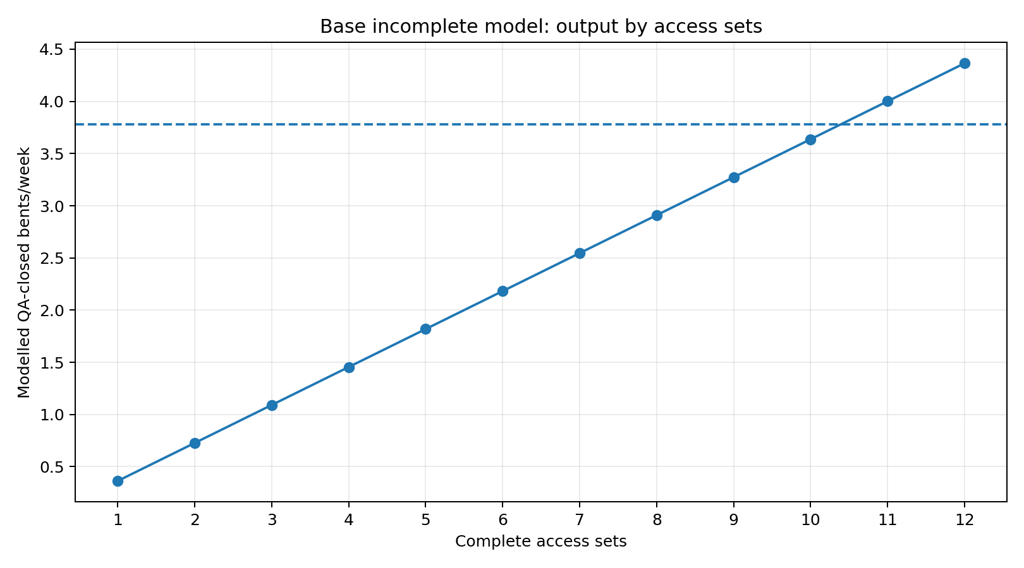
Figure 5. Base incomplete model output by complete access sets. Diagnostic only.

11.4 Improvement sensitivities
Scenario | Weld crews/set | Accepted lm/crew-shift | Routine hold, d | Cycle, d | Sets required at 3.783/week
S1 base incomplete | 2 | 6 | 3 | 14.02 | 11
S2 improved welding | 4 | 8 | 3 | 11.26 | 9
S3 repair library / no routine hold | 4 | 8 | 0 | 8.26 | 7
S4 stronger weld / no routine hold | 6 | 10 | 0 | 7.48 | 6

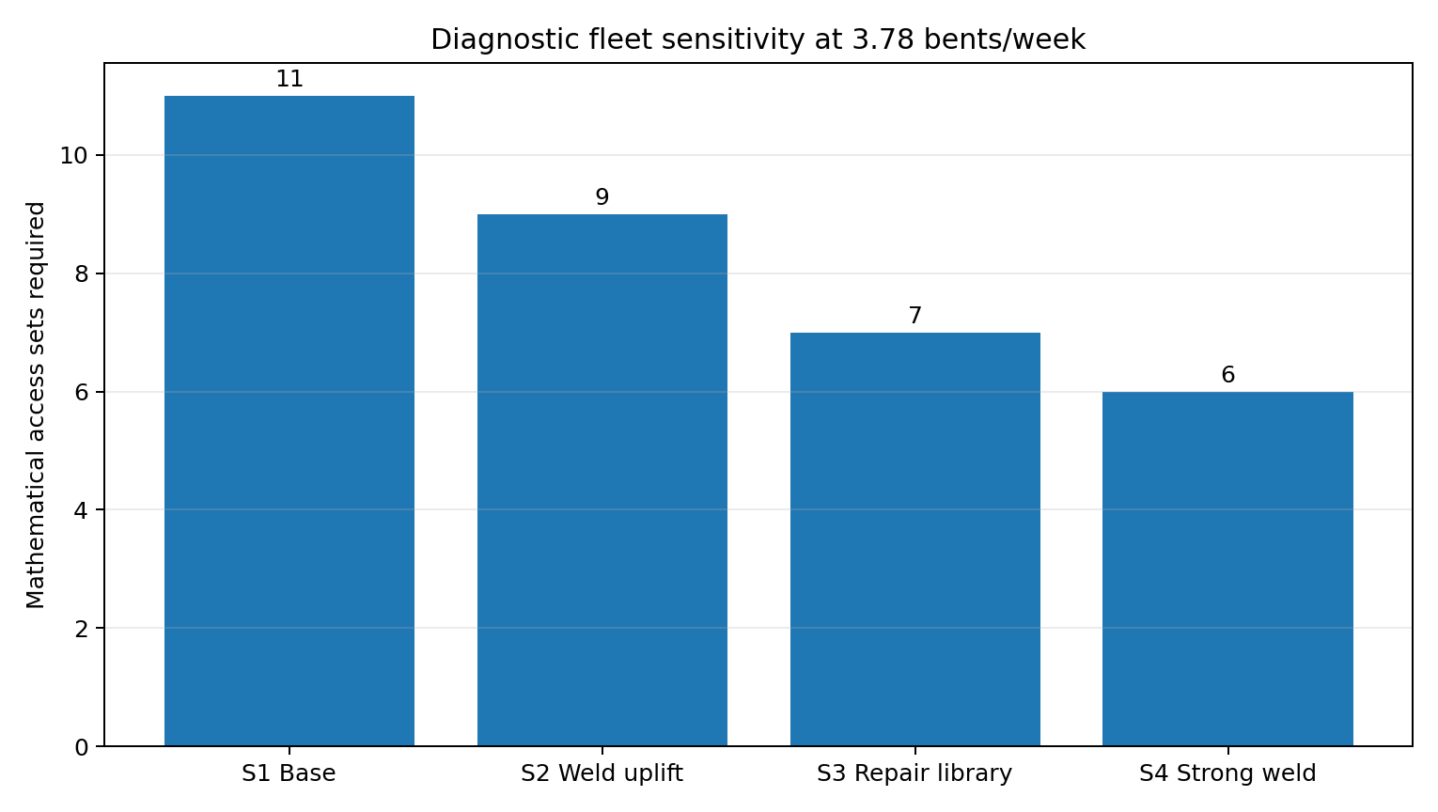
Figure 6. Mathematical fleet sensitivity. Not a recommended fleet.
The scenario result is not that six sets will complete the project. It is that six sets is the best displayed sensitivity before the omitted work is added. The proving campaign must establish safe weld zones, accepted output, approval logic, coating elapsed time, headstock cycle, below-LAT work and marine availability before a production fleet is recommended.

12. Programme and calendar basis
The Stage 1 report should carry two linked schedules: an engineering/procurement/proving schedule and a dated 2027-2028 production line-of-balance. The following minimum sequence is required.
Step | Phase | Required output
1 | Owner inputs | Bent register, priority boundary, bathymetry, metocean, outages and ship basis.
2 | Market sounding | GGC platforms/containment, JUB/workboats, labour, accommodation and waste quotes.
3 | Concept workshop | Select candidate method and allocate methods by bent family.
4 | Temporary works and method design | Platform, suspension, traversing decks, containment, JUB, rescue and approvals.
5 | Cost and calendar model | Bottom-up estimate and dated line-of-balance with explicit losses.
6 | Fabrication/modification | Build, inspect and proof load the selected access system.
7 | Mobilisation and proving | Two-set trial on representative bents, including recovery drills.
8 | Production decision | Update measured cycle, fleet, labour, cost and programme.
9 | Ramp-up and 2027 season | Monitor QA-closed output and constrain WIP.
10 | Wet-season demob | Preserve part-complete bents and recover the fleet.
11 | 2028 remobilisation and completion | Complete priority package and close records.

Known calendar events must be inserted explicitly. These include the 2027 outage when confirmed, 10-14 annual ship calls as the current planning range, two-day make-safe, full Dec-Mar demobilisation, proving/ramp-up and reinstatement. A standalone 85% factor cannot replace the dated calendar.

13. Cost model and commercial comparison
The companion workbook contains a bottom-up cost structure. No total should issue while the rate, fleet, duration and remaining-scope inputs remain incomplete. Every cost must trace to a methodology activity and every methodology activity must have an explicit cost treatment or stated exclusion.

13.1 Required cost build-up
- Engineering: surveys, temporary works, independent check, containment, marine operations, approvals and trial support.
- Mobilisation: JUB, workboats, platforms, access towers, containment, shore base, transport, assembly and proof load.
- Time-related plant: JUB, workboat, rescue craft, access sets, containment sets, compressors, generators, extraction, vehicles, base and accommodation.
- Labour: management, marine, HSE, QA, inspection/NDT, welding, blasting/coating, jackets, rigging/platform and logistics crews.
- Per-bent materials: repair steel, welding consumables, abrasive, coatings, jackets, NDT, waste and rework.
- Operational events: ship make-safe/restart, wet-season demob/remob, cyclone recovery, maintenance and spares.
- Contingency and escalation with a stated Basis of Estimate only after the underlying estimate is complete.

13.2 Current versus proposed commercial basis
The current contract access basis is approximately AUD 9.275 million ex GST for the firm access scope on the earlier reconciled basis. This is a historical contract basis, not the remaining avoidable cost and not a termination value. The comparison required for STL is remaining cost to complete on one consistent as-at date, including committed costs, preservation of part-complete bents, mobilisation, whole campaign duration and risk.
Comparison output | Required basis
Total remaining campaign cost | Same remaining bent register, scope, calendar and price date for both methods.
Cost per QA-closed bent | Total cost divided by accepted completed bents, not claim-stage quantities.
Time-related exposure | Full JUB/platform/scaffold and labour duration including waiting, ship calls and wet-season treatment.
One-off transition cost | Engineering, procurement, fabrication, proving, mobilisation and transfer from current works.
Risk-adjusted view | Transparent contingency/risk treatment, not a false point estimate.
Contractual boundary | Technical comparison only. STL and its advisers decide variation, continuation or termination.

14. Critical risks and verification gates
Gate | Area | Acceptance condition | Decision affected
G1 | Scope | STL bent register and priority boundary accepted. | Required rate and cost basis.
G2 | Platform | Certified configuration, mass, CoG, buoyancy, deck load and lift points. | Hoist/TW feasibility.
G3 | Suspension | Winch location, synchronisation, travelling clamp range, locking and fault response. | Alignment and safety.
G4 | Traversing decks | Checked load path, movement, locking, edge protection and rescue. | 360-degree access.
G5 | Containment | Pile/headstock geometry, pressure, filtration, waste, wash water, wind and noise accepted. | Constructability/environment.
G6 | Jackets | Above- and below-LAT manufacturer/marine method accepted. | Bent closeout cycle.
G7 | Approval | Bent-level or pile-level repair approval philosophy confirmed. | Hold count and fleet.
G8 | Welding | Accepted lm/crew-shift and safe simultaneous work zones proven. | Likely production driver.
G9 | Coating | Active work and elapsed recoat work-lot proven. | Access-set occupancy.
G10 | Marine spread | Bathymetry, JUB reach/services, vessel status and refuge accepted. | Support capacity and calendar.
G11 | Calendar | Dated ship, outage, weather, wet-season and proving blocks agreed. | Completion confidence.
G12 | Commercial | Written rates, fleet/duration and current cost-to-complete reconciled. | Board decision.

15. Supplier and market-sounding requirements

15.1 GGC / floating platform and containment supplier
- Identify exact platform drawing/configuration and controlled revision.
- Confirm dimensions, bare mass, rigged mass, buoyancy, freeboard, deck load, lifting points and structural condition.
- Confirm winch quantity, WLL, speed, duty, power, synchronised control, emergency/manual lowering and maintenance.
- Define travelling suspension/sliding beam clamps, travel range, locking and headstock interface.
- Define traversing decks and half-shell containment, including headstock configuration.
- State assembly, modification, transport, mobilisation, relocation and demobilisation durations.
- State operational and survival limits.
- Provide availability, ownership/hire basis, rates, inclusions, exclusions, maintenance, spares and support crew.

15.2 JUB and marine suppliers
- Candidate unit dimensions, draft, legs, penetration/preload requirements and site suitability.
- Deck capacity and layout for utilities, stores, waste, welfare and platform recovery.
- Crane chart and reach for access towers and platform components.
- Coverage per set-up, relocation cycle and weather limits.
- Walk-to-work, boat landing and emergency interfaces.
- Mobilisation, demobilisation, daily/monthly rates, fuel, crew, insurance, class and exclusions.
- Cyclone refuge and full fleet recovery capacity.

16. Recommended implementation roadmap
Decision gate | Action | Responsible | Proceed condition
DG1 Direction | STL endorse reusable marine access as preferred candidate for typical bents and hybrid approach for others. | STL / Endura | Concept workshop complete.
DG2 Evidence | Close bent register, GGC, containment, JUB and bathymetry inputs. | STL / Endura / suppliers | Written source pack accepted.
DG3 Design | Complete temporary works, marine, environmental and rescue design. | Execution contractor / RPEQ | Independent checks and approvals complete.
DG4 Proving | Run two-set proving campaign and timed drills. | Contractor / STL / Endura | QA-closed trial bents and measured cycle.
DG5 Production | Select fleet, crew, programme, price and contracting strategy. | STL Board / advisers | Risk-adjusted comparison supports decision.
DG6 Scale | Ramp up only after stable measured output and quality. | Contractor / STL | Production control limits achieved.

17. Conclusions for the author
- Do not claim that the current completed-bent rate is 0.36/week. It is a claimed safe-access stage equivalent rate.
- Do not claim that two access sets achieve the end-2028 programme. Two sets are the proving/leapfrog pair.
- Do not claim a final fleet until the complete elapsed cycle and dated calendar are modelled.
- Do not state that welding is proven to govern. It is the largest modelled item and a likely pacing candidate.
- Do not state that tidal waiting is eliminated. It is materially reduced for platform-accessible work; below-LAT work remains open.
- Do not claim cost savings until the remaining current cost and proposed bottom-up estimate are reconciled.
- Do not force the typical-bent system onto anchor, passing-bay, special or EJ bents without family-specific layouts.
- Present the concept as technically plausible and worth proving, not as selected plant or a construction-ready method.
- Keep legal/contractual action outside Endura’s technical recommendation. Provide evidence for STL and its advisers.
Recommended author conclusion: The reusable marine access concept is the strongest current candidate for removing repeated scaffold build/strip and improving workfront availability on typical bents. Its programme case is not yet proven. Stage 1 should proceed through supplier development, bent-family mapping, temporary-works design, dated calendar modelling and a two-set proving campaign. The measured proving result should determine the production fleet, programme, cost and procurement recommendation.

Appendix A. Fact, assumption and open-item register
Classification | Statement | Basis / closure
Project fact | 5.7 km jetty, 284 bents, approximately 670 piles. | Drawings / Shoreline.
Project fact | Typical headstock 7.9 m long, 900 mm deep, approximately 450 mm wide; piles 850/920 mm, rake 1:4. | Drawings.
Project fact | LAT RL -0.300, HAT RL 3.660. | Aurecon/jetty levels.
Client basis | Priority integrity repairs close by end 2028. | STL advice; priority boundary open.
Engineering stress case | 227 bents over 60 nominal production weeks. | Not the confirmed priority quantity.
Client progress basis | 7.9 safe-access equivalents in 21.9 weeks. | Claim extract; not completed bents.
Engineering sensitivity | 53 lm weld per typical-bent equivalent. | 473.025 lm / 9.0 inspection equivalents.
Engineering assumption | Two weld crews at 6 accepted lm/crew-shift in base model. | Requires timed trial.
Engineering assumption | One bent-level three-day repair approval. | Requires Jed/reviewing engineer confirmation.
Engineering assumption | 11 h relocation package. | Requires timed trial.
Open item | Headstock containment cycle. | Supplier/TW design.
Open item | Below-LAT jacket method. | Manufacturer/marine method.
Open item | Coating elapsed work-lot. | Manufacturer/trial.
Open item | Final access set fleet. | Output of complete model.
Open item | Complete cost estimate. | Rates, scope, fleet and duration.

Appendix B. Mandatory author self-check before checker review
- Every proposal deliverable is addressed or explicitly located in another deliverable.
- Every headline quantity reconciles across narrative, workbook, schedule, figures and cover note.
- Current stage equivalents are never labelled completed bents.
- The 227-bent quantity is labelled a stress case pending the bent register.
- The work sequence matches the accepted diagnosis, approval and pile-by-pile basis.
- The full coating sequence and elapsed holds are visible.
- Headstock containment and below-LAT jackets remain explicit open gates unless evidence exists.
- Two access sets are described as the proving/leapfrog pair, not the production fleet.
- All productivity scenarios are formula-driven and use one calendar convention.
- Known outages, ship calls, wet season and proving are explicit, not buried in an availability factor.
- Every cost line has scope, unit, quantity, rate source, duration and status.
- No total cost issues while material rate or duration inputs remain TBC.
- No unsupported supplier capacities, rates, operating limits or availability are introduced.
- Figures match the accepted plan/elevation and are labelled indicative/not for construction.
- Entity, document control, Australian English, confidentiality and Endura visual conventions are correct.
- No public claim or contractual recommendation exceeds Endura’s owner-side advisory scope.

