SUGAR TERMINALS LIMITED
Lucinda Bulk Sugar Terminal
Jetty Pile and Headstock Remediation
Stage 1 Access Methodology Options Assessment
Draft for internal review

Prepared for | Sugar Terminals Limited
Prepared by | Endura Decommissioning (Van Iersel Projects Pty Ltd)
Engagement | ED-018-2026-01, Access Methodology Options Assessment
Document number | To be assigned by Endura
Revision | Working Draft A
Date | 20 August 2026
Status | Not for construction, procurement or contractual reliance

Important | This report is an options assessment. It does not certify the proposed temporary works and does not recommend contractual action against the incumbent contractor. Detailed engineering, supplier selection, bathymetry, regulatory approvals and commercial quotations remain separate gates.

Document control
Revision | Date | Description | Prepared by | Checked by | Approved by
Working Draft A | 20 August 2026 | Stage 1 options assessment draft | Endura | Independent assurance pending | Shaun / Jed

Contents
- 1. Executive summary
- 2. Appointment and purpose
- 3. Deliverable compliance
- 4. Evidence basis and limitations
- 5. Asset, scope and constraint envelope
- 6. Current delivery method and demonstrated performance
- 7. Options considered and screening
- 8. Preferred concept
- 9. Detailed execution methodology
- 10. Marine logistics and access
- 11. Containment, coating, waste and environmental controls
- 12. Temporary works, HSE and operability
- 13. Productivity model and schedule comparison
- 14. Indicative programme
- 15. Cost and commercial comparison
- 16. Multi-criteria assessment
- 17. Market sounding and supplier position
- 18. Proving campaign and acceptance gates
- 19. Implementation roadmap
- 20. Recommendation and decision required
- Appendix A. Proposal deliverable matrix
- Appendix B. Assumptions and open items
- Appendix C. Source register

1. Executive summary
Purpose. Sugar Terminals Limited engaged Endura to assess credible alternatives to the current landside scaffold delivery method and provide a quantified basis for methodology selection, programme recovery and procurement planning.
Current position. The contractor programme contains 257 bent activities and, after the major shutdown periods are removed, represents approximately 2.46 completed bents per production week. The conservative whole-scope stress test requires 3.783 QA-closed bents per week. The current programme therefore does not meet the stress target. Claimed safe-access production from March to July 2026 is approximately 0.36 stage equivalents per calendar week. That figure is not a completed-bent rate and is not divided into the proposed model to claim a false uplift.
Preferred direction. The preferred concept for detailed development is a suspended floating-platform system for typical bents, supported by an adjacent jack-up or equivalent marine services base. Two long platforms work the opposite long faces of each headstock. Traversing decks connect them for 360-degree pile access. Portable half-shell containment encloses the active pile work zone. The platform set stays at the bent through inspection, diagnostic blasting, repair, coating, wrapping and QA, then is lowered, floated and reconnected at the next pre-rigged bent.
Programme conclusion. The concept directly removes repeated scaffold erection and dismantling, bulk roadway logistics and much of the tide dependence above the waterline. It does not, by itself, prove the required completion rate. The incomplete model requires 11 complete access sets in the conservative base case and six sets in the strongest diagnostic sensitivity. Headstock containment, coating elapsed time, below-LAT jacket work, clean-out/rework and the dated operating calendar remain incomplete. Fleet size is therefore an output of the proving campaign, not a current recommendation.
Commercial conclusion. The executed contract contains an access basis of approximately AUD 9.275 million ex GST when the base access value and bespoke tooling are combined. That value is not the remaining avoidable cost. The proposed cost model is activity based and complete in structure, but uses editable Endura working allowances because a structured supplier quotation was not verified in the supplied folder. No cost advantage is claimed at this stage.
Recommendation. Advance the preferred concept through supplier development, RPEQ temporary-works design and a controlled proving campaign on representative typical bents. Retain conventional or hybrid access for non-typical bent families until separate concept plates are accepted. Do not commit to a fleet, completion date or procurement recommendation until the gates in Section 18 are closed.
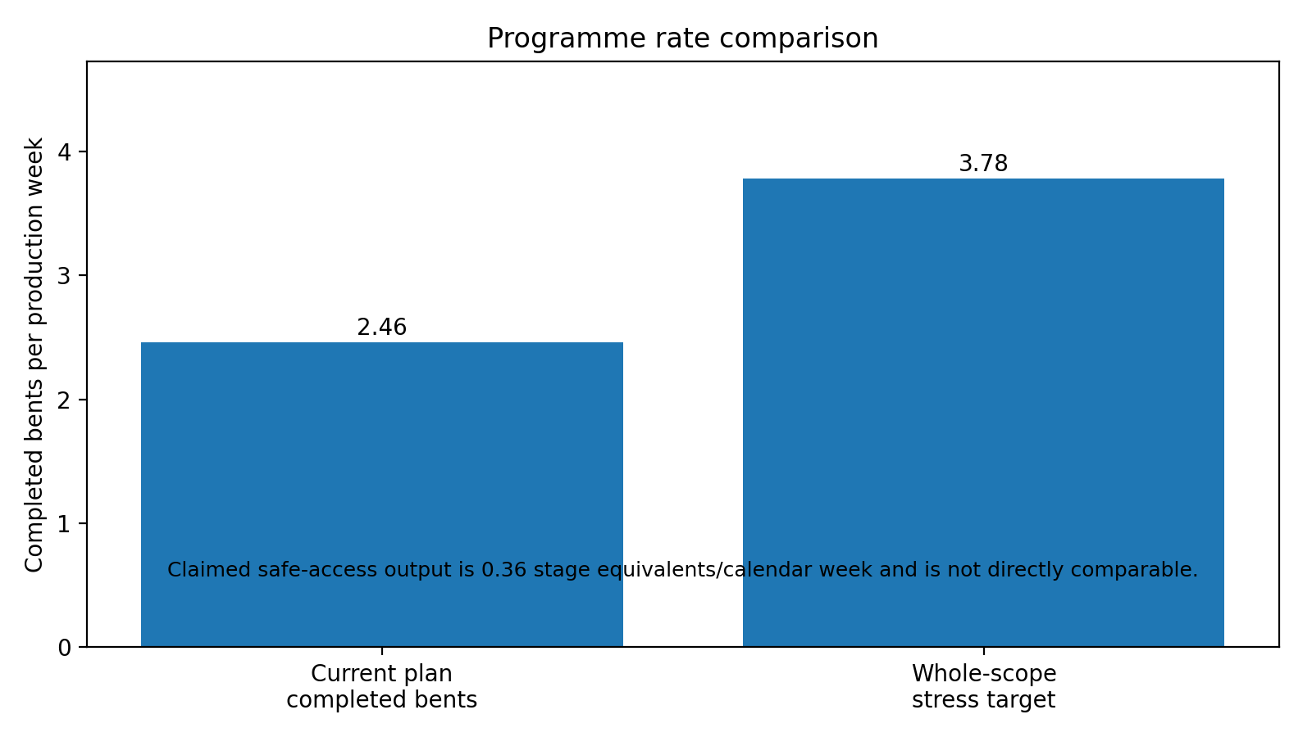
Figure 1. Programme rate comparison. The claimed 0.36/week figure is a stage equivalent and is shown separately in the note.
Source basis: [S01], [S02], [S03], [S04], [S05], [S06]

2. Appointment and purpose
The engagement requires an independent assessment of alternative access methodologies for the remaining pile and headstock remediation works. The assessment is intended to support STL’s owner-side decision making. It is not detailed design and does not replace the contractor’s execution planning, RPEQ certification or legal advice.
- Review the contract scope, specification, methodology, programme and available execution evidence.
- Confirm the physical, operational, environmental and commercial constraint envelope.
- Screen credible access options and develop the leading concepts.
- Compare productivity, programme, cost and risk on a consistent basis.
- Undertake supplier and contractor market soundings.
- Recommend a methodology direction and implementation roadmap.
Boundary | The assessment compares delivery methods. It does not assess the incumbent contractor’s legal or contractual position.

Source basis: [S01], [S02]

3. Deliverable compliance
Proposal deliverable | Report response | Status | Remaining action
Constraint envelope | Sections 5, 10-12 | Partially complete | Bathymetry, metocean and approvals remain open
Option screening | Sections 7 and 16 | Complete for workshop | Scores require STL confirmation
Concept development | Sections 8-12 | Complete at concept level | Supplier design and bent-family plates remain
Deployment and relocation cycle | Section 9 | Working basis established | Timed proving required
Operability | Sections 10 and 12 | Conditional | Site data and activity limits required
Containment and waste | Section 11 | Conditional | Headstock enclosure and mass balance open
Marine logistics | Section 10 | Concept established | JUB layout and umbilicals open
Structural interfaces | Section 12 | Gate identified | RPEQ design not performed
Cyclone and shipping response | Section 12 | Concept established | Timed recovery and dated calls open
Programme comparison | Sections 13-14 | Completed with qualifications | Dated bent-level line of balance open
Cost comparison | Section 15 | Structured, not commercially closed | Supplier quotations and remaining scope required
Market soundings | Section 17 | In progress | GGC evidence received; quotations pending
Implementation roadmap | Sections 18-19 | Complete at concept level | Dates subject to supplier lead times

Source basis: [S01]

4. Evidence basis and limitations
The review uses project evidence as the primary basis. Values are classified as project fact, client-provided basis, supplier precedent, engineering assumption or open item. The principal limitations are listed below.
- The current STL bent closeout, preservation and priority register was not supplied. The 227-bent quantity remains a whole-scope stress case.
- The native Microsoft Project logic, calendars, constraints, resources, float and critical path were not independently verified. The schedule analysis uses the supplied Schedule.pdf and validated extracted values.
- The claim workbook contains cached payment-stage values, but the parent progress workbook and certification trail were not supplied.
- GGC platform and workboat evidence demonstrates relevant precedent. It does not certify the proposed Lucinda configuration, capacity or commercial rate.
- Bathymetry, seabed, current metocean records, regulator positions and final shipping dates remain open.
- The commercial model contains editable working allowances where supplier quotations are absent. Those allowances are not commitments.
Evidence rule | No document should convert these limitations into certainty through confident wording. Every decision-driving open item is carried into the verification-gate register.

5. Asset, scope and constraint envelope

5.1 Asset and work scope
The Lucinda jetty extends approximately 5.7 km and is supported by 284 pile bents comprising approximately 670 steel piles. The conveyor gallery is on the northern side and the single-lane roadway is on the southern side. A typical bent is a welded box headstock approximately 900 mm deep on two 850 mm or 920 mm diameter raked steel piles. The typical pile rake is approximately 1 horizontal to 4 vertical.
Item | Current basis | Assurance position
Firm contract bents | 237 | 212 typical, 13 anchored, 10 passing-bay variants and 2 specials
Optional expansion-joint bents | 20 | Separate option and access method
Excluded bents | 27 | Not included in firm package
Working remaining quantity | Approximately 227 | Whole-scope stress case pending STL register
Roadway capacity | 8 t limit | Materials and waste should move by water where practicable
Coating system | Two 500 µm coats to G01 | Full work-lot sequence includes stripe coats, wash/dry, recoat and DFT
Tidal jacket band | To 1.9 m above LAT and 1.7 m below LAT | Below-LAT installation method is unresolved

5.2 Governing constraints
- Priority integrity repairs are required by end 2028, but the priority boundary is not yet reconciled to the whole remaining scope.
- STL requires full wet-season demobilisation. The current working basis assumes production in the 2027 and 2028 dry seasons.
- Shipping occurs approximately 10 to 14 times per year. The method must make safe on two days’ notice.
- The road is single lane and carries terminal traffic. It cannot remain the bulk logistics route for a scaled remediation campaign.
- Blasting and coating require effective negative-pressure containment, dust and waste recovery, occupational-hygiene controls and accepted noise limits.
- The site is cyclone exposed and within a sensitive marine environment. Full-spread recovery, biosecurity and regulator requirements are feasibility gates.
- Typical, anchored, passing-bay, special, underpass and expansion-joint families do not share one access geometry.
Source basis: [S02], [S05], [S07], [S08]

6. Current delivery method and demonstrated performance

6.1 Current method
The current landside method uses kerb-hung scaffold with full-bent encapsulation. Access, materials and waste are routed along the single-lane roadway. The bent remains occupied through inspection, repair approval, welding, blasting, coating, jackets and scaffold removal. Scaffold is hired by erected volume and standing time, so waiting extends both programme and cost.

6.2 Claimed stage output
Claimed item | March-July total | Normalised stage rate
Safe access equivalent | 7.90 | 0.36 per calendar week
Inspection / UT equivalent | 9.00 | 0.41 per calendar week
Blast / coating equivalent | 7.00 | 0.32 per calendar week
Denso jacket pile equivalent | 12.00 | 0.55 per calendar week
Keeper angles | 16.00 | 0.73 per calendar week
8 mm weld prep / weld, lm | 183.86 | 8.40 per calendar week
10 mm weld prep / weld, lm | 289.17 | 13.20 per calendar week

Measurement boundary | These are payment-stage quantities. The supplied records do not establish the number of fully completed, QA-closed bents. The proposed completed-bent rate is not divided by these figures.

6.3 Programme baseline
The contractor programme contains 257 bent activities between 3 November 2025 and 2 December 2028. After the three major shutdown periods are removed, the validated extraction contains approximately 104.4 production weeks. The implied in-season rate is 2.46 completed bents per production week. The whole-scope stress target is 3.783 bents per week, approximately 54% above the programme rate.
Typical programmed cycles are generally 14 to 15 days. The mean across all families is higher because anchored, passing-bay, expansion-joint and special bents carry additional work. Peak programme work in progress reaches nine bents, but that is not evidence of nine physical scaffold sets. Four scaffold sets were observed during the execution period.

6.4 Execution evidence
- July inspection reports record welders stood down when suitable safe workfronts were unavailable.
- Lower deck access was incomplete at several fronts.
- Weather affected scaffold removal and restricted lower access.
- Repair defects were found after blasting, creating repair and reblast activity.
- Scaffold contact areas created coating touch-up requirements.
- Approval waits and removal backlogs reduced the usable workfront count.
The evidence supports a multi-constraint diagnosis. The dominant recoverable issue is the serial access and workflow cycle. Repair quantity, approval, coating, weather, tide, shipping and workfront control remain material.
Source basis: [S03], [S04], [S06]

7. Options considered and screening
Option | Description | Strengths | Principal limitations | Assessment position
Current scaffold baseline | Retain full-bent scaffold and improve planning/resources | Known method; local capability | Serial cycle, roadway occupation, standing hire, tide/weather exposure | Baseline only
JUB as direct workface | JUB positioned at each active bent with crane/access plant | Stable tide-independent deck | Frequent relocations, seabed/bathymetry, crane reach, cost | Secondary option
Modular/spud pontoon | Spud-anchored barge or pontoon supporting workface | Marine logistics, reusable deck | Wave response, relocation, shallow transition | Secondary option
Suspended floating platforms + JUB logistics | Float platform sets to bent, winch clear, work full height, JUB supplies services | Directly removes repeated scaffold cycle and road logistics | Temporary works, fleet scale, containment, rescue and supplier design | Preferred for typical bents
Marine rope access | Boat-supported rope access for targeted work | Low mobilisation, flexible | Poor fit for heavy welding, blasting containment and high-volume coating | Supplementary
Hybrid | Preferred marine system for typical bents, conventional/rope/JUB methods for exceptions | Matches method to bent family | More interfaces and procurement packages | Preferred campaign basis

7.1 Multi-criteria result
The concept-stage weighted assessment favours the hybrid campaign built around suspended floating platforms and JUB logistics for typical bents. The score is driven by productivity potential, roadway relief and tide independence above the waterline. Its score is reduced by temporary-works maturity, rescue complexity, cyclone recovery and low commercial certainty.
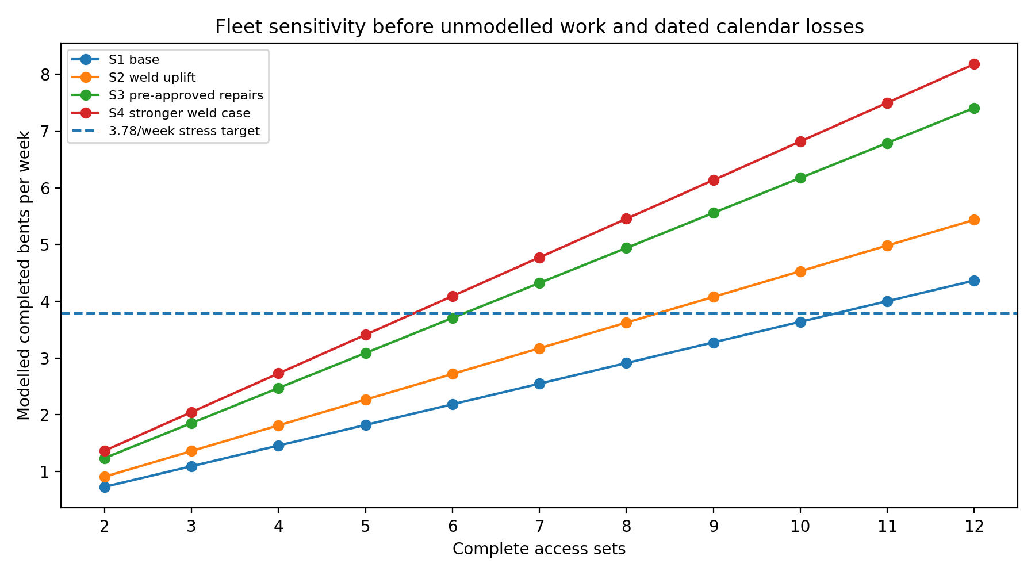
Figure 2. Fleet-rate sensitivity. The curves exclude material unmodelled work and are diagnostic only.
Source basis: [S01], [S05], [S09]

8. Preferred access and delivery concept
The preferred reference concept uses reusable marine access plant rather than rebuilding temporary access at every typical bent. It is a concept for supplier development and proving. It is not a selected proprietary system or certified temporary works.
Element | Function and current maturity
Main floating platforms | Two long modular aluminium platforms, one on each long face of the headstock. Each is buoyant for relocation and suspended clear of the water for normal work.
Travelling suspension | Winches or hoists connect through sliding or travelling points so the platform can move laterally as it descends alongside the 1:4 raked piles.
Traversing decks | Short access decks connect the two main platforms at the current pile positions and provide 360-degree access. Their load path, locking and relative-movement tolerance require temporary-works design.
Pile containment | Opposing half-shell containment units close around the active pile work zone and connect to extraction and recovery plant.
Headstock containment | A separate reusable enclosure is required for the headstock soffit, faces, ends, pile connections, gallery feet and keeper angles. This remains undeveloped.
Access towers | Prefabricated towers hang from the jetty edge to a safe upper platform landing and are moved by the JUB crane.
JUB / support base | The JUB is a services, welfare, storage, lifting and waste-handling base. It is not the main workface.
Workboat and rescue craft | A workboat positions and tows the platforms and supports logistics. Independent rescue coverage may require a separate craft.

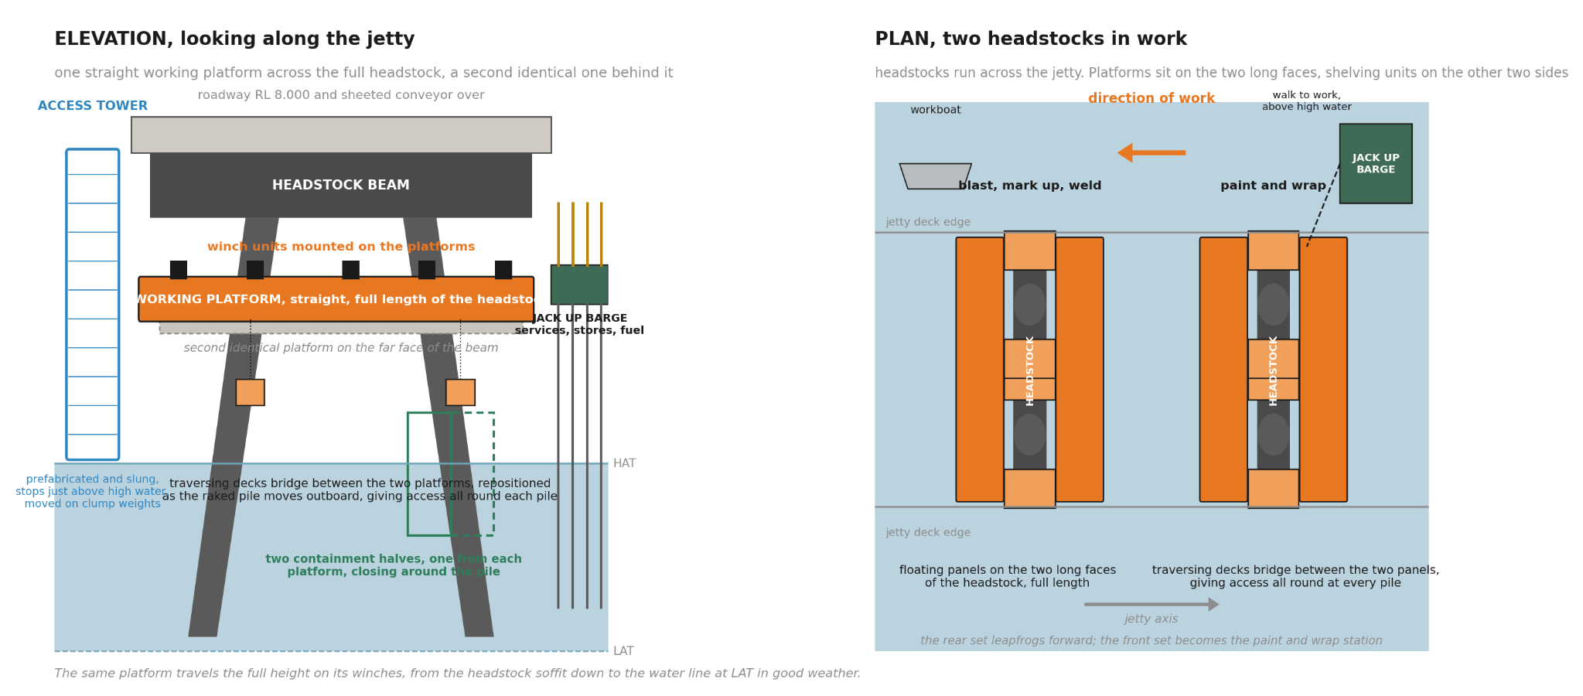
Figure 3. Current reference plan/elevation concept. Concept only, not for construction.
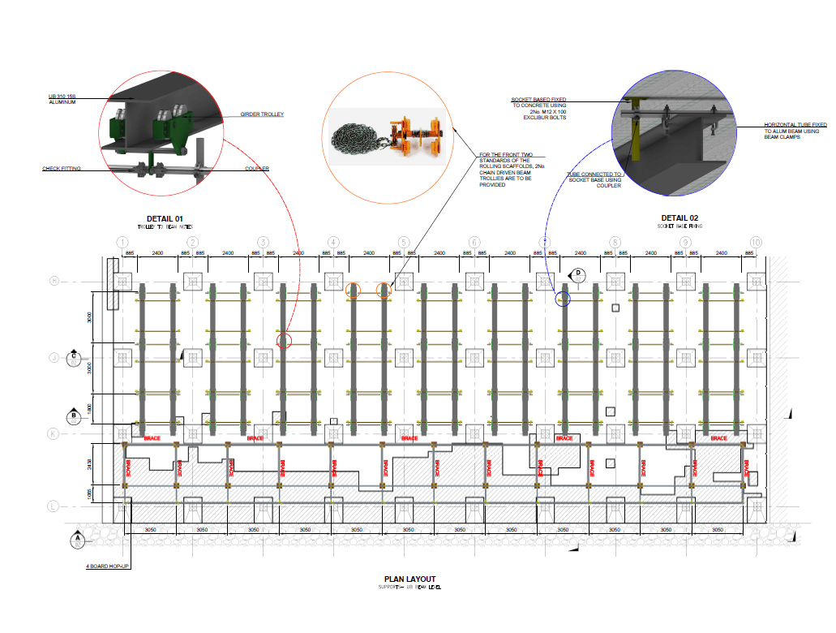 | 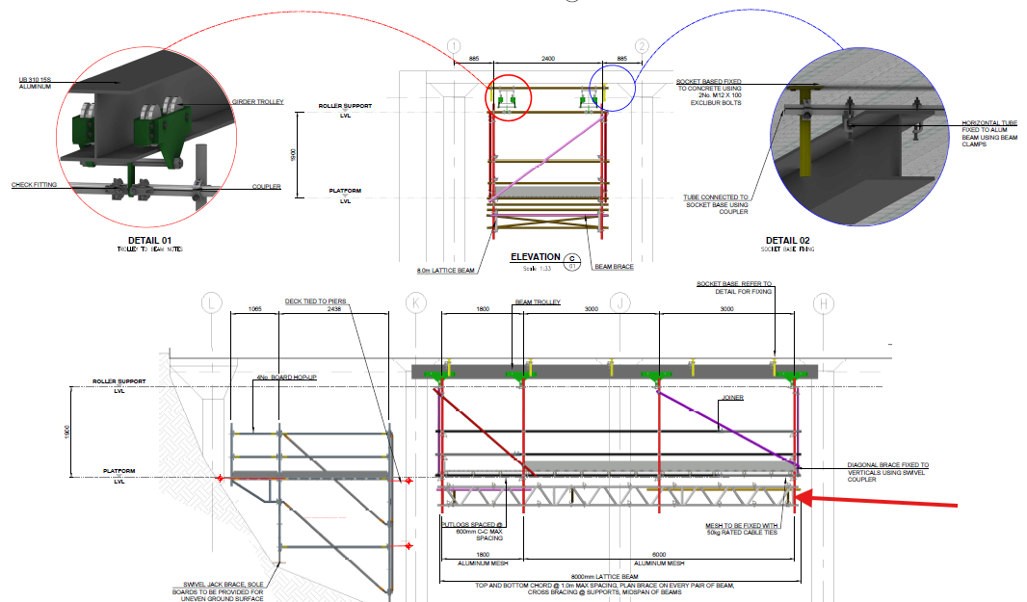 | 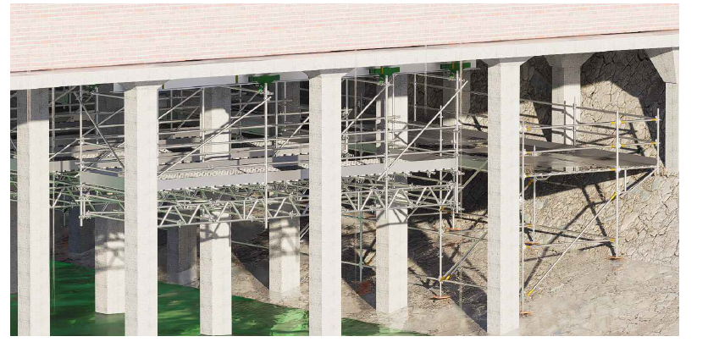
Figure 4. GGC precedent images supplied for concept development. These images do not certify the proposed Lucinda configuration or rate.
Source basis: [S07], [S09]

9. Detailed execution methodology

9.1 Mobilisation, assembly and proving
- Complete supplier selection, temporary-works design, mass and centre-of-gravity schedule, lifting/hoist design, containment design, access/rescue design and independent check.
- Establish an onshore or barge-based assembly area. Assemble each platform set, winches, rails, traversing decks, handrails, containment interfaces, service connections and emergency systems.
- Complete factory acceptance, inspection, functional testing and proof loading before the set approaches the jetty.
- Mobilise the JUB, workboat, rescue craft, utilities, waste system, accommodation and spares.
- Undertake a proving campaign on representative typical bents. Record every activity, delay, quantity, acceptance result and fault before freezing the production model.

9.2 Advance preparation at the next bent
- Verify the bent identity, family, remaining scope and structural condition.
- Install the engineered suspension and lateral-travel interfaces. Inspect and proof test in accordance with the temporary-works design.
- Confirm that the access-tower position, platform envelope, JUB crane reach, service routing and rescue routes are clear.
- Pre-stage the next bent while the current bent remains in production, subject to SIMOPS separation and the available rigging crew.

9.3 Platform relocation and establishment
- Secure containment, traversing decks, tools and services. Lower the completed platform pair under coordinated control until buoyancy supports the move.
- Disconnect or transfer the suspension arrangement in accordance with the approved procedure.
- Tow the platform pair to the next bent within the approved approach and tow limits.
- Position, connect, winch to the first working level, level and restrain the platforms.
- Move and secure the access tower. Install traversing decks and connect power, compressed air, breathing air, extraction, wash water, communications and emergency systems.
- Complete a pre-use inspection and confirm normal access, secondary recovery, emergency lowering and rescue coverage before personnel enter.
Cycle basis | The current model allows approximately 11 hours for the complete advance-rigging share and relocation package. That value is an unverified working allowance and must be replaced by measured proving data.

9.4 Bent diagnostic phase and repair approval
- Remove existing wrapping where required, wash the work zone and complete initial visual inspection and UT.
- Close the pile half-shell containment and diagnostically blast the upper bands of both piles. The two typical pile bands are approximately 27 to 29 m².
- Use the headstock containment arrangement to expose the headstock work zones. This method and duration remain open.
- Open the containment, mark all defects on exposed steel and compile one bent-level repair package covering both piles and the headstock.
- Submit the repair package for review. The current model carries one three-shift hold while the access set remains attached.
Approval gate | The one bent-level submission is a proposed programme strategy, not a confirmed project fact. If the reviewing engineer requires separate pile or headstock approvals, the additional access occupancy must be added to the model.

9.5 Repair and finish sequence
After approval, the work proceeds pile by pile while the main platforms remain at the headstock.
- Prepare, fit and weld the approved repair plates on pile 1 and the associated connection zone. Complete NDT, rectification and acceptance.
- Complete post-weld local surface preparation and preservation to the accepted coating hold point.
- Close the containment and apply the coating system, including first coat within the specified preparation window, stripe coats, wash and thorough drying where required, recoat verification, second coat, DFT and QA.
- Lower/reposition the platforms and traversing decks to install the petrolatum jacket on pile 1. The below-LAT component remains a separate method gate.
- Protect the completed pile from hot work, abrasive and coating operations on pile 2. Reinspect before final closeout.
- Repeat the accepted repair, preparation, coating and jacket sequence on pile 2.
- Complete headstock repair and coating work using the accepted headstock containment arrangement.
- Close all weld, NDT, coating, jacket, environmental, waste and digital QA records. A bent counts as complete only after full QA release.

9.6 Leapfrog logic
Two complete access sets form one basic leapfrog pair. One set can be in repair while the second is in coating, jacket or closeout. When the trailing bent is accepted, that set moves ahead. The full campaign fleet may comprise several pairs or additional sets. It is determined by the completed line-of-balance model, not by the two-set illustration.
Source basis: [S07], [S09]

10. Marine logistics, access and workfront support
Interface | Proposed arrangement | Open verification
Personnel | Daily minibus along roadway; access tower to platform; walk-to-work link to JUB where applicable | Roadway controls, tower geometry and two independent recovery routes
Materials | Delivered to JUB and workfront by water | Vessel capacity, lifting plan and storage limits
Services | JUB-based power, compressors, breathing air, wash water and extraction | Umbilical routing, snag protection and emergency disconnect
Waste | Vacuum/recovery to sealed containers on JUB; classified offsite disposal | Mass balance, dangerous-goods and waste contractor acceptance
Platform moves | Workboat tow with coordinated suspension transfer | Tow/approach sea state, mooring and collision controls
JUB moves | Reposition after the available reach is exhausted | Bathymetry, leg penetration, crane coverage and move duration
Rescue | Crewed rescue capability whenever personnel work over water | Stretcher path, recovery drills and all platform elevations

The single-lane roadway remains available for personnel and light operational traffic. It is not the bulk materials and waste route under the preferred concept. The JUB should remain outside the production critical path, but that outcome must be demonstrated by the layout, services continuity and relocation schedule.

11. Containment, coating, waste and environmental controls

11.1 Pile containment
The pile enclosure consists of two opposing half shells supported from the two main platforms. The halves close and seal around the active work zone. The selected supplier must define permissible relative movement between platforms, mechanical interlocks, wind limits, emergency opening, extraction criteria, filtration, worker exposure controls, abrasive recovery and wash-water recovery.

11.2 Headstock containment
The headstock requires a separate enclosure arrangement covering the soffit, long and end faces, pile connections, gallery feet, keeper angles and other G02 interfaces. Removing the pile shells does not constitute a headstock containment method. Supplier layout and a measured work-lot cycle are required before the production model is complete.

11.3 Coating sequence
- Verify environmental conditions, surface cleanliness and profile.
- Apply the first 500 µm coat within four hours of final preparation.
- Complete stripe coats to edges, welds and difficult geometry.
- Wash and thoroughly dry the first coat where required by G01.
- Verify the recoat condition and the 14 h to 14 d recoat window.
- Apply the second 500 µm coat.
- Complete DFT, visual inspection, repair and final acceptance.
Active labour and elapsed access-set occupancy are not the same. The current model includes 1.5 active coating shifts but leaves the drying and recoat elapsed holds unmodelled. The proving campaign must establish the dated work-lot sequence.

11.4 Environmental and occupational controls
- Negative-pressure criteria, airflow, filtration and boundary monitoring.
- Respiratory protection and breathing-air arrangements.
- Noise limits for blasting, extraction, compressors and night work.
- Static, fire and hazardous-atmosphere controls.
- Sealed handling of coal-tar coating debris, spent abrasive, filters and wash water.
- Marine-fauna, seagrass, vessel-strike, biosecurity and spill-response requirements.
Source basis: [S02], [S07]

12. Temporary works, HSE and operability

12.1 Temporary-works load path
The selected platform system requires a certified mass and centre-of-gravity schedule covering the bare platform, winches, traversing decks, containment, personnel, tools, services, abrasive, recovered waste and retained water. Load cases must include normal operation, unequal loading, snag or stalled chain, loss of power, one-hoist fault, wind, collision, floating transition, lowest operating position and survival condition.
Every hang-off point and the host jetty structure require RPEQ design and independent check. GGC and other precedent information is relevant evidence of concept feasibility, not a capacity certificate for Lucinda.

12.2 Access and rescue
- Two independent means of egress or recovery must be demonstrated at every platform elevation.
- Emergency and manual lowering must be confirmed by the selected winch/control supplier.
- A stretcher route must be shown in the geometry and demonstrated in a drill.
- Rescue coverage must remain available during workboat movements, JUB relocation and service failure.
- Dropped-object controls, tool tethering and exclusion zones are mandatory.

12.3 SIMOPS
A SIMOPS matrix must set the minimum separation between welding, blasting, coating, jacket work, lifting, boat traffic and inspection. The matrix should consider wind direction, dust and vapour plume, hot-work spark travel, noise, service-line routing and emergency access. The number of simultaneously active bents is limited by safe separation and rescue capacity as well as plant quantity.

12.4 Shipping and cyclone response
- Define the two-day ship-call make-safe sequence for platforms, containment, access towers, services, workboats and JUB.
- Insert known ship-call dates explicitly in the final programme rather than burying them inside an availability percentage.
- Define the cyclone trigger, recovery sequence, refuge location, time to recover every set and restart inspection requirements.
- Demonstrate the full-fleet recovery in the proving campaign before production scale-up.

13. Productivity model and schedule comparison

13.1 Model basis
The whole-scope stress test is 227 bents over 60 nominal production weeks, or 3.783 QA-closed bents per week. The base model uses 6 working days per week and an 85% residual factor for stochastic weather and breakdown after known calendar blocks are applied explicitly.
The base cycle contains 14.02 modelled access-set occupancy days, including one three-day approval hold and 11 hours of relocation activity. It excludes headstock enclosure/blast, coating elapsed holds, below-LAT jacket work and clean-out/QA/rework. It is not a demonstrated complete cycle.
Scenario | Basis | Cycle d/set | Sets | Rate/week | Weeks for 227 | Weld crews
S1 | Base: 2 weld crews/set at 6 lm/crew-shift, one 3-day bent-level approval hold | 14.02 | 11 | 4.00 | 56.7 | 22
S2 | 4 weld crews/set at 8 lm/crew-shift, full approval hold | 11.26 | 9 | 4.08 | 55.7 | 36
S3 | S2 plus no routine approval hold under accepted repair library/delegation | 8.26 | 7 | 4.32 | 52.5 | 28
S4 | 6 weld crews/set at 10 lm/crew-shift, no routine approval hold | 7.48 | 6 | 4.09 | 55.5 | 36

The set counts are mathematical diagnostics. They do not demonstrate that the JUB, rescue system, containment fleet, available labour, accommodation or safe work zones can support those quantities.

Figure 5. Modelled fleet sensitivity before omitted activities and dated losses.

13.2 Comparison with the current schedule
Measure | Current programme / claim | Preferred concept model | Comparison rule
Completed bents per production week | 2.46 planned | 3.78 stress target; scenario dependent | Like-for-like programme measure
Typical cycle | Generally 14-15 programmed days | 14.02 modelled days before material omissions | Not yet a demonstrated uplift
Safe-access claimed output | 0.36 stage equivalents/calendar week | Not used as proposed completed-bent denominator | Unlike measures
Access handling | Approximately 2 d install + 1 d dismantle typical | Approximately 11 h working relocation package | Both require field validation
Approval hold | 3 d bent hold | 3 d bent-level hold in base; zero only in upper scenarios | Pre-approved library/delegation required
Peak WIP / sets | 9 bents WIP; 4 scaffold sets observed | 6-11 sets in diagnostics | WIP is not physical set count

Source basis: [S03], [S04], [S06]

14. Indicative implementation programme
The programme below is a roadmap for decision and procurement planning. It is not the final execution schedule.
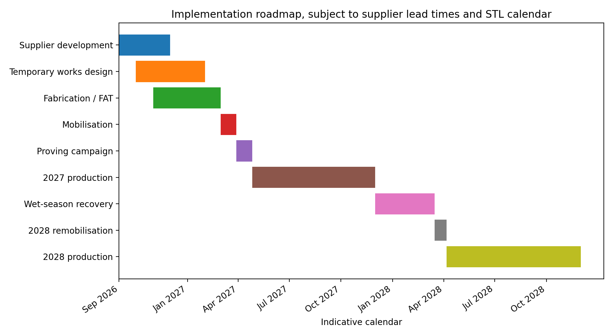
Figure 6. Indicative implementation roadmap.
- Supplier development and temporary-works design should start before procurement commitment.
- Fabrication and FAT can overlap late design only where interfaces are frozen.
- A four-week mobilisation allowance and four-week proving campaign are carried as working assumptions.
- Known outages, ship calls, wet-season recovery, proving and ramp-up should be explicit calendar blocks.
- The final critical path must include supplier lead times, approvals, JUB mobilisation, accommodation, proof loading and regulator requirements.
Programme gate | The model does not support an end-2028 commitment until the current priority register, measured cycle, full fleet, calendar and commercial basis are accepted.

15. Cost and commercial comparison

15.1 Current-method reference
Reference | AUD ex GST | Interpretation
Current safe-access basis including optional EJ access | 9,321,982 | Executed contract pricing basis
Safe-access basis excluding optional EJ access | 8,190,472 | Derived from executed pricing
Bespoke access tooling | 1,085,000 | Separate contract item
Base access excluding optional EJ plus tooling | 9,275,472 | Reference only, not remaining avoidable cost

15.2 Proposed cost model
The companion workbook builds the proposed cost by fixed engineering, set capital, marine mobilisation, time-related spread, set-related weekly cost and variable production cost. Yellow inputs are editable. The current totals use Endura working allowances because a structured GGC/JUB/containment quotation was not verified. They are not supplier rates or budget commitments.
Scenario | Sets | Model weeks | Working total | Cost/bent | Qualification
S1 | 11 | 56.7 | $51.7M | $228k | Before omitted work and final calendar
S2 | 9 | 55.7 | $47.2M | $208k | Before omitted work and final calendar
S3 | 7 | 52.5 | $41.9M | $185k | Before omitted work and final calendar
S4 | 6 | 55.5 | $41.2M | $181k | Before omitted work and final calendar

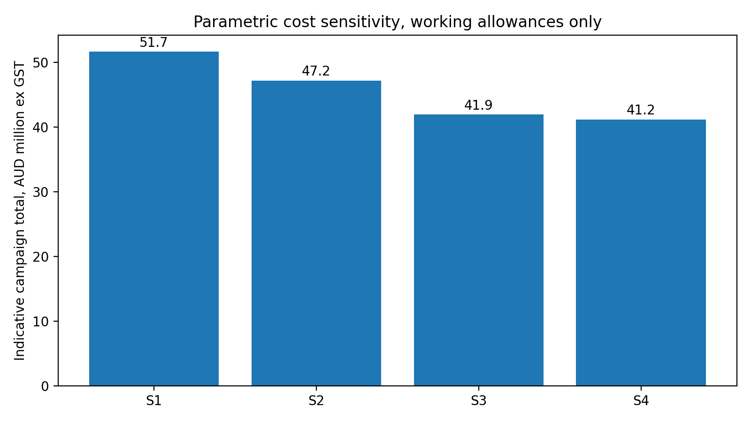
Figure 7. Parametric cost sensitivity using working allowances, not quotations.
A valid commercial comparison requires the same remaining scope, same bent families, same calendar, same quality standard and the same risk treatment. The current contract access value is not automatically avoidable, and the proposed campaign total cannot be closed until supplier rates and the bent register are received.
Source basis: [S02], [S09]

16. Multi-criteria assessment
Criterion | Weight | Scaffold | JUB direct | Pontoon | Suspended + JUB | Rope | Hybrid
Productivity / scalability | 20% | 2 | 3 | 3 | 4 | 2 | 4
Weather resilience | 10% | 2 | 4 | 2 | 4 | 1 | 4
Tide independence | 8% | 1 | 5 | 2 | 4 | 1 | 4
Environmental containment | 12% | 3 | 4 | 3 | 4 | 2 | 4
Structural / seabed interfaces | 8% | 3 | 1 | 4 | 2 | 4 | 3
Roadway / terminal interference | 10% | 1 | 4 | 4 | 4 | 4 | 4
Shipping make-safe | 7% | 3 | 2 | 3 | 3 | 4 | 3
Cyclone recovery | 8% | 3 | 1 | 3 | 2 | 4 | 3
Safety in design / rescue | 7% | 3 | 4 | 3 | 2 | 2 | 3
Mobilisation / availability | 5% | 4 | 1 | 3 | 3 | 4 | 3
Cost confidence | 3% | 4 | 1 | 2 | 1 | 3 | 2
Approvals / insurance | 2% | 4 | 1 | 2 | 2 | 3 | 3

Option | Weighted score / 5
Current scaffold | 2.44
JUB direct | 2.96
Modular/spud pontoon | 2.95
Suspended + JUB | 3.29
Rope access | 2.63
Hybrid | 3.57

The recommended direction is a hybrid campaign. Suspended floating platforms with JUB logistics are developed for the typical-bent population. Other methods remain available for anchored, passing-bay, special, underpass and expansion-joint locations where geometry or loading makes the reference set unsuitable.

17. Market sounding and supplier position
The supplied GGC pack contains relevant platform, lifting and workboat precedent, including modular aluminium access-platform information, lift-plan/methodology precedent and a small workboat. This supports continued supplier engagement. It does not establish the mass, capacity, winch travel, containment, temporary-works interface, availability or commercial rate for the proposed Lucinda system.
Market input | Evidence received | Information still required
Floating platform | Photos, drawings and prior lifting precedent | Certified mass, buoyancy, deck capacity, winch system, travel and rate
Workboat | Capability precedent | Survey status, operating limits, crew and commercial rate
Pile containment | Concept only | Supplier system, mass, seal, extraction, wind and movement cycle
Headstock containment | No accepted supplier design | Complete enclosure geometry and cycle
JUB | Generic candidate information only | Selected unit, crane chart, bathymetry, coverage and rate
Coating / jackets | Project product basis | Manufacturer confirmation, below-LAT method and trial cycle

Commercial evidence | The raw OCR evidence from the GGC folder is preserved in the workbook. No OCR amount has been treated as a verified quotation.

18. Proving campaign and acceptance gates
A proving campaign is the control point between concept selection and fleet procurement. It should cover representative typical bents and measure the complete accepted cycle, not isolated trade production.
Gate | Acceptance requirement
Scope and inspection | As-built geometry and remaining scope confirmed; accepted inspection dossier
Platform / suspension | Mass, CoG, proof load, controlled travel, restraint, fault recovery and survival passed
Traversing decks | Load path, locking, edge protection and relative movement accepted
Containment | Pressure, filtration, boundary monitoring, exposure, waste recovery and wind limits achieved
Approval workflow | One bent-level submission or accepted repair-library process demonstrated
Welding | Accepted lm/crew-shift measured over complete shifts including fit-up, NDT and rework
Coating | Full G01 work-lot elapsed cycle achieved including stripe, wash/dry, recoat and QA
Jackets | Accessible and below-LAT methods accepted, with lower termination verified
Relocation | Full 11 h package replaced by measured float, connect, tower, services and proof cycle
SIMOPS and rescue | Safe separation, egress, emergency lowering and stretcher drill passed
Marine spread | JUB reach, services, workboat, recovery and cyclone response demonstrated
Commercial | One reconciled supplier-priced cost model accepted

Production ramp-up should be released only when the accepted cycle and safe resource loading support the intended fleet. A failed gate should change the method or fleet, not be hidden inside contingency.

19. Implementation and procurement roadmap
- Confirm the STL priority and remaining bent register and classify every bent by family, condition, preservation and proposed access method.
- Issue focused RFIs to GGC, the containment supplier, JUB providers, coating/jacket manufacturers and the reviewing engineer.
- Develop dimensioned typical-bent and exception-family concept plates.
- Prepare the RPEQ temporary-works design basis and independent-check plan.
- Obtain supplier availability and firm commercial quotations on one common scope.
- Hold the STL options workshop and confirm the preferred hybrid strategy.
- Develop the proving-campaign tender package with measurable acceptance criteria.
- Run the proving campaign and freeze the accepted cycle, fleet, SIMOPS, calendar and cost.
- Issue the final procurement recommendation and implementation programme.

Figure 8. Decision and implementation roadmap.

20. Recommendation and decision required
The current scaffold method is retained as the baseline but is not recommended as the sole recovery methodology for the typical-bent population. Its serial access cycle, roadway dependence and standing-hire exposure do not align with the required whole-scope stress rate.
The suspended floating-platform and JUB logistics concept is recommended for supplier development and proving on typical bents. It is technically plausible and directly targets the dominant recoverable constraints. It is not yet demonstrated to meet the end-2028 requirement.
A hybrid campaign is recommended. The preferred marine concept should be developed for typical bents, while conventional scaffold, rope access, direct JUB or other bespoke arrangements remain available for exception families.
STL is asked to approve the following direction:
- Proceed with supplier and temporary-works development of the preferred typical-bent concept.
- Provide the current priority/closeout register, bathymetry, metocean and shipping forecast.
- Authorise market soundings and a priced proving-campaign package.
- Confirm the proposed one bent-level diagnostic and approval workflow with the reviewing engineer.
- Return for a decision workshop before procurement commitment.
Contract boundary | This recommendation does not advise termination, variation or award of any contract. STL should make those decisions with its legal and commercial advisers after the methodology, programme and cost evidence is complete.

Appendix A. Proposal deliverable matrix
Proposal commitment | Response | Current status
Constraint envelope | Sections 5, 10-12 | Partially complete
Option screening | Sections 7 and 16 | Complete for workshop
Concept development | Sections 8-12 | Complete at concept level
Deployment and relocation cycle | Section 9 | Working basis established
Operability | Sections 10 and 12 | Conditional
Containment and waste | Section 11 | Conditional
Marine logistics | Section 10 | Concept established
Structural interfaces | Section 12 | Gate identified
Cyclone and shipping response | Section 12 | Concept established
Programme comparison | Sections 13-14 | Completed with qualifications
Cost comparison | Section 15 | Structured, not commercially closed
Market soundings | Section 17 | In progress
Implementation roadmap | Sections 18-19 | Complete at concept level

Appendix B. Principal assumptions and open items
Assumption | Current value | Treatment
Whole-scope quantity | 227 bents | Stress test only, pending STL register
Available production period | Two nominal 30-week seasons | Dated calendar required
Residual availability | 85% | Weather/breakdown only after explicit blocks
Typical weld quantity | 52.56 lm/bent equivalent | Payment-data denominator, not final quantity
Approval hold | One three-day bent-level hold | Requires reviewing-engineer acceptance
Relocation | 11 h/bent package | Proving measurement required
Active coating work | 1.5 shifts | Elapsed wash/dry/recoat not included
Below-LAT jackets | Not modelled | Method required
Headstock containment | Not modelled | Supplier design required
Commercial rates | Endura working allowances | Replace with written quotations

The complete live RFI and gate register is in workbook sheet 12 Risks & RFIs.

Appendix C. Source register
Reference | Source
[S01] | ED-018-2026-01 STL Method Assessment Proposal Rev A
[S02] | AAB Contract Scope & Specification, supplied pages 1-407
[S03] | Schedule.pdf and June 2026 programme screenshots/extraction
[S04] | AAB Claim Qty's.xlsx, March-July 2026
[S05] | SCMC-22020-REP-001 Rev 1, Phase 1 Summary Report
[S06] | JPHR inspection reports dated 10, 15 and 25 July 2026
[S07] | Drawing Package.pdf, including original/Aurecon/G01/G02 information
[S08] | Annual ship-loading profile screenshot
[S09] | GGC platform drawings, photos, workboat and prior lifting methodology/lift plan
[S10] | Lucinda Marine Access Concept Discussion presentation

