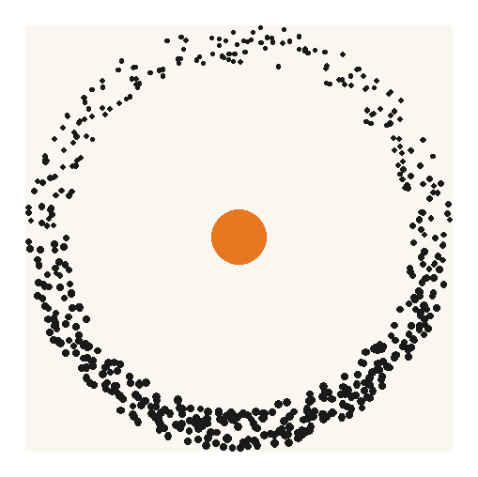
ENDURA DECOMMISSIONING

Lucinda Jetty Remediation
Access Methodology Options Assessment
Prepared for Sugar Terminals Limited, attention Tim Coltzau
Stage 1 study deliverable under accepted proposal ED-018-2026-01
Commercial in confidence
Document number | Revision | Date | Status
ED-018-2026-02 | B | 26 August 2026 | Issued for client review

Name and role | Signature and date
Prepared by S Kurien, Consultant, Endura Decommissioning
Reviewed by J van Iersel, Director, Endura Decommissioning
Approved for issue J van Iersel, Director, Endura Decommissioning

Revision history
Rev | Date | Description of revision | Prepared | Checked
A | 21 August 2026 | First issue to Sugar Terminals Limited | S Kurien | J van Iersel
B | 26 August 2026 | Issued following the STL review of 21 August 2026. Recommendation moved to the Option 1 day shift configuration. Marine base scenarios added at Section 9.2 with productivity and cost for each. Connection of the access system, securing of the stages and the structural verification route added at Section 10 with supplier evidence at Appendix C. Proving campaign scoped and priced at Section 13.4. | S Kurien | J van Iersel

Companion model: ED-018-2026-06 Access Options Model Rev B. The cycle, fleet, cost and sensitivity figures in this report are computed there. Progress is measured throughout in completed, quality closed bents per week. The contractor’s claimed output is a payment stage equivalent and is labelled as such wherever it appears; it is not a completed bent rate and is not treated as one.
Scope of this assessment. This report assesses the provision, movement and logistics of access to the works: how crews, plant and containment reach each pilebent and move to the next. The trade works themselves, the welding, blasting, coating and jacket installation, are held at the contractor programme durations, crew make ups and rates throughout, and are not repriced.

1. Executive summary
This assessment addresses three questions: the production rate required to meet the deadline, whether the current access method can achieve that rate, and the cost of an access method that can. The STL review of 21 August 2026 asked for three further matters, and this revision carries them: the position without a jack up barge, with its effect on productivity and cost; the connection of the access system to the structure and the verification of its strength; and the marine base bought in different ways across the exposure zones. Each is answered in this revision with numbers: the scenarios at Section 9.2, the connection, its securing and its verification route at Section 10.
Required and achieved delivery rates
Clearing the 227 priority bents within the 2027 and 2028 work seasons requires 4.5 completed bents per week. The contract programme was planned at 2.0 to 2.5 bents per week, so the plan itself was roughly half the required rate before a single day was lost. The claims record for March to July 2026 shows about 0.36 stage equivalents earned per week, one twelfth of what the deadline requires.
Rate per week, basis stated | Value | Outcome at that rate
Required for the priority scope by end 2028 | 4.5 | October 2028
Contract programme planned rate | 2.0 to 2.5 | 2030 and beyond
Claimed stage equivalents, March to July 2026, derived from the progress claims: 7.9 typical pilebent safe access equivalents over 21.9 calendar weeks | 0.36 | Beyond 2035 on that arithmetic; payment stage output, not QA closed bents

Limitations of the current method
The constraint sits in the access method, not in the crews. A scaffold bent runs 15 to 16 working days, of which only about half is trade work; the balance is scaffold erection, encapsulation, dismantling and the engineering approval hold, repeated at every bent. Delivering 4.5 bents per week on that cycle would take 14 to 18 simultaneous scaffold fronts. The method is capped near five fronts by the scaffold cycle itself, the single welding and blasting spiders, and the single lane 8 tonne roadway that every erection and strip movement must share. Five scaffold fronts running without interruption deliver 1.3 to 1.7 bents per week, five or more seasons of work.
The proposed access method
The recommended system replaces the rebuilt scaffold with a relocating marine platform: scaffold stages built on modular float pontoons, pushed to each bent by workboat, joined around the piles, and lifted clear of the tide on four synchronised electric chain blocks per stage. The access cost is paid once and moved, not paid again at every bent. The trade work on the platform is unchanged.
 | Option 1 Base case | Option 2 Optimised | Compressed day pattern, within Option 2
Working arrangement | All work in day shift, six day week | Trades work day and night on the secured platform; all boat moves and lifting in daylight | Both trade shifts inside 0600 to 2200; the 2200 to 0700 band is never entered
Work fronts required | 8 | 5 | 6
Stage halves in the water | 16 | 10 | 12
Access cost, concept stage, plus 25 percent contingency | $16.04M | $14.22M | about $13.95M
Access cost per bent | $70,647 | $62,623 | about $61,500
Completion at the modelled rates | October 2028 | October 2028 | October 2028

Option 1 is the recommended case. STL advised on 21 August 2026 that night work is not currently available: the board’s tolerance for marine work over water after dark, and the noise and light approvals, are expected to preclude it, and the current environmental authority is understood to exclude it. STL is enquiring on the approval requirements, and Option 2 is therefore carried as a live, costed case. Its fleet requirement holds at five to six fronts across the whole credible range of weather availability, where Option 1 moves between eight and ten fronts on an assumption that cannot be verified before the fleet is ordered, and its compressed day pattern delivers most of that benefit without entering the night band at all: the contract noise limit from 1800 to 2200 is the same background plus 10 dB(A) that applies through the working day. Noise and light are least constrained at the wharf head in Zone 3, which the campaign works first.
The figures above hold the trade content at the current contractor’s own productivity, seven trade shifts per bent, as a deliberately conservative basis. Section 9.2 also prices what the marine base does for a working day: with crib, ablutions, stores and services a gangway from the work face instead of a drive along the jetty, about one shift in seven returns to the tools, and the with base case then finishes five weeks earlier or runs on seven fronts instead of eight. Counted that way, the barge’s true net cost against doing without it is about $2.1M, and the campaign buys weather resilience, a sheltered holding point and a clear roadway with it.
Access cost comparison
Access provision | Cost | Delivered rate | Completion
Current scaffold method, priced access allowance derived from the contract schedule | $9.24M | 0.36 stage equivalents per week | Beyond 2035 on that arithmetic
Marine access, Option 1, day shift | $16.04M | 4.5 to 5.1 per week | October 2028
Marine access, Option 2, day and night | $14.22M | 4.5 to 5.1 per week | October 2028

For the recommended day shift case, about $6.8M of additional access provision, a factor of about 1.7, converts a trajectory that does not close the priority scope into a completion in October 2028, with the trade scope, crews and rates unchanged throughout. If extended hours are approved the addition falls to about $5.0M, a factor of about 1.5. The $9.24M allowance includes about $1.24M priced against optional provisional expansion joint access items, and the marine scope of 227 bents likewise excludes the expansion joint bents, so that exclusion sits on both sides and the figure is used whole. Cost figures are concept stage screening estimates; they exclude the platform fleet build or hire beyond the five existing platforms, marine insurances, permits, port charges, accommodation and escalation, each identified in Section 9, and an estimate class is not claimed until a controlled basis of estimate is issued at hold point HP8. Section 9.3 sets out the optimisation path under which the day shift case falls to about $11.3M and the Option 2 case to about $9.5M, converging on the cost of the scaffold access it replaces.
Recommendation
1. Adopt the marine access method as the reference concept, in the Option 1 day shift configuration, with Option 2 and its compressed day pattern held open pending the STL approvals enquiry.
2. Procure it through a reference concept and performance specification, with a proving campaign of the first bents as the award gate, so the fleet order is placed on a measured cycle instead of an assumed one.
3. Instruct the paid proving trial for September and October 2026 and agree the repair library principle with the Superintendent now; both sit on the critical path ahead of any packaging decision. The trial runs one week with the marine base and one week without it, so the largest open cost question in this report is settled by measured cycle times.

2. Basis of assessment
This assessment is built from primary documents: the contract scope and specification with drawings QSL2501 JPHR G01 to G04 and the CTQ-1122-S design drawing series, the contractor programme separable portion sheets, the progress claims workbook, the July 2026 inspection reports, the Phase 1 engineering summary that establishes the 227 priority bents from the structural condition assessment, supplier material including fabrication drawings, product data sheets, certification records and a certified lift plan from a comparable project, a manned jack up barge quotation, a marine contractor concept submission of 24 August 2026 carrying written marine spread rates, and a recorded discussion with the coating system supplier representative. An independent marine operability review was completed against the same sources and its findings are carried in the operability model. Supplier and contractor names are held in the project record and released on request. Every figure in this report was recomputed at this revision and reconciles to the companion model to the dollar; the current method allowance is derived line by line from the priced schedule; and the marine spread rates are corroborated by an independent written submission. The arithmetic is reproduced at Appendix A so it can be checked without the model open.
Two limitations are declared. First, the equipment basis rests principally on one access supplier; market soundings with comparator suppliers and marine contractors are programmed for September and are a hold point (HP8) before the delivery model is locked. Second, several inputs remain unverified and are flagged where they appear: the tidal datum interpretation, the bathymetry along the alignment, and the weather availability percentages, which derive from operator judgement pending metocean records. The marine base day rate is carried at the quoted $10,000 per day; an earlier indicative monthly figure on file sits well below it, a written reconciliation letter to the barge operator has been issued, and the model carries the higher figure until it is answered.
Proposal output (ED-018-2026-01) | Where it is answered
Information review and constraint envelope | Sections 2, 3 and Appendix B
Options identification and screening | Section 5
Concept development: configuration, relocation, operability, containment, logistics, structural interfaces, cyclone and shipping response | Sections 6, 7 and 10
Multi criteria assessment and sensitivity | Sections 5, 7 and 9.2
Indicative programme and cost comparison against the current methodology | Sections 4, 8 and 9
Market soundings | Section 13 roadmap, hold point HP8; first written data point received 24 August 2026
Recommended methodology and implementation roadmap | Sections 1, 12 and 13
Options workshop | Scheduled early September 2026

3. The site and its constraints
The jetty is about 5.7 kilometres of repeating two pile bents: a welded box headstock about 7.9 metres long and 900 millimetres deep on two raked piles of 850 and 920 millimetres diameter at a 1 in 4 rake. The deck sits at RL 8.000 with a single lane 8 tonne roadway and a sheeted conveyor gallery above. The tidal range is about 3.96 metres from LAT at RL minus 0.300 to HAT at RL 3.660; the datum interpretation is carried as derived pending verification against drawing G01 and the MSQ tidal planes. Cyclone season runs 1 November to 30 April, leaving two 26 week work seasons in 2027 and 2028, or 50.4 available weeks after shipping allowances. The terminal takes 11 to 15 ship calls a year with jetty access held open on short notice. There is no power on the jetty, the surrounding waters are marine park, and the steel is corroded, so any load hung from the structure requires a certified and proof tested load path.
Night work is excluded from the recommended case at the direction of STL, and STL is enquiring on the approval requirements that would govern it. The executed contract itself carried a night work provision requiring permanent supervision, so the constraint is environmental and governance rather than contractual. The contract noise limits are background plus 10 dB(A) from 0700 to 1800, background plus 10 dB(A) from 1800 to 2200, and background plus 8 dB(A) from 2200 to 0700; the evening band carries the same limit as the working day. The regulator position on marine plant, anchoring, noise, light and working hours forms part of hold point HP5.
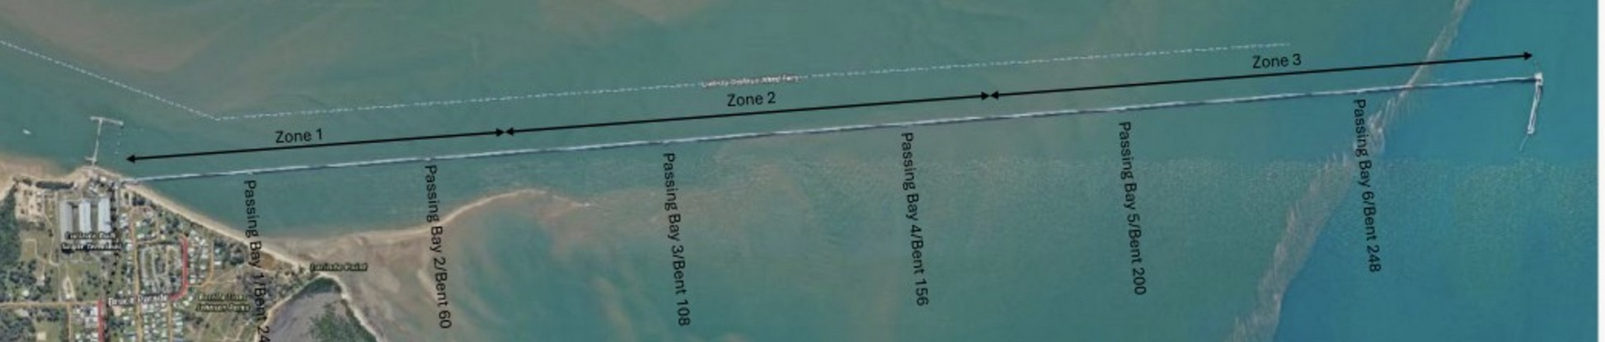
Figure 1. The jetty and its exposure zones. Zone 3 at the wharf head is open water and is worked first; the campaign finishes in the shelter of Zone 1.
4. The current delivery method and its production ceiling
The current sequence at each bent: scaffold is hung from the kerb and the bent fully encapsulated from the roadway; the old wrapping is stripped and the steel washed, inspected and tested; weld repairs are submitted and held for engineering approval with the scaffold standing; welding, blasting and coating follow; pile jackets are fitted in tidal windows; and the scaffold is then dismantled and rebuilt at the next bent.
The productivity constraint of this method is structural. Of a 15 to 16 working day bent, about seven days are trade work; the remainder is access handling, the approval hold and calendar. The access provision is rebuilt at every bent, every bent queues through single welding and blasting spiders, and every erection and strip movement shares the single lane roadway inside its timed windows and 8 tonne limit. The claims record for March to July 2026 shows about 0.36 stage equivalents per week against a planned 2.5. These are payment stage equivalents instead of completed bents; no record establishes the completed, quality closed bent count, and the close out survey at HP7 settles it.
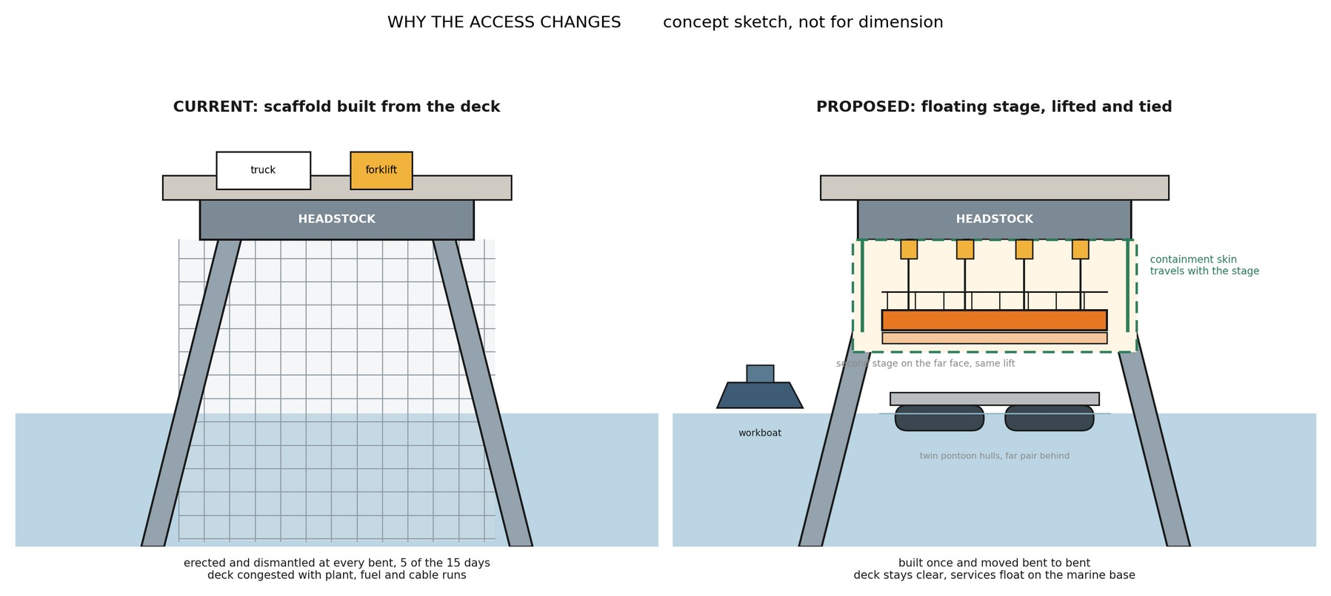
Figure 2. The access change in one picture: scaffold erected and dismantled at every bent, against a stage built once, lifted on chain blocks and moved from bent to bent. Concept sketch, not for dimension.
The ceiling test | Value | Basis
Scaffold fronts needed to reach 4.5 bents per week | 14 to 18 | 15 to 16 day cycle at 70 to 85 percent availability
Fronts the method can sustain | About 5 | Scaffold cycle, single spiders, single lane roadway
What five perfect fronts deliver | 1.3 to 1.7 per week | Five or more seasons of work

The conclusion is a finding about the method, not about any party: the current access arrangement has not shown a credible pathway to the required outcome at the resourcing levels demonstrated, because the constraint that limits it is built into the way access is provided. Retendering the same method transfers the same arithmetic to the next contractor. At the claimed rate the remaining 227 bents represent about 630 weeks of work, a completion beyond 2035; at the best claimed months, about 0.7 per week, completion falls around 2032.

5. Options identified and screened
Six candidate methods were screened against the criteria that decide this job: production rate, tide independence, containment, roadway impact, structural loading, cyclone response, safety in design, approvals exposure, and reuse. Scores are one to five, assessed by this office; the full matrix with scoring notes is held in the project record.
Method | Screening outcome | Disposition
Scaffold, current | Meets containment; pays the access cost at every bent; capped near five fronts | Retained as baseline
Jack up barge as roving workfront | About four working hours per relocation after jacking cycles; one location serves about two bents; draft and seabed unproven | Rejected as workfront; retained as static marine base
Floating modular pontoon spread | Tide following and relocatable; sea state limited for fine work over open water | Carried into the recommended system as the flotation element
Floating winched stages | Relocatable, tide independent once lifted, containment on the stage, reduced roadway demand | Recommended for typical bents
Suspended fixed pods | Strong operability; less relocatable along 5.7 km; higher fabrication content | Reserve configuration
Marine rope access | No encapsulated blasting possible | Rejected for headstock works; retained for pile and jacket support tasks

No single method covers every bent family. The recommendation is therefore a hybrid: the floating winched stage system for the roughly 212 typical bents, conventional or re oriented access for the 13 anchor bents and 10 passing bay variants decided plate by plate against the drawings, bent specific methods for the 2 special bents, and the gallery wrapping running as a topside stream inside conveyor outages. Anchor and bracing bents carry materially more intertidal work than typical bents and are carried in the programme at a family multiplier pending the STL bent register.
6. The selected access system
A work front is a scaffold stage built in two halves on the access supplier’s modular pontoon platforms, with platform module masses in the 2.4 to 4.7 tonne class and fabrication drawings held in the project record. A workboat pushes the halves to the bent, a rigging crew joins them around the piles, and the stage lifts clear of the tidal zone on four 2 tonne electric chain blocks per stage, run through a control panel to a wireless pendant. The blocks jog individually to take tension, then lift synchronised as a multiple hoisting operation under the Australian standard; the supplier holds third party man riding certification for the system from recent projects. At height the stage transfers onto positive ties, the blocks leapfrog to the next bent, and crews step on from the deck. Crews are off the stage for every lift, and a dedicated rescue craft is on the water whenever crews work over it. Anchor points are installed and proof tested one bent ahead by the rigging crew. Two stages hang on the long faces of the headstock, giving access right around each pile with about 2.2 metres of working clearance each face.
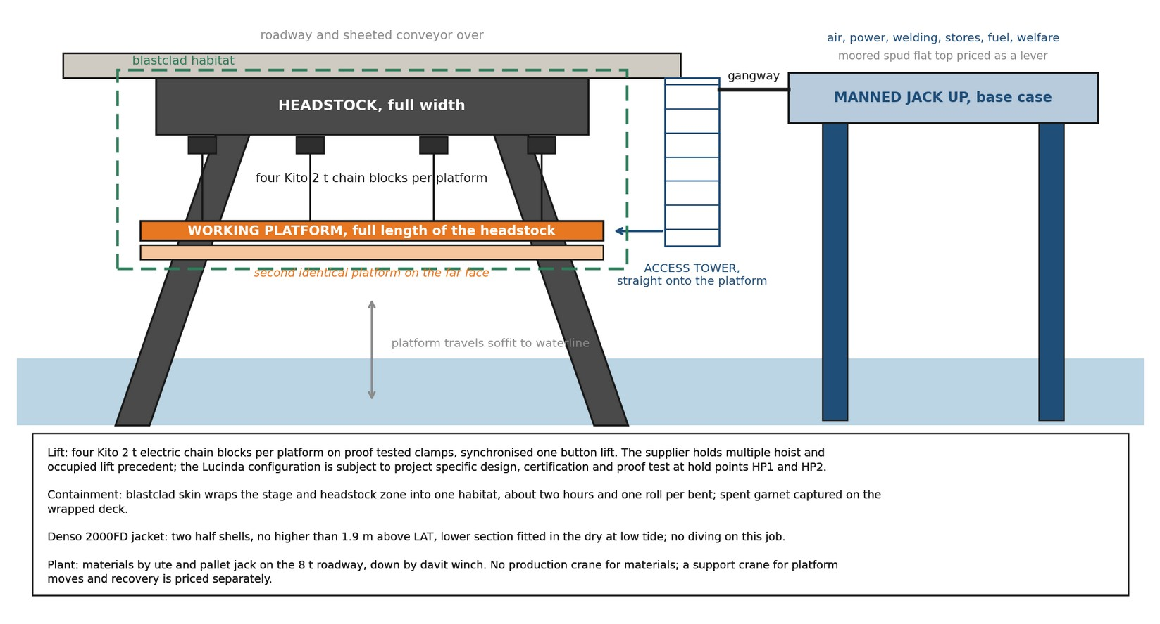
Figure 3. One work front: the floating stages, the chain block lifting system, the containment skin, the jacket band and the materials path. Concept sketch, not for dimension.
Containment wraps the stage itself: sheeting over the stage and the headstock zone turns the work face into one floating habitat, about two hours and one roll per bent, with spent media landing on the wrapped deck for recovery. The pile jacket is supplied as two half shells closed around the pile, fitted within the band the coating specification defines, with the lower section placed in the dry at low tide. There is no diving.
The campaign spread behind the fronts is one marine production system: the manned jack up as its base, the floating stages, the workboat and the support crane. The jack up hosts compressed air and welding power reticulated to the fronts, breathing air, coating stores held at temperature, a bunded fuel cell drawn down weekly, water and waste handling, equipment and spares storage, and crib, washrooms and drying space at deck level. Crews travel the jetty by vehicle at shift start, drop at the working bents and step down to the stages; through the shift the barge is a gangway from the work face, and at shift end the vehicle run takes them off the wharf. Every one of those services would otherwise queue on the single lane 8 tonne roadway. Section 9.2 quantifies what that is worth. The support crane, priced separately at the card low band, covers platform moves and recovery where floating conditions do not allow a water move. The workboat runs the moves, the lifts and the crew transfers, in daylight only.
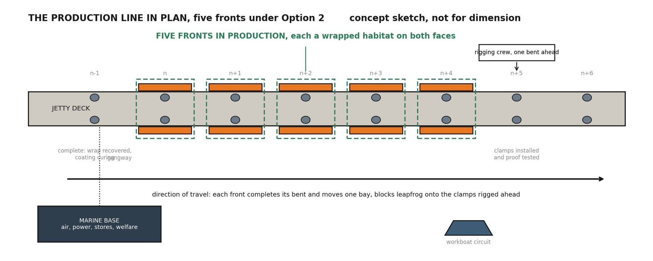
Figure 4. The production line in plan: fronts in work, the rigging crew one bent ahead, the completed bent curing behind, the marine base serving the fleet. Concept sketch, not for dimension.

7. Two configurations: the base case and the optimised case
Both options use the identical access system, the identical trade content and the identical rates. They differ only in when the trades work.
7.1 Option 1, base case: day shift only
All activity runs in a six day, single shift week. The platform moves, lifts and trade work share the same daylight calendar. With the repair library agreed the cycle is nine working shifts per bent; the operability model derates moves at the floating plant availability and trade work at the fixed platform availability, giving an effective cycle of about 10.3 days and 0.58 bents per week per front. Meeting 4.5 per week takes eight fronts at the reported availabilities, and nine at the mid case.
7.2 Option 2, optimised: trades work day and night, platforms move by day
Every marine activity, the moves, the lifting, the man riding transfers, stays in daylight. Once the platform is lifted, transferred onto positive ties and secured, it is no longer marine plant; it is a fixed suspended work platform accessed from the jetty deck. On that platform the welding, blasting, coating and wrapping continue through a night shift under lighting inside the encapsulated habitat. The seven trade shifts per bent are worked in about three and a half calendar days, the effective cycle falls to about 6.4 days, each front delivers 0.94 bents per week, and the fleet requirement falls to five fronts at the reported availabilities, six at the mid case. Option 2 requires a variation to the environmental authority, a night rescue and medevac capability over water carried in the cost as a dedicated night standby crew, a noise assessment against the background plus 8 dB(A) night limit, a light spill assessment against marine park conditions, and coating supplier confirmation of night application. STL advised on 21 August 2026 that these are not currently available and is enquiring on the requirements. Option 2 is carried on that basis: its fleet requirement barely moves with the weather assumption, it protects the coating recoat window in a way a single day shift cannot, and its costs are stated so the option can be taken up or closed on the strength of the written approvals position.
7.3 The compressed day pattern within Option 2
Most of what Option 2 buys comes from working two trade shifts per calendar day, and nothing requires the second shift to run past 2200. With both shifts inside 0600 to 2200 the cycle is about 7.4 days, 0.82 bents per front per week, and six fronts carry the campaign, twelve stage halves against five existing platforms. The 2200 to 0700 band is never entered, the 1800 to 2200 noise limit is the same as the daytime limit, and the residual requirements reduce to task lighting inside the habitat, a standby cover for the dusk to 2200 window, and a light spill check. The pattern is carried at concept level subject to trade contractor confirmation of the roster.
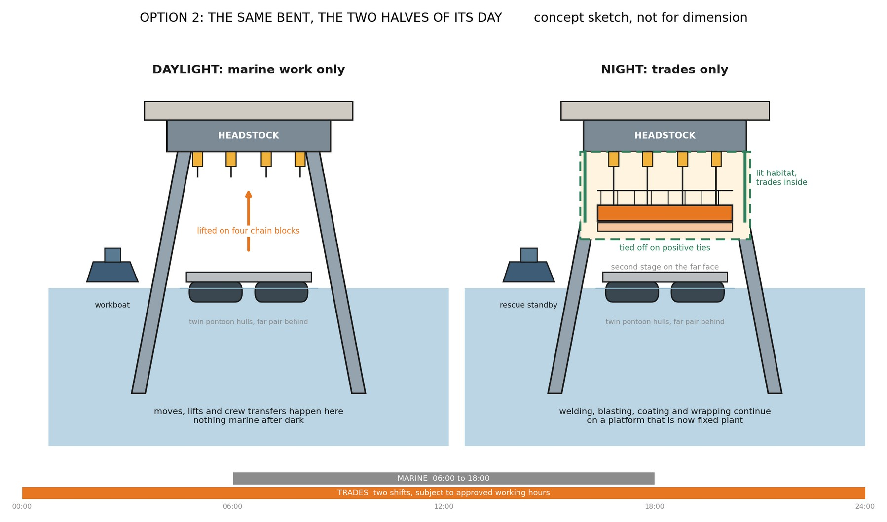
Figure 5. Option 2 in one bent: marine operations in daylight, trades continuing on a platform tied off as fixed plant. The compressed day pattern holds both shifts inside 0600 to 2200. Concept sketch, not for dimension.
Availability scenario (floating / fixed) | Option 1 fronts | Option 2 fronts | Compressed day fronts
Reported: marine review upper band, floating 80%, fixed 90% | 8 | 5 | 6
Mid: floating 70%, fixed 85% | 9 | 6 | 7
Pessimistic: floating 60%, fixed 80% | 10 | 6 | 7
Repair library not agreed | 11 | 8 | 8

Two assumptions sit under the reported row and both are decisions rather than facts. The cycle assumes the pre approved repair library of Section 12 is agreed with the Superintendent; without it a three day engineering hold returns to every bent and the day shift fleet grows to eleven fronts. The availabilities are the marine review’s upper band, with the mid case one front higher. The library is the largest single productivity decision available to STL and it costs no plant. Because the trade content is unchanged in every configuration, every gain in this assessment comes from utilisation; that utilisation gain accrues to whoever performs the trade works and is deliberately not counted in the access case made here.

8. Programme
The campaign calendar: a fortnight to one month proving trial in September and October 2026, ahead of the 1 November cyclone closure, on the supplier’s five existing platforms, two hours from site, the lowest cost assurance available; tender and award through the wet season; fabrication of the fleet balance, mobilisation, assembly and proof loading through March and April 2027 with cyclone readiness triggers in place; season one from May to October 2027 working Zone 3 into Zone 2, about 118 bents; wet season lay up with the fleet on care and maintenance; season two from May 2028 finishing about 109 bents in the shelter of Zone 1; demobilisation and records to close. At the modelled rates Option 2 completes the priority scope on 9 October 2028 and Option 1 about 11 October 2028, both about three weeks before the closure and about 82 days before the administrative end 2028 date. A dated, bent by bent programme with approvals, fabrication, outage and ship call blocks is a hold point deliverable before the fleet order, and the finish above is a modelled outcome, not a programmed date. A September trial start requires the STL instruction within weeks of this issue.
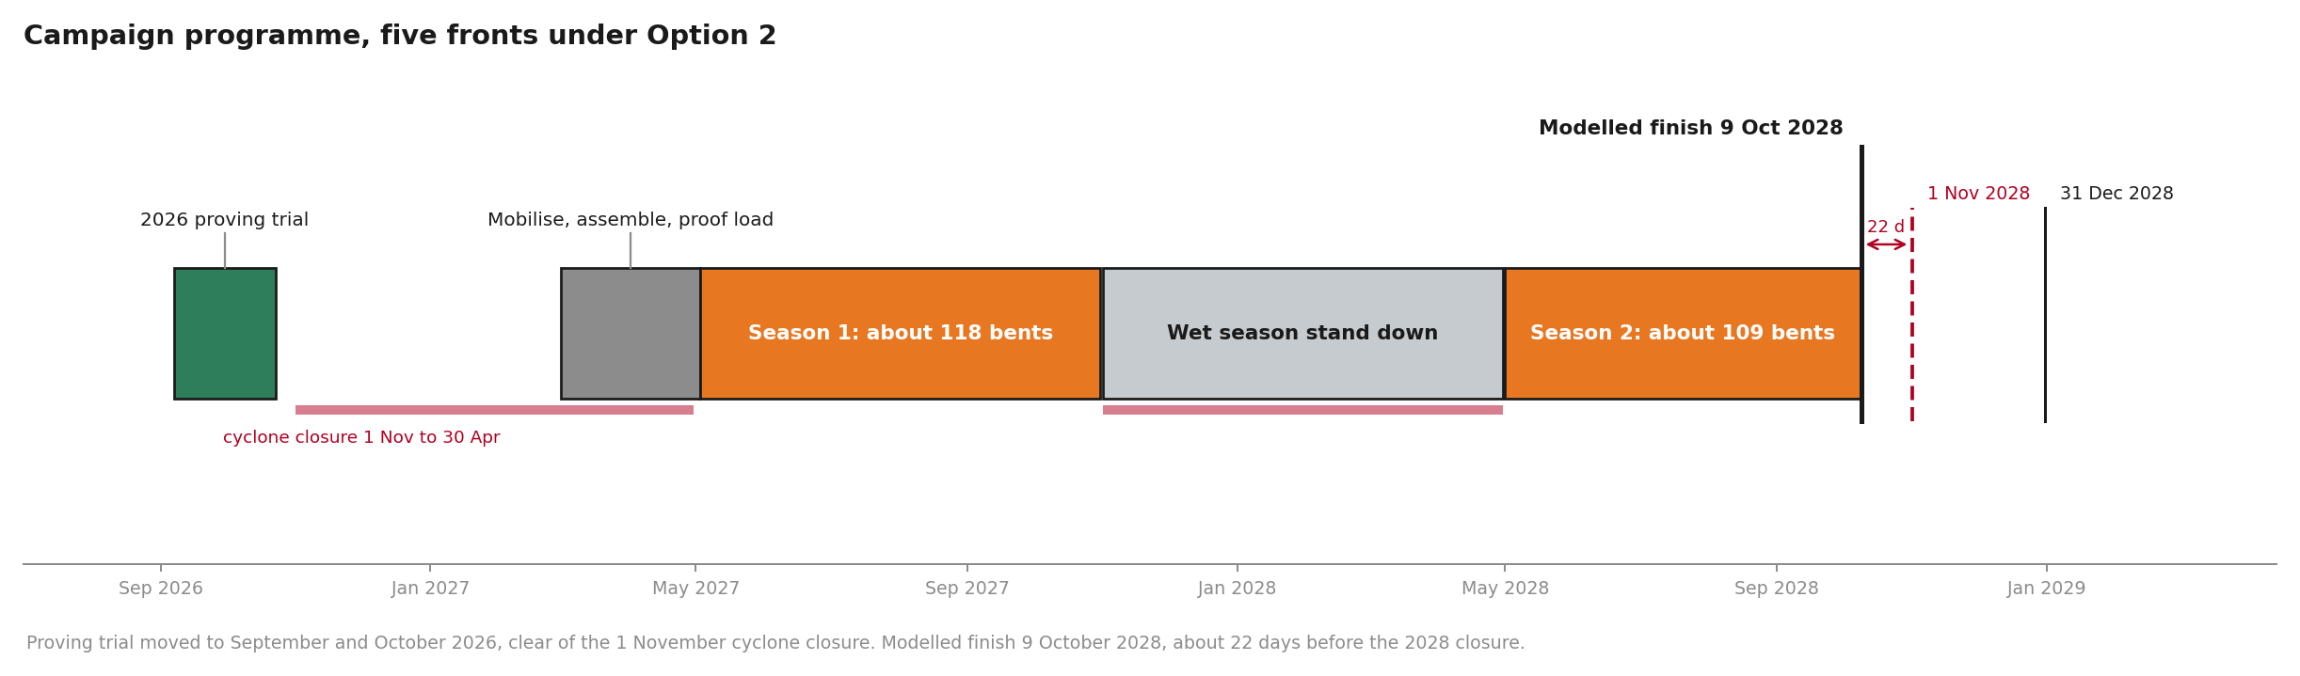
Figure 6. The campaign programme: proving trial September and October 2026 clear of the closure, two work seasons, modelled finish October 2028.
Three programme risks outrank the weather. The platform fabrication lead time and the marine park approvals pathway both sit ahead of mobilisation and neither is yet on a programme; and the priority scope quantity itself spans 227 to 257 depending on the register extract requested in Section 12. Shipping calls concentrate July to December, so the season one work at the wharf head runs around berth exclusion windows and the make safe rules; the 1.6 week shipping allowance inside the available weeks is a stated allowance to be tested against the shipping programme at HP5.

9. Access cost
9.1 Basis and build
The costs below are the access provision only, at concept stage screening accuracy with 25 percent contingency, in August 2026 dollars. They exclude, and Sections 10 to 12 request the inputs to price: the platform fleet build or hire beyond the five existing platforms, marine hull and protection and indemnity insurances, marine park and maritime permits, port charges, campaign accommodation, and escalation across the campaign. Trade labour, materials and consumables are excluded by scope definition and are unchanged from the current arrangements. Night trade work under Option 2 may attract a shift premium under the trade contractor’s own agreement; that premium sits in the trade scope and is confirmed with the trade contractor before the option is adopted.
Access crew labour is built from two documents. The contract schedule of rates carries the scaffolder at item 4.1.2 and the supervisor at item 4.1.5, taken at the 2027 column; the contract carries no marine role, so the coxswain and deckhand are taken from the access supplier’s card of 20 August 2026, with the 30 percent nightshift uplift and the annual escalation stated on that card. The blended rate is $1,471.43 per head day on a 10 hour shift including allowances. Kit is $5,400 per front week plus a shared crane at $2,600 per week. The manned jack up barge is carried at the quoted $10,000 per day with wet season standby at half rate; a marine contractor concept submission of 24 August 2026 carries the same day rate in writing at budget status, a wet season standby of $30,000 per week against the $35,000 per week carried here, a $120,000 mobilisation and demobilisation lump sum, and an equivalent marine spread priced at $4.89M on its own 60 week programme. The earlier indicative monthly figure on file remains unreconciled with the day rate; the written reconciliation is the action ahead of the workshop and the model carries the higher figure until it lands. The current access allowance is derived from the priced schedule, not assumed: the provision of safe access line items across all bent families total $9,242,779, with a typical pilebent priced at $28,966 in the 2026 to 2027 year and $30,414 in the 2027 to 2028 year across 212 typical bents.
Access cost build, $M | Option 1, 8 fronts | Option 2, 5 fronts | Compressed day, 6 fronts
Access kit: winches, pontoons, modules | 2.23 | 1.43 | 1.72
Marine base, operating | 3.40 | 3.38 | 3.25
Access labour, fleet crew over the campaign | 4.72 | 4.08 | 4.62
Fixed lines: certification, mobilisation, wet season lay up, trial bent, demobilisation | 2.48 | 2.48 | 2.48
Contingency at 25 percent | 3.21 | 2.84 | 3.02
Access total | 16.04 | 14.22 | about 13.95
Per bent | $70,647 | $62,623 | about $61,500

9.2 The marine base: scenarios, productivity and cost
The jack up barge is the largest single line in the estimate: $4.31M raw on the Option 1 campaign and $5.39M with contingency, 33.6 percent of the Option 1 access total and 37.8 percent of Option 2’s. It is also a service load, not only a cost line: air, power, breathing air, fuel, waste, stores, crib and ablutions, held afloat and off the 8 tonne roadway. A trade crew reaches the work by vehicle along the jetty and steps down to the stage; without a base, every crib break, ablution run, consumable top up and stores fetch is a return trip along up to 5.7 kilometres of single lane roadway inside its timed passing windows, about 12 minutes each way, which compounds to roughly 58 minutes lost in a 10 hour shift. With the base those needs are a gangway from the face and the hour returns to the tools.
That recovered hour counts only where the work is crew paced. Welding, blasting, coating application and wrapping are paced by crew hours at the face and gain from it; coating cure and recoat windows, tidal windows for the jacket lower sections, and the engineering approval hold are paced by chemistry, tide and calendar and gain nothing. Applied to the crew paced share of the seven trade shifts, the recovery is worth about one shift per bent, and the serviced case is carried at six trade shifts per bent against seven, a deliberately modest translation of the arithmetic to be confirmed by measurement at the proving trial. The without base case holds the trade content at the current productivity exactly as it stands today. Each scenario below carries its own cycle and availability assumption beside its cost, and the working savings before those adjustments, $3.76M for the spud swap, $3.09M zone phased and $4.68M zone phased on a spud, are shown so the adjustment is visible rather than silent.
Marine base scenario, Option 1 campaign | Trade shifts per bent | Fixed avail | Fronts | Access cost | Modelled finish | Net vs reported
S1 No marine base. Services from the wharf deck and layup areas; current productivity held; ninth front added | 7.0 | 0.82 | 9 | $12.49M | late Sep 2028 | +3.55
S2 Jack up barge, whole campaign, tendered content held. The conservative reported case | 7.0 | 0.90 | 8 | $16.04M | 11 Oct 2028 | base
S3 Jack up barge, whole campaign, serviced productivity, fleet held | 6.0 | 0.90 | 8 | $14.64M | 5 Sep 2028 | +1.40 and five weeks
S4 Jack up barge, whole campaign, serviced productivity, fleet trimmed | 6.0 | 0.90 | 7 | $15.41M | 18 Oct 2028 | +0.63 and one front
S5 Zone phased: barge in Zone 3 through season one, deck serviced in the shelter for season two, fleet held | 7.0 s1 / 7.0 s2 | 0.90 / 0.82 | 8 | $14.68M | 23 Oct 2028 | +1.36
S6 Zone phased with one added season two front, date held | 7.0 | 0.90 / 0.82 | 8+1 | $14.56M | 4 Oct 2028 | +1.48
S7 Zone phased on a moored spud flat top in season one | 7.0 | 0.90 / 0.82 | 8 | $13.08M | 23 Oct 2028 | +2.96
S8 Moored spud flat top, whole campaign, same services | 7.0 | 0.90 | 8 | $12.26M | 11 Oct 2028 | +3.78
S9 Self sufficient fronts: powered set added per front for resilience | 7.0 | 0.90 | 8 | $18.59M | 11 Oct 2028 | −2.55

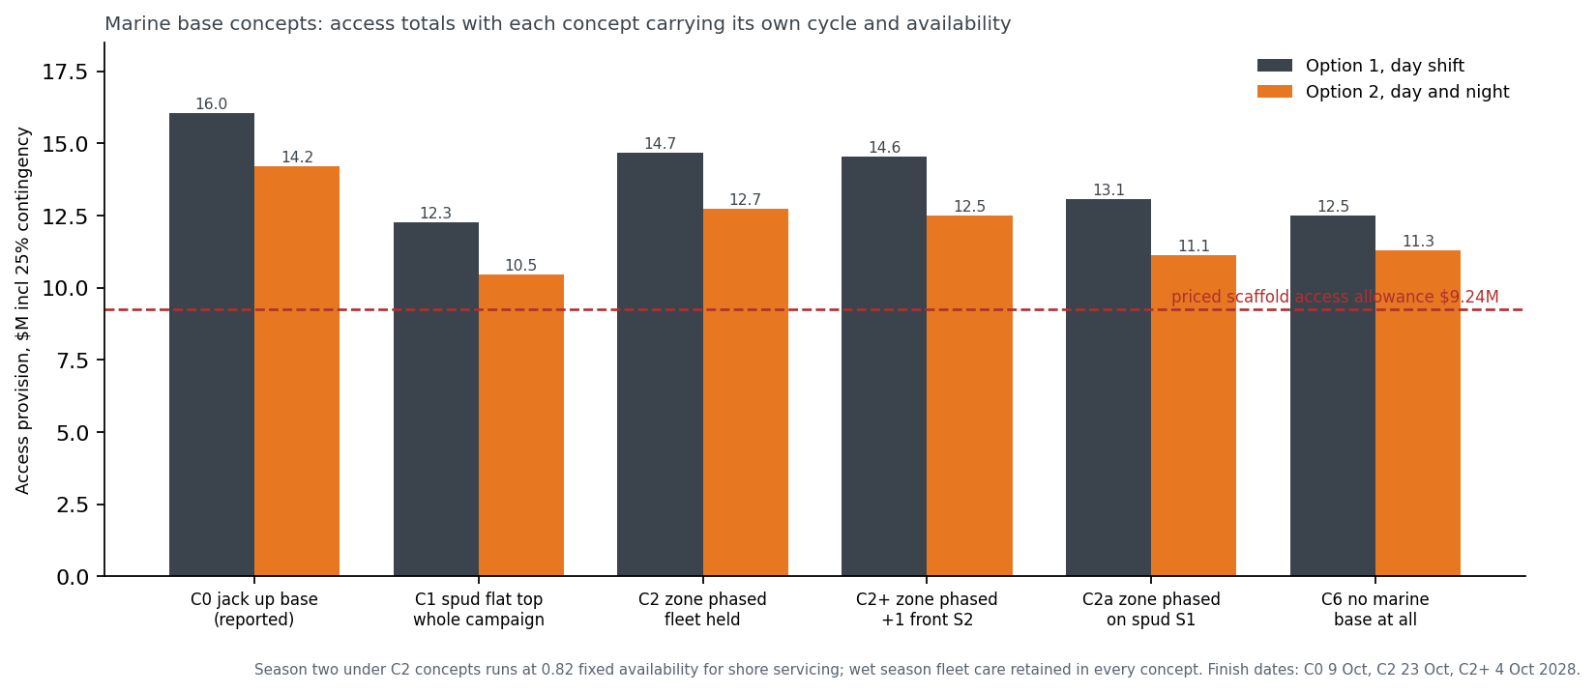
Figure 7. Marine base scenarios: access totals with each carrying its own cycle and availability, against the $9.24M scaffold access allowance.
Read together, the scenarios answer the STL questions of 21 August directly. Removing the base saves $3.55M against the conservative case, at the price of the ninth front, the 58 minutes per shift, and services returning to the roadway; once the base’s productivity is counted, the true cost of keeping it is about $2.1M. The zone phased cases are a method refinement as much as a saving: jack up locations need more than 4 metres of water, so the barge belongs at the wharf head in Zone 3, the most exposed water on the job, through season one, and peels off as the campaign comes into the shelter of Zones 2 and 1 where the fronts can be serviced from the deck. Season two then runs at the without base availability, which is why the zone phased nets sit below the working $3.09M: the season two derate and the retained wet season fleet care are priced next to the saving, not hidden from it. One counterweight frames every scenario: a work front costs about $0.27M a season in kit and crane share plus its fabrication against a buy or hire breakeven of about $320,000, so a base saving that costs the campaign two fronts is mostly handed back. Under Option 2 the same structure gives $13.25M serviced at five fronts and about $12.92M under the compressed day pattern at six. A dry hired deck and a wharf deck service train remain open scenarios priced on STL confirmation of the bargemaster question and the laydown and power points.
9.3 Cost optimisation path
The levers below were rebuilt at this revision so every package reconciles from the lines above it. None is claimed in the reported figure; each is banked only when its verification lands. Kit ownership in place of hire is held as a threshold test: buy below about $320,000 per front against the hire plus standby breakeven, with fabrication drawings already in hand and residual value retained.
Lever, pre contingency $M | Option 1 | Option 2 | What must be true
Moored spud flat top in place of the manned jack up, wet standby at half rate each | 3.02 | 3.00 | Written spud quotation carrying the same services
Wet season off hire and shore lay up, net of one $120,000 written remobilisation lump sum | 0.79 | 0.79 | Off hire terms agreed; season two availability secured
Night rescue reclassification, dedicated night crew released (Option 2 only) |  | 1.09 | Safety case accepts the lifted, tied, enclosed platform as a fixed workplace; regulator concurrence

Package, with contingency | Option 1 | Option 2 | Against $9.24M
Reported base | 16.04 | 14.22 | +6.80 / +4.98
Credible: spud base plus wet season off hire | 11.28 | 9.47 | +2.04 / +0.23
Stretch: plus night reclassification | 11.28 | 8.11 | +2.04 / −1.13
Stretch at 15 percent contingency on award | 10.38 | 7.46 | at controlled basis of estimate

10. Connection to the structure and verification of the lifting arrangement
The STL review of 21 August 2026 put this first: where the winches connect, and how the strength and safety of the lifting arrangement is confirmed. STL also set the governing precedent from its own works: a previous over water project at the terminal core drilled through the concrete, set supports above the deck, and suspended everything through those, with nothing hung from the steelwork. This assessment adopts that direction. The load path runs through the precast concrete roadway and kerb, and the corroded headstock steel carries nothing.
10.1 The connection points
The access supplier’s standard concrete connection uses screw anchors carrying forged lifting points, with socket base plates on the same anchor family where a scaffold tube interface is wanted. At each hanging point a plate carrying a group of M14 concrete screw anchors at 115 millimetre installation depth is fixed to the deck unit or kerb, and a swivel lifting point takes the chain block hook. The anchor is assessed under AS 5216 with European Technical Assessment for cracked concrete: at that embedment in 20 MPa concrete the published design resistances are 28.94 kN tension in uncracked concrete, 20.26 kN in cracked concrete, and 35.15 kN in shear. The lifting point is forged, rated to EN 1677-1 and AS 3776 with a 4 to 1 safety factor and the same working load limit in every direction, and swivels through 360 degrees so the load stays axial as the stage travels. The anchors install without expansion, tolerate edge proximity, and back out cleanly at demobilisation, leaving patchable holes as the only permanent trace. Structure penetrations are discussed with the Superintendent before any drilling, as clause 3.20.14 of the specification requires.
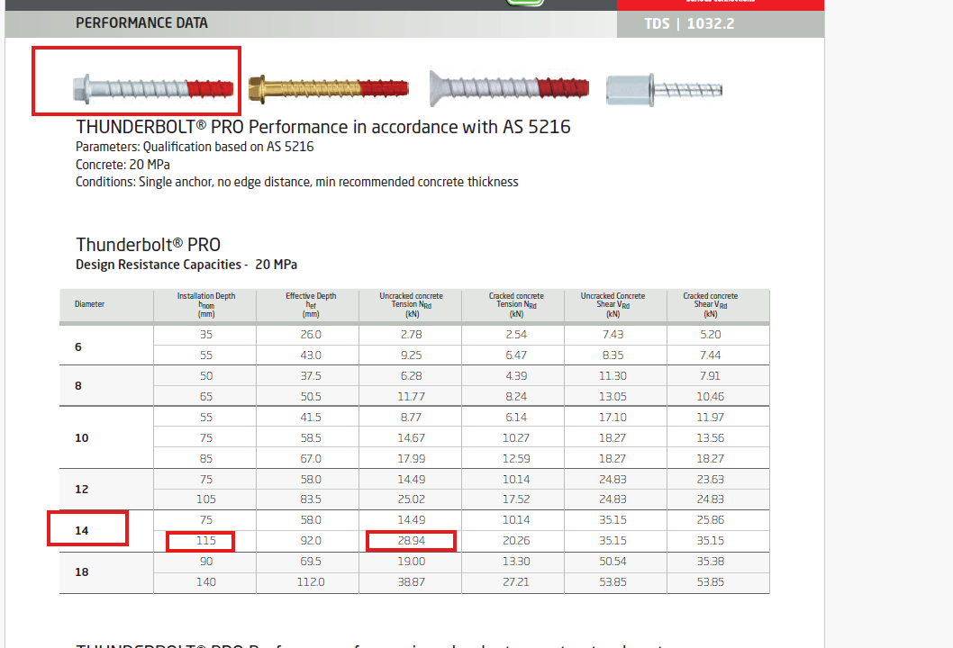
Plate 1. Supplier anchor performance data to AS 5216 at 20 MPa. The highlighted row is the arrangement carried here: M14 at 115 mm installation, 92 mm effective embedment, 28.94 kN design tension uncracked, 20.26 kN cracked, 35.15 kN shear.
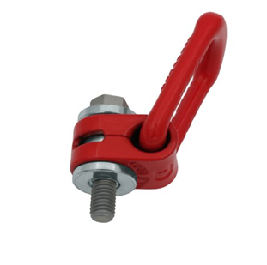  Plate 2. Forged swivel lifting point, EN 1677-1 and AS 3776, safety factor 4 to 1, same working load limit in all directions; the standard bolt is replaced with the screw anchor for the concrete fixing. | 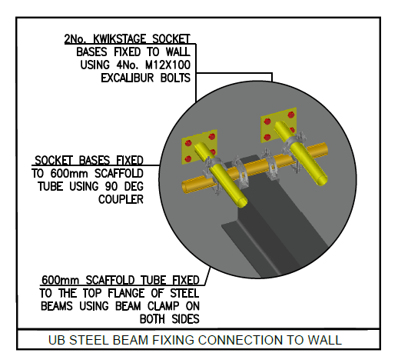  Plate 3. Supplier standard socket base detail on the same anchor family: plates on M12 screw anchors carrying scaffold tube by coupler.

Against the demand: a 2 tonne block at full rating puts about 19.6 kN static on its point plus hoisting dynamics, and the certified precedent below shows the blocks running at under half that in service. A single M14 in cracked concrete is marginal at full block rating; a four anchor group carries it with real margin before group, edge and member reductions. Those reductions are the professional engineer’s work and are exactly what remains open: measured strength and thickness of the 1977 deck units against drawings CTQ-1122-S-005, 030 and 033, cracked or uncracked classification near the keeper angle works, edge distances at the kerb, group spacing, and cyclic loading from repeated lifts.
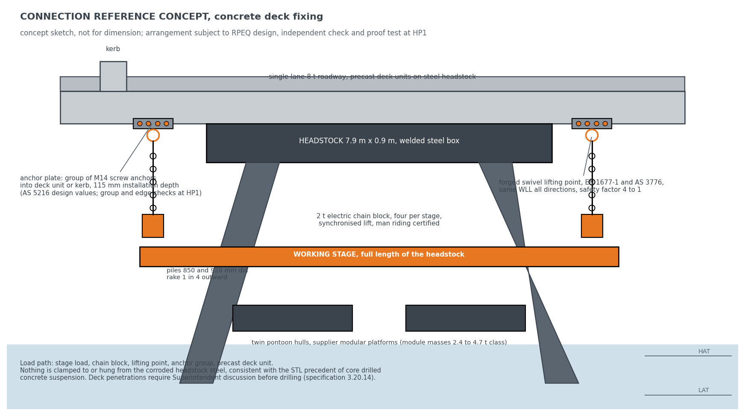
Figure 8. The connection reference concept: anchor plate groups in the concrete deck and kerb, swivel lifting points, synchronised chain blocks, nothing hung from the headstock steel. Concept sketch, not for dimension.
10.2 Securing the stage
The stage is held by layered, independent controls, and no single failure drops it. Four 2 tonne electric chain blocks share the lift, each fitted with a load holding brake, and on the certified precedent each carries less than half its rated load, so the group holds the stage with margin even with one hoist discounted. Each anchor point is installed and proof load tested one bent ahead of the work by the rigging crew, before any load and before any person relies on it. The blocks jog individually to take even tension and then lift as one synchronised operation, so no point is shock loaded. Lifting is the exception, not the norm: on arrival at working height the stage transfers onto positive ties to the structure, the hoists come off load, and the stage stands as a tied, fixed platform for the days of trade work; the chain blocks carry load only during travel between bents. Crews are off the stage for every lift, man riding transfers run under the supplier’s third party certification, a dedicated rescue craft is on the water whenever crews work over it, and the reserve buoyancy of the pontoon modules remains beneath the stage through the tidal band. Every element of that arrangement is proven at the trial bent under proof load and inspection before the method is committed. No single failure lowers the stage.
10.3 The verification route
Five arrangements were considered against the STL precedent before the concrete fixing was adopted, and the verification route below states who signs what and when. Endura’s engagement covers methodology, programme and procurement; the design duty for the connection and the temporary works sits with the supplier’s and STL’s engineers, and if the concept develops into connection design that is separately instructed scope outside this study.
Arrangement | Assessment | Standing
Bolted clamp around the headstock | Clamps to the member being remediated; capacity rests on corroded section | Ruled out by the STL precedent
Through bolted bracket on the headstock | Drills a primary member; permanent modification of corroded steel | Not carried
Welded lug on the headstock | Hot work on corroded in service steel; permanent | Not carried
Pile clamp | Moves load to the raked piles; changes stage geometry and habitat sealing | Reserve only
Concrete deck and kerb fixing: screw anchor groups with forged lifting points | Load path in the 1977 precast, off the corroded steel, removable, matching the STL precedent | Adopted as the reference concept

Verification item | Verified by | When
Anchor group capacity in the deck units: measured strength, thickness, edge distance | Registered professional engineer concept design plus independent check | Before the trial, not before the fleet order
Synchronised four block hoisting | Supplier engineering plus third party certification | Before man riding
Man riding certification | Third party | Before the trial
Linked deck load cases: articulation, unequal loading | Registered professional engineer | Before the arrangement is fixed
Certified mass schedule: stage, containment, materials, crew | Supplier, checked by Endura | Feeds every item above
Lift plan, proof test regime, rescue arrangement | Supplier, accepted by the STL Superintendent | Before the trial

The lifting system carries direct precedent. The supplier’s certified lift plan on a comparable bridge span ran the same four block synchronised arrangement at a maximum lift of 3.802 tonnes including two scaffolders aboard, 0.951 tonnes per hoist, 48.3 percent of the 2 tonne working load limit, prepared and certified by a registered professional engineer; it is reproduced at Appendix C as the sample. Its connection was beam clamps to structural steel, which the STL precedent rules out here, so the hoisting method transfers as it stands and the connection transfers to the concrete as above. The Lucinda specific lift plan on this connection has been requested from the supplier, will carry the certified mass schedule, the load per hanging point, the anchor layout, the proof test regime and the rescue arrangement, and follows under separate cover as an attachment to this report.

11. Hold points
Every recommendation in this report sits behind these gates. If any one fails, the framework stands, because the tender then answers it; but none should be assumed closed.
Ref | What must be proven | Cleared by
HP1 | Hanging point capacity in the concrete deck and kerb | Registered professional engineer concept design plus independent check; proof load at the trial
HP2 | Containment, extraction, noise and lighting performance in the field | Trial bent under the proving campaign
HP3 | Surface preparation and coating compatibility, including waste classification | Written coating supplier position and first batch waste test
HP4 | Seabed and bathymetry along the alignment; jack up locations need over 4 m | Survey data from STL, or an early commissioned sweep
HP5 | Regulator position on marine plant, anchoring, working hours, noise and light | Marine park, maritime safety and port authority engagement, with a vessel biosecurity plan
HP6 | Real weather and tide downtime, split between floating and fixed regimes | Operability model built on metocean records
HP7 | Condition, preservation and true completion status of part complete bents | Close out survey before the restart sequence is set
HP8 | Market appetite and capability beyond the single supplier basis | Market soundings before the delivery model is locked

12. Decisions requested of STL
1. The repair library principle, with the Superintendent and the reviewing engineer, including confirmation of the contract mechanism. The reported cycle assumes it; without it the day shift fleet grows from eight fronts to eleven.
2. Written confirmation of the position on night and evening work, including the compressed day pattern to 2200, following the STL enquiry of 21 August.
3. Chart depths along the alignment and the declared berth depth, for the marine base selection; jack up locations need over 4 metres of water.
4. Instruction of the paid proving trial for September and October 2026, priced in Section 13.4; a September start needs the instruction within weeks.
5. The preferred marine base scenario from Section 9.2, so the barge operator reconciliation and the spud market enquiry are focused before the workshop.
13. Delivery model and implementation roadmap
Having selected an access method, the question that follows is how STL buys it, and what must happen between the decision gate and the first bent of the 2027 season.
13.1 Scope separation of access and trade works
Packaging route | What it means | Where it fits
A. Instructed change within the existing arrangements | The access method is changed under the contract already in place, using its own change mechanism. Trade scope, rates and parties untouched. | Fastest to the 2027 season. Whether the existing arrangements accommodate a change of this size is a matter for STL and its advisers.
B. Separate access package, principal supplied | STL procures the access system as a standalone package and makes the platform available to the trade works. Access measured on platform availability; trade measured on completed bents. | Follows directly from the scope separation. Puts the access risk with a specialist. Needs a clean interface schedule.
C. Consolidated package | A single package covering access and trade works for the remaining scope. | Simplest interface, widest market test, longest lead time to the field.

13.2 Evaluation framework
Production rate and operability are weighted at 40, safety, environment and containment at 25, plant, people and marine capability at 20, and price at 15, weighted last deliberately: the access provision is a small share of the outcome, and the cost of a slow method is measured in seasons. Weights are indicative and agreed with STL. Mandatory tender content: a production build up bent by bent with the availability evidence; a tide and weather operability model distinguishing floating from fixed regimes; the containment method and waste classification assumed; the cyclone demobilisation plan with trigger and duration; a structural loading report with independent check; and the shift pattern proposed, with a noise model where extended hours are offered.
13.3 Endura’s role
Under the recommended model Endura builds the evaluation framework, completes the market soundings, prepares the performance specification against the reference concept, and scores bids alongside STL. Endura is independent of the equipment suppliers and contractors assessed and holds no interest in the outcome of any tender. Endura’s advice under this engagement relates to methodology, programme and procurement; STL retains its own legal and contractual advisers in respect of its existing contractual arrangements, and nothing in this report is advice on them.
13.4 The proving campaign
Three different activities have carried the name trial in this work and they are separated here. An off site familiarisation on the supplier’s five existing platforms trains crews but proves nothing about Lucinda. The trial bent line inside the fixed costs, $155,400, is the first production bent’s proof load and acceptance. The proving campaign is the one that matters: a two to four week measured programme on the real bents in September and October 2026, priced at $350,000 to $600,000 at Class 5 screening accuracy, covering mobilisation of the five existing platforms, a workboat, the access crew, anchor installation and proof testing, containment, and measurement. It runs one week with the marine base and one week without it, so the marine base question of Section 9.2 is settled by measured cycle times. The measured set: move on and move off times, lift and transfer times, anchor install and proof test rate on the real deck units, containment set and strip times, achieved trade hours per platform day, weather standdowns, and crib and fuel demand per shift. Pass criteria are agreed with the Superintendent before the trial starts, as measurements. The commercial instrument is a variation under accepted proposal ED-018-2026-01 or a separate purchase order at STL’s election, with the approvals allowance for the trial itself carried at HP5.

Client review and acceptance
This deliverable is issued to Sugar Terminals Limited for review under engagement ED-018-2026-01. Acceptance below records that STL has reviewed this revision and accepts it as the basis for the decisions described in it. Acceptance does not transfer design duty for the reference concept, which remains subject to the hold points in Section 11.
Sugar Terminals Limited | Name and position | Signature and date
Reviewed by
Accepted by

Comments may be returned in lieu of acceptance, in which case a revised issue follows under the revision history above.

Appendix A. The arithmetic
Required rate: 227 bents over 50.4 available weeks, two 26 week seasons less 1.6 shipping weeks, 4.5 per week. Current method: 15 to 16 day cycle, about 5 sustainable fronts, 1.3 to 1.7 per week ceiling. Marine cycle: 7 trade shifts plus 2 move shifts, plus 3 hold shifts where the repair library is not agreed. Option 1 effective cycle: 2 moves at 0.80 floating availability plus 7 trade days at 0.90 fixed availability, 2.50 plus 7.78, about 10.3 days; 6 working days over 10.3 gives 0.58 per front; 4.5 over 0.58 gives 8 fronts. Option 2: trade shifts at 2 per calendar day, 2.50 plus 3.89, about 6.4 days, 0.94 per front, 5 fronts. Compressed day: both shifts inside 0600 to 2200, 1.6 shifts per calendar day, 2.50 plus 4.86, about 7.4 days, 0.82 per front, 6 fronts. Serviced case: six trade shifts per bent with the base, cycle 9.2 days, 0.65 per front. No base: seven shifts at 0.82 fixed availability, cycle 11.0, 0.54 per front, nine fronts. At the mid availability case the same arithmetic gives 9, 6 and 7 fronts, the sensitivity carried in Section 7. Access cost: kit per front week plus marine base plus fleet access crew on campaign weeks plus fixed lines, plus 25 percent. All computed live in companion model ED-018-2026-06 Rev B.

Appendix B. Technical plates
The plates below support Sections 6 and 8. They are concept arrangements and supplier evidence, not construction drawings. Dimensions are indicative and are confirmed at hold points HP1 and HP2.
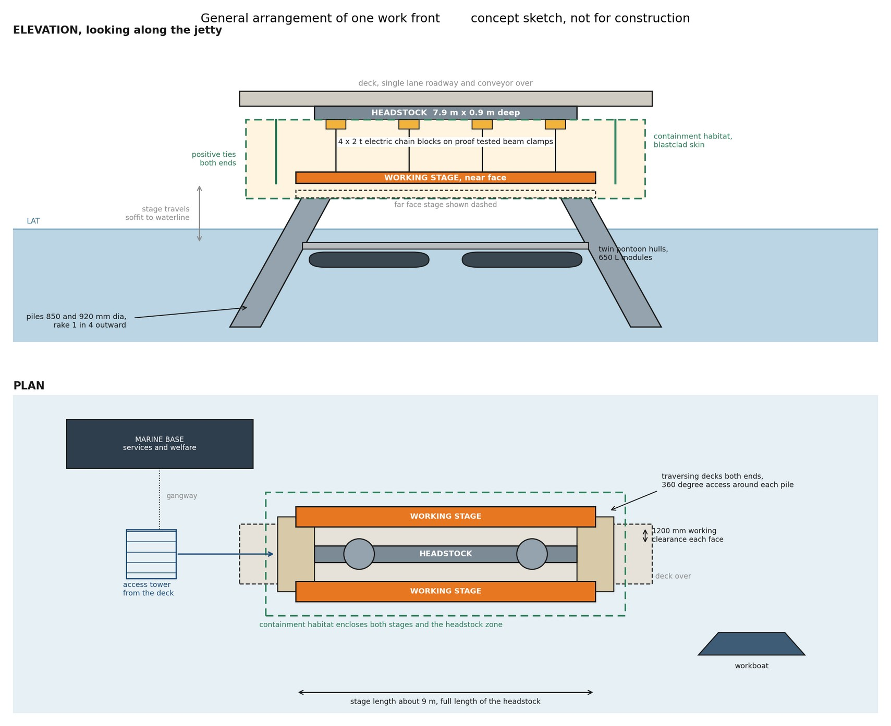
Figure 9. General arrangement of one work front, elevation and plan. Two stages hang on the long faces of the headstock on four 2 t electric chain blocks each, with traversing decks at both ends giving access around each pile. Concept sketch, not for construction.
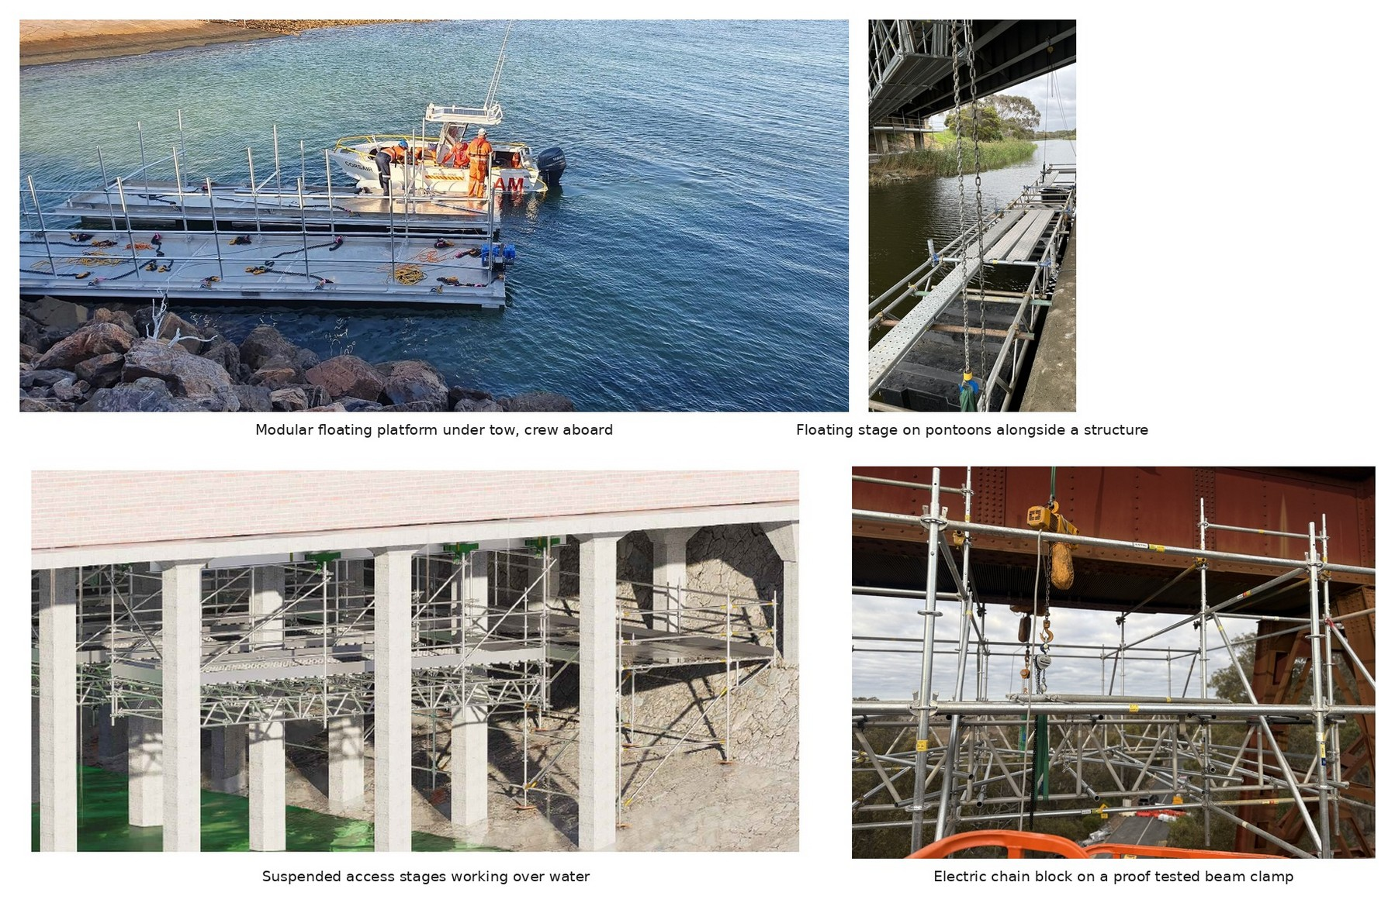
Figure 10. Supplier equipment of the type proposed, in service on other structures. The arrangement for Lucinda is subject to project specific design and certification at hold points HP1 and HP2.
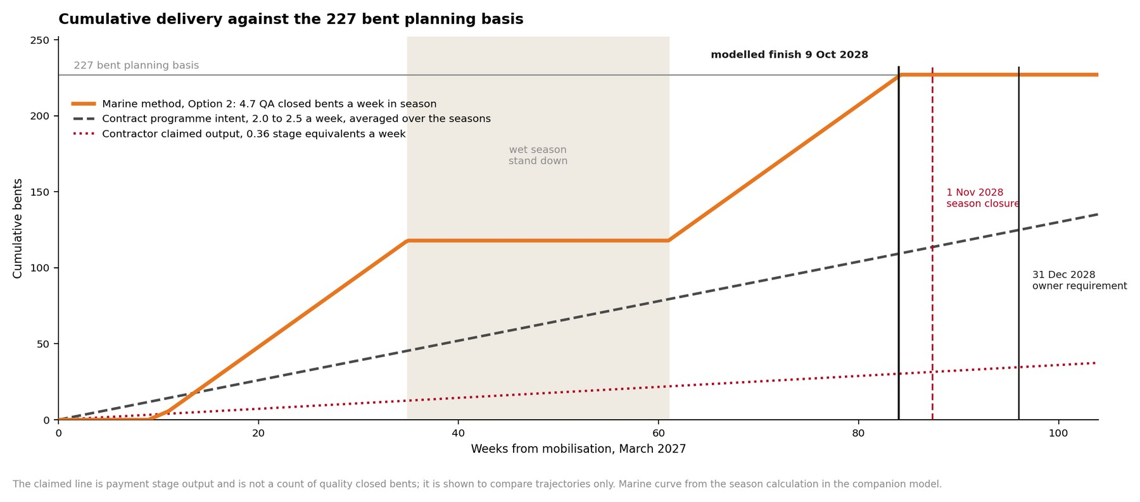
Figure 11. Cumulative delivery against the 227 bent planning basis. The claimed line is payment stage output and is not a count of quality closed bents; it is shown to compare trajectories only.

Appendix C. Supplier connection evidence and sample lift plan
The supplier’s in service reference and the sample certified lift plan supporting Section 10. The full product data sheets, the screw anchor technical data sheet TDS 1032.2 and the lifting point data sheet, accompany this issue as separate documents.
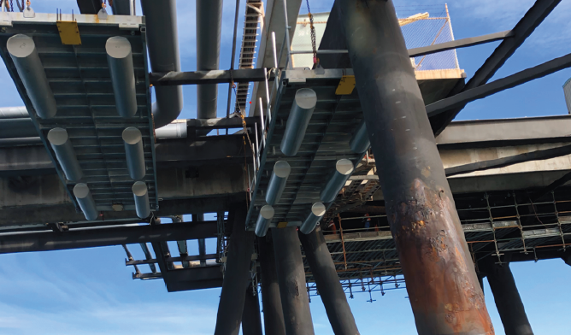
Plate 4. Supplier modular platforms suspended beneath a wharf structure alongside large diameter piles, in service on a comparable over water remediation.
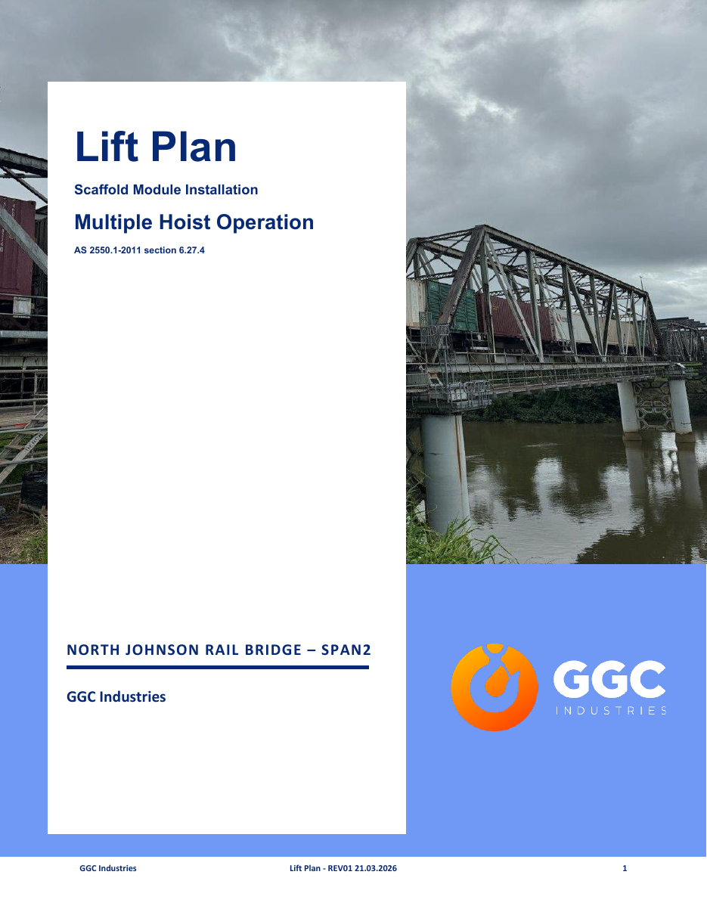
Plate 5. Sample certified lift plan, cover sheet: the same four block synchronised system on a comparable bridge span, maximum lift 3.802 t including two scaffolders aboard, 0.951 t per hoist, 48.3 percent of working load limit, certified by a registered professional engineer. The connection differs at Lucinda per Section 10.1; the Lucinda lift plan follows under separate cover.

