System Specification & Architecture Design
Enterprise Smart Workspace, Desk, Meeting Room & Asset Management System (SAMS)
Version: 1.2 (Visual Floorplan Builder & Media CMS Spec) | Target Audience: Product, Architecture & Real Estate Facilities
Date: October 2026 | Scope: Global Multi-Location Desk, Room & Asset Platform

1. Executive Summary & Architecture Overview
The Enterprise Smart Workspace & Asset Management System (SAMS) provides a unified digital ecosystem for multi-location global enterprises. It consolidates hybrid desk hoteling, meeting room scheduling, computing peripherals, and office infrastructure into a geo-aware, interactive map interface.
- Global Data Topology: Multi-region data tenancy with global directory replication across EMEA, Americas, and APAC to adhere to GDPR, UK-GDPR, and regional compliance standards.
- Real-Time State Backplane: Real-time WebSocket/SSE state engine reflecting instantaneous availability across maps, tablet kiosks, and schedules to prevent double bookings.
- Enterprise Calendar Synchronisation: Bi-directional calendar synchronization with Microsoft 365 (Graph API / Exchange Online) and Google Workspace.
2. Domain-Led Architecture & Automated Onboarding
The platform is engineered around a domain-led tenancy model. Instead of relying solely on manual invitations, organization accounts and workspaces are anchored to verified corporate email domains (e.g., '@company.com', '@subsidiary.co.uk').
2.1. Domain Whitelisting & Verification Lifecycle
- Domain Registration & Verification: Global Super Admins register root and subsidiary domains in the central management portal (e.g., adding 'cloudfy.com' or 'williamscommerce.com'). Domain ownership is verified via DNS TXT records or direct SAML 2.0 / OpenID Connect metadata handshakes.
- Zero-Touch Self-Registration: Once a domain is verified and active, any employee signing up or authenticating via SSO using an email address matching that domain is immediately routed into the appropriate corporate environment without administrative bottlenecks.
- Multi-Domain Group Mapping: Supports multi-domain enterprises where holding companies, joint ventures, or regional sister brands share global office inventory while maintaining department-level cost centers.
2.2. Just-In-Time (JIT) Provisioning & Access Control
- JIT Account Creation: User accounts are generated instantaneously on first sign-in via SAML/OAuth claims, populating name, email, department, and default home office.
- Default Role Policies: Admins can configure domain-level default roles (e.g., standard employee booker vs. restricted contractor) and set automatic desk quotas.
- Automated Deprovisioning: If a domain is deactivated or an employee email is revoked via SCIM / identity provider, all upcoming desk and room reservations across all global offices are automatically freed up.
3. End-to-End User Experience Journey
3.1. Global Geo-Location & Campus Switcher
Upon logging in, the system detects the employee's current location via HTML5 geolocation or corporate IP mapping, centering the map on their local campus hub while allowing intuitive selection of any office globally.
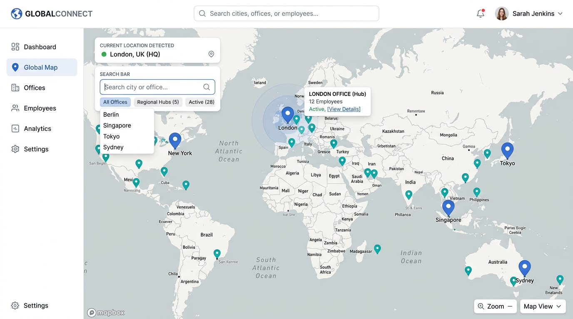
Figure 1: Global Map Navigation Screen: Current location detection overlay, interactive global campus pins, and regional switcher.
3.2. Interactive Floor Plan & Desk Hover Tooltip
Employees navigate through building levels to inspect an interactive vector floor plan. Desk nodes display color-coded availability in real time. Hovering over any desk reveals hardware, computing, and amenity details.
- Ergonomics & Desk Type: Electric sit/stand vs. standard height, ergonomic chair model.
- Compute & Connectivity: Dual 27" 4K USB-C displays, 90W Power Delivery, universal docking hub, wired gigabit LAN.
- Zone & Facilities: Distance to coffee stations, silent focus pods, restrooms, and emergency exits.
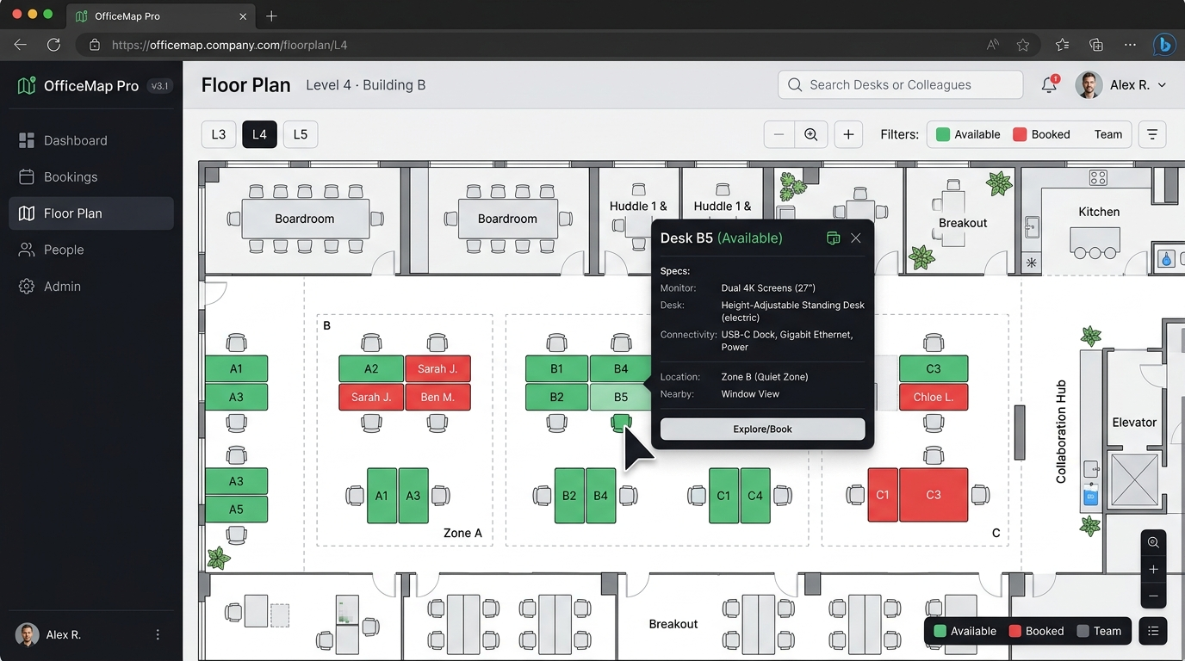
Figure 2: Interactive Floor Map & Desk Inspection: Real-time desk occupancy status, department zones, and hardware specification flyout card.
3.3. Booking Logic, Calendar States & Weather Integration
Booking logic differentiates between individual workspace and group collaboration spaces:
- Desk Reservations: Synchronized automatically to Outlook/Google with 'Show As' set strictly to 'Free' so availability for meetings is not compromised.
- Meeting Room Reservations: Synchronized with 'Show As' set to 'Busy', generating multi-attendee invitations and automated Microsoft Teams video conference links.
- Contextual Intelligence: Displays a live 3-day weather forecast for the office city, local commute/parking guidance, and floor-specific amenities.
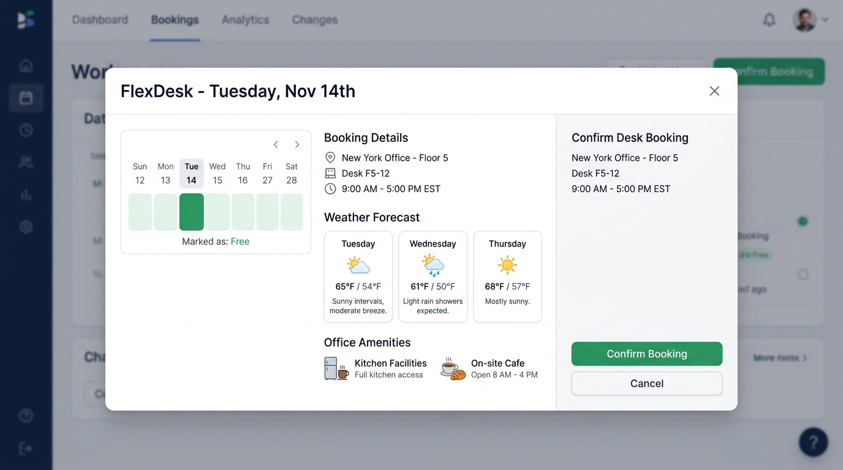
Figure 3: Confirmation Dialog & Contextual Intelligence: Booking modal showing calendar integration ('Marked as Free'), 3-day weather preview, and amenities.
3.4. Smart Nudges, Check-in Grace Period & Teams Fallback
- Automated Reminders: Automated notifications delivered 24 hours and 2 hours prior to the reservation start.
- No-Show Auto-Release: 15-minute check-in grace period via desk QR code scan or corporate Wi-Fi handshake. Unclaimed spaces are auto-released.
- Virtual Meeting Fallback: If a physical meeting room is released or cancelled, attendees receive an automated notice switching the session to 'Teams Virtual Only'.
4. Multi-Tier Administrative Specifications & Floorplan Builder
The administrative tier implements a bifurcated Role-Based Access Control (RBAC) hierarchy, providing central governance for global leadership alongside operational flexibility for local facilities teams.
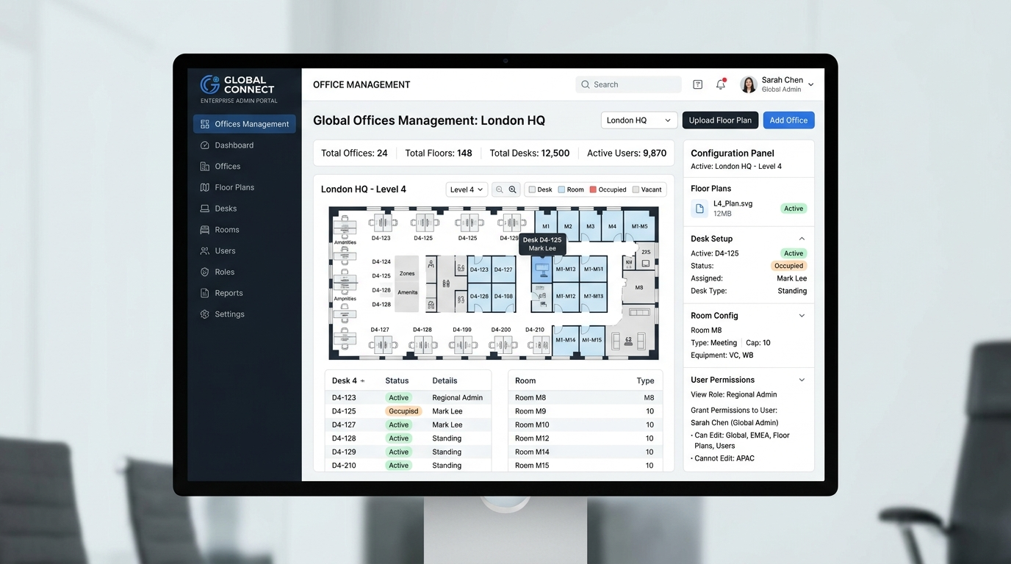
Figure 4: Multi-Tier Administration & Operations Portal: Management console showing global offices, interactive SVG floorplan mapper, and role matrix.
4.1. Visual Floorplan Builder, Floor Hierarchy & Media Management
The administrative suite provides a dedicated visual authoring tool allowing admins to construct building hierarchies, map physical floorplans, and manage localized multimedia assets:
- Building & Floor Hierarchy Management: Admins can create and organize structural hierarchies: Enterprise -> Region -> Campus/City -> Building -> Floors/Levels -> Wings/Zones.
- Interactive Floorplan Canvas & Upload: Local admins can upload raw architectural blueprints or vectorized floorplans (SVG, high-res PNG, or CAD-exported DWG). The visual canvas includes snapping grids, scaling rulers, and orientation calibrators.
- Visual Node Plotting & Drag-and-Drop Editor: Interactive click-and-drag tools to place desk nodes, draw polygon boundaries for meeting rooms, establish department neighborhoods, and define walk paths.
- Location Photo & Media Asset CMS: Facilities teams can upload high-resolution photo galleries for each location, specific meeting rooms, kitchen facilities, breakout lounges, and exterior entrance guides. Supports thumbnail banners, 360-degree panoramic tours, and accessibility walkthroughs.
- Facility & Amenity Pin Mapping: Ability to designate interactive amenity icons (coffee stations, water dispensers, printer hubs, restrooms, first aid rooms, emergency exits) with photo tooltips and operating hours.
4.2. Global Super Admin vs. Local Office Admin Matrix
Functional Area | Global Super Administrator | Local Office Administrator
Domain Governance | Add/verify authorized corporate domains (DNS/SAML), configure JIT self-registration | View active domain users assigned to local office; request alias additions
Tenant Scope | Global enterprise tenant (all regions, entities) | Assigned campus, building(s), or floors only
Building & Floor Hierarchy | Provision new global campus sites, define standard floor numbering conventions | Add/edit building floors, mezzanine levels, wings, and zones
Floorplan Builder & SVGs | Define architectural SVG rendering standards and global layer templates | Upload SVG/CAD floor plans, calibrate scale, drag-and-drop desk/room nodes
Photo & Media CMS | Set image compression, media retention, and brand photo guidelines | Upload high-res photos of offices, kitchens, meeting rooms, and access maps
Asset Management | Standardize enterprise hardware catalog | Tag serial numbers, manage local peripherals, monitors, and lockers
Local Amenities | Set global hygiene and facility guidelines | Update kitchen photos, coffee bean status, Wi-Fi passwords, and cafe menus
Booking Rules | Global booking window (e.g. 30 days max) | Local adjustments (grace periods, VIP desk reserves)
Reporting & Audit | Worldwide real estate utilization and ESG carbon metrics | Daily check-in rosters, no-show lists, repair tickets
Security & SSO | Configure SAML/Entra ID SSO, SCIM, and RBAC | Manage team neighborhoods and local admin delegates
5. Recommended Enterprise Enhancements
- Find a Colleague & Neighborhoods: Enables staff to favorite colleagues, view scheduled office days, and book desks within shared neighborhoods.
- Room Display Signage Kiosks: Dedicated lightweight web tablet application for 7"-10" wall mounts showing live status and ad-hoc booking.
- Visitor Management: Pre-registration of external guests with badge generation and host arrival notifications.
- Space Utilization Analytics: Space optimization metrics tracking peak occupancy to assist corporate lease and footprint planning.

