1. Linked Lists - Create a Swap Method
   1. A computer screen with text and images

      AI-generated content may be incorrect.
   2. A screenshot of a computer program

      AI-generated content may be incorrect.
2. Asymptotic Notations - Computing the Complexity
   1. O(n)
      1. Two loops run one after the other. Each runs n times, which simplifies to O(n).
   2. O(n^2)
      1. One loop is inside the other. So whatever n times the outer loop runs, the inner loop runs n times, so n \* n would be n^2.
   3. O(n^3)
      1. There are about n recursive calls, and each call’s tasks add up to about n^2 work, so n \* n^2 = n^3.
   4. O(n^2 log n)
      1. We do about n^2 calls to a function that is O(log n) each, so we are looking at n^2 \* log n.
3. Brute-Force Algorithm - Create the Difference of Two Sets
   1. 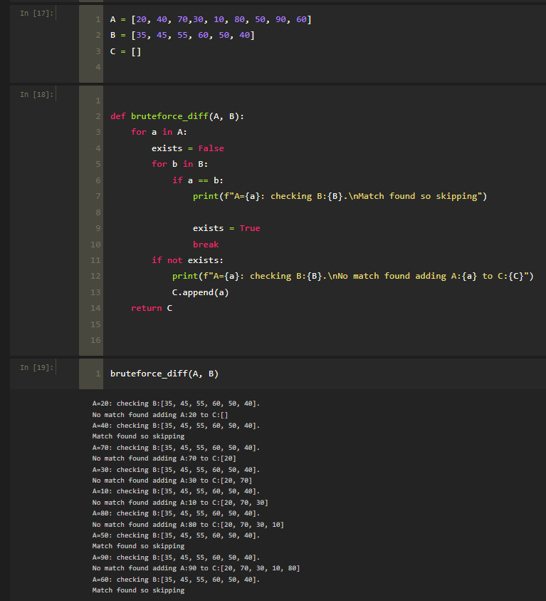
   2. Worst case scenario is if every element in A did not exist in B. That means every n element in A would be compared to every M element in B. O(n\*m)
4. Recursion - Breadth First Search and Depth First Search
   1. A black rectangular object with a black border

      AI-generated content may be incorrect.
   2. DFS
      1. A screen shot of a computer code

         AI-generated content may be incorrect.
5. Recursion - Master Method
   1. T(n) = 4T(n/2) + n^3
      1. Since n^3 > n^2
      2. O(n^3)
   2. T(n) = 4T(n/2) + n^2
      1. Since n^2 = n^2
      2. O(n^2 log n)
   3. T(n) = 4T(n/2) + n
      1. Since n < n^2
      2. O(n^2)
6. Decrease-and-Conquer Algorithm – Maximum Element in Array
   1. A screenshot of a computer program

      AI-generated content may be incorrect.
7. Divide-and-Conquer Algorithms – Mergesort and Quicksort
   1. Worst case Big O:
      1. Mergesort: O(n log n)
      2. Quicksort: O(n^2)
   2. Average case Big O:
      1. Mergesort: O(n log n)
      2. Quicksort: O(n log n)
   3. A diagram of numbers and arrows

      AI-generated content may be incorrect.
   4. A screenshot of a spreadsheet

      AI-generated content may be incorrect.