How to Mount a Windows Shared on an Ubuntu Machine using NFS

1. Ensure that the Windows machine has been configured to share the specific folder

2. Open Terminal chdir to you Amazon folder; Ensure you are connected to the SUPERGROUP VPN & ssh into their ubuntu server

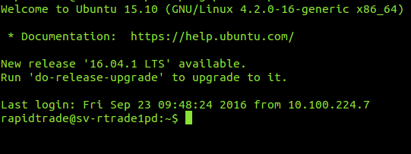

3. Install smb client called cifs by running attached command :

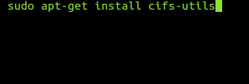

sudo apt-get install cifs-utils

4. Create a Directory where you’ll mount the shared folder with the following command :

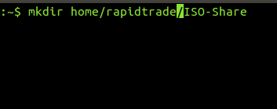

mkdir home/rapidtrade/ISO-Share

5. Mount the shared folder onto your shared drive with the following command

* Enter same password as your ssh password, then enter Windows machine password as seen below

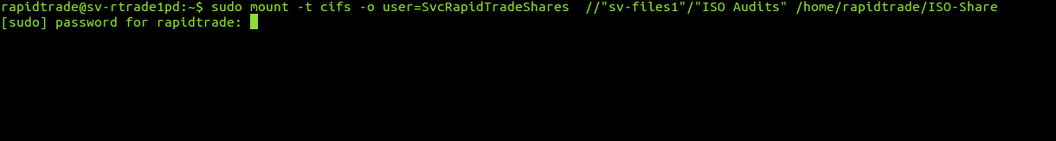



sudo mount -t cifs -o user=SvcRapidTradeShares //"sv-files1"/"ISO Audits" /home/rapidtrade/ISO-Share

Password for user SvcRapidTradeShares = $vCR@P!Dtr@d3$h@r3.!#@

6. Change directory to your shared folder i.e. ISO-Share and list the file items by running the following command :

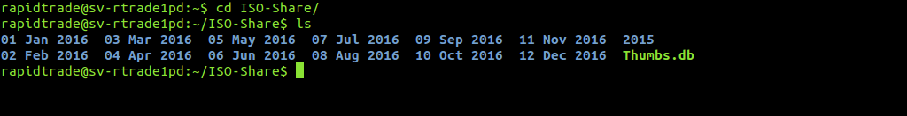

cd ISO-share

ls

7. In order to unmount the shared folder run the following command chdir out and back into the shared drive . run a ls command to see contents of folder. It will be blank:

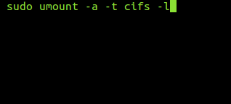

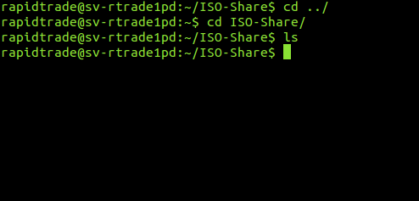

sudo umount -a -t cifs -l