PROJECT REPORT
on
Heart Disease Prediction System
(CSE V Semester Mini project PCS-504)
2020-2021

Submitted to: Submitted by:
Ms. Rishika Yadav Mr. Shubham Rana
(CC-CSE-B-V-Sem) Roll. No.: 1018604
CSE-A-V-Sem
Session: 2020-2021

DEPARTMENT OF COMPUTER SCIENCE AND INFORMATION TECHNOLOGY
GRAPHIC ERA HILL UNVERSITY, DEHRADUN
CERTIFICATE

Certified that Mr. Shubham Rana (Roll No.- 1018604) has developed mini project on “Heart disease prediction system” for the CS V Semester Mini Project Lab (PCS-504) in Graphic Era Hill University, Dehradun. The project carried out by Students is their own work as best of my knowledge.

Date:12/12/2020

(Ms. Rishika Yadav)
Project Co-ordinator
CC-CSE-B-V-Sem
(CSE Department)
GEHU Dehradun

(Dr Mahesh manchanda)
Project Guide
Resource Person
(CSE Department)

ACKNOWLEDGMENT

We would like to express our gratitude to The Almighty Shiva Baba, the most Beneficent and the most Merciful, for completion of project.
We wish to thank our parents for their continuing support and encouragement. We also wish to thank them for providing us with the opportunity to reach this far in our studies.
We would like to thank particularly our project Co-ordinator Ms. Rishika Yadav and our Project Guide Mr. XYZ for his patience, support, and encouragement throughout the completion of this project and having faith in us.
We also acknowledge to teachers like Mr PQR and Mr. XYZ who help us in developing the project.
At last but not the least We greatly indebted to all other persons who directly or indirectly helped us during this work.

Mr. Shubham rana
Roll No.- 1018604
CSE-A-V-Sem
Session: 2020-2021
GEHU, Dehradun
TABLE OF CONTENTS

CHAPTER NO. TITLE PAGE NO.
LIST OF TABLES vi
LIST OF FIGURES vii
LIST OF SYMBOLS, ABBREVIATIONS viii
1. INTRODUCTION 8
1.1 About Project 8
1.2 ANN 9
1.2.1 DNN 9-10
2. PROJECT 11
2.1 Proposed Architecture 11
2.2 Naïve bias Classifer 11-12
2.3 Flow Chart / DFD 13-14
2.4 Software Reqirement 14
2.5 Hardware requirement 15

3. SNAPSHOT OF PROJECT 16
3.1 snaps 16-17

4. CONCLUSION 18

LIST OF TABLES

TABLE Page No.

Table 2.1 Naïve Bias Classifier 11

LIST OF FIGURES

FIGURE Page No.

Figure 1.1 Flow Chart of naïve bias algorithm 12
Figure 2.1 Project Flow Chart 13
Figure 2.2 DFD 14

LIST OF ALGORITHMS (if required)

ALGORITHM Page No.
Naïve bias Algorithm 11-12

CHAPTER 1
INTRODUCTION

  - ABOUT PROJECT
Heart disease is a deadly disease that large population of people around the world suffers from. When considering death rates and large number of people who suffers from heart disease, it is revealed how important early diagnosis of heart disease. Traditional way of diagnosis is not sufficient for such an illness. Developing a medical diagnosis system based on machine learning for prediction of heart disease provides more accurate diagnosis than traditional way. In this paper, a heart disease prediction system which uses artificial neural network backpropagation algorithm is proposed. 13 clinical features were used as input for the neural network and then the neural network was trained with backpropagation algorithm to predict absence or presence of heart disease with accuracy of 95%.

The health care industries collect huge amounts of data that contain some hidden information, which is useful for making effective decisions. For providing appropriate results and making effective decisions on data, some advanced data mining techniques are used. In this study, an effective heart disease prediction system (EHDPS) is developed using neural network for predicting the risk level of heart disease. The system uses 15 medical parameters such as age, sex, blood pressure, cholesterol, and obesity for prediction. The EHDPS predicts the likelihood of patients getting heart disease. It enables significant knowledge, eg, relationships between medical factors related to heart disease and patterns, to be established. We have employed the multilayer perceptron neural network with backpropagation as the training algorithm. The obtained results have illustrated that the designed diagnostic system can effectively predict the risk level of heart diseases.

1.2 ANN

Artificial neural networks (ANNs) or connectionist systems are computing systems inspired by the biological neural networks that constitute animal brains. Such systems learn (progressively improve their ability) to do tasks by considering examples, generally without task-specific programming. For example, in image recognition, they might learn to identify images that contain cats by analyzing example images that have been manually labeled as "cat" or "no cat" and using the analytic results to identify cats in other images. They have found most use in applications difficult to express with a traditional computer algorithm using rule-based programming.
An ANN is based on a collection of connected units called artificial neurons, (analogous to biological neurons in a biological brain). Each connection (synapse) between neurons can transmit a signal to another neuron. The receiving (postsynaptic) neuron can process the signal(s) and then signal downstream neurons connected to it. Neurons may have state, generally represented by real numbers, typically between 0 and 1. Neurons and synapses may also have a weight that varies as learning proceeds, which can increase or decrease the strength of the signal that it sends downstream.
Typically, neurons are organized in layers. Different layers may perform different kinds of transformations on their inputs. Signals travel from the first (input), to the last (output) layer, possibly after traversing the layers multiple times.
The original goal of the neural network approach was to solve problems in the same way that a human brain would. Over time, attention focused on matching specific mental abilities, leading to deviations from biology such as backpropagation, or passing information in the reverse direction and adjusting the network to reflect that information.

1.2.1 DNN
A deep neural network (DNN) is an artificial neural network (ANN) with multiple layers between the input and output layers. There are different types of neural networks but they always consist of the same components: neurons, synapses, weights, biases, and functions. These components functioning similar to the human brains and can be trained like any other ML algorithm.
For example, a DNN that is trained to recognize dog breeds will go over the given image and calculate the probability that the dog in the image is a certain breed. The user can review the results and select which probabilities the network should display (above a certain threshold, etc.) and return the proposed label. Each mathematical manipulation as such is considered a layer, and complex DNN have many layers, hence the name "deep" networks.
DNNs can model complex non-linear relationships. DNN architectures generate compositional models where the object is expressed as a layered composition of primitives. The extra layers enable composition of features from lower layers, potentially modeling complex data with fewer units than a similarly performing shallow network.
Deep architectures include many variants of a few basic approaches. Each architecture has found success in specific domains. It is not always possible to compare the performance of multiple architectures, unless they have been evaluated on the same data sets.
DNNs are typically feedforward networks in which data flows from the input layer to the output layer without looping back. At first, the DNN creates a map of virtual neurons and assigns random numerical values, or "weights", to connections between them. The weights and inputs are multiplied and return an output between 0 and 1. If the network did not accurately recognize a particular pattern, an algorithm would adjust the weights. That way the algorithm can make certain parameters more influential, until it determines the correct mathematical manipulation to fully process the data.
Recurrent neural networks (RNNs), in which data can flow in any direction, are used for applications such as language modeling. Long short-term memory is particularly effective for this use.
Convolutional deep neural networks (CNNs) are used in computer vision. CNNs also have been applied to acoustic modeling for automatic speech recognition (ASR).

CHAPTER 2
PROJECT
2.1 Proposed Architecture
In this system we are implementing effective heart attack prediction system using Naïve Bayes algorithm. We can give the input as in CSV file or manual entry to the system. After taking input the algorithms apply on that input that is Naïve Bayes. After accessing data set the operation is performed and effective heart attack level is produced. The proposed system will add some more parameters significant to heart attack with their weight, age and the priority levels are by consulting expertise doctors and the medical experts. The heart attack prediction system designed to help the identify different risk levels of heart attack like normal, low or high and also giving the prescription details with related to the predicted result

2.1 Naïve Bayes Classifier
Naïve Bayes classifier is based on Bayes theorem. This classifier uses conditional independence in which attribute value is independent of the values of other attributes. The Bayes theorem is as follows: Let X= {x1, x2, ......, Xn} be a set of n attributes. In Bayesian, X is considered as evidence and H be some hypothesis means, the data of X belongs to specific class C. We have to determine P (H|X), the probability that the hypothesis H holds given evidence i.e. data sample X. According to Bayes theorem the P (H|X) is expressed as: P(H|X) = P(X|H) P(H) / P(X).4
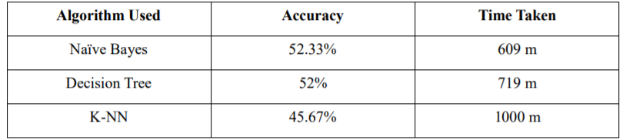
Table2.1

Using Bayesian classifiers, the system will discover the concealed knowledge associated with diseases from historical records of the patients having heart disease. Bayesian classifiers predict the class membership probabilities, in a way that the probability of a given sample belongs to a particular class statistically. Bayesian classifier is based on Bayes’ theorem. We can use Bayes theorem to determine the probability that a proposed diagnosis is correct, given the observation. A simple probabilistic, the naive Bayes classifier is used for classification based on which is based on Bayes’ theorem. According to naïve Bayesian classifier the occurrence or an occurrence of a particular feature of a class is considered as independent in the presence or absence of any other feature. When the dimension of the inputs is high and more efficient result is expected, the chief Naïve Bayes Classifier technique is applicable. The Naïve Bayes model identifies the physical characteristics and features of patients suffering from heart disease. For each input, it gives the possibility of attribute of the expectable state. Naïve Bayes is a statistical classifier which assumes no dependency between attributes. This classifier algorithm uses conditional independence, means it assumes that an attribute value of a given class is independent of the values of other attributes. The advantage of using Naïve Bayes is that one can work with the Naïve Bayes model without. using any Bayesian methods.

2.2 Flowchart of Naïve Bayes Decision Tree Algorithm

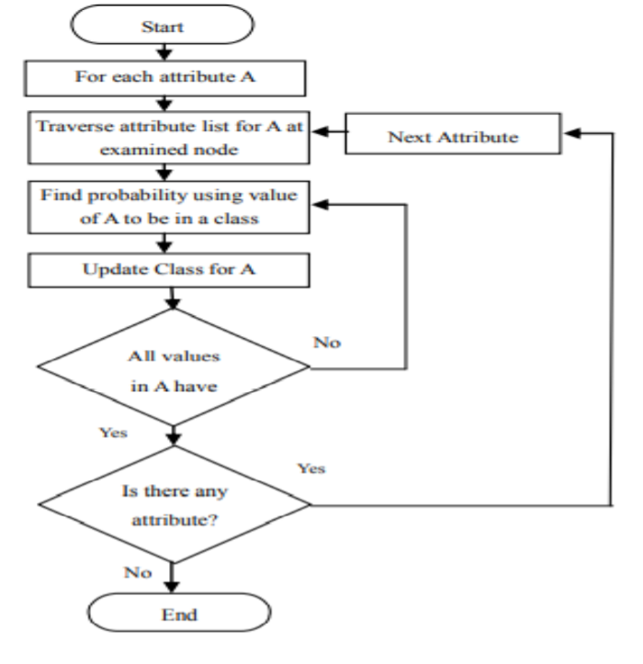
Figure 2.1

2.3 Project Flow Chart
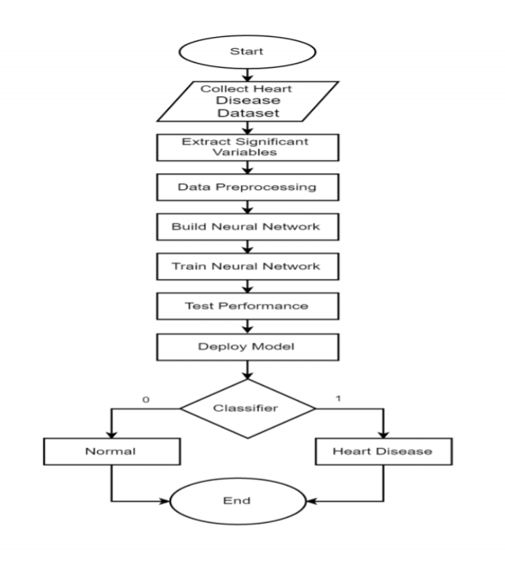
Figure 2.2

2.4 Data flow diagram
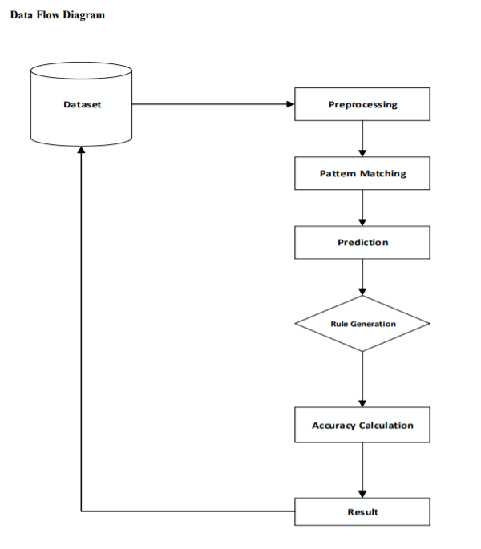
Figure 2.3

2.5 Software requirements:
Operating System Any OS with clients to access the internet
Network Wi-Fi Internet or cellular Network
IDE JupyterLab
Programming language Python

2.6 Hardware Requirements:
For application development, the following Software Requirements are:
Processor: Intel or high
RAM: 1024 MB
Space on disk: minimum 100mb
For running the application:
Device: Any device that can access the internet
Minimum space to execute: 20 MB

CHAPTER 3
SNAPSHOT OF PROJECT
3.1 Snaps
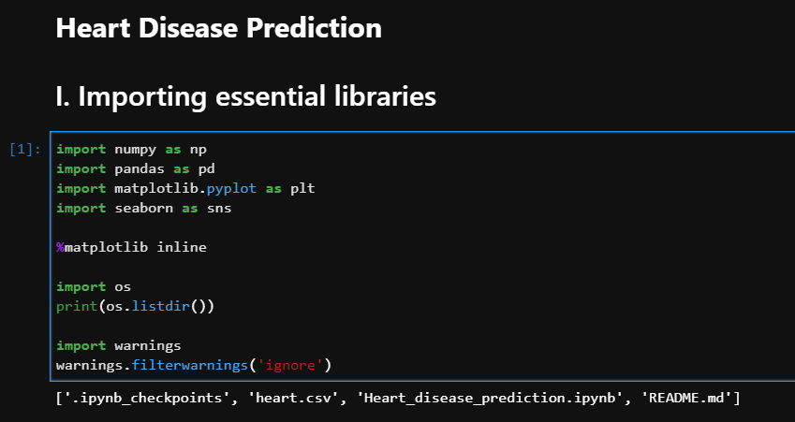

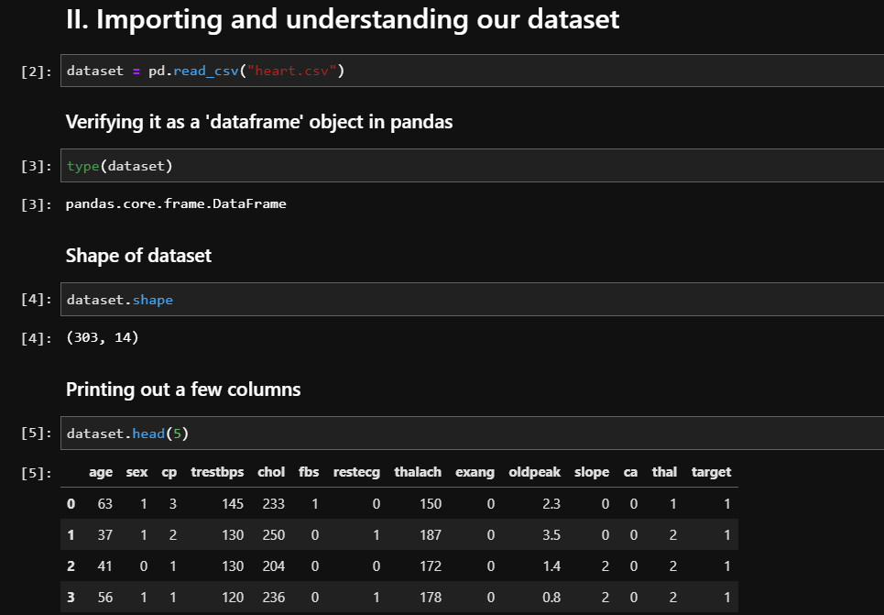

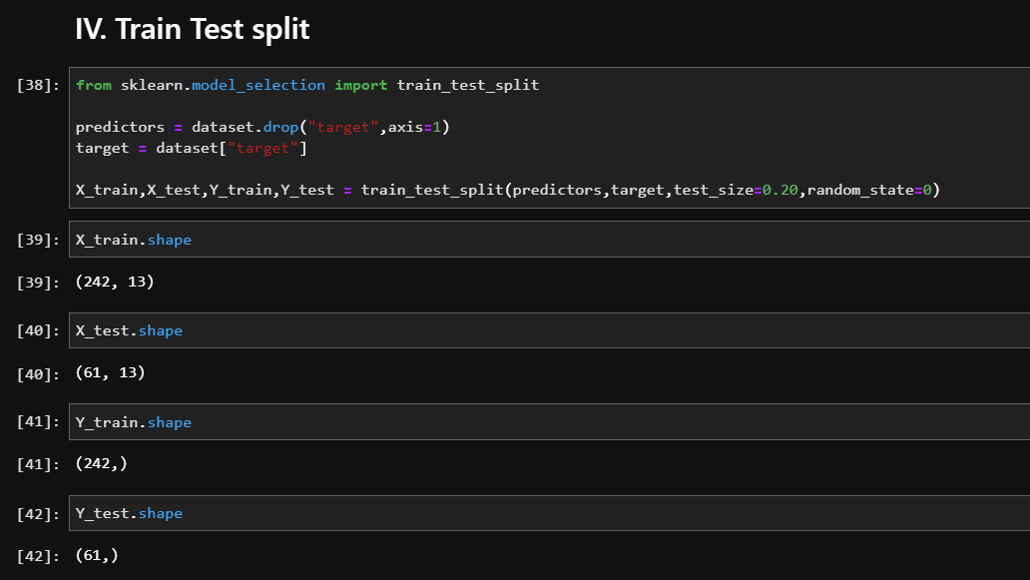

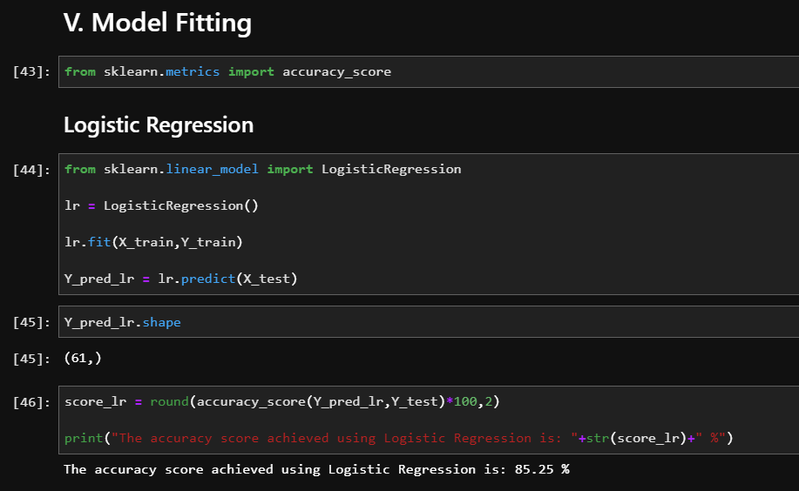
CHAPTER 4
CONCLUSION
4.1 CONCLUSION
The proposed system is GUI-based, user-friendly, scalable, reliable and an expandable system. The proposed working model can also help in reducing treatment costs by providing Initial diagnostics in time. The model can also serve the purpose of training tool for medical students and will be a soft diagnostic tool available for physician and cardiologist. General physicians can utilize this tool for initial diagnosis of cardio-patients. There are many possible improvements that could be explored to improve the scalability and accuracy of this prediction system. As we have developed a generalized system, in future we can use this system for the analysis of different data sets. The performance of the health’s diagnosis can be improved significantly by handling numerous class labels in the prediction process, and it can be another positive direction of research. In DM warehouse, generally, the dimensionality of the heart database is high, so identification and selection of significant attributes for better diagnosis of heart disease are very challenging tasks for future research.

REFERENCE
- A, A. S., & Naik, C. (2016). Different Data Mining Approaches for Predicting Heart Disease, 277– 281. https://doi.org/10.15680/IJIRSET.2016.0505545
- Kirmani, M. (2017). Cardiovascular Disease Prediction using Data Mining Techniques. Oriental Journal of Computer Science and Technology, 10(2), 520–528. https://doi.org/10.13005/ojcst/10.02.38
- Brownlee, J. (2016). Naive Bayes for Machine Learning. Retrieved March 4, 2019, from https://machinelearningmastery.com/naive-bayes-for-machine-learning/

