IoT Hardware Connect Bench
Interactive Breadboarding, Simulation, and Live Hardware Prototype Workbench
Architecture and Implementation Requirements
25 September 2026
Version | 1.0 - Proposed Architecture and Requirements
Status | Developer Implementation Proposal; no production code included
Prepared for | IoT Hardware Connect Bench
Scope | Discovery-to-prototype projection, component catalog, simulation, live hardware binding, persistence, and AI-ready APIs

Contents
Executive Summary | 17. Inspector and Component Controls
1. Document Purpose and Design Authority | 18. API and Event Architecture
2. Product Definition | 19. AI-Ready Design Requirements
3. Current Prototype Assessment | 20. Suggested Frontend Structure
4. Governing Design Principles | 21. Suggested Backend Structure
5. Two-Stage Architecture | 22. Implementation Plan
6. Recommended Adoption of SolderHub | 23. Quality and Test Strategy
7. Component Asset and Catalog Strategy | 24. Required Acceptance Scenarios
8. Canonical Component Model | 25. Definition of Done
9. Persistence, Database, and GraphQL | 26. Final Architectural Recommendation
10. Workbench User Experience | Appendix A — Requirement Traceability Matrix
11. Component Library Requirements | Appendix B — Terminology
12. Custom Component Builder | References
13. Handling Unresolved Attachments | Appendix C — SolderHub Porting Map
14. Electrical and Connection Semantics | Appendix D — Architecture Options and Decisions
15. Simulation Architecture | Appendix E — Developer Delivery Checklist
16. Live Physical Hardware Binding
This contents page lists the principal sections. Subsections are available through Word’s Navigation pane and heading hierarchy.

Executive Summary
I am building a browser-based microcontroller breadboarding and rapid-prototyping workbench that begins with real hardware rather than an empty CAD page. The existing application already discovers hardware connected through USB, serial/COM, Bluetooth, Wi-Fi, network interfaces, mounted storage, and device-specific adapters. The next stage must take the resulting hardware map and project it into a simple interactive grid where the user can see the detected controller or circuit, connect additional components, configure component properties, validate the design, simulate electrical and logical behavior, and—when a supported live adapter exists—send and receive real signals through the physical device.
This document defines the complete proposed architecture, requirements, implementation sequence, and acceptance criteria for that Prototype Workbench. It is intentionally not an instruction to replace KiCad, LibrePCB, Fritzing, Wokwi, or a full PCB editor. The product is a hardware-aware breadboarding environment. It should feel like a grid-based electronic construction set: simple enough that a new user can drag a part, connect two visible endpoints, and immediately understand the result, but structured deeply enough that every component, port, property, wire, bus, signal, simulation result, and physical binding can be inspected, persisted, tested, exported, and later operated by an AI agent.
The implementation should reuse the strongest concepts and licensed code from the locally cloned SolderHub Simulator at:
C:\Users\Frontside\Documents\0.AI_LLM\solderhub-simulator
SolderHub is a strong starting point because it separates a component’s definition, pins, metadata, electrical behavior, and SVG renderer; maintains a registry of component types; groups connected pins into nets; and computes component state from pin voltages. Its repository is MIT licensed. However, its current simulator is client-only and primarily digital. Its documentation explicitly identifies the absence of Ohm’s-law current calculation, realistic resistor effects, and current-based LED brightness as open gaps. Therefore, SolderHub should be adapted as a component-and-interaction foundation, not treated as the final simulation engine. [2][3][4]
The implementation should also ingest compatible assets and metadata from Wokwi Elements, Wokwi Boards, and Fritzing breadboard parts. Wokwi Elements supplies browser-native visual components and pin coordinates but deliberately does not supply the simulation behavior. Wokwi Boards supplies board SVGs and JSON pin coordinates. Fritzing parts combine .fzp metadata with breadboard SVGs and connector-to-SVG mappings. These sources can sharply reduce the number of boards and parts that must be drawn manually, subject to a formal asset-license audit. [5][6][7][8]
The system shall preserve the application’s existing discovery logic, evidence states, device adapters, operation approvals, and live telemetry. It must not overwrite that logic with a simulator’s assumptions. The selected real device is the authoritative starting component. If the scanner maps only one ESP32 board, Prototype should initially display only that ESP32 board. It must not insert an unrelated DHT sensor, LED, or demonstration circuit unless the user explicitly chooses a sample project.
The central architectural decision is to maintain two related but distinct graphs:
- Hardware Evidence Graph — what the application has detected, documented, inferred, or received from the user about the physical hardware.
- Prototype Circuit Graph — what has been placed, connected, configured, simulated, or bound to real hardware in the breadboarding environment.
A controlled projection process translates the first graph into the second. This keeps physical truth separate from user-added virtual design while allowing both to appear in one hybrid prototype.
The final product shall provide:
- a searchable reusable component catalog;
- realistic or simplified 2D component views with accurate connection endpoints;
- a generic component builder for unsupported or custom devices;
- an inspector with simple and advanced views;
- parameterized generic components such as batteries, resistors, capacitors, LEDs, switches, connectors, and LED strips;
- voltage, current, power, direction, protocol, frequency, bus, and compatibility validation;
- digital, behavioral, electrical, and firmware-simulation adapters;
- real-time physical-device binding through the application’s existing FastAPI services;
- WebSocket event streaming and WebRTC media where appropriate;
- persistent projects, revisions, audit history, and deterministic change plans;
- structured APIs that later allow AI agents to inspect and modify the prototype without manipulating pixels or the browser DOM.
The developer should use this paper as the governing design proposal. Implementation decisions may vary where testing proves a better option, but the product behavior and acceptance criteria must remain intact.

1. Document Purpose and Design Authority
This paper converts the product owner’s complete design brief into a developer-ready architecture. It covers the intended user experience, the current prototype gaps, the correct reuse of SolderHub, Wokwi, Fritzing, and related tools, the component and port schema, persistence, simulation, physical-device integration, custom component creation, API design, AI readiness, implementation phases, and quality gates.
The design is grounded in four source groups:
- The attached product-owner brief, which defines the desired breadboarding workflow, live physical interaction, configurable components, inspector behavior, custom component creation, mapped-device projection, and future AI access. [1]
- The existing IoT Hardware Connect Bench product vision and prototype notes, which already define a discovery-first workbench and distinguish detected physical evidence from virtual additions. [9]
- The SolderHub Simulator source and documentation, including its component-definition contract, registry, SVG renderer pattern, net engine, reducer-based state, and current digital-only limitations. [2][3][4]
- The official Wokwi, Fritzing, tscircuit, GraphQL, and SQLite sources used to evaluate asset formats, circuit interchange options, API design, and local persistence. [5][6][7][8][10][11][12]

1.1 Local Reference Locations
The developer should treat the following as required reference locations:
- SolderHub local clone: C:\Users\Frontside\Documents\0.AI_LLM\solderhub-simulator
- Design screenshots and research folder: Ideas\Rapid Prototype Tool\Solder Hub Simulator
- Primary application: IoT-Hardware-Connect-Bench
- Current prototype step: the existing Prototype workspace in the React client
- Existing hardware service: the current FastAPI backend, device adapters, operation manager, evidence model, and SQLite store
The SolderHub clone should initially be treated as a read-only reference while its architecture, component registry, renderer files, simulation engine, tests, and licensing are audited. The developer should copy or port only the portions intentionally adopted, preserving license notices and attribution.

2. Product Definition
The product is an interactive microcontroller breadboarding environment. It is not a full PCB-layout tool and it is not a manufacturing footprint editor. It may consume PCB footprints, schematic symbols, and 3D/2D assets as reference data, but the user-facing goal is simpler:
Take a real or virtual controller, expose every usable input, output, connector, bus, service, and capability, connect it to other complete boards and ordinary components, and observe what the assembled prototype should do.
A user should be able to start in either of two ways:
- Discovery-first: Connect physical hardware, inspect and map it, then open the mapped topology in Prototype.
- Canvas-first: Open an empty prototype, choose boards and parts from the catalog, and build a virtual design without physical hardware.
The discovery-first path is the principal differentiator. Traditional CAD applications begin with an empty project. This product should begin with the real hardware that the application has already identified.

2.1 Explicit Non-Goals
The first production version shall not attempt to:
- replace KiCad or LibrePCB for production PCB layout;
- route copper traces or generate complete manufacturing outputs;
- infer every passive component through a USB serial bridge;
- claim that a visual image proves physical population or connectivity;
- simulate every transistor or processor at silicon level;
- force the user to define every internal chip on a commercial development board;
- expose raw shell, arbitrary serial writes, or unrestricted physical-pin control to the UI or future AI agents;
- treat every connection as a simple binary zero or one.
The workbench may export to engineering tools later, but it should remain focused on rapid breadboarding, verification, simulation, live control, and understanding.

3. Current Prototype Assessment
The existing Prototype workspace is a useful structural start. It already contains a parts catalog, a grid, draggable objects, visible connection handles, an inspector area, a selected physical target, and simulation/tool status. Those foundations should be retained wherever practical.
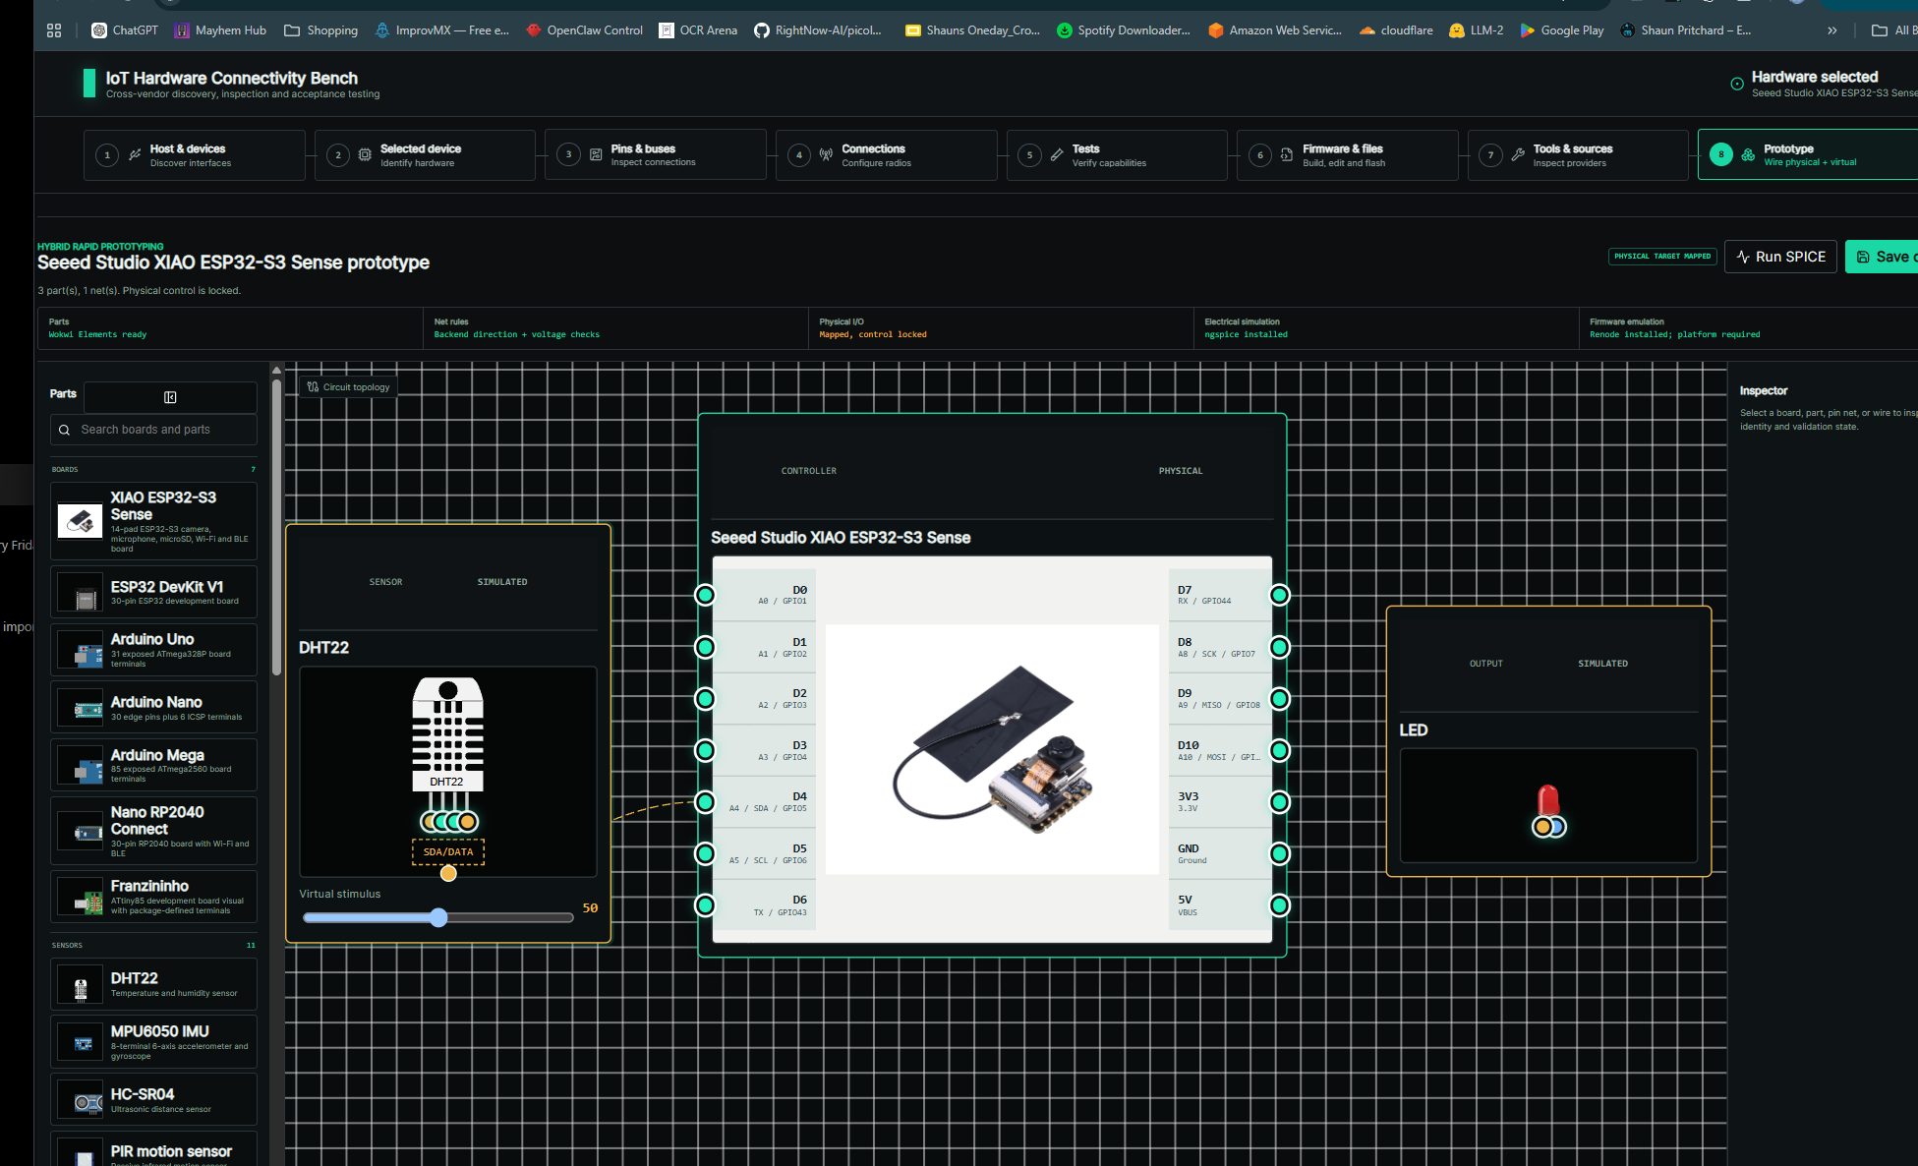
Current IoT Hardware Connect Bench prototype surface. The current structure is useful, but the central objects are oversized information cards rather than concise breadboard components.
The current implementation also exposes several problems that must be corrected:
- The selected controller is rendered as a large generic information card with headers such as CONTROLLER and PHYSICAL. These labels consume space without helping the user connect hardware.
- Example parts such as a DHT22 and LED appear even when they were not physically detected or intentionally added. This conflicts with the discovery-first requirement.
- The board picture is nested inside a large card rather than acting as the board itself.
- Pin handles are visible, but their meaning, alignment, electrical constraints, and relationship to the real hardware are not sufficiently clear.
- Component headers such as SENSOR / SIMULATED and OUTPUT / SIMULATED are visually dominant and confusing. Physical/simulated state should be indicated with a small status badge or icon, not a large title region.
- The Inspector does not expose the complete component schema, property definitions, constraints, live state, evidence, code/behavior, and physical bindings.
- The Run SPICE control assumes the user knows SPICE and does not clearly explain whether the current graph is supported, what will be simulated, or what result was produced.
- Save Circuit does not provide a proper naming and confirmation workflow. The user needs a real Save Prototype dialog with project name, description, optional tags, revision behavior, and success feedback.
- The initial canvas zoom is too close. The default should fit the imported physical topology with comfortable padding.
- Interactive controls embedded inside draggable nodes can conflict with drag behavior. Inputs, sliders, selectors, and buttons must be marked as non-draggable interaction zones.
- The catalog provides names and thumbnails but needs improved filtering, preview, compatibility, variants, source, license, and “create custom component” affordances.
- The current component metadata is too shallow. For example, an LED needs configurable electrical and visual properties, not merely a color label.
These are not reasons to discard the existing work. They are a clear refactoring target.

4. Governing Design Principles

4.1 Reality First
A physical device imported from discovery must remain authoritative. Prototype may decorate or extend it, but must not silently rewrite its identity, pin capabilities, or evidence status.

4.2 One-to-One Addressability
Every component, internal feature, connector, port, pin, property, net, bus, visual endpoint, simulation value, and physical binding must have a stable ID. If an object can be seen or changed, it must be addressable through the internal service layer.

4.3 Simple Surface, Deep Model
The visible canvas should be simple: recognizable parts, clear endpoints, clean wires, straightforward controls. Complexity belongs in the underlying schema and the Inspector.

4.4 Definition Separate From Instance
A reusable component definition is not the same as a component placed in a project. The catalog should store the definition once; each project instance stores position, chosen variant, property values, live bindings, and state.

4.5 Visual Separate From Behavior
An SVG, picture, or generated rectangle describes appearance. A behavior model describes state transitions. An electrical model describes voltage/current behavior. A physical adapter describes live hardware. One component may have any subset of these without blocking the rest.

4.6 Evidence Before Assumption
Detected, verified, expected, inferred, and user-declared information must remain distinct. A user can declare an unresolved load to be an LED and resistor, but the system must not label that declaration as physically verified.

4.7 Deterministic Engineering Before AI
AI may later explain, propose, and orchestrate changes. Electrical compatibility, voltage limits, current limits, bus constraints, and physical safety must be enforced by deterministic rules and simulation engines.

4.8 Modular Reuse
SolderHub, Wokwi, Fritzing, tscircuit, CircuitJS, ngspice, Renode, and the existing application should communicate through adapters and canonical schemas. No external format should become the entire product’s internal truth.

5. Two-Stage Architecture
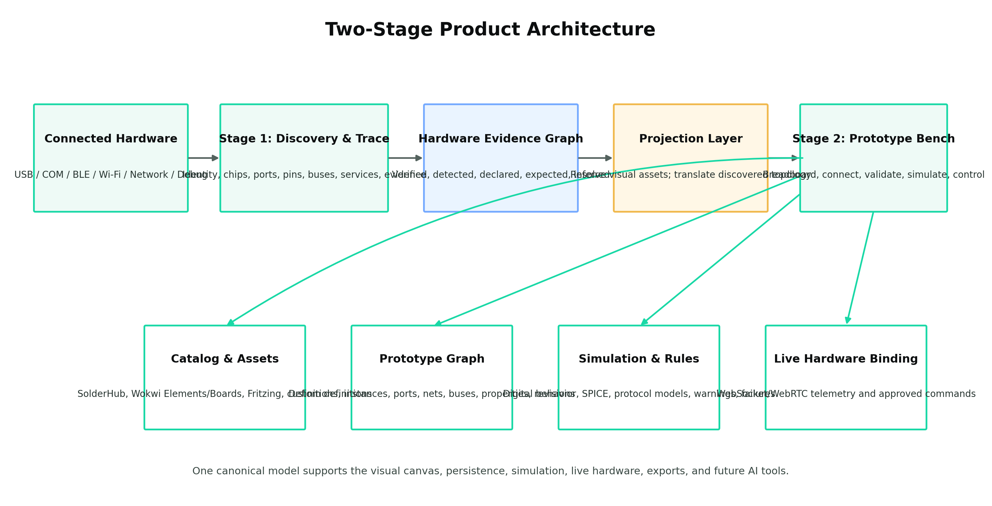
The discovery and prototype systems are separate, but share a controlled projection and common IDs.

5.1 Stage One: Hardware Discovery and Trace
Stage One produces the Hardware Evidence Graph. It answers:
- What host-visible interface is connected?
- What bridge, processor, module, carrier board, runtime, operating system, or firmware is present?
- What ports, connectors, pins, buses, onboard components, services, and files exist?
- Which attachments were verified through a runtime or protocol?
- Which attachments were expected from documentation?
- Which signals and devices remain unresolved?
- Which live operations are available through the present connection?
- Which facts came from USB descriptors, ROM probes, debug access, DeviceTree, SDK metadata, bus scans, visual evidence, or user declarations?
The Stage One graph must contain provenance and confidence. It should not flatten all claims into one undifferentiated board record.

5.2 Stage Two: Prototype Projection and Interaction
Stage Two creates the Prototype Circuit Graph. It translates the detected physical topology into placed components, ports, nets, buses, bindings, and visual representations.
The projection process shall:
- Create one Prototype instance for each selected physical board or device.
- Resolve the best available visual representation.
- Map canonical hardware pins to visual connection coordinates.
- Recreate verified or declared physical connections.
- Create unresolved placeholders where a connection exists but the attached component cannot be identified.
- Mark physical components as live, disconnected, or unavailable without replacing them.
- Leave the canvas empty of unrelated demonstration parts.
- Preserve links back to Stage One evidence.

5.3 Physical, Virtual, and Hybrid State
Each Prototype instance must declare one of these modes:
- Physical: state comes from a real connected device.
- Virtual: state comes from a behavioral, electrical, or firmware simulator.
- Hybrid: some capabilities are physical and others simulated.
- Declared: the user has specified the component but it has not been verified.
- Disconnected: the component was physically bound but the device is currently unavailable.
These states should appear as subtle status indicators, not giant headers.

6. Recommended Adoption of SolderHub
SolderHub is the best immediate starting point for the breadboarding interaction model. Its README describes a browser-based Arduino/ESP32 simulator with drag-and-drop parts, pin wiring, live simulation, real SVG artwork, a registry, and a net-based engine. It is fully client-side and MIT licensed. [2]
Its component contract already separates:
- a reusable ComponentDefinition;
- a placed component instance;
- pin templates and instantiated pins;
- component metadata;
- internal electrical connections;
- a simulate() function;
- an SVG renderer;
- wires and viewport state. [3]
Its registry currently includes a practical seed catalog: Arduino Uno, ESP32 DevKit, breadboard, LED, resistor, push button, buzzer, relay, potentiometer, DHT11, LCD1602, battery, slide switch, speaker, HC-SR04, servo, tilt switch, RGB LED, and IR receiver. [4]

6.1 SolderHub Elements to Reuse or Port
The developer should audit and selectively port the following:
- Component Definition + Renderer Pairing
Retain the pattern in which each component type has one definition file and one SVG renderer. Extend the definition rather than abandoning it.
- Registry Pattern
Retain dynamic registration, but replace the hard-coded array with a catalog loader that can register built-in, imported, local, and project-specific definitions.
- Pin Hit Areas and Wire Interaction
Reuse the concepts behind visible connection points, pointer handling, wire drafts, rewiring, and SVG-based rendering.
- Reducer/Action Semantics
Reuse the explicit operations for adding, removing, moving, rotating, selecting, updating metadata, adding wires, rewiring, changing viewport, running, and loading state. Move the canonical mutations into a service layer so the UI, API, and future agent all use the same actions.
- Net Resolution
Retain the union-find concept for grouping connected pins into nets. Extend it to distinguish electrical nets, buses, data links, media streams, and virtual control bindings.
- Internal Connections
Retain per-component internal connection rules for breadboard rows, closed switches, relay contacts, and similar behavior.
- Test Pattern
Retain unit tests for component definitions, simulation behavior, state reducers, and connection rules. Add schema and hardware-binding tests.
- SVG-First Rendering
Preserve the principle that parts are rendered as actual SVG artwork rather than generic icons.

6.2 SolderHub Elements to Replace or Extend
The following are insufficient for the target product:
- The existing pin types are limited to digital, analog, power, ground, and passive. The target system needs richer electrical, protocol, connector, storage, network, media, and virtual domains. [3]
- The existing state is client-only. The target system needs persistence, revisions, multi-source events, audit history, and physical-device bindings.
- The existing registry is hard-coded. The target system needs importers and versioned catalog packages.
- The existing engine is digital-only. SolderHub itself documents that resistor values, current, direct-short detection, PWM, and realistic LED brightness remain gaps. [2][4]
- The existing simulation code uses simplified voltage conflict behavior. It is acceptable as a quick logical prototype, but not as the source of truth for destructive or high-current designs.
- The existing board logic is target-specific. The target application must use the discovered board’s capability map, not special-case only Arduino or ESP32.
- The existing UI does not distinguish evidence, physical binding, live connection quality, or verified versus declared data.
- The existing project has no backend, database, authentication, or live-hardware service. The target product already has those foundations and must integrate them.

6.3 Licensing Requirement
Before copying files, assets, or code, complete a license inventory:
- SolderHub Simulator: MIT. [2]
- Wokwi Elements: MIT. [5]
- Wokwi Boards: verify repository and per-asset permission before bulk redistribution; do not assume all board artwork is licensed identically merely because it is publicly visible.
- Fritzing core graphics/documentation: Creative Commons Attribution-ShareAlike 3.0 according to its repository license notice. This may require attribution and share-alike handling for redistributed graphics. [8]
- Manufacturer libraries: evaluate each repository or asset separately.
Every imported asset record must store source URL, source project, license, author/attribution, version/commit, and redistribution status.

7. Component Asset and Catalog Strategy
The component catalog must combine built-in generic components, imported visual assets, board definitions, manufacturer libraries, and user-defined components.

7.1 Resolver Priority
For each detected or searched part, the resolver should use this order:
- Existing normalized local catalog.
- Exact manufacturer-supplied representation and metadata.
- SolderHub built-in definition.
- Wokwi Board definition.
- Wokwi Element.
- Fritzing breadboard part.
- Other approved component/EDA sources.
- User-provided SVG or image.
- Automatically generated generic rectangle/circle/connector representation.
A missing visual must never block the component from being usable.

7.2 Wokwi Elements
Wokwi Elements supplies browser Web Components for electronics, but its own documentation states that it provides presentation only and leaves functional simulation to the consuming application. This is desirable: the workbench can reuse the visual and pin information while applying its own behavior, physical bindings, and simulation. [5]
Many Wokwi elements expose pinInfo containing at least pin names and X/Y coordinates, and some include signal metadata. The importer should convert those into canonical Port Definitions. [6]

7.3 Wokwi Boards
Wokwi Boards uses board.svg plus board.json. A board definition includes dimensions and explicit X/Y coordinates for each exposed pin, mapped to MCU pins, power, or ground. The same format supports custom boards and external component connections. [7]
The target system should implement a Wokwi Board importer that:
- parses JSON-with-comments safely;
- loads and sanitizes SVG;
- normalizes pin names and targets;
- records dimensions and coordinates;
- maps power targets into electrical metadata;
- imports onboard LED relationships when present;
- stores the original source and commit;
- preserves unmatched fields for future compatibility.

7.4 Fritzing Breadboard Parts
Fritzing parts provide a second large visual source. Their .fzp records refer to breadboard SVG element IDs and terminal IDs. The importer should extract:
- part identity and aliases;
- breadboard SVG;
- connectors and connector types;
- terminal points;
- internal buses where available;
- tags and family information;
- source/license metadata.
Fritzing artwork should not be silently republished without satisfying its license requirements.

7.5 Catalog Packages
The catalog should support packages rather than one monolithic source folder. A package should contain:
- manifest.json
- one or more component-definition JSON files;
- SVG/image assets;
- optional behavior modules;
- optional simulation model files;
- optional documentation;
- license and attribution files;
- tests/fixtures.
Packages may be:
- built-in;
- manufacturer-specific;
- imported from Wokwi/Fritzing;
- local user libraries;
- organization libraries;
- project-local definitions.

8. Canonical Component Model
The data model must not be one uncontrolled giant JSON object repeated for every placed part. It should be modular and normalized, while still allowing a complete project to be exported as one portable JSON document.
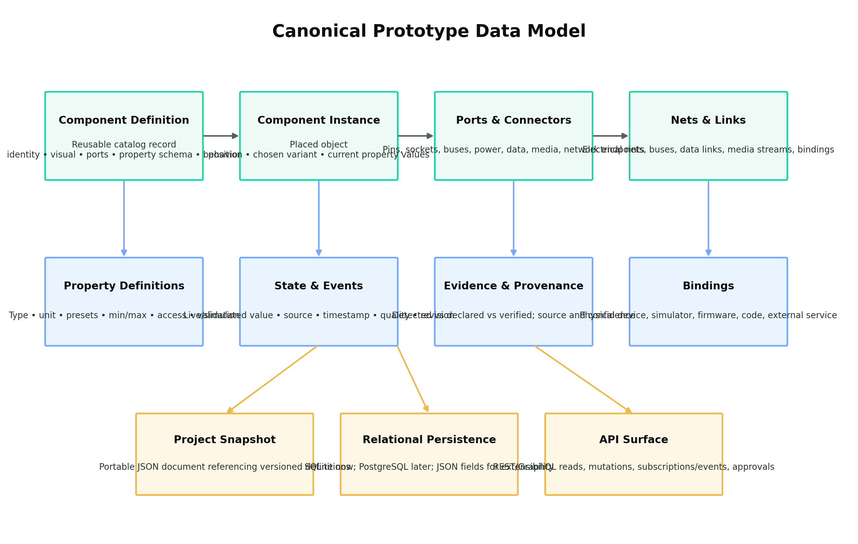
The catalog definition, project instance, ports, properties, state, evidence, nets, and bindings are related but separate.

8.1 Definition Versus Instance
A Component Definition describes a reusable type, such as “generic LED,” “Seeed XIAO ESP32-S3 Sense,” or “USB-C connector.”
A Component Instance is one placed occurrence in a project. It references a definition and stores:
- project-specific name;
- X/Y position, rotation, scale, and layer;
- selected variant;
- current property values;
- connections;
- physical binding;
- simulation state;
- evidence links;
- user notes.
This prevents duplicating the full ESP32 board definition every time it is placed.

8.2 Recommended Component Definition Structure
{
"schemaVersion": "1.0.0",
"id": "builtin:led:generic",
"version": "1.0.0",
"identity": {
"name": "Generic LED",
"category": "indicator",
"manufacturer": null,
"model": null,
"aliases": ["LED", "light-emitting diode"]
},
"visuals": [
{
"id": "default",
"kind": "svg",
"asset": "led.svg",
"width": 40,
"height": 70
}
],
"ports": [
{
"id": "anode",
"label": "A",
"domain": "electrical",
"role": "passive",
"direction": "bidirectional",
"position": {"x": 13, "y": 68},
"electrical": {
"maxForwardCurrentA": 0.02,
"maxReverseVoltageV": 5
}
},
{
"id": "cathode",
"label": "C",
"domain": "electrical",
"role": "passive",
"direction": "bidirectional",
"position": {"x": 27, "y": 60}
}
],
"properties": {
"color": {
"type": "enum",
"default": "red",
"options": ["red", "green", "blue", "white", "amber", "uv", "ir"]
},
"forwardVoltageV": {
"type": "number",
"unit": "V",
"default": 2.0,
"minimum": 0.5,
"maximum": 6
},
"ratedCurrentA": {
"type": "number",
"unit": "A",
"default": 0.02
}
},
"behaviorModels": ["builtin:led-behavior"],
"simulationModels": ["builtin:led-electrical"],
"sources": []
}
This schema is illustrative. The developer may change field names, but the responsibilities must remain.

8.3 Port and Connector Model
A port must contain enough information to answer:
- What is it called?
- Where is it visually located?
- Is it one pin, a grouped connector, a socket, a wireless interface, or a logical endpoint?
- Is it electrical, data, network, media, storage, compute, or virtual?
- Does it accept input, output, bidirectional traffic, power input, or power output?
- What voltage, current, impedance, frequency, bandwidth, protocol, lane count, or logic level applies?
- What alternate functions are available?
- Is it reserved, shared, boot-sensitive, internal, or currently occupied?
- What physical pin or service does it bind to?
- What evidence supports the metadata?
Recommended domains include:
- electrical
- digital
- analog
- bus
- power
- ground
- connector
- network
- wireless
- media
- storage
- compute
- virtual-control
Recommended directions include:
- input
- output
- bidirectional
- power-input
- power-output
- passive
- open-drain
- open-collector
- high-impedance
- differential-pair
A simple binary zero/one is not enough to decide whether two endpoints are compatible. Compatibility depends on direction, drive type, voltage, current, pull state, protocol, and sometimes timing.

8.4 Property Definition and Property Value
Every configurable value needs a typed definition. It should include:
- data type;
- unit;
- default;
- min/max;
- common presets;
- editable/read-only/computed access;
- validation rules;
- display control type;
- source/provenance;
- whether changes apply only to simulation or can be bound to real hardware.
Every current property value needs:
- current value;
- state source: user, simulation, hardware, firmware, imported;
- timestamp;
- quality/status;
- revision;
- validation result.

8.5 Nets, Buses, Data Links, and Bindings
Not every visible line means the same thing. The graph must distinguish:
- Electrical net: terminals sharing electrical potential.
- Bus: related signals and devices participating in a protocol such as I²C, SPI, CAN, or UART.
- Connector link: a cable or plug relationship such as USB-C, HDMI, M.2, CSI, or Ethernet.
- Data link: a logical stream or service such as BLE GATT, Wi-Fi, HTTP, MQTT, video frames, or AI inference messages.
- Control binding: a UI slider, switch, scenario, or automation controlling a simulation or physical operation.
- Physical binding: a prototype port mapped to a discovered real-device endpoint.
- Simulation binding: a component instance mapped to a behavior or electrical model.
The UI may render several of these as lines, but the schema must preserve their meaning.

9. Persistence, Database, and GraphQL

9.1 GraphQL Is Not a Database
GraphQL is an API query language and server runtime; it is not a storage engine. It can expose a typed graph over SQLite, PostgreSQL, files, services, and the existing FastAPI code. The official GraphQL documentation explicitly states that GraphQL is storage-agnostic and not tied to a specific database. [11]
Therefore, “use GraphQL instead of SQLite” is not a valid database choice. The actual decisions are:
- Which database stores the catalog, projects, revisions, events, and bindings?
- Which service/API style exposes them to the React UI, local tools, and future agents?

9.2 Recommended Persistence Decision

Local-First Release
Use SQLite with:
- normalized relational tables for identity, relationships, and revisions;
- JSON/JSONB columns or text JSON for extensible component metadata;
- WAL mode;
- foreign keys;
- transactions;
- append-only event/audit records;
- periodic project snapshots.
SQLite already supports built-in JSON functions and recursive JSON traversal. [12] It is appropriate for a local single-user bench and aligns with the application’s existing state store.

Hosted or Team Release
Move the same schema to PostgreSQL, optionally through Supabase, when the product needs:
- multiple users;
- collaboration;
- remote synchronization;
- row-level security;
- larger catalog indexing;
- cloud jobs;
- hosted device history.
PostgreSQL JSONB can hold extensible metadata while normalized tables preserve indexes and referential integrity.

Graph Database
Do not introduce Neo4j or another graph database in the first implementation. A prototype contains graph-shaped data, but ordinary relational node/edge tables and recursive queries are sufficient at this scale. Evaluate a graph database only if real profiling demonstrates that cross-project path queries or catalog-scale relationship traversal have become a bottleneck.

9.3 GraphQL Recommendation
Do not make GraphQL a prerequisite for the first refactor.
The recommended sequence is:
- Build a clean domain-service layer.
- Keep the current FastAPI REST endpoints for explicit commands and operation planning.
- Use WebSockets or server-sent events for live state.
- Add GraphQL as an optional read/query layer when the canonical schema has stabilized.
- Consider GraphQL subscriptions only if they simplify—not duplicate—the existing event infrastructure.
GraphQL could be valuable for:
- the Inspector requesting only relevant fields;
- catalog exploration;
- component relationships;
- future AI introspection;
- subscriptions to selected project/component state.
GraphQL should not bypass service validation, approvals, or physical-operation safety.

9.4 Recommended Core Tables
The local schema should include, at minimum:
- component_definitions
- component_definition_versions
- component_assets
- component_sources
- component_ports
- component_property_definitions
- prototype_projects
- prototype_revisions
- prototype_component_instances
- prototype_property_values
- prototype_nets
- prototype_net_members
- prototype_buses
- prototype_links
- prototype_bindings
- prototype_unknown_attachments
- prototype_events
- prototype_validation_results
- prototype_simulation_runs
- prototype_measurements
- prototype_scenarios
- catalog_packages
- license_attributions
A project export may serialize these records into one versioned JSON package.

10. Workbench User Experience
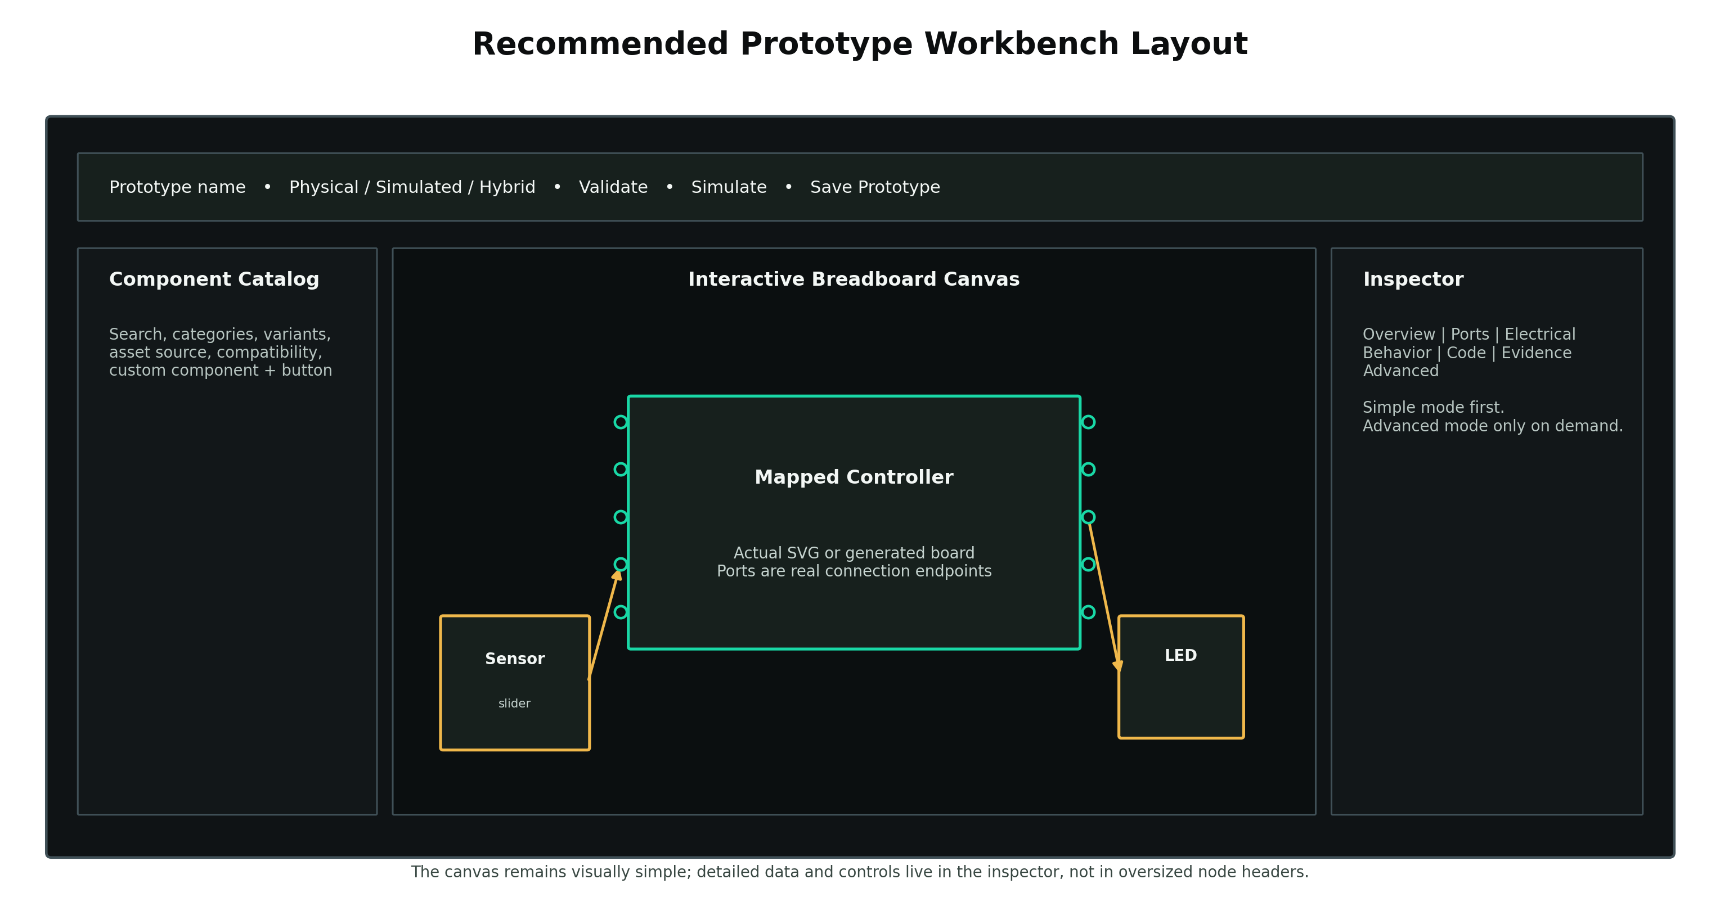
Recommended workbench layout. The detailed schema belongs in the Inspector, not in oversized canvas headers.

10.1 Primary Layout
The Prototype step should have four stable regions:
- Top command bar
- Left component catalog
- Center breadboard canvas
- Right Inspector
- Optional bottom instrumentation panel

Top Command Bar
The top bar should include:
- Prototype name
- connection state
- Physical / Virtual / Hybrid mode
- Validate
- Run Simulation
- Pause/Reset
- Save Prototype
- Undo/Redo
- View selector: Physical / Logical / Dataflow
- optional advanced tools menu
Replace Run SPICE with language that a normal user understands:
- Validate
- Quick Simulation
- Advanced Electrical Analysis
SPICE can remain the engine name in the advanced details.

Component Catalog
The catalog should support:
- search;
- categories;
- manufacturer/model filtering;
- compatible-with-selected-device filtering;
- visual preview;
- pin count;
- protocol badges;
- voltage range;
- asset source and license;
- local/imported/built-in status;
- variants;
- “Create custom component”;
- “Import component package.”

Canvas
The canvas should:
- start zoomed to fit the mapped topology with padding;
- use a smaller, less visually dominant grid;
- support snap, pan, zoom, selection, move, rotate, copy, duplicate, delete, and grouping;
- make pins/connectors obvious on hover;
- highlight compatible targets during wiring;
- show invalid or risky connections before committing;
- keep UI controls such as sliders and buttons non-draggable;
- support wire rerouting and clean line styles;
- show physical, virtual, and disconnected status subtly;
- avoid large generic headers inside components.

Inspector
The Inspector should use tabs and progressive disclosure:
- Overview
- Ports & Connections
- Electrical
- Properties
- Behavior & Controls
- Runtime / Live State
- Code / Script
- Evidence & Sources
- Advanced
Basic mode shows only the common fields required to configure the component. Advanced mode reveals full metadata, source records, alternate functions, raw JSON, simulation providers, physical bindings, and internal components.

10.2 Two Component Views
Each board or complex component should support:

Interactive Visual View
This is the default canvas representation. It should be concise:
- actual or generated image/SVG;
- connection points;
- optional small labels;
- live highlights;
- minimal status icon;
- small menu/info control.

Logical Information View
This is a structured representation showing:
- identity;
- processor(s);
- memory;
- storage;
- radios;
- sensors;
- connectors;
- ports;
- buses;
- power domains;
- firmware/runtime;
- live status;
- evidence.
The recommended implementation is not to literally “flip” the physical object if that would move connection points. Instead, keep the canvas representation stable and open the logical view in the Inspector or an expandable overlay. A global Physical / Logical canvas mode may provide a second renderer using the same canonical port IDs.

10.3 Physical/Simulated Indicators
Remove dominant labels such as CONTROLLER / PHYSICAL or OUTPUT / SIMULATED.
Use small consistent badges:
- green plug: physical and connected;
- amber cube: simulated;
- split icon: hybrid;
- gray broken link: disconnected;
- blue person/check: user-declared;
- question mark: unresolved.

10.4 Save Prototype Workflow
Save Prototype must open a modal with:
- required project name;
- optional description;
- tags;
- selected physical target(s);
- save as new or update current;
- current revision;
- include current live measurements yes/no;
- validation status;
- save confirmation and error message.
The system should autosave safe layout/property changes while still allowing explicit named revisions.

11. Component Library Requirements
The catalog must distinguish parameterized generic components from specific boards/modules.
A parameterized generic component avoids creating thousands of almost identical catalog entries. The user places one generic battery or resistor, then chooses its real properties.

11.1 Generic Passive and Protection Components
Component | Required configurable properties
Resistor | resistance, tolerance, power rating, package/display style, temperature coefficient
Capacitor | capacitance, type, polarity, voltage rating, tolerance, ESR, leakage
Inductor | inductance, current rating, DC resistance, tolerance, saturation current
Potentiometer | total resistance, taper, position, number of gangs, end-stop behavior
Thermistor | NTC/PTC, nominal resistance, beta/coefficient, temperature
Photoresistor | resistance curve, illumination input, response time
Fuse/PTC | current rating, trip behavior, voltage rating, reset behavior
Crystal/Oscillator | frequency, tolerance, load capacitance, voltage, enable
Transformer | turns ratio, winding count, isolation, current/power rating
Ferrite bead | impedance/frequency point, current rating, DC resistance

11.2 Generic Semiconductor Components
Component | Required configurable properties
Diode | type, forward voltage curve, current rating, reverse voltage
Zener diode | breakdown voltage, current/power rating
LED | color/wavelength, forward voltage, rated current, max current, package, brightness
RGB/RGBW LED | common anode/cathode, channel forward voltages/currents
LED strip/matrix | protocol, pixel count, arrangement, voltage, max current per pixel, brightness, color order
BJT transistor | NPN/PNP, gain, voltage/current ratings, package
MOSFET | N/P channel, gate threshold, RDS(on), voltage/current rating, logic-level status
Optocoupler | input LED properties, output type, CTR, isolation rating
Op-amp/comparator | channels, supply range, input/output limits, bandwidth, offset
Voltage regulator | topology, input/output range, setpoint, max current, dropout, efficiency
Level shifter | channel count, low/high voltage domains, direction behavior
Motor/LED driver | channels, supply ranges, current limits, control interface

11.3 Power Components
The generic battery object should not have “baud rate,” because baud rate describes communication timing, not stored energy. Battery properties should include:
- chemistry;
- cell form;
- cell count;
- series/parallel arrangement;
- nominal/min/max voltage;
- capacity in mAh or Wh;
- maximum continuous and pulse current;
- internal resistance;
- state of charge;
- connector;
- protected/unprotected state.
Other power objects should include:
- bench/DC supply;
- USB power source;
- barrel-jack source;
- solar source;
- charger;
- DC/DC converter;
- LDO;
- power switch/load switch;
- ground/reference;
- current-limited source.
A USB power source must model connector type, role, negotiated profile where applicable, and voltage/current availability. Merely naming the connector USB-C is not enough.

11.4 Switch and Control Components
Use parameterized switch families rather than dozens of unrelated pictures:
- momentary push button;
- toggle;
- slide;
- rotary;
- DIP switch;
- reed/magnetic;
- relay contact;
- virtual on/off control;
- slider/dimmer;
- dial/knob;
- timer/pulse;
- threshold trigger;
- BLE control;
- Wi-Fi/network control;
- infrared control;
- GPIO event;
- automation/scenario trigger.
Communication controls are logical control sources. They may connect to a service or firmware endpoint rather than directly behaving like a copper wire.

11.5 Sensors
Sensors often require distinct definitions because their pins, protocols, units, ranges, and behavior vary. Initial categories should include:
- light/ambient/UV/color;
- temperature;
- humidity;
- pressure;
- gas/air quality;
- sound/microphone;
- proximity;
- ultrasonic distance;
- LiDAR/time-of-flight;
- PIR/motion;
- IMU/accelerometer/gyroscope/magnetometer;
- touch/capacitive;
- force/weight/strain;
- current/voltage/power;
- Hall/magnetic;
- GPS/GNSS;
- camera/image;
- biometric;
- environmental multi-sensor.
Each simulated sensor should expose a control appropriate to its domain: lux, temperature, distance, orientation, motion state, image/video source, etc.

11.6 Actuators and Outputs
Include:
- single LED;
- RGB LED;
- LED strip and matrix;
- seven-segment display;
- LCD;
- OLED;
- e-paper;
- buzzer;
- speaker;
- haptic motor/driver;
- DC motor;
- servo;
- stepper motor;
- relay;
- solenoid;
- heater;
- fan;
- pump.

11.7 Connectors, Slots, and Cables
Create reusable connector definitions for:
- pin headers and sockets;
- screw terminals;
- JST families;
- Grove/Qwiic/STEMMA;
- USB-A/B/C, mini USB, micro USB;
- HDMI, mini HDMI, micro HDMI;
- Ethernet;
- audio jacks;
- barrel connectors;
- SD and microSD;
- M.2 keys and sizes;
- PCIe;
- camera/display FFC/FPC;
- MIPI CSI/DSI;
- antenna/U.FL;
- CAN, RS-485, UART headers;
- SWD/JTAG/debug connectors.
Connector definitions must include pin groups and protocol/electrical metadata, not merely a picture.

11.8 Boards, Compute, Storage, and Accelerators
The catalog should support complete objects for:
- Arduino families;
- ESP families;
- Raspberry Pi and compute modules;
- STM32/Nucleo/Discovery;
- Nordic boards;
- RP2040/RP2350 boards;
- Seeed XIAO and Grove;
- Lichee/Sipeed/RISC-V boards;
- Jetson boards/modules;
- Hailo/Coral/Kneron accelerators;
- M.2 AI/storage/network modules;
- cameras and camera modules;
- FPGA boards;
- custom controller boards.
The board definition should expose all external connection surfaces and internal capabilities relevant to prototyping without requiring the user to model every internal resistor on the commercial board.

11.9 AI and Software Functional Blocks
Computer-vision, NLP, ASR, LLM, OCR, and sensor-fusion blocks are not ordinary electrical passives. Model them as dataflow components with:
- input type;
- output type;
- model family;
- runtime target;
- expected latency;
- throughput/frame rate;
- resource requirements;
- confidence/output schema;
- live endpoint or simulated response;
- optional camera/audio binding.
These blocks allow system-level prototyping without claiming to electrically simulate an AI model.

12. Custom Component Builder
The product must be unrestricted enough to represent hardware not present in any library.
The Create Component workflow should be a guided wizard:
- Identity
  - name, category, manufacturer, model, aliases, revision.
- Starting Template
  - board, module, passive, sensor, actuator, connector, power source, compute block, dataflow block, or blank.
- Visual
  - generic rectangle/circle/strip;
  - upload PNG/JPEG;
  - upload SVG;
  - choose existing Wokwi/Fritzing asset;
  - set dimensions and background.
- Ports and Connectors
  - add individual pins;
  - add a pin bank/header;
  - choose connector type;
  - place ports visually;
  - specify physical order;
  - group ports.
- Port Metadata
  - names and aliases;
  - domain;
  - role/direction;
  - voltage/current/frequency;
  - protocol;
  - alternate functions;
  - internal/reserved status.
- Internal Capabilities
  - processors;
  - memory;
  - storage;
  - radios;
  - sensors;
  - cameras;
  - connectors;
  - services;
  - buttons/LEDs.
- Properties and Variants
  - typed fields;
  - presets;
  - validation;
  - simple versus advanced visibility.
- Behavior
  - static/passive;
  - digital state;
  - sensor stimulus;
  - output effect;
  - protocol model;
  - custom TypeScript/WASM behavior plugin.
- Simulation
  - SolderHub-style logical model;
  - SPICE model;
  - external simulation adapter;
  - unsupported/not yet modeled.
- Live Binding
  - supported adapter operations;
  - firmware/runtime requirements;
  - safe command mapping.
- Preview and Test
  - connection handles;
  - property controls;
  - sample circuit;
  - schema validation.
- Save
  - personal catalog;
  - project only;
  - organization catalog;
  - exportable component package.
For auto-generated unknown boards, the builder should prepopulate the pins and capabilities discovered in Stage One. The user then confirms physical order and fills unresolved parts instead of starting from nothing.

13. Handling Unresolved Attachments
When Stage One knows that a pin or bus has activity but cannot identify the attached part, Prototype should create an unresolved placeholder.
The placeholder should show:
- source pin/bus;
- observed evidence;
- possible candidates;
- confidence;
- what is missing;
- a Define attachment action.
The user should be able to:
- search the component catalog;
- choose a generic component;
- create a custom component;
- declare inline passive components;
- attach a photo/document;
- enter values;
- leave it unresolved.
The resulting record must remain declared unless later verified.

14. Electrical and Connection Semantics

14.1 Compatibility Is More Than Input Versus Output
The system should validate:
- output-to-input compatibility;
- driven-output conflicts;
- open-drain/open-collector requirements;
- voltage domain compatibility;
- maximum and expected current;
- current sourcing/sinking;
- pull-up/pull-down requirements;
- analog range;
- ADC reference;
- PWM/frequency support;
- bus controller/target role;
- bus speed;
- address conflicts;
- chip-select conflicts;
- differential-pair rules;
- connector pinout;
- boot-strap and reserved pins;
- shared onboard resources;
- ground/reference continuity;
- power budget;
- regulator capacity;
- polarity;
- required protection/support components.

14.2 Initial Deterministic Rules
The first rules catalog should detect, at minimum:
- LED without current-limiting resistor;
- 5 V output into 3.3 V-only input;
- output tied to output;
- missing common ground;
- I²C bus missing pull-ups;
- I²C address collision;
- SPI device missing or conflicting chip select;
- UART TX-to-TX or RX-to-RX;
- motor/relay/solenoid directly driven from GPIO;
- missing flyback diode on inductive load;
- GPIO current exceeded;
- board power budget exceeded;
- reversed polarity;
- required decoupling missing where definition specifies it;
- ADC overvoltage;
- boot-strap conflict;
- flash/PSRAM/reserved-pin conflict;
- unsupported alternate function;
- incompatible connector protocol;
- incomplete circuit/open return path;
- simulated component without a model;
- physical control requested without a safe live adapter.
Warnings should explain what is wrong, what evidence supports the rule, and the recommended correction.

15. Simulation Architecture
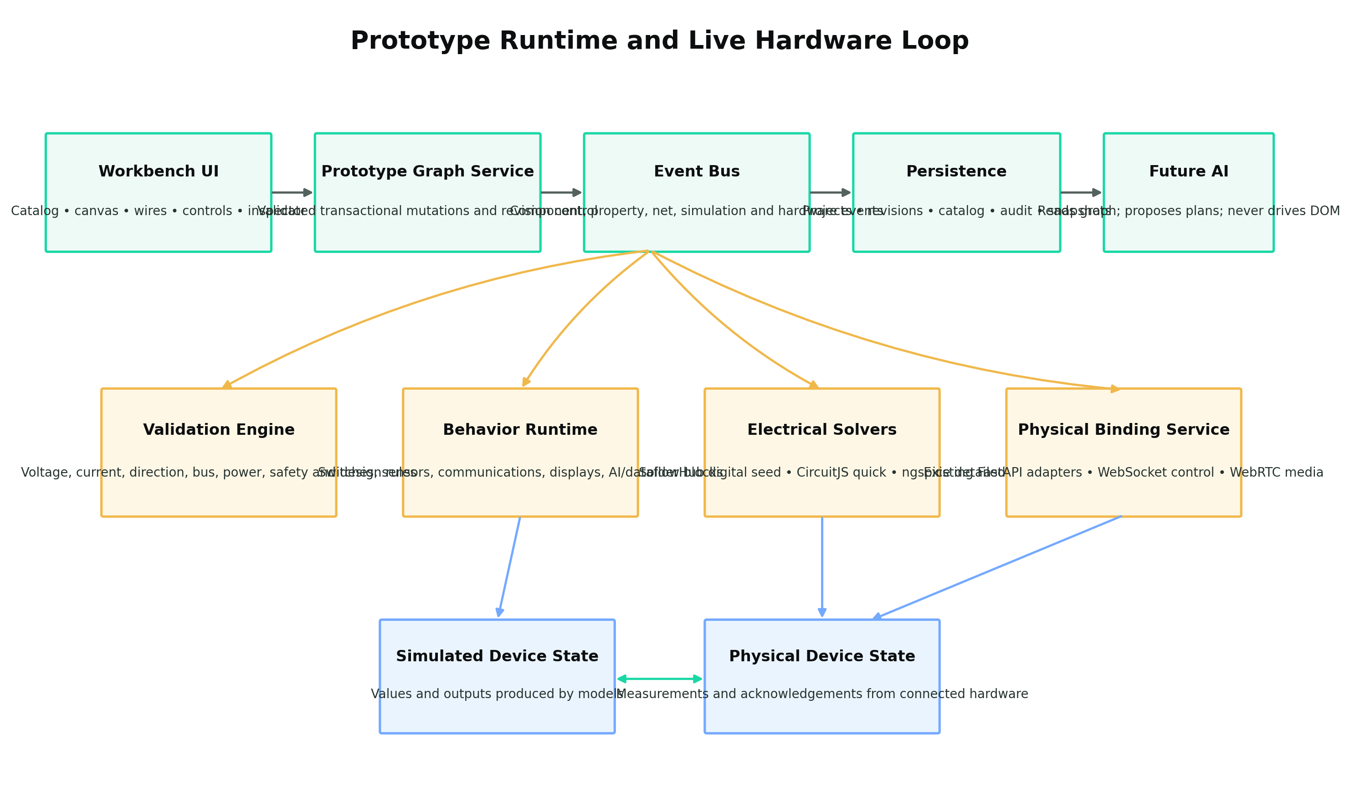
The UI, rules, simulation, persistence, and live hardware all operate on the same graph and event stream.
No single simulator should be forced to handle every domain. Use layered adapters.

15.1 Tier One: Logical and Net Simulation
Port SolderHub’s net grouping and per-component behavior to support immediate interaction:
- high/low/floating;
- basic analog numeric values;
- switch state;
- relay state;
- sensor stimulus;
- output indicators;
- data/control events.
This tier should be fast and available for most components. It is not authoritative electrical analysis.

15.2 Tier Two: Behavioral Components
Behavior models should support:
- light value to sensor register/output;
- temperature/humidity values;
- distance measurements;
- button/switch events;
- PWM/dimmer control;
- BLE/Wi-Fi/IR events;
- display text/frames;
- camera image/video source;
- storage events;
- AI/dataflow mock responses.
Behavior plugins should expose a stable interface such as:
- initialize
- setProperty
- receiveSignal
- readPort
- writePort
- tick
- reset
- injectFault

15.3 Tier Three: Electrical Simulation
Use an electrical solver for supported circuits:
- CircuitJS or another browser engine for quick interactive analysis;
- ngspice for detailed backend analysis;
- manufacturer SPICE models where licensed and available.
The graph-to-netlist compiler must identify unsupported components before running.
The UI should return:
- node voltage;
- branch current;
- power;
- transient waveform;
- duty/frequency;
- warnings;
- convergence/model errors;
- assumptions.
A simulation result must never silently imply that unsupported portions were analyzed.

15.4 Tier Four: Firmware/Processor Emulation
Use Renode, AVR8js, rp2040js, or other target-specific emulators where supported. Firmware emulation should remain optional. A board without an emulator must still be usable in visual and live modes.

15.5 Failure and Fault Injection
Support scenarios including:
- open circuit;
- short circuit;
- stuck high/low;
- intermittent wire;
- noisy analog input;
- undervoltage/overvoltage;
- component tolerance;
- sensor out of range;
- I²C NACK;
- packet loss;
- disconnection;
- overtemperature;
- depleted battery;
- unavailable model/service.

16. Live Physical Hardware Binding
The workbench must connect simulations and UI controls to real hardware only through explicit capability adapters.

16.1 Binding Model
A physical binding should include:
- prototype component/port ID;
- selected physical device ID and stable fingerprint;
- physical pin/bus/service identifier;
- supported operations;
- required runtime/firmware/debug adapter;
- read/write permissions;
- safety constraints;
- current connection state;
- last acknowledgement;
- evidence source.

16.2 Live Interaction Examples
A virtual slider may control:
- PWM duty cycle on a supported GPIO;
- a firmware test variable;
- a simulated sensor value;
- a BLE characteristic;
- a Wi-Fi/API command;
- display brightness;
- LED strip intensity.
A real measurement may update:
- ADC gauge;
- sensor value;
- GPIO state;
- camera stream;
- serial terminal;
- network state;
- logic trace.

16.3 WebSocket and WebRTC
Use WebSockets for:
- property/state events;
- GPIO/ADC/PWM telemetry;
- connection status;
- test progress;
- simulation events;
- logs;
- operation acknowledgements.
Use WebRTC where it is beneficial for:
- camera/video streaming;
- low-latency audio;
- remote media sessions.
Existing MJPEG/HTTP paths may remain as fallback.

16.4 Physical Limitations
A USB or COM connection does not automatically grant arbitrary access to every physical pin. Live control requires at least one of:
- cooperative diagnostic firmware;
- a standard protocol such as Firmata;
- operating-system GPIO/bus access;
- a debug interface;
- a vendor API;
- an approved hardware fixture.
The UI must disable unsupported controls and explain what adapter or firmware is required.

17. Inspector and Component Controls
The Inspector is the primary place for detailed interaction.

17.1 Overview Tab
Show:
- name;
- type;
- selected variant;
- physical/virtual state;
- source;
- confidence;
- basic description;
- current warnings;
- key live values.

17.2 Ports & Connections Tab
Show every active connection surface grouped by:
- power;
- ground/reference;
- GPIO;
- analog;
- buses;
- connectors;
- network/wireless;
- media;
- storage;
- debug;
- virtual controls.
Active connectable entries should use a subtle transparent highlight. Occupied, incompatible, unresolved, and unavailable states should be visibly distinct.

17.3 Electrical Tab
Show:
- voltage/current/power ratings;
- live/simulated values;
- logic level;
- direction;
- impedance where applicable;
- frequency/bandwidth;
- safety margins;
- calculated load/power budget.

17.4 Properties Tab
Generate controls from the typed property schema:
- number fields;
- units;
- sliders;
- switches;
- enums;
- presets;
- color selectors;
- file/media selectors;
- series/parallel configuration;
- validation messages.

17.5 Behavior & Controls Tab
Show:
- virtual inputs;
- triggers;
- switch/dimmer controls;
- sensor stimulus;
- event generation;
- fault injection;
- automation/scenarios.

17.6 Runtime Tab
Show:
- live values;
- simulation values;
- source of truth;
- timestamps;
- connection latency;
- last command and acknowledgement;
- disconnected/stale state.

17.7 Code / Script Tab
Show:
- component behavior code when present;
- associated firmware source;
- protocol adapter;
- generated configuration;
- read-only or editable state;
- build/flash link where appropriate.

17.8 Evidence & Sources Tab
Show:
- detection evidence;
- user declarations;
- imported asset source;
- documentation;
- licensing;
- confidence;
- contradictions.

17.9 Advanced Tab
Show:
- raw normalized JSON;
- definition version;
- instance ID;
- physical binding;
- simulation provider;
- graph edges;
- provenance;
- revision history.

18. API and Event Architecture
The Prototype UI must not own the canonical truth. The backend/domain service should.

18.1 Required Domain Services
- ComponentCatalogService
- ComponentImportService
- PrototypeProjectService
- PrototypeGraphService
- PrototypeValidationService
- PrototypeSimulationService
- PrototypeBindingService
- PrototypeEventService
- ComponentBuilderService
- AssetLicenseService

18.2 Representative API Operations

Catalog
- list/search definitions
- retrieve definition/version
- import package
- create/update custom definition
- preview asset
- inspect license

Project
- create/list/open/save/archive project
- create revision
- restore revision
- export/import project

Graph
- add/remove/move/rotate component;
- set instance property;
- add/remove/reconnect link;
- create/merge/split net;
- assign bus;
- resolve unresolved attachment;
- change view/layout;
- validate transaction.

Simulation
- inspect supported subset;
- run/stop/reset;
- subscribe to results;
- set stimulus;
- inject fault;
- compare scenarios.

Physical Binding
- list eligible live endpoints;
- bind/unbind;
- request read;
- plan write/control;
- execute approved operation;
- subscribe to telemetry;
- report disconnect.

18.3 Asynchronous Event Model
Every meaningful state change should emit an event:
- component added/removed/moved;
- property changed;
- port connected/disconnected;
- net changed;
- validation added/resolved;
- simulation started/updated/failed;
- physical device bound/disconnected;
- hardware input/output changed;
- project saved/revision created;
- unresolved attachment declared;
- plan proposed/applied/rolled back.
Each event should include:
- event ID;
- project ID;
- revision;
- timestamp;
- source: user, system, simulator, hardware, future agent;
- subject ID;
- before/after data;
- correlation ID;
- optional operation/audit reference.

19. AI-Ready Design Requirements
AI implementation is not part of the first breadboarding refactor, but the system must be ready for it.
Every object and editable property must be addressable through a typed API. A future agent should issue:
connect(board_1.GPIO5, sensor_3.SDA)
rather than attempting to drag the mouse between screen coordinates.
Required preparation includes:
- stable global IDs;
- typed schemas;
- read/write/computed access modes;
- graph query operations;
- trace-from-port and trace-net operations;
- optimistic revision checks;
- transactional change plans;
- validation before commit;
- rollback;
- operation audit;
- structured simulation results;
- catalog search;
- component creation APIs;
- layout coordinates separate from electrical connectivity.
The AI must later operate the same services as the human UI. It must not receive a raw browser DOM, unrestricted database access, or raw physical command channel.

20. Suggested Frontend Structure
react-app/src/features/prototype/
├── catalog/
│ ├── ComponentCatalog.tsx
│ ├── ComponentPreview.tsx
│ ├── CatalogFilters.tsx
│ └── CreateComponentButton.tsx
├── canvas/
│ ├── PrototypeCanvas.tsx
│ ├── ComponentNode.tsx
│ ├── PortHandle.tsx
│ ├── WireRenderer.tsx
│ ├── ViewportControls.tsx
│ └── StatusOverlay.tsx
├── inspector/
│ ├── PrototypeInspector.tsx
│ ├── OverviewTab.tsx
│ ├── PortsTab.tsx
│ ├── ElectricalTab.tsx
│ ├── PropertiesTab.tsx
│ ├── BehaviorTab.tsx
│ ├── RuntimeTab.tsx
│ ├── CodeTab.tsx
│ ├── EvidenceTab.tsx
│ └── AdvancedTab.tsx
├── builder/
│ ├── ComponentBuilderDialog.tsx
│ ├── ShapeEditor.tsx
│ ├── ImagePinMapper.tsx
│ └── PropertySchemaEditor.tsx
├── simulation/
│ ├── SimulationControls.tsx
│ ├── ResultsPanel.tsx
│ └── FaultScenarioEditor.tsx
├── save/
│ └── SavePrototypeDialog.tsx
├── api.ts
├── types.ts
└── store.ts
Use shadcn/Radix-style components for dialogs, tabs, sheets, dropdowns, forms, tables, accordions, tooltips, command search, resizable panels, scroll areas, sliders, switches, and alerts.

21. Suggested Backend Structure
ai-api/app/prototype/
├── models/
│ ├── component.py
│ ├── project.py
│ ├── graph.py
│ ├── simulation.py
│ └── binding.py
├── services/
│ ├── catalog_service.py
│ ├── graph_service.py
│ ├── project_service.py
│ ├── validation_service.py
│ ├── simulation_service.py
│ ├── binding_service.py
│ └── event_service.py
├── importers/
│ ├── solderhub.py
│ ├── wokwi_elements.py
│ ├── wokwi_boards.py
│ ├── fritzing.py
│ └── custom_package.py
├── simulation/
│ ├── logical_runtime.py
│ ├── behavior_runtime.py
│ ├── circuitjs_adapter.py
│ ├── ngspice_adapter.py
│ └── renode_adapter.py
├── validation/
│ ├── electrical_rules.py
│ ├── protocol_rules.py
│ ├── power_rules.py
│ └── safety_rules.py
├── bindings/
│ ├── hardware_binding.py
│ ├── websocket_bridge.py
│ └── media_bridge.py
└── api/
├── catalog_routes.py
├── project_routes.py
├── graph_routes.py
├── simulation_routes.py
└── binding_routes.py

22. Implementation Plan

Phase 0 — Preserve, Audit, and Baseline
Objective: Protect current behavior and establish a measurable baseline.
Actions:
- create a dedicated feature branch;
- capture current Prototype screenshots and Playwright snapshots;
- document current API contracts and existing discovered-device projection;
- inventory SolderHub files and dependencies;
- record exact SolderHub commit;
- complete license audit for SolderHub, Wokwi, Fritzing, and imported assets;
- write a gap matrix comparing current Prototype, SolderHub, and target requirements.
Exit criteria:
- no changes to discovery or live-device behavior;
- current tests pass;
- visual baseline exists;
- license decisions are documented.

Phase 1 — Canonical Schema and Service Boundary
Objective: Establish data contracts before visual refactoring.
Actions:
- define versioned Component Definition and Instance schemas;
- define Port, Property, Net, Bus, Link, Binding, Event, Evidence, and Revision schemas;
- implement Pydantic/Zod validation;
- create PrototypeGraphService;
- add SQLite migrations;
- implement project export/import;
- preserve current React Flow state through an adapter.
Exit criteria:
- a project round-trips through JSON and SQLite without information loss;
- stale revisions are rejected;
- all graph mutations are tested and transactional.

Phase 2 — Port SolderHub Component Foundation
Objective: Reuse the strongest SolderHub patterns without importing its limitations.
Actions:
- port definition/renderer pairing;
- port registry pattern;
- port pin hit-area logic;
- port net union-find logic;
- port component tests;
- convert the current SolderHub components into normalized definitions;
- add source/license attribution.
Exit criteria:
- SolderHub seed components load from the new catalog;
- they render with connectable ports;
- their definitions are no longer hard-coded into one registry file;
- existing current-app prototype components remain compatible through an adapter.

Phase 3 — Refactor the Workbench UI
Objective: Replace oversized cards with concise breadboard components.
Actions:
- make the board itself the visual object;
- move detailed metadata to the Inspector;
- remove giant physical/simulated headers;
- add subtle status badges;
- enforce discovered-only initial population;
- fix initial zoom using fit-to-topology;
- add non-drag interaction zones;
- implement proper save modal;
- replace Run SPICE with Validate/Simulate workflows;
- improve catalog preview and filtering;
- add simple/advanced Inspector tabs.
Exit criteria:
- a selected ESP appears alone when no attachments are mapped;
- no dummy sensor/LED is added;
- every visible port is a real endpoint;
- sliders work without dragging the parent node;
- Save Prototype persists and reloads a named project.

Phase 4 — Asset Importers
Objective: Build the component library without manually redrawing everything.
Actions:
- Wokwi Board importer;
- Wokwi Element importer;
- Fritzing .fzp/.fzpz importer;
- SVG sanitization;
- coordinate normalization;
- source/license tracking;
- manufacturer package support;
- import golden fixtures.
Exit criteria:
- at least one board from each source renders with correct port coordinates;
- import failures produce actionable diagnostics;
- no unlicensed asset is silently bundled.

Phase 5 — Generic Components and Custom Builder
Objective: Make the catalog comprehensive and extensible.
Actions:
- implement parameterized generic component families;
- implement LED strip/matrix generator;
- implement battery/source configuration;
- implement switch/control families;
- implement connector families;
- implement custom shape/image/SVG builder;
- implement pin-bank tool;
- implement property-schema editor;
- implement unresolved-attachment workflow.
Exit criteria:
- a user can create a custom controller with ports and metadata without code;
- a user can upload an image and place ports;
- generic properties change both visual and simulation data.

Phase 6 — Validation and Quick Simulation
Objective: Make connections meaningful.
Actions:
- implement deterministic rule engine;
- port SolderHub logical simulation;
- create behavioral component runtime;
- add validation messages and suggestions;
- add scenarios and fault injection;
- add Quick Simulation results panel.
Exit criteria:
- invalid direction and voltage connections are blocked or clearly warned;
- LED-without-resistor rule works;
- switch/sensor/LED demo produces deterministic visual behavior;
- unsupported components are disclosed.

Phase 7 — Electrical Simulation
Objective: Add voltage/current/power fidelity for supported subsets.
Actions:
- graph-to-netlist compiler;
- CircuitJS or equivalent quick adapter;
- ngspice worker/service;
- model library and model provenance;
- waveform/measurement results;
- power budget and damage warnings.
Exit criteria:
- known resistor/LED circuit matches expected calculations;
- battery series/parallel results are correct;
- convergence and unsupported-model errors are actionable;
- simulations never claim unsupported sections were analyzed.

Phase 8 — Live Hardware Binding
Objective: Link the same graph to physical devices.
Actions:
- map discovered device ports to Prototype ports;
- implement physical binding records;
- stream telemetry through WebSocket;
- support camera/media through WebRTC or fallback;
- expose supported controls based on adapter capabilities;
- implement disconnect/reconnect behavior;
- preserve simulation fallback.
Exit criteria:
- a supported physical GPIO/LED example can be controlled from the UI;
- live state is acknowledged and displayed;
- disconnect disables physical actions without destroying the project;
- the same prototype can switch between simulated and physical modes.

Phase 9 — AI Readiness and External Interfaces
Objective: Make the graph safely operable by future agents.
Actions:
- graph query and trace APIs;
- transaction/change-plan API;
- component-search and custom-component APIs;
- mutation permissions;
- event subscriptions;
- raw JSON/GraphQL exploration if justified;
- MCP/agent tool mapping later.
Exit criteria:
- every UI action has a corresponding service operation;
- a headless test can build and validate a prototype without UI automation;
- future AI can inspect and propose changes without DOM access.

23. Quality and Test Strategy

23.1 Unit Tests
Test:
- schema validation;
- definitions and variants;
- property constraints;
- pin compatibility;
- net merging/splitting;
- bus/address logic;
- behavior models;
- electrical rules;
- persistence;
- revision conflicts.

23.2 Importer Golden Tests
Maintain fixed fixtures for:
- SolderHub definitions;
- Wokwi Board JSON/SVG;
- Wokwi Element pinInfo;
- Fritzing .fzp/.fzpz;
- malformed and unlicensed assets;
- custom packages.
A successful importer must produce stable normalized JSON.

23.3 Visual Regression
Use Playwright screenshots for:
- grid/zoom;
- common boards;
- port alignment;
- wire routing;
- selected/hover states;
- Inspector tabs;
- custom builder;
- unresolved placeholders;
- responsive layout.

23.4 Simulation Verification
Compare supported circuits against:
- analytical calculations;
- known SPICE examples;
- expected component states;
- reference hardware measurements where available.

23.5 Hardware-in-the-Loop Tests
Maintain controlled fixtures for:
- digital output + resistor + LED;
- PWM dimming;
- ADC/potentiometer;
- I²C sensor;
- UART loopback;
- BLE characteristic;
- camera stream;
- disconnect/reconnect;
- interrupted command;
- wrong target fingerprint.

23.6 Safety Tests
Verify:
- no unknown pin is driven during discovery;
- unsupported controls are disabled;
- destructive actions require approval;
- physical target changes invalidate plans;
- secrets are not logged;
- device disconnect cancels unsafe actions;
- current/voltage violations are surfaced.

24. Required Acceptance Scenarios
The release is not complete until all of these work.

Scenario A — Mapped Device Only
A Seeed XIAO ESP32-S3 Sense is detected and selected. Prototype opens with only that mapped board. No DHT22, LED, or sample parts appear automatically.

Scenario B — Unknown Attachment
Activity is associated with a pin but the part is unidentified. Prototype shows a question-mark attachment. The user declares a resistor and LED, sets the resistor to 220 Ω, and the graph stores the declaration separately from verified evidence.

Scenario C — Catalog Wiring
The user adds a light sensor, connects power, ground, SDA, and SCL, and receives compatibility guidance and pull-up validation.

Scenario D — Generic Component Configuration
The user adds a generic battery, selects chemistry, cell count, series/parallel arrangement, capacity, and current limit. The calculated pack voltage and energy update.

Scenario E — Custom Board
The user creates a board from a rectangle, adds a processor description, four GPIO pins, I²C, ground, 3.3 V, USB-C, camera connector, BLE, and Wi-Fi capability. The resulting component is reusable.

Scenario F — Live PWM
A real board with a physically connected LED circuit is bound to the prototype. A UI dimmer changes supported PWM on the physical board and updates the virtual LED after acknowledgement.

Scenario G — Hybrid Sensor
A simulated light sensor drives a real controller and real LED through a supported runtime test interface.

Scenario H — Save and Restore
The user names and saves the prototype, closes it, reopens it, and receives identical components, values, connections, viewport, bindings, and revision history.

Scenario I — Detailed Inspector
The user selects a board and can inspect ports, electrical properties, components, storage, radios, camera, runtime, code links, evidence, physical state, and raw normalized JSON.

Scenario J — Electrical Warning
A 5 V output is connected to a 3.3 V-only input. The system prevents or strongly warns about the connection and proposes a level shifter or divider.

25. Definition of Done
The Prototype Workbench is complete when it behaves as a discovery-driven electronic breadboard, not merely a visual node diagram.
A complete result must:
- take mapped physical hardware as its starting truth;
- project mapped components and connections into a 2D workbench;
- use realistic or generated visuals with precise endpoints;
- allow major boards and simple components to be added;
- allow unknown/custom parts to be defined;
- maintain complete typed metadata;
- provide simple and advanced Inspector views;
- validate electrical and protocol compatibility;
- simulate supported behavior and electrical properties;
- bind supported ports to real hardware;
- stream state and media;
- persist named projects and revisions;
- expose all capabilities through reusable services;
- remain ready for future AI and MCP integration;
- never claim greater physical certainty or simulation fidelity than the evidence and models support.

26. Final Architectural Recommendation
The developer should retain the existing IoT Hardware Connect Bench discovery and hardware-control architecture. The Prototype implementation should be refactored around:
- SolderHub’s component definition/renderer/registry/net concepts;
- Wokwi Elements and Wokwi Boards for browser-native visuals and pin coordinates;
- Fritzing breadboard parts for a larger visual library;
- a canonical component-and-prototype schema owned by this application;
- SQLite relational persistence plus extensible JSON metadata;
- FastAPI service contracts and WebSocket/WebRTC streaming;
- layered validation and simulation adapters;
- physical binding through existing device adapters;
- a custom component builder;
- a simple breadboard canvas with a deep tabbed Inspector.
GraphQL may be added later as a typed query and subscription interface, especially for complex Inspector and agent use cases, but it is not a database and should not delay the core service model.
The final product should feel like a grid-based electronic LEGO set backed by a real engineering graph. The user sees boards, connectors, parts, wires, controls, and results. Underneath, the system maintains accurate identity, port semantics, properties, evidence, electrical rules, simulation state, and physical bindings.

Appendix A — Requirement Traceability Matrix
The following requirements are normative.
ID | Requirement | Acceptance evidence
PROTO-001 | Prototype shall start from mapped physical hardware when available. | Selected device creates authoritative instance.
PROTO-002 | No unrelated sample part shall be inserted automatically. | ESP-only mapping opens as ESP-only project.
PROTO-003 | Every visible connection endpoint shall have a stable canonical ID. | API can retrieve every endpoint.
PROTO-004 | Component definitions and project instances shall be separate. | Multiple instances reference one definition version.
PROTO-005 | Catalog shall support built-in, imported, local, and project components. | All four sources load.
PROTO-006 | Component assets shall retain source and license metadata. | Inspector shows attribution.
PROTO-007 | Missing artwork shall fall back to generated shapes. | Unknown board remains usable.
PROTO-008 | Physical and logical views shall share the same port IDs. | Switching views preserves connections.
PROTO-009 | Inspector shall provide simple and advanced modes. | User can toggle without losing state.
PROTO-010 | Generic components shall be parameterized. | One battery/resistor type supports variants.
PROTO-011 | Custom component builder shall require no code for basic components. | Rectangle/image + pins + properties can be saved.
PROTO-012 | Unresolved attachments shall remain visibly unresolved. | Question-mark workflow preserves evidence status.
PROTO-013 | User declarations shall not become verified automatically. | Evidence status remains declared.
PROTO-014 | Port compatibility shall consider domain, direction, voltage, current, protocol, and timing. | Rule tests cover each dimension.
PROTO-015 | Electrical nets, buses, data links, and control bindings shall be distinct. | Graph exposes separate types.
PROTO-016 | SolderHub digital simulation shall not be presented as full electrical truth. | UI labels simulation tier and assumptions.
PROTO-017 | Detailed electrical simulation shall report unsupported components. | No silent omission.
PROTO-018 | Physical controls shall appear only when an adapter exposes them safely. | Unsupported controls disabled with reason.
PROTO-019 | Physical-device disconnect shall preserve the project. | Reconnect test succeeds.
PROTO-020 | Save Prototype shall request a name and persist a revision. | Save/reopen acceptance test.
PROTO-021 | Interactive form controls shall not drag their parent component. | Slider/button interaction tests.
PROTO-022 | Default viewport shall fit mapped topology. | Visual regression.
PROTO-023 | Current, voltage, power, frequency, baud, bandwidth, and capacity shall use correct domains and units. | Schema tests reject invalid property use.
PROTO-024 | Battery configuration shall support series/parallel packs. | Calculated voltage/capacity tests.
PROTO-025 | LED configuration shall use forward voltage/current, not battery capacity. | Property schema verified.
PROTO-026 | LED strips/matrices shall support configurable pixel count and layout. | Generated strip renders and simulates.
PROTO-027 | Switches shall support physical, virtual, threshold, BLE, Wi-Fi, and IR control models. | Catalog and behavior tests.
PROTO-028 | Camera and media components shall support live or simulated sources. | WebRTC/MJPEG path test.
PROTO-029 | AI functional blocks shall be modeled as dataflow components. | Typed input/output ports.
PROTO-030 | Every graph mutation shall be transactional and revision checked. | Concurrent-change test.
PROTO-031 | Every meaningful mutation shall emit an event. | Event-stream test.
PROTO-032 | Future AI shall operate APIs, not pixels. | Headless graph test completes.
PROTO-033 | SolderHub, Wokwi, and Fritzing imports shall be adapter based. | No external format becomes canonical.
PROTO-034 | Current discovery, evidence, and approval logic shall remain intact. | Existing hardware tests remain green.
PROTO-035 | Physical actions shall retain audit and approval controls. | Operation receipt present.

Appendix B — Terminology
Breadboard representation: A user-facing 2D component image or shape with connectable endpoints. This is the primary asset type for the workbench.
PCB footprint: Manufacturing geometry for pads, holes, courtyard, and placement. It may be imported as engineering metadata but is not the main visual model.
Component Definition: Versioned reusable catalog description.
Component Instance: One placed use of a definition in a project.
Port: Any addressable connection surface, including a pin, grouped connector, network endpoint, media stream, storage interface, or virtual control.
Pin: A physical or logical terminal, usually one member of a connector or component.
Net: A set of electrically connected terminals.
Bus: A protocol-aware group of signals/devices.
Behavioral simulation: A model that reproduces useful input/output behavior without solving detailed circuitry.
Electrical simulation: Mathematical analysis of voltage, current, power, and time-domain behavior.
Firmware emulation: Running compiled firmware against a modeled processor/peripheral environment.
Physical binding: Mapping a prototype endpoint to a real detected device endpoint.

References
[1] Product-owner design brief supplied in the attached Markdown file, 25 September 2026.
[2] SolderHub Simulator README: https://github.com/solderhubofficial/solderhub-simulator/blob/main/README.md
[3] SolderHub simulator types and component contract: https://github.com/solderhubofficial/solderhub-simulator/blob/main/types/simulator/index.ts
[4] SolderHub contributing guide and component architecture: https://github.com/solderhubofficial/solderhub-simulator/blob/main/CONTRIBUTING.md
[5] Wokwi Elements README: https://github.com/wokwi/wokwi-elements/blob/main/README.md
[6] Wokwi Elements pin information examples and contributing guide: https://github.com/wokwi/wokwi-elements
[7] Wokwi Boards README and ESP32 board definition: https://github.com/wokwi/wokwi-boards
[8] Fritzing Parts repository and license: https://github.com/fritzing/fritzing-parts
[9] Existing IoT Hardware Connect Bench rapid-prototype product vision: https://github.com/shaungt1/IoT-Hardware-Connect-Bench/blob/main/docs/ideas/rapid_iot_prototype_tool.md
[10] tscircuit README and ecosystem overview: https://github.com/tscircuit/tscircuit
[11] GraphQL official overview: https://graphql.org/
[12] SQLite JSON functions: https://www.sqlite.org/json1.html

Appendix C — SolderHub Porting Map
The developer should review the locally cloned files below before writing replacement code. The goal is not to copy the whole application blindly. The goal is to identify reusable contracts and transplant them behind the IoT Hardware Connect Bench’s existing services.
SolderHub area | File or folder | Recommended treatment
Shared types | types/simulator/index.ts | Use as the seed for definitions, instances, wires, simulation results, and reducer actions. Replace narrow pin categories with the richer canonical schemas in this paper.
Registry | lib/simulator/registry.ts | Replace the hard-coded imports/array with a versioned registry and package loader. Preserve the simple lookup interface.
Pin instantiation | lib/simulator/utils/pins.ts | Reuse the pattern that instantiates unique pin IDs from templates. Extend it with aliases, domains, constraints, and evidence.
Reducer/state | lib/simulator/reducer.ts | Preserve explicit actions and undoable state transitions. Move canonical mutations behind PrototypeGraphService.
Net engine | lib/simulator/engine/simulation-engine.ts | Reuse union-find grouping and internal-connection concepts for logical nets. Do not rely on its simplified voltage model for electrical safety.
Component behavior | lib/simulator/engine/component-simulation.ts | Port simple behavior models, then convert them to plugin providers.
Canvas | components/simulator/canvas/simulator-canvas.tsx | Study pointer, pan, zoom, drag, selection, and component placement. Decide whether to preserve React Flow or port selected interaction logic.
Wire layer | components/simulator/canvas/wire-layer.tsx | Reuse wire draft, hit testing, selection, deletion, and rewiring concepts. Render from canonical links/nets.
Pin hit areas | components/simulator/components/base/pin-hit-area.tsx | Reuse the visible/interactive endpoint pattern. Map each hit area to a canonical Port ID.
Component definitions | lib/simulator/components/*/definition.ts | Convert every usable component into the normalized catalog format and retain source attribution.
SVG renderers | components/simulator/components/*/renderer.tsx | Reuse or adapt visual renderers. Remove assumptions that metadata is limited to the current SolderHub property panel.
Palette thumbnail | components/simulator/component-thumbnail.tsx | Reuse renderer-at-small-scale pattern for catalog previews.
Code panel | components/simulator/code-editor-panel.tsx | Study for integration with the existing Firmware & Files workspace; do not create a second conflicting code system.
Tests | __tests__/ | Port useful behavior tests and add import, schema, rules, persistence, and physical-binding coverage.
The initial SolderHub seed catalog should be imported as a controlled package containing the current registered definitions: Arduino Uno, ESP32 DevKit, breadboard, LED, resistor, push button, buzzer, relay, potentiometer, DHT11, LCD1602, battery, slide switch, speaker, HC-SR04, servo, tilt switch, RGB LED, and IR receiver. The package should not be treated as the complete catalog.

Appendix D — Architecture Options and Decisions

D.1 Canvas Engine

Option A — Preserve React Flow (Recommended First)
Keep React Flow for viewport, placement, selection, handles, edges, undo/redo integration, and current application continuity. Replace generic cards with imported SVG/component renderers and canonical port handles.
Advantages: preserves existing implementation; lower migration risk; compatible with current step shell; strong node/edge interaction.
Risks: electronic parts can still feel like diagram nodes unless component chrome is stripped away; port positioning and internal interactive controls require care; very large circuits need performance testing.

Option B — Port the SolderHub Canvas
Adopt SolderHub’s plain SVG canvas and wire layer more directly.
Advantages: purpose-built visual style; no node-card assumptions; close to desired look.
Risks: larger rewrite; must recreate integration with current React application, selection state, viewport, persistence, accessibility, and live device data.

Option C — Hybrid Canvas
Use React Flow as the outer workspace but render each component through the SolderHub/Wokwi/Fritzing visual contract. React Flow remains invisible infrastructure.
This is the recommended practical interpretation of Option A.

D.2 Canonical Circuit Format

Option A — Own Canonical Schema (Recommended)
Use the schemas in this paper as the product’s truth and write import/export adapters for SolderHub, Wokwi, Fritzing, tscircuit, CircuitJS, SPICE, and KiCad.
Advantages: aligns perfectly with physical evidence, live bindings, and future AI; no external format controls product evolution.
Risks: requires schema governance and migration tooling.

Option B — Use Circuit JSON as Canonical
Evaluate tscircuit’s Circuit JSON for component/port/net/trace interchange, then store application-specific evidence and physical binding extensions alongside it.
Advantages: open ecosystem, TypeScript tooling, viewers, routing, conversion.
Risks: focused on circuit/PCB design rather than discovery evidence and live hardware; extensions may become awkward; schema evolution depends partly on another project.

Recommendation
Use the application’s own canonical schema, but build a first-class Circuit JSON adapter. Conduct a short proof of concept before finalizing every low-level field.

D.3 API Style

Option A — REST + WebSocket (Recommended Initially)
Continue the existing FastAPI approach. Use explicit endpoints for mutations and WebSocket events for live state.

Option B — GraphQL Read Layer
Add GraphQL after the domain services stabilize. Use it for catalog/project inspection, deep relationship queries, and future agent introspection.

Option C — GraphQL Everywhere
Not recommended initially. Hardware operations, approvals, long-running simulations, file uploads, and media paths are often clearer as explicit service operations.

D.4 Database

Option A — SQLite (Recommended Local Release)
Lowest operational complexity and consistent with the current application.

Option B — PostgreSQL/Supabase
Use for hosted multi-user mode, synchronization, team catalogs, and remote access.

Option C — Graph Database
Defer until profiling proves a need.

Appendix E — Developer Delivery Checklist
Before declaring any phase complete, the developer should be able to answer yes to the following:

Data and Schema
- ☐ Does every component have a versioned definition ID?
- ☐ Does every placed object have an instance ID?
- ☐ Does every pin, connector, socket, service, or virtual control have a stable Port ID?
- ☐ Are property types, units, ranges, presets, and access modes defined?
- ☐ Are definition data and current instance state separate?
- ☐ Are evidence and provenance retained?
- ☐ Can the project export and re-import without information loss?

Visual Workbench
- ☐ Does the selected mapped device appear without unrelated demo parts?
- ☐ Is the board/component itself the visible object rather than a giant generic card?
- ☐ Are handles aligned with their actual terminals?
- ☐ Can all controls be used without dragging the parent?
- ☐ Does the default viewport fit the project?
- ☐ Can the user switch between physical and logical views?
- ☐ Does the Inspector expose simple and advanced information?
- ☐ Do physical/simulated/disconnected states use subtle consistent badges?

Catalog and Custom Parts
- ☐ Are SolderHub components imported through a package?
- ☐ Can Wokwi Board and Wokwi Element assets be imported?
- ☐ Can Fritzing parts be imported with license attribution?
- ☐ Can unsupported devices use a generated shape?
- ☐ Can the user create a custom component without code?
- ☐ Can the user add a pin bank and specify physical order?
- ☐ Can the user configure generic resistors, batteries, LEDs, switches, connectors, and LED strips?
- ☐ Can new component packages be added without modifying core UI code?

Validation and Simulation
- ☐ Are incompatible direction, voltage, current, and bus connections detected?
- ☐ Is the simulation tier clearly identified?
- ☐ Are unsupported components disclosed?
- ☐ Do resistor and battery values affect detailed simulation?
- ☐ Can the user create and rerun scenarios?
- ☐ Can faults be injected and reset?
- ☐ Are results linked to the project revision and assumptions?

Physical Hardware
- ☐ Does each live binding point to a stable physical device fingerprint?
- ☐ Are physical operations limited to supported adapter capabilities?
- ☐ Are acknowledgements and stale states visible?
- ☐ Does disconnect preserve the project and disable unsafe commands?
- ☐ Can simulation continue when physical hardware is unavailable?
- ☐ Are camera/video and telemetry paths handled with appropriate streaming technology?
- ☐ Are physical writes still gated by existing approvals and audit receipts?

Persistence and Quality
- ☐ Does Save Prototype open a real modal and persist a named revision?
- ☐ Is autosave safe and conflict-aware?
- ☐ Are undo/redo and revision restore tested?
- ☐ Do unit, importer, visual, simulation, and hardware-in-the-loop tests pass?
- ☐ Has the gap analysis been updated?
- ☐ Has the license inventory been updated?
- ☐ Has current application behavior outside Prototype remained intact?

