**Buddy System Technical Specifications**

An explicit set of fulfilled requirements satisfied by the Buddy System application using the Appian BPM tool

# **Overview**

This will serve as a static document to capture technical specifications for the Buddy System application located within the Appian BPM product as of June 18th, 2014. It contains user interface navigation, models, complex rules, security, reports, complex data types, and intricate design efforts. It is to be utilized by any personnel seeking to modify or understand the basic implementation and delivery of the Buddy System solution.

# **Table of Contents**

Overview

Table of Contents

User Interface Navigation

Update Proxies

User Proxies Administration

Proxy / Delegates Task Report

Reassign Your Tasks

Reassign Available Proxy Tasks to Yourself

Process Models

Update Proxies

GEN_setAndUpdateProxies

User Proxies Administration

GEN_managerSetUserProxyParent

Reassign Your Tasks

GEN_User Select Own Tasks to Reassign

Reassign Available Proxy Tasks to Yourself

GEN_GetMyDelegatesTasksAndReassign

GEN_myDelegatesTasks

GEN_User Selects Delegates Tasks

GEN_Reassign Delegates Tasks

Security

Update Proxies

User Proxies Administration

Reassign Your Tasks

Reassign Available Proxy Tasks to Yourself

Reports

Proxy / Delegates Task Report

Complex Data Types

GEN_userProxies

GEN_taskReportBuddySystem

Intricate Design Efforts

Update Proxies

Reassign Your Tasks

Reassign Available Proxy Tasks to Yourself

# **User Interface Navigation**

## Update Proxies

Basic users are able to identify proxy users, who have the ability to take responsibility for tasks the basic user which is assigned. Users can view their existing proxies and change them accordingly. If the user wishes to have no proxies, the user can leave the “Select New Proxies” field blank, select the button “Update”, and this will remove any proxies assigned.

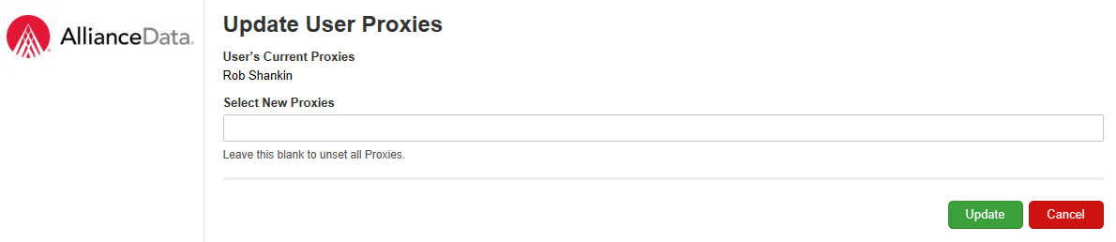

## User Proxies Administration

In addition to the functionality described above, “Update Proxies”, users have the ability not only to identify proxy users for themselves, but also to identify and update proxy users for any other user. This is a dynamic form, so the user can type in any user into the “Select User to Update” field, and it will display the existing proxy settings below. The user then has the ability to change, update, or remove proxies for the selected user.

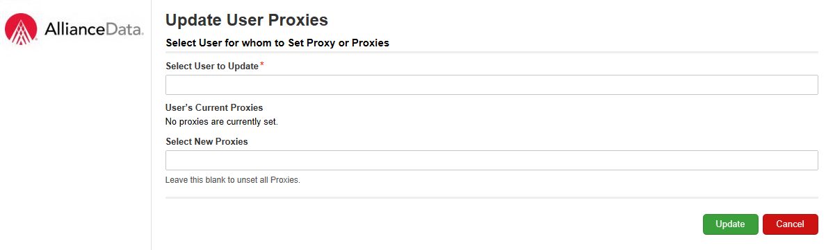

**Confirm Proxies for User Proxies Administration**

After selecting “Update” from the form above, a confirmation screen appears which allows the user to review the selections made. If he or she is finished setting proxies for users, the user can simply select “Finish”. However if the user selected the wrong proxies or wishes to set proxies for another user, he or she can select “Set Proxies for Another User” and the form displayed above will give the user that ability. This form will only display if the user manually selects the user for which to set proxies in the “Selected User” field.

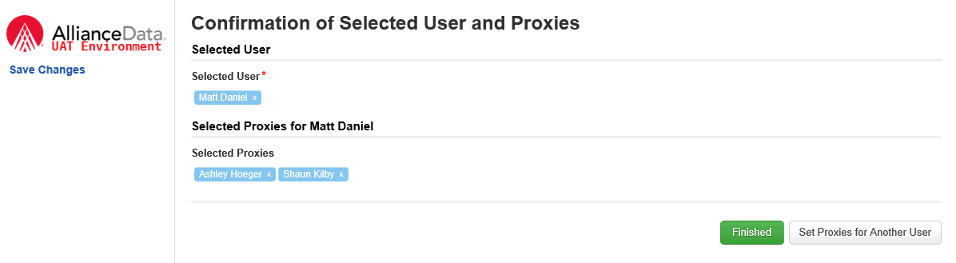

## Proxy / Delegates Task Report

A user can navigate to this screen by clicking on the “Tasks” tab in Tempo. This report shows all of the tasks that have the status of “Assigned” or “Accepted”. The “Status” field allows the user to filter down the report as well as sorting on each column.

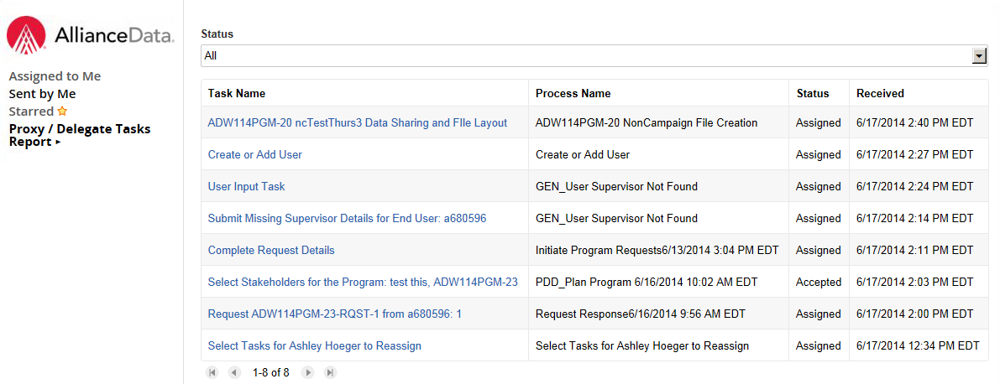

## 

## 

## Reassign Your Tasks

This form allows a user to reassign tasks that have been assigned or accepted by them. The “Status” field allows the user to filter down the report, as well as sort each column.

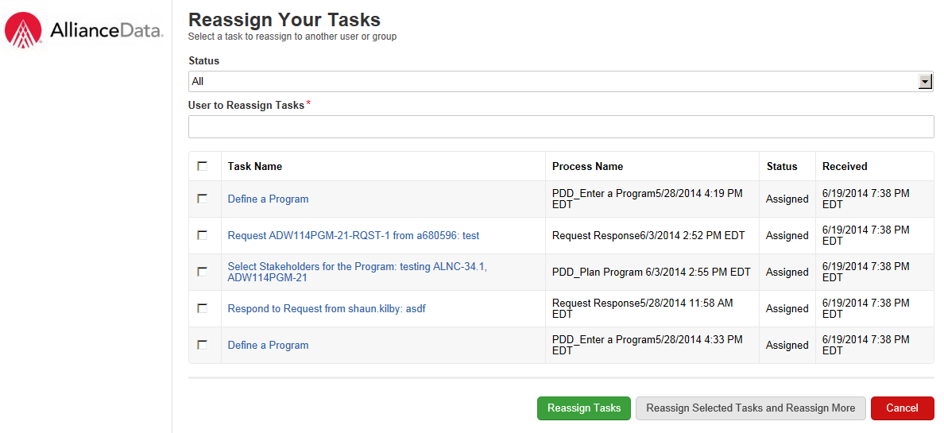

## Reassign Available Proxy Tasks to Yourself

This form allows a user to select tasks that were assigned to people that set them as their proxies and reassign them.

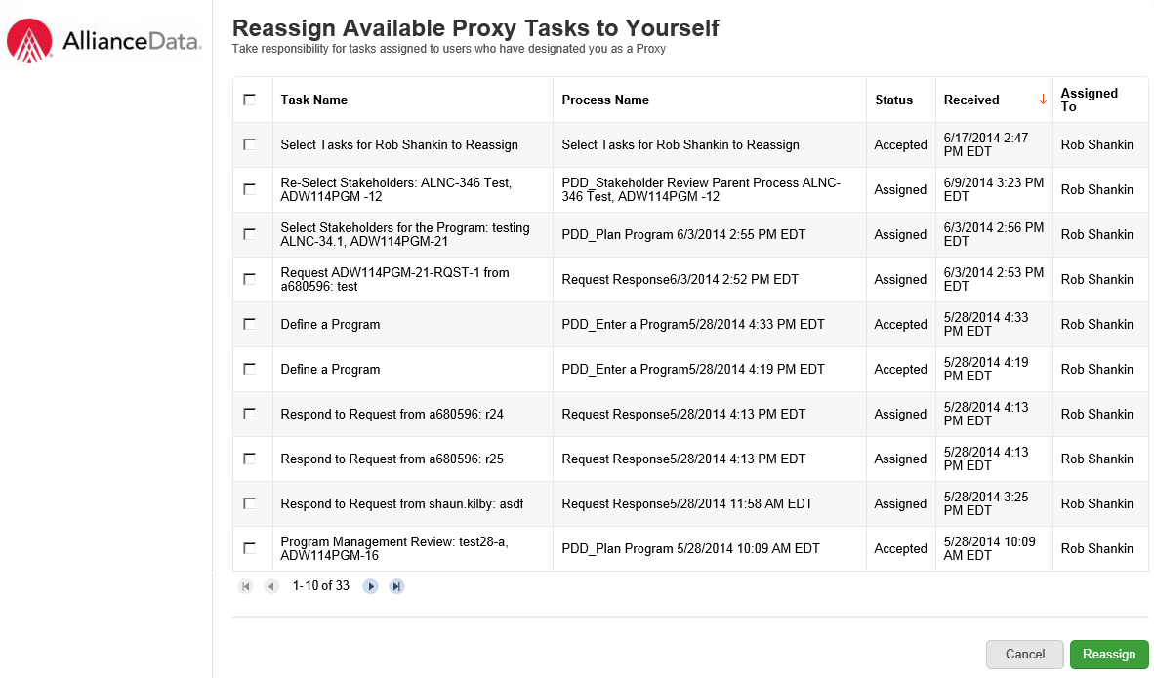

# **Process Models**

## Update Proxies

### GEN_setAndUpdateProxies

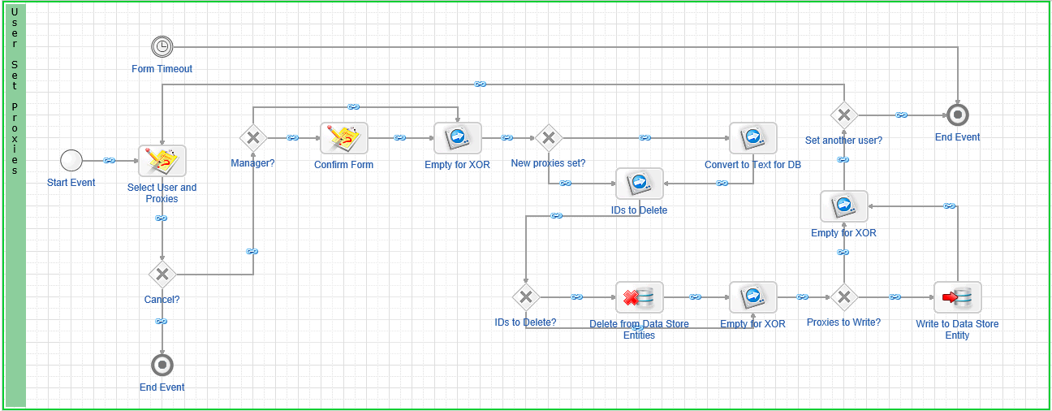

* Select User and Proxies: This task displays the form which allows basic users to set their own proxies and supervisors to set proxies for other users. ***See Intricate Design Details (IDD) Section 1.1 at the End of This Document***.
* Manager: This gateway determines if the user is a supervisor. If yes, the process moves to the Confirm Form node. If not, the process moves to the Empty for XOR node.
* Confirm Form: This form displays only for supervisors. This displays the user and proxies set by the supervisor and gives the supervisor the option to complete the process or set proxies for another user.
* New Proxies Set: ***See IDD Section 1.2 at the End of This Document.***
* Convert to Text for Database: For writing to the database, the users and proxies must be converted to text datatype.
* IDs to Delete: ***See IDD Section 1.3 at the End of This Document.***
* Delete from Data Store Entities: ***See IDD Section 1.4 at the End of This Document.***
* Write to Data Store Entity: Writes the users and new proxies to the database.
* Set another User: If the user selected to set proxies for another user, the process will return to “Set User and Proxies.” If not, the process is complete.
* Form Timer: ***See IDD Section 1.5 at the End of This Document.***

## User Proxies Administration

### GEN_managerSetUserProxyParent

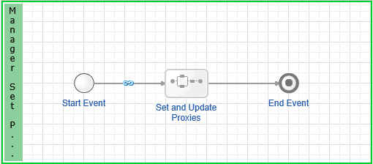

* Set and Update Proxies: This sub-process calls GEN_setAndUpdateProxies, recognizing that the user executing the process has the permission to set proxies for other users.

## Reassign Your Tasks

### GEN_User Select Own Tasks to Reassign

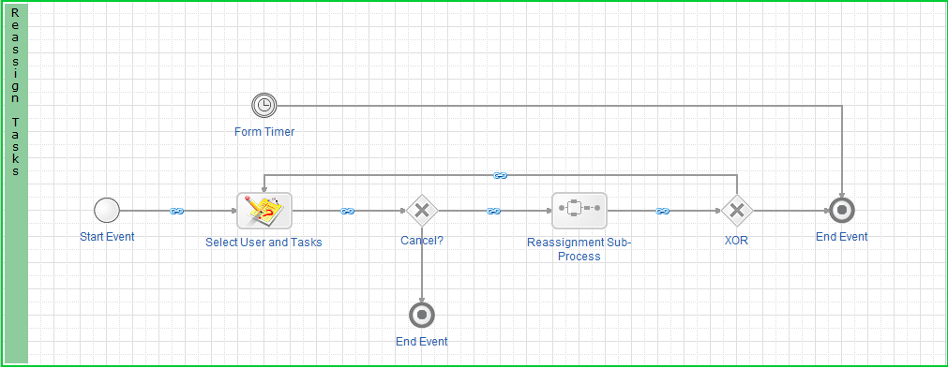

* Select User and Tasks: This task displays the form that allows the logged-in user to reassign any of their tasks to a group or user. ***See IDD Section 3.1 at the End of This Document.***
* Reassignment Sub-Process: This sub-process runs GEN_Reassign Tasks passing the user or group selected as well as the tasks the logged-in user wishes to reassign.
* Form Timer: ***See IDD Section 3.2 at the End of This Document.***

**GEN_Reassign Tasks**

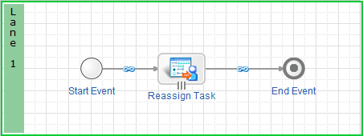

* Reassign Task: This reassigns the selected task(s) to the selected user / group.

## Reassign Available Proxy Tasks to Yourself

### GEN_GetMyDelegatesTasksAndReassign

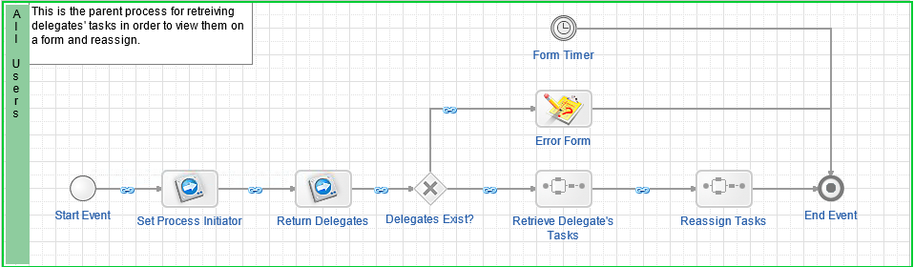

* Set Process Initiator: This script task saves the initiator of this task in a process variable to be used across the subprocesses. Since all of the subprocesses run as the person who designed the model, this enables the initiator to be saved and used instead of loggedInUser().
* Return Delegates: This script task contains a query rule which returns the initiator’s proxies
* Delegates Exist?: This gateway looks at the query rule to bring back users that have designated the logged in user as their proxy. If the user does not have delegates, then an error form appears and ends the process.
* Retrieve Delegate’s Tasks: This subprocess links to the process “GEN_myDelegatesTasks”
* Reassign Tasks: This subprocess links to the process “GEN_User Selects Delegates Tasks”

### GEN_myDelegatesTasks

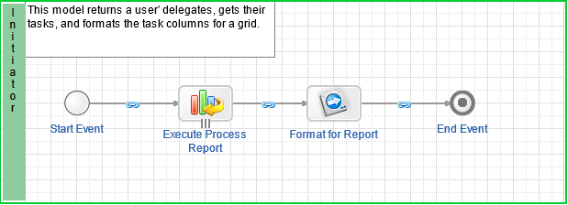

* Execute Process Report: This smart service node reads the portal report used to generate all tasks and enables us to save the information into process variables to use throughout the process.
* Format for Report: This formats the “Status” field to display text in the form, converts the “Assigned To” user/ group to a text field, and saves all other fields to the cdt as primitive data types.

### GEN_User Selects Delegates Tasks

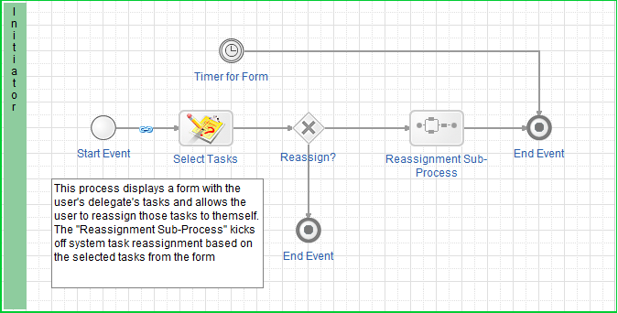

* Select User and Tasks: This task displays the form that allows the user to reassign any of their tasks to a group or user. ***See IDD Section 4.1 at the End of This Document.***
* Reassignment Sub-Process: This sub-process runs GEN_Reassign Tasks passing the user or group selected as well as the tasks the logged-in user wishes to reassign.
* Timer for Form: ***See IDD Section 4.2 at the End of This Document.***

### GEN_Reassign Delegates Tasks

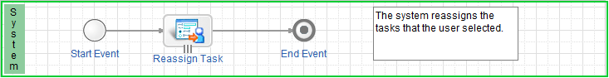

* Reassign Task: This reassigns the selected task(s) to the user who initiated the process to reassign available proxy tasks.

# Security

## Update Proxies

|  |  |  |
| --- | --- | --- |
| **Group** | **Security Level** | **Security Permissions** |
| ADS System Administrators | Administrator | Admins can set and update their own proxies. In addition, Admins can edit, delete, and execute the process in Designer Mode. |
| APN All Users | Viewer | Users can set and update their own proxies. |

## 

## User Proxies Administration

|  |  |  |
| --- | --- | --- |
| **Group** | **Security Level** | **Security Permissions** |
| ADS System Administrators | Administrator | Admins can set and update proxies for other users. In addition, Admins can edit, delete, and execute the process in Designer Mode. |
| GEN_Proxy Managers | Viewer | Users can set and update proxies for other users. |

## 

## Reassign Your Tasks

|  |  |  |
| --- | --- | --- |
| **Group** | **Security Level** | **Security Permissions** |
| ADS System Administrators | Administrator | Admins can reassign one or more their tasks to a different user or group. In addition, Admins can edit, delete, and execute the process in Designer Mode. |
| APN All Users | Viewer | Users can reassign one or more their tasks to a different user or group. |

## 

## Reassign Available Proxy Tasks to Yourself

|  |  |  |
| --- | --- | --- |
| **Group** | **Security Level** | **Security Permissions** |
| ADS System Administrators | Administrator | Admins can take responsibility for tasks assigned to users who have designated them as a Proxy. In addition, Admins can edit, delete, and execute the process in Designer Mode. |
| APN All Users | Viewer | Users can take responsibility for tasks assigned to users who have designated them as a Proxy. |

# **Reports**

|  |  |
| --- | --- |
| **Report** | **Description** |
| Task Report:  Proxy / Delegates Task Report  Portal Report:  “My Alliance Tasks” | Purpose  To display tasks assigned to the current user  Design  This report was created by saving a copy of the out-of-box “My Tasks” portal report. All tasks that are *Assigned* or *Accepted* by the current user display ,with the exception of the tasks created from the “Reassign Your Tasks” process, are shown. This task is filtered out to so that users cannot reassign their reassignment tasks. |
| Portal Report:  “My Delegates' Tasks” | Purpose  To display all users’ tasks  Referenced in-process to filter out the tasks from people that have designated the current user as their proxy.  *(Refer to User Interface Navigation sections Reassign Your Tasks and Reassign Available Proxy Tasks to Yourself for more information).*  Design  This report was created by saving a copy of the out-of-box “All Tasks” portal report. All tasks are pulled into the report and are filtered to only display tasks that have the status of *Assigned* or *Accepted*. |

## 

# **Complex Data Types**

### GEN_userProxies

This CDT stores information related to users and their assigned proxies.

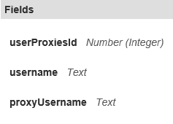

### GEN_taskReportBuddySystem

This CDT is used to save data populated from the Proxy / Delegates Task Report task report. It is used in the “Reassign Available Proxy Tasks to Yourself” process. It is not written to the database.

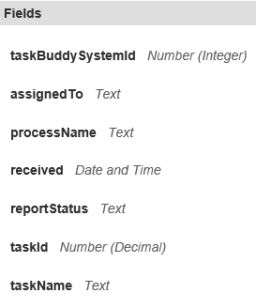

# **Intricate Design Efforts**

## Update Proxies

|  |  |  |  |
| --- | --- | --- | --- |
| **#** | **Process Model Node** | **Intricate Design Type** | **Explanation** |
| 1.1 | Select Users and Proxies | Quick Task | This node is set up as a Quick Task so it will not show up on the Tasks Report associated with the process “Reassign Your Tasks” and “Reassign Available Proxy Tasks to Yourself.” |
| 1.2 | New Proxies Set | XOR | The expected functionality of the subsequent node would not execute properly if a null value is passed. This XOR ensures proper functionality of the process. |
| 1.3 | IDs to Delete | XOR | The expected functionality of the subsequent node would not execute properly if a null value is passed. This XOR ensures proper functionality of the process. |
| 1.4 | Proxies to Write | XOR | The expected functionality of the subsequent node would not execute properly if a null value is passed. This XOR ensures proper functionality of the process. |
| 1.5 | Form Timeout | Timer | If the process is not completed within the 60 minutes, the process will be terminated to ensure tasks are not left unattended and processes are not left idle. |

## 

## Reassign Your Tasks

|  |  |  |  |
| --- | --- | --- | --- |
| **#** | **Process Model Node** | **Intricate Design Type** | **Explanation** |
| 3.1 | Select Users and Tasks | Quick Task | This node is set up as a Quick Task so it will not show up on the Tasks Report associated with the process “Reassign Your Tasks” and “Reassign Available Proxy Tasks to Yourself.” |
| 3.2 | Form Timeout | Timer | If the process is not completed within the 60 minutes, the process will be terminated to ensure tasks are not left unattended and processes are not left idle. |

## 

## 

## Reassign Available Proxy Tasks to Yourself

|  |  |  |  |
| --- | --- | --- | --- |
| **#** | **Process Model Node** | **Intricate Design Type** | **Explanation** |
| 4.1 | Select Tasks | Quick Task | This node is set up as a Quick Task so it will not show up on the Tasks Report associated with the process “Reassign Your Tasks” and “Reassign Available Proxy Tasks to Yourself.” |
| 4.2 | Form Timeout | Timer | If the process is not completed within the 60 minutes, the process will be terminated to ensure tasks are not left unattended and processes are not left idle. |