SCM 651 - Business Analytics

Homework #4

December 6, 2023

Group 1:

Darius Parker,

David Mansoir,

Katlyn Kincaid,

Sarah Morris,

Shaun McKellar, Jr.

Sophia Carnicelli

# 

## Question 1

**Logit Analysis:**

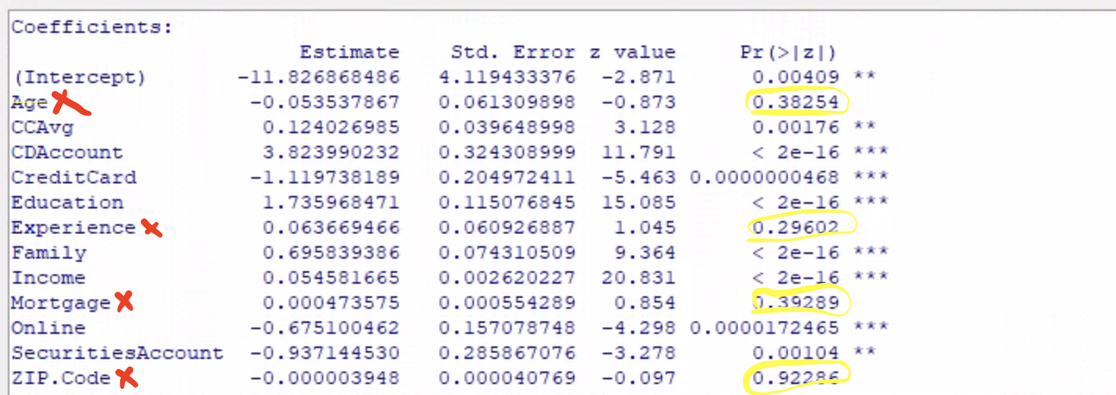

Removing coefficients that are not statistically significant:

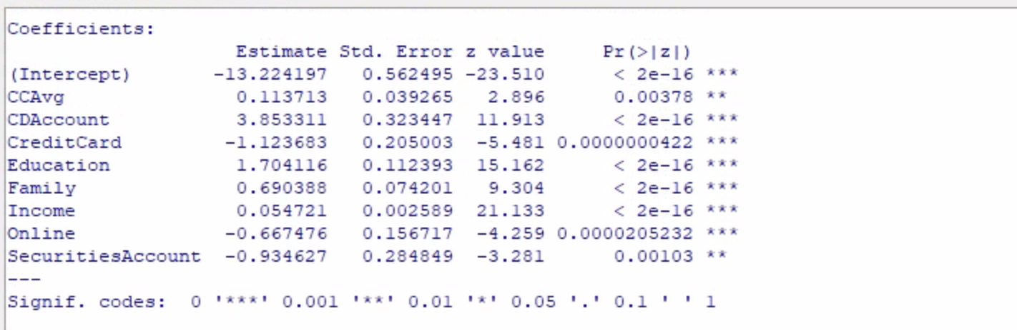

**The following variables are significant and influence the likelihood of taking out a loan:**

* **Credit Card Average**: The more credit cards a customer has, the more likely they are to take out a loan
* **CD Account**: If the customer has a CD Account with the bank, they’re more likely to take out a loan.
* **Credit Card**: If the customer has a credit card with the bank, they are less likely to take out a loan.
* **Education**: The more education a customer has, the more likely they are to take out a loan.
* **Family**: The more people in a customer’s family, the more likely they are to take out a loan.
* **Income**: The more a customer makes, the more likely they are to take out a loan.
* **Online**: If the customer uses internet banking facilities, they are less likely to take out a loan.
* **Securities Account**: If the customer has a securities account with the bank, they are less likely to take out a loan.

Therefore, the best potential customer to take out a loan would be someone who has multiple credit cards, a higher education, a higher income, and multiple people in their family. They would have a CD Account with the bank but not a credit card or securities account with the bank.

**Probit Analysis:**

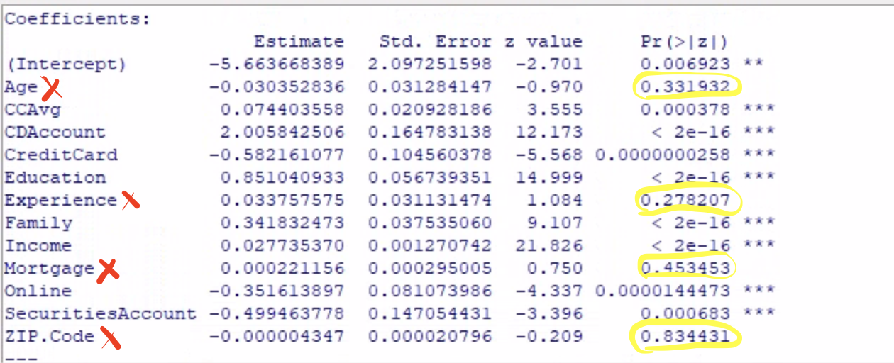

Removing coefficients that are not statistically significant:

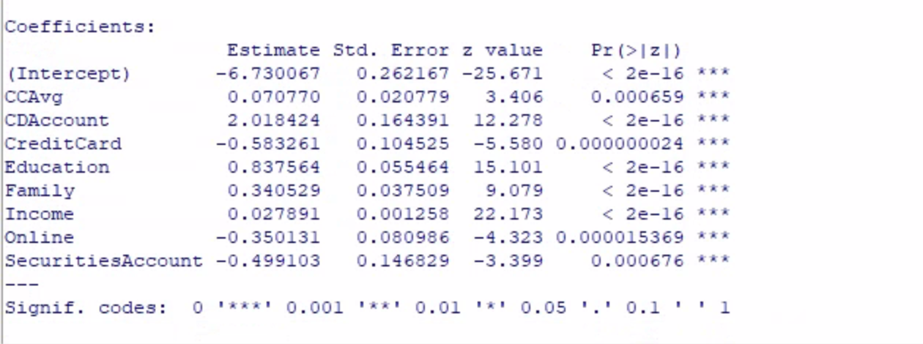

**The following variables are significant and influence the likelihood of taking out a loan:**

* **Credit Card Average**: The more credit card debt a customer has, the more likely they are to take out a loan
* **CD Account**: If the customer has a CD Account with the bank, they’re more likely to take out a loan.
* **Credit Card**: If the customer has a credit card with the bank, they are less likely to take out a loan.
* **Education**: The more education a customer has, the more likely they are to take out a loan.
* **Family**: The more people in a customer’s family, the more likely they are to take out a loan.
* **Income**: The more a customer makes, the more likely they are to take out a loan.
* **Online**: If the customer uses internet banking facilities, they are less likely to take out a loan.
* **Securities Account**: If the customer has a securities account with the bank, they are less likely to take out a loan.

This is the same as the logit analysis. Interestingly, in both analyses, the variable that is most likely to influence the loan is whether or not the customer has a CD Account at the bank, followed by education, and if they have a credit card or securities account with the bank. Basically, their past interactions with the bank have the strongest determining factor on if they will take out a loan. Perhaps the bank’s CD program is very strong, giving customers a good experience and making them more likely to engage with the bank more, whereas perhaps the bank’s credit card and securities accounts programs are weaker, making it more likely that customers would look elsewhere for a loan. These are perhaps areas of growth for the bank.

Another potential analysis of the above: people with CD accounts generally have longer term investment strategies, and may be more “money minded”. This is a step below taking out a loan, which is another longer term money move and which may only be taken by people with a high credit score and who are more “financially literate”.

## Question 2

First we tried CD Account and Education, since they were the strongest two variables, but they are not statistically significant:

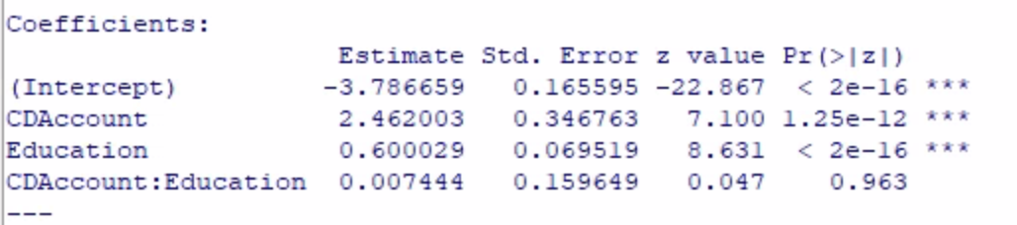

Next we tried education and income, since those often go together and make sense conceptually. These are statistically significant (and were one of the few pairs I could find that were):

## 

## Question 3

The sensitivity analysis shows that customers most likely to get loans are those who have an undergraduate or graduate degree and make more money.

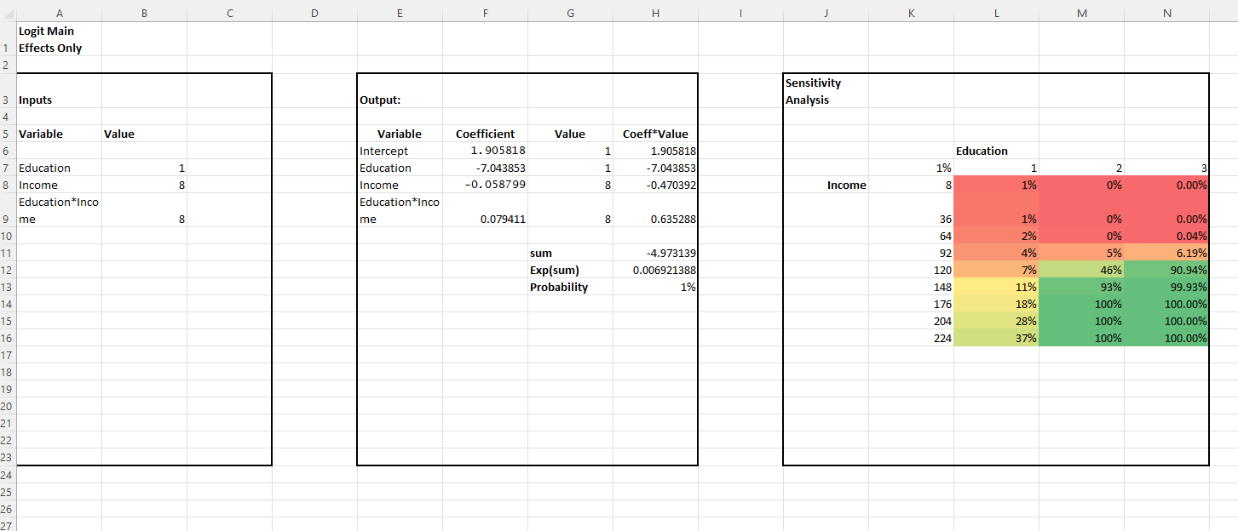

## Question 4

Perform a neural network analysis of the variables in part 3 above. Copy screen snapshots of your final neural network model in R to your report. (20%)

ed_incomenet<-neuralnet(PersonalLoan ~ Education + Income, homework4, hidden=2, lifesign = "minimal", linear.output=FALSE, threshold=0.01)

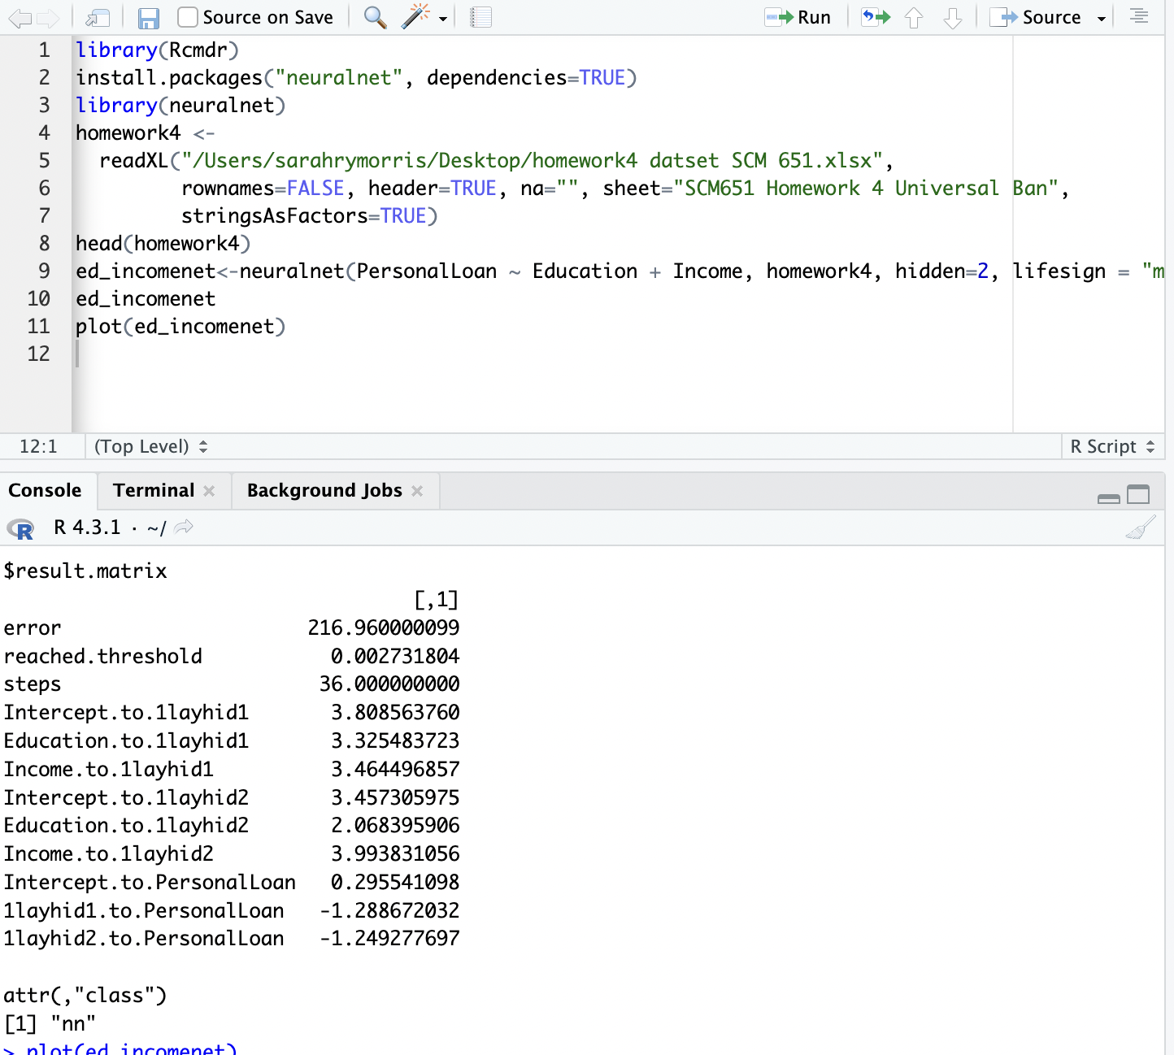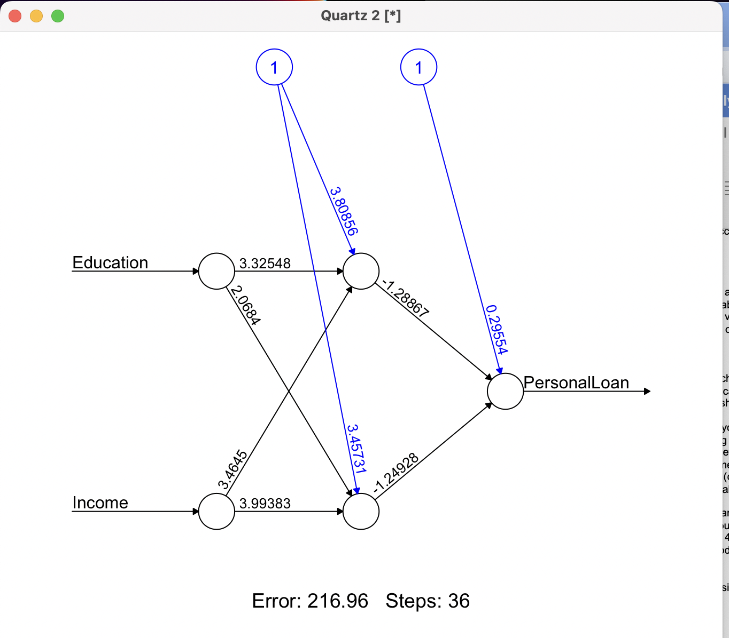

## Question 5

Create a prediction model of the neural network in part 4. Using the prediction model, perform a sensitivity analysis for the neural network model like the logit and probit sensitivity analysis. (20%)

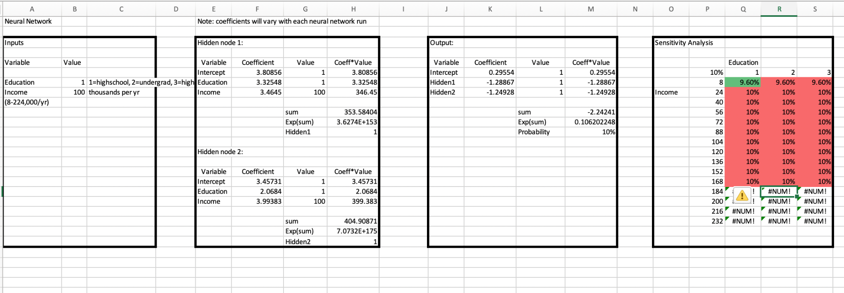

After completing the prediction model for the neural network, we all had a strange sensitivity analysis that does not seem correct. After deep diving the issue, we believe that the issue might be that our coefficients and values are too high and are making our hidden nodes too close to 1 (in the equation y=x/(x+1), the higher the number x, the closer y is to 1). Excel is simply displaying hidden nodes 1 and 2 as 1, and therefore the output probability does not change as you adjust the input variables. Therefore, the sensitivity analysis is incorrect.

We believe that if we had originally chosen different variables with smaller or negative coefficients for hidden nodes 1 and 2 in our neural network, we would ultimately have a more useful sensitivity analysis.