Bulk upload to Lingq

First you install the 2.7 version of python for windows

<https://www.python.org/download/releases/2.7.6/>

Then you add the installation directory to your system environment PATH variable

From the Desktop, right-click **My Computer** and click **Properties**.

Click **Advanced System Settings** link in the left column.

In the System Properties window click the **Environment Variables** button.

You'll see an environment variable called PATH. Select it and click Edit. Then you append   
;C:\Python27\  
to it. Include the Semi-Colon. You should be able to find instruction for "adding a directory to your path variable" online. -- It’s different for many versions of windows. See notes below, this syntax may be different.

Follow these steps:

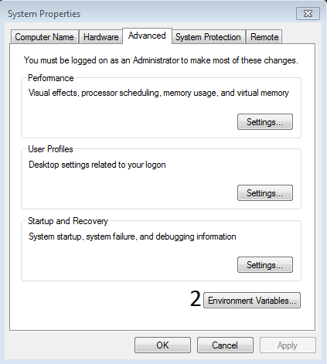

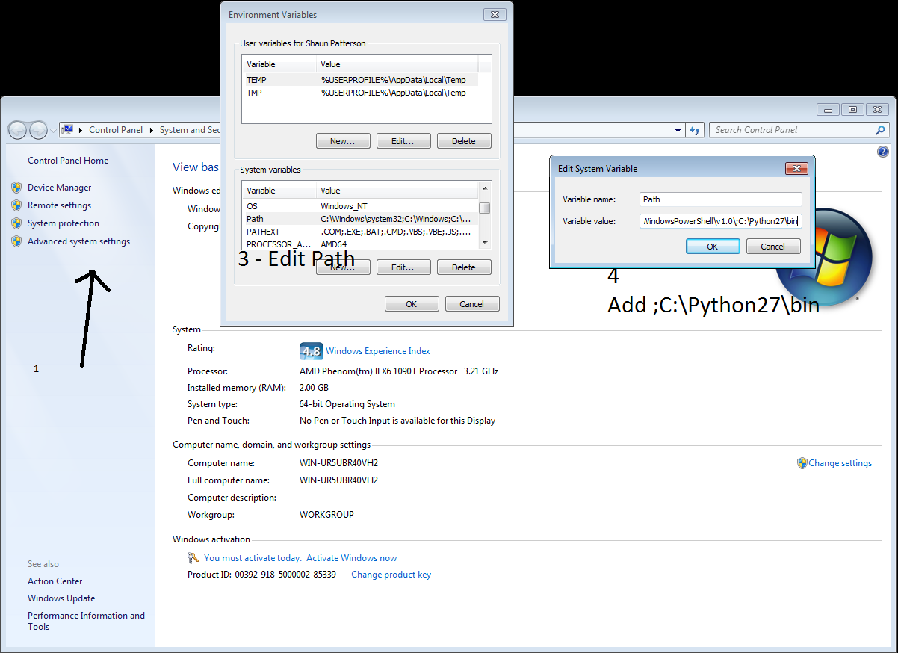

More instructions here: <http://www.computerhope.com/issues/ch000549.htm>

Then... you install "pip"

<https://pip.pypa.io/en/latest/installing.html>

After installing you are supposed to run the following (which may require administrator access):

python get-pip.py

To start a command prompt as an administrator

1. Click **Start**, click **All Programs**, and then click **Accessories**.
2. Right-click **Command prompt**, and then click **Run as administrator**.
3. If the **User Account Control** dialog box appears, confirm that the action it displays is what you want, and then click **Continue**.

If you get this message “Python is not recognized as an internal or external command, operational program or batch file” you may need to check in which folder the file python.exe was created during installation and correct the Path accordingly.

# Read more information if you have this error message ‘python’ is not recognized as an internal or external command):

<http://www.pythoncentral.io/add-python-to-path-python-is-not-recognized-as-an-internal-or-external-command/>

<https://docs.python.org/2/faq/windows.html>

for example:

C:\Python27\python.exe get-pip.py

Then you open up a command window via: Start -> Run -> cmd   
type in   
pip install selenium

Here again you have to check where pip.exe is located. It may be in the Scripts folder. In that case, you’ll have to change the directory to: C:\Python27\Scripts

See how to change directories in a Command Prompt: <http://coweb.cc.gatech.edu/ice-gt/339>

If everything is ok, you’ll see this:

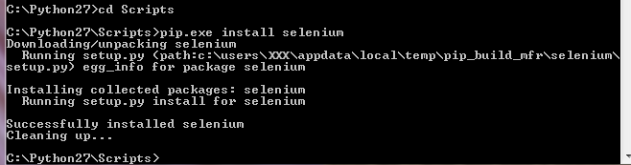

Finally, go to my [github.com](http://github.com) account

<https://github.com/spattersongt/lingq/tree/master/bulk_upload>

and download "selenium_approach.py"

Direct link: <https://raw.githubusercontent.com/spattersongt/lingq/master/bulk_upload/selenium_approach.py>

Select the whole text and save it as "selenium_approach.py" using a text editor like NoteTab Light or Notepad++ (both are free)

<http://notepad-plus-plus.org/>

<http://www.notetab.com/>

Also read the Instructions.txt file.

<https://github.com/spattersongt/lingq/blob/master/bulk_upload/Instructions.txt>

You essentially run this from the "cmd" window via:  
  
selenium_approach.py username password LANG_CODE COURSE_ID BOOK TITLE

Additional Notes:

When creating the Book.txt save the file with the encoding format UTF-8. You can do it with NoteTab Light or Notepad++

The file TOC.txt shouldn’t have empty lines.

Make sure you have the right number of chapters in your TOC.txt file other wise you’ll get an error message (out of range):

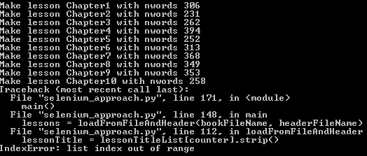

Save the files Book.txt, TOC.txt and selenium_approach.py in the same folder as python.exe. It will be easier to type in the final instruction if you need the full path. Or you can write it in a text editor and then paste it in the Windows Command Prompt.

Instructions here: <http://www.techsupportalert.com/content/how-copy-and-paste-windows-command-prompt.htm>