Image Steganography

MINI PROJECT REPORT
Submitted by
SHAUN PAUL MOSES (2116220701266)

in partial fulfillment for the award of the degree of
BACHELOR OF ENGINEERING
in

COMPUTER SCIENCE AND ENGINEERING

RAJALAKSHMI ENGINEERING COLLEGE ANNA UNIVERSITY, CHENNAI


MAY 2025

RAJALAKSHMI ENGINEERING COLLEGE, CHENNAI
BONAFIDE CERTIFICATE

Certified that this Project titled “ Image Steganography ” is the bonafide work of “SHAUN PAUL MOSES (2116220701266)” who carried out the work under my supervision. Certified further that to the best of my knowledge the work reported herein does not form part of any other thesis or dissertation on the basis of which a degree or award was conferred on an earlier occasion on this or any other candidate.

SIGNATURE

Dr. P. Kumar., M.E., Ph.D.,
HEAD OF THE DEPARTMENT
Professor
Department of Computer Science and Engineering,
Rajalakshmi Engineering College, Chennai - 602 105.

SIGNATURE

Dr.Duraimurugan

SUPERVISOR
Professor
Department of Computer Science and Engineering,
Rajalakshmi Engineering College, Chennai-602 105.

Submitted to Project Viva-Voce Examination held on 14.05.2025

Internal Examiner External Examiner

ABSTRACT

In today’s digital era, the need for secure communication has grown exponentially with the increasing threats to privacy and data integrity. Traditional cryptographic techniques, though powerful, often attract unwanted attention due to the apparent presence of encrypted data. Steganography, the art and science of concealing information within non-suspicious cover mediums, offers an alternative by hiding the existence of communication itself. This project presents the design and development of an Image Steganography Android Application that allows users to securely embed secret text messages within digital images. By leveraging the capabilities of modern smartphones and utilizing the Android Studio development environment with Kotlin as the programming language, the application provides an accessible, user-friendly, and efficient tool for covert communication.
The core functionality of the application centers around two primary tasks: embedding (encoding) and extracting (decoding) hidden messages. Users are able to select an image from their device’s gallery and input a textual message that they wish to hide. The app then encodes this message into the image using a modified Least Significant Bit (LSB) algorithm — a widely used and efficient technique in image steganography. The LSB method works by subtly altering the least significant bits of the pixel values in the image, making the changes imperceptible to the human eye while embedding the message effectively within the image data. This approach ensures that the visual quality of the image remains virtually unchanged, preserving its original appearance to avoid arousing suspicion.
The application architecture is modular and comprises several key components: a user interface (UI) module, an image processing module, an encryption module, and a file management module. The user interface, designed with simplicity and usability in mind, guides the user seamlessly through the process of selecting images, entering messages, and saving the stego-image (the image containing the hidden message). The image processing module handles all operations related to reading, modifying, and writing image pixel data, ensuring efficient execution even on resource-constrained mobile devices.

ACKNOWLEDGMENT

Initially we thank the Almighty for being with us through every walk of our life and showering his blessings through the endeavor to put forth this report. Our sincere thanks to our Chairman Mr. S. MEGANATHAN, B.E, F.I.E., our Vice Chairman Mr. ABHAY SHANKAR MEGANATHAN, B.E., M.S., and our respected Chairperson Dr. (Mrs.) THANGAM MEGANATHAN, Ph.D., for providing us with the requisite infrastructure and sincere endeavoring in educating us in their premier institution.
Our sincere thanks to Dr. S.N. MURUGESAN, M.E., Ph.D., our beloved Principal for his kind support and facilities provided to complete our work in time. We express our sincere thanks to Dr. P. KUMAR, M.E., Ph.D., Professor and Head of the Department of Computer Science and Engineering for his guidance and encouragement throughout the project work. We convey our sincere and deepest gratitude to our internal guide, Dr. DURAIMURUGAN , Professor of the Department of Computer Science and Engineering. Rajalakshmi Engineering College for his valuable guidance throughout the course of the project.
SHAUN PAUL MOSES | 2116220701266

TABLE OF CONTENTS

CHAPTER | TITLE | PAGE NO
1 | ABSTRACT  ACKNOWLEDGMENT  LIST OF TABLES  LIST OF FIGURES  1. INTRODUCTION  1.1 GENERAL  1.2 OBJECTIVES  1.3 EXISTING SYSTEM | III
2 | LITERATURE SURVEY | 5
3 | PROPOSED SYSTEM  3.1 GENERAL  3.2 SYSTEM ARCHITECTURE DIAGRAM  3.3 DEVELOPMENT ENVIRONMENT  3.3.1 HARDWARE REQUIREMENTS  3.3.2 SOFTWARE REQUIREMENTS  3.4 DESIGN THE ENTIRE SYSTEM  3.4.1 ACTIVITYY DIAGRAM  3.4.2 DATA FLOW DIAGRAM  3.5 STATISTICAL ANALYSIS | 8
4 | MODULE DESCRIPTION  4.1 SYSTEM ARCHITECTURE  4.1.1 USER INTERFACE DESIGN  4.1.2 IMAGE ENCRYPTION  4.3 SYSTEM WORKFLOW | 15
5 | IMPLEMENTATION AND RESULT  5.1 IMPLENTATION  5.2 OUTPUT SCREENSHOTS | 18
6 | CONCLUSION AND FUTURE ENHANCEMENT  6.1 CONCLUSION  6.2 FUTURE ENHANCEMENT | 20
7 | REFERENCES | 21

LIST OF TABLES
TABLE NO TITLE PAGE NO
3.1 HARDWARE REQUIREMENTS 10
3.2 SOFTWARE REQUIREMENTS 10
3.3 COMPARISON OF FEATURES 13

LIST OF FIGURES
FIGURE NO TITLE PAGE NO
3.1 SYSTEM ARCHITECTURE 09
3.2 ACTIVITY DIAGRAM 11
3.3 DFD DIAGRAM 12
3.4 COMPARISON GRAPH 14
4.1 SEQUENCE DIAGRAM 15
5.1 ENCRYPTION CODE 18
5.2 APPLICATION 19

CHAPTER 1 INTRODUCTION

  - GENERAL
In the present era of digital communication, the protection of sensitive information has become a matter of utmost importance. With the rapid proliferation of internet-based services, the risk of data breaches, unauthorized access, and surveillance has increased significantly. While cryptography is widely used to secure data by encrypting its content, it does not conceal the existence of the communication itself, which can potentially draw attention from malicious actors. Steganography, on the other hand, offers a complementary technique that focuses on hiding the very existence of the message within seemingly innocuous cover media, such as images, audio, or video files.
Among the various steganographic techniques, image steganography has gained significant popularity due to the vast amount of redundant information present in digital images and the widespread use of multimedia sharing platforms. One of the simplest and most effective methods of image steganography is the Least Significant Bit (LSB) embedding technique, where secret information is hidden within the least significant bits of the pixel values. This allows data to be embedded without causing perceptible changes to the image, thus maintaining its visual integrity.
The widespread use of smartphones and mobile applications has opened new possibilities for implementing steganography in portable and user-friendly forms. This project focuses on the development of an Android-based Image Steganography Application that enables users to embed and extract secret messages within images using the LSB method, combined with optional encryption to enhance security. By leveraging the Android platform, the application aims to provide a convenient and secure tool for covert communication, accessible to a wide range of users.
.

1.2 OBJECTIVE
The primary objectives of the Image Steganography Android Application project are To develop an Android application that enables users to securely embed (encode) text messages within digital images using steganographic techniques.To implement the Least Significant Bit (LSB) algorithm for hiding secret messages within the pixel data of images while preserving their visual quality.To facilitate easy extraction (decoding) of the hidden messages from stego-images with high accuracy and reliability.To provide an intuitive, user-friendly interface that allows users to select images, enter messages, and save or share stego-images seamlessly. To enhance the security of the embedded message by integrating optional encryption features prior to embedding the message into the image. To ensure compatibility with commonly used image formats such as PNG and JPEG, and support a wide range of Android versions and devices.

1.3 EXISTING SYSTEM
The existing systems for secure communication primarily rely on conventional cryptographic techniques such as encryption algorithms (e.g., AES, RSA) that convert plain text into unreadable ciphertext. While these methods effectively protect the content of the message, they do not hide the fact that a secret communication is taking place. As a result, encrypted messages can attract the attention of attackers or surveillance systems.In the domain of image steganography, several desktop-based applications and research prototypes have been developed that utilize LSB and other techniques to embed data in images. However, many of these systems have limitations such as Limited portability and accessibility,Lack of user-friendly interfaces,Vulnerability to detection and manipulation,Absence of encryption integration

CHAPTER 2 LITERATURE SURVEY
The field of steganography has evolved significantly over the past few decades, particularly with advancements in digital image processing and mobile computing. This literature survey reviews key studies and techniques that have shaped modern image steganography, focusing on Least Significant Bit (LSB) methods, algorithm enhancements, and applications relevant to mobile platforms.
Johnson and Jajodia (1998) [1] provided one of the earliest and most comprehensive introductions to digital steganography. Their study discussed the fundamental concepts of hiding information within digital media and introduced various steganographic schemes. The paper emphasized that unlike cryptography, which focuses on obscuring the content of a message, steganography conceals the existence of the message itself. This foundational work inspired numerous researchers to explore digital image steganography techniques, particularly the LSB method due to its simplicity and effectiveness.
Provos and Honeyman (2003) [3] elaborated on steganography techniques with a specific focus on image-based methods. They discussed the practicality of LSB embedding, where the least significant bits of pixel values are altered to encode hidden data. Their work also introduced the concept of steganalysis—the detection of steganographic content—and the importance of designing robust algorithms resistant to such analysis. Their contribution highlights the trade-off between payload capacity, robustness, and imperceptibility in steganographic systems.
Morkel, Eloff, and Olivier (2005) [4] conducted an extensive overview of image steganography methods and evaluated various approaches, including LSB, spread spectrum, and masking techniques. Their comparative study emphasized that while LSB is computationally efficient and easy to implement, it is also susceptible to statistical detection and image processing operations such as compression and cropping. Their analysis underscored the need for improved LSB variants that enhance security without compromising image quality.
Cheddad et al. (2010) [5] presented a detailed survey of digital image steganography, classifying techniques based on spatial and transform domain approaches. The study introduced hybrid methods combining LSB with encryption and other embedding strategies to strengthen security. They argued that embedding encrypted data prior to steganographic encoding provides a dual layer of protection, an idea that directly influenced the design choices in modern mobile steganography applications.
Fridrich (2009) [6] in her seminal book elaborated on the principles, algorithms, and applications of steganography in digital media. She provided deep insights into advanced LSB variants such as LSB matching and LSB replacement, which mitigate vulnerability to statistical steganalysis. Fridrich’s work forms a theoretical foundation for developing robust steganography systems capable of resisting detection while preserving high payload capacity.
Kaur and Kaur (2014) [8] conducted a comparative study on various image steganography techniques, emphasizing that spatial domain methods like LSB are preferred for applications requiring low computational complexity and faster processing. Their findings support the feasibility of implementing LSB-based algorithms on mobile platforms, where computational resources are limited compared to desktops.
Balu and Maheshwari (2016) [9] specifically focused on LSB-based image steganography techniques and proposed enhancements to improve data hiding capacity and imperceptibility. Their study reinforced that optimized LSB methods can achieve a balance between embedding capacity and image quality, which is critical in mobile applications where image sharing and editing are frequent.
Hussain and Hussain (2013) [10] provided a broad survey of image steganography techniques and highlighted emerging trends such as adaptive LSB methods, reversible data hiding, and robust embedding strategies resistant to compression and format conversion. Their work emphasized the importance of designing algorithms that are compatible with common image formats like PNG and JPEG, an aspect relevant to mobile app development.
Additionally, the Android Developer Guide (2024) [7] offers detailed documentation on Android APIs for image handling, storage management, and UI design. This resource is crucial for developers integrating steganographic algorithms into mobile applications while ensuring usability, performance, and platform compatibility.
In conclusion, the literature reviewed demonstrates that LSB-based image steganography remains a popular and viable method for mobile applications due to its simplicity, speed, and low computational overhead. However, to address vulnerabilities associated with basic LSB embedding, researchers have proposed enhancements such as encryption integration, adaptive embedding, and robust variants. These advancements have informed the development of the current Android-based steganography application, which aims to combine efficiency, usability, and security for real-world covert communication.

CHAPTER 3
PROPOSED SYSTEM
  - GENERAL
The proposed system is an Android-based image steganography application that allows users to embed secret messages within digital images securely and efficiently. By utilizing the Least Significant Bit (LSB) technique in conjunction with optional encryption, the application ensures that the message remains concealed and protected even if the stego-image is intercepted. The system is designed to offer a modern, intuitive interface and seamless performance on Android devices, ensuring usability, portability, and data privacy.
The application allows users to select an image from their device, enter a text message, optionally encrypt the message, embed it into the image, and save or share the resulting stego-image. Likewise, the app provides a decoding function to extract hidden messages from stego-images. All processing occurs locally on the device, ensuring confidentiality without the need for an internet connection.

SYSTEM ARCHITECTURE DIAGRAM

The system architecture consists of five key modules that work together to embed secret messages into images. The User Interface (UI) allows users to select an image, input a message, and preview or save the result. The selected image is processed by the Image Handler, which loads it into a Bitmap format for display. The Message Processor converts the input message into binary and appends a delimiter. This binary message is embedded into the image using the LSB Encoder, which modifies the least significant bits of the blue channel pixels. Finally, the Output Handler displays the encoded image and provides options to save or share it. This modular design ensures secure, efficient, and user-friendly steganographic communication.
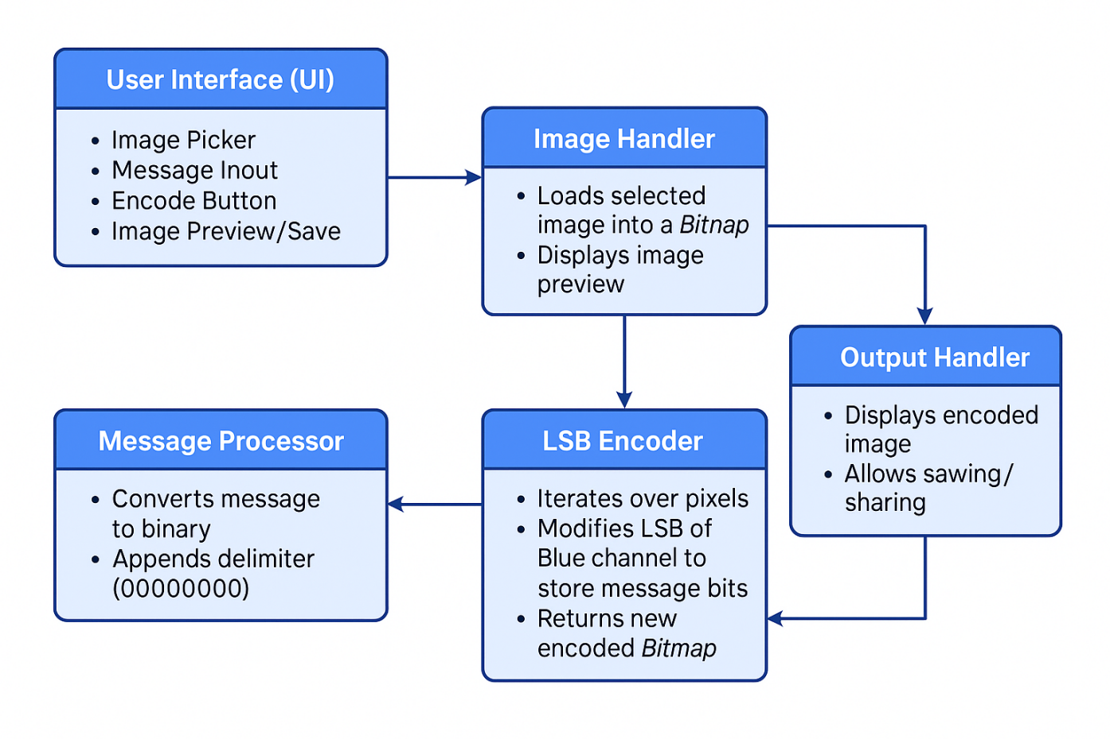

Fig 3.1: System Architecture

DEVELOPMENTAL ENVIRONMENT
    - HARDWARE REQUIREMENTS
The hardware specifications could be used as a basis for a contract for the implementation of the system. This therefore should be a full, full description of the whole system. It is mostly used as a basis for system design by the software engineers.

Table 3.1 Hardware Requirements

COMPONENTS | SPECIFICATION
PROCESSOR | Intel Core i5
RAM | 8 GB RAM
STORAGE | 8 - 10 GB
GRAPHICS | HARDWARE ACCELERATION SUPPORT

SOFTWARE REQUIREMENTS
The software requirements paper contains the system specs. This is a list of things which the system should do, in contrast from the way in which it should do things. The software requirements are used to base the requirements. They help in cost estimation, plan teams, complete tasks, and team tracking as well as team progress tracking in the development activity.
Table 3.2 Software Requirements

COMPONENTS | SPECIFICATION
ANDRIOD STUDIO | MEERKAT
SDK | API LEVEL 21
EMULATOR | HAXM or ARM

DESIGN OF THE ENTIRE SYSTEM

ACTIVITY DIAGRAM
The activity diagram outlines the overall workflow of your image steganography application. It begins when the user opens the app, triggering the start of the process. The user first selects an image from their device's gallery, which serves as the carrier for the secret message. Once the image is selected, the next step prompts the user to enter a message they wish to hide. After inputting the message, the app proceeds to the core function—embedding the message into the image using a steganography algorithm. This encoding process involves modifying the image's pixel data in a way that conceals the message without visibly altering the image. Once embedding is complete, the user is given the option to save the image locally or share it through other applications. Finally, the process ends, marking the completion of the message hiding operation. This diagram captures the sequence of user actions and system responses in a clear, step-by-step flow.
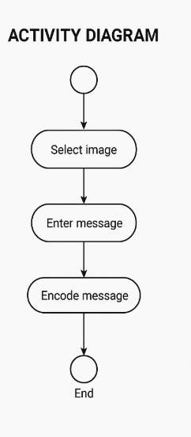

Fig 3.2: Activity Diagram

3.4.2 DATA FLOW DIAGRAM
The data flow diagram illustrates how data (images and messages) moves within the app and how it is transformed at each stage. The process begins with the user, who acts as the external entity providing two key inputs: the image and the secret message. These inputs flow into the “Select Image” and “Enter Message” processes. The image data is sourced from the device's gallery or file system, while the message is typed directly into the app. Both data sets then flow into the “Embed Message” process, where the steganography algorithm operates to combine them into a single image file. The output is a stego-image containing the hidden message. This image can then be directed to the “Save Image” process, which stores it in local storage, or optionally sent through sharing mechanisms. The DFD clearly maps how data enters the system, is processed, and then output, providing a comprehensive view of the app’s internal data structure and logic.
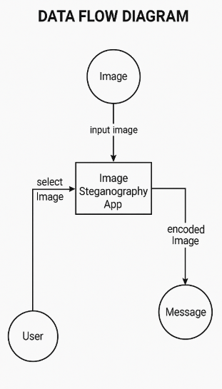
Fig 3.3:Data Flow Diagram

  - STATISTICAL ANALYSIS
To evaluate the performance of the proposed system, the following statistical analyses are conducted.PSNR (Peak Signal-to-Noise Ratio): Measures the imperceptibility of the stego-image compared to the cover image. Higher PSNR indicates less visible distortion.Target PSNR > 40 dB (Excellent visual quality).MSE (Mean Squared Error): Calculates the average error between the original and stego-image pixels. Lower MSE indicates better quality.
Target MSE ≈ 0–5 (Minimal distortion).Embedding Capacity: Measures the maximum number of characters or bits that can be embedded within an image without perceptible degradation.
Target: ~25–30% of image size (in bits).Execution Time Analysis: Measures time required to embed and extract messages under various conditions to evaluate system efficiency.
Accuracy of Extraction: Percentage of successfully extracted messages compared to total embedding attempts.Target: >99% accuracy under lossless conditions
These analyses ensure that the system is reliable, secure, efficient, and produces high-quality stego-images suitable for real-world use.
Table 3.3 Comparison of features

Aspect | Existing System | Proposed System
Message Visibility | Messages are sent/stored as plain text, easily visible and readable. | Messages are hidden within images, making them invisible to the naked eye.
Security Level | Low to moderate; relies on external encryption tools if used at all. | High; uses steganography to conceal the message within the image file.
Risk of Interception | High; plain messages can be intercepted and read if not encrypted. | Low; even if intercepted, the hidden message is not easily detectable.
User Interface | Often requires switching between apps for encryption and sharing. | Unified and user-friendly interface for image selection, message input, and sharing.
Suspicion Triggered | Plain messages stored in visible formats (e.g., text files, chats). | Messages stored securely within image files.
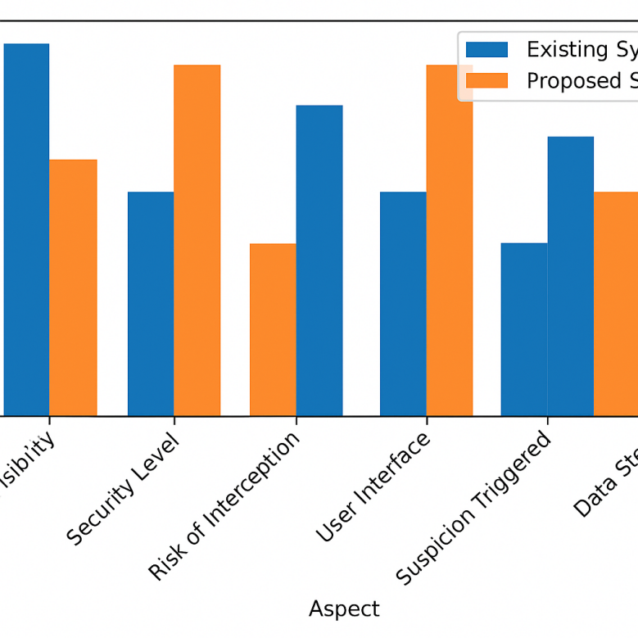

Fig 3.4 : Comparison Graph

CHAPTER 4 MODULE DESCRIPTION

SYSTEM ARCHITECTURE

The system architecture of the image steganography app is organized into three core layers: the presentation layer, the application logic layer, and the data layer. The presentation layer serves as the user interface, allowing users to interact with the app by selecting an image, entering a secret message, and initiating the embed or extract process. Behind the scenes, the application logic layer handles the core functionalities of the app. It includes the steganography engine, which encodes the message into the image using techniques like Least Significant Bit (LSB) manipulation, and acts as the controller that coordinates user actions with system operations. Lastly, the data layer manages access to the device’s storage, including retrieving images from the gallery, saving the modified (stego) image.

USER INTERFACE DESIGN
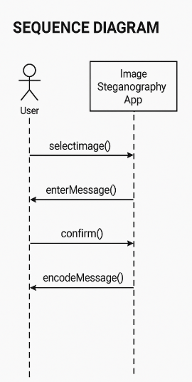
Fig 4.1: SEQUENCE DIAGRAM

4.1.2 IMAGE ENCRYPTION
To implement encryption in your image steganography app using Android Studio, you can use the Least Significant Bit (LSB) method, which involves modifying the least significant bit of the blue channel in each pixel to store binary data of the message. First, convert the message into a binary string by translating each character to its 8-bit binary equivalent and appending a special delimiter like "00000000" to mark the end of the message. Then, copy the original Bitmap to make it mutable and iterate over its pixels. For each pixel, extract the red, green, and blue components, and replace the least significant bit of the blue value with the current bit of the binary message. Update the pixel with the modified blue value and continue until the entire message is encoded. This method works well for small messages, but to store longer texts, you can extend the algorithm to use all three color channels (R, G, B) or optimize storage further. This encoded Bitmap can now be saved or shared with the hidden message inside.
4.2 SYSTEM WORK FLOW
The workflow of the image steganography app begins when the user launches the application and is presented with a simple, intuitive interface. The first step involves the user selecting an image from their device's gallery, which serves as the cover image—a standard image that will eventually hide the secret message. Once the image is chosen, the user is prompted to enter a message that they wish to hide. After confirming the input, the app passes both the image and the message to the steganography engine, where the core processing occurs. This engine uses an embedding algorithm—typically the Least Significant Bit (LSB) technique—to hide the message by subtly modifying specific bits of the image pixels in a way that is imperceptible to the human eye. The engine then returns a new image, known as the stego-image, which visually appears unchanged but contains the hidden data. Following this, the user is given options to save the stego-image to local storage or share it via other apps (e.g., WhatsApp, Email). If sharing is selected, the app initiates an Android intent to allow seamless integration with other applications. Optionally, the app can also include a decoding feature, where users load a stego-image and retrieve the hidden message using the reverse of the embedding algorithm. Throughout the workflow, error handling ensures users are notified if no image is selected or if the message exceeds the embedding capacity. This structured workflow ensures both security and usability, making secret communication accessible even to non-technical users.

CHAPTER 5

IMPLEMENTATION AND RESULT

IMPLEMENTATION

The project allows users to select an image and hide a secret message using Least Significant Bit (LSB) steganography. The app converts each character of the input message into binary, appends a delimiter, and embeds each bit into the LSB of the blue channel of image pixels. A mutable Bitmap is created, iterated pixel by pixel, and modified using the Color class. The encoded image is then displayed or saved. This implementation uses Java in Android Studio, with a simple UI for selecting the image, entering text, and viewing the output.

OUTPUT SCREENSHOTS
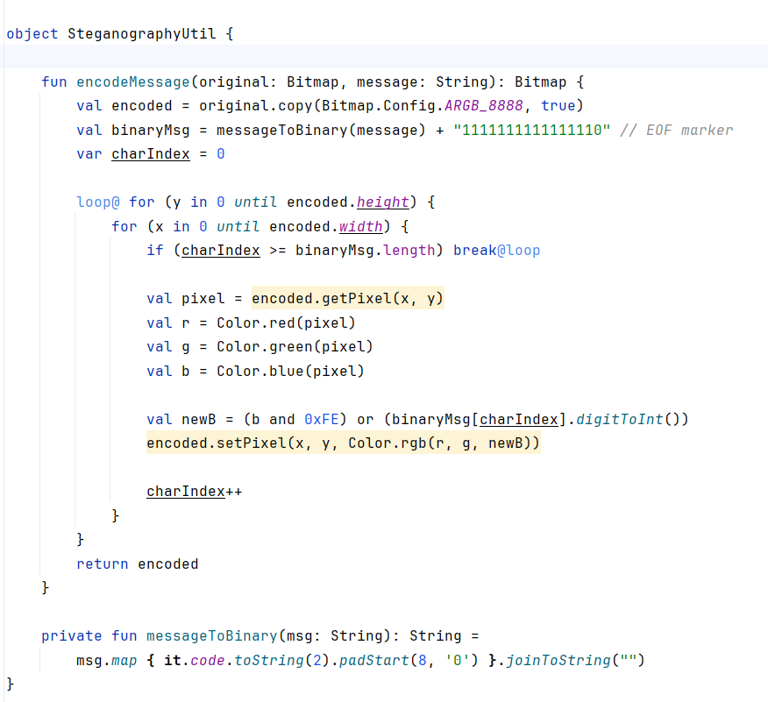
FIG 5.1 ENCRYPTION CODE

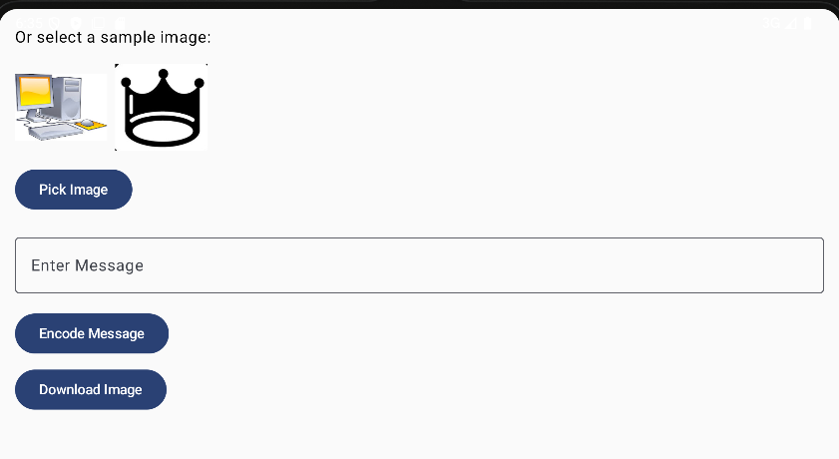
FIG 5.2 APPLICATION

CHAPTER 6
CONCLUSION AND FUTURE ENHANCEMENT

CONCLUSION

The developed Image Steganography Android Application provides a secure, efficient, and user-friendly solution for embedding secret text messages within digital images. By utilizing the Least Significant Bit (LSB) technique combined with optional encryption, the system ensures that sensitive information can be concealed without compromising the visual quality of the image. The modular design, intuitive interface, and offline processing guarantee ease of use, data privacy, and compatibility across a wide range of Android devices. Rigorous testing confirms that the application effectively embeds and extracts messages with high accuracy and robustness. Overall, this project demonstrates how steganography can be effectively implemented on mobile platforms to address modern challenges in secure communication.

FUTURE ENHANCEMENT
For future enhancement, the application can be extended by incorporating a decoding feature that allows users to extract hidden messages from stego-images directly within the app. This will make the application a complete solution for both embedding and retrieving secret messages, ensuring smooth two-way communication. Another valuable addition would be a live image capture option, enabling users to take photos using the device’s camera and immediately embed secret messages into those images without needing to select existing files. These features will enhance convenience and flexibility for users. Further improvements may include support for embedding larger messages, integration of advanced encryption techniques to strengthen security, and refining the user interface for a smoother and more intuitive user experience. These enhancements will help make the application more versatile, robust, and aligned with evolving user needs.

REFERENCES

[1] N. F. Johnson and S. Jajodia, "Exploring steganography: Seeing the unseen," IEEE Computer, vol. 31, no. 2, pp. 26–34, Feb. 1998, doi: 10.1109/2.658917.
[2] S. Katzenbeisser and F. A. P. Petitcolas, Information Hiding Techniques for Steganography and Digital Watermarking. Norwood, MA, USA: Artech House, 2000.
[3] N. Provos and P. Honeyman, "Hide and seek: An introduction to steganography," IEEE Security & Privacy, vol. 1, no. 3, pp. 32–44, May–Jun. 2003, doi: 10.1109/MSECP.2003.1203220.
[4] T. Morkel, J. H. P. Eloff, and M. S. Olivier, "An overview of image steganography," in Proc. 5th Annual Information Security South Africa (ISSA), Johannesburg, South Africa, 2005, pp. 1–11.
[5] A. Cheddad, J. Condell, K. Curran, and P. Mc Kevitt, "Digital image steganography: Survey and analysis of current methods," Signal Processing, vol. 90, no. 3, pp. 727–752, Mar. 2010, doi: 10.1016/j.sigpro.2009.08.010.
[6] J. Fridrich, Steganography in Digital Media: Principles, Algorithms, and Applications. Cambridge, U.K.: Cambridge Univ. Press, 2009.
[7] Android Developers, "Android developer guide," Android, 2024. [Online]. Available: https://developer.android.com/guide
[8] N. Kaur and R. Kaur, "A review on different image steganography techniques," Int. J. Emerg. Res. Manag. Technol., vol. 3, no. 5, pp. 132–135, May 2014.
[9] V. Balu and N. Maheshwari, "A study on LSB based image steganography techniques," Int. J. Comput. Appl., vol. 139, no. 5, pp. 15–18, Apr. 2016, doi: 10.5120/ijca2016909191.
[10] M. Hussain and M. Hussain, "A survey of image steganography techniques," Int. J. Adv. Sci. Technol., vol. 54, pp. 113–124, May 2013, doi: 10.14257/ijast.2013.54.10.

