Employee Database

Documentation

Shaun Ren and Colin Lee

November 19, 2012

## Using the Main GUI

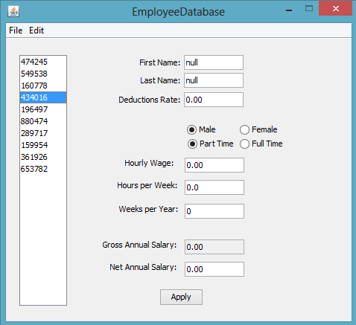

This is the main window seen at startup of the application. The database GUI will automatically load the contents of database already entered either previously, or manually through the database.txt file. A list of the employees can be seen in the list box on the left. Clicking each employee will load the information of the selected employee, including first name, last name, deductions rate, hourly wage, hours worked per week, weeks worked per year, gross annual salary and net annual salary. Another way to select an employee is typing the first few numbers of the employee number through the keyboard’s number pad into the list box. To change an employee’s information, simply change the information listed in the textboxes and press apply. To demonstrate:

1. 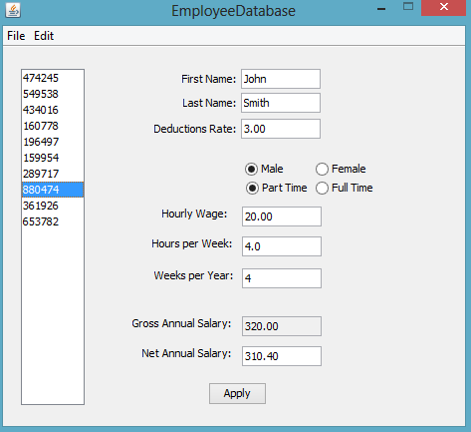2. 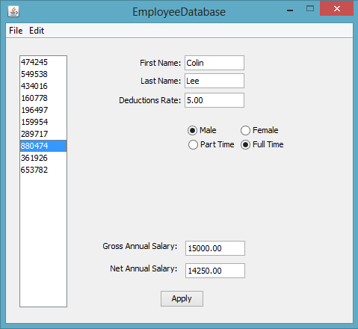
2. Select an employee.
3. Change the fields to what the employee should be edited to, then press apply to save the changes. A part time employee can be changed to a full time employee.

## File Menu Functions

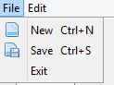

In the file menu, there are three functions: new, save and exit.

**New:** Pressing on New will clear the current database and replace it with a completely empty one. The hotkey for this is Ctrl+N.

**Save:** Pressing on Save will save the current contents of the database to database.txt. The hotkey for this is Ctrl+S.

**Exit:** Pressing on exit will close the database application, and also save the contents of the database to database.txt. This can also be done by holding Alt and F4.

## Edit Menu Functions

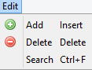

**Add:** Inserts a new employee into the database and selects it. The new employee can then be edited with the main GUI. The hotkey is the Insert key.

**Delete:**  Deletes the currently selected employee in the database. The hotkey is delete.

**Search:** Opens a search form to easily select employees given an employee number.

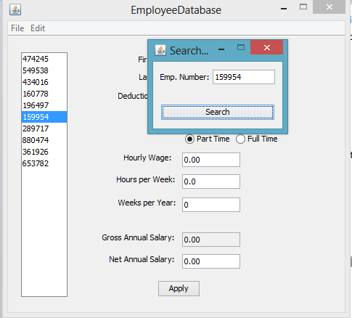

If the employee is not found, no employee will be selected and the search box will say “Employee not found”.