Enhanced Honeycomb Rectangular Mesh $EHReM(6,7)$
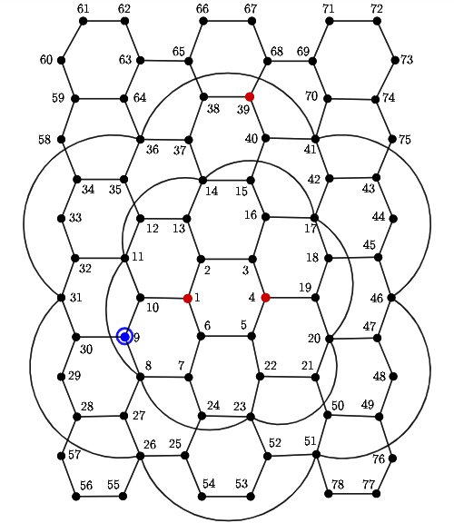
Metric dimension - 4
BIGS index - 6
- {1, 4, 9, 39}
- {1, 4, 9, 67}
- {1, 4, 9, 68}
- {2, 5, 9, 39}
- {2, 5, 9, 67}
- {2, 5, 9, 68}

