Enhanced Honeycomb Rectangular Mesh of type 2 $EHReM_{2}(6,7)$
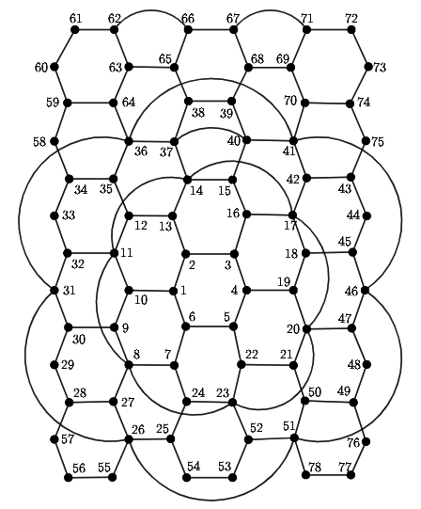
Metric dimension - 4
BIGS index -10
- {1, 4, 9, 39}
- {1, 4, 9, 67}
- {1, 4, 9, 68}
- {2, 5, 9, 39}
- {2, 5, 9, 67}
- {2, 5, 9, 68}
- {2, 18, 54, 62}
- {7, 15, 62, 78}
- {16, 24, 51, 62}
- {16, 24, 62, 78}

