Enhanced Honeycomb rectangular mesh of type 2 ${EHReM}_{2}(10,11)$
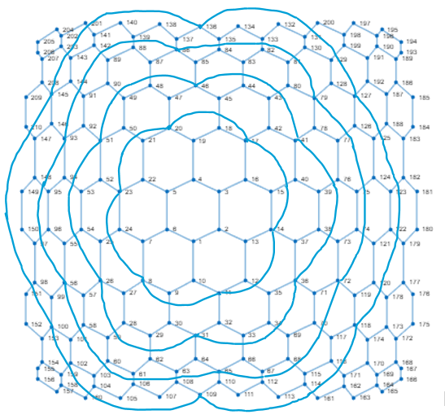
Metric dimension – 5
BIGS index – 85

- {1, 4, 61, 89, 181}
- {1, 4, 61, 141, 181}
- {1, 4, 61, 142, 181}
- {1, 4, 61, 181, 201}
- {1, 4, 89, 105, 181}
- {1, 4, 96, 114, 132}
- {1, 4, 96, 132, 161}
- {1, 4, 105, 141, 181}
- {1, 4, 105, 181, 201}
- {1, 47, 61, 89, 180}
- {1, 47, 89, 105, 180}
- {2, 5, 61, 89, 181}
- {2, 5, 61, 141, 181}
- {2, 5, 61, 142, 181}
- {2, 5, 61, 181, 201}
- {2, 5, 89, 105, 181}
- {2, 5, 96, 114, 132}
- {2, 5, 96, 132, 161}
- {2, 5, 105, 141, 181}
- {2, 5, 105, 181, 201}
- {2, 34, 131, 150, 164}
- {2, 34, 131, 150, 175}
- {2, 34, 150, 164, 200}
- {2, 34, 150, 175, 200}
- {2, 44, 114, 149, 176}
- {2, 44, 149, 161, 176}
- {2, 52, 96, 114, 131}
- {2, 52, 96, 114, 200}
- {2, 52, 96, 131, 161}
- {2, 52, 96, 161, 200}
- {2, 68, 82, 150, 167}
- {2, 68, 82, 150, 175}
- {2, 69, 82, 150, 175}
- {3, 6, 61, 89, 181}
- {3, 6, 61, 141, 181}
- {3, 6, 61, 142, 181}
- {3, 6, 61, 181, 201}
- {3, 6, 89, 105, 181}
- {3, 6, 96, 114, 132}
- {3, 6, 96, 132, 161}
- {3, 6, 105, 141, 181}
- {3, 6, 105, 181, 201}
- {3, 27, 61, 140, 181}
- {3, 82, 114, 150, 189}
- {3, 82, 114, 150, 193}
- {3, 82, 114, 150, 195}
- {3, 82, 114, 150, 196}
- {3, 82, 115, 150, 193}
- {3, 82, 150, 161, 189}
- {3, 82, 150, 161, 193}
- {3, 82, 150, 161, 195}
- {3, 82, 150, 161, 196}
- {5, 49, 104, 181, 209}
- {5, 49, 160, 181, 209}
- {5, 61, 89, 181, 209}
- {5, 61, 90, 181, 209}
- {5, 96, 114, 132, 209}
- {5, 96, 132, 161, 209}
- {6, 61, 141, 154, 181}
- {6, 61, 141, 155, 181}
- {6, 61, 141, 156, 181}
- {6, 61, 142, 154, 181}
- {6, 61, 142, 155, 181}
- {6, 61, 142, 156, 181}
- {6, 61, 154, 181, 201}
- {6, 61, 155, 181, 201}
- {6, 61, 156, 181, 201}
- {6, 96, 100, 114, 132}
- {6, 96, 100, 132, 161}
- {6, 96, 114, 132, 152}
- {6, 96, 114, 132, 153}
- {6, 96, 114, 132, 154}
- {6, 96, 114, 132, 155}
- {6, 96, 114, 132, 156}
- {6, 96, 132, 152, 161}
- {6, 96, 132, 153, 161}
- {6, 96, 132, 154, 161}
- {6, 96, 132, 155, 161}
- {6, 96, 132, 156, 161}
- {13, 73, 132, 150, 162}
- {13, 73, 132, 150, 163}
- {15, 66, 88, 98, 184}
- {15, 66, 88, 151, 184}
- {15, 67, 88, 98, 184}
- {15, 67, 88, 151, 184}

