Enhanced Honeycomb rectangular mesh of type 3 ${EHReM}_{3}(10,11)$
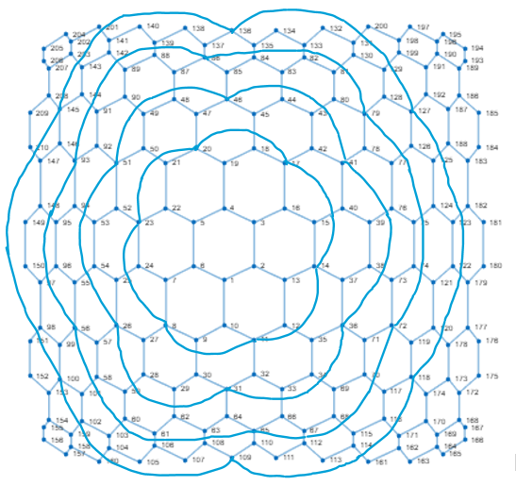
Metric dimension – 5
BIGS index - 188

- {1, 4, 61, 89, 123}
- {1, 4, 61, 89, 181}
- {1, 4, 61, 89, 182}
- {1, 4, 61, 123, 141}
- {1, 4, 61, 123, 142}
- {1, 4, 61, 123, 201}
- {1, 4, 61, 141, 181}
- {1, 4, 61, 141, 182}
- {1, 4, 61, 142, 181}
- {1, 4, 61, 142, 182}
- {1, 4, 61, 181, 201}
- {1, 4, 61, 182, 201}
- {1, 4, 89, 105, 123}
- {1, 4, 89, 105, 181}
- {1, 4, 89, 105, 182}
- {1, 4, 96, 114, 132}
- {1, 4, 96, 132, 161}
- {1, 4, 105, 123, 141}
- {1, 4, 105, 123, 201}
- {1, 4, 105, 141, 181}
- {1, 4, 105, 141, 182}
- {1, 4, 105, 181, 201}
- {1, 4, 105, 182, 201}
- {1, 4, 114, 132, 150}
- {1, 4, 132, 150, 161}
- {1, 47, 61, 89, 122}
- {1, 47, 61, 89, 179}
- {1, 47, 61, 89, 180}
- {1, 47, 89, 105, 122}
- {1, 47, 89, 105, 179}
- {1, 47, 89, 105, 180}
- {2, 5, 61, 89, 123}
- {2, 5, 61, 89, 181}
- {2, 5, 61, 89, 182}
- {2, 5, 61, 123, 141}
- {2, 5, 61, 123, 142}
- {2, 5, 61, 123, 201}
- {2, 5, 61, 141, 181}
- {2, 5, 61, 141, 182}
- {2, 5, 61, 142, 181}
- {2, 5, 61, 142, 182}
- {2, 5, 61, 181, 201}
- {2, 5, 61, 182, 201}
- {2, 5, 89, 105, 123}
- {2, 5, 89, 105, 181}
- {2, 5, 89, 105, 182}
- {2, 5, 96, 114, 132}
- {2, 5, 96, 132, 161}
- {2, 5, 105, 123, 141}
- {2, 5, 105, 123, 201}
- {2, 5, 105, 141, 181}
- {2, 5, 105, 141, 182}
- {2, 5, 105, 181, 201}
- {2, 5, 105, 182, 201}
- {2, 5, 114, 132, 150}
- {2, 5, 132, 150, 161}
- {2, 34, 97, 131, 175}
- {2, 34, 97, 175, 200}
- {2, 34, 131, 150, 175}
- {2, 34, 150, 175, 200}
- {2, 44, 114, 149, 176}
- {2, 44, 149, 161, 176}
- {2, 52, 96, 114, 131}
- {2, 52, 96, 114, 200}
- {2, 52, 96, 131, 161}
- {2, 52, 96, 161, 200}
- {2, 61, 75, 142, 168}
- {2, 61, 75, 142, 175}
- {2, 68, 82, 97, 167}
- {2, 68, 82, 97, 175}
- {2, 68, 82, 150, 167}
- {2, 68, 82, 150, 175}
- {2, 69, 82, 150, 175}
- {2, 75, 105, 141, 168}
- {2, 75, 105, 141, 175}
- {2, 75, 105, 168, 201}
- {2, 75, 105, 175, 201}
- {3, 6, 61, 89, 123}
- {3, 6, 61, 89, 181}
- {3, 6, 61, 89, 182}
- {3, 6, 61, 123, 141}
- {3, 6, 61, 123, 142}
- {3, 6, 61, 123, 201}
- {3, 6, 61, 141, 181}
- {3, 6, 61, 141, 182}
- {3, 6, 61, 142, 181}
- {3, 6, 61, 142, 182}
- {3, 6, 61, 181, 201}
- {3, 6, 61, 182, 201}
- {3, 6, 89, 105, 123}
- {3, 6, 89, 105, 181}
- {3, 6, 89, 105, 182}
- {3, 6, 96, 114, 132}
- {3, 6, 96, 132, 161}
- {3, 6, 105, 123, 141}
- {3, 6, 105, 123, 201}
- {3, 6, 105, 141, 181}
- {3, 6, 105, 141, 182}
- {3, 6, 105, 181, 201}
- {3, 6, 105, 182, 201}
- {3, 6, 114, 132, 150}
- {3, 6, 132, 150, 161}
- {3, 27, 61, 123, 140}
- {3, 27, 61, 140, 181}
- {3, 27, 61, 140, 182}
- {3, 68, 82, 97, 185}
- {3, 68, 82, 97, 193}
- {3, 75, 89, 105, 189}
- {3, 82, 114, 150, 189}
- {3, 82, 114, 150, 193}
- {3, 82, 114, 150, 195}
- {3, 82, 114, 150, 196}
- {3, 82, 115, 150, 193}
- {3, 82, 150, 161, 189}
- {3, 82, 150, 161, 193}
- {3, 82, 150, 161, 195}
- {3, 82, 150, 161, 196}
- {4, 33, 82, 97, 184}
- {5, 29, 122, 141, 210}
- {5, 29, 122, 201, 210}
- {5, 29, 141, 179, 210}
- {5, 29, 141, 180, 210}
- {5, 29, 179, 201, 210}
- {5, 29, 180, 201, 210}
- {5, 49, 104, 123, 209}
- {5, 49, 104, 181, 209}
- {5, 49, 104, 182, 209}
- {5, 49, 123, 160, 209}
- {5, 49, 160, 181, 209}
- {5, 49, 160, 182, 209}
- {5, 61, 89, 123, 205}
- {5, 61, 89, 123, 206}
- {5, 61, 89, 123, 209}
- {5, 61, 89, 181, 205}
- {5, 61, 89, 181, 206}
- {5, 61, 89, 181, 209}
- {5, 61, 89, 182, 205}
- {5, 61, 89, 182, 206}
- {5, 61, 89, 182, 209}
- {5, 61, 90, 123, 209}
- {5, 61, 90, 181, 209}
- {5, 61, 90, 182, 209}
- {5, 96, 114, 132, 205}
- {5, 96, 114, 132, 206}
- {5, 96, 114, 132, 209}
- {5, 96, 132, 161, 205}
- {5, 96, 132, 161, 206}
- {5, 96, 132, 161, 209}
- {6, 61, 123, 141, 154}
- {6, 61, 123, 141, 155}
- {6, 61, 123, 141, 156}
- {6, 61, 123, 142, 154}
- {6, 61, 123, 142, 155}
- {6, 61, 123, 142, 156}
- {6, 61, 123, 154, 201}
- {6, 61, 123, 155, 201}
- {6, 61, 123, 156, 201}
- {6, 61, 141, 154, 181}
- {6, 61, 141, 154, 182}
- {6, 61, 141, 155, 181}
- {6, 61, 141, 155, 182}
- {6, 61, 141, 156, 181}
- {6, 61, 141, 156, 182}
- {6, 61, 142, 154, 181}
- {6, 61, 142, 154, 182}
- {6, 61, 142, 155, 181}
- {6, 61, 142, 155, 182}
- {6, 61, 142, 156, 181}
- {6, 61, 142, 156, 182}
- {6, 61, 154, 181, 201}
- {6, 61, 154, 182, 201}
- {6, 61, 155, 181, 201}
- {6, 61, 155, 182, 201}
- {6, 61, 156, 181, 201}
- {6, 61, 156, 182, 201}
- {13, 73, 97, 132, 162}
- {13, 73, 97, 132, 163}
- {13, 74, 97, 116, 132}
- {13, 74, 97, 132, 162}
- {13, 74, 97, 132, 163}
- {13, 74, 97, 132, 171}
- {22, 94, 105, 123, 143}
- {22, 94, 105, 123, 202}
- {22, 94, 105, 123, 203}
- {22, 95, 105, 123, 143}
- {22, 95, 105, 123, 202}
- {22, 95, 105, 123, 203}
- {22, 95, 105, 123, 204}

