Enhanced Honeycomb rectangular mesh of type 4 ${EHReM}_{4}(10,11)$
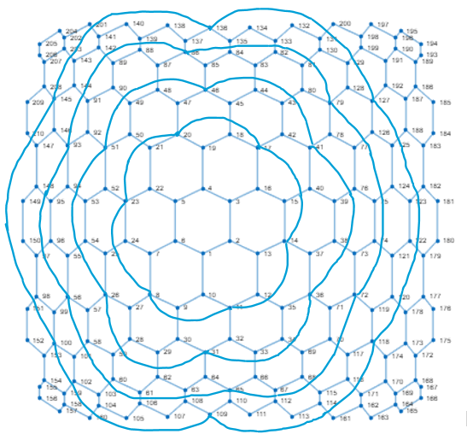
Metric dimension – 5
BIGS index - 25

- {1, 47, 61, 89, 180}
- {1, 47, 89, 105, 180}
- {2, 34, 131, 150, 164}
- {2, 34, 131, 150, 175}
- {2, 34, 150, 164, 200}
- {2, 34, 150, 175, 200}
- {2, 44, 114, 149, 176}
- {2, 44, 149, 161, 176}
- {2, 68, 82, 150, 167}
- {2, 68, 82, 150, 175}
- {2, 69, 82, 150, 175}
- {3, 27, 61, 140, 181}
- {3, 82, 114, 150, 189}
- {3, 82, 114, 150, 193}
- {3, 82, 114, 150, 195}
- {3, 82, 114, 150, 196}
- {3, 82, 115, 150, 193}
- {3, 82, 150, 161, 189}
- {3, 82, 150, 161, 193}
- {3, 82, 150, 161, 195}
- {3, 82, 150, 161, 196}
- {5, 49, 104, 181, 207}
- {5, 49, 104, 181, 209}
- {5, 49, 160, 181, 207}
- {5, 49, 160, 181, 209}

