Enhanced Honeycomb Rhombic Mesh of type 1 $EHRoM_{1}(10,10)$
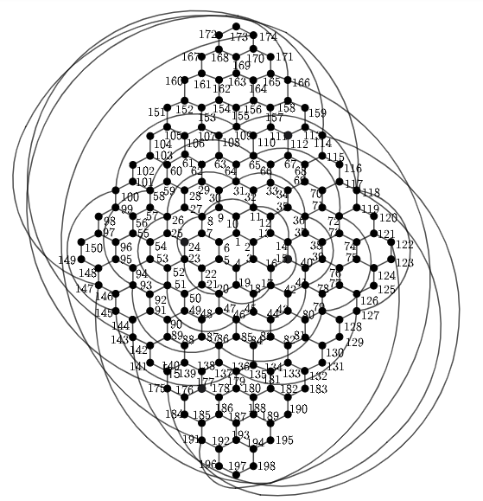
Metric dimension - 5
BIGS index - 1
- {2, 5, 54, 67, 82}

