Enhanced Honeycomb Rhombic mesh of dimension 6
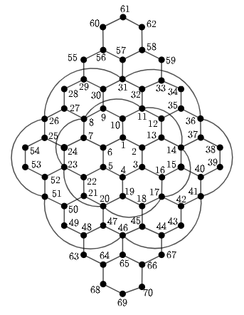
Metric dimension – 4
BIGS index - 25

- {1, 15, 49, 58}
- {1, 15, 49, 62}
- {4, 24, 34, 64}
- {4, 24, 34, 68}
- {7, 15, 58, 68}
- {7, 15, 62, 68}
- {9, 15, 56, 68}
- {9, 15, 60, 68}
- {12, 22, 58, 68}
- {12, 22, 62, 68}
- {13, 21, 62, 64}
- {13, 21, 62, 68}
- {14, 23, 58, 64}
- {14, 23, 58, 68}
- {14, 23, 62, 64}
- {14, 23, 62, 68}
- {14, 24, 62, 64}
- {14, 24, 62, 68}
- {15, 23, 58, 68}
- {15, 23, 62, 68}
- {15, 24, 62, 68}
- {16, 24, 62, 64}
- {16, 24, 62, 68}
- {18, 24, 62, 66}
- {18, 24, 62, 70}

