Enhanced Honeycomb Rhombic mesh $EHRoM(8,8)$
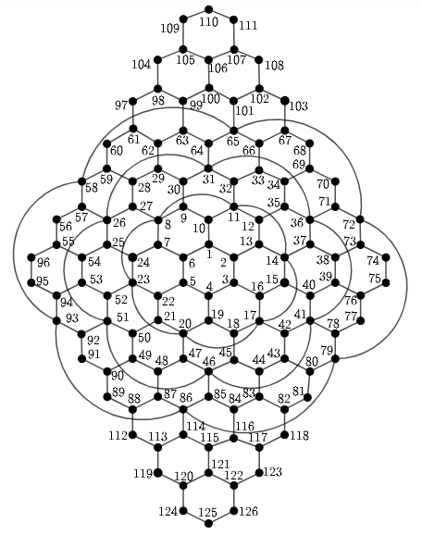
Metric dimension – 4
BIGS index - 4
- {15, 24, 102, 113}
- {15, 24, 102, 119}
- {15, 24, 108, 113}
- {15, 24, 108, 119}

