Enhanced Honeycomb Rhombic mesh of type 1 and 2 of dimension 4
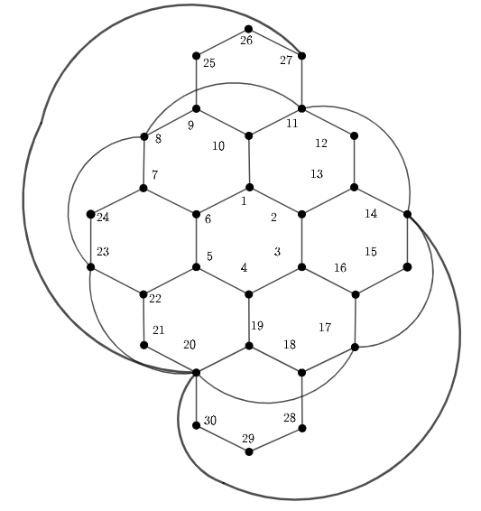
Metric dimension – 4
BIGS index - 126

- {1, 3, 14, 24}
- {1, 3, 15, 24}
- {1, 3, 16, 24}
- {1, 3, 17, 24}
- {1, 5, 8, 15}
- {1, 5, 9, 15}
- {1, 5, 18, 26}
- {1, 5, 18, 27}
- {1, 5, 23, 25}
- {1, 5, 24, 25}
- {1, 5, 26, 28}
- {1, 5, 27, 28}
- {1, 12, 15, 26}
- {1, 12, 16, 24}
- {1, 14, 23, 25}
- {1, 14, 24, 25}
- {1, 15, 21, 25}
- {1, 15, 22, 26}
- {1, 16, 24, 25}
- {1, 19, 24, 25}
- {2, 5, 17, 26}
- {2, 5, 17, 27}
- {2, 5, 18, 26}
- {2, 5, 18, 27}
- {2, 5, 24, 25}
- {2, 5, 26, 28}
- {2, 5, 27, 28}
- {2, 7, 19, 25}
- {2, 10, 17, 21}
- {2, 12, 17, 24}
- {2, 12, 17, 26}
- {3, 6, 9, 19}
- {3, 6, 9, 20}
- {3, 6, 9, 29}
- {3, 6, 9, 30}
- {3, 6, 13, 20}
- {3, 6, 13, 30}
- {3, 6, 14, 20}
- {3, 6, 14, 30}
- {3, 6, 15, 20}
- {3, 6, 15, 30}
- {3, 6, 19, 27}
- {3, 6, 20, 27}
- {3, 6, 27, 29}
- {3, 6, 27, 30}
- {3, 7, 12, 17}
- {3, 7, 12, 18}
- {3, 7, 12, 19}
- {3, 7, 12, 20}
- {3, 7, 12, 28}
- {3, 7, 12, 29}
- {3, 7, 12, 30}
- {3, 7, 13, 19}
- {3, 7, 13, 20}
- {3, 7, 13, 29}
- {3, 7, 13, 30}
- {3, 9, 12, 17}
- {3, 9, 13, 17}
- {3, 9, 15, 19}
- {3, 9, 15, 20}
- {3, 9, 15, 29}
- {3, 9, 15, 30}
- {3, 10, 16, 24}
- {3, 12, 17, 24}
- {3, 12, 17, 26}
- {4, 6, 15, 20}
- {4, 6, 15, 30}
- {4, 6, 27, 29}
- {4, 13, 21, 29}
- {4, 13, 26, 29}
- {4, 13, 27, 29}
- {5, 8, 13, 29}
- {5, 8, 15, 19}
- {5, 8, 15, 20}
- {5, 8, 15, 29}
- {5, 8, 15, 30}
- {5, 9, 13, 29}
- {5, 9, 15, 20}
- {5, 9, 15, 23}
- {5, 9, 15, 29}
- {5, 9, 15, 30}
- {5, 10, 15, 23}
- {5, 10, 16, 23}
- {5, 13, 19, 26}
- {5, 13, 19, 27}
- {5, 16, 19, 26}
- {5, 16, 19, 27}
- {5, 16, 23, 26}
- {5, 16, 23, 27}
- {6, 8, 13, 19}
- {6, 8, 13, 29}
- {6, 8, 14, 19}
- {6, 8, 14, 29}
- {6, 8, 15, 19}
- {6, 8, 15, 20}
- {6, 8, 15, 29}
- {6, 8, 15, 30}
- {6, 9, 13, 29}
- {6, 9, 14, 29}
- {6, 9, 26, 29}
- {6, 9, 27, 29}
- {6, 11, 15, 20}
- {6, 11, 15, 30}
- {6, 11, 26, 29}
- {6, 12, 15, 23}
- {6, 12, 16, 24}
- {6, 13, 19, 21}
- {6, 13, 19, 22}
- {6, 13, 19, 25}
- {6, 13, 25, 29}
- {6, 14, 25, 29}
- {6, 21, 25, 29}
- {6, 25, 26, 29}
- {6, 25, 27, 29}
- {7, 12, 26, 29}
- {7, 12, 27, 29}
- {7, 13, 26, 29}
- {8, 15, 25, 29}
- {9, 15, 26, 29}
- {9, 15, 27, 29}
- {11, 13, 26, 29}
- {12, 15, 26, 29}
- {12, 16, 26, 29}
- {13, 22, 26, 29}
- {15, 25, 26, 29}
- {15, 25, 27, 29}

