In Air PAR Sensor Calibration

Date: Jun -22 - 2017
Customer: Sea Bird
Project Number: 2017-034205
Model: PAR LOG 1000m
Serial Number: 1101

Calibration Coefficients

a₁ = 0.8048

a₀ = 0.8467

Equation: 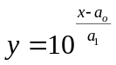

where,
PAR is y, [y] = μmol photons/m²/s
Analog signal is x, [x] = V

For users of Sea-Bird Electronics data processing software, SEASOFT, calibration coefficients are converted in accordance with Sea-Bird Electronics application note No. 11 QSP-L. The corresponding coefficients for use in SEASOFT are:

multiplier = 1.0
M = 0.8048
B = 0.8467
Calibration_const = 1.0*10⁹
offset = 0

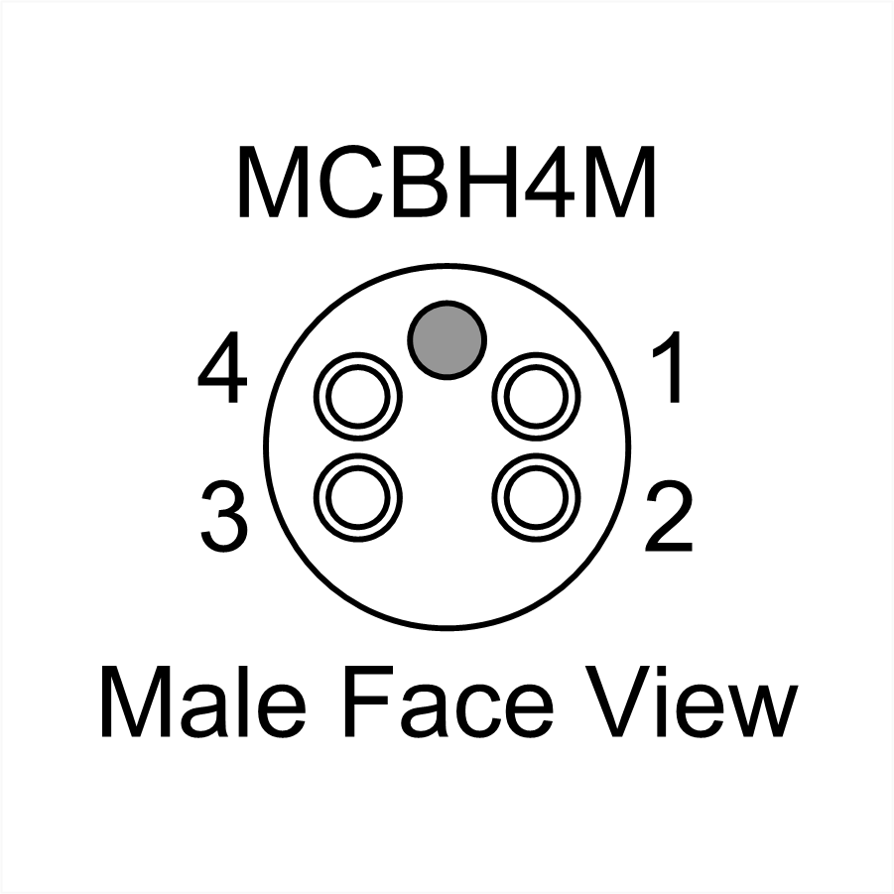
Table 1 - Connector Pin Descriptions
Pin | Signal | Description
1 | GND | Power Supply Return
2 | SIG | Analog signal (0 to 5 volts)
3 | AGND | Analog ground ¹
4 | V+ | DC Power Supply (6 to 30 VDC)
¹ GND and AGND are connected internally.

