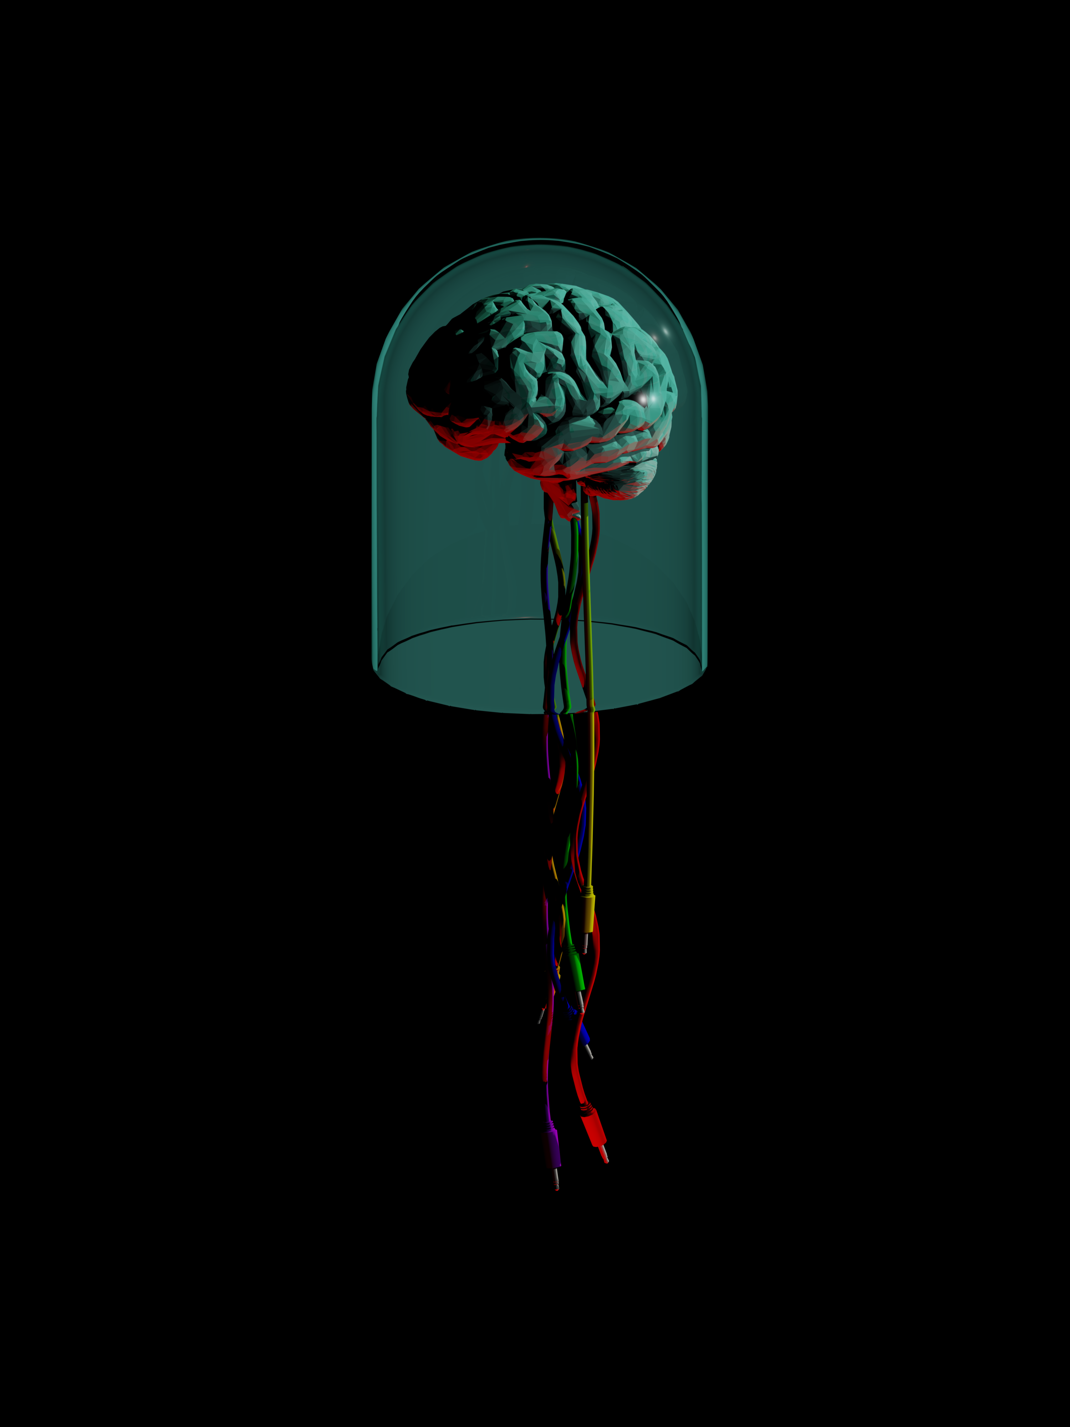

Introducing The MindBrain

The MindBrain is a two input, eight output AC or DC coupled two-way computer to CV interface with an included software package which aims to bridge the gap between the two worlds of hardware modular synthesis and computer music production and software.

Max for Live Software Package

We have created a software package to use with the MindBrain in Max for Live, which contains a number of utility modules that allow one to take control of fundamental aspects of a modular system such as pitch, envelopes and gates. We have also included a number of more esoteric devices to facilitate more experimental compositional practices. This is a brief overview of the devices in the MindBrain Software Package and how they can be used -

Pitch Calibration Tools

The first pair of devices in the MindBrain Software Package is to allow the user to tune oscillators in a modular system and control them using pitch information from Live. This system allows for reliable tuning between multiple oscillators and software instruments if used correctly.

MIDI to Gate/Trigger

The MIDI to Gate/Trigger is a simple device that outputs a single Gate or Trigger output for each incoming MIDI note. This device can be used to trigger sequencers and/or envelope generators based on incoming MIDI notes.

Dual Envelope Generator

The Dual Envelope Generator is a versatile modulation source. Each side of the Dual Envelope Generator can be set to one of two modes – the N-Point Envelope Generator or the classic West Coast style Rise/Fall Envelope Generator. Both modes allow either triggered or cycling operation.

Dual Random Generator

The Dual Random Generator device can be used to obtain many flavors of random modulation. Each side of the Dual Random Generator can be set to one of three modes – The first mode outputs random stepped voltages, the second mode outputs random smoothed voltages and the last mode outputs random gates or timing pulses. Each mode has controls for rate, variance and scaling functions like offset and depth. The Dual Random Generator