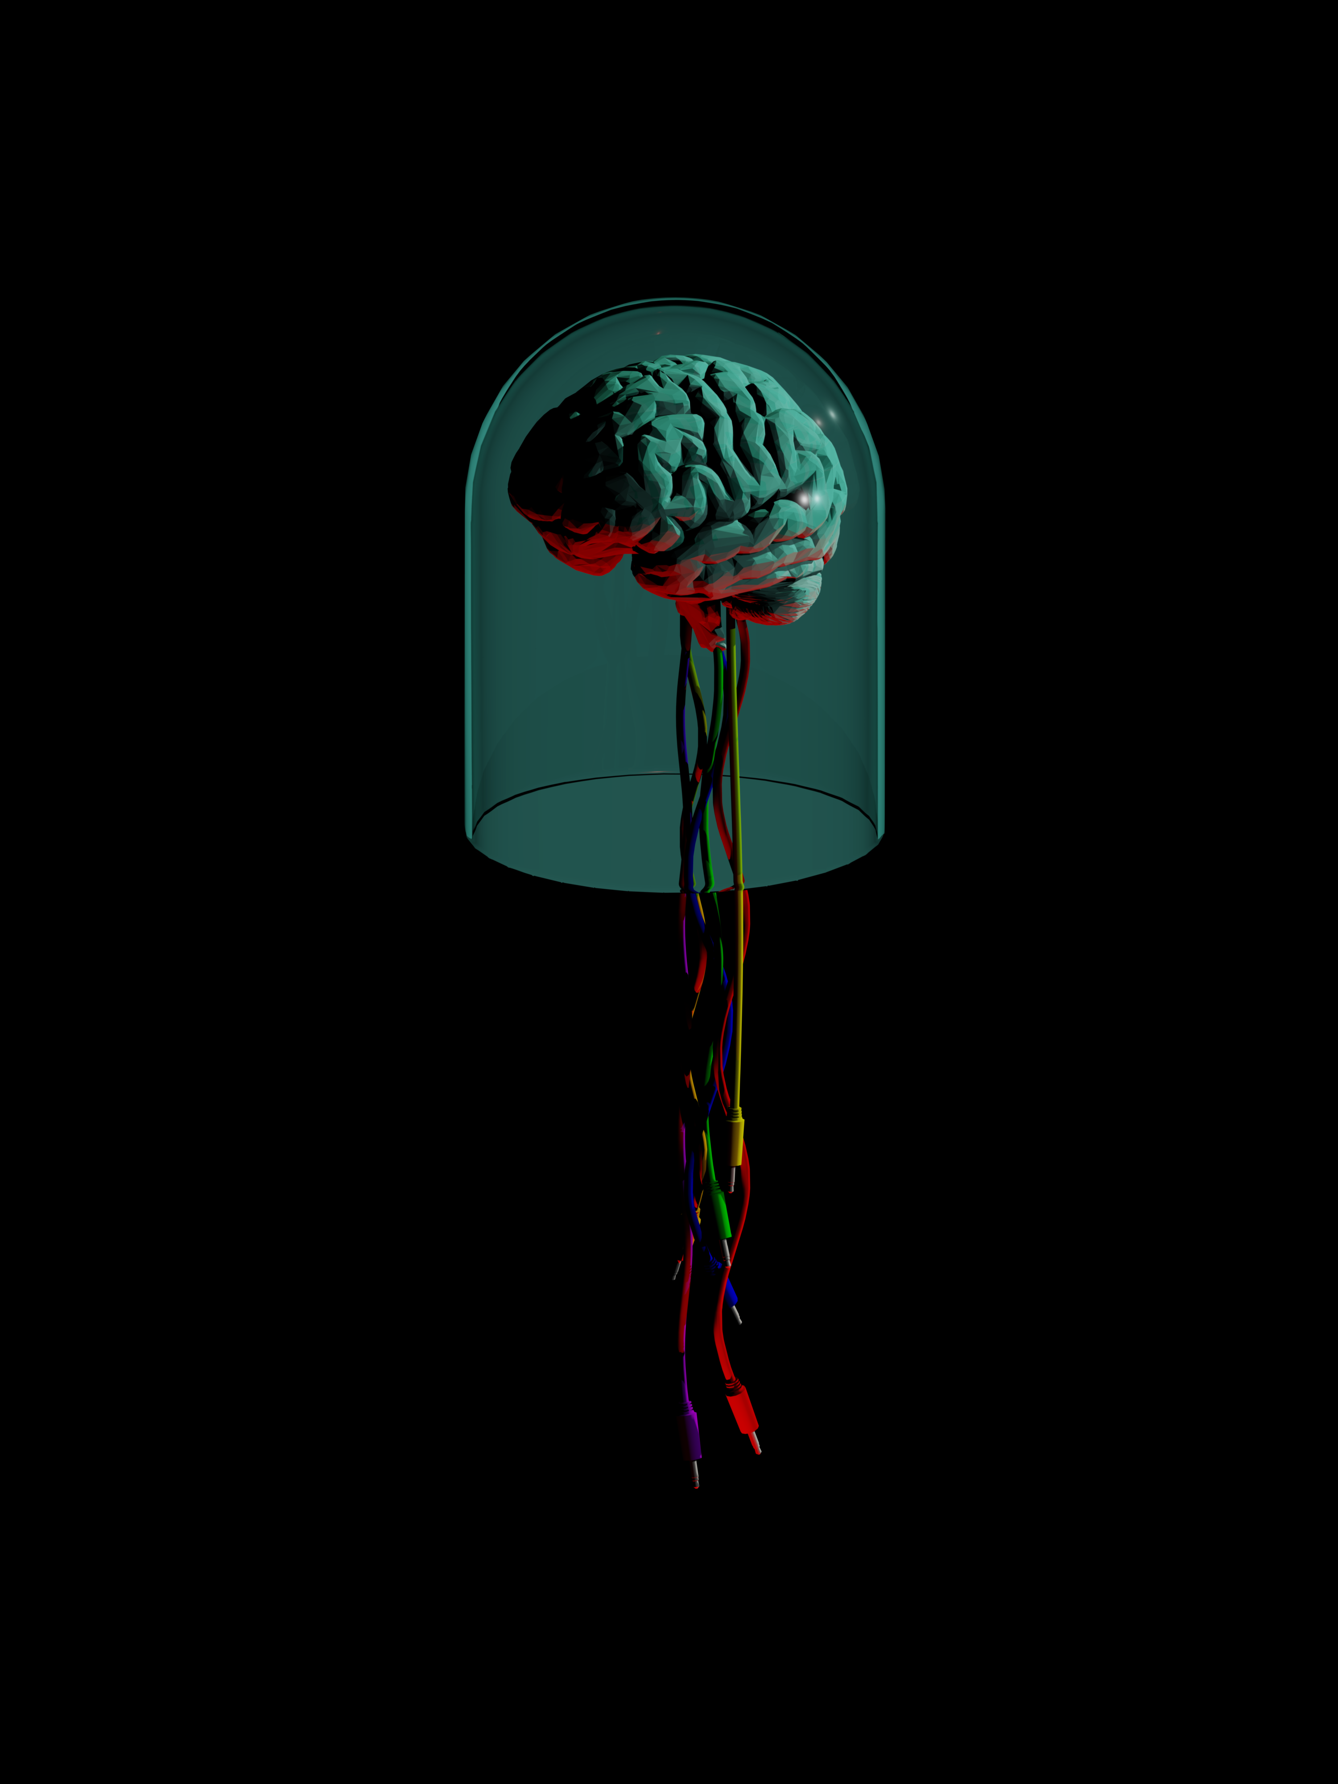

Introducing The MindBrain

The MindBrain is a two input, eight output AC or DC coupled two-way computer to Control Voltage interface with an included software package which aims to bridge the gap between the two worlds of hardware modular synthesis and computer music production and software.

Using the MindBrain with Ableton Live

Max for Live Software Package

We have created a software package to use with the MindBrain in Max for Live, which contains a number of utility modules that allow one to take control of fundamental aspects of a modular system such as pitch, envelopes and gates. We have also included a number of more esoteric devices to facilitate more experimental compositional practices. This is a brief overview of the devices in the MindBrain Software Package and how they can be used -

MindBrain Pitch Calibration Tools

The first pair of devices in the MindBrain Software Package is to allow the user to tune oscillators in a modular system and control them using pitch information from Live. This system allows for reliable tuning between multiple oscillators and software instruments if used correctly.

MindBrain Pitch Calibrator

The first of the two devices is the MindBrain Pitch Calibrator device. It sends out a stepped DC voltage from its outputs and listens to the incoming audio from the oscillator to be tuned. It creates transfer function, (a map of the pitch response of the oscillator) which will then be used by the Pitch and Gate/Envelope Out to send the oscillator pitch information.

Start by patching the Sine or Triangle outputs of your oscillator into one of the MindBrain’s two inputs. Then set the input attenuator to get a healthy signal on Live’s input meters. A signal that’s loud but isn’t clipping is ideal for this. Then, patch the first of the two outputs that you’re using to the CV input of your VCO. 1V/Octave inputs work best for this. Now lets setup the software.

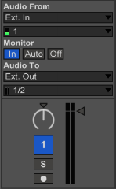Add the *MindBrain.PitchCalibrator.amxd* file to an empty audio track, set its ‘Audio From’ field to ‘Ext. In 1’ or ‘Ext. In 2’, depending on which of the two inputs your oscillator is plugged into. Set the ‘Track Monitor’ status to ‘In’.

Once you have set your levels with the input attenuator, its time to get calibrating.

MindBrain Pitch & Gate/Envelope Out

Text here

MindBrain MIDI to Gate/Trigger

The MindBrain MIDI to Gate/Trigger is a simple device that outputs a single Gate or Trigger output for each incoming MIDI note. This device can be used to trigger sequencers and/or envelope generators based on incoming MIDI notes.

MindBrain Dual Low Frequency Oscillator

The MindBrain Dual Low Frequency Oscillator device is a simple but deep LFO module. Each of its two sides can be set to one of seven different wave shapes – Sine, Ramp Up, Ramp Down, Triangle, Rectangle, Random and Bin. The LFO can be set to sync with Live’s clock, or can be set to an independent frequency up to 2KHz.

MindBrain Dual Envelope Generator

The MindBrain Dual Envelope Generator is a versatile modulation source. Each side of the Dual Envelope Generator can be set to one of two modes – the N-Point Envelope Generator or the classic West Coast style Rise/Fall Envelope Generator. Both modes allow either triggered or cycling operation.

MindBrain Dual Random Generator

The MindBrain Dual Random Generator device can be used to obtain many flavors of random modulation. Each side of the Dual Random Generator can be set to one of three modes – The first mode outputs random stepped voltages, the second mode outputs random smoothed voltages and the last mode outputs random gates or timing pulses. Each mode has controls for rate, variance and scaling functions like offset and depth.

The Dual Random Generator also has a manual mode for all of its three modes, with which the next random value can be triggered using incoming MIDI notes or the manual trigger button.