Game Design Document

Fill up the Following document

1. Write the title of your project.

Pick your money

1. What is the goal of the game?

To pick the money

1. Write a brief story of your game?

A player should use a stone to broke the big stone

And the player will get the money.

1. Which are the playing characters of this game?

* Playing characters are the ones which respond to the user based on the input from the user
* Cars, monkeys, dinos, wizards etc, are the playing characters in the game.

|  |  |  |
| --- | --- | --- |
| Number | Character Name | What can this character do? |
| 1 | Name of the person (eg:mohan) | He can broke the stone |
| 2 |  |  |
| 3 |  |  |
| 4 |  |  |
| 5 |  |  |
| 6 |  |  |
| 7 |  |  |
| 8 |  |  |

1. Which are the Non Playing Characters of this game?

* Non Playing characters are the ones which don't have an action or a behaviour when the user interacts with the game.
* Hurdles, stones, bananas, coins, etc are non playing characters in the game.

|  |  |  |
| --- | --- | --- |
| Number | Character Name | What can this character do? |
| 1 | Stone | To save the money |
| 2 | water | If money went to the water the half of the money will go to the player and he cant get the full money |
| 3 |  |  |
| 4 |  |  |
| 5 |  |  |
| 6 |  |  |
| 7 |  |  |
| 8 |  |  |

Draw your imagination of this game. What does this game look like?

* Draw the game either on your computer or on paper,
* Add images of scenes of the game to show each of the playing and non-playing characters at least once.

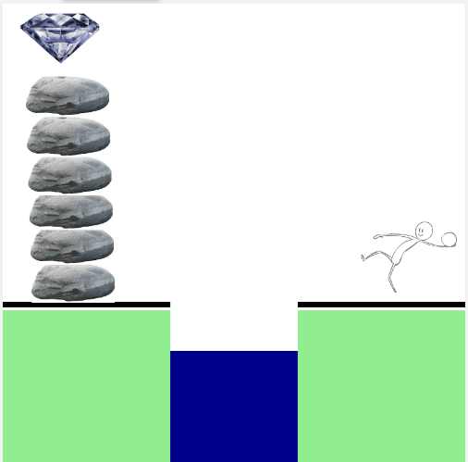

It looks like a benefiting game

How do you plan to make your game engaging?